Extended Data Table 1. Detailed information on the vertical observation dataset.
Tower | Guangzhou tower | Shenzhen tower | Beijing tower | Eric, CO tower
City | Guangzhou  (China) | Shenzhen  (China) | Beijing  (China) | Erie, CO  (USA)
Latitude | 23.11 ° N | 22.65 ° N | 39.98 ° N | 40.05° N
Longitude | 113.33 ° E | 113 .89 ° E | 116 .37 ° E | 105.00° W
Vertical range
Observation | Surface*, 118 m,  168 m ,488 m | 60/70 m, 110/120 m,  210/220 m,325/335 m | 8 m, 60 m,  160 m, 280 m | 0-270m
Time range#
Year | 2014-2020 | 2022 | 2019 | 2011
Month | Jan, Apr, Jul, Oct | Jan, Apr, Jul, Oct | Jan, Apr, Jul, Oct | 02/15-03/15
Resolution
Time | 1 h | 1 h | 1 h | 1 h
Instruments
NO₂ | Thermo 42i | Thermo 42i | Chemiluminescence | CRDS
O₃ | Thermo 49i | Thermo 49i | UV photometry | CRDS
Note:
*Surface data for Guangzhou tower in 2014 was missing due to instrument malfunctions, data from a nearby station (Guangdong University of Commerce) were used to supplement.
※The surface observation in Shenzhen tower is missed, thus the average concentration from two national stations (Nanhaizi and Huaqiaocheng) closer to the Shenzhen tower were selected to supplement the surface data.
#Due to instrument malfunctions and other factors, vertical observation data in Guangzhou tower was missing for July in 2017, 2018, and 2020, as well as October 2020.
Serial number | Relative concentration of  gNO₂ and gO₃ | Vertical distribution of NO₂ and O₃ |  | Relative concentration of hNO₂ and hO₃
1 | gNO₂<gO₃ | gO₃<hO₃ | gNO₂<hNO₂ | hNO₂<hO₃
2 | gNO₂<gO₃ | gO₃<hO₃ | gNO₂<hNO₂ | hNO₂>hO₃
3 | gNO₂<gO₃ | gO₃<hO₃ | gNO₂>hNO₂ | hNO₂<hO₃
4 | gNO₂<gO₃ | gO₃>hO₃ | gNO₂<hNO₂ | hNO₂<hO₃
5 | gNO₂<gO₃ | gO₃>hO₃ | gNO₂<hNO₂ | hNO₂>hO₃
6 | gNO₂<gO₃ | gO₃>hO₃ | gNO₂>hNO₂ | hNO₂<hO₃
7 | gNO₂<gO₃ | gO₃>hO₃ | gNO₂>hNO₂ | hNO₂>hO₃
8 | gNO₂>gO₃ | gO₃<hO₃ | gNO₂<hNO₂ | hNO₂<hO₃
9 | gNO₂>gO₃ | gO₃<hO₃ | gNO₂<hNO₂ | hNO₂>hO₃
10 | gNO₂>gO₃ | gO₃<hO₃ | gNO₂>hNO₂ | hNO₂<hO₃
11 | gNO₂>gO₃ | gO₃<hO₃ | gNO₂>hNO₂ | hNO₂>hO₃
12 | gNO₂>gO₃ | gO₃>hO₃ | gNO₂<hNO₂ | hNO₂>hO₃
13 | gNO₂>gO₃ | gO₃>hO₃ | gNO₂>hNO₂ | hNO₂<hO₃
14 | gNO₂>gO₃ | gO₃>hO₃ | gNO₂>hNO₂ | hNO₂>hO₃
Extended Data Table 2. All possible vertical distribution patterns of NO₂ and O₃. The gNO₂ and gO₃ represent the NO₂ and O₃ concentration at the ground, and the hNO₂ and hO₃ represent the NO₂ and O₃ concentration above the ground.

Extended Data Table 3. NO₃-involved gas-phase reactions in CMAQ.
Process | Formula
NO3_Prod | O3P+NO2=NO3
NO3_Prod | O3+NO2=NO3
NO3_Prod | N2O5=NO2+NO3
NO3_Prod | OH+HNO3=NO3
NO3_Prod | HNO4+hv=.61*HO2+.61*NO2+.39*OH+.39*NO3
NO3_Prod | PAN+hv=.6*MECO3+.6*NO2+.4*MEO2+.4*CO2+.4*NO3
NO3_Prod | PAN2+hv=.6*RCO3+.6*NO2+.4*RO2C+.4*xHO2+.4*yROOH+.4*xCCHO+.4*CO2+.4*NO3
NO3_Prod | PBZN+hv=.6*BZCO3+.6*NO2+.4*CO2+.4*BZO+.4*RO2C+.4*NO3
NO3_Prod | MAPAN+hv=.6*MACO3+.6*NO2+.4*CO2+.4*HCH+.4*MECO3+.4*NO3
NO3_Prod | HCOCO3+NO2=HO2+CO+CO2+NO3
NO3_Prod | CLONO2+hv=CL+NO3
NO3_Prod | CL+CLONO2=CL2+NO3
NO3_Prod | ISOPNO+NO=.34*PRD2+.15*PROPNN+.44*HACE+.07*MVKN+.13*ETHLN+.31*HCOOH+.31*NO3+.72*HCHO+.15*HOCCHO+1.34*NO2+.35*HO2
NO3_Prod | ISOPNO+MEO2=.17*PRD2+.075*PROPNN+.22*HACET+.035*MVKN+.065*ETHLN+.155*HCOOH+.155*NO3+1.11*HCHO+.075*HOCCHO+.17*NO2+.675*HO2+.5*RNO3I+.25*MEOH
NO3_Prod | ISOPNO+RO2C=.17*PRD2+.075*PROPNN+.22*HACET+.035*MVKN+.065*ETHLN+.155*HCOOH+.155*NO3+.36*HCHO+.075*HOCCHO+.17*NO2+.175*HO2+.5*RNO3I
NO3_Prod | ISOPNO+MECO3=MEO2+CO2+.34*PRD2+.15*PROPNN+.44*HACET+.07*MVKN+.13*ETHLN+.31*HCOOH+.31*NO3+.72*HCHO+.15*HOCCHO+.34*NO2+.35*HO2
NO3_Prod | MVKN+OH=.65*HCOOH+.65*MGLY+.35*HCHO+.35*PYRUAC+NO3
NO3_Prod | MACRN+OH=.08*CCOOH+.08*HCHO+.15*NO3+.07*HCOOH+.07*MGLY+.85*HACET+.85*NO2+.93*CO2
NO3_Prod | IMAPAN+hv=.6*IMACO3+.6*NO2+.4*CO2+.4*HCHO+.4*MECO3+.4*NO3
NO3_Prod | IMAPAN+OH=.03*HACET+.03*CO+.81*NO3+.21*IMAE+.57*IHMML+.19*PAN+.19*HCHO+.19*HO2
NO3_VOC | MEO2+NO3=HCHO+HO2+NO2
NO3_VOC | RO2C+NO3=NO2
NO3_VOC | RO2XC+NO3=NO2
NO3_VOC | MECO3+NO3=MEO2+CO2+NO2
NO3_VOC | RCO3+NO3=NO2+RO2C+xHO2+yROOH+xCCHO+CO2
NO3_VOC | BZCO3+NO3=NO2+CO2+BZO+RO2C
NO3_VOC | HCHO+NO3=HNO3+HO2+CO
NO3_VOC | CCHO+NO3=HNO3+MECO3
NO3_VOC | RCHO+NO3=HNO3+RCO3
NO3_VOC | GLY+NO3=HNO3+.7*HO2+1.4*CO+.3*HCOCO3
NO3_VOC | MGLY+NO3=HNO3+CO+MECO3
NO3_VOC | CRES+NO3=HNO3+BZO
NO3_VOC | BALD+NO3=HNO3+BZCO3
NO3_VOC | IPRD+NO3=.15*MACO3+.15*HNO3+.799*RO2C+.799*xHO2+.051*RO2XC+.051*zRNO3+.572*xCO+.227*xHCHO+.218*xRCHO+.008*xMGLY+.572*xRNO3+.85*yR6OOH
NO3_VOC | HOCCHO+NO3=HNO3+MECO3
NO3_VOC | ACROLE+NO3=.031*xHO2+.967*MACO3+.031*RO2C+.002*RO2XC+.002*zRNO3+.967*HNO3+.031*xCO+.031*xRNO3+.033*yROOH
NO3_VOC | ETHENE+NO3=xHO2+RO2C+xRCHO+yROOH
NO3_VOC | PROPEN+NO3=.949*xHO2+.949*RO2C+.051*RO2XC+.051*zRNO3+yROOH
NO3_VOC | BUTADI+NO3=.815*xHO2+.12*xNO2+1.055*RO2C+.065*RO2XC+.065*zRNO3+.115*xHCHO+.46*xMVK+.12*xIPRD+.355*xRNO3+yROOH
NO3_VOC | APIN+NO3=.056*xHO2+.643*xNO2+.007*xRCO+1.05*RO2C+.293*RO2XC+.293*zRNO3+.005*xCO+.007*xHCHO+.684*xRCHO+.069*xACETO+.002*xMGLY+.056*xRNO+yR6OOH
NO3_VOC | OLE1+NO3=.772*xHO2+1.463*RO2C+.228*RO2XC+.228*zRNO3+.013*xCCHO+.003*xRCHO+.034*xACETO+.774*xRNO+.169*yROOH+.831*yR6OOH
NO3_VOC | OLE2+NO3=.4*xHO2+.426*xNO2+.035*xMEO2+1.193*RO2C+.14*RO2XC+.14*zRNO3+.072*xHCHO+.579*xCCHO+.163*xRCHO+.116*xACETO+.002*xMEK+.32*xRNO3+.319*yROOH+.681*yR6OOH
NO3_VOC | TERP+NO3=TERPNR
NO3_VOC | TERPNR+NO3=1.531*NO2+.422*MTNO3+.786*RO2C+.42*HO2+.048*RCO3+.022*CO+.043*HCHO+.004*HOCCHO+.746*RCHO+.443*ACETON+.009*MACR+.002*MVK+.007*IPRD
NO3_VOC | SESQ+NO3=.227*xHO2+.287*xNO2+.026*xRCO+1.786*RO2C+.46*RO2XC+.46*zRNO3+.012*xCO+.023*xHCHO+.002*xCCHO+.403*xRCHO+.239*xACETO+.005*xMAC+.001*xMVK+.004*xIPRD+.228*xRNO3+yR6OOH+SESQRX
NO3_VOC | ISOPRE+NO3=NISOPO
NO3_VOC | NISOPO+NO3=.7*NIT1+.035*MVK+.035*MACR+1.3*NO2+.8*HO2+.07*HCHO+.23*HC5
NO3_VOC | NIT1+NO3=.6*NIT1NO+.6*HNO3+.4*NIT1NO
NO3_VOC | NIT1NO+NO3=NO2+PROPNN+CO+CO2+HO2
NO3_VOC | NIT1NO+NO3=ISOPNN+GLY+NO2
NO3_VOC | MACO3+NO3=NO2+CO+CO2+HCHO+MEO2
NO3_VOC | MACR+NO3=.5*IMACO3+.5*RO2C+.5*HNO3+.5*xHO2+.5*xCO+.5*yROOH
NO3_VOC | IMACO3+NO3=NO2+CO+CO2+HCHO+MEO2
NO3_Loss | NO+NO3=2*NO2
NO3_Loss | NO2+NO3=N2O5
NO3_Loss | NO2+NO3=NO+NO2
NO3_Loss | NO3+hv=NO
NO3_Loss | NO3+hv=NO2+O3P
NO3_Loss | OH+NO3=HO2+NO2
NO3_Loss | NO3+HO2=.8*OH+.8*NO2+.2*HNO3
NO3_Loss | NO3+NO3=2*NO2
NO3_Loss | MEO2+NO3=HCHO+HO2+NO2
NO3_Loss | RO2C+NO3=NO2
NO3_Loss | RO2XC+NO3=NO2
NO3_Loss | MECO3+NO3=MEO2+CO2+NO2
NO3_Loss | RCO3+NO3=NO2+RO2C+xHO2+yROOH+xCCHO+CO2
NO3_Loss | BZCO3+NO3=NO2+CO2+BZO+RO2C
NO3_Loss | HCHO+NO3=HNO3+HO2+CO
NO3_Loss | CCHO+NO3=HNO3+MECO3
NO3_Loss | RCHO+NO3=HNO3+RCO3
NO3_Loss | GLY+NO3=HNO3+.7*HO2+1.4*CO+.3*HCOCO3
NO3_Loss | MGLY+NO3=HNO3+CO+MECO3
NO3_Loss | CRES+NO3=HNO3+BZO
NO3_Loss | BALD+NO3=HNO3+BZCO3
NO3_Loss | IPRD+NO3=.15*MACO3+.15*HNO3+.799*RO2C+.799*xHO2+.051*RO2XC+.051*zRNO3+.572*xCO+.227*xHCHO+.218*xRCHO+.008*xMGLY+.572*xRNO3+.85*yR6OOH
NO3_Loss | HOCCHO+NO3=HNO3+MECO3
NO3_Loss | ACROLE+NO3=.031*xHO2+.967*MACO3+.031*RO2C+.002*RO2XC+.002*zRNO3+.967*HNO3+.031*xCO+.031*xRNO3+.033*yROOH
NO3_Loss | ETHENE+NO3=xHO2+RO2C+xRCHO+yROOH
NO3_Loss | PROPEN+NO3=.949*xHO2+.949*RO2C+.051*RO2XC+.051*zRNO3+yROOH
NO3_Loss | BUTADI+NO3=.815*xHO2+.12*xNO2+1.055*RO2C+.065*RO2XC+.065*zRNO3+.115*xHCHO+.46*xMVK+.12*xIPRD+.355*xRNO3+yROOH
NO3_Loss | APIN+NO3=.056*xHO2+.643*xNO2+.007*xRCO+1.05*RO2C+.293*RO2XC+.293*zRNO3+.005*xCO+.007*xHCHO+.684*xRCHO+.069*xACETO+.002*xMGLY+.056*xRNO+yR6OOH
NO3_Loss | OLE1+NO3=.772*xHO2+1.463*RO2C+.228*RO2XC+.228*zRNO3+.013*xCCHO+.003*xRCHO+.034*xACETO+.774*xRNO+.169*yROOH+.831*yR6OOH
NO3_Loss | OLE2+NO3=.4*xHO2+.426*xNO2+.035*xMEO2+1.193*RO2C+.14*RO2XC+.14*zRNO3+.072*xHCHO+.579*xCCHO+.163*xRCHO+.116*xACETO+.002*xMEK+.32*xRNO3+.319*yROOH+.681*yR6OOH
NO3_Loss | TERP+NO3=TERPNR
NO3_Loss | TERPNR+NO3=1.531*NO2+.422*MTNO3+.786*RO2C+.42*HO2+.048*RCO3+.022*CO+.043*HCHO+.004*HOCCHO+.746*RCHO+.443*ACETON+.009*MACR+.002*MVK+.007*IPRD
NO3_Loss | SESQ+NO3=.227*xHO2+.287*xNO2+.026*xRCO+1.786*RO2C+.46*RO2XC+.46*zRNO3+.012*xCO+.023*xHCHO+.002*xCCHO+.403*xRCHO+.239*xACETO+.005*xMAC+.001*xMVK+.004*xIPRD+.228*xRNO3+yR6OOH+SESQRX
NO3_Loss | CL+NO3=CLO+NO2
NO3_Loss | ISOPRE+NO3=NISOPO
NO3_Loss | NISOPO+NO3=.7*NIT1+.035*MVK+.035*MACR+1.3*NO2+.8*HO2+.07*HCHO+.23*HC5
NO3_Loss | NIT1+NO3=.6*NIT1NO+.6*HNO3+.4*NIT1NO
NO3_Loss | NIT1NO+NO3=NO2+PROPNN+CO+CO2+HO2
NO3_Loss | NIT1NO+NO3=ISOPNN+GLY+NO2
NO3_Loss | MACO3+NO3=NO2+CO+CO2+HCHO+MEO2
NO3_Loss | MACR+NO3=.5*IMACO3+.5*RO2C+.5*HNO3+.5*xHO2+.5*xCO+.5*yROOH
NO3_Loss | IMACO3+NO3=NO2+CO+CO2+HCHO+MEO2
NO3_Loss | NO3=HNO3

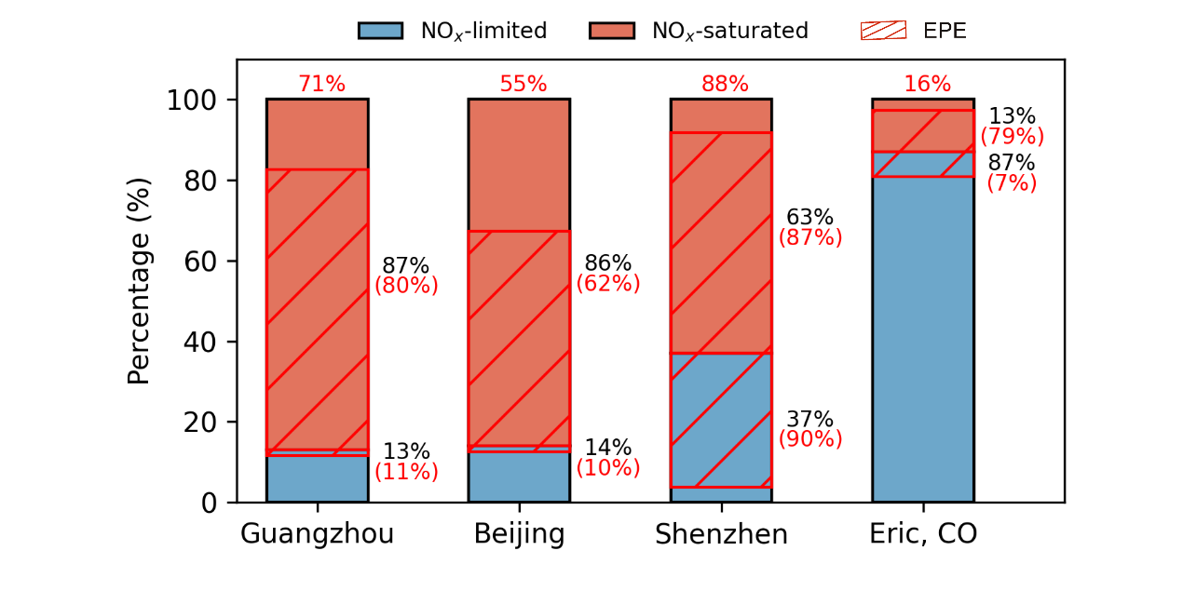
Extended Data Fig. 1. PNO₃ enhancement in different towers under varies NOx level condition during winter. The black percentage on the right indicates the proportions of NOx-saturated and limited scenarios. The red percentage on the right side represents the proportion of EPE under NOx-saturated and limited scenarios. The red percentage above the column indicates the overall proportion of EPE in each region.

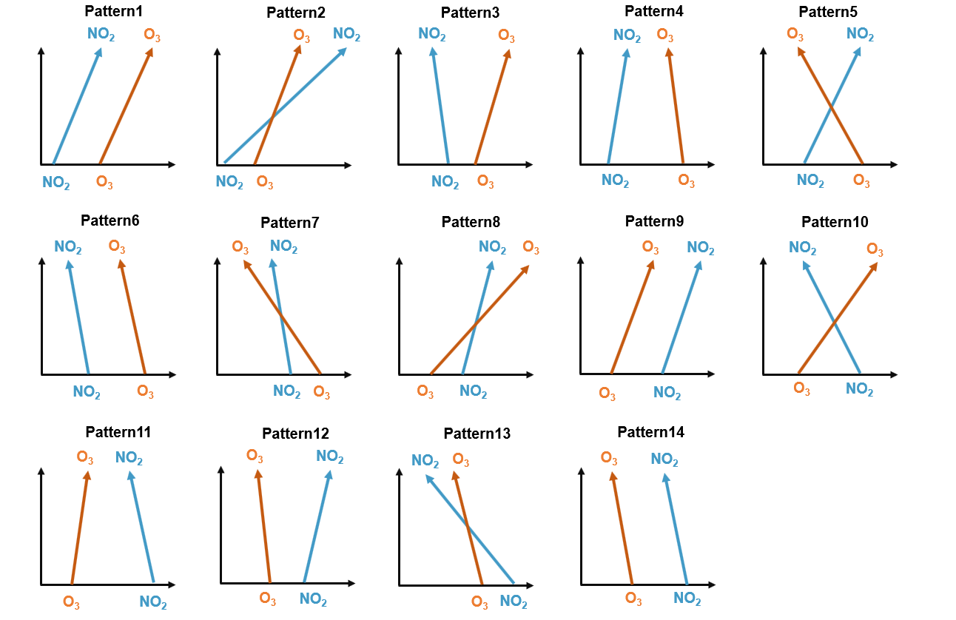
Extended Data Fig. 2. All vertical distribution patterns of NO₂ and O₃.

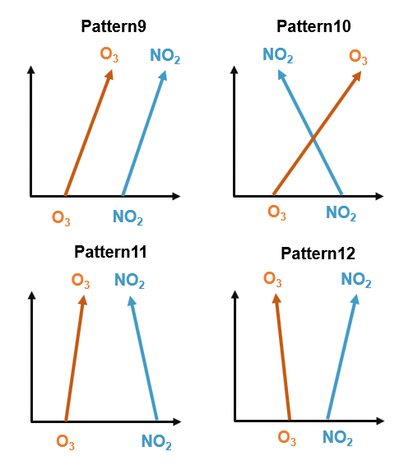
Extended Data Fig. 3. Main vertical distribution patterns of NO₂ and O₃ with PNO₃ enhancement.

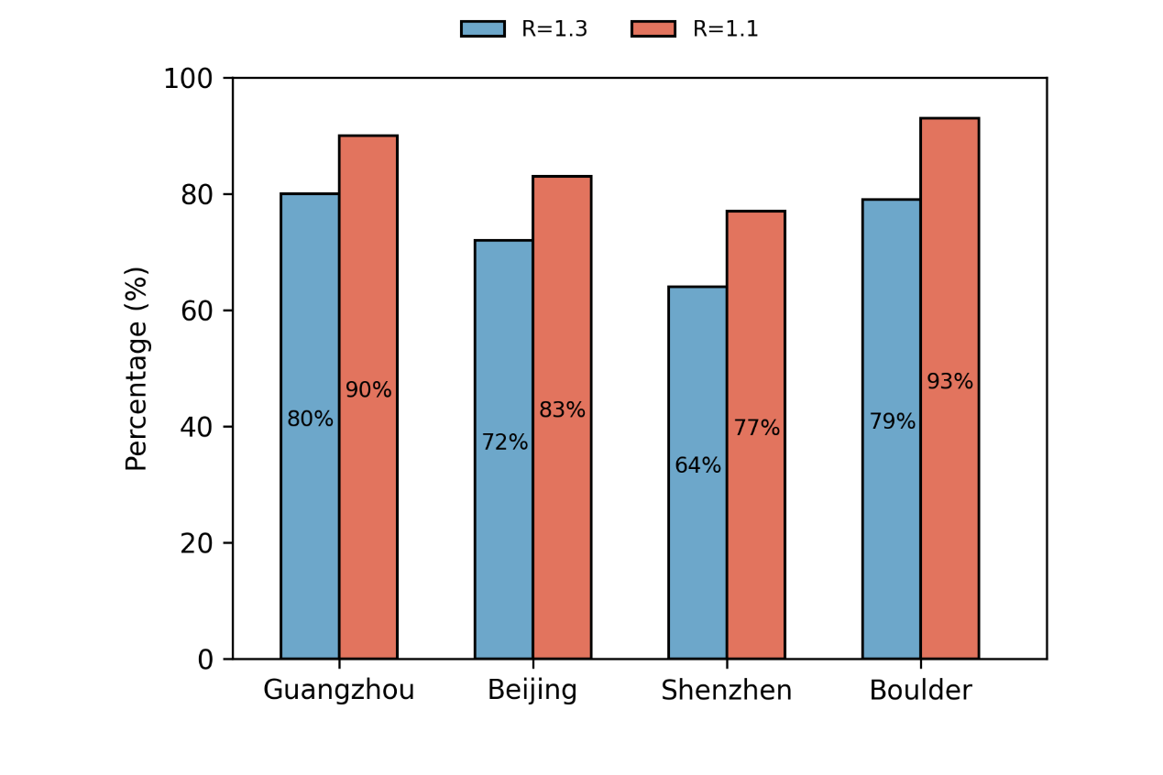
Extended Data Fig. 4. Proportion of EPE under different thresholds in the NOx-saturated condition.

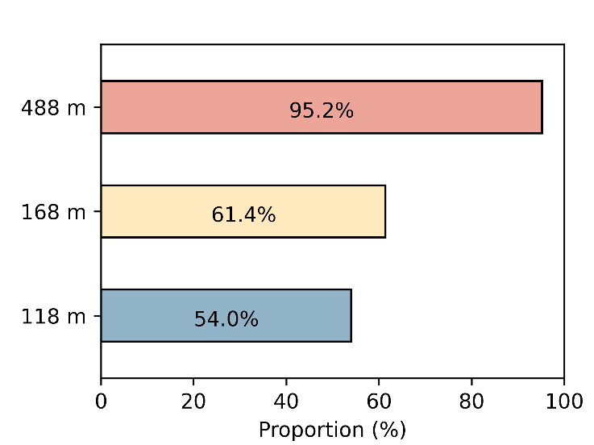
Extended Data Fig. 5. The proportion of high nocturnal ozone concentrations aloft. The proportion of nocturnal ozone concentrations exceeding 10 ppb in the Guangzhou Tower at 118 m, 168 m, and 488 m, respectively.

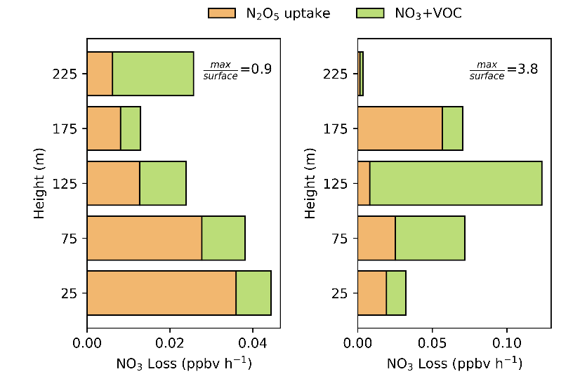
Extended Data Fig. 6. The observation derived loss rate (NO₃+VOC and N₂O₅ uptake) of NO₃ in the Eric Tower in US. The left and right panel represents the case in NEPE and EPE, respectively. The value of max/surface in each panel represents the ratio of the maximum NO₃ loss rate of the upper mixing layer to the surface loss rate.
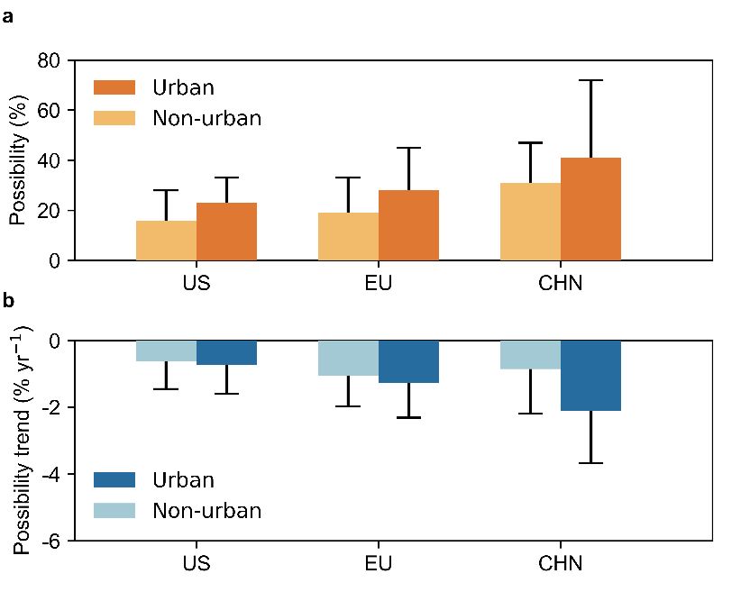
Extended Data Fig. 7. Differences between urban and non-urban areas. Panel a and b show an urban and non-urban comparison of the estimated average possibility of NO_{x}-saturated and its trend during 2014-2021 in the US, EU, and China.

