Supplemental Figure 1: Anxiety and Depression by Gender

Females report more anxiety and depression than males. Those identifying as “other” gender (e.g. transgender) report more problems with anxiety and depression compared to males and females.

Supplemental Figure 2: Anxiety and Depression by BMI

Those who are classified as underweight or obese tend to have worse anxiety and depression.

Supplemental Figure 3: Graphical representation of confidence intervals generated by bootstrap OLS following lasso

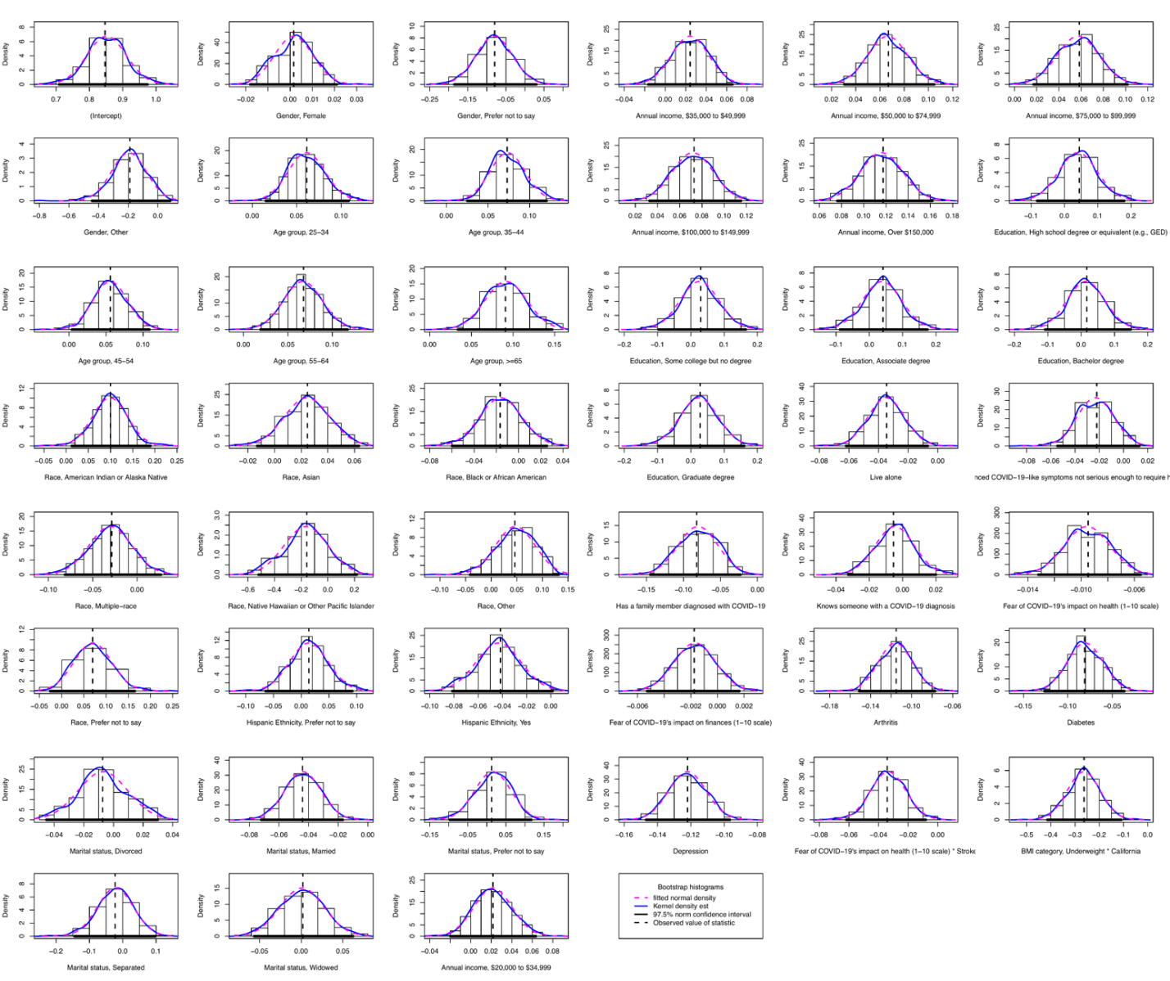

This figure provides a graphical view of the confidence intervals generated by the post-lasso OLS bootstrap, displaying a separate histogram for each bootstrapped coefficient in addition to the kernel density estimates and the normal density based on the bootstrap mean and standard deviation. The vertical dashed line marks the original point-estimate, and the thick horizontal line gives a confidence interval based on the bootstrap. As demonstrated by the figure, the normal approximation for the coefficients is relatively good, and the confidence intervals are close to symmetric about the original values, suggesting that inference from the bootstrap is likely to be normal.

Supplemental Table 1: Variance-covariance matrix of bootstrap OLS following lasso

Table is too large for Word, please see link: https://rpubs.com/nzawadzki/JGIM_suppTable1_2020

Technical Appendix
Lasso
Since the number of predictors in this second specification (p=4,058) exceeded our sample of complete responses (n=2,111), we employed lasso regression, a supervised machine learning algorithm that performs both variable selection and regularization in order to reduce overfitting and multicollinearity while increasing the interpretability of the statistical model it produces. In high-dimensional settings (p variables > n observations), lasso will shrink unimportant coefficients to zero terms by utilizing an L1 penalty thus reducing the number of predictors such that p is no longer greater than n.
To ensure their inclusion in the model and for comparison to other models in the literature, we constrained lasso from regularizing the characteristics of interest listed above and employed 10-fold cross-validation to select the penalty parameter λ for the lasso estimator that minimized the mean squared error (MSE) of prediction. Because lasso tunes λ by cross-validation, its prediction performance is less likely to be affected by internal validation bias than "out-of-the-box" stepwise selection methods. In other words, by relying on statistical significance for model selection, the models identified by stepwise methods have an inflated risk of discarding useful variables while spuriously including nuisance variables. As such, a stepwise regression model may fit well in-sample but perform poorly out-of-sample.
As a regularization procedure, lasso characteristically trades increased bias for smaller variance by omitting variables that, if associated with the outcome or a predictor, will introduce bias if excluded. The justification for post-lasso OLS surrounds its ability to reduce error of fit and thus improve efficiency of the selected coefficients over standard OLS. Since the subset of predictors selected by lasso was put into a new OLS regression, its estimates may be biased due to omitted variables. However, given the relatively large sample size, we contend that the post-lasso OLS estimator asymptotically approaches the unbiased estimator for coefficients and standard error, and, given the congruence of results between models, it is unlikely that lasso significantly biased the results. Nevertheless, the threshold question that we have answered with the partial F-test is that the post-lasso OLS fits the data better than the standard OLS, and thus its employment is justified in increasing power to detect significant covariates.
E-values
E-values indicate the “minimum strength of association, on the risk ratio (RR) scale, that an unmeasured confounder would need to have with both the treatment and outcome, conditional on the measured covariates, to fully explain away a specific treatment-outcome association.” The E-value is generally calculated as follows: E-value = RR + $\sqrt{\text{RR × (RR-1)}}$ , where RR is the relative risk. Since our utility outcome is continuous, effect-size conversions in Chinn (2000) and VanderWeele (2017) approximately convert the mean difference between hypothetical exposure "groups" to the odds ratio that would arise from dichotomizing the continuous outcome. Similarly, we use E-values to assess the strength of a potential confounder to expand the confidence interval to include the null (estimate=0).
F-test
The F-test was employed to compare the fit of the models. The residual sum of squares (RSS) for the standard and post-lasso models are 90.3 and 76.5, respectively, and the calculated F-statistic is 74.7 (p<0.001). Thus, we conclude that the additional coefficients estimated by the post-lasso OLS model significantly improve the model’s ability to predict EQ-5D utility.
R packages
R version 4.0.1 was used to perform the statistical analysis. The R package ‘HCDI’ was used to implement LASSO, and analyze the post-lasso OLS model and the R package ‘car’ was used for the bootstrap procedure.

Tibshirani R. Regression Shrinkage and Selection via the Lasso. J R Stat Soc. 1996;58(1):267-288. doi:10.1017/s0272503700054525
Smith, G. Step away from stepwise. J Big Data 5, 32 (2018). https://doi.org/10.1186/s40537-018-0143-6
Hastie T, Tibshirani R, Friedman, JH (2009). The elements of statistical learning: data mining, inference, and prediction. 2nd ed. New York: Springer; page 91. https://web.stanford.edu/~hastie/Papers/ESLII.pdf.
VanderWeele TJ, Ding P. Sensitivity analysis in observational research: Introducing the E-Value. Ann Intern Med. 2017;167(4):268-274. doi:10.7326/M16-2607
Chinn S. A simple method for converting an odds ratio to effect size for use in meta-analysis. Stat Med. 2000;19(22):3127-3131. doi:10.1002/1097-0258(20001130)19:22<3127::AID-SIM784>3.0.CO;2-M
VanderWeele TJ. On a Square-Root Transformation of the Odds Ratio for a Common Outcome. Epidemiology. 2017;28(6):e58-e60. doi:10.1097/EDE.0000000000000733
Liu H, Xu X, Li JJ. High-Dimensional Metrics in R. cran.r-project.org. Published 2017. Accessed October 2020. https:// cran.r-project.org/web/packages/HDCI/HDCI.pdf
Fox J, Weisberg S, Price B et al. Companion to Applied Regression. Published 2020. Accessed October 2020. https://cran.r-project.org/web/packages/car/car.pdf

