Supplementary information
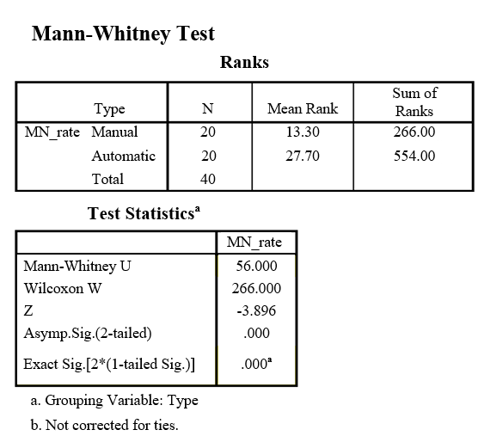
Figure S1. Mann-Whitney U test results

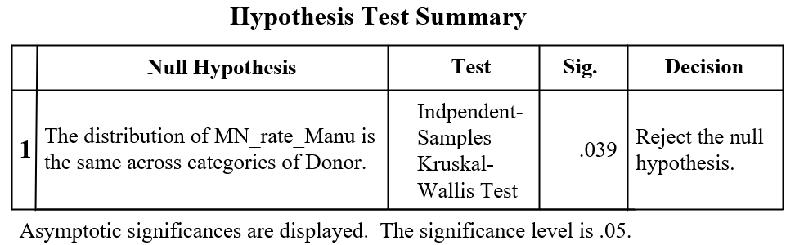
Figure S2. Kruskal-Wallis H hypothesis test results of manually detected MN rate data

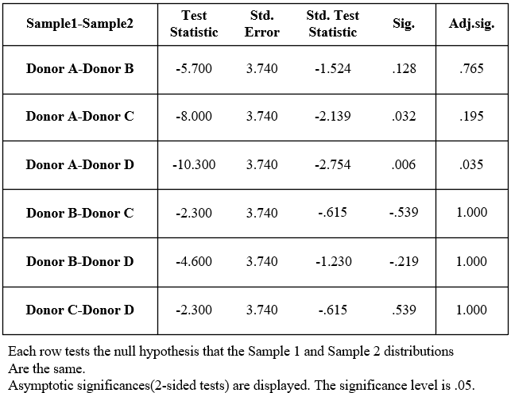
Figure S3. Results of Pairwise Comparisons of MN rate of manual detection

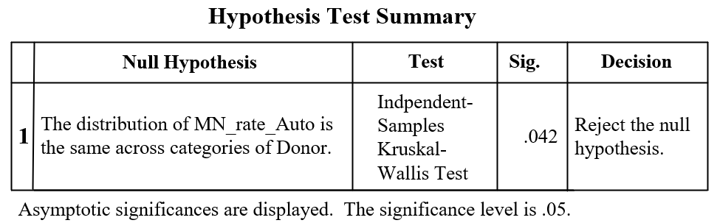
Figure S4. Kruskal-Wallis H hypothesis test results of automatically analyzed MN rate data

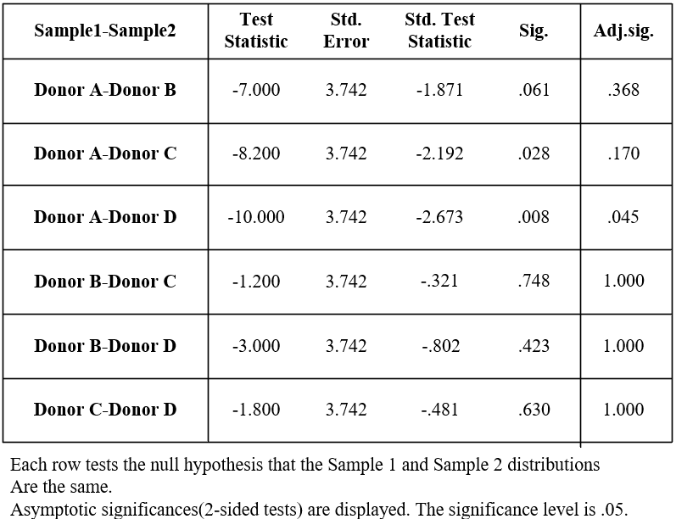
Figure S5. Results of Pairwise Comparisons of MN rate of automatic analysis

