Supplementary Information for

Observation of quantum phase transition and tunable giant Griffiths phase in twisted trilayer graphene
Phanibhusan S. Mahapatra,¹ Haining Pan,² Kenji Watanabe,³
Takashi Taniguchi,⁴ J.H. Pixley,², ⁵ and Eva Y. Andrei,^{1∗}
¹ Department of Physics and Astronomy, Rutgers the State University of New Jersey, 136 Frelinghuysen Rd, Piscataway, New Jersey 08854, USA
$​^{2}$Center for Materials Theory, Rutgers University, 136 Frelinghuysen Road, Piscataway, NJ 08854, USA
³ Research Center for Functional Materials, National Institute for Materials Science, Namiki 1-1, Tsukuba, Ibaraki 305-0044, Japan
⁴ International Center for Materials Nanoarchitectonics, National Institute for Materials Science, Namiki 1-1, Tsukuba, Ibaraki 305-0044, Japan
⁵ Center for Computational Quantum Physics, Flatiron Institute, New York, New York 10010, USA

∗To whom correspondence should be addressed, E-mail: eandrei@physics.rutgers.edu
- Quantum anomalous metal phase

Fig. S1a shows the scanning electron microscope (SEM) image of the superconducting channel, highlighting the high aspect ratio of the channel. Fig. S1b shows the saturation of the sheet resistance $R_{s}$ at low $T$ at finite magnetic fields ($B_{⊥}$). The apparent saturation has been a topic of much debate due to the sensitivity of the finite resistance state to the various external measurement conditions. Measurements in superconducting NbSe2 flakes suggests that the magnetoresistance in the anomalous metal phase is strongly sensitive to the circuit impedance due to dissipative coupling¹. We verify this by changing the impedance in the circuit, which is series resistor that converts ac voltage (lock-in amplifier) to a constant current source with $I_{ac}=\frac{V_{Lockin}}{R_{series}}$ and $R_{series}≫R_{sample}$. For the two configurations depicted in Fig. S1c, the ac excitation current is the same ($=500 pA$) but the circuit impedance is varied. As evident, we do not observe any change between the two configurations in magnetoresistance $R_{s}$. Fig. S1d shows the comparison of $R_{s}$ as a function of $B_{⊥}$ with and without external RC filters with cut-off frequency $f\sim 1000$ Hz at $-3$dB attenuation. This suggests that the observed metallic state is not manifested due to coupling of the vortex lattice to external RF radiation^{2,3}. Fig. S1e and S1f show the attenuation ($=10\log{\frac{V_{out}}{V_{in}}}$) as a function of the excitation frequency $f$ for the internal and externals filters, respectively.
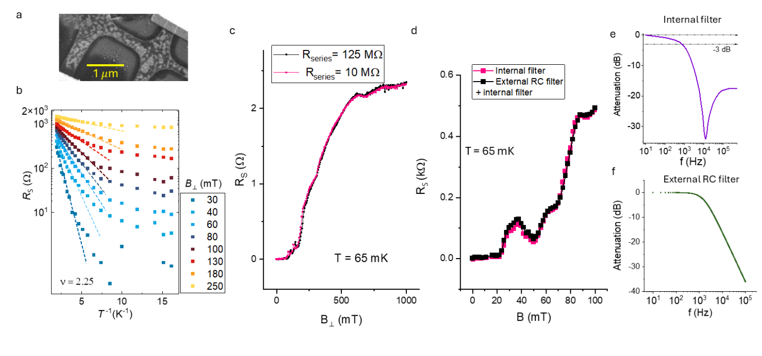
Fig S1: (a) SEM image of the device. (b) Sheet resistance $R_{s}$ vs inverse temperature $T^{-1}$for different $B_{⊥}$ values at $ν=2.25$. (c) Sheet resistance $R_{s}$ vs $B_{⊥}$ for two different series resistors. (d) Comparison of $R_{s}$ vs $B_{⊥}$ with and without external RC filters at $ν=1.85$. Attenuation vs excitation frequency for (e) internal RLC filters and (f) external RC filters.

- Quantum Interference effects and Weak localization

Fig. S2a shows the sheet resistance $R_{s}$ as a function of $ν$for different temperatures. The aperiodic but repeatable oscillations in $R_{s}$ are signatures of universal conductance fluctuations (UCF) due to quantum interference effects around impurity scattering ⁴. The oscillations gradually diminish at higher temperature since the phase coherence length $L_{ϕ}$ decrease at high $T$. Another manifestation of quantum interference effects can be observed through weak localization (WL) where the $R_{s}$(averaged within doping window $ν=1-1.25)$shows a sharp decrease at low $B_{⊥}$ (Fig. S1b).
The magnetoresistance correction from the weak localization can be expressed as ^{5,6}
$$\begin{aligned}ΔR_{s}=-\frac{e^{2}R_{s}^{2}}{πℏ}\left[F\left(\frac{B}{B_{ϕ}}\right)-F\left(\frac{B}{B_{ϕ}+2B_{iv} }\right)-2F\left(\frac{B}{B_{ϕ}+B_{*}}\right)\right]\#\left(S1\right)\end{aligned}$$

Where $e$is the electronic charge, $ℏ=h/2π$, $B_{ϕ}$ is the phase breaking magnetic field, and $B_{iv}$ and $B_{*}$ are characteristic magnetic field scales for inter valley and intra valley scattering. The phase coherence length can be extracted from $B_{ϕ}$ as $L_{ϕ}^{2}=ℏ/eB_{ϕ}$. A fit to the Eq. S1 suggests $L_{ϕ}∼500$ nm at $65$ mK, which is in the order of the sample dimensions ($∼μ$m). In contrast, Fig. S2c shows a positive magnetoresistance at $ν=2.125$and $T=2$K, which is a signature of weak antilocalization (WAL). A similar $T-$dependent transition from WL to WAL has been previously seen in graphene and can be attributed to the different scattering scenarios⁷. The fitted $L_{ϕ}∼16$ nm at $2$K, which is substantially reduced from its value at low $T$.

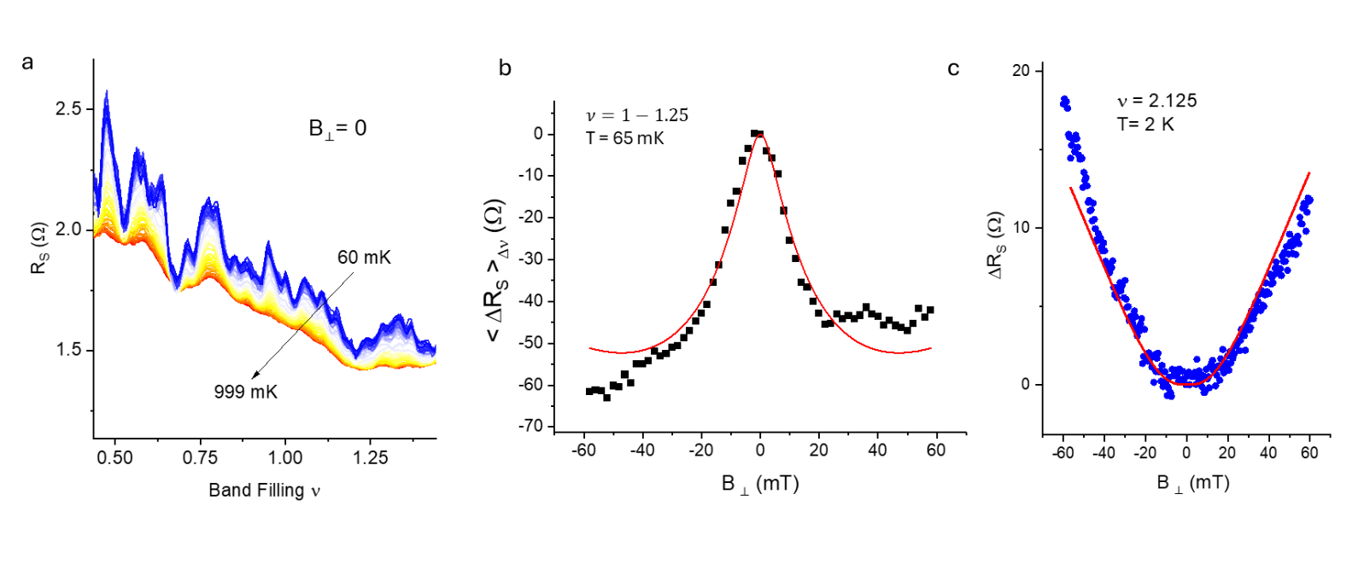

Fig S2: (a) Sheet resistance $R_{s}$ vs $ν$ for different $T$. (b) Change in $R_{s}$ (averaged over a doping window $ν=1-1.25$) as a function of $B_{⊥}$ at $T=65$ mK. (c) Change in $R_{s}$ as a function of $B_{⊥}$ at a fixed $ν=2.215$ and $T=2$K. The solid lines in (b) and (c) are a fit to theoretic model of the weak localization in graphene.

- Global phase breaking boundary from bias-current dependent transport
To identify the global phase breaking boundary in $B-T$ phase space, we identify the corresponding value of the temperature $T$ for which the sharp central peak (between $I_{dc}∼±2$ nA) disappears. The procedure is then repeated for several different magnetic fields in the vicinity of the phase transition.

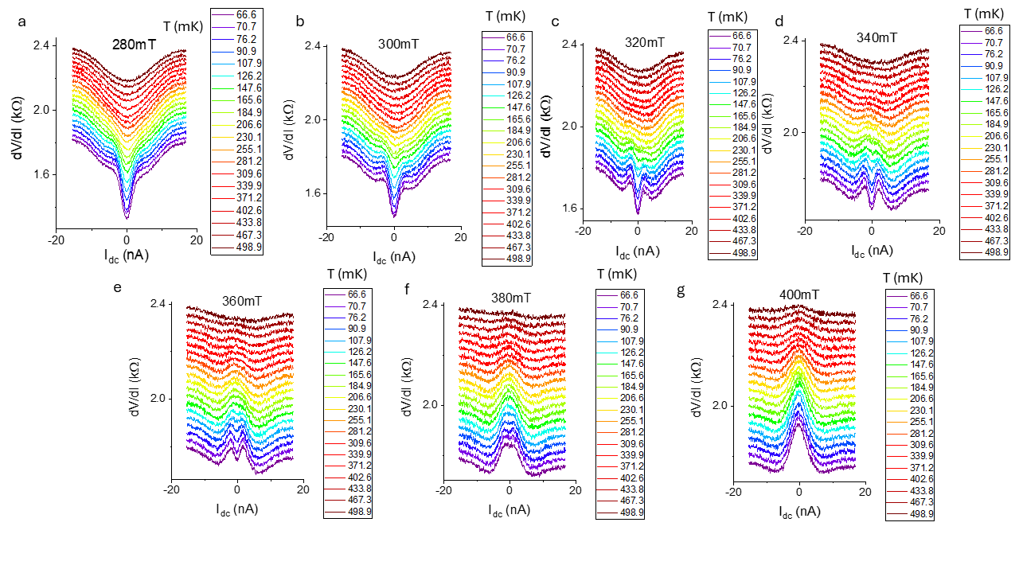

Fig S3: (a) –(g) Dynamic resistance $dV/dI$ vs bias current $I_{dc}$ for different $T$ at $ν=2.25$and $B_{⊥}=280, 300, 320, 340, 360, 380$ and $400$ mT, respectively. The curves are offset for better clarity.

- Nonequilibrium effects in the weakly localized state
Increasing $I_{dc}$ increases the bias energy $=eI_{dc}R,$where $R$ is the total resistance of the channel. For example, at $I_{dc}=1$ nA, the bias energy is $≈10.7 μ$eV compared to the thermal energy at base temperature (~ 60 mK), $k_{B}T≈$5.8$μ$eV. Such conditions ($eV>k_{B}T$) broadens the energy of the incoming and outgoing interfering paths thus enhances the dephasing. This suppresses the localization of the wavefunction and reduces the total resistance. Previous experiments in graphene⁸ suggests that under the dephasing in nonequilibrium condition, the change in resistance ($ΔR$) should follow a logarithmic decrease, $ΔR∝\log{I_{dc}}$. In contrast, the expected change resistance in should follow $∝I_{dc}^{2}$for local Joule heating. Our experimental transport data (Fig. S4a and Fig. S4b) corroborates the former, indicating a novel dephasing mechanism from the nonequilibrium measurement conditions.

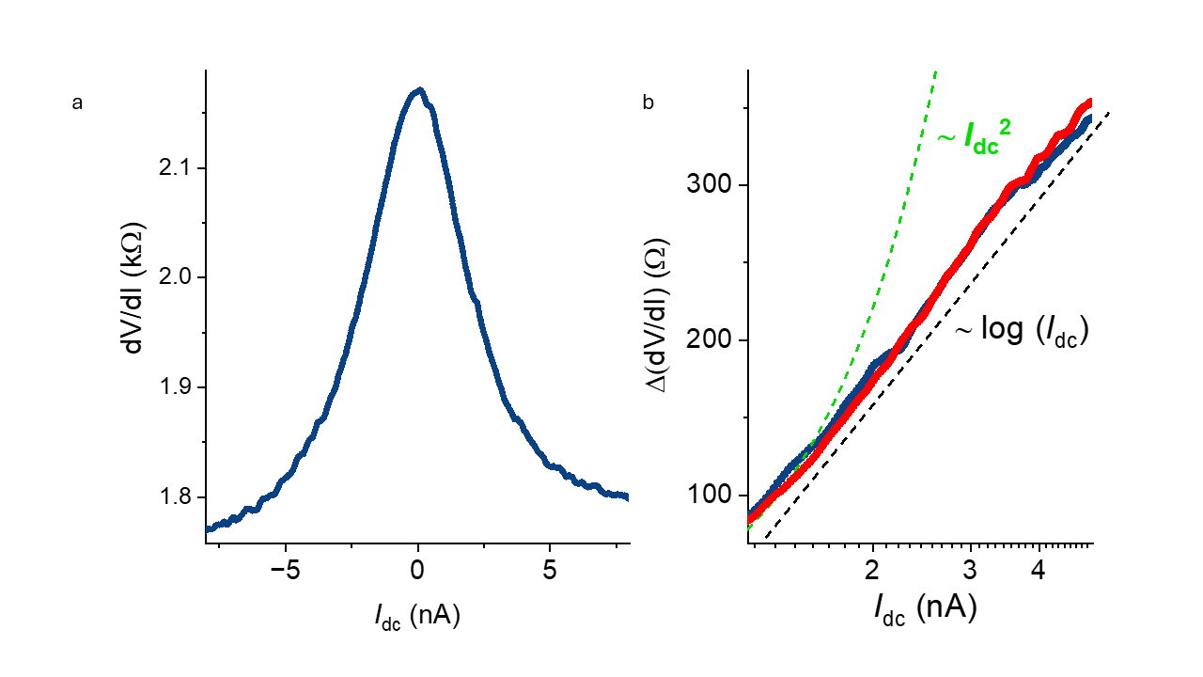
Fig S4: (a) $dV/dI$ as function of the bias current $I_{dc}$ at $T=65$mK, $ν=2.25$ and $B_{⊥}=600$mT. (b) The change in $dV/dI$ as a function of $I_{dc}$ in linear-log scale. The red and blue squares represent the change in dynamic resistance $Δ\left(\frac{dV}{dI}\right)$ for positive and negative $I_{dc}$ values, respectively. The black and the green dashed lines show the $\log{I_{dc}}$ and $I_{dc}^{2}$ dependence as reference, respectively.

- Infinite random fixed point and finite temperature scaling (FTS)

In this section, we first derive the activated dynamical scaling form for the infinite randomness fixed point used in Fig. 3b based on the conventional (for a non-Griffiths continuous phase transition) scaling form used in Fig. 3c within a temperature window and then explain the numerical details to implement this finite temperature scaling using nonlinear least-square minimalizations.

For a typical continuous phase transition induced by the tuning parameter $λ$, the correlation length $ξ$ diverges algebraically at the critical point $λ_{c}$ as $ξ∼{\left|λ-λ_{c}\right|}^{-ν}$ . In the finite system, the IR cutoff restricts the correlation length to be at most the system size $L$, and therefore leads to a typical finite size scaling of $F\left({\left|λ-λ_{c}\right|}^{ }L^{\frac{1}{ν}}\right)$, where $F$ is a universal function independent of the system parameters. In a dynamical system, the dynamical exponent $z$ is defined as $t\sim L^{z}$, and therefore leads to a temporal version of the scaling form of $F\left({\left|λ-λ_{c}\right|}^{ }t^{\frac{1}{νz}}\right)$.
In the finite temperature field theory, we can intuitively relate the temperature $T$ with the inverse of the time $t$, due to the Wick’s rotation in the Euclidean metrics. Therefore, we can define the following temporal scaling form $F\left({\left|λ-λ_{c}\right|}^{ }T^{-\frac{1}{νz}}\right)$. With the tuning parameter being the out-of-place magnetic field $B_{⊥}$, we obtain the scaling of the resistance $R_{s}\sim {\left|B-B_{c}\right|}^{ }T^{-\frac{1}{νz}}$ as used in Fig. 3c.

In the Griffiths phase, the spacetime becomes extremely asymmetric, and the temporal varies much slower than the spatial dimension, therefore, we relate the dynamical exponent $z$ with the a so-called activated exponent $ψ$ as $z∼L^{ψ}\sim {\left|B-B_{c}\right|}^{-νψ}≡k{\left|B-B_{c}\right|}^{-νψ}$. Substituting the dynamical exponent $z$ into the previous scaling form and, we obtain the following scaling form
$$\begin{aligned}\log{R_{s}}\sim \log\left|B-B_{c}\right|-k{\left|B-B_{c}\right|}^{νψ}\log{T}\#\left(1\right)\end{aligned}$$
Here, given the estimate of $νψ\sim O(1)$, the second term is much larger than the first term in Eq. (1), and therefore, we can safely ignore the first term and which, at the same time, also reduces the fitting parameters by one, $k$, namely, the final activated dynamical scaling form used in Fig. 3b is
$$\begin{aligned}\log{R_{s}}\sim {\left|B-B_{c}\right|}^{νψ}\log{T}.\#\left(2\right)\end{aligned}$$

With the scaling form Eq. (1) or (2), we perform the finite temperature scaling to the experimental data with a magnet field and resistance $B_{i}$ , $R_{s, i}$ under a specific temperature $T_{i}$ , in order to extract the critical field $B_{c}$, and critical exponent $zν_{B}$.
Based on the finite temperature scaling ansatz in Eq.1, we can define the following loss function,
$$\begin{aligned}χ^{2}=\sum_{i=1}^{N}{{\left(R_{s,i}-R_{s,i}^{'}\right)}^{2}} \#\left(3\right)\end{aligned}$$
where N is the total number of data points with different $\left(B_{i},T_{i}\right)$, and $R_{s,i}^{'}$ is the linear interpolation between $R_{s,i}$ and $R_{s,i+1}$ (with $R_{s,i}$ being sorted in ascending order), i.e.,
$$\begin{aligned}R_{s,i}^{'}=R_{s,i-1}+\frac{R_{s,i+1}-R_{s,i-1}}{B_{s,i+1}-B_{s,i-1}} \left(B_{s,i}-B_{s,i-1}\right) \#\left(4\right)\end{aligned}$$
We minimize the loss function Eq.2 using the Levenberg-Marquardt algorithm⁹ ¹⁰ provided by the Python package lmfit¹¹ to find the best fit of $B_{c}$ and $zν_{B}$.
The error bars of the critical point $B_{c}$ and the critical exponent $zν_{B}$ are estimated by first choosing a threshold of $1.3$ times the minimal loss function $χ_{min}^{2}$as an operational definition, and then plotting the contour of the loss function Eq.2 as the function of different choices of $B_{c}$ and $zν_{B}$ near the best fit values, and finally taking the extents of the $1.3χ_{min}^{2}$-contour in the parameter space of $\left(B_{c},zν_{B}\right)$ on both dimensions as the error bars.

Finally, we present some typical $1.3χ_{min}^{2}$-contour (yellow curves) in Fig. S5
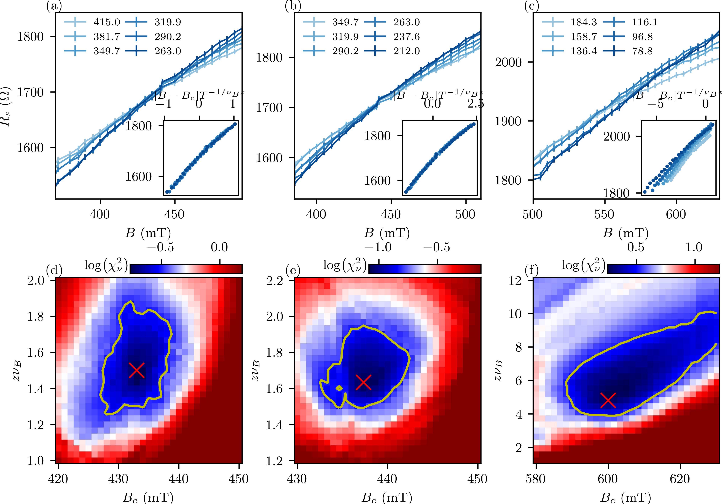

Fig.S5: Typical examples of finite temperature scaling following Eq. (1) on the top row, and the spatial profile of the loss function in Eq. (3) with $1.3χ_{min}^{2}$-contours on the bottom row (yellow curves). The optimal set of parameters is at ${argminχ}_{ }^{2}$labeled by the red cross. Different columns are for different ranges of temperature (in mK) windows as shown in the legend on the top row.

References:

1 Banerjee, A., Mohapatra, A., Ganesan, R. & Kumar, P. S. A. Restoring Superconductivity in the Quantum Metal Phase of NbSe2 Using Dissipative Coupling. Nano Letters 19 (2019). https://doi.org/10.1021/acs.nanolett.8b04538
2 Dutta, S. et al. Extreme sensitivity of the vortex state in a-MoGe films to radio-frequency electromagnetic perturbation. Physical Review B 100, 214518 (2019). https://doi.org/10.1103/PhysRevB.100.214518
3 Tamir, I. et al. Sensitivity of the superconducting state in thin films. Science Advances 5, eaau3826 (2019).
4 Morozov, S. V. et al. Strong Suppression of Weak Localization in Graphene. Physical Review Letters 97, 016801 (2006). https://doi.org/10.1103/PhysRevLett.97.016801
5 McCann, E. et al. Weak-Localization Magnetoresistance and Valley Symmetry in Graphene. Physical Review Letters 97 (2006). https://doi.org/10.1103/PhysRevLett.97.146805
6 Tikhonenko, F. V., Horsell, D. W., Gorbachev, R. V. & Savchenko, A. K. Weak Localization in Graphene Flakes. Physical Review Letters 100 (2008). https://doi.org/10.1103/PhysRevLett.100.056802
7 Tikhonenko, F. V., Kozikov, A. A., Savchenko, A. K. & Gorbachev, R. V. Transition between Electron Localization and Antilocalization in Graphene. Physical Review Letters 103 (2009). https://doi.org/10.1103/PhysRevLett.103.226801
8 Somphonsane, R. et al. Universal scaling of weak localization in graphene due to bias-induced dispersion decoherence. Scientific Reports 10, 5611 (2020). https://doi.org/10.1038/s41598-020-62313-3
9 Levenberg, K. A Method for the Solution of Certain Non-Linear Problems in Least Squares. Quarterly of applied mathematics 2, 164--168 (1944).
10 Marquardt, D. W. An Algorithm for Least-Squares Estimation of Nonlinear Parameters. Journal of the society for Industrial and Applied Mathematics 11, 431--441 (1963).
11 Newville, M., Stensitzki, T., Allen, D. B. & Ingargiola, A. LMFIT: Non-Linear Least-Square Minimization and Curve-Fitting for Python. Astrophysics Source Code Library, ascl--1606 (2014).

