Supplementary Materials and Methods
SCARD Methodology
For each sample from the 16 cases with ascertained exonic deletions or duplications, paired-end reads were aligned to the human reference genome (GRCh38) using the Minimap2 (with -Y function)(1). The resulted CRAM files were sorted and remarked PCR duplication using SAMtools(2), and each file was processed independently through our SCARD pipelines (Fig. S1). SCARD includes four main components: (1) split-read, (2) chimeric read-pairs, (3) read-depth difference, and (4) results integration for structural variation (SV) detection and delineation. To exclude variants located in regions with a higher likelihood of false positives, we defined poorly aligned regions by selecting aligned reads with a MAPping Quality (MAPQ) below 60 from NA12878 and subjected them to mpileup (SAMtools). Regions with more than 5 reads (with low MAPQs) and exceeding 150bp in size were considered poorly aligned.
In the split-read analysis, reads with supplemental alignments were extracted if two segments of the read aligned to the same chromosome but were separated by at least 150 base pairs. After sorting, reads were clustered if the aligned coordinates differed by less than 50 base pairs at both breakpoints. Clusters were discarded if they contained only two reads or multiple aligned strand groups. Clusters were used to establish a reference dataset, retaining only those with an allelic frequency below 1% for further analysis. To reduce false positives from repeat elements like Segmental Duplication, Human Self-Chained Alignment, and Simple Repeat (curated by UCSC Genome Browser), clusters with breakpoints not involving these regions were retained.
For chimeric read-pairs, pairs of reads with primary alignments on the same chromosome but separated by more than 1,000 base pairs were extracted as per our previous study(3). After sorting, clusters were defined if the aligned coordinates differed by less than 1,000 base pairs at both breakpoints. Aligned strand groups were defined as “+|-”, “-|+”, “+|+” and “-|-”, respectively(4). Groups “+|-” and “-|+” were considered as the same type of rearrangements as the DNA rejoined sequences always shared the same DNA sequence orientation, while groups “+|+” and “-|-” were from the same type of rearrangements as the DNA rejoined sequences always involved one in forward orientation and the other in reverse. Clusters were removed if they contained more than two aligned strand groups or if the strand groups were not of the same type of rearrangements. Clusters with two strand groups were divided into independent clusters based on aligned strands. These clusters were also used to set up a reference dataset, retaining only those with a minor allelic frequency below 1% for further analysis. Clusters with breakpoints outside the aforementioned repeat regions were retained to minimize false positives.
For read-depth difference analysis, only read1 from a pair of reads with primary alignment and MAPQ of at least 20 was used for further analysis. The sex of each sample was determined by the ratio of reads aligned to chromosome Y compared to chromosome X, as described in our previous study(5). For each sex, 100 samples were down-sampled to have 30 million reads per sample and merged after sorting the aligned chromosomes and coordinates. We used the aligned coordinates of 1,000 reads as the start-end boundary of a non-overlapping window with an adjustable size of 1,000bp, and also set up a sliding window with an adjustable size of 10,000bp and with an increment of 1,000bp(6). The overall qualified reads of a case were then subjected to coverage calculation using the reads aligned to each window. The coverage of each window was normalized by the average value in the same sample, then underwent GC correction and population normalization as previously described(6). A deletion was considered if two or more consecutive windows showed a normalized copy-ratio of less than 0.75 (0.5 for the X or Y variants in male cases), while a duplication had two or more consecutive windows with a normalized copy-ratio greater than 1.25 (1.5 for the X or Y variants in male cases). All copy number variations (CNVs) were used to set up a reference dataset, retaining only those with an allelic frequency below 1% for further analysis. A CNV was removed if it overlapped by 85% with centromere or heterochromatin, 75% with N region, 75% with poorly aligned regions, or had a copy-ratio greater than 3.
Integration of results from the three domains involved further clustering of clusters from chimeric read-pairs and split-read domains. Two or more clusters were merged into a single cluster if (1) they belonged to the same strand group and (2) both breakpoint differences were smaller than 200bp. Additionally, for each cluster, both breakpoints were annotated with candidate CNVs, and two or more clusters were grouped as a rearrangement if they involved the same CNV or had breakpoint differences smaller than 3,000bp at one of the breakpoints. A cluster initially removed due to one of its breakpoints being located in the aforementioned repeat regions, as identified by chimeric read-pairs or split-read analysis, was reconsidered for further analysis if one of its breakpoints was involved by CNV(s). It was also reconsidered if the size was smaller than 3,000bp, for coverage ratio calculation (using SAMtools coverage and normalized by the average coverage of three housekeeping genes: ACTB, GAPDH, and YWHAZ) to determine if it resulted from a CNV. Isolated clusters might be classified as (1) a simple CNV if both breakpoints were located at the same CNV, (2) a rearrangement involving CNV(s) if one breakpoint was located at a CNV, or (3) uncertain. For an uncertain cluster smaller than 3,000bp, the coverage ratio was calculated following forementioned method to determine if it resulted from a CNV. For a deletion or duplication reported by read-depth difference algorithm and there was absence of split-read or chimeric read-pairs, it was only reported whether it involved three or more windows. Candidate rearrangements involving two clusters were compared and subclassified into different types of rearrangements (Fig. S2): (1) an inversion with/without deletions involved in one or both breakpoints, and (2) an insertion with/without a CNV involved in the insertion site and with a forward or reverse orientation.

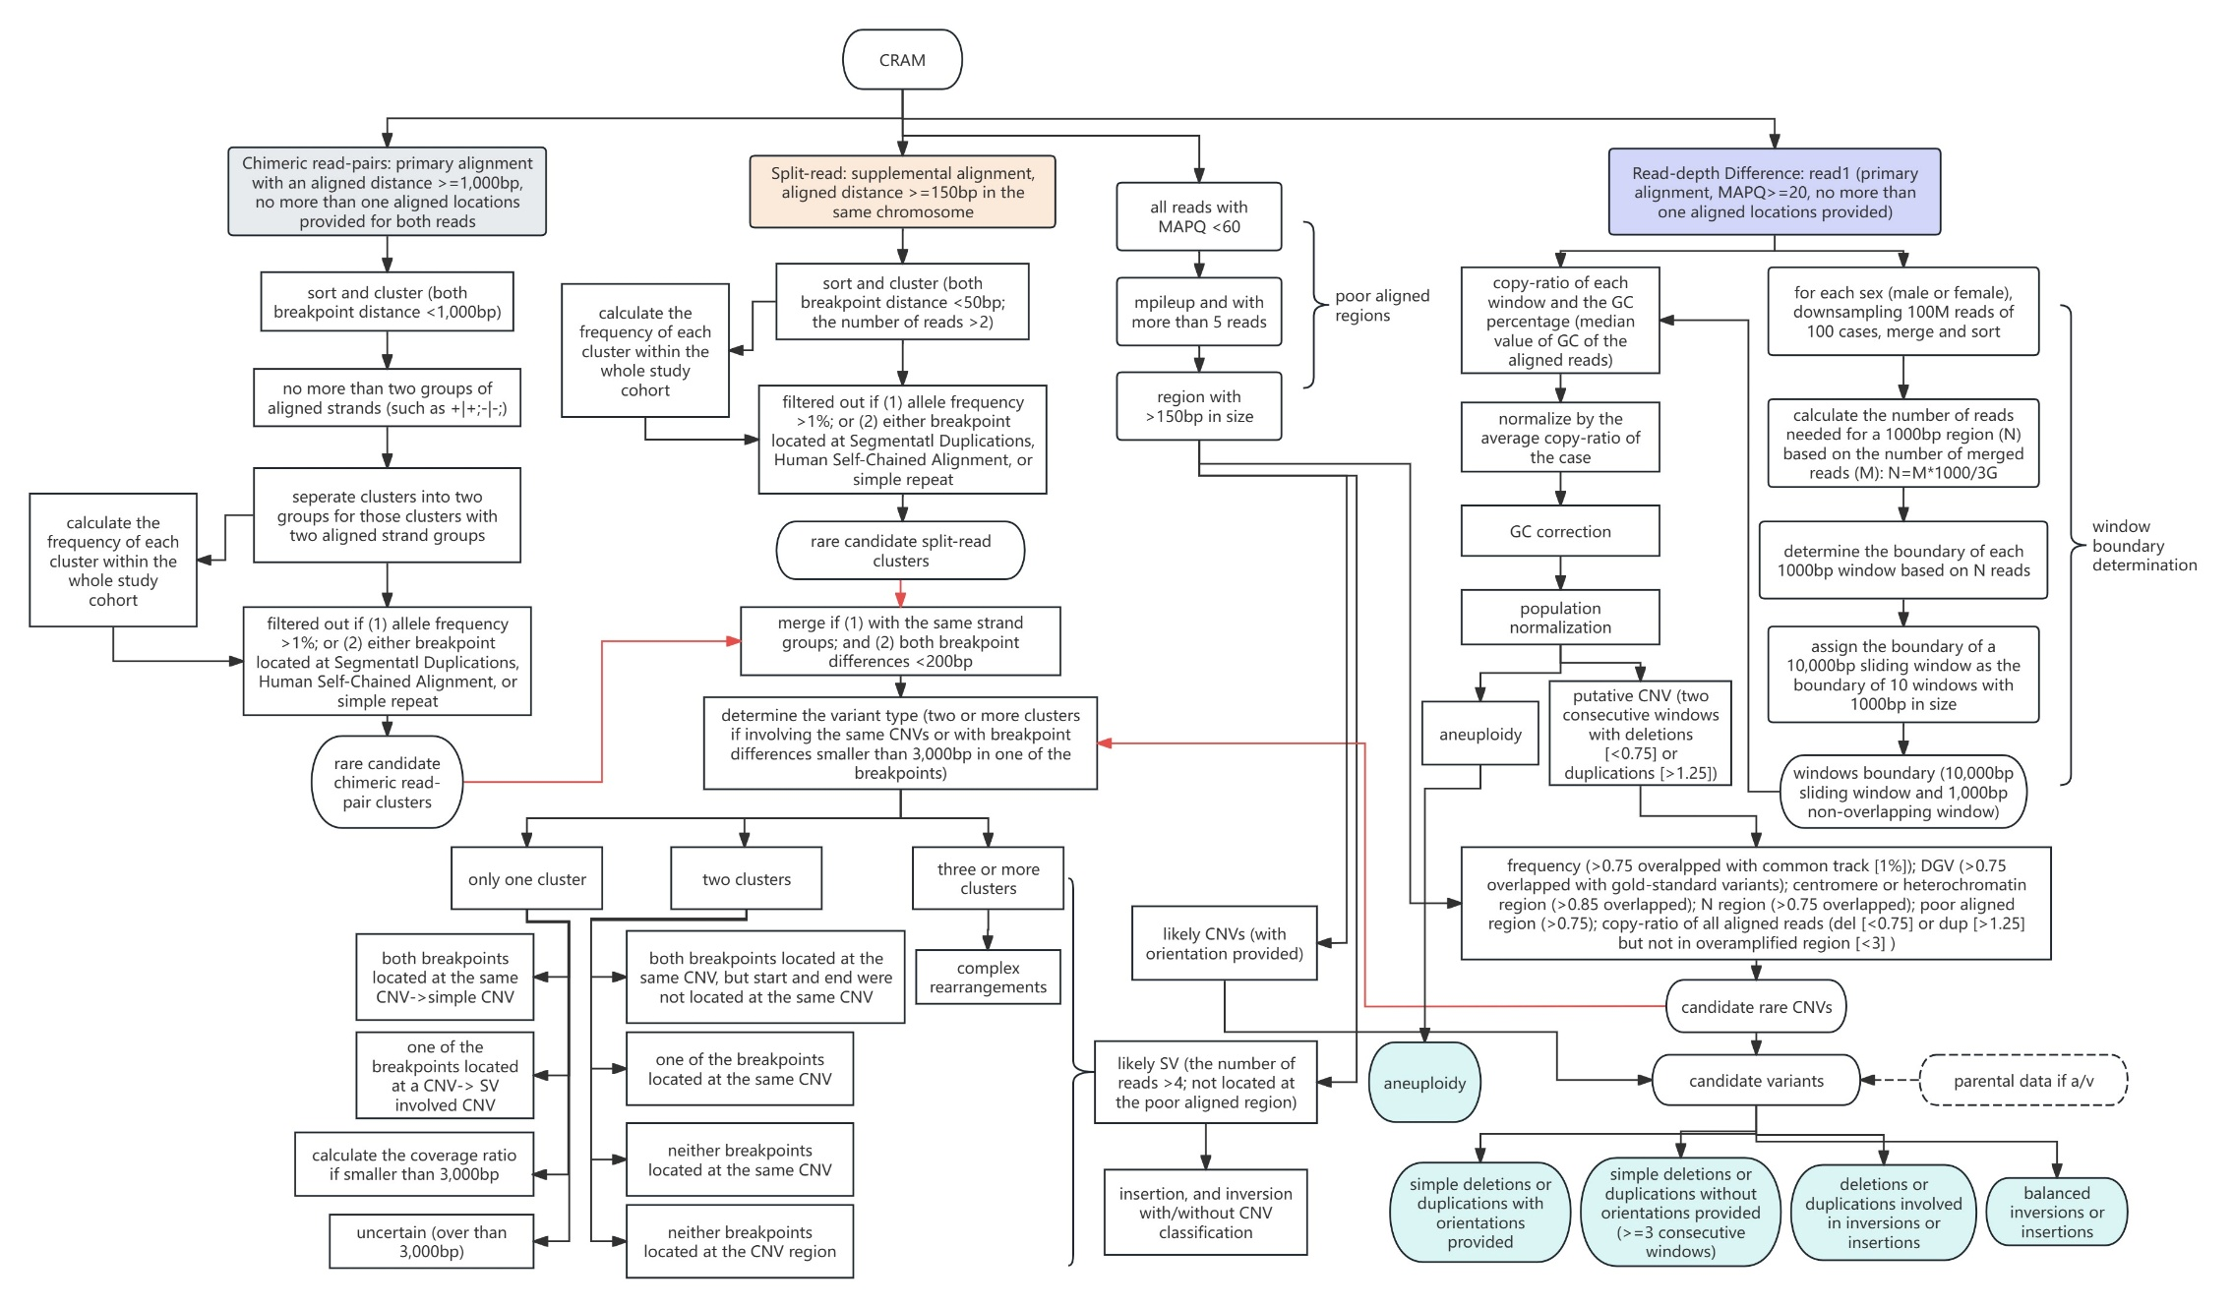

Figure S1. The comprehensive workflow of SCARD analysis. It consists of four domains: (1) chimeric read-pairs (highlighted in grey), (2) split-read (in orange), (3) read-depth difference (in purple), and (4) results integration for structural variation (SV) detection and delineation (in blue). The detailed workflow is provided in Additional Methods.

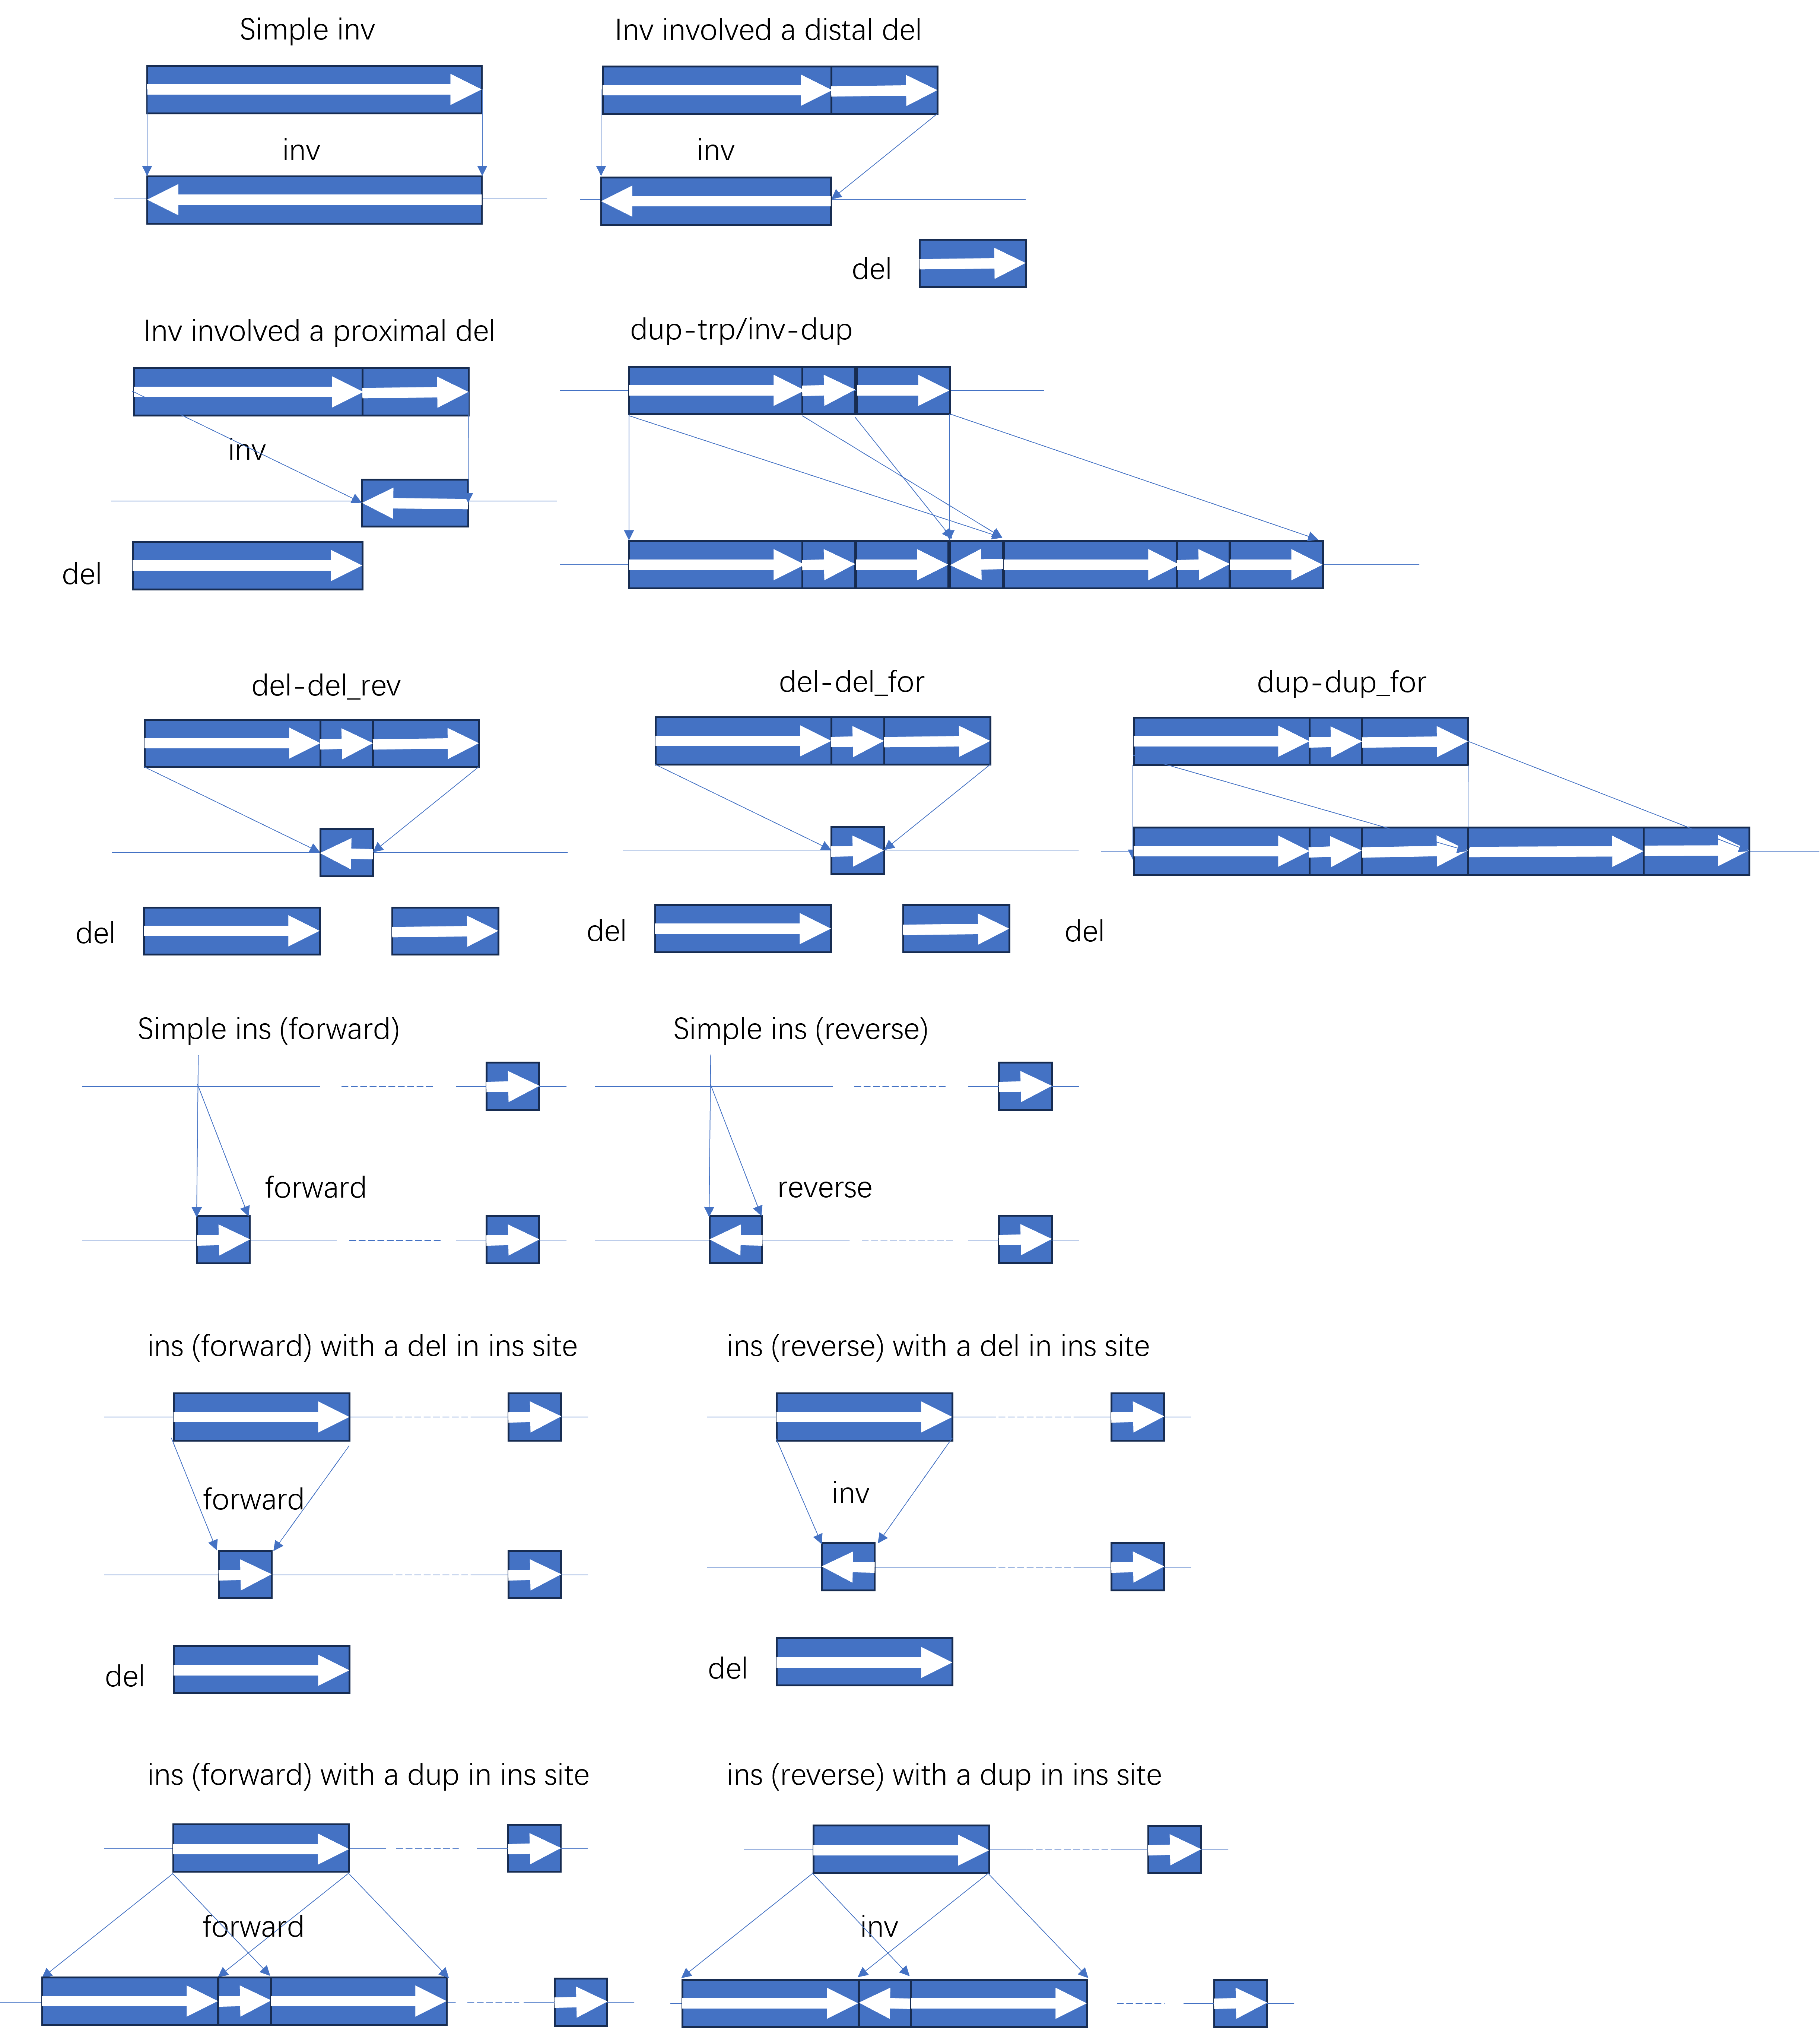
Figure S2. Diagram of different rearrangement types with/without the involvement of copy-number variant(s). For each subfigure, the upper panel shows the original composition, and the lower panel shows the structural rearrangement. The white arrow in each bar indicates the genomic orientation of the DNA segment. The light arrow shows the original location of the segment involved in the structural rearrangement. Dup, del, inv and ins refers to duplication, deletion, inversion, and insertion, respectively. Dotted line indicates an intra-chromosomal distance between two segments.

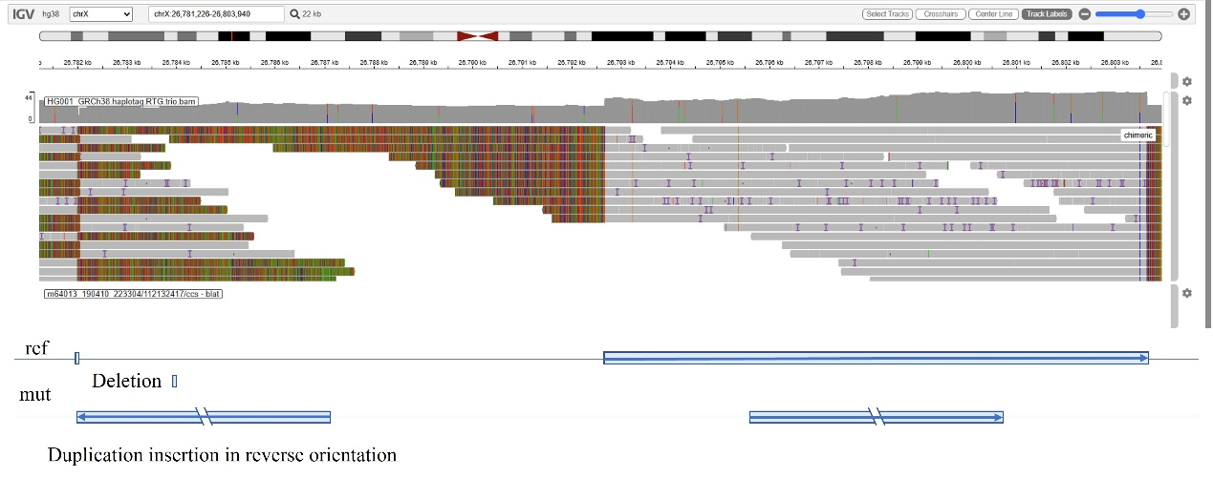
Figure S3. A complex insertion identified by SCARD in NA12878. A 10.8kb duplication at Xp21.3 [Xp21.3(26792663_26803441)x3] (in light blue) inserted into a region 10.3kb upstream in a reverse orientation (each blue arrow indicates the DNA sequence orientation) leading to a 585bp heterozygous deletion [Xp21.3(26781728_26782313)x1] (in light green). The upper panel shows the read alignments of the long-read sequencing dataset in NA12878 (Pacbio, HiFi), and the chimeric reads (non-grey bars) confirmed this complex rearrangement. The lower panel shows the diagram of this complex insertion involving a duplication and a deletion.

References:
1. Li H. Minimap2: pairwise alignment for nucleotide sequences. Bioinformatics. 2018;34(18):3094-100.
2. Li H, Handsaker B, Wysoker A, Fennell T, Ruan J, Homer N, et al. The Sequence Alignment/Map format and SAMtools. Bioinformatics. 2009;25(16):2078-9.
3. Cao Y, Chau MHK, Zheng Y, Zhao Y, Kwan AHW, Hui SYA, et al. Exploring the diagnostic utility of genome sequencing for fetal congenital heart defects. Prenat Diagn. 2022;42(7):862-72.
4. Dong Z, Jiang L, Yang C, Hu H, Wang X, Chen H, et al. A robust approach for blind detection of balanced chromosomal rearrangements with whole-genome low-coverage sequencing. Hum Mutat. 2014;35(5):625-36.
5. Wang H, Dong Z, Zhang R, Chau MHK, Yang Z, Tsang KYC, et al. Low-pass genome sequencing versus chromosomal microarray analysis: implementation in prenatal diagnosis. Genet Med. 2020;22(3):500-10.
6. Dong Z, Zhang J, Hu P, Chen H, Xu J, Tian Q, et al. Low-pass whole-genome sequencing in clinical cytogenetics: a validated approach. Genet Med. 2016;18(9):940-8.

