Supplementary Material
Determination of cow's milk β-lactoglobulin allergens in foods based on a rapid and sensitive immunochromatographic test strip method
Yang Wan a, Wenhan Kang a, Jincheng Han a, Jiukai Zhang a, Ning Yu a, *, Ying Chen a, *
ª Chinese Academy of Quality and Inspection & Testing, Beijing, 100176, People's Republic of China
* Corresponding author:
Ying Chen
Tel (Fax): +86-10-53897910
Email: chenyingcaiq@163.com

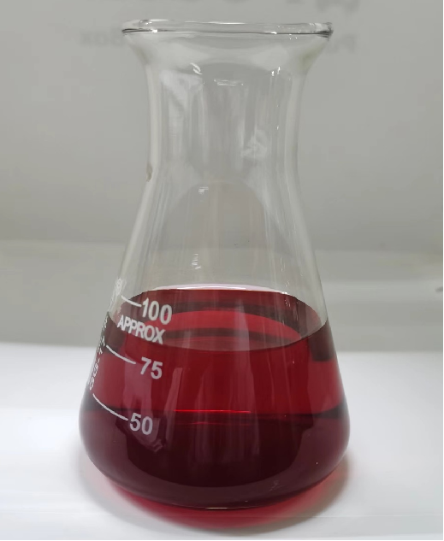
Fig. S1 Colloidal gold solutions synthesized by reduction of chloroauric acid with trisodium citrate.
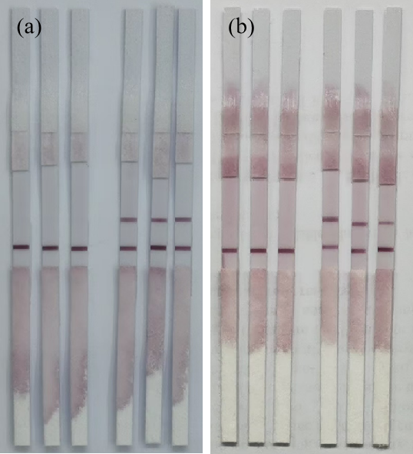
Fig. S2 Storage stability of immunochromatographic test strips (a) 0 days. (b) 100 days.

