Supplementary Information for “Physics-Guided Dataset Homogeneity Enables Universal Deep Learning Generalization in Scattering Media”
Xuyu Zhang^{1,2}, Haofan Huang³, Dawei Zhang², Songlin Zhuang², Shensheng Han^{1,5}, Puxiang Lai^{3,4, *}, and Honglin Liu^{1,5, *}
¹Shanghai Institute of Optics and Fine Mechanics, Chinese Academy of Sciences, Shanghai 201800, China
²School of Optical-Electrical and Computer Engineering, University of Shanghai for Science and Technology, Shanghai 200093, China
³Department of Biomedical Engineering, The Hong Kong Polytechnic University, Hong Kong SAR, China
⁴Photonics Research Institute, The Hong Kong Polytechnic University, Hong Kong SAR, China
⁵Center of Materials Science and Optoelectronics Engineering, University of Chinese Academy of Science, Beijing 100049, China
*puxiang.lai@polyu.edu.hk, and hlliu4@hotmail.com

A. Comparison of the characteristics of Face-LFW and MNIST datasets
The characteristics of Face-LFW and MNIST datasets used in the study are analyzed based on histograms of pixel values. The images are 256×256 arrays in 8-bit depth greyscale. Fig. S1a shows an example of face image, where 10 pixels are randomly selected and marked. Fig. S1b shows the normalized histograms of pixel value of Points 1-10 across 9950 face images. It can be observed that the histograms vary among different pixels, with pixels on the face having higher values. Fig. S1c is the arithmetic average of the ten histograms, which is continuous with a nearly uniform distribution.
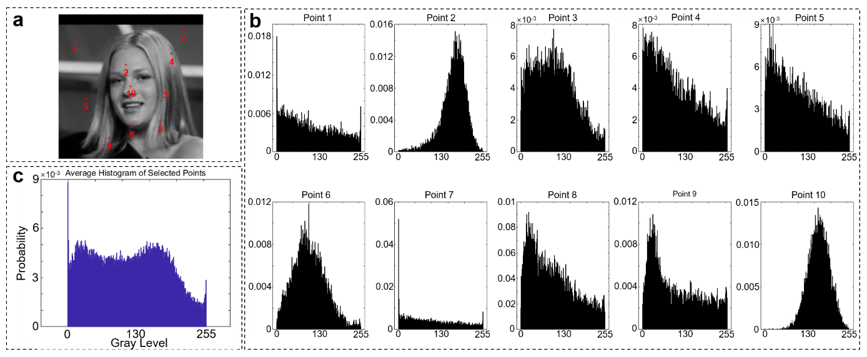
Fig. S1 Histograms of pixel value of face images in LFW dataset. a, an example of face image from LFW dataset with 10 pixels marked. b, normalized histograms of Points 1-10, respectively. c, arithmetic average of the statistical histograms for the 10 points in b.
The histograms of original and intensity modified MNIST dataset are shown in Fig. S2 and Fig. S3, respectively. The same 10 pixels are selected. There are two spikes at 0 and 255 in the histograms of the 10 pixels except Points 1&7 (see Fig. S2), who have only one spike at 0 since it is always dark at the edge of digit images. Their average in Fig.S2c also has two peaks with higher peak at 0. In Fig. S3, the 0 value will not be changed by intensity modification, hence, the spike at 0 remains almost the same. The spike at 255 is diffused over 0-255, with a continuous and relatively uniform distribution. It can be seen that, apart from the 0 values, the remaining histograms are continuous, showing a trend towards the nearly uniform distribution, although there are still differences overall.
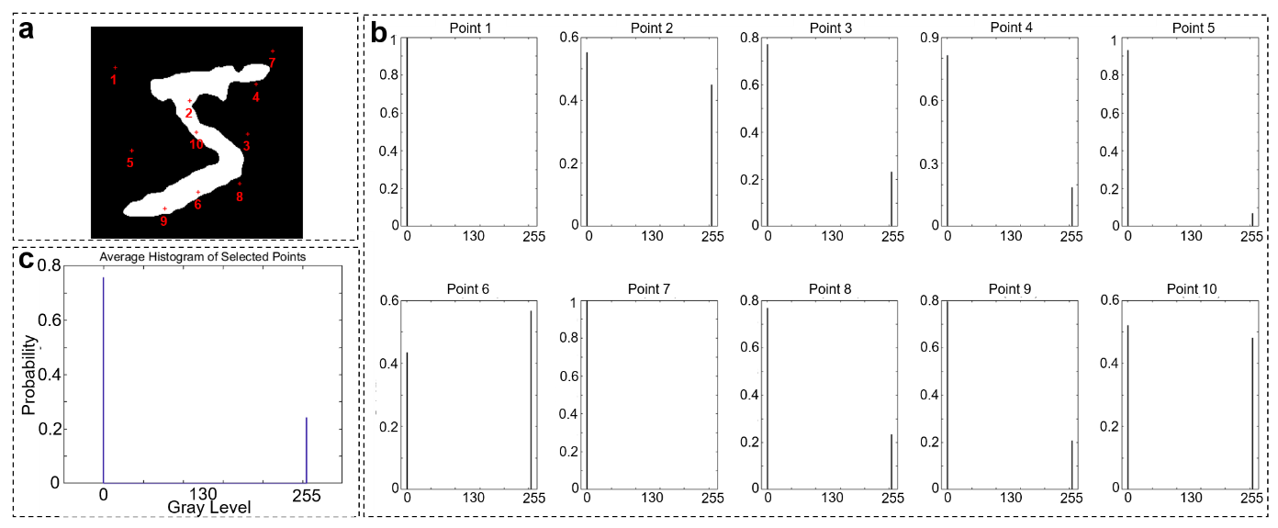
Fig. S2 Histograms of pixel value of digit images in MNIST dataset. a, an example of digit image from MNIST dataset with 10 pixels marked. b, normalized histograms of Points 1-10, respectively. c, arithmetic average of the statistical histograms for the 10 points in b.
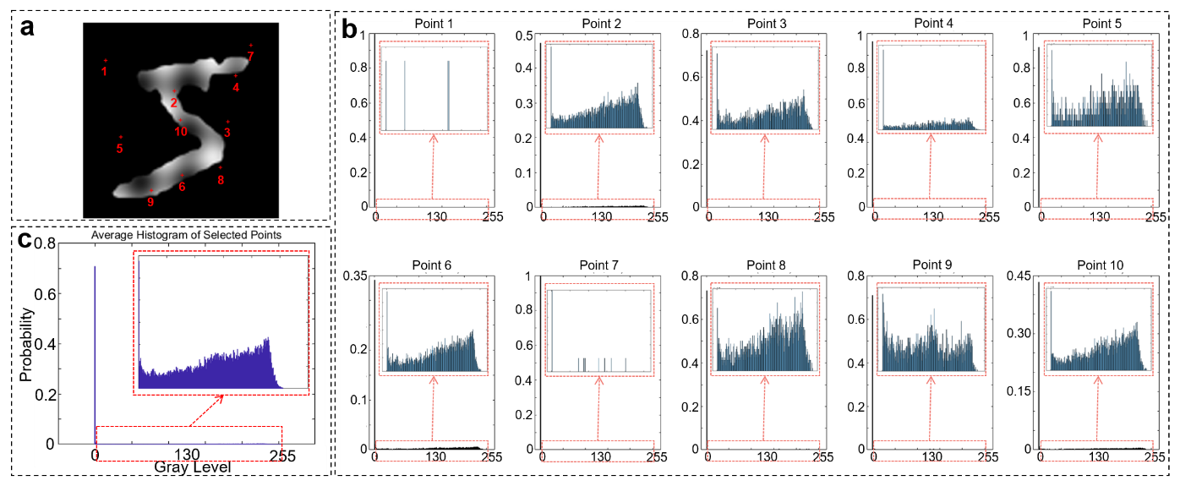
Fig. S3 Histograms of pixel value of intensity-modified digit images. a, an example of the intensity-modified digit image with 10 pixels marked. b, normalized histograms of Points 1-10, respectively. c, arithmetic average of the statistical histograms for the 10 points in b. The insert in each histogram is the amplified histogram from 1 to 255.
For the enlarged and intensity-modified digit images in Case 4, scaling from $64×64$ to $96×96$ corresponding to reshaping the $256×256$ arrays to a $384×384$ one. The positions of the 10 pixels in the central areas are denoted in Fig. S4a. The corresponding results are shown in Fig. S4. When the target is enlarged, the areas with intensity fluctuations also become larger, making the intensity variations within the region used for calculating histogram more pronounced and increasing the proportion of non-zero grayscale areas, leading to reduced height of 0 peak. By comparing the localized enlargements in Fig. S4c and Fig. S3c, it is evident that enlarging the MNIST image increases the complexity of pixel intensities within the original training region, making it more similar to the grayscale distribution of face images. Consequently, the results in Case 4 of the main text show that the enlarged images are more favorable for reconstructing face test images.
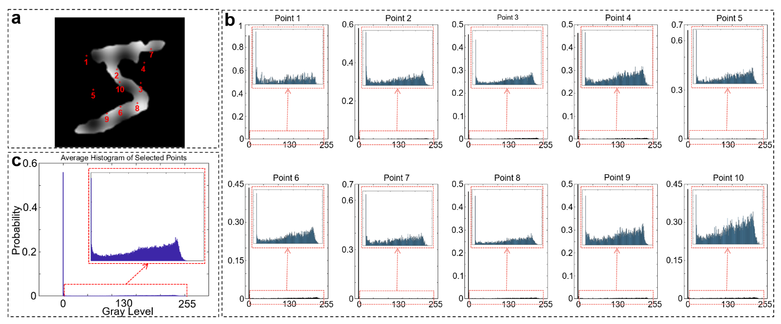
Fig. S4 Histograms of pixel value of enlarged and intensity-modified digit images. a, an example of the digit image with 10 pixels marked. b, normalized histograms of Points 1-10, respectively. c, arithmetic average of the statistical histograms for the 10 points in b. The insert in each histogram is the amplified histogram from 1 to 255.
B. Comparison of the image reconstruction quality with different parameters
Fig. 3 in the main text has demonstrated that the network trained with dataset with more diversities has better generalization from cases 1 to 4, along with the corresponding PCC values. Here, we have incorporated two additional metrics commonly used to quantify the quality of reconstructed images—Structural Similarity Index (SSIM) and Cosine Similarity (CS)—to further illustrate the trend observed in our study, where the testing results progressively improve as the dataset evolves. Table 1 presents the PCC, SSIM, and Cosine Similarity values for each reconstructed image compared to its corresponding ground truth, following the same layout format of Fig. 3 in the main text. Furthermore, the specific distribution of these metrics is visualized as scatter plots in Fig.S5, with the optimal values for the facial images highlighted in bold. It is evident that, whether considering SSIM or Cosine Similarity, the trend in the testing results from cases 1 to 4 is similar to that of the PCC values, albeit with slight variations in magnitude.
Table 1 PCC, SSIM, and Cosine Similarity values for each reconstructed image compared to its corresponding ground truth.
 |  | Test with facial targets |  |  |  |  | Test with digital targets
PCC | C#1 | 0.8521 | 0.8163 | 0.8680 | 0.8197 | 0.8359 | 0.7783 | 0.8172 | 0.8128 | 0.7639 | 0.7455
PCC | C#2 | 0.4747 | 0.2959 | 0.5197 | 0.0983 | 0.0908 | 0.9471 | 0.9508 | 0.9723 | 0.9583 | 0.9567
PCC | C#3 | 0.5417 | 0.3802 | 0.5546 | 0.2001 | 0.1774 | 0.8641 | 0.8763 | 0.9498 | 0.8876 | 0.8780
PCC | C#4a | 0.4522 | 0.4091 | 0.4806 | 0.2400 | 0.3870 | 0.9249 | 0.9229 | 0.9338 | 0.8734 | 0.9348
PCC | C#4b | 0.6115 | 0.4473 | 0.6819 | 0.5203 | 0.5442 | 0.8696 | 0.9470 | 0.9604 | 0.9580 | 0.9357
PCC | C#4c | 0.6922 | 0.4558 | 0.7354 | 0.5104 | 0.5157 | 0.9410 | 0.9384 | 0.9594 | 0.9236 | 0.9480
SS  IM | C#1 | 0.8367 | 0.8109 | 0.8648 | 0.8162 | 0.8391 | 0.2419 | 0.2728 | 0.3102 | 0.2582 | 0.1529
SS  IM | C#2 | 0.0208 | 0.0307 | 0.1682 | 0.0259 | 0.0227 | 0.6005 | 0.6456 | 0.7551 | 0.6705 | 0.6148
SS  IM | C#3 | 0.0576 | 0.0390 | 0.2106 | 0.0285 | 0.0393 | 0.4759 | 0.4658 | 0.6989 | 0.5983 | 0.5709
SS  IM | C#4a | 0.1351 | 0.0623 | 0.2772 | 0.1106 | 0.1061 | 0.4796 | 0.5077 | 0.6582 | 0.4447 | 0.4122
SS  IM | C#4b | 0.4051 | 0.3741 | 0.4896 | 0.3161 | 0.2533 | 0.5903 | 0.6277 | 0.7726 | 0.7365 | 0.6747
SS  IM | C#4c | 0.4282 | 0.3622 | 0.4241 | 0.3427 | 0.3131 | 0.5835 | 0.6049 | 0.7683 | 0.7182 | 0.6630
CS | C#1 | 0.9834 | 0.9729 | 0.9779 | 0.9735 | 0.9853 | 0.6688 | 0.6745 | 0.6724 | 0.6609 | 0.6139
CS | C#2 | 0.5684 | 0.3952 | 0.6374 | 0.4776 | 0.4918 | 0.7441 | 0.6891 | 0.7161 | 0.6439 | 0.7288
CS | C#3 | 0.6226 | 0.5397 | 0.7154 | 0.5377 | 0.6245 | 0.6279 | 0.5176 | 0.6253 | 0.5836 | 0.5920
CS | C#4a | 0.8023 | 0.5454 | 0.6956 | 0.6109 | 0.7236 | 0.6598 | 0.5498 | 0.6106 | 0.6017 | 0.6066
CS | C#4b | 0.8898 | 0.8152 | 0.8406 | 0.8072 | 0.7993 | 0.5735 | 0.5923 | 0.6478 | 0.7178 | 0.6372
CS | C#4c | 0.9263 | 0.8252 | 0.8879 | 0.8137 | 0.8569 | 0.6933 | 0.5386 | 0.6126 | 0.5842 | 0.7096

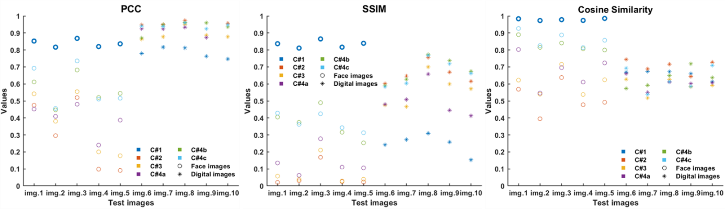
Fig. S5 From left to right, the diagram sequentially presents the PCC values, SSIM values, and Cosine Similarity for the testing results of Cases 1-4, as shown in Fig. 3 of the main text. "img.1" to "img.10" correspond to the ten facial images and handwritten digit images used for testing in Fig. 3, listed from left to right, with different colors representing different cases. Circles and asterisks are used to denote testing with facial images and handwritten digit images, respectively. The optimal values for the facial image tests are highlighted in bold.
C. Illustration of the relationship among different learned mappings
For better understanding, a diagram of the relationship of learned mappings under different conditions is shown in Fig. S6.
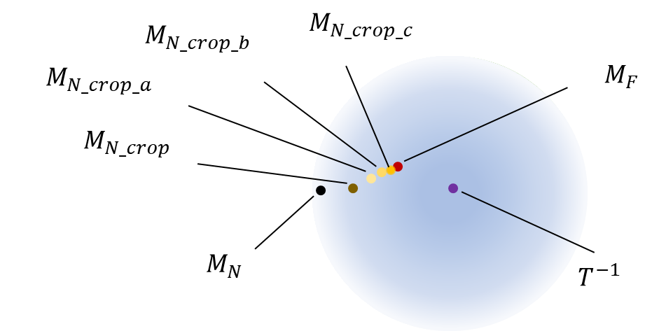
Fig. S6 Schematic illustration of the relationship among learned mappings under different training datasets. Comparing to $M_{N}$, $M_{F}$ is closer to $T^{-1}$. As the central area of digital images is cropped and intensity-tuned, learned mappings gradually approach $M_{F}$. $M_{N_crop}$ denotes the mapping learned in Case 3, $M_{N_crop_a}$, $M_{N_crop_b}$ and $M_{N_crop_c}$ are the mappings learned in Cases 4a, 4b and 4c, respectively.
D. Prediction with network trained with randomly distributed digit images
In Case 5, it has been demonstrated that regions of the object plane that were not trained by the network could not be predicted, indicating that the network had not yet learned the mapping relationship for those regions. To enhance the comprehensiveness of this conclusion, we conducted a supplementary experiment. In our experiments, the central illumination range covers a 128×128 array, whereas in Case 5, only the central 64×64 region is used to display the targets. In the supplementary experiment, we randomly display the 64×64 targets within the 128×128 training range and collected corresponding speckle patterns for training. The schematic of the data collection strategy is depicted in Fig. S7. After training, we tested the network by randomly positioning the same digit image "5" in four different locations within the illumination range. The results, shown in Fig. S7b, include the PCC values between the reconstructions and the ground truth, highlighted in yellow in the lower right corner of each image. The test results reveal that due to the random placement of the handwritten digit targets during training, a larger portion of the object plane within the illumination range was illuminated, greatly exceeding the central 64×64 region used in Case 5. As a result, the network successfully established a mapping relationship $M$ over a broader area on object plane with the detection area, enabling accurate reconstruction of targets at various positions within the illumination range with high similarity.
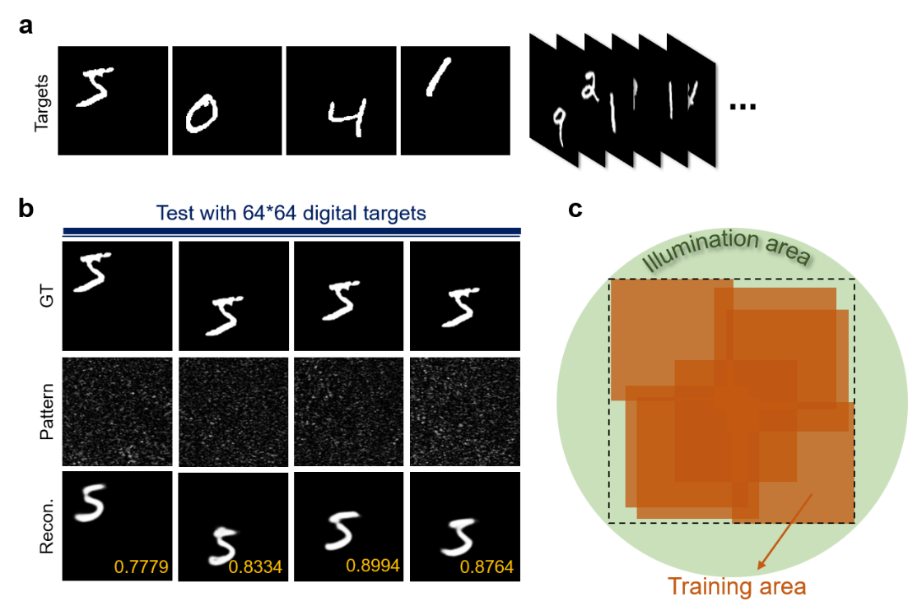
Fig. S7 Results of the supplementary experiment corresponding to Case 5. a, a set of target images was generated by randomly placing 64×64 handwritten digit images within the 128×128 range, and corresponding speckle patterns were collected to train the network. b, the network testing results of digits 5 at 4 different positions, where the yellow numbers in the lower right corner of the reconstructed images are the PCC values. c, a schematic illustration of the target displaying area and the illumination range, where the orange training areas are the regions of training targets, and the dash square denotes the 128×128 training area.

