Supplementary Material for
Physics-aware Bayesian Vision Transformer enables structure-level uncertainty in seismic inversion

Zhen Liu¹
¹School of Geosciences, China University of Petroleum (East China), Qingdao, China, 266580.

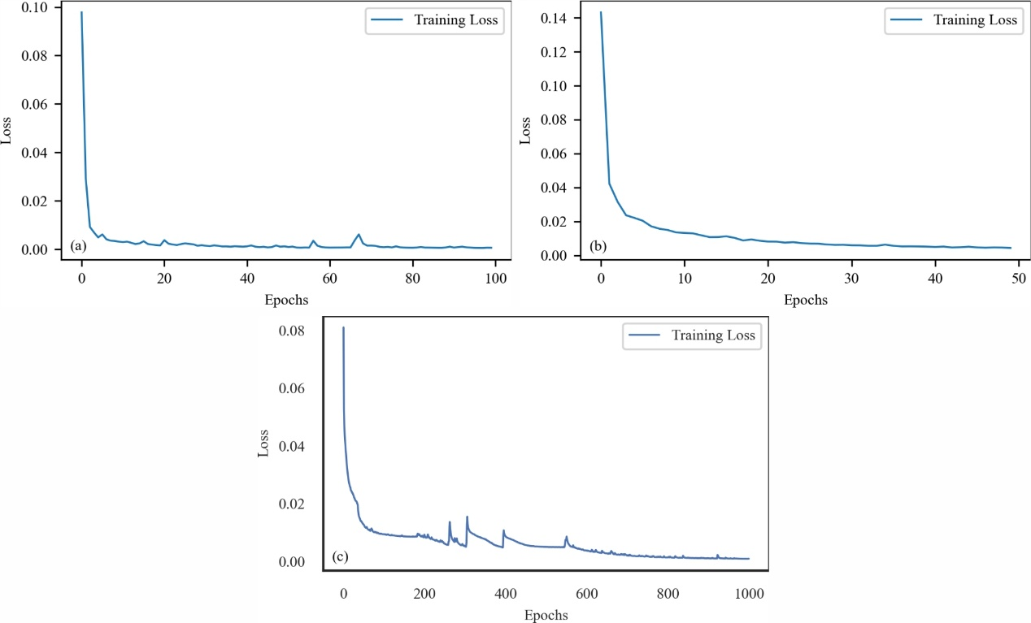
Supplementary Figure 1. Convergence curves for three physics-informed neural network architectures. (a) PINN; (b) BPINN; (c) BPI-ViT.

Supplementary Figure 2. Attention entropy curves of all heads across different Transformer layers in the BPI-ViT model, showing the evolving distribution of attention focus from shallow to deep layers. (a) Layer 0: Large entropy variation, strong local focus. (b) Layer 1: Slightly increased entropy, partial structure selectivity remains. (c) Layer 2: Entropy grows uniformly across heads, indicating semantic integration. (d) Layer 3: Entropy converges near theoretical maximum, fully distributed attention.

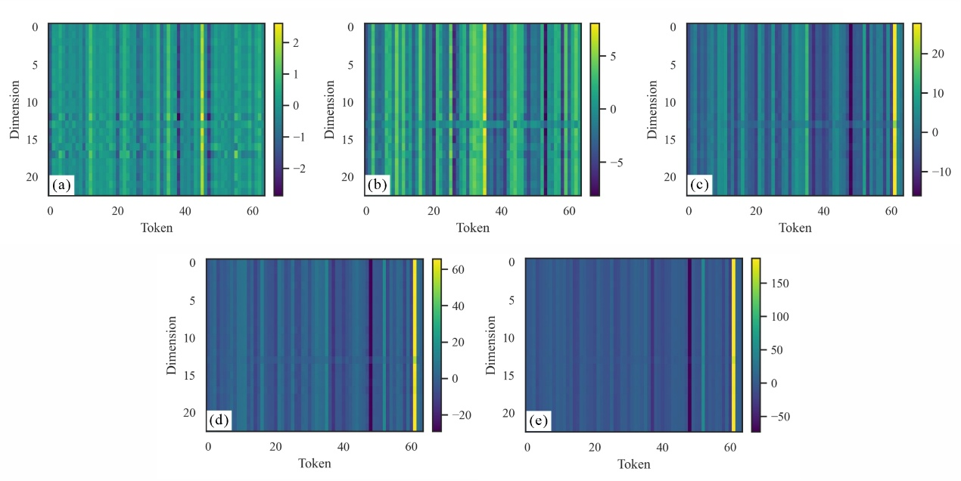
Supplementary Figure 3. Token-Dimension embedding maps of sample #200 from different layers of BPI-ViT. (a) Layer 0: disordered shallow features; (b) Layer 1: local grouping emerges; (c) Layer 2: transition stage with partial semantic alignment; (d) Layer 3: clear token-wise structural highlighting; (e) Layer 4: concentrated embedding with maximum contrast for final prediction.

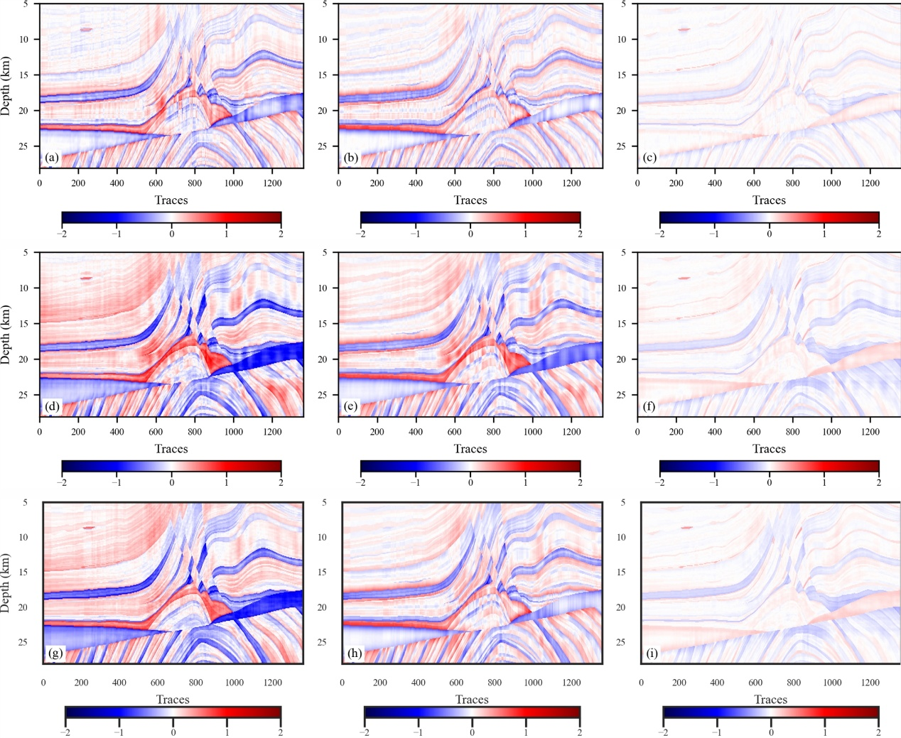
Supplementary Figure 4. Residual maps between inversion results and the ground truth using three methods. (a–c) show the differences between the predicted V_{P}, V_{S} ​, and ρ by PINN and the true models, respectively; (d–f) show the residuals for the BPINN inversion results; (g–i) illustrate the residuals for the BPI-ViT inversion results.

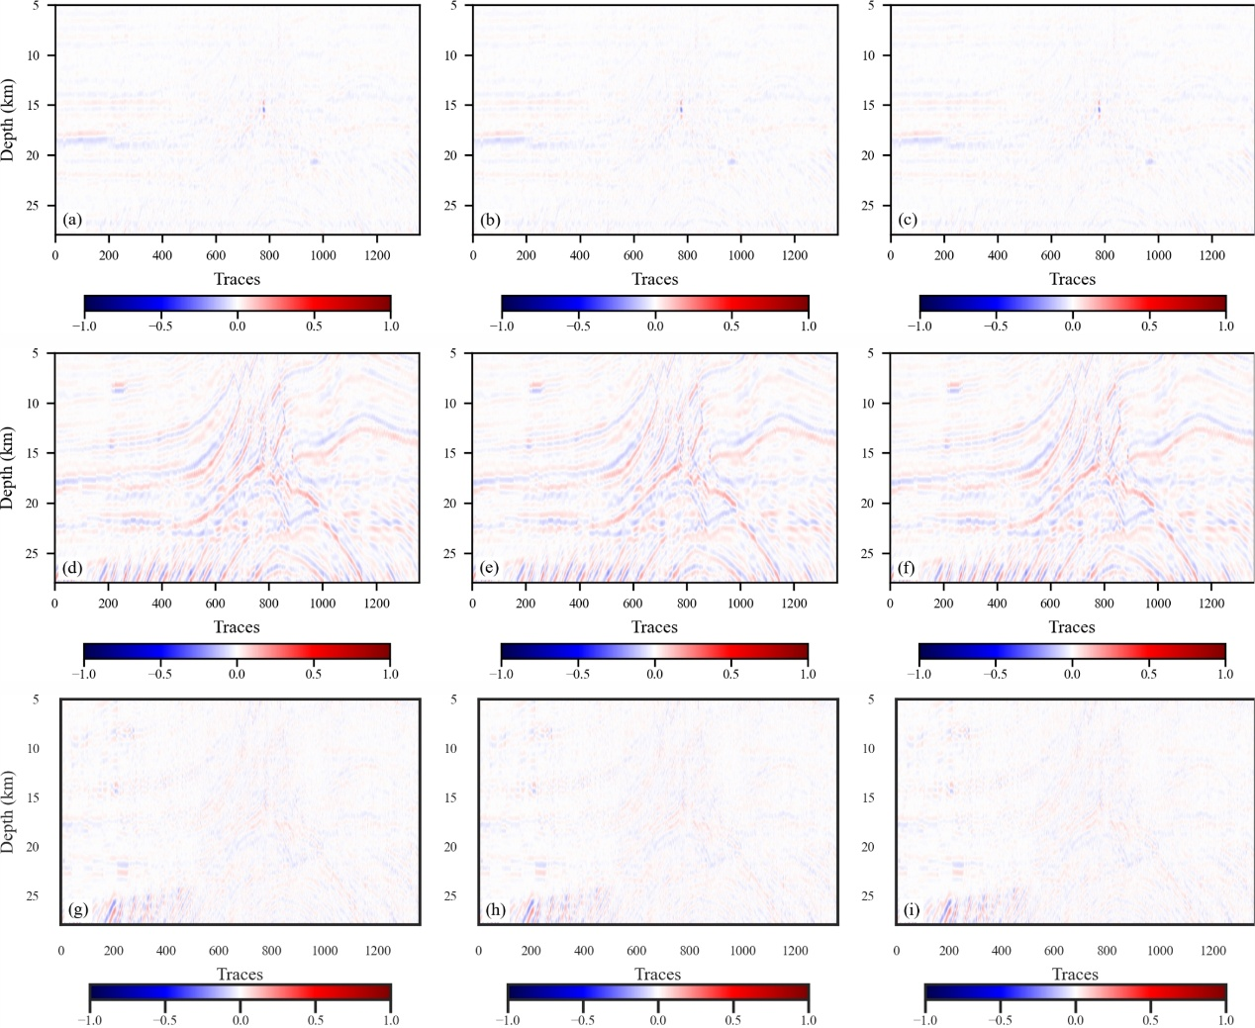
Supplementary Figure 5. Residual comparison between synthetic records generated by inversion-based forward modeling and observed seismic data. (a)–(c) show the residuals between the observed data and the synthetic records reconstructed using V_{P}, V_{S}, and ρ predicted by the PINN model; (d)–(f) correspond to the residuals obtained from the BPINN model; (g)–(i) represent the residuals produced by the BPI-ViT model.

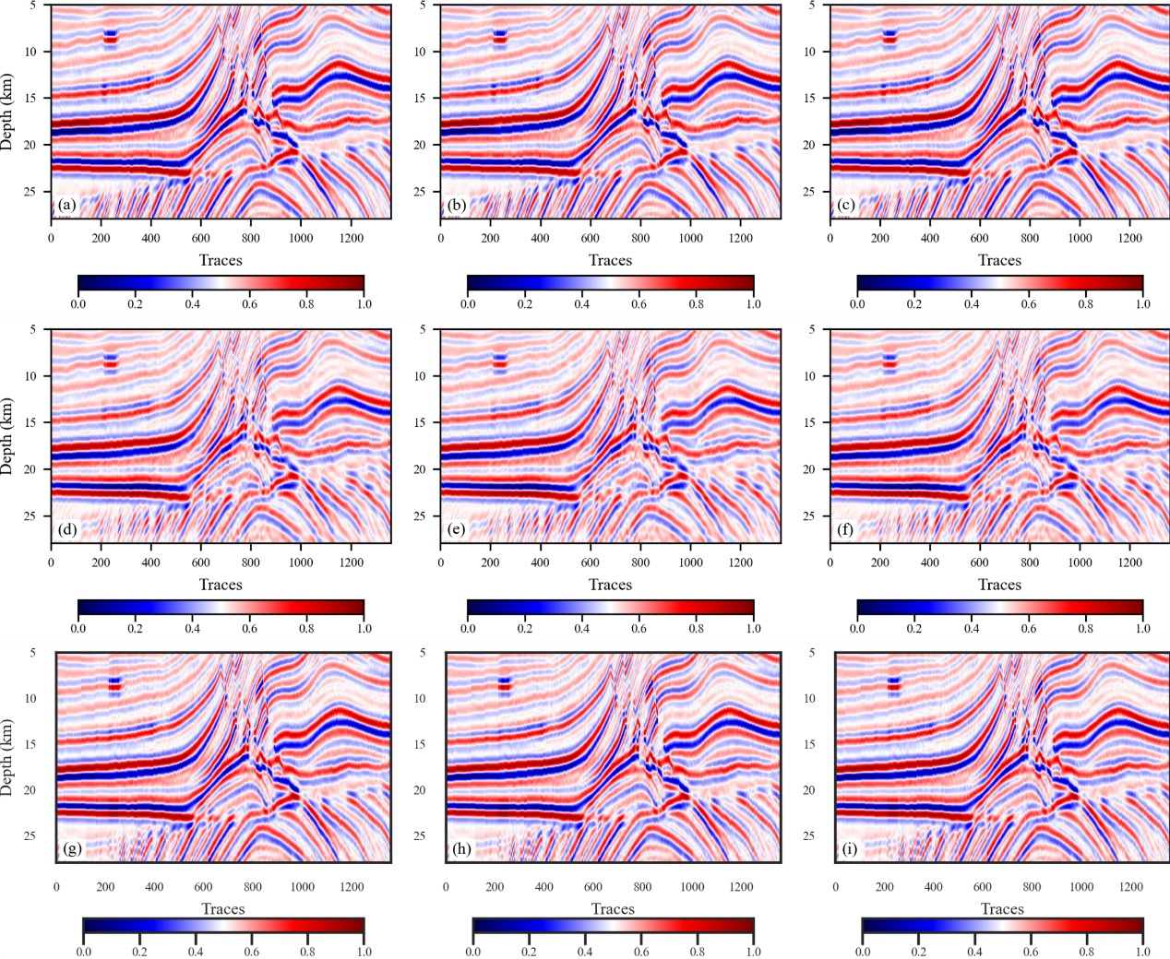
Supplementary Figure 6. Synthetic seismic records generated by forward modeling based on inversion results from three methods. (a)–(c) are synthetic records based on the inversion results of P-wave velocity, S-wave velocity, and density from the PINN method, respectively. (d)–(f) correspond to the BPINN-based inversion results. (g)–(i) are derived from the BPI-ViT-based inversion results.

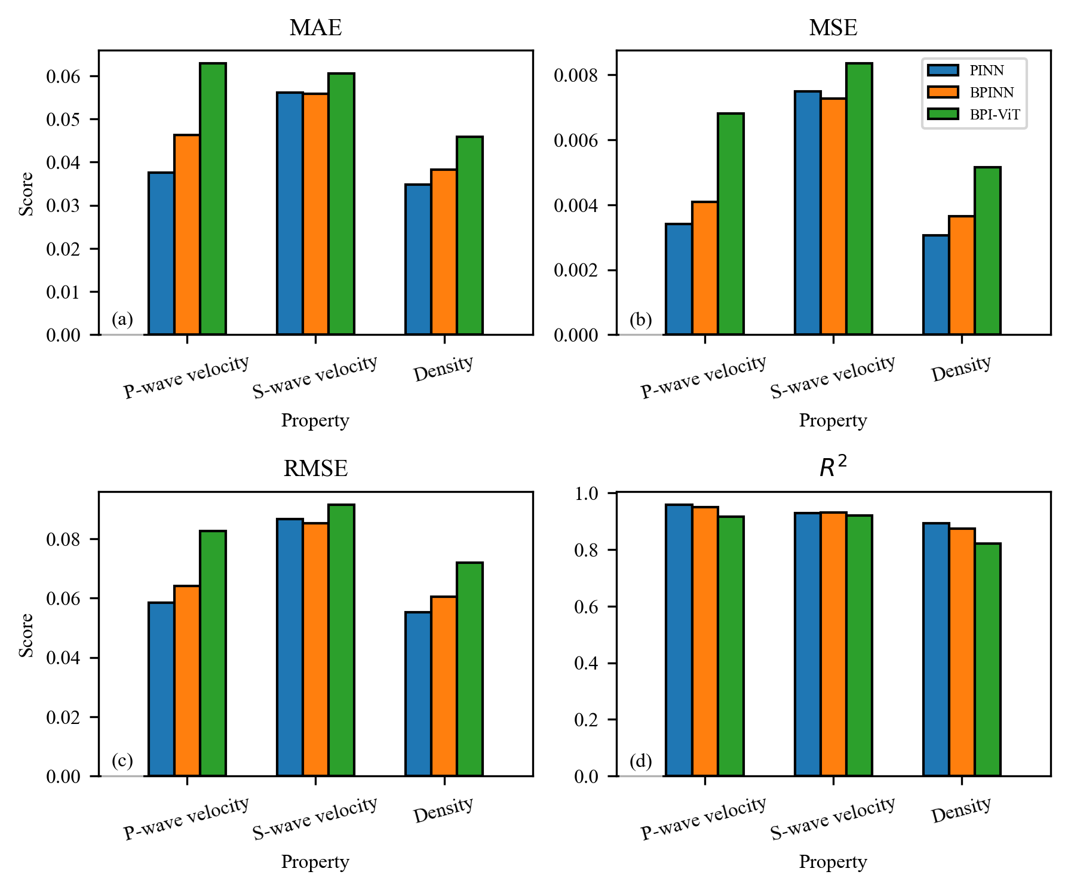
Supplementary Figure 7. Quantitative comparison of prediction accuracy for three inversion methods across different geophysical properties. (a) Mean Absolute Error (MAE); (b) Mean Squared Error (MSE); (c) Root Mean Squared Error (RMSE); (d) Coefficient of determination (R²).

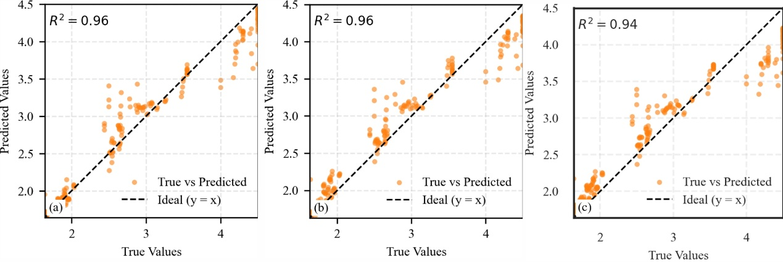
Supplementary Figure 8. Crossplots between predicted and true values obtained by (a) PINN, (b) BPINN, and (c) BPI-ViT.

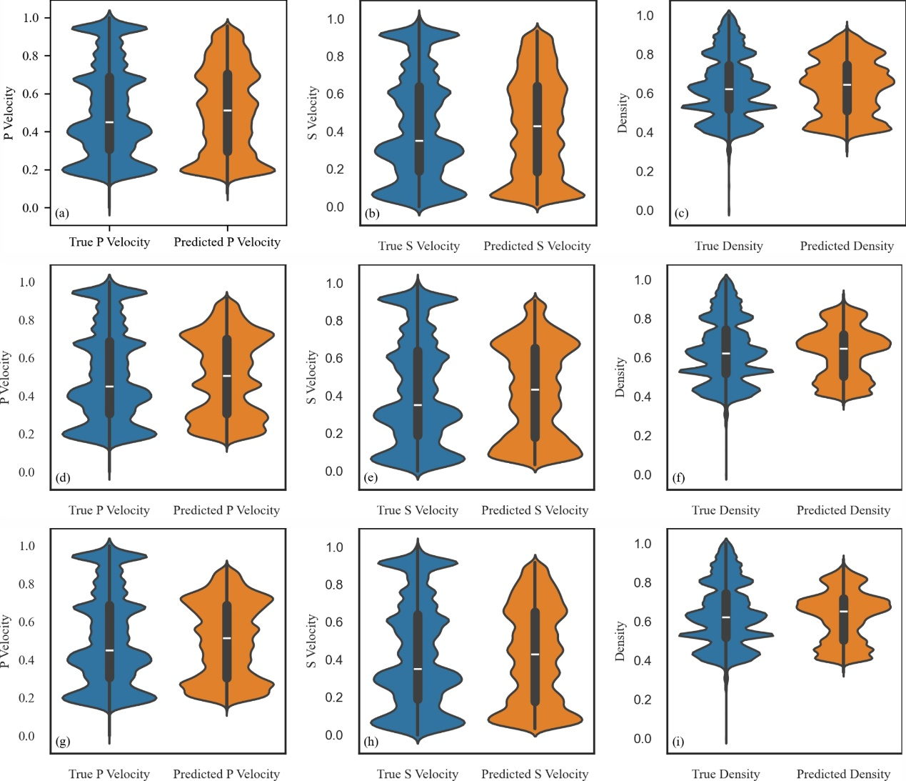
Supplementary Figure 9. Violin plots comparing the predicted and true distributions of physical properties for different inversion methods. Figures (a)–(c) show the predicted and true distributions of P-wave velocity, S-wave velocity, and density obtained using the PINN model. Figures (d)–(f) present the corresponding results for the BPINN model. Figures (g)–(i) illustrate the prediction versus ground truth distributions using the BPI-ViT model.
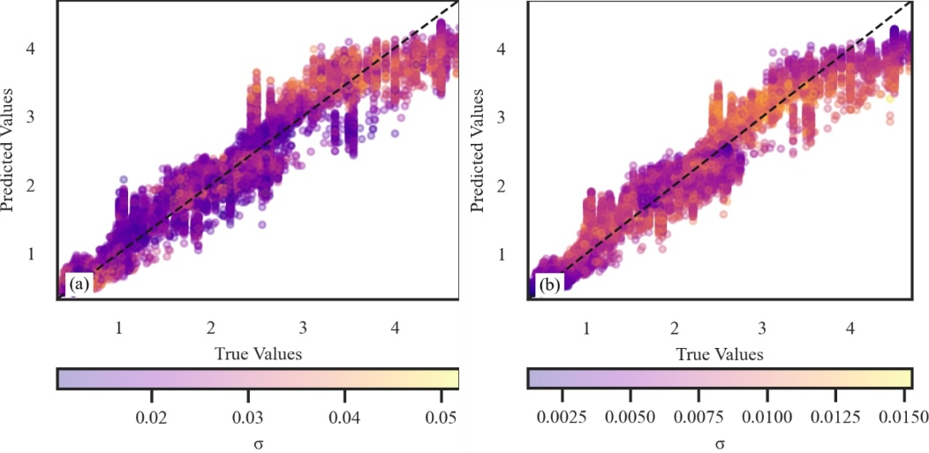
Supplementary Figure 10. Scatter plots of inversion results versus ground truth for BPINN (a) and BPI-ViT (b).

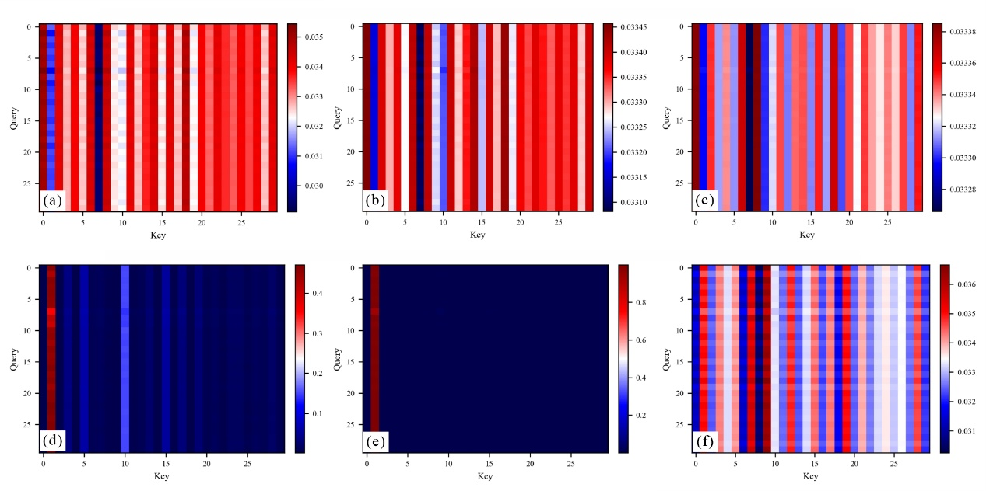
Supplementary Figure 11. Representative multi-head attention weight distributions at the seismic trace near Well A. (a) layer1_head2; (b) layer2_head2; (c) layer3_head2; (d) layer0_head1; (e) layer0_head3; (f) layer1_head6.

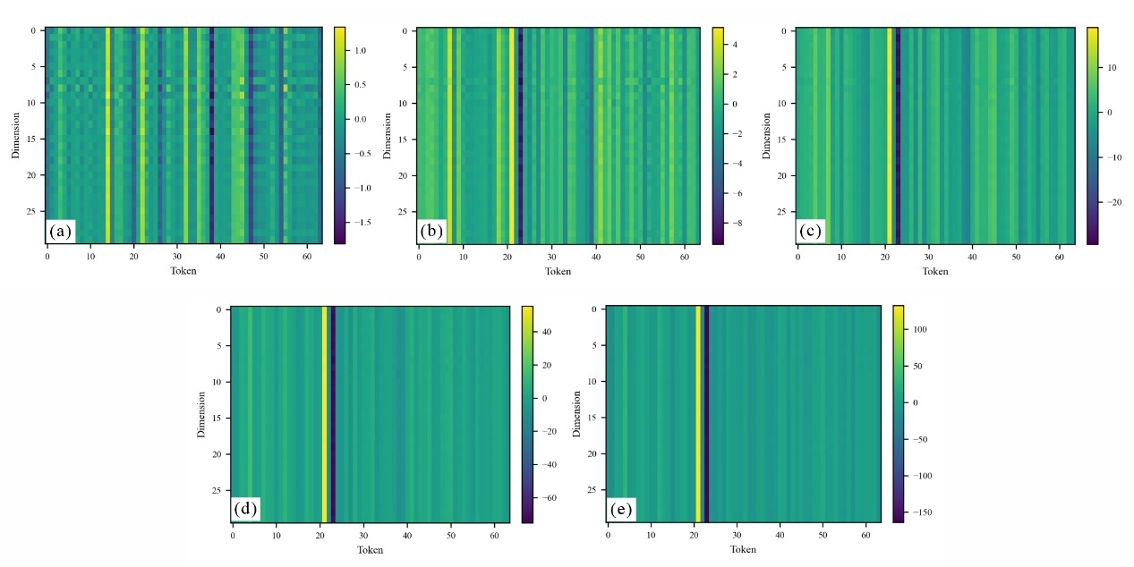
Supplementary Figure 12. Feature representations of the seismic trace near Well A at different Transformer layers. (a) layer0; (b) layer1; (c) layer2; (d) layer3; (e) layer4.
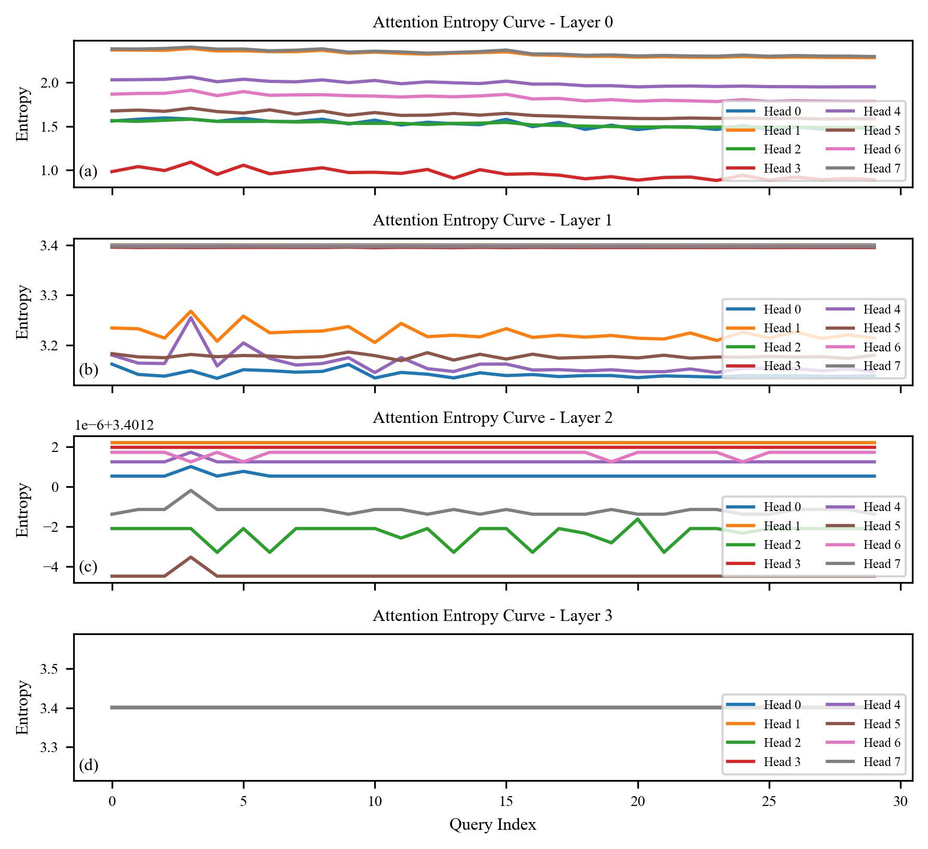
Supplementary Figure 13. Globally averaged multi-head attention entropy curves at the seismic trace near Well A for different Transformer layers.
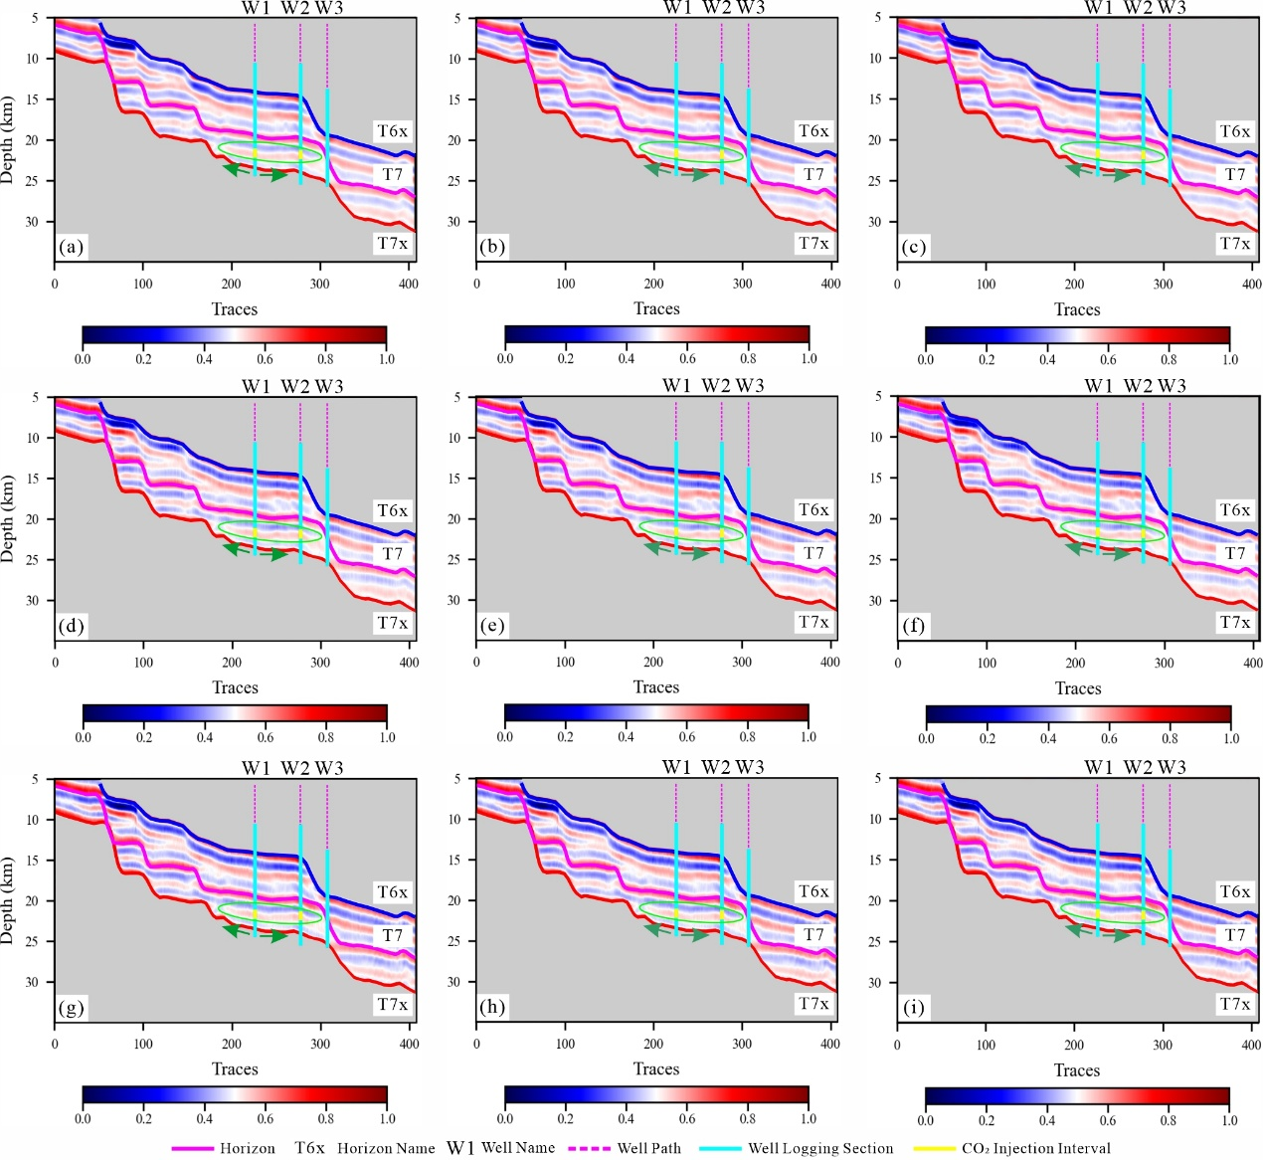
Supplementary Figure 14. Comparison of forward-modeled synthetic records from field data inversion results using three neural network methods. (a)–(c) Synthetic records for near-, middle-, and far-angle gathers by PINN; (d)–(f) by BPINN; (g)–(i) by BPI-ViT.

