Supplementary information
Topical application of Cas9 ribonucleoprotein inhibits corneal neovascularization in a mouse model of alkali burn injury

Seok Jae Lee, Bae-Geun Nam, Sung-Ah Hong, Dong Hyun Jo, Sang-Mok Lee, Sangsu Bae, Jeong Hun Kim

Content:
Figure S1. Indel confirmation in NIH/3T3 cells
Figure S2. VEGFA protein expression throughout the whole corneal layers after intrastromal administration of Cas9-RNPs targeting Vegfa
Figure S3. Analysis of Cas9 RNPs distribution in the cornea following topical treatment in vivo
Figure S4. VEGFA protein expression and recruitment of macrophages of the corneal layer following administration of Cas9-RNPs targeting Vegfa

Table S1. List of Pirmers for targeted deep sequencing

Table S2. Sequences of primers for real-time qPCR

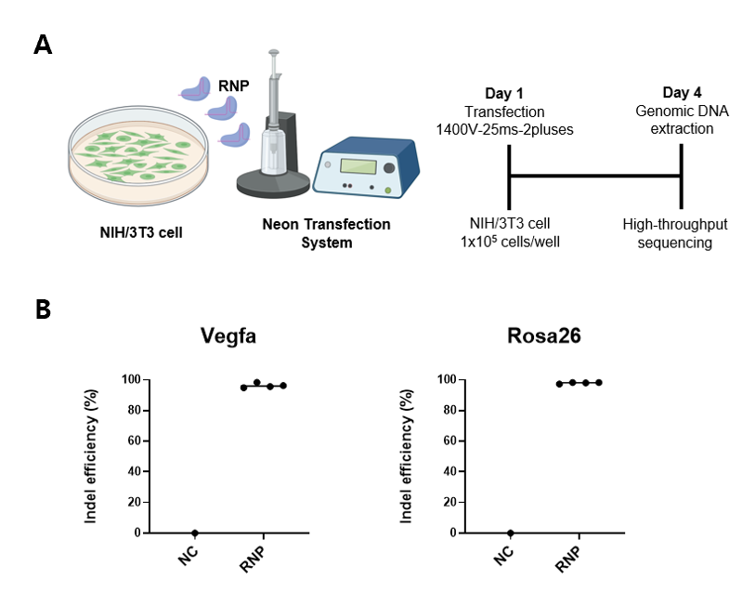

Fig. S1 Indel confirmation in NIH/3T3 cells
A To measure sgRNA activity, NIH/3T3 cells were transfected with Cas9 RNPs using a Neon Transfection System with the following parameters: voltage, 1,400; width, 25 ms; 2 pulses and collected 4 days after transfection. B Individual quantifications of indel frequencies in the mock and two ribonucleoprotein groups are confirmed by targeted deep sequencing on the Vegfa and Rosa26 locus in NIH3T3 (n=1, respectively).

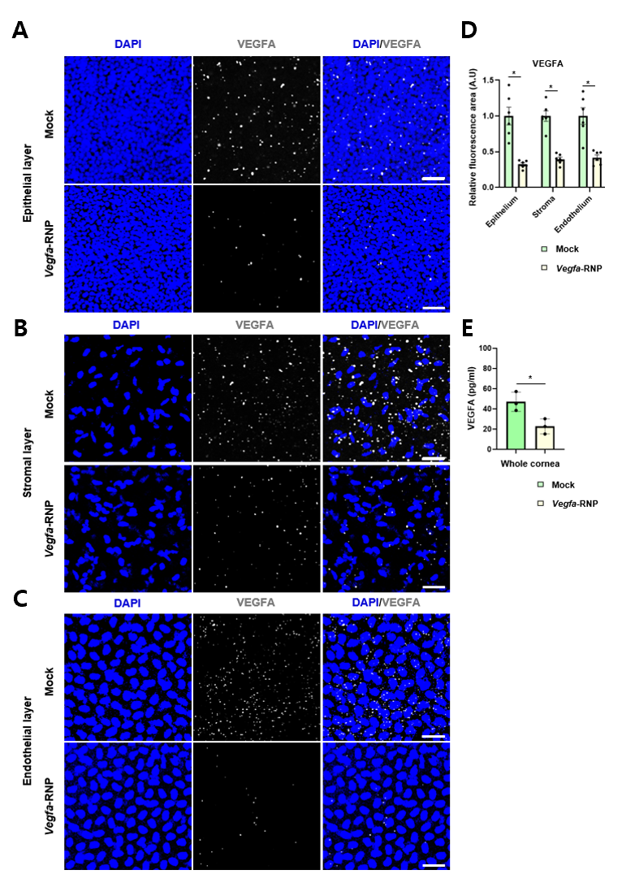
Fig. S2 VEGFA protein expression throughout the whole corneal layers after intrastromal administration of Cas9-RNPs targeting Vegfa
A-C Representative immunofluorescence images of anti-vascular endothelial growth factor (VEGFA, gray) and 4′,6-diamidino-2-phenylindole (DAPI, blue) in the central cornea (epithelial, stromal and endothelial layer) of an alkali burn injury model at 3D in the intrastromal mock and Cas9-RNPs targeting Vegfa injection groups. The scale bars correspond to 50 μm. D Quantitative analyses of the VEGFA positive areas in the whole corneal layers in the mock and Cas9-RNPs targeting Vegfa groups. Error bars indicate SEM (n=6 for each data set). *P < 0.001, obtained using Student's T test. E mouse VEGF protein levels in the dissected corneal tissues in the mock and Cas9-RNPs targeting Vegfa groups were determined by ELISA (n=3). Error bars indicate SEM. *P < 0.001, obtained using Student's T test.

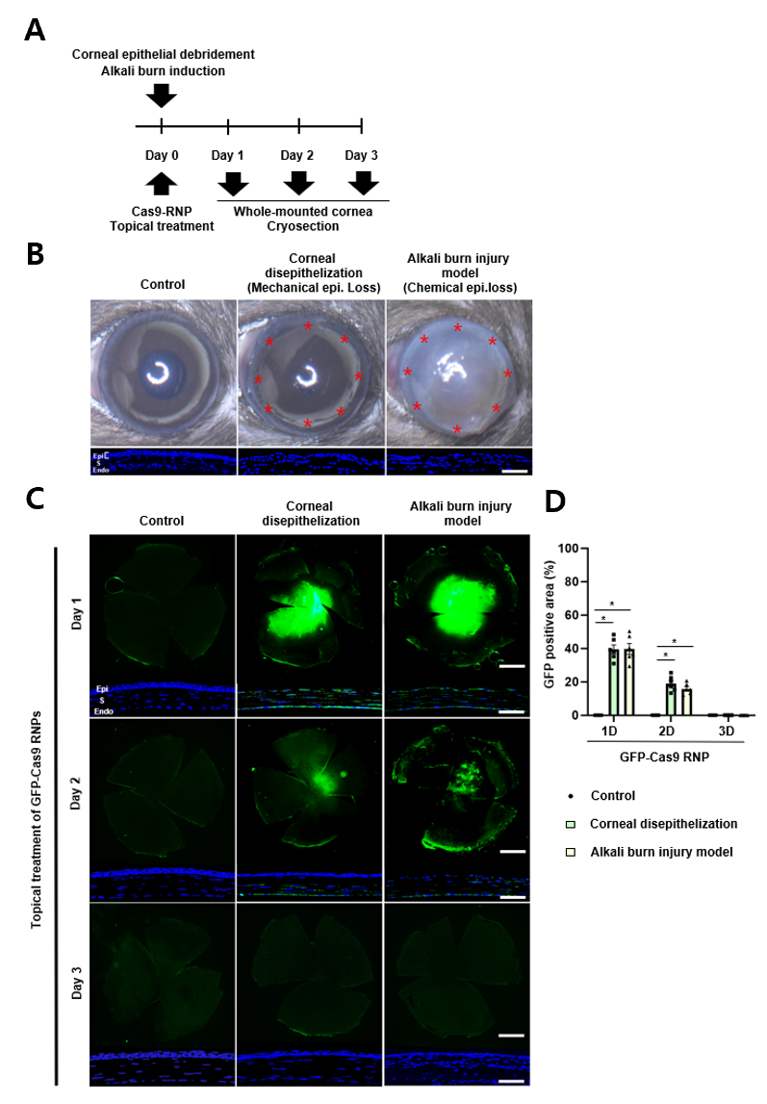
Fig. S3 Analysis of Cas9 RNPs distribution in the cornea following topical treatment in vivo A Flowchart for evaluating the corneal distribution of green fluorescent protein-clustered regularly interspaced short palindromic repeats-associated protein 9 ribonucleoproteins (GFP-Cas9 RNPs) following topical treatment in vivo. Cas9 RNPs composed of Cas9 protein (5 μg), sgRNA targeting Vegfa or Rosa26 (1.67 μg), and Lipofectamine 2000 (20% v/v) mixed in a 3 μL injection volume were applied to the corneas of normal C57BL/6J mice, corneal disepithelization mice, and alkali burn injury mice. Mouse eyeballs were retrieved to prepare whole-mounted corneal samples for immunofluorescence analysis. B Representative anterior photo images and cryosected corneas images of normal mice with intact corneal epithelium (control group), mice with mechanical epithelial loss through Alger Brush II® rust ring remover (0.5 mm burr, The Alger Company, Inc.), and mice with alkali burn (1N Sodium Hydroxide)-induced corneal epithelial damage. Asterisks indicate the boundary between the intact and removed epithelial layers of the cornea. The scale bar corresponds to 50 μm. Epi, epithelium; S, stroma; Endo, endothelium. C Representative images of whole-mounted and cryosected corneas at 1D, 2D, 3D after single topical GFP-Cas9 RNPs treatment. Scale bars of the whole-mounted and cryosected images correspond to 500 μm and 50 μm, respectively. Images were obtained using a fluorescein microscope (BX50; Olympus) and a confocal microscope (Leica TCS STED; Leica Microsystems Ltd.). D Quantification of the GFP-positive area in the whole-mounted corneas in the indicated groups. Error bars represent the standard error of mean (SEM, n =6 for each data set). *P < 0.001, obtained using one-way ANOVA and Tukey’s post-hoc test.

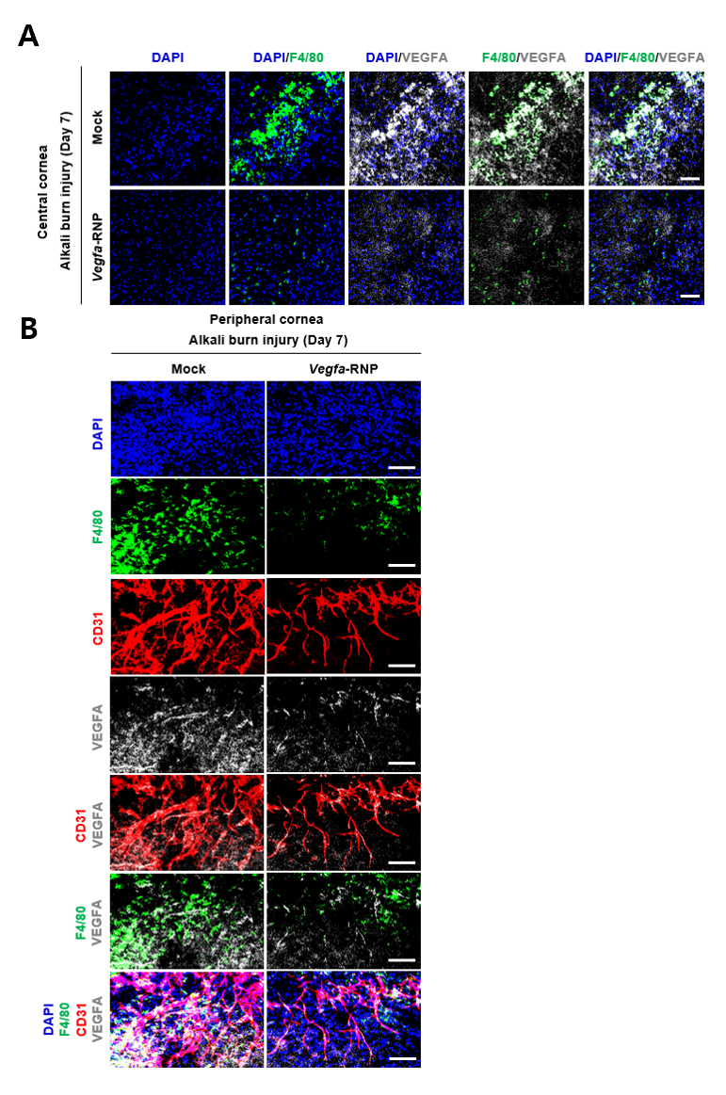
Fig. S4 VEGFA protein expression and recruitment of macrophages of the corneal layer following administration of Cas9-RNPs targeting Vegfa
A Representative immunofluorescence images of anti-F4/80 (green), vascular endothelial growth factor (VEGFA, gray), and 4′,6-diamidino-2-phenylindole (DAPI, blue) in the central cornea of an alkali burn injury model at 7D in the mock and Cas9-RNPs targeting Vegfa treatment groups. The scale bars correspond to 50 μm. B Representative immunofluorescence images of anti-F4/80 (green), cluster of differentiation 31 (CD31, red), vascular endothelial growth factor (VEGFA, gray), and 4′,6-diamidino-2-phenylindole (DAPI, blue) in the peripheral cornea of an alkali burn injury model at 7D in the mock and Cas9-RNPs targeting Vegfa treatment groups. The scale bars correspond to 50 μm.

Table S1 List of Primers for targeted deep sequencing
Gene | Forward (5’-3’) | Reverse (5’-3’)
Vegfa | ACACTCTTTCCCTACACGACGCTC  TTCCGATCTcaaatctgggtggcgataga | GTGACTGGAGTTCAGACGTGTGCT  CTTCCGATCTccagggcttcatcgttaca
Rosa26 | ACACTCTTTCCCTACACGACGCTC  TTCCGATCTtcccaaagtcgctctgagtt | GTGACTGGAGTTCAGACGTGTGCT  CTTCCGATCTctttaagcctgcccagaaga

Table S2 Sequences of primers for real-time qPCR
 | Gene | Forward (5’-3’) | Reverse (5’-3’)
Mouse specific | TNF-α | GGTGCCTATGTCTCAGCCTCTT | GCCATAGAACTGATGAGAGGGAG
Mouse specific | IL-6 | TACCACTTCACAAGTCGGAGGC | CTGCAAGTGCATCATCGTTGTTC
Mouse specific | CCL2 | GCTACAAGAGGATCACCAGCAG | GTCTGGACCCATTCCTTCTTGG
Mouse specific | CXCL12 | GGAGGATAGATGTGCTCTGGAAC | AGTGAGGATGGAGACCGTGGTG
Mouse specific | GAPDH | CATCACTGCCACCCAGAAGACTG | ATGCCAGTGAGCTTCCCGTTCAG

