Clinical Course and Outcomes of Cardiogenic Shock in COVID-19
: Insights from the COVID-19 Critical Care Consortium
Supplementary Files
Supplementary Table 1. Definitions of Variables
Variables | Definitions
Smoking | Smoking at least one cigarette, cigar, pipe or equivalent per day before the onset of the current illness. Do not include smoke-free tobacco products such as chewed tobacco or electronic nicotine delivery devices.
Diabetes | Type 1 or Type 2 diabetes mellitus requiring oral or subcutaneous treatment.
Hypertension | Elevated arterial blood pressure diagnosed clinically, >140mmHg systolic or >90mmHg diastolic.
Chromic pulmonary disease | Any of chronic obstructive pulmonary disease (chronic bronchitis, chronic obstructive pulmonary disease, emphysema), cystic fibrosis, bronchiectasis, interstitial lung disease, pre-existing requirement for long term oxygen therapy. Do not include asthma.
Chronic kidney disease | Any of clinician-diagnosed chronic kidney disease, chronic estimated glomerular filtration rate < 60 mL/min/1.73m², history of kidney transplantation
Malignant neoplasm | Current solid organ or hematological malignancy. do not include malignancies that have been declared ‘cured’ ≥5 years ago with no evidence of ongoing disease. Do not include non-melanoma skin cancers. Do not include benign growths or dysplasia.
Ischemic heart disease | Any previous self-reported or documented history (recent or remote) of an ischemic heart disease (angina symptoms, percutaneous coronary intervention, or coronary artery bypass graft)
Congestive heart failure | Any previous self-reported or documented history (recent or remote) of heart failure symptoms.
Ventricular arrhythmia | Any previous self-reported or documented history (recent or remote) of ventricular tachycardia or ventricular fibrillation
Previously implanted cardiac device | Any previous self-reported or documented history (recent or remote) of any permanent cardiac device implantation.
Congenital heart disease | Any previous self-reported or documented history of congenital heart defect that has or has not undergone percutaneous or surgical intervention, including atrial septal defects, ventricular septal defects, Tetralogy of Fallot, ventricular malformation, aortic coarctation, etc.)
Pre-existing cardiomyopathy | Any previous self-reported or documented history (recent or remote) of ischemic or non-ischemic cardiomyopathy.
Presence of prosthetic valve | Any previous self-reported or documented history (recent or remote) of any prosthetic valve implantation/replacement
Recent ACS withing 6 months | Any previous self-reported or documented history of either a ST elevated ACS or non-ST-elevated ACS in the preceding 6 months prior to admission.
Cardiogenic shock | Cardiogenic Shock was diagnosed at ICU admission  by persistent hypotension, SBP <90 mmHg or MAP <65 mmHg  and evidence of the followings:  - Severe reduction in cardiac output/index  - Elevated filling pressures
Cardiac arrest | Sudden and unexpected cessation of cardiac activity with no normal breathing and no signs of circulation
Mechanical circulatory support | 1) Venoarterial extracorporeal membrane oxygenator  2) Micro axial flow pump  3) Intra-aortic balloon pumping
SCAI CS staging | Stage C - CS without CA or MCS from 24 hours after ICU admission through a 30-day period  Stage D - MCS initiation after 24 hours of ICU admission through 30 days  Stage E - CA after 24 hours of ICU admission through 30 days
Diagnosis of acute myocardial infarction | Diagnosis made by cardiologist based on coronary angiography or coronary CT
Diagnosis of congestive heart failure | Failure of the heart to pump enough blood to meet the needs of the body tissues, resulting in tissue congestion and oedema
Diagnosis of arrhythmia | Arrhythmia below requires  - pharmacological therapy (e.g. Amiodarone)  - cardioversion ± pacing - temporary or permanent  - Atrial fibrillation  - Atrial flutter  - Supra-ventricular tachycardia  - Sick sinus syndrome  - Advanced or Complete atrioventricular block/Complete heart block  - Sustained ventricular tachycardia (>10 beats)  - Ventricular fibrillation  - Torsade’s de Pointe
Diagnosis of myocarditis/pericardium | Diagnosis made by cardiologist based on magnetic resonance imaging, cardiac CT, myocardial perfusion scintigraphy, or myocardial biopsy.
Diagnosis of endocarditis | Diagnosis made based on modified Duke criteria, using evidence from microbiological results, echocardiogram and clinical signs.
Diagnosis of Takotsubo syndrome | Diagnosis made by a cardiologist reviewing echocardiographic images.
Acute respiratory distress syndrome | Defined according to Berlin criteria as:  • Occurring within 1 week of a known clinical insult or worsening respiratory symptoms  • Bilateral radiological opacities not fully explained by effusions, lobar/lung collapse, or nodules  • Respiratory failure not fully explained by cardiac failure or fluid overload
Pulmonary embolism | Obstruction of pulmonary artery by thrombus, air or fat. Physician diagnosis based on clinical signs, CT pulmonary angiography and/or ventilation/perfusion scanning.
Pleural effusion | Increased amounts of fluid within the pleural cavity. It may be diagnosed clinically, with or without radiological or interventional confirmation.
Stroke/cerebrovascular accident | Clinical diagnosis, with or without supportive radiological findings.
Meningitis/encephalitis | Inflammation of the meninges or the brain parenchyma diagnosed clinically, radiologically or microbiologically.
Acute kidney injury | Acute renal injury is defined as any of:  • Increase in serum creatinine by ≥0.3 mg/dL (≥26.5 µmol/L) within 48 hours  • Increase in serum creatinine to ≥1.5 times baseline, which is known or presumed to have occurred within the prior 7 days  • Urine volume <0.5 mL/kg/hour for 6 hours
Liver dysfunction | A finding that indicates abnormal liver function, may refer to any of the following:  • Clinical jaundice  • Hyperbilirubinaemia (blood bilirubin level twice the upper limit of the normal range)  • An increase in alanine transaminase or aspartate transaminase that is twice the upper limit of the normal range
Coagulation disorder/DIC | Abnormal coagulation identified by abnormal prothrombin time or activated partial thromboplastin time. Disseminated intravascular coagulation (DIC; consumption coagulopathy; defibrination syndrome) is defined by thrombocytopenia, prolonged prothrombin time, low fibrinogen, elevated D-dimer and thrombotic microangiopathy.
Bacteremia | Growth of bacteria on a blood culture. Select ‘no’ if the only bacteria grown were believed to be skin contaminants (e.g. coagulase negative Staphylococci or diphtheroids).
Hemorrhage | Refers to bleeding originating from any part of the gastrointestinal tract (from the oropharynx to the  rectum).
ACS, acute coronary syndrome; ICU, intensive care unit; SBP, systolic blood pressure; MAP, mean arterial pressure; SCAI, The Society for Cardiovascular Angiography and Interventions; CS, cardiogenic shock; CA, cardiac arrest; MCS, mechanical circulatory support, CT, computed tomography; DIC, disseminated intravascular coagulation.
Supplementary Table 2. Clinical Presentations within 24 Hours of ICU Admission
All summary statistics show the number of non-missing observations. The number of observations, along with the median and interquartile range (IQR), are presented in the format: n; median (IQR).
 | All patients  n=780 | No CS  n=706 | CS  n=74
Heart rate (/min)  (n; median [IQR]) | 345;  99.0 [85.0-117.0] | 297;  99.0 [84.0-116.0] | 102.0;  [90.5-119.2]
Respiratory rate (/min)  (n; median [IQR]) | 343;  26.0 [22.0-32.0] | 297;  26.0 [22.0-32.5] | 48;  27.0 [22.0-31.2]
SaO2 (%)  (n; median [IQR]) | 339;  93.0 [88.0-97.0] | 291;  93.0 [88.5-97.0] | 48;  92.5 [87.0-97.0]
SBP (mmHg)  (n; median [IQR]) | 342;  125.0 [109.0-144.0] | 300;  130.0 [108.0-150.2] | 42;  114.0 [94.2-132.0]
Laboratory Data
Total bilirubin (μmol/L)  (n; median [IQR]) | 234;  0.50 [0.30-0.87] | 201;  0.50 [0.30-0.80] | 33;  0.64 [0.40-1.1]
Serum creatinine (μmol/L)  (n; median [IQR]) | 326;  1.1 [0.75-1.8] | 280;  1.0 [0.73-1.7] | 46;  1.4 [1.0-2.3]
Troponin I (ng/ml)  (n; median [IQR]) | 104;  0.03 [0.01-0.16] | 90;  0.03 [0.01-0.11] | 14;  0.15 [0.02-0.46]
Lactate (mmol/L)  (n; median [IQR]) | 165;  1.5 [1.00-2.4] | 136;  1.5 [1.1-2.3] | 29; 1.7 [0.78-2.8]
Hemoglobin (g/L)  (n; median [IQR]) | 327;  12.3 [10.4-13.7] | 282;  12.4 [10.5-13.8] | 45;  12.1 [10.4-13.6]
WBC count (x10⁹/L)  (n; median [IQR]) | 332;  10.5 [7.4-15.8] | 287;  10.5 [7.2-15.8] | 45;  10.5 [8.7-15.1]
CRP (mg/L)  (n; median [IQR]) | 200;  89.4 [19.5-201.7] | 171;  82.6 [16.0-188.2) | 29;  144.8 [65.0-239.0]
CS, cardiogenic shock; IQR, interquartile range, SaO2, arterial oxygen saturation; SBP, systolic blood pressure, WBC, white blood cell; CRP, C-reactive protein.
Supplementary Table 3. Variance Inflation Factors for Multivariable Analysis Variables
Parameter | VIF
Age, years | 1.171
Female | 1.035
Unvaccinated | 1.009
Known Ischemic Heart Disease | 1.113
Known Congestive HF | 1.358
Known Arrhythmia (VT/VF) | 1.359
Recent ACS | 1.322

VIF, Variance Inflation Factor; HF, heart failure; VT, ventricular tachycardia; VF, ventricular fibrillation; ACS, acute coronary syndrome.

Supplementary Table 4. SCAI Cardiogenic Shock Stage Stratification and Mortality

 | N | 30-day mortality rate | 90-day mortality rate
Stage C | 41 | 43.9% | 73.2%
Stage D | 2 | 50.0% | 50.0%
Stage C/D | 43 | 44.2% | 72.1%
Stage E | 31 | 74.2% | 83.9%

SCAI, Society for Cardiovascular Angiography and Interventions.

Supplementary Table 5. Baseline characteristics: Stage C/D and Stage E
Continuous variables were summarized using medians and interquartile range (IQR: Q1 to Q3) for consistency. The number in parentheses represents the percentage (%).
Characteristic | All patients (n=74) | Stage C/D (n=43) | Stage E (n=31)
Age (median [IQR]) | 60.0 [49.0-66.0] | 61.0 [50.0-67.5] | 57.0 [46.5-65.5]
Female (%) | 26 (35.1) | 13 (30.2) | 13 (41.9)
BMI (median [IQR]) | 28.6 [25.1-34.7] | 30.0 [26.3-34.9] | 28.3 [22.8-32.0]
Ethnicity
Aboriginal (%) | 0 (0.0) | 0 (0.0) | 0 (0.0)
Asian (%) | 22 (29.7) | 7 (16.3) | 15 (48.4)
Arab (%) | 5 (6.8) | 1 (2.3) | 4 (12.9)
Black (%) | 6 (8.1) | 1 (2.3) | 5 (16.1)
White (%) | 33 (44.6) | 26 (60.5) | 7 (22.6)
Other (%) | 6 (8.1) | 5 (11.6) | 1 (3.2)
Geographic Region
Africa (%) | 1 (1.4) | 0 (0.0) | 1 (3.2)
Asia (%) | 26 (35.1) | 8 (18.6) | 18 (58.1)
Europe (%) | 2 (2.7) | 0 (0.0) | 2 (6.5)
Latin America  and the Caribbean (%) | 21 (28.4) | 19 (44.2) | 2 (6.5)
Northern America (%) | 24 (32.4) | 16 (37.2) | 8 (25.8)
Admission Era
2020 (%) | 54 (73.0) | 29 (67.4) | 25 (80.6)
2021 (%) | 20 (27.0) | 14 (32.6) | 6 (19.4)
2022 (%) | 0 (0.0) | 0 (0.0) | 0 (0.0)
Medical History
Smoking (%) | 21 (28.4) | 15 (34.9) | 6 (19.4)
Diabetes (%) | 27 (36.5) | 15 (34.9) | 12 (38.7)
Hypertension (%) | 41 (55.4) | 25 (58.1) | 16 (51.6)
Chronic pulmonary disease (%) | 8 (10.8) | 5 (11.6) | 3 (9.7)
Chronic kidney disease (%) | 12 (16.2) | 8 (18.6) | 4 (12.9)
Malignant neoplasm (%) | 1 (1.4) | 1/43 (2.3) | 0/31 (0.00)

CS, cardiogenic shock; IQR, interquartile range; BMI, body mass index.

Supplementary Table 6. Univariable Cox Proportional Hazards Analysis for 30-Day Mortality in Patients with Cardiogenic Shock
Parameter | HR (95% CI) | P value
Cardiac arrest after 24 hours (Stage E) | 2.20 (1.37-4.01) | 0.012
MCS use | 1.01 (0.21-5.50) | 0.983
Bacteremia | 0.62 (0.24-1.56) | 0.307
Bleeding | 2.55 (0.68-12.31) | 0.191
Not vaccinated for COVID-19 | 4.62 (0.98-33.18) | 0.073

HR, hazard ratio; CI, confidence interval; MCS, mechanical circulatory support.

Supplementary Figure 1. Transition in the number of ICU Admissions and Cardiogenic Shock
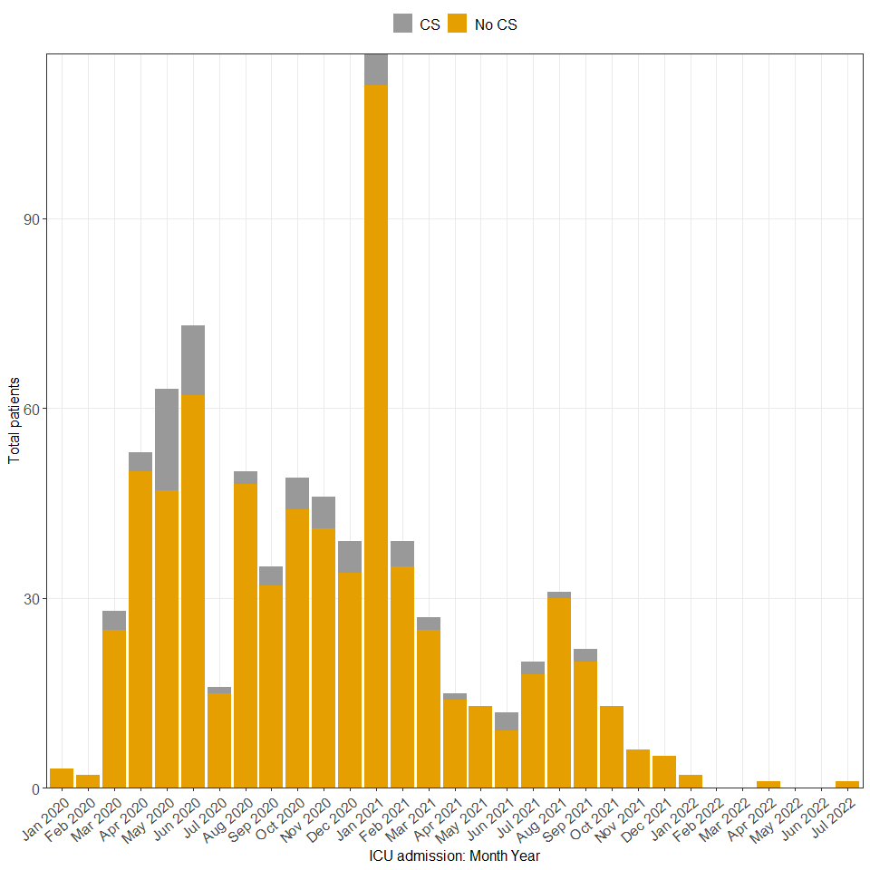

ICU admissions and CS cases were primarily observed between 2020 and July 2021. Over the study period, ICU admissions gradually declined, and no new CS cases were recorded after October 2021. This trend aligns with real-world clinical practice, suggesting that severe COVID-19 cases accompanied by CS were particularly notable during the earlier phase of the pandemic. ICU, intensive care unit; CS, cardiogenic shock.

Supplementary Figure 2. Cause of Death in Patients with Cardiogenic Shock
The bar graph depicts the causes of death in patients with CS, including only in-hospital deaths. In 4 cases (8.8%), the cause of death was not specified in the case report forms (‘unknown’). Multiorgan failure was the most common cause, followed by cardiac death and respiratory death. Septic shock and hemorrhagic shock contributed to mortality but had the lowest prevalence.
CS, cardiogenic shock.

