Supplementary Information for
Light-Perception-Based Interactive Control of an Underwater Digital Twin Hand
Jinlong Lu^{1,2†}, Chao Zhang^{3,1†}, Hengchang Nong^{1,2†}, Dongying Wang^{4†}, Hongyu Zhou^{5,1}, Junjie Weng⁶, Yuehua Deng^{1,7}, Yang Yu^{1*}, Qiang Bian⁴, Jianfa Zhang⁸, Chaofan Zhang⁹, Zhenrong Zhang², Junbo Yang¹
¹College of Science, National University of Defense Technology, Changsha 410073, China
²Key Laboratory of Multimedia Communication and Network Technology in Guangxi, School of Computer, Electronics and Information, Guangxi University, Nanning 530004, China
³School of Automation, Central South University, Changsha, 410075, China
⁴College of Meteorology and Oceanography, National University of Defense Technology, Changsha 410073, China
⁵School of Optical and Electronic Information, National Engineering Research Center of Next Generation Internet Access-system, Huazhong University of Science and Technology, Wuhan 430074, China
⁶College of Intelligence Science and Technology, National University of Defense Technology, Changsha 410073, China
⁷School of Physics, Central South University, Changsha 410083, China
⁸Hunan Provincial Key Laboratory of Novel Nano-Optoelectronic, Information Materials and Devices, National University of Defense Technology, Changsha 410073, China
⁹College of Advanced Interdisciplinary Studies, National University of Defense Technology, Changsha 410073, China
*Corresponding authors: Yang Yu (e-mail:yuyang08a@nudt.edu.cn; Telephone number:18670013227);
These authors contributed equally: Jinlong Lu, Chao Zhang, Hengchang Nong, Dongying Wang;
Jinlong Lu, Chao Zhang, Hengchang Nong, Dongying Wang, Hongyu Zhou, Junjie Weng, Yuehua Deng, Qiang Bian, Jianfa Zhang, Chaofan Zhang, Zhenrong Zhang, Junbo Yang(e-mail: lujinlong@st.gxu.edu.cn; zhangchao08113@163.com; nongnong182@163.com; wdy2434@foxmail.com; zhouhongyu0525@163.com; junjie.weng@qq.com; dengyuehua22@qq.com; qiang.bian@nudt.edu.cn; jfzhang85@nudt.edu.cn; c.zhang@nudt.edu.cn; zzr76@gxu.edu.cn; yangjunbo@nudt.edu.cn;

The PDF file includes:
Supplementary Note 1: Fabrication Process of the BPSM
Supplementary Note 2: Detailed Results of Gesture Recognition
Supplementary Note 3: Pneumatic Control System
Supplementary Note 4: Posture Monitoring
Supplementary Note 5: Control Strategy Optimization Based on Reinforcement Learning
Supplementary Note 1: Fabrication Process of the BPSM
The fabrication of the pneumatic actuators for the BPSM follows a stepwise casting and molding approach that supports the integration of multi-material and multilayer structures.
As shown in Supplementary Fig. 1a, the three-channel reinforced pneumatic chamber for the soft arm is fabricated through the following procedure:
Step 1: Inner cavity molding. Components A and B of Dragon Skin 10 silicone are mixed thoroughly, degassed, and poured into a pre-designed mold to form an inner cavity with three parallel channels. The mold is left at room temperature until the silicone cures completely.
Step 2: Fiber reinforcement winding. After curing, the outer surface of the inner cavity is wrapped with cotton thread (diameter: 0.5 mm) in a cross-helical pattern. This configuration minimizes unwanted torsion during bending and improves the mechanical stability of the actuator.
Step 3: Outer encapsulation layer casting. Ecoflex 00-30 silicone is cast over the fiber-wrapped inner structure to form an outer encapsulation layer. This layer reinforces the fiber mesh and enhances the bonding between the fibers and the inner cavity.
Step 4: End sealing of the pneumatic chamber. Both ends of the chamber are sealed using silicone with a Shore hardness of 40A. An inlet port is reserved at the top for pneumatic connection. The end caps not only ensure airtight sealing but also provide mechanical support for the integration of the soft arm.
Fabrication of the three-joint and two-joint pneumatic actuators (Supplementary Fig. 1b, c) was performed through six steps:
Step 1: Inner cavity formation. Parts A and B of Dragon Skin 10 silicone were mixed, degassed, and cast into a predesigned mold. The material cured at room temperature to form an elastic, airtight inner chamber.
Step 2: Fiber reinforcement. A cross-helical layer of cotton thread (diameter: 0.5 mm) was wound around the cured inner cavity. This fiber layer restricted unwanted torsion during actuation.
Step 3: Unidirectional constraint layer. A cotton fabric strip was bonded to the underside of the fiber layer using Dragon Skin 10. This layer constrained bending to a single direction.
Step 4: Semi-rigid constraint segment. A segment made of thermoplastic polyurethane (TPU) was assembled onto the structure. Grooved arc-shaped notches were embedded at joint regions to define flexible bending zones that mimic anatomical finger joints.
Step 5: Outer encapsulation. Ecoflex 00-30 silicone was applied to encapsulate the entire actuator, enhancing structural integrity and improving its external appearance.
Step 6: Base sealing. The actuator base was sealed using silicone with a Shore hardness of 40A. A small opening was reserved for the insertion of pneumatic tubing.
Fabrication of the thumb adduction actuator (Supplementary Fig. 1d) was completed in five steps:
Step 1: Inner cavity formation. Degassed Dragon Skin 10 silicone was poured into a predesigned mold and cured at room temperature to form the inner chamber.
Step 2: Fiber reinforcement. A cotton thread (diameter: 0.5 mm) was helically wound around the cured chamber to create a fiber-reinforcement layer.
Step 3: Semi-rigid constraint layer. A thermoplastic polyurethane (TPU) segment was mounted on the outer surface of the fiber layer. This segment included an arc-shaped notch that mimicked a biological joint and guided the actuator to bend at a predefined location under pneumatic input, replicating thumb adduction.
Step 4: Outer encapsulation. The assembled component was placed into an outer mold and cast with Ecoflex 00-30 silicone to form the encapsulation layer.
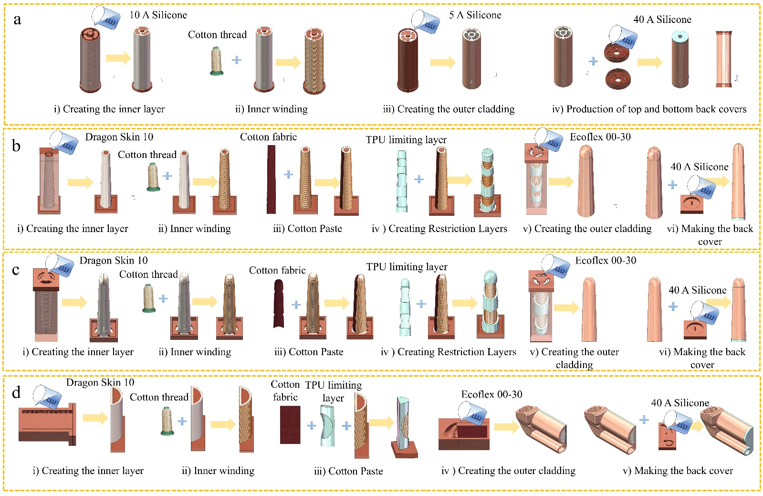
Step 5: Base sealing. The actuator base was sealed with silicone to ensure airtightness and complete the thumb adduction structure.
Supplementary Fig. 1 | Fabrication process of actuators for the BPSM. a, Stepwise fabrication of a three-channel reinforced pneumatic chamber. b, Assembly process of the three-joint pneumatic actuator. c, Fabrication steps of the two-joint pneumatic actuator. d, Construction process of the thumb adduction actuator.
Supplementary Note 2: Detailed Results of Gesture Recognition
To evaluate the discrepancy between model predictions and ground truth, the Sparse Categorical Cross Entropy (SCCE) loss function was employed during training. Model optimization was performed using the Adam optimizer with an initial learning rate of 0.001. The batch size was set to 32, and training was conducted over 100 epochs. The dataset was randomly shuffled and split into training and validation sets in an 8:2 ratio. Details of the training environment are provided in Supplementary Table 1.
Supplementary Table 1 | Performance Comparison of Model Validation Set under Single Sensor
Development environment
Instruction set | X86
CPU | Intel i9-14900K
Memory (RAM) | 128GB
GPU | NVIDIA RTX 4090
Operating System | Ubuntu 22.04
To enable a comprehensive comparison of the baseline models' performance in extracting features from FBG signals, we conducted a series of experiments using data collected from a single thumb-mounted sensor. Several representative models were evaluated, including a Recurrent Neural Network (RNN), Fully Connected Neural Network (FCNN), Long Short-Term Memory (LSTM), Gated Recurrent Unit (GRU), and Temporal Convolutional Network (TCN). Performance was assessed across multiple metrics, including model complexity (number of parameters), inference time per step, classification accuracy, F1 score, and the area under the receiver operating characteristic curve.
Accuracy is one of the most intuitive evaluation metrics, representing the proportion of correctly predicted samples to the total number of samples. It is formally defined as:
$\text{Accuracy} =\frac{TP+TN}{TP+TN+FP+FN}$.
Here, TP, TN, FP, and FN denote True Positives, True Negatives, False Positives, and False Negatives, respectively. While accuracy is a useful and intuitive metric under balanced class distributions, it may provide misleading results when the dataset is imbalanced.
The F1 score provides a harmonic mean of precision and recall, thereby offering a more balanced evaluation of model performance under class-imbalanced conditions. It is defined as:
$F1 Score=2×\frac{\text{ Precision }×\text{ Recall }}{\text{ Precision }+\text{ Recall }}$.
Here, Precision = TP / (TP + FP)，Recall = TP / (TP + FN). A higher F1 score indicates that the model maintains a favourable trade-off between recall and precision, achieving both comprehensive coverage of relevant instances and a low false positive rate.
The Area Under the Curve (AUC) measures the model’s ability to distinguish between positive and negative samples, corresponding to the area under the ROC (Receiver Operating Characteristic) curve. AUC values closer to 1.0 indicate stronger classification performance. Compared to accuracy, AUC provides a more comprehensive evaluation of the model’s discriminative capacity across different thresholds, making it especially suitable for tasks in multimodal environments where decision boundaries may be ambiguous.
As shown in Supplementary Table 2, the GRU and TCN models achieved the highest performance across classification metrics, with accuracy reaching 0.9844, F1 scores of 0.9844 (GRU) and 0.9843 (TCN), and an AUC of 0.9906. These values substantially exceeded those of the conventional RNN (accuracy: 0.7383) and FCNN (accuracy: 0.9297), demonstrating the superior capability of GRU and TCN architectures in temporal feature extraction and sequence classification. In terms of inference speed, the FCNN model was the fastest due to its non-sequential structure. The TCN also showed high efficiency, with a per-step runtime of 6 ms. In contrast, the RNN and LSTM models required 80 ms and 21 ms, respectively, indicating lower inference efficiency.
The results reveal notable differences in recognition accuracy and inference time across models on the validation set. Considering both performance and computational efficiency, we selected the TCN as the baseline architecture. This model was subsequently refined and employed for extracting temporal features from the Bragg wavelength signals of the FBG.
Supplementary Table 2 | Performance Comparison of Multiple Model Validation Sets for Single Sensor Training
Model | Parameters | Time/step | Accuracy | F1 Score | AUC
RNN | 132K | 80ms | 0.7383 | 0.7045 | 0.8427
FCNN | 1,041K | 2ms | 0.9297 | 0.9307 | 0.9579
LSTM | 530K | 21ms | 0.9297 | 0.9292 | 0.9577
GRU | 399K | 17ms | 0.9844 | 0.9844 | 0.9906
TCN | 228K | 6ms | 0.9844 | 0.9843 | 0.9906
Supplementary Note 3: Pneumatic Control System
The proposed BPSM is pneumatically actuated, with bending of different segments controlled by adjusting the internal pressure of the pneumatic actuators. A 12-channel pneumatic control system based on Proportional–Integral–Derivative (PID) closed-loop feedback was developed to achieve accurate modulation of both positive and negative pressure. As shown in Supplementary Fig. 2a, the system hardware includes a control board, power module, motor driver module, pressure sensors, MOSFET switch board, two-way solenoid valves, an air pump, and a vacuum pump. The prototype provides twelve pneumatic channels and supports expansion for broader deployment in soft robotic applications.
Supplementary Fig. 2b shows the pneumatic components in a single channel. The host computer communicates with the control board via a serial interface to send pressure target commands. The power module supplies energy to all system modules. The motor driver controls the air pump and vacuum pump. The air pump connects to the inlet to provide positive pressure. The vacuum pump connects to the outlet to generate negative pressure. Pressure sensors monitor the channel in real time and provide feedback for control. The control board processes sensor data and sends signals to the solenoid valves. Each channel has two two-way solenoid valves—one for positive and one for negative pressure. These are used to switch among pressurization, holding, and exhaust states. The MOSFET switch board serves as the driver interface for the valves and executes switching actions based on control signals.
To enable precise pneumatic control of the BPSM, a closed-loop feedback control strategy based on the PID algorithm was implemented. The PID algorithm is a widely adopted method in industrial control systems. It adjusts the actuator response by evaluating the real-time error and its rate of change, allowing the system output to track the target pressure accurately. This feedback mechanism ensures stable and responsive modulation of the pneumatic actuators, which is critical for achieving fine manipulation and consistent motion in soft robotic applications.
As illustrated in Supplementary Fig. 2c, the control flow of the pneumatic regulation program is described as follows. The host computer initiates the process by sending pressure-setting commands, where each pneumatic channel is identified by an uppercase letter (A, B, C... I). These commands are transmitted to the control board via serial communication. The control board decodes the received instructions to obtain the target pressure $P_{tar}i$ for each channel i =1,2,…,12. The system then compares the target pressure $P_{tar}i$ with the real-time measured pressure $P_{cur}i$ (t) from the pressure sensor to compute the instantaneous pressure error $e_{t}^{i}$ . A PID control algorithm processes this error along with its historical accumulation and rate of change to determine the solenoid valve actuation time $T_{t}^{i}$ .Based on $T_{t}^{i}$ , the controller adjusts the on/off duration of either the positive or negative pressure solenoid valve, enabling precise regulation of pneumatic pressure in each channel. The value of $T_{t}^{i}$ is computed according to the standard PID formula:
$T_{t}^{i}=K_{p}e_{t}^{i}+K_{i}Σe_{t}^{i}+K_{d}Δe_{t}^{i}$.
Here, $K_{p}$ , $K_{i}$ , and $K_{d}$ denote the proportional, integral, and derivative gains, respectively. These parameters must be tuned according to the dynamic response characteristics of the system to achieve optimal control performance. In this design, the PID parameters were optimized by analyzing the system's response to a step input and adjusting the coefficients based on the resulting waveform. Each pneumatic channel is configured with a distinct set of PID coefficients to accommodate the varying dynamic properties of the corresponding actuators. The pressure error $e_{t}^{i}$ at time 𝑡 is defined as the difference between the target and actual pressure values; the integral term $Σe_{t}^{i}$ represents the accumulated error over time; and the derivative term $Δe_{t}^{i}$ reflects the rate of change of the error. These quantities are computed as follows:
$e_{t}^{i}=P_{tar}i-P_{cur}i$,
$Σe_{t}^{i}=\sum_{j=0}^{t}{e_{t}^{i}}$,
$Δe_{t}^{i}=\frac{e_{t}^{i}-e_{t-1}^{i}}{∆t}$.
After computing $T_{t}^{i}$, a correction mechanism is applied based on the magnitude of the current pressure error $e_{t}^{i}$. If the error falls within an acceptable range (${|e}_{t}^{i}|≤2$), the system considers the pneumatic channel to be stable, and $T_{t}^{i}$ is set to zero, placing the actuator in a holding state. Only when the error exceeds the predefined tolerance does the control system initiate dynamic adjustment of the valve opening duration. To prevent overshoot and ensure the overall stability and safety of the control system, a saturation limit is imposed on $T_{t}^{i}$. This constraint ensures that control actions remain within operational boundaries. Moreover, to guarantee the correct operation of the miniature solenoid valves, a minimum opening time is enforced: the valves require a minimum activation time of 8 ms to fully open. The miniature solenoid valve requires a minimum fully open duration of 8 ms to operate correctly. If the control signal falls below this threshold, the valve may fail to actuate reliably. Therefore, the control output $T_{t}^{i}$ is constrained by the following lower-bound condition:
$$T_{t}^{i}=\left\{\begin{aligned}8,if e_{t}^{i}>0&&\text{&&} T_{t}^{i}<8, \\ -8,if e_{t}^{i}<0&& \text{&&} T_{t}^{i}>-8.\end{aligned}\right.$$
Subsequently, the control system evaluates the value of $T_{t}^{i}$ . If $T_{t}^{i}$>0, the positive-pressure solenoid valve is opened and the compressor is activated to initiate the inflation process. Conversely, if $T_{t}^{i}$ <0, the system opens the negative pressure solenoid valve and activates the vacuum pump to enter the deflation mode. These control steps are executed iteratively until the pressure in all channels stabilizes within their respective target ranges. 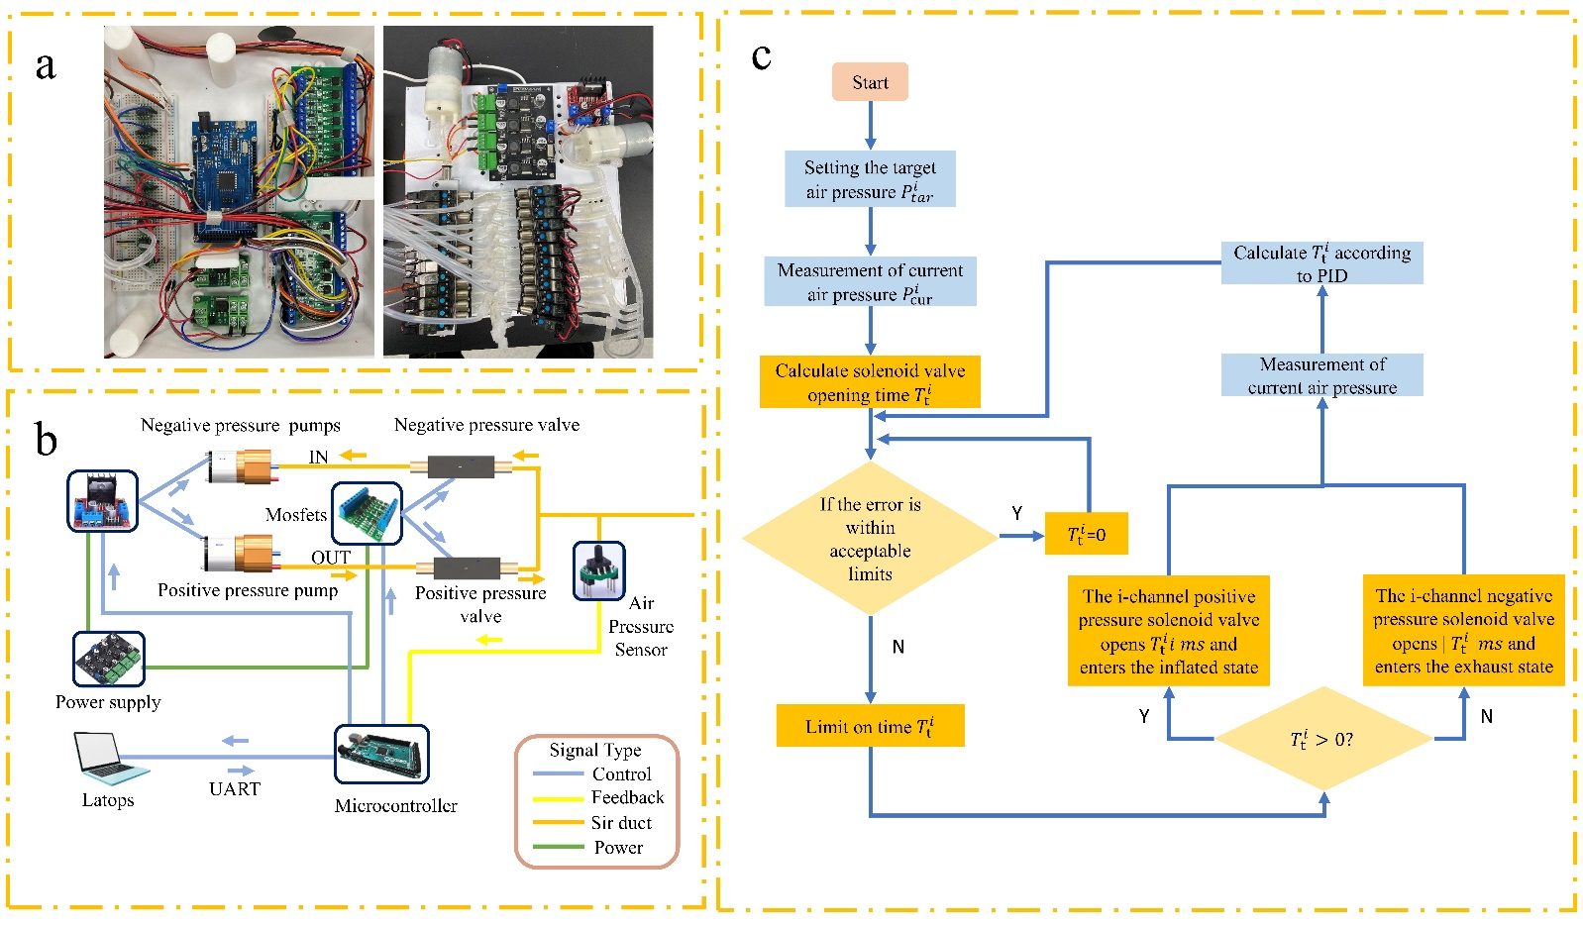
Supplementary Fig. 2 | Pneumatic control system. a, Physical layout of the pneumatic control system. b, Pneumatic components in a single-channel control branch. c, Flowchart of the closed-loop feedback control process for pneumatic regulation.
Supplementary Note 4: Posture Monitoring
As shown in Supplementary Fig. 3, we conducted interaction validation of the entire LP-UDTHS using a human hand and the index and middle fingers of the BPSM, both equipped with the FBG-SenseGlove. Real-time FBG response data transmitted during the motion control process can be clearly observed.
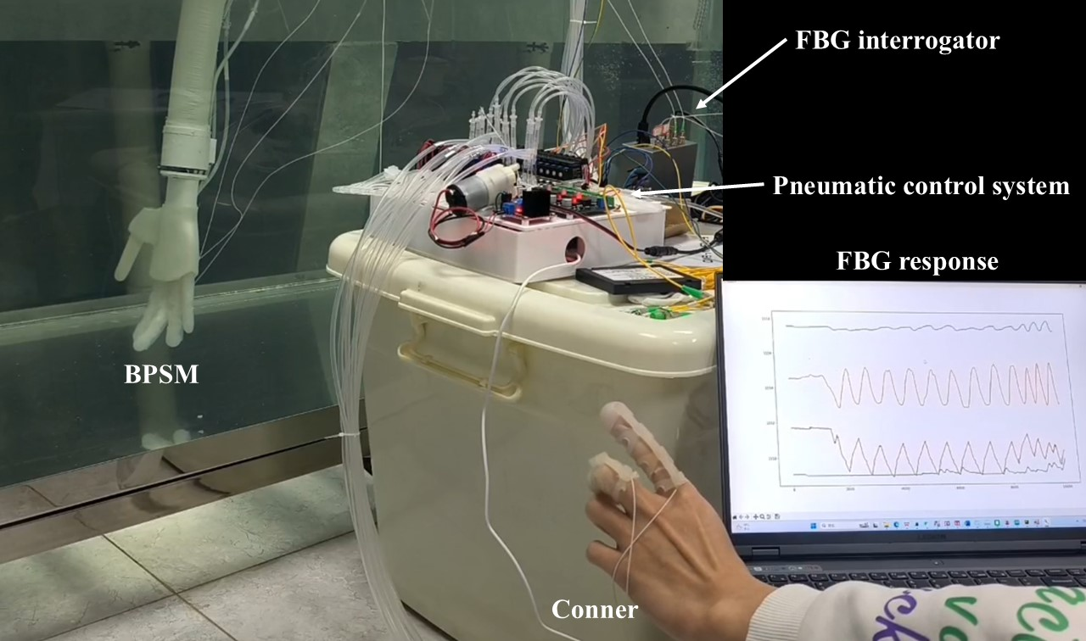
Supplementary Fig. 3 | Underwater interaction test of the BPSM.
Supplementary Note 5: Control Strategy Optimization Based on Reinforcement Learning
Simulation environment setup. In the optimization study of robotic arm control strategies, the flexible pneumatic hand was modeled in SolidWorks and converted into a Unified Robot Description Format (URDF) model. The robotic arm was derived from ROS development files provided by Realman and integrated into a unified system description using URDF, as shown in Supplementary Fig. 4a.
The assembled model includes 23 links and 22 joints, consisting of six revolute joints (joint1 to joint6) for arm articulation, one fixed joint (joint_hand) connecting the arm and hand, and five fingers each with three rotational degrees of freedom (joint_1_1 to joint_5_3). This forms a complete system comprising a six-DOF arm and a fifteen-DOF soft hand. All joints are revolute with clearly defined motion ranges and physical constraints. The bending limits of the robotic arm joints were configured to match the physical prototype, and the rotational limits of the finger joints were set to approximately 0–45°, consistent with the compliance of the soft materials. These constraints ensure physical plausibility and dynamic stability during simulation.
To ensure consistency between the simulation system and the physical device, a high-fidelity dynamic simulation environment was constructed using the PyBullet platform. The URDF model was loaded through the loadURDF() interface, as shown in Supplementary Fig. 4b. Each link in the URDF was explicitly defined with its physical parameters, including mass, inertia matrix, and collision geometry. For example, the base link of the robotic arm (base_link) was assigned a mass of 0.84108 kg, with principal moments of inertia of 1.726×10⁻³, 1.710×10⁻³, and 9.040×10⁻⁴ kg·m². Collision geometries were modeled using simplified primitives or mesh approximations to balance simulation fidelity and computational efficiency. The initial friction coefficient for revolute joints was set to 0.3 and allowed to vary dynamically during simulation to adapt to different contact conditions, such as sliding or pulling. Damping coefficients were calibrated based on technical specifications to ensure that joint dynamic response errors remained within 3% during operation.
To meet the perceptual demands of interactive tasks, the simulation environment was enhanced with multimodal sensor emulation. RGB images at a resolution of 640×480 were generated using PyBullet and processed through OpenCV to establish the visual input channel for object recognition. Joint angles were retrieved in real time using the getJointState() interface for motion state estimation and control input. Contact force data from the soft hand were monitored using the getContactPoints() interface, with a contact threshold of 10 N configured to simulate a realistic force-feedback safety interrupt.
To improve policy robustness, dynamic external perturbations were introduced during training. Impulsive forces of 5 N were applied to the arm’s end-effector, and friction coefficients were randomly varied in tasks involving sliding components, such as drawer rails. These conditions created a high-uncertainty training environment that enhanced the adaptability and stability of the learned control policy in complex physical scenarios. 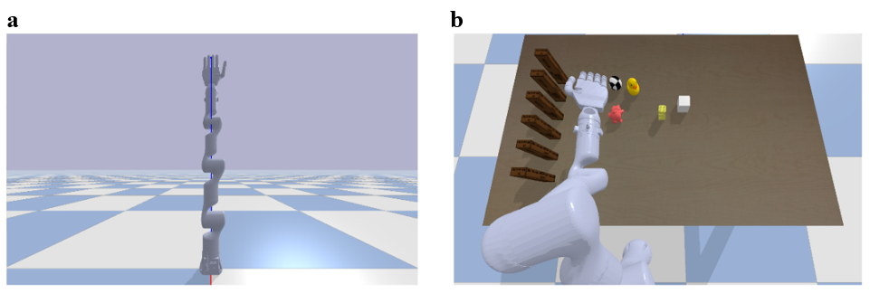
Supplementary Fig.4 | Simulation Environment Setup. a, URDF model integrating the robotic arm and the flexible pneumatic hand. b, Dynamic simulation environment constructed in PyBullet.
Reinforcement learning algorithm design. To address the complexity of coordinated control between the soft pneumatic hand and the robotic arm, we developed a reinforcement learning algorithm based on the Deep Deterministic Policy Gradient (DDPG) framework, incorporating several key optimizations to improve learning efficiency and system robustness. The network adopts a decoupled Actor–Critic architecture. The Actor network receives a state vector comprising joint angles from the robotic arm, the pose of the soft end-effector, and the finger joint positions, and outputs continuous control actions. The Critic network combines these actions with visual features to estimate Q-values, thereby improving the accuracy and stability of policy evaluation.
To improve the efficiency of training sample utilization, the experience replay mechanism employs a temporal-difference (TD) error-driven prioritized sampling strategy, enabling dynamic adjustment of sample selection probabilities and significantly increasing the usage of high-value transitions. For exploration, a time-varying noise process based on the Ornstein–Uhlenbeck model is incorporated, with an initial noise amplitude of 0.15 that decays by 10% every 1,000 steps, facilitating a balanced trade-off between exploration and exploitation over the course of training. In addition, state space design, reward function, and domain randomization collectively enhances learning efficiency and bolsters the policy’s robustness and transferability from simulation to real-world scenarios.
(1)State space design. A reasonable definition of the state space forms the foundation for efficient training and successful sim-to-real transfer in reinforcement learning. In this study, the state vector is constructed solely from information directly obtainable by onboard sensors. By intentionally avoiding variables that depend on external perception or inference, the design minimizes perceptual discrepancies between simulation and the real world.
Proprioception, comprising core information from both the joint level and the soft end-effector, is defined as follows:
$s_{p}=\left[q_{m},p_{ee},θ_{ee},q_{fingers},a_{t-1}\right]$.
It includes the flexion angles of all 22 joints—6 from the robotic arm and 15 from the soft hand—denoted as
$q_{m}∈R^{22}$, the end-effector position $p_{ee}∈R^{3}$, its orientation $θ_{ee}∈R^{3}$, and the flexion angles of the five individual fingers $q_{fingers}∈R^{5}$. To promote action continuity and improve policy stability, the action command executed in the previous timestep $a_{t-1}∈R^{22}$ is also included in the state vector as historical context.
The Goal State (Goal State)is derived from a digital twin system comprising FBG-SenseGlove, inertial measurement units (IMUs), and RGB cameras, with their outputs faithfully emulated within the PyBullet simulation environment. It is defined as follows:
$s_{g}=\left[p_{ee}^{g},θ_{ee}^{g},q_{fingers}^{g}\right]$.
It comprises the position of the soft robotic end-effector $p_{ee}^{g}∈R^{3}$, its orientation $θ_{ee}^{g}∈R^{3}$, and the bending angles of each finger $q_{fingers}^{g}∈R^{5}$.
All state variables are normalized prior to being fed into the network, ensuring that features with different physical units are distributed within a consistent numerical range. This normalization facilitates faster convergence and improved stability during training. Through this design, the defined state space preserves the most critical dynamic information required for robotic motion control, while maintaining strict consistency between the simulation and real-world environments. This provides a robust foundation for subsequent policy learning and sim-to-real transfer.
(2) Reward Design. To meet the demands of high-precision manipulation tasks, we developed a composite reward function based on pose and soft-finger joint angle errors, guiding the policy to progressively converge toward the desired goal state during training. The reward is composed of three terms: the end-effector position error, end-effector orientation error, and the soft finger joint angle error, each modeled using an exponential decay function. The position term encourages the end-effector to approach the target location, the orientation term promotes alignment accuracy during grasping, and the joint angle term enhances control over the soft hand’s grasping posture. These components are assigned distinct weights to provide tailored guidance across different training phases. The specific formulation and weighting scheme are detailed in Supplementary Table 3.
Supplementary Table 3 | Details of Reward Function Design
Term | Expression | Weight
Position | $$exp⁡(-0.5∥p_{ee}-p_{ee}^{g}∥_{2})$$ | $$4e^{ }$$
orientation | $exp⁡(-0.25∥θ_{ee}-θ_{ee}^{g}∥_{2}$) | 2.4$e^{ }$
Finger angles | $$exp⁡(-0.25-∥q_{fingers}-q_{fingers}^{g}∥_{2})$$ | 2.4$e^{ }$
To ensure the physical feasibility and operational safety of the learned control strategy, a set of negative reward terms were incorporated into the overall reward structure as constraints. These terms penalize physically implausible behaviours and include penalties for soft hand configurations exceeding workspace limits, joint limit violations, and excessive joint torques. As summarized in Supplementary Table 4, each term is designed to suppress unstable or overly aggressive motions during training, guiding the policy towards safe and executable actions. By integrating these penalty terms with the main task rewards, the final reward function balances convergence efficiency with physical realizability, providing a robust foundation for reinforcement learning in flexible manipulation tasks.
Supplementary Table 4 | Penalty design details
Term | Expression | Weight
Out-of-bound soft hand | $$∥p_{ee}∥_{2}>610 \text{mm}$$ | -2$e^{2}$
Joint limit violation | $$q_{t}∉\left[q_{min},q_{max}\right]$$ | -1$e^{2}$
Torque limit violation | $$τ_{t}∉\left[τ_{min},τ_{max}\right]$$ | -2$e^{-1}$
(3) Domain randomization. To improve the generalization performance of the learned policy in real-world scenarios, systematic domain randomization was introduced during simulation training. For physical parameters, joint friction coefficients were randomly varied within the range of 0.2 to 1.1, link masses were perturbed within 70% to 130% of their nominal values, and the proportional and derivative (P and D) gains of the joint-level PD controllers were dynamically adjusted within 75% to 125% of their default values. To simulate communication uncertainty commonly encountered in physical systems, a random delay between 20 ms and 60 ms was applied during control signal transmission.In terms of environmental perturbations, external forces were applied every 5 seconds, with random directions and a fixed speed of 0.5 m/s, simulating external disturbances and enhancing the policy’s adaptability to varied operational environments.
Experimental results. This study systematically compares the motion accuracy and dynamic performance of three control strategies—conventional PID control, model predictive control (MPC), and the proposed deep deterministic policy gradient (DDPG) reinforcement learning algorithm—under complex task execution scenarios. To quantitatively evaluate the precision and responsiveness of each control method, we define three core error metrics:
(1) Positional error ($E_{pos}$): The positional error quantifies the average Euclidean distance between the actual position of the soft robotic end-effector $p_{ee}^{t}$ and the target position $p_{ee}^{g}$ , and is defined as follows:
$E_{pos}=\frac{1}{T}\sum_{t=1}^{T}{ }{∥p_{ee}^{t}-p_{ee}^{g}∥}_{2}$.
where 𝑇 denotes the total number of time frames, and the error is measured in millimetres (mm). A lower value of $E_{pos}$ indicates a higher spatial tracking accuracy of the controller.
(2) Acceleration error ($E_{acc}$): quantifies the mean squared deviation between the actual end-effector acceleration $a_{ee}^{t}$ and the desired acceleration $a_{ee}^{g}$, and is defined as:
$E_{acc}=\frac{1}{T}\sum_{t=1}^{T}{ }{∥a_{ee}^{t}-a_{ee}^{g}∥}_{2}$.
The unit is mm/frame². A lower value of $E_{acc}$ indicates smoother motion of the robotic hand, with reduced vibrations and impact forces, which is critical for the execution of precision tasks.
(3) Velocity error ($E_{vel}$): quantifies the deviation between the actual end-effector velocity $v_{ee}^{t}$ and the target velocity $v_{ee}^{g}$, and is defined as follows:
$E_{vel}=\frac{1}{T}\sum_{t=1}^{T}{ }{∥v_{ee}^{t}-v_{ee}^{g}∥}_{2}$.
The unit is mm/frame. A lower velocity error indicates reduced latency and overshoot in dynamic response, reflecting higher control fidelity and smoother execution.
Supplementary Table 5 presents a comparative analysis of the three control strategies across the key performance metrics. The DDPG-based controller achieved the lowest errors in position, velocity, and acceleration, indicating superior tracking accuracy and smoother dynamic behavior relative to both the PID and MPC methods.
Supplementary Table 5 | Comparison of control errors under complex manipulation tasks across different methods
Methods | E_{pos}(mm) | E_{acc}(mm/frame²) | E_{vel}(mm/frame)
PID | 14.8 | 21.4 | 18.2
MPC | 11.5 | 17.9 | 14.7
DDPG | 9.4 | 12.5 | 10.1
The system’s robustness under external disturbances was also evaluated. Compared to the PID controller, the DDPG-based method showed a significantly lower drop in task success rate, with only a 7% reduction under perturbation, whereas the PID controller exhibited a 32% decrease. In terms of recovery time, the improved algorithm achieved a faster response of 0.7 seconds, outperforming both PID and MPC methods, further demonstrating its stability in complex environments. Regarding sim-to-real transfer performance, the success rate difference between simulation and physical deployment was limited to 4.8%, indicating a highly effective model transfer and strong generalization ability. Under communication delay conditions, the algorithm maintained an 80% success rate even with a latency of up to 200 ms, highlighting its robustness against timing uncertainties.

