Critical evaluation of the agronomic effectiveness of recovered phosphate fertilizer produced from incinerated sewage sludge ash

List of Appendix:

Text S1 Processes for RPFs production
Text S2 Pot experiment process
Fig. S1 Leaf number of choy sum during the cultivation. The data are the averages of six replicates ± SE.
Fig. S2 The maximum length (a) and width (b) of the largest leaf of choy sum during the cultivation. The data are the averages of six replicates ± SE.
Table S1 Legal limited values of different countries’ Fertilizer Ordinances for relevant trace elements (Adam et al., 2009; Imai, 2019; Xu et al., 2012)

Text S1 Processes for RPFs production
BP: Mg-biochar was produced by mixing of MgCl2·6H2O with sugarcane biomass to 20% and soaking for 1 h by adding DI water and oven-dried at 105 ºC. This modified biomass was pyrolyzed at 700 ºC for 1 h in an inert N₂ atmosphere. The produced biochar was denoted as Mg-biochar and used to adsorb P from acid-extract of ISSA. This acid-extract of ISSA was produced by leaching of ISSA by 0.2 M H₂SO₄ and filtrated through 0.45 μm filter. Finally, by centrifugation and filtration, the recovered biochar was P-laden and was the BP. The detailed information can be found in our previous study (Fang et al., 2018a).
CaP: The acid-extract of ISSA was produced by a two-step leaching method. Firstly, 20 ml of 0.02 M EDTA was used to pretreating 1 g ISSA by an end-to-end mechanical rotator for 120 min. After that, the filtered pretreated ISSA was oven-dried for next step. Secondly, pretreated ISSA was extracted by 0.2 M H₂SO₄ at 20:1 of liquid to solid ratio for 120 min. Finally, Ca(OH)2 was added to this acid-extract till 4 pH and this recovered precipitate was denoted as CaP. This detailed process can be found in our previous study ( Fang et al., 2018b)
SP: Dried (105 ℃, 24h) ISSA samples were reacted with 0.2 N sulfuric acid with a liquid solid ratio of 20 mL/g in an end-over-end rotator, the speed was 30 rpm and the reaction time was 2 h. The leachate was filtered by 0.45 μm filter and heavy metal free precipitates at pH 3.0 were collected and dried at 55 ℃ for 72 h. Afterwards, the precipitates were re-dissolved in 2.0 N hydrochloric acid with Fe and Al adsorbed by a cation exchange resin to get purified P solution. Finally, P in the purified solution was crystallized as struvite. The detailed information is present in our previous study (Wang et al., 2018).

Text S2 Pot experiment process
Hydroponics:
The choy sum, one of the major and most favorable vegetable crops in southern China (Chen et al., 2017), was cultivated in hydroponics using Hoagland’s nutrient solution with P substituted by RPFs under indoor environments for a 30-day period in the laboratory of the Hong Kong Polytechnic University. Because of the frequent cultivation and short growth period for leafy vegetables, fertilizers were applied one time for choy sum growth (Jia et al. 2012). The RPFs and MP were applied at the beginning of the cultivation at a rate of 31 mg P/L, with an unfertilized blank control (BC) as a reference. Each treatment was conducted in triplicate.
To be specific, firstly the seeds of the choy sum were disinfected using 95% ethanol and germinated on moistened filter paper in the dark at 22 ºC. After a 7-day germination period, two seedlings of uniform growth were selected and transferred into pots (height:11 cm, bottom 10 cm and mouth 12 cm) containing 500 mL Hoagland’s nutrient solution with P from RPFs and MP. The water level was recorded at the beginning and the nutrient solution without P was provided once every 2~3 days according to the water level. And the group name of the pots was based on the applied fertilizer.
Soil cultivation:
Ryegrass used in this experiment is a kind of hardy grass. To simulate the field pot situations, round plastic pots with a diameter of 27 cm and a depth of 20 cm were used. Prior to sowing, the seeds of the ryegrass were sterilized with 95% ethanol for half of an hour and soaked in deionized water for 3 hours. The sowing was carried out by spreading 20 g of urea evenly into the prepared 1.5 kg sieved soil followed by covering with 1 kg of the sieved soil. (This soil was sampled from the campus of the Southern University of Science and Technology, Shenzhen, China.) Then P fertilizer was applied separately with the same P content (5 g CP and SP, 10 g BP and 1 g CoP) and then again covered with 0.5 kg sieved soil (the control group, BC group, only covered soil). Finally, an aliquot of sterilized seeds (around 100 grains) was sowed uniformly and carefully and covered with another 0.5 kg of the sieved soil. During the cultivation, distilled water was added to each pot once every two days. The effect of RPFs on growing of ryegrass was compared with the CoP group and the BC group. The experiment of each group was conducted in triplicate. These five of experiments were separately and synchronously carried out outdoor under natural sunshine conditions over 40 day in the campus of the Southern University of Science and Technology.

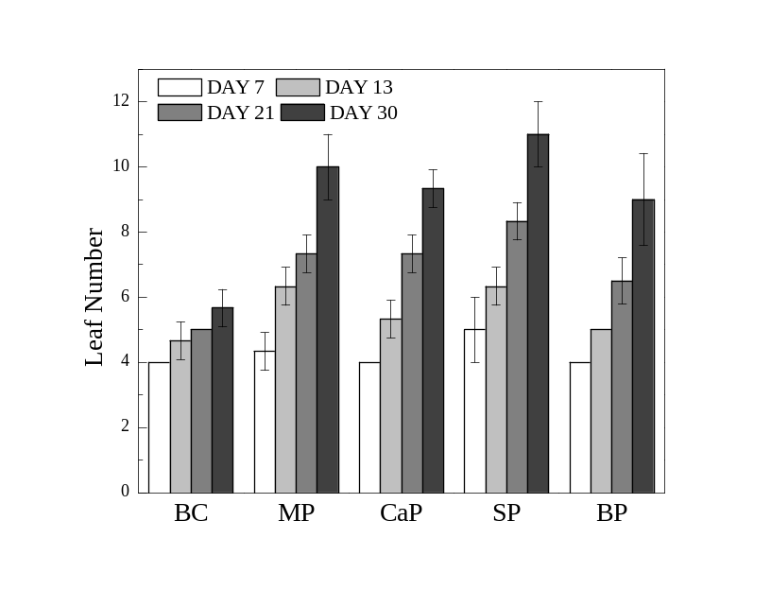
Fig. S1 Leaf number of choy sum during the cultivation. The data are the averages of six replicates ± SE.

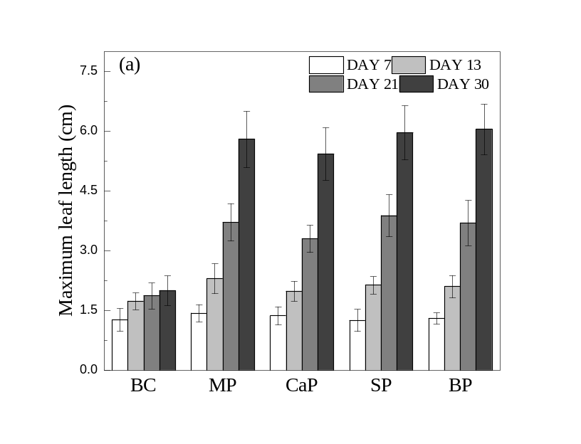
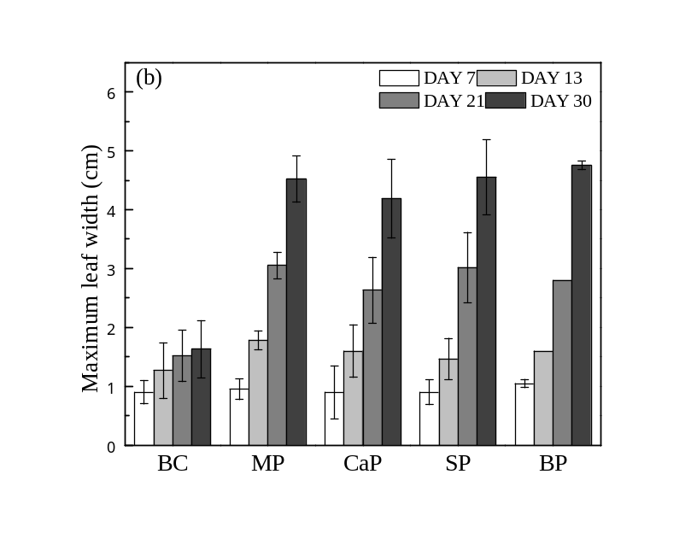
Fig. S2 The maximum length (a) and width (b) of the largest leaf of choy sum during the cultivation. The data are the averages of six replicates ± SE.

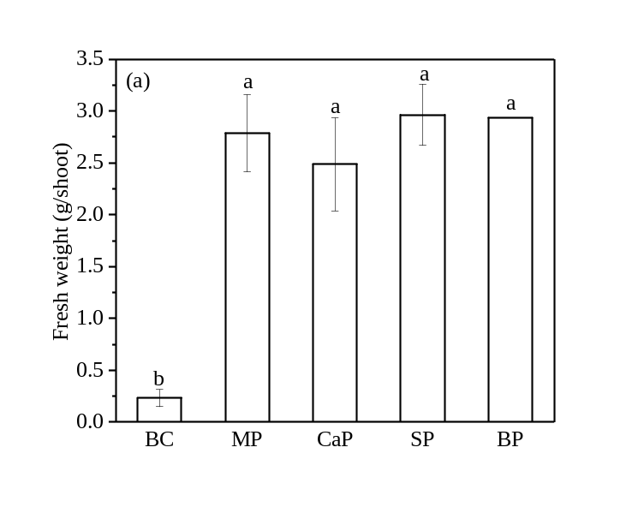
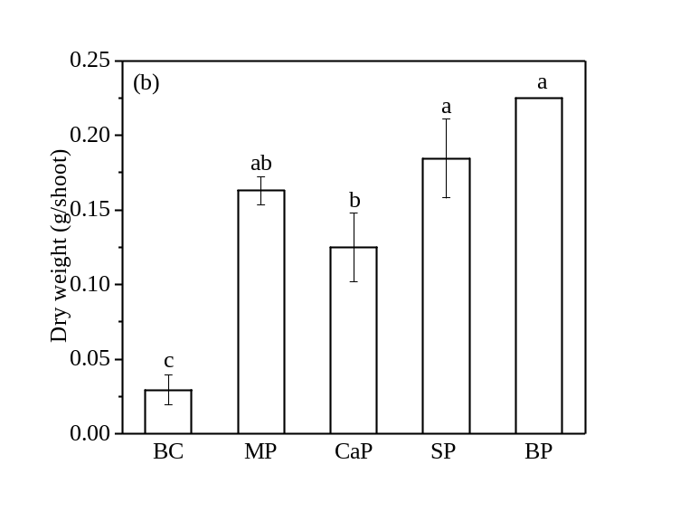
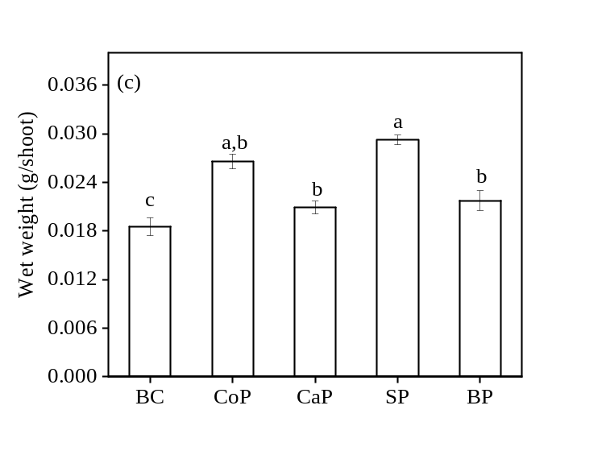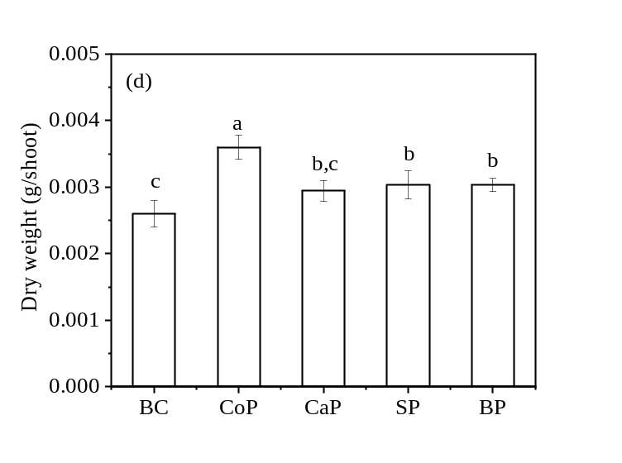
Fig. 3 Fresh weight and dry weight of choy sum shoot (a and b) and ryegrass (c and d).

Table S1 Legal limited values of different countries’ Fertilizer Ordinances for relevant trace elements (Adam et al., 2009; Imai, 2019; Xu et al., 2012)
Trace element | Germany | Australia | China | Switzerland | Turkey | Japan
As (mg/kg) | 40 | - |  |  |  | 50
Cd (mg/kg) | 4 | 15 | 10 | 3 |  | 5
Cr (mg/kg) |  | 667 | 500 | 299 | 270 | 500
Cu (mg/kg) | 70 | 778 | - | 400
Hg (mg/kg) | 1 | 1 | 5 | 3 |  | 2
Ni (mg/kg) | 80 | 100 | - | 50 | 120 | 300
Pb (mg/kg) | 150 | 100 | 150 | 200 |  | 100
Zn (mg/kg) | 1000 | 3333 | - | 1300 | 1100
Co (mg/kg) |  |  |  | 40
Notes: Germany and Australia (Adam et al., 2009)
China, Switzerland and Turkey (Xu et al., 2012)
Japan (Imai, 2019)

