Supporting Information for
Efficient clustering of GNSS stations for processing using double differences
Shane P. Grigsby^{, 2*} and Demián D. Gómez^{2*}
1. Cooperative Institute for Research in Environmental Sciences, University of Colorado, Boulder, CO, USA
2. Division of Geodetic Science, School of Earth Sciences, Ohio State University, Columbus, OH, USA

SG ORCID: https://orcid.org/0000-0003-4904-7785
DG ORCID: https://orcid.org/0000-0002-5276-581X

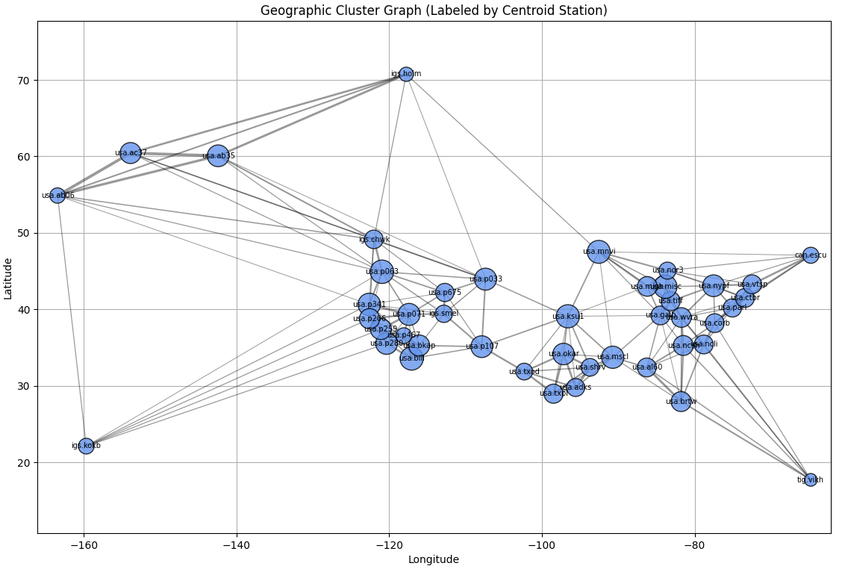
Fig S1. Geographic representation of the clusters and their relative sizes using 40+10. Circle sizes scaled according to the number of stations in each cluster. Clusters labeled using the station closest to the cluster centroid. Thickness of the connections between clusters is proportional to the number of stations connecting each cluster.

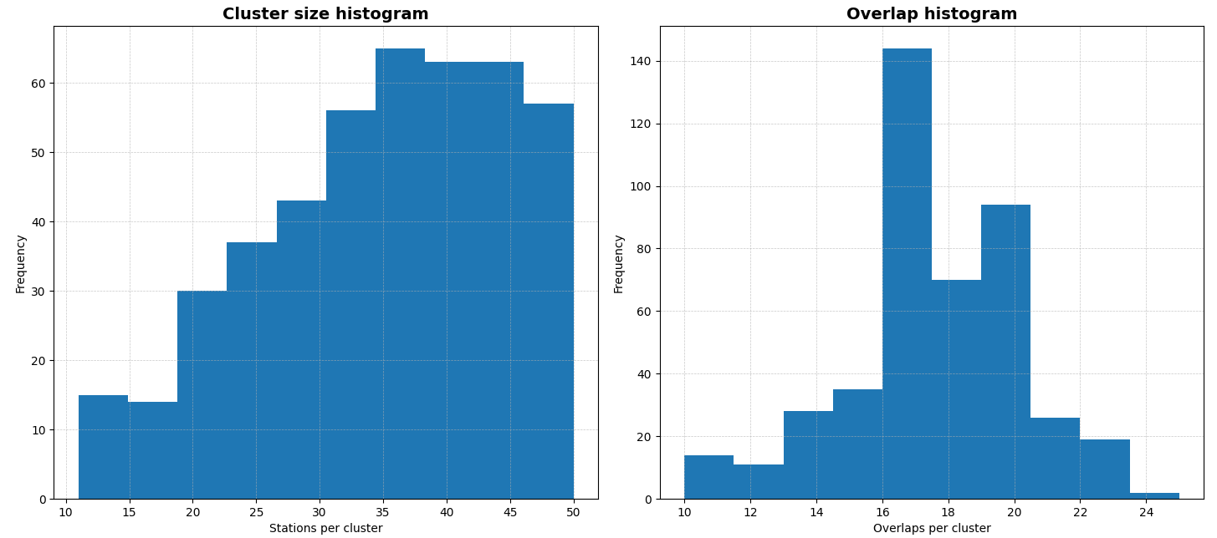
Fig S2. Left: cluster histogram for day 1 of 2008. Right: overlap station histogram for day 1 of 2008.

Network Backbone Formation
To create a backbone network of stations from a larger set of points, we use a Delaunay triangulation to iteratively filter out points that are too close to others (based on the distance threshold, initially set to 5 km). The threshold is doubled on each iteration to relax the filtering process. The result is a subset of stations that forms a sparse network of at least n members (predefined to 45), representing a reduced but well-spaced network of GNSS stations.

*Corresponding author:

