Supplemental Information
Title:
Quality Control of ²²⁵Ac and associated Radiopharmaceuticals: ²²¹Fr to be or not to be?

Authors:
Miguel Toro Gonzalez,¹ Luke Wheeless ¹, Vijai Kumar Reddy Tangadanchu ¹, Cory Hawkins ¹, Shannon Provo ¹, William Smith ¹, Michael Hommen ¹, Dan De Vries ¹, Jim Harvey ¹, Tyler Drum ¹, Diane S. Abou.^{1,2}

Affiliation:
¹ NorthStar Medical Radioisotope., LLC Research and Development, 1800 Gateway Boulevard, Beloit, WI 53511, USA
² Mallinckrodt Institute of Radiology, Washington University School of Medicine in St. Louis, 510 S Kingshighway Blvd, St. Louis, MO 63110, USA

Corresponding Author: Diane S. Abou, PhD; dabou@northstarnm.com

Keywords: ²²⁵Ac quality control, Liquid Scintillation, High Purity Germanium, Gamma well counting, Thin Layer Chromatography, HPLC

Material and Methods
All handling of radioactive substances was performed by trained personnel following ALARA principles using adequate equipment and protection at NorthStar Medical Radioisotopes under an approved license issued by the Wisconsin Department of Health and Services.
All chemicals utilized in this study were purchased at Fisher scientific (USA). ²²⁵Ac-nitrate, supplied by U.S. Department of Energy Isotope Program, was transferred into chloride and characterized with a radionuclidic purity >99.8%. The list of radiolabeled constructs utilized for each experiment are tabulated in Suppl. Info. Table 2A-B. None of the drug preparation described in this manuscript were utilized for patient administration.
- Linearity and limit of quantification
Actinium chloride (²²⁵AcCl₃) was dissolved in 0.1N HCl or DTPA 10 mM (pH 5-6) and split for the preparation of standard solutions. HPGe and dose calibrator defined the exact ²²⁵Ac amounts of dissolved source before each dilution. Standard solutions of ²²⁵Ac were prepared using gravimetric assessments for exact volume transfer. Each standard solution was measured using liquid scintillation counting (LS), high purity germanium (HPGe) and gamma well counting.
Liquid scintillation counting was completed utilizing a Hidex 300 SL, counting each sample 1 min under alpha window setting (pulse length index - PLI 39). ²²⁵Ac solutions were prepared from 2.96 mBq/ µL to 740 Bq/µL (or 0.08 pCi/µL to 20 nCi/µL). A 5 µL aliquot of each standard sample was added to 10 mL of Ultima Gold AB. Samples were mixed gently and stored in the dark for at least 15 min before measuring.
For the linearity check using Instant Thin Layer chromatographic (iTLC) silica-gel (Agilent), strips were cut into 1 cm × 5.5 cm rectangles. Standards were prepared with activity concentration ranging from 37 mBq/ µL (1 pCi/µL) and 1.48 Bq/ µL (40 pCi/µL) and spotted 5 µL. Strips were transferred into a LS vial containing 10 mL of Ultima Gold AB™, ensuring that the ²²⁵Ac spot was immerged in the vial. Samples were mixed gently, stored in the dark for at least 15 minutes. Acquisition was performed for 1 min with a PLI of 39 for alpha/beta discrimination.
HPGe (GEM10P4-70, Ortec®, GFG-ICS-P4 cooler, GammaVision) was first calibrated utilizing a mixed radioisotope standard (Eckert & Ziegler 7500 model) in a 20-mL polyethylene scintillation vial. Serial dilution of ²²⁵Ac solution were dissolved (10 µL) in a vial filled with 20 mL of water. Samples were prepared with activity concentration ranging 1.85 to 498 Bq/µL (0.05 to 13.45 nCi/µL). All were measured 5 min at exact same position directly onto the detector. Net peak areas were retrieved for 218 keV and 440 keV and plotted for linearity.
The TLC strips were prepared as stated above and transferred into a plastic bag and sealed. The sealed strip was secured in a 3D printed holder to ensure consistent position onto the HPGe detector (i.e., spotted activity towards the center of the detector). Samples were acquired 300 s. Net peak area were retrieved at 218 keV and 440 keV and plotted for linearity.
Gamma-well counting was acquired 5 min per sample utilizing three energy windows 195-240 keV for ²²¹Fr (218 keV); 350-530 keV for ²¹³Bi (440 keV) and 15-530 keV for an open range. The ²²⁵Ac samples (0.925 - 37 kBq or 0.025 to 1µCi) were measured in solution (750 µL) straight in a HPLC vial (capacity 1.5 mL). Another linearity was completed using smaller volume (20 µL) in microcentrifuge tube (capacity 1.5 mL). TLC strips were completed in triplicates, spotting 5 µL standard solution in 1×1 cm² strip sealed and placed at the bottom of the gamma counting well. Specimen were measured 60 s utilizing all energy windows described above. Background corrected counts from blank measurements were plotted for linearity.
The linearity for both TLC scanners were evaluated acquiring ²²⁵Ac standard solutions spotted on strips (10 µL) with activity ranging from 37 Bq to 148 kBq (1 nCi to 4 µCi), acquired 30 min for the silica detector; and 7.4 – 29,600 Bq (0.2 - 800 nCi) acquired 1 min for the gas-filled proportional counter at 1,000 V.
The linear regression was plotted for each instrument, verifying R² >0.99 (Supplemental Figure 1&2). From the linear regression, equations were retrieved and enabled the calculation the Limit of Quantification (LOQ) following equation 1, per ICH Q2(R2).
Eq 1. LOQ= 10 × SDy-i/Slope (with SDy-i the standard deviation of the y-intercept).
The later was defined utilizing the lowest 5 activity amounts / counts of the linear regression and calculated using the LINEST function.
- RCP% evaluation TLC and HPLC
A DOTA-conjugated chemical precursor of choice peptide or monoclonal antibody (Suppl. Info Table 2) was radiolabeled using ²²⁵Ac suspended in HCl (0.1N). To eliminate ²¹³Bi-radiolabled product interference, the drug samples were evaluated > 5 h post synthesis. Radiochemical purity (RCP%) was evaluated using either using TLC or HPLC methods.
TLC were migrated using citric acid (50 mM pH5) or EDTA (10 mM pH5). The developed strips were measured intact 30 min or > 5 hr post-development using TLC scanners equipped with a gas-filled proportional counter or a silicon detector. The gas-filled proportional counter (AR-2000 Eckert&Ziegler, connected with a P-10 methane/argon gas tank) acquisitions were acquired 1 min per strip using either 1,000 or 1,500V.
Similarly, migrated strips were measured 20-30 min using the silicon detector TLC scanner (Lablogic, Scan-ram v1) at 30 min or > 5 hr post TLC-development. For each acquisition counts were background corrected and utilized for RCP% calculation.
RCP% was calculated integrating selected region of interest, including region1 (0 < Rf < 0.5) the unmigrated radiolabeled precursor and region 2 the free isotopes impurity (0.5 < Rf < 1), per Equation 2.
Eq 2: RCP% = ROI region 1 × 100 / [∑ ROI region 1&2]
TLC were cut at completion of development and counted using LS, HPGe and gamma well counting. All strips were cut at 55 mm from the edge of the TLC strips, verifying the radiolabeled precursor never migrated beyond this point. The bottom ½ strips (0 < R_{f} < 0.5) matching the spotted area, was identified as the radiolabeled DP; the top ½ strips (0.5 < R_{f} < 1) was identified as the free isotopes impurities. Each ½ strips were measured utilizing various instruments: LS 60 s at 30 min and > 5 hr post-TLC development; HPGe 300 s at 218 keV (30 min) and 440 keV (> 5h) and gamma well counting 60 s per ½ strip at 195-240 keV (30 m); 350-500 keV and 15-530 keV (>5h). RCP% was calculated based on background corrected counts of each ½ strip following Eq. 2.
The HPLC / gamma-well counting RCP% evaluation was completed by injecting 50 µL of drug product sample into a HPLC (Thermo Scientific Vanquish™ Flex HPLC System) equipped with a Multiple Wavelength Detector and a fraction collector. The collection was completed at 30 s per fraction with a flow rate of 0.4 mL/min. Each fraction was transferred to the gamma well counter and counted at 30 min (195-240 keV) or > 5 h (350-530 keV) after fraction collection. RCP% was calculated following Eq 2, integrating the sum of the background corrected counts for the free ²²⁵Ac and progenies (early eluted peak 1-4 min) with that of the retained radiolabeled drug (Rt= 12-16 min) (Suppl. Fig. 3).
- Accuracy or impurity spiking assay
The impurity spiking assay was completed, as described by Gillings et al (7). Briefly, the DP was measured unaltered for RCP% and subsequently split and spiked with various amount of free ²²⁵Ac impurity, expressed as % impurity to total activity content.
Expected free ²²⁵Ac quantification was calculated based on the initial impurity % in the unaltered drug product batch combined with the % of added free ²²⁵Ac. The added free ²²⁵Ac was precisely measured using gravimetry (for exact volume) and HPGe/ionization chamber (for exact activity) evaluations. Expected impurity % ranged from 3-14% after addition. A metric of instrument accuracy includes calculating the recovery in measured impurity with respect to expected value. Recovery indicated accuracy when ranging between 90-110% (7). Recovery has been calculated following Eq. 3.
Eq. 3 Recovery % = [Measured Impurity %] × 100 / [Expected Impurity %]

Suppl. Table 1: Relevant decay energies and abundance of ²²⁵Ac daughters
Isotopes | Decay and Energy | Abundance %I
²²¹Fr | α 6241 keV | 83.3
²¹⁷At | α 7066.9 keV | 99.89
²¹³Bi | α 5875 keV  β⁻ 491.8 keV | 1.96  66.8
²¹³Po | α 8536.2 keV | 99.99
²⁰⁹Tl | β⁻ 660.0 keV | 97.7
²⁰⁹Pb | β⁻ 197.4 keV | 100

Suppl. Table 2A: Sample identification in Figure 2 with radioactive concentrations
Figure | Technique | Sample | RAC (nCi/µL)
2A | Gas Proportional | DOTA-peptide | 46
2B | Silicon | DOTA-peptide | 45
2C | LS | DOTA-peptide | 28
2D | HPGe | DOTA-peptide | 28
2E | γ | DOTA-peptide | 45
2F-1 | HPLC - γ | DOTA-peptide | 35
2F-2 | HPLC - γ | DOTA-peptide | 28
2F-3 | HPLC - γ | DOTA-peptide | 23
Suppl. Table 2B: Sample identification in Figure 3 with radioactive concentrations and TLC spotted activity

Figure | Technique | Sample | RAC  (nCi/µL) | Exp.  spike % | Total Act.  spotted ( nCi) | Spiked Act.  spotted (nCi)
3A | Gas Proportional | DOTA-peptide | 46 | 6.3 | 460 | 29
3B1 | Silicon | DOTA-peptide | 40 | 6.8 | 400 | 27
3B2 | Silicon | DOTA-mAb | 36 | 6 | 109 | 7
3B3 | Silicon | DOTA-mAb | 4 | 4.5 | 40 | 2
3C | LS | DOTA-peptide | 28 | 7.2 | 280 | 20
3D1 | HPGe | DOTA-mAb | 36 | 6 | 109 | 7
3D2 | HPGe | DOTA-mAb | 4 | 4.5 | 40 | 2
3E1 | γ | DOTA-peptide | 30 | 3.5 | 300 | 11
3E2 | γ | DOTA-peptide | 30 | 4 | 300 | 12
3E3 | γ | DOTA-peptide | 30 | 5.5 | 300 | 17
3E4 | γ | DOTA-peptide | 30 | 7 | 300 | 21
3F1 | HPLC + γ | DOTA-peptide | 43 | 3.1 | n/a | n/a
3F2 | HPLC + γ | DOTA-peptide | 40 | 6.8 | n/a | n/a
3F3 | HPLC + γ | DOTA-peptide | 37 | 13.1 | n/a | n/a

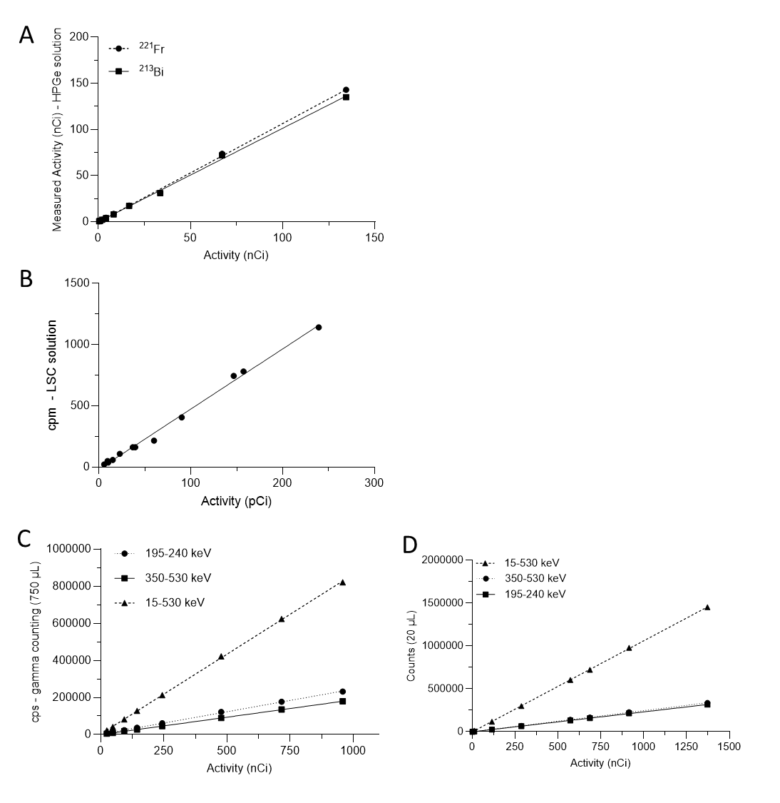
Suppl. Figure 1: Linearity of ²²⁵Ac in solution measured using (A) HPGe; (B) LS; (C) Gamma well counting at 750 µL, LOQ ²²¹Fr = 20.9 nCi (773.3 Bq); LOQ ²¹³Bi = 17.4 nCi (643.8 Bq); LOQ open = 15.3 nCi (566.1 Bq); (D) Gamma well counting at 20 µL, LOQ ²²¹Fr =2.5 nCi (92.5 Bq); LOQ ²¹³Bi =1.1 nCi (40.7 Bq); LOQ open= 0.3 nCi (11.1 Bq). All assays resulted in R²>0.99.

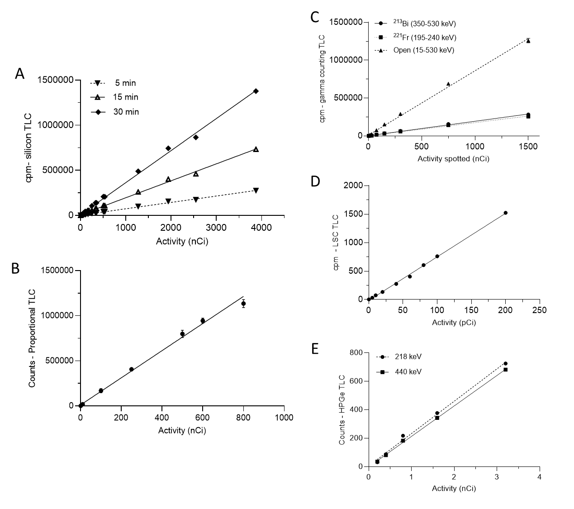
Suppl. Figure 2: Linearity of ²²⁵Ac spotted on TLC measured using: (A) silicon detector TLC plate scanner; (B) gas-filled proportional counter TLC scanner, 1,000 V; (C) Gamma well counting (cut/count); (D) LS (cut/count) PLI39; (E) HPGe (cut/count) 218 keV (30 m) and 440 keV (> 5hr). All assays resulted in R²>0.99.

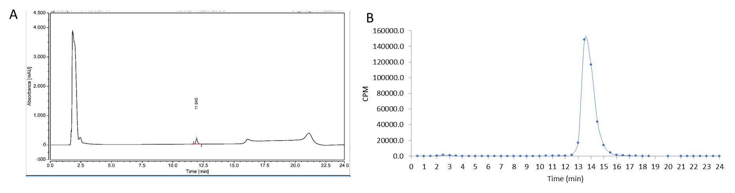
Suppl. Figure 3: Representative HPLC chromatograms of ²²⁵Ac-DP (A) UV chromatogram and associated (B) radiochromatogram plotted using gamma well counting of collected fractions.
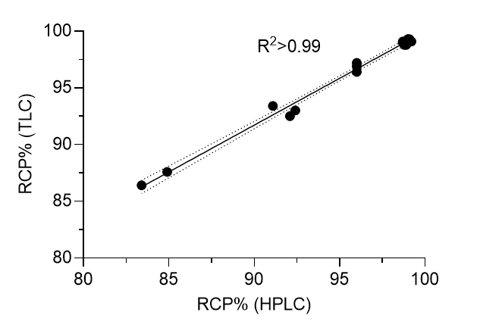
Suppl. Figure 4: Comparative linear regression of drug product RCP% determined using TLC (scanned) versus HPLC fraction collection and gamma well counting.
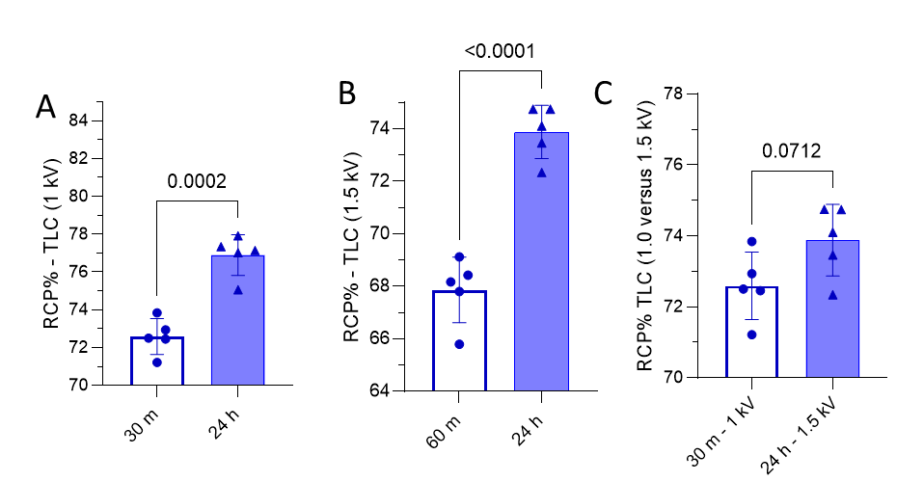
Suppl. Figure 5: (A) Sample 2A (Supp Table 2A) TLC gas-filled proportional counter 1,000 V at 30 min and 24 hr; (B) 1,500 V acquisition at 60 m and 24 hr; (C) 1,000 V at 30 min versus 1,500 V at 24 hr.
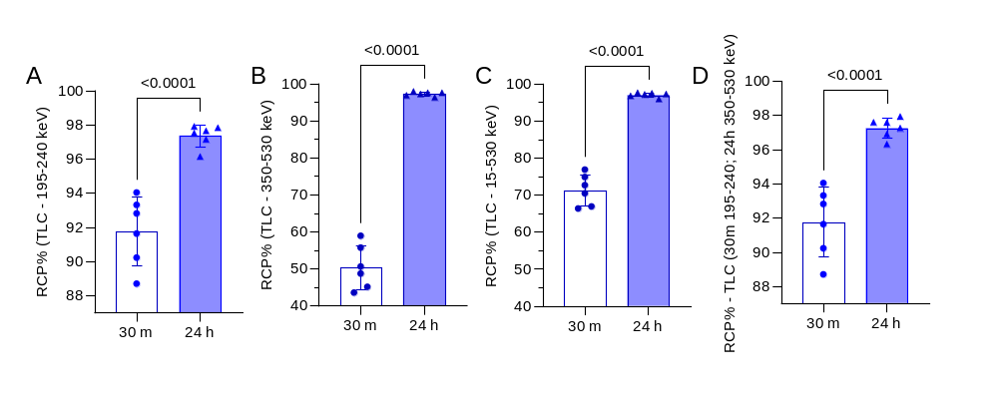
Suppl. Figure 6: (A) Sample 2E (Supp Table 2A) TLC cut and measured using a gamma well counter 195-240 keV at 30 min and 24 hr post-TLC development; (B) 350-530 keV at 30 min and 24 hr; (C) open window 15-530 keV at 30 min and 24 hr; (D) 195-240 keV at 30 min and 350-530 keV at 24 hr. All parameters demonstrate significant RCP% differences comparing measurements of ²²¹Fr and ²¹³Bi equilibrium.

