Supplementary Materials
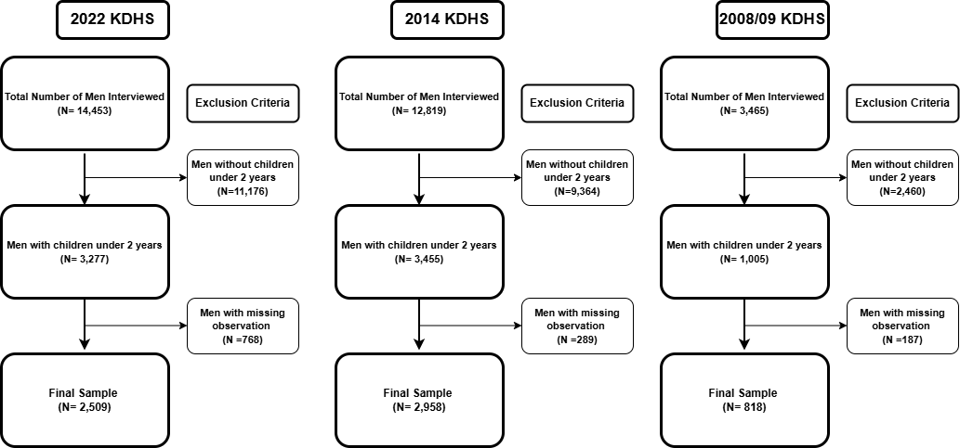

Supplementary Fig. 1: Sample size flow chart

Supplementary Table 1: Variance inflation factor
Variable | VIF | 1/VIF
Wealth Index | 2.463 | 0.406
Children No | 2.445 | 0.409
Cohabitation Years | 2.298 | 0.435
Education Level | 1.818 | 0.55
Residence | 1.812 | 0.552
Wife Age | 1.775 | 0.563
Media Exposure Level | 1.463 | 0.683
Household Size | 1.412 | 0.708
Ethnicity | 1.248 | 0.801
Occupation | 1.179 | 0.848
Religion | 1.156 | 0.865
Number of Wives | 1.147 | 0.872
Age | 1.074 | 0.931
Region | 1.06 | 0.943
Mean VIF | 1.596 | .

Supplementary Table 2: Model postestimation tests- Goodness-of-fit test after logistic model
Var | Statistics
Number of observations | 2,958
Number of covariate patterns | 2,750
Pearson chi2 | 2737.56
p value | 0.279

