Supplementary Materials

Figure S1: LD structure in the region of interest on chromosome 1. Pairwise LD, showing both r2 (red) and D’ (blue) is on the top. At the bottom is a schematic showing the position of all the genes in the region, with the significant genes highlighted in red. Note that the scale is based on SNP indexes and is therefore non-linear but monotonic with respect to genomic position.
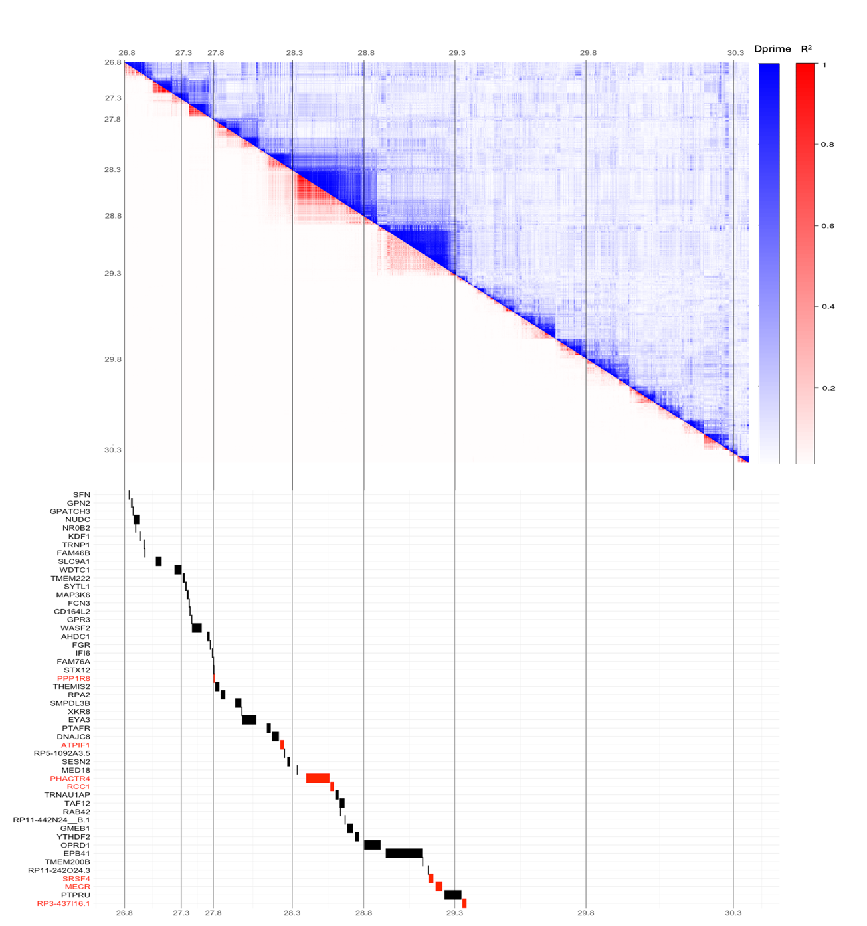

Figure S2: QQ plot for MDC cohort

Figure S3 Correlation heatmap of measured expression, predicted expression in training data, predicted expression in PLCO for GTEx and metastasis

Table S1: TWAS results for all significant genes FDR<0.1 in MDC cohort

Dataset | Gene Name | CHROM | Start | End | No of SNPs | CV R2 | Z score | P-value
GTEx | PPP1R8 | 1 | 27830778 | 27851676 | 1740 | 0.054 | 3.975 | 7.05E-05
GTEx | THEMIS2 | 1 | 27872543 | 27886685 | 1781 | 0.030 | -4.667 | 3.06E-06
GTEx | FCN3 | 1 | 27369112 | 27374824 | 1663 | 0.014 | -4.268 | 1.97E-05
GTEx | GPR3 | 1 | 27392644 | 27395814 | 1671 | 0.025 | -3.715 | 2.03E-04
GTEx | PHACTR4 | 1 | 28369603 | 28500369 | 2244 | 0.043 | -5.315 | 1.06E-07
GTEx | RP11-442N24__B.1 | 1 | 28643228 | 28648581 | 2390 | 0.008 | -4.968 | 6.78E-07
GTEx | BDH1 | 3 | 197509783 | 197573323 | 2827 | 0.074 | -4.286 | 1.82E-05
GTEx | NDUFA2 | 5 | 140638740 | 140647785 | 2150 | 0.023 | -4.021 | 5.81E-05
GTEx | PCDHA12 | 5 | 140875302 | 141012344 | 2633 | 0.017 | 4.220 | 2.44E-05
GTEx | SYBU | 8 | 109573978 | 109691791 | 2639 | 0.049 | -3.725 | 1.95E-04
GTEx | XRRA1 | 11 | 74807739 | 74949200 | 2776 | 0.738 | 4.213 | 2.52E-05
GTEx | YIF1A | 11 | 66284580 | 66289170 | 1687 | 0.017 | 3.795 | 1.48E-04
GTEx | CATSPER1 | 11 | 66016752 | 66026517 | 1906 | 0.037 | 4.232 | 2.32E-05
GTEx | DPP3 | 11 | 66480013 | 66509657 | 1646 | 0.085 | -4.424 | 9.67E-06
GTEx | ETFA | 15 | 76215355 | 76311472 | 2215 | 0.030 | -4.012 | 6.02E-05
GTEx | PLA2G4D | 15 | 42067009 | 42094554 | 2534 | 0.008 | -3.815 | 1.36E-04
GTEx | NSF | 17 | 46590669 | 46757464 | 3859 | 0.046 | 5.907 | 3.48E-09
GTEx | WNT3 | 17 | 46762506 | 46833154 | 3497 | 0.034 | -3.851 | 1.18E-04
GTEx | CRHR1 | 17 | 45784280 | 45835828 | 3570 | 0.008 | 4.491 | 7.09E-06
GTEx | MAPT | 17 | 45894382 | 46028334 | 3728 | 0.096 | 5.661 | 1.50E-08
GTEx | PLEKHM1 | 17 | 45435900 | 45490749 | 3944 | 0.023 | -3.990 | 6.62E-05
GTEx | FAM215B | 17 | 46558830 | 46562795 | 3684 | 0.103 | -4.220 | 2.44E-05
GTEx | LRRC37A2 | 17 | 46511511 | 46555650 | 3679 | 0.474 | -4.797 | 1.61E-06
GTEx | RP13-20L14.1 | 17 | 82381110 | 82382690 | 3456 | 0.106 | 3.742 | 1.82E-04
GTEx | ZNF382 | 19 | 36604817 | 36634113 | 2703 | 0.050 | -4.230 | 2.34E-05
GTEx | ZNF83 | 19 | 52594060 | 52690496 | 5821 | 0.262 | -3.728 | 1.93E-04
GTEx | ZNF570 | 19 | 37467585 | 37488652 | 2702 | 0.035 | -4.509 | 6.51E-06
GTEx | ZFP82 | 19 | 36383120 | 36418656 | 2917 | 0.015 | -4.041 | 5.31E-05
GTEx | ZNF829 | 19 | 36888124 | 36916291 | 2615 | 0.019 | -4.521 | 6.16E-06
GTEx | ZNF529 | 19 | 36534774 | 36605276 | 2765 | 0.039 | 4.770 | 1.84E-06
GTEx | ZNF420 | 19 | 37007857 | 37130314 | 2937 | 0.030 | -3.800 | 1.45E-04
GTEx | ZNF675 | 19 | 23525631 | 23687220 | 306 | 0.023 | -4.462 | 8.13E-06
GTEx | ZNF461 | 19 | 36637192 | 36666853 | 2698 | 0.045 | -4.486 | 7.25E-06
GTEx | ZNF850 | 19 | 36714383 | 36772825 | 2672 | 0.086 | 4.316 | 1.59E-05
GTEx | CTD-2554C21.2 | 19 | 37817359 | 37826638 | 2752 | 0.046 | -4.571 | 4.86E-06
GTEx | CTD-2017D11.1 | 19 | 24033445 | 24066909 | 306 | 0.439 | 4.231 | 2.32E-05
GTEx | RRP1B | 21 | 43659548 | 43696079 | 2994 | 0.038 | -3.878 | 1.05E-04

Dataset | Gene Name | CHROM | Start | End | No of SNPs | CV R2 | Z score | P-value
TCGA | EXO5 | 1 | 40508741 | 40516556 | 3484 | 0.131 | -4.996 | 5.86E-07
TCGA | RCC1 | 1 | 28505943 | 28539300 | 2315 | 0.014 | -5.703 | 1.17E-08
TCGA | DPP3 | 11 | 66480013 | 66509657 | 1699 | 0.039 | -4.218 | 2.46E-05
TCGA | KANSL1 | 17 | 46029916 | 46225374 | 3932 | 0.042 | -4.447 | 8.69E-06

Dataset | Gene Name | CHROM | Start | End | No of SNPs | CV R2 | Z score | P-value
GCMCRPC | FGR | 1 | 27612064 | 27635277 | 1726 | 0.042 | 5.097 | 3.44E-07
GCMCRPC | SRSF4 | 1 | 29147743 | 29181987 | 3282 | 0.055 | 4.698 | 2.62E-06
GCMCRPC | MECR | 1 | 29192873 | 29230942 | 3381 | 0.030 | 3.939 | 8.19E-05
GCMCRPC | SERPINC1 | 1 | 173903804 | 173917378 | 2444 | 0.018 | 4.694 | 2.68E-06
GCMCRPC | RPA2 | 1 | 27891524 | 27914746 | 1911 | 0.021 | -4.395 | 1.11E-05
GCMCRPC | AHDC1 | 1 | 27534035 | 27604431 | 1786 | 0.030 | 5.768 | 8.00E-09
GCMCRPC | IFI6 | 1 | 27666061 | 27672218 | 1739 | 0.062 | -6.355 | 2.09E-10
GCMCRPC | SESN2 | 1 | 28259527 | 28282491 | 2028 | 0.040 | 5.405 | 6.49E-08
GCMCRPC | SMPDL3B | 1 | 27934993 | 27959157 | 1918 | 0.025 | 4.190 | 2.79E-05
GCMCRPC | ATPIF1 | 1 | 28236109 | 28246906 | 2006 | 0.032 | -4.308 | 1.65E-05
GCMCRPC | XKR8 | 1 | 27959462 | 27968096 | 1912 | 0.119 | 4.057 | 4.96E-05
GCMCRPC | EPB41 | 1 | 28887091 | 29120046 | 3522 | 0.027 | 4.101 | 4.12E-05
GCMCRPC | RCC1 | 1 | 28505943 | 28539300 | 2334 | 0.053 | 5.506 | 3.67E-08
GCMCRPC | ZBTB37 | 1 | 173868082 | 173903549 | 2494 | 0.083 | -3.967 | 7.27E-05
GCMCRPC | RAB42 | 1 | 28592200 | 28595443 | 2428 | 0.125 | 4.619 | 3.86E-06
GCMCRPC | OXCT2 | 1 | 39769523 | 39771348 | 2962 | 0.015 | -4.512 | 6.42E-06
GCMCRPC | PHACTR4 | 1 | 28369603 | 28500369 | 2352 | 0.011 | 5.855 | 4.76E-09
GCMCRPC | RP3-437I16.1 | 1 | 29329620 | 29350114 | 3456 | 0.038 | -3.695 | 2.20E-04
GCMCRPC | ZNF184 | 6 | 27450743 | 27473118 | 2893 | 0.102 | -4.060 | 4.91E-05
GCMCRPC | CTD-2339F6.1 | 8 | 57746149 | 57750199 | 4161 | 0.087 | 4.636 | 3.56E-06
GCMCRPC | WNT3 | 17 | 46762506 | 46833154 | 4082 | 0.019 | -3.945 | 7.97E-05
GCMCRPC | EFTUD2 | 17 | 44849943 | 44899662 | 3474 | 0.054 | 3.808 | 1.40E-04
GCMCRPC | CRHR1 | 17 | 45784280 | 45835828 | 4221 | 0.063 | 4.854 | 1.21E-06
GCMCRPC | NMT1 | 17 | 45051610 | 45109016 | 4029 | 0.052 | 3.892 | 9.94E-05
GCMCRPC | PLCD3 | 17 | 45108967 | 45133354 | 4067 | 0.025 | 4.324 | 1.53E-05
GCMCRPC | HEXIM2 | 17 | 45160700 | 45170040 | 4194 | 0.031 | -4.013 | 5.99E-05
GCMCRPC | STRA13 | 17 | 82018702 | 82024107 | 3970 | 0.033 | 3.759 | 1.71E-04
GCMCRPC | PLEKHM1 | 17 | 45435900 | 45490749 | 4579 | 0.063 | -4.352 | 1.35E-05
GCMCRPC | LRRC37A2 | 17 | 46511511 | 46555650 | 4338 | 0.103 | -5.455 | 4.90E-08
GCMCRPC | RP11-798G7.6 | 17 | 45545804 | 45563230 | 4502 | 0.075 | 4.744 | 2.09E-06
GCMCRPC | OVOL3 | 19 | 36111202 | 36113711 | 3544 | 0.043 | 4.566 | 4.97E-06
GCMCRPC | SIPA1L3 | 19 | 37907228 | 38208372 | 3690 | 0.100 | -3.772 | 1.62E-04
GCMCRPC | TMEM145 | 19 | 42313325 | 42325062 | 3003 | 0.015 | 3.793 | 1.49E-04
GCMCRPC | ZNF146 | 19 | 36214602 | 36238774 | 3327 | 0.177 | 3.855 | 1.16E-04
GCMCRPC | ZNF540 | 19 | 37551406 | 37614097 | 2786 | 0.075 | 3.882 | 1.04E-04
GCMCRPC | HKR1 | 19 | 37312837 | 37369365 | 2954 | 0.187 | -5.671 | 1.42E-08
GCMCRPC | ZNF829 | 19 | 36888124 | 36916291 | 2758 | 0.097 | 4.020 | 5.82E-05
GCMCRPC | ZNF529 | 19 | 36534774 | 36605276 | 2928 | 0.015 | 4.960 | 7.06E-07
GCMCRPC | ZNF793 | 19 | 37506939 | 37548762 | 2833 | 0.069 | 3.628 | 2.86E-04
GCMCRPC | ZNF565 | 19 | 36182060 | 36246257 | 3474 | 0.121 | 4.486 | 7.27E-06
GCMCRPC | ZNF781 | 19 | 37667751 | 37692322 | 2719 | 0.070 | 4.689 | 2.75E-06
GCMCRPC | ZNF585A | 19 | 37106734 | 37172741 | 3041 | 0.022 | -4.067 | 4.76E-05
GCMCRPC | ZNF568 | 19 | 36916329 | 36998700 | 2903 | 0.104 | -4.166 | 3.10E-05
GCMCRPC | AC016582.2 | 19 | 37823722 | 37855215 | 2910 | 0.031 | -4.503 | 6.69E-06
GCMCRPC | LINC01535 | 19 | 37251912 | 37265535 | 2879 | 0.102 | -5.828 | 5.62E-09
GCMCRPC | ZNF260 | 19 | 36510695 | 36528660 | 2900 | 0.020 | 3.711 | 2.06E-04
GCMCRPC | CTD-2162K18.4 | 19 | 36773153 | 36777078 | 2732 | 0.014 | 3.928 | 8.57E-05
GCMCRPC | CTD-3220F14.1 | 19 | 37265939 | 37271518 | 2847 | 0.058 | -5.204 | 1.95E-07
GCMCRPC | CTD-3234P18.6 | 19 | 36668102 | 36669404 | 2799 | 0.034 | -6.108 | 1.01E-09

