Supplementary Figure S1
Edge Stability Estimate for Parent and Teacher Ratings of the ODD Symptoms - Tested Using Non-Parametric Bootstrapped Estimate
Parent | Teacher
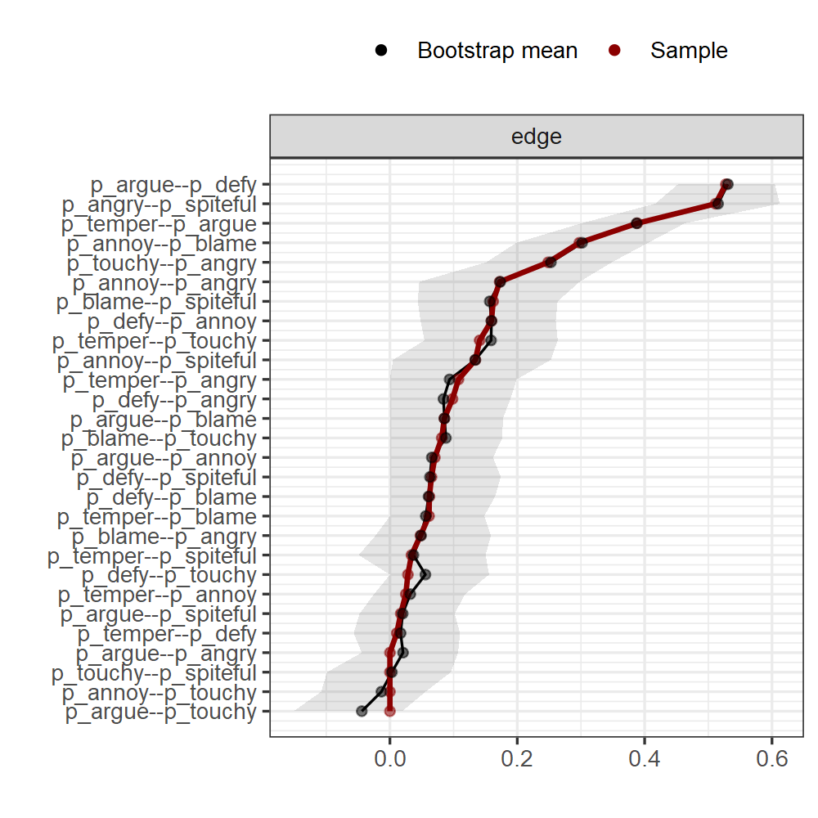 | 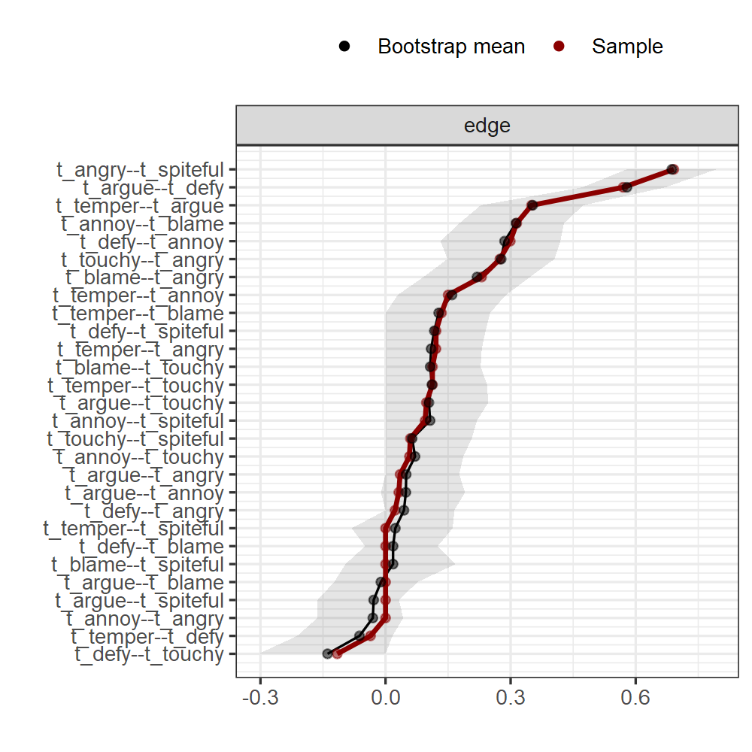
Note. The x-axis represents the edges, while every line on the y-axis represents a specific edge. The red line shows the estimate of the edge weights, and the gray bars the 95% confidence intervals for the estimates.

Supplementary Figure S2
Stability of Central Indices for Parent and Teacher Ratings of the ODD Symptoms
Parent | Teacher
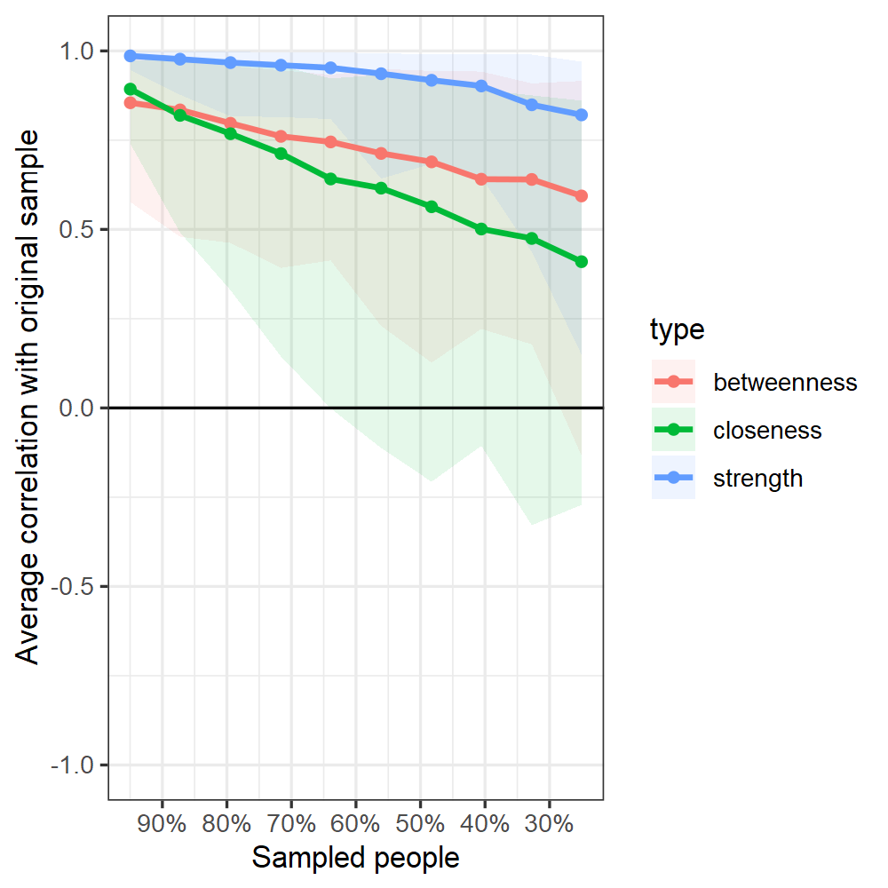 | 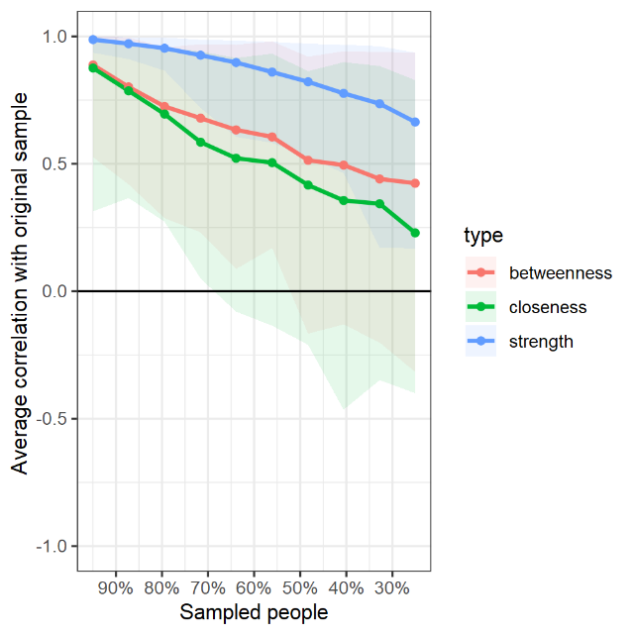
Note. The graph shows the average correlation between bootstrap centrality indices of networks sampled with node-dropping and network of the ODD symptoms.The shaded area represents the 95% confidence interval.

