Supporting Information

Localized Cation Unlocks Unique Activity–Selectivity Trends in Molecular Oxygen Reduction Catalysis

Hwi Yul Jo†ª, Vom Kang†ª, Dongyoung Kim†ª, Youngchol Jeongª, Jinrok Ohª, Jihyun Kimª, Jaeyune Ryu ^{d,e}*, and Seung Jun Hwang ^{a,b,c}*

ªDepartment of Chemistry, Pohang University of Science and Technology, Pohang, 37673, Republic of Korea
^{b}Division of Advanced Materials Science, Pohang University of Science and Technology, Pohang, 37673, Republic of Korea
^{c}Institute for Convergence Research and Education in Advanced Technology (I-CREATE), Yonsei University, Seoul, 03722, Republic of Korea
^{d}Center for Nanoparticle Research, Institute for Basic Science (IBS), Seoul 08826, Republic of Korea
^{e}School of Chemical and Biological Engineering, Institute of Chemical Processes, Seoul National University (SNU), Seoul, 08826, Republic of Korea
*Email: sjhwang17@postech.ac.kr

Table of Contents
1. Detailed Synthesis and Characterization 3
2. Investigation of Field Effects in Model Complexes through Spectroscopic Analysis 33
3. Optical Kinetic Data: UV-vis Spectroscopic Experimental Results 58
4. Quantitative Analysis of H₂O₂ Formed by UV-vis Spectroscopy 66
5. X-ray Absorption Spectroscopy Analysis of FeL1–Cl and Fe^{III}L1–OO Complexes
: Comparative Study of Sc(OTf)₃ Effects 77
6. Cleavage of Fe^{III}L1–OOH by the Addition of a Chemical Reductant 79
7. RDE&RRDE Set-up 82
8. RDE (Rotating Disk Electrode) Measurement 83
9. RRDE (Rotating Ring Disk Electrode) Measurement 87
10. Mechanistic Study 122
11. Computational Analysis 127
12. Copies of NMR spectra 136
13. Reference 146

Detailed Synthesis and Characterization
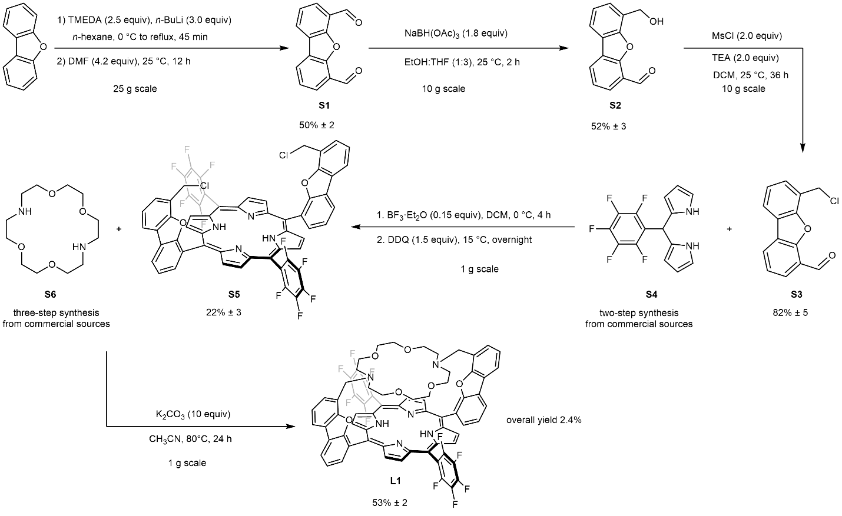
Supplementary Scheme 1. Overall synthesis of L1

Synthesis of S1
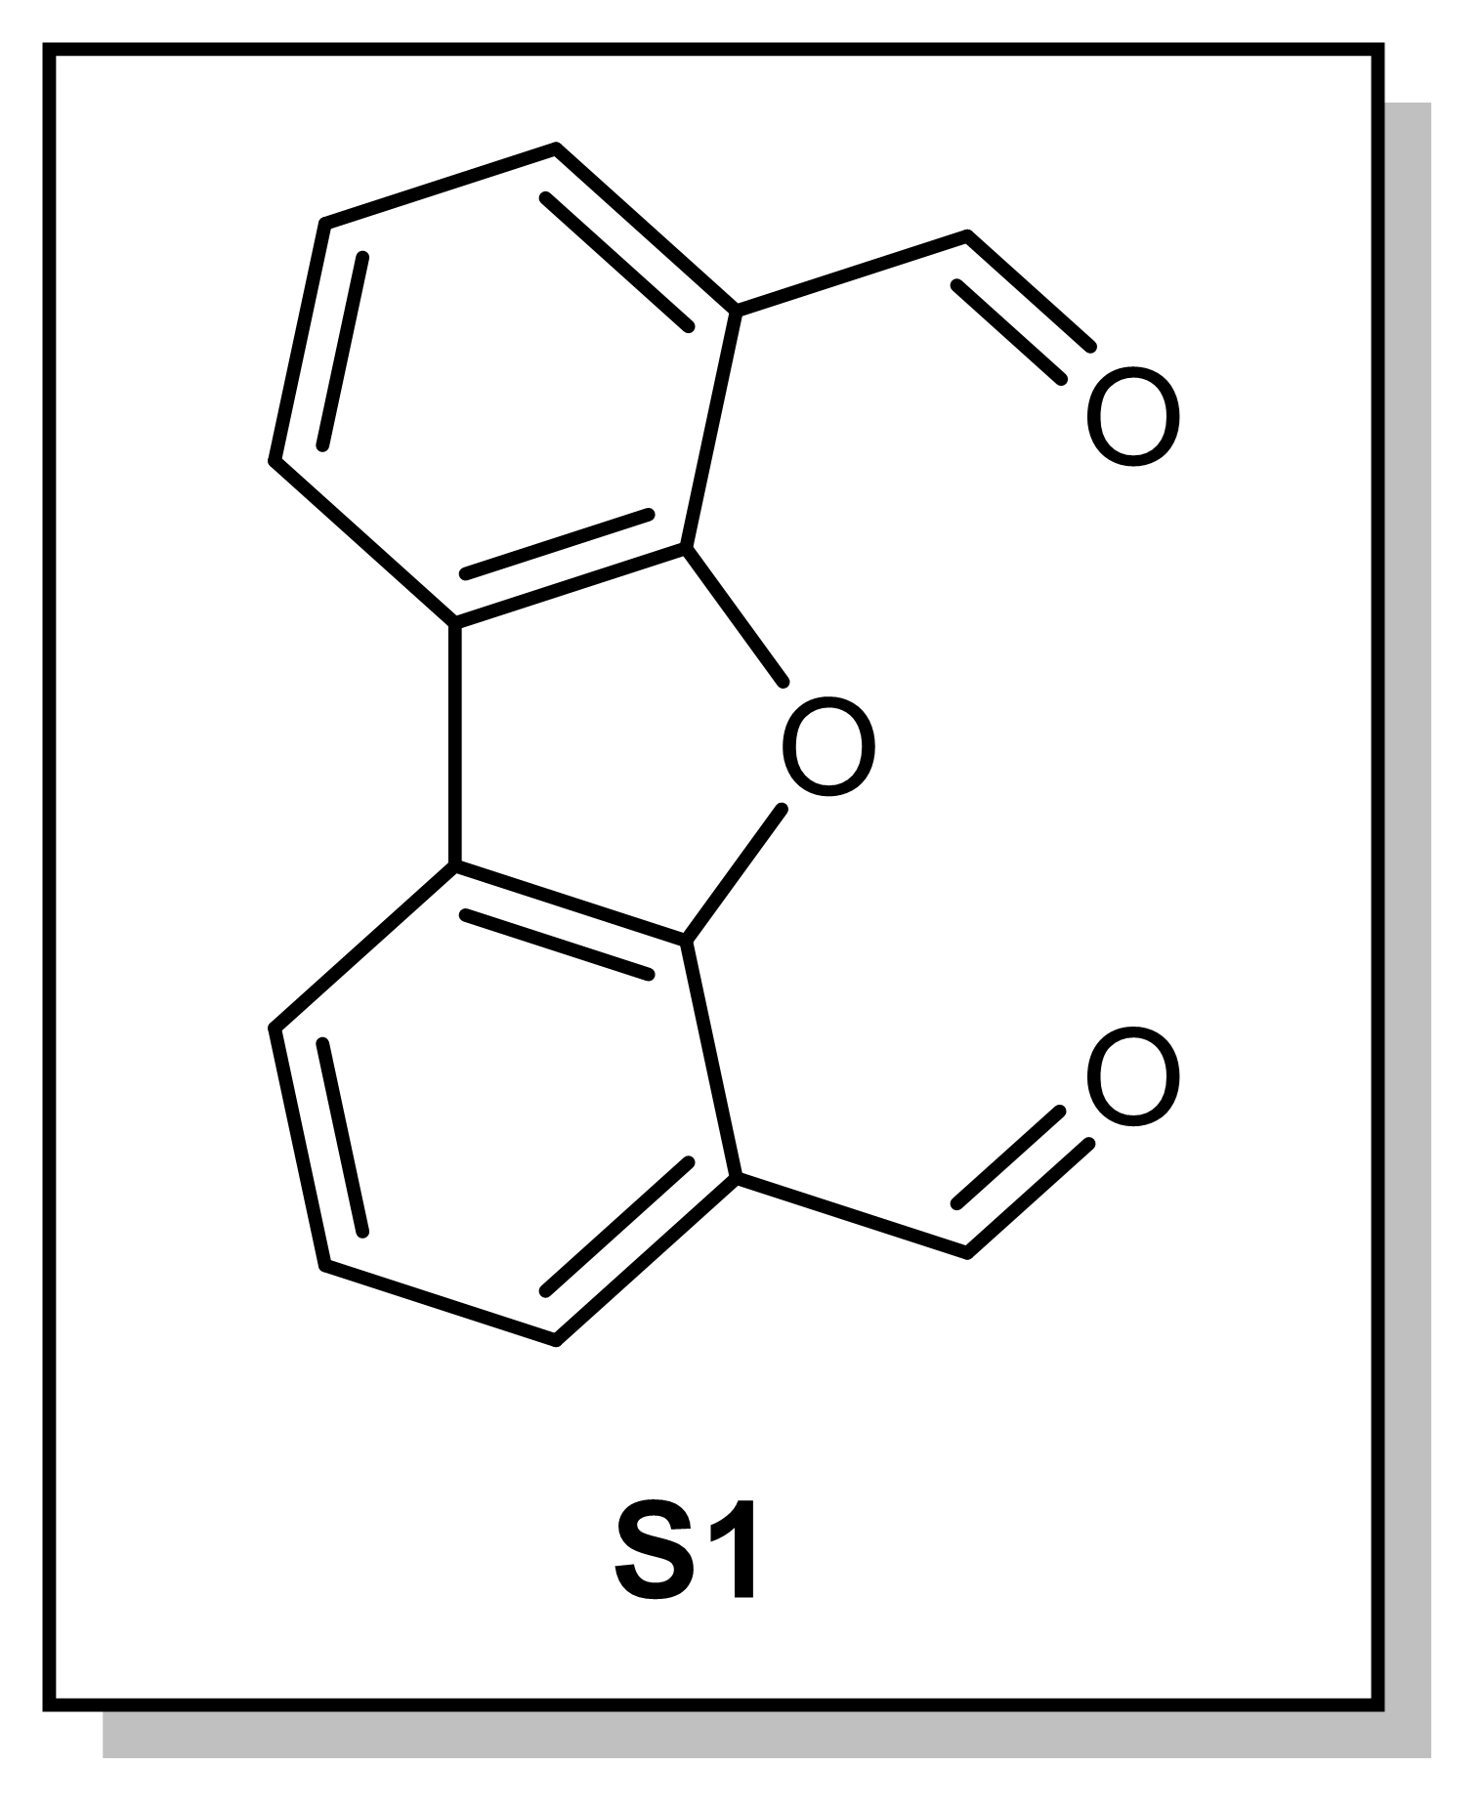
A mixture of dibenzofuran (25 g, 0.15 mol, 1.0 equiv) and freshly distilled n-hexane (140 mL) was stirred 25 ℃ in a two-neck-1-L round-bottomed flask under N₂, then add freshly distilled N,N,N’,N’-tetramethylethylenediamine (54 mL, 0.36 mmol, 2.5 equiv) by using 60 mL syringe. The resulting mixture was cooled down to 0 ℃ with ice-bath and equipped with dropping funnel against the flow of N₂. After filling the dropping funnel with n-butyllithium (1.6 M in hexane, 270 mL, 0.43 mol, 3.0 equiv) was added dropwise for 90 min. Upon the complete addition of n-butyllithium, the dropping funnel was changed to a reflux condenser and the reaction was heated to reflux at 90 ℃ for 45 min. After cooling to 25 ℃, freshly distilled DMF (48 mL, 62 mmol, 4.2 equiv) was added with syringe pump (1 mL/min) for 48 min. After stirring the reaction mixture at 25 ℃ for overnight under N₂, the reaction was quenched with slurry ice-water (400 mL) by pouring to the reaction mixture against N₂ with vigorous stirring. Precipitated ivory solids were collected by vacuum filtration and dried for 90 min. Collected solids were triturated with EtOAc (1 × 250 mL + 2 × 25 mL) and MeOH (1 × 100 mL + 1 × 50 mL). The triturated solids were dried under reduced pressure for an hour to afford S1 (16.7 g, 74.5 mmol, 50.2%).
¹H NMR (500 MHz, CDCl₃, 23 ℃): δ 10.71 (s, 2H, CHO), 8.26 (d, J = 7.5 Hz, 2H, ArH), 8.06 (d, J = 8.0 Hz, 2H, ArH), 7.56 (t, J = 7.5 Hz, 2H, ArH).

Synthesis of S2
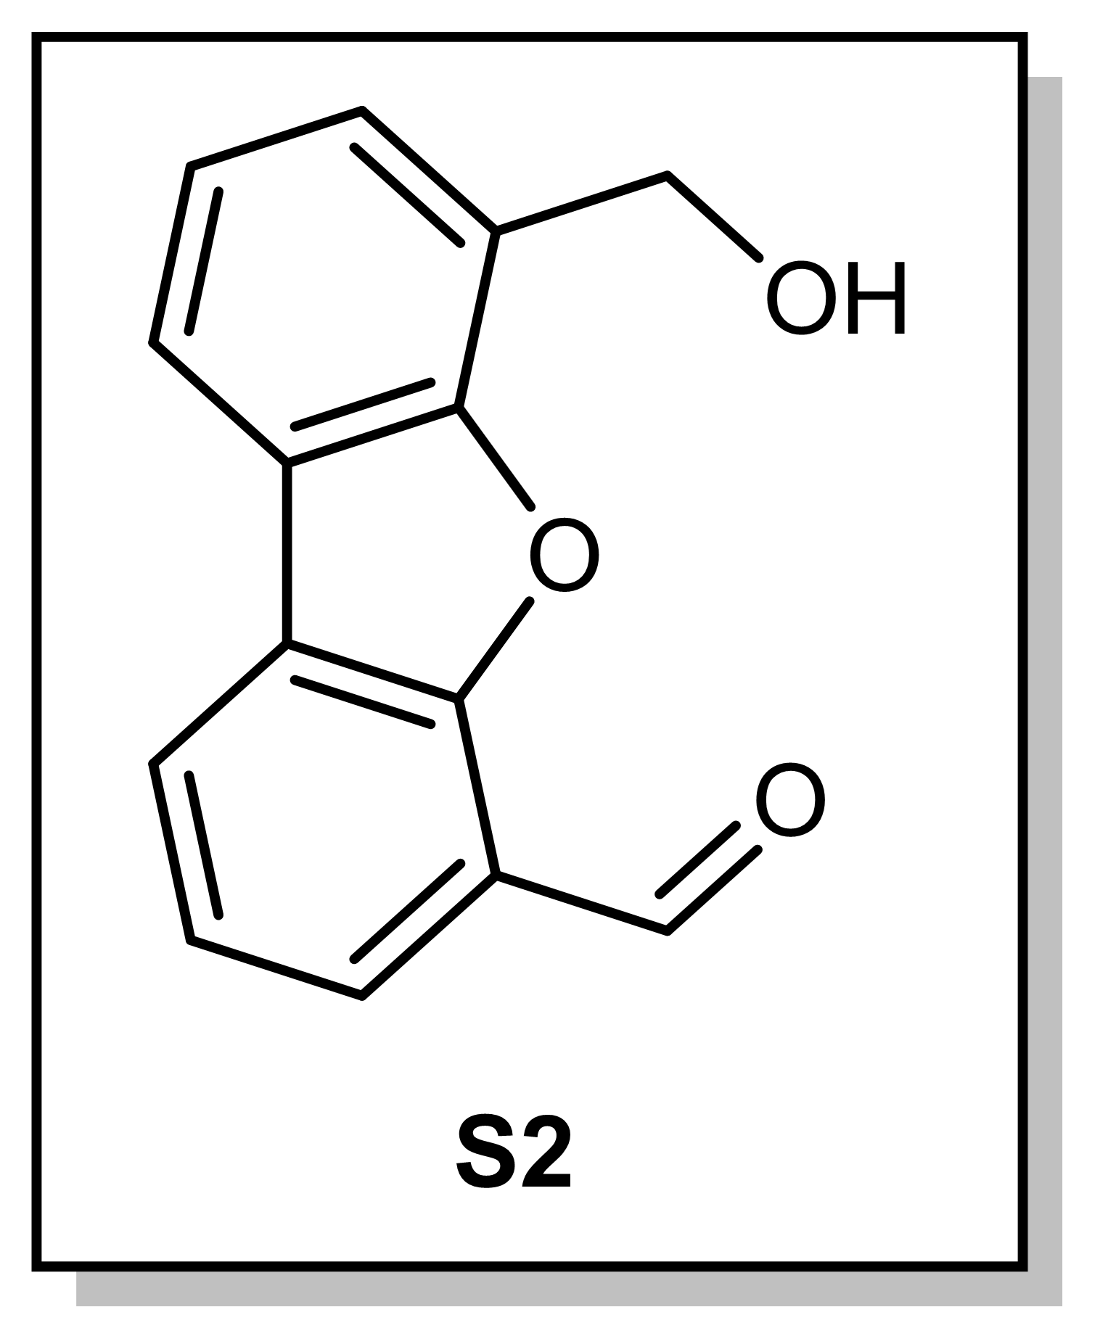
A 1-L round-bottomed flask equipped with a PTFE-coated magnetic stir bar was charged with S1 (10.0 g, 44.6 mmol, 1.00 equiv.), sodium triacetoxyborohydride (17.0 g, 80.3 mmol, 1.80 equiv.), THF (720 mL) and EtOH (240 mL). The mixture was stirred at 25 ℃ for 75 min, then after the reaction 1 N HCl (9.6 mL) was added to quench the reaction. Then all solvent was removed under reduced pressure and the residue was extracted with H₂O (1 × 300 mL) and CH₂Cl₂ (3 × 250 mL + 1 × 150 mL). The combined organic layers were dried over anhydrous Na₂SO₄, filtrated and the collected organic layer was evaporated under reduced pressure. The resulting residue was mixed with 40 g of silica gel in CH₂Cl₂ and dried under reduced pressure to prepare a dry load for flash column chromatography. The mixture was then purified by flash column chromatography with gradient elution of CH₂Cl₂-acetone mixture (50:1 to 5:1) to afford analytically pure S2 (5.33 g, 23.6 mmol, 52.8%).
¹H NMR (300 MHz, CDCl₃, 23 ℃): δ 10.64 (s, 1H, CHO), 8.21 (d, J = 7.5 Hz, 1H, ArH), 7.98 (d, J = 7.4 Hz, 1H, ArH), 7.94 (d, J = 7.3 Hz, 1H, ArH), 7.59 (d, J = 6.8 Hz, 1H, ArH), 7.49 (t, J = 7.4 Hz, 1H, ArH), 7.42 (t, J = 7.4 Hz, 1H, ArH), 5.16 (s, 2H, CH₂).

Synthesis of S3
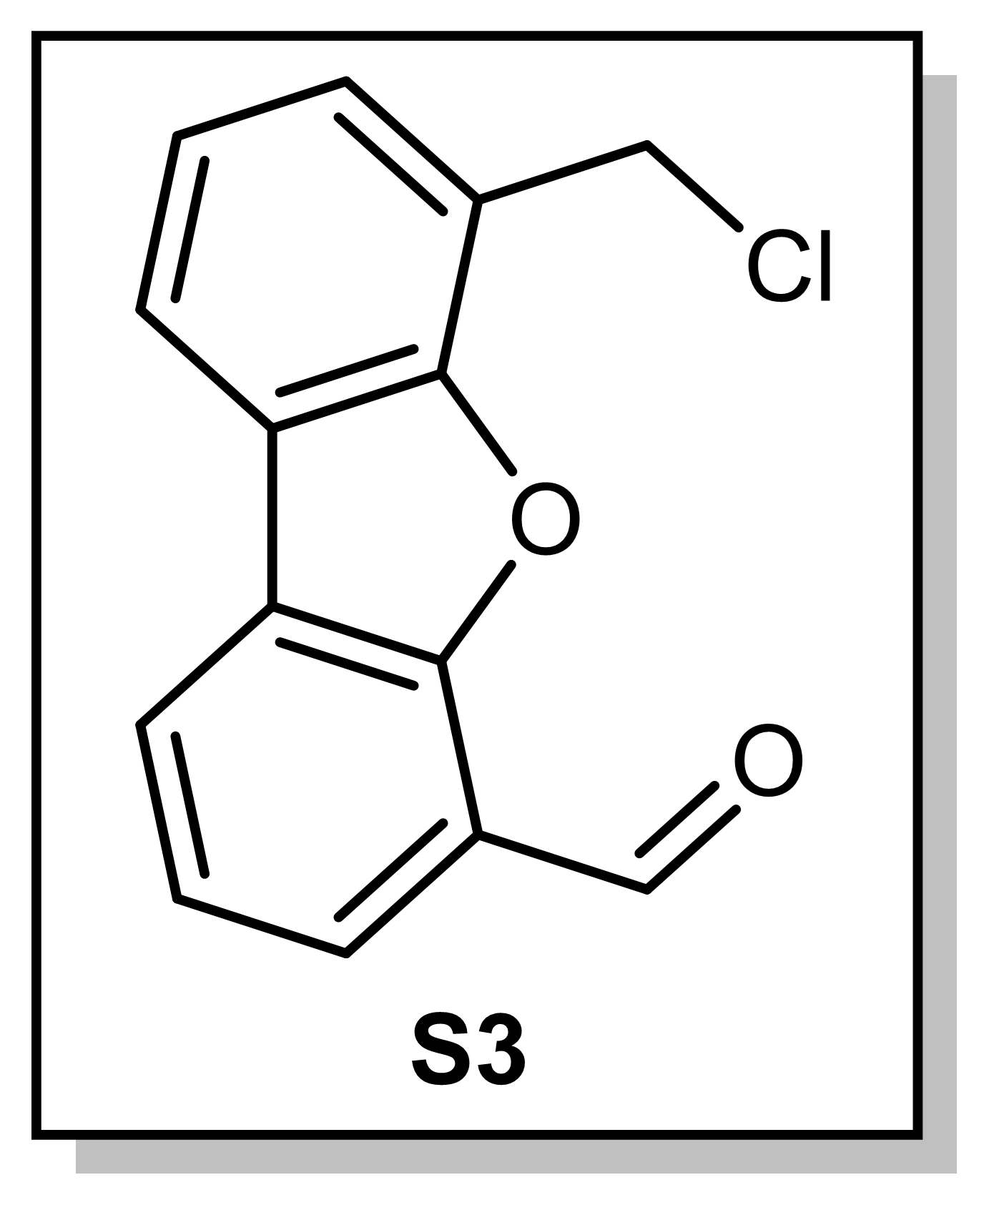
A 250-mL round-bottomed flask equipped with a PTFE-coated magnetic stir bar was charged with S2 (10.0 g, 44.2 mmol, 1.00 equiv) and CH₂Cl₂ (150 mL). Triethylamine (12.3 mL, 88.4 mmol, 2.00 equiv) was added to the stirred solution at 25 ℃. After complete dissolution of all solids, methanesulfonyl chloride (6.85 mL, 88.4 mmol, 2.00 equiv) was added dropwise via syringe. During the addition, the solution gradually turned into a dark orange-red color. The reaction mixture was stirred at 25 ℃ for 36 h. The mixture was concentrated under reduced pressure and the residue was subjected to aqueous extraction with H₂O (1 × 600 mL) and Et₂O (2 × 600 mL + 1 × 350 mL). The combined organic layers were dried over anhydrous Na₂SO₄, filtered, and dried using rotary evaporator. The crude product was obtained as a brown-yellow solid, then crystallized in hot Et₂O (150 mL) to afford S3 as a bright yellow solid (8.75 g, 35.8 mmol, 81.0%).
¹H NMR (300 MHz, CDCl₃, 23 ℃): δ 10.69 (s, 1H, CHO), 8.19 (d, J = 8.3 Hz, 1H, ArH), 7.99 (d, J = 8.3 Hz, 1H, ArH), 7.96 (d, J = 7.7 Hz, 1H, ArH), 7.59 (d, J = 7.7 Hz, 1H, ArH), 7.49 (t, J = 7.4 Hz, 1H, ArH), 7.42 (t, J = 7.4 Hz, 1H, ArH), 5.03 (s, 2H, CH₂).

Synthesis of S4
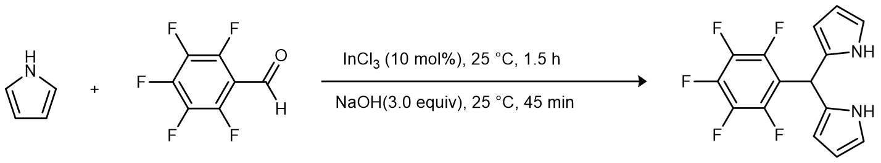
Supplementary Scheme 2. Synthesis of S4
In an N₂ filled glove box, a 250-mL round-bottomed flask equipped with a PTFE-coated magnetic stir bar was first charged with freshly distilled pyrrole (150 mL, 2.16 mol), then added pentafluorobenzaldehyde (5.00 g, 25.5 mmol, 1.00 equiv.) at 25 ℃. After adding InCl₃ (564 mg, 2.55 mmol, 0.100 equiv) in one portion, the cloudy mixture was stirred for 90 min. The reaction was quenched by adding NaOH powder (3.06 g, 76.5 mmol, 3.00 equiv.) and stirred for 45 min. Unreacted pyrrole was removed by vacuum distillation and the remaining mixture was filtered under vacuum filtration. Filtrated solid was washed with a small amount of pyrrole (ca. 10 mL). The filtrate was concentrated in vacuo to yield a dark green solid, which was left under vacuum overnight to remove remaining pyrrole. Purification by column chromatography over silica gel with elution (CH₂Cl₂) gave the titled compound S4 (5.95 g, 19.1 mmol, 74.7%) as an off-white solid.
¹H NMR (300 MHz, CDCl₃, 23 ℃): δ 8.12 (bs, 2H, NH), 6.73 (m, 2H, CHNH), 6.17 (dd, J = 5.7, 2.8 Hz, 2H, CHCHNH), 6.03 (bs, 2H, CHCNH), 5.90 (bs, 1H, CH).

Synthesis of S5
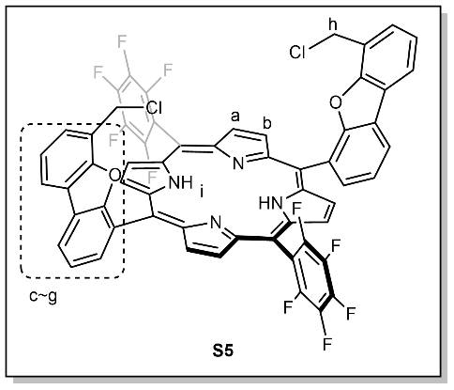
A three-neck 100-mL round-bottomed flask equipped with a PTFE-coated magnetic stir bar was charged with S4 (1.00 g, 4.08 mmol, 1.00 equiv), S3 (1.28 g, 4.08 mmol, 1.00 equiv), and anhydrous CH₂Cl₂ (50 mL) under N₂. While stirring the reaction mixture at 0 ℃ under N₂, BF₃·OEt₂ (76 µL, 0.62 mmol, 0.15 equiv) was added dropwise via syringe, and the mixture was stirred for 4 h. Subsequently, 2,3-dichloro-5,6-dicyano-1,4-benzoquinone (1.40 g, 6.12 mmol, 1.50 equiv) was added in one portion, and the reaction mixture was allowed to warm slowly to 25 ℃ while stirring 12 h under N₂. The reaction was quenched by adding triethylamine (1.80 mL), followed by stirring for an additional 15 min. The mixture was extracted with CH₂Cl₂ (250 mL + 2 × 300 mL) and H₂O (150 mL). The combined organic layers were dried over anhydrous Na₂SO₄, filtered and concentrated under reduced pressure. The resulting residue was recovered and mixed with 20 g of silica gel in CH₂Cl₂ and dried under reduced pressure to prepare a dry load for flash column chromatography and purified by flash column chromatography with elution of hexane-benzene mixture (3:2) to afford analytically pure S5 (479 mg, 0.447 mmol, 21.9%).
¹H NMR (500 MHz, CDCl₃, 23 ℃): δ 8.92 (s, 4H_{a}), 8.80 (s, 4H_{b}), 8.56 – 8.36 (m, 2H_{c}), 8.31 (dd, J = 24.0, 11.9 Hz, 2H_{d}), 8.22 – 8.00 (m, 2H_{e}), 7.84 (d, J = 7.6 Hz, 2H_{f}), 7.43 (m, 4H_{g}), 4.46 – 4.02 (m, 4H_{h}), –2.60 (s, 2H_{i}).
¹³C{¹H} NMR (126 MHz, CDCl_{3,} 23 ℃): δ 157.1, 155.7, 138.6, 136.6, 132.2, 129.3, 125.4, 124.3, 124.0, 123.1, 122.2, 121.6, 120.1, 116.2, 115.2, 102.4, 67.4, 67.0, 52.4, 51.8.
¹⁹F NMR (471 MHz, CDCl₃, 23 ℃): δ 135.5 (d, J = 18.6 Hz, 2F), 136.0 (dd, J = 7.2, 24.0 Hz, 2F), 151.0 (t, J = 20.7 Hz, 2F), 160.5 (td, J = 6.3, 23.2 Hz, 2F), 160.8 (td, J = 5.3, 23.1 Hz, 2F).
Elemental analysis (calcd., found for C₅₈H₂₆N₄O₂Cl₂F₁₀): C (65.00, 65.07), H (2.45, 2.54), N (5.23, 5.37).

Synthesis of L1
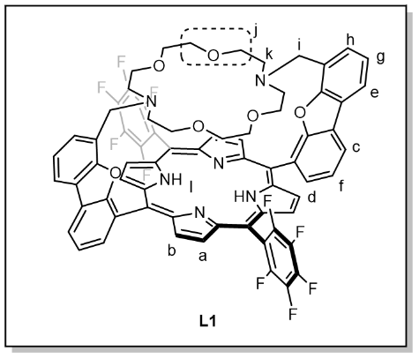
A 250-mL round bottomed flask equipped with a PTFE-coated magnetic stir bar was charged with S6 (0.50 g, 0.46 mmol, 1.0 equiv), S7 (0.15 g, 0.56 mmol, 1.2 equiv), K₂CO₃ (0.65 g, 4.6 mmol, 10 equiv) and CH₃CN (80 mL). The reaction mixture was stirred at 80 ℃ for 20 h while protected from light by wrapping the flask with aluminum foils. The reaction mixture was then concentrated under reduced pressure to remove the solvent. The resulting residue was extracted with CH₂Cl₂ (3 × 150 mL) and H₂O (150 mL). The combined organic layers were dried over anhydrous Na₂SO₄, filtrated and evaporated under reduced pressure. The resulting residue was mixed with 7 g of silica gel in CH₂Cl₂ and dried under reduced pressure to prepare a dry load for chromatography and purified by flash column chromatography with elution of 1% of triethylamine in EtOAc to afford analytically pure S8 (295 mg, 0.243 mmol, 50.1%) as a solid.
¹H NMR (500 MHz, CDCl₃, 23 ℃): δ 8.96 (d, J = 4.0 Hz, 4H_{a}), 8.90 – 8.75 (m, 4H_{b}), 8.59 (d, J = 7.2 Hz, 2H_{c}), 8.43 (d, J = 7.9 Hz, 2H_{d}), 8.06 (d, J = 7.9 Hz, 2H_{e}), 7.91 (s, 2H_{f}), 7.33 (t, J = 7.5 Hz, 2H_{g}), 7.23 (d, J = 6.7 Hz, 2H_{h}), 3.17 (s, 4H_{i}), 2.01 (s, 16H_{j}), 0.94 (s, 8H_{k}), –2.57 (s, 2H_{l}).
¹³C{¹H} NMR (126 MHz, CDCl_{3,} 23 ℃): δ 157.1, 155.7, 138.6, 136.6, 132.2, 129.3, 125.4, 124.3, 124.0, 123.1, 124.0, 122.2, 121.6, 120.1, 116.2, 115.2, 102.4, 67.4, 67.0, 52.4, 51.6.
¹⁹F NMR (471 MHz, CDCl₃, 23 ℃): δ 135.5 (d, J = 18.6 Hz, 2F), 136.0 (dd, J = 7.2, 24.0 Hz, 2F), 151.0 (t, J = 20.7 Hz, 2F), 160.5 (td, J = 6.3, 23.2 Hz, 2F), 160.8 (td, J = 5.3, 23.1 Hz, 2F).
Elemental analysis (calcd., found for C₇₀H₅₀N₆O₆F₁₀): C (66.66, 67.25), H (4.00, 4.25), N (6.66, 6.37).
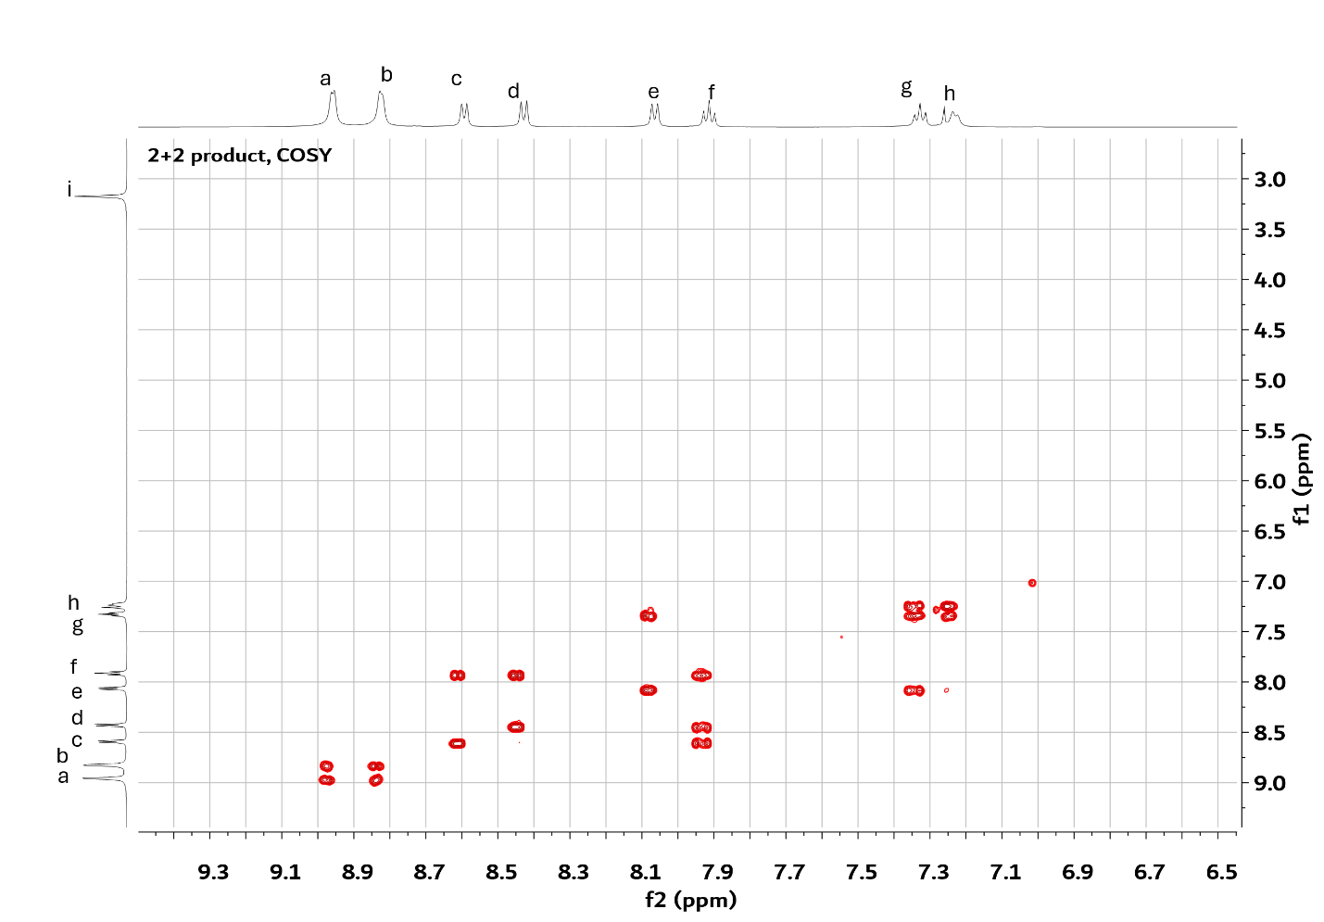
Supplementary Fig 1. Full ¹H COSY spectrum (magnitude mode) for L1 taken at 50 min.

Synthesis of L2
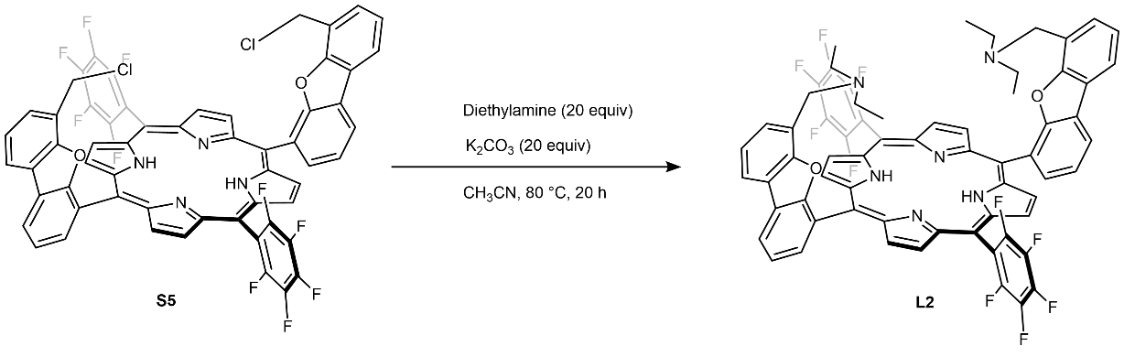
Supplementary Scheme 3. Synthesis of L2
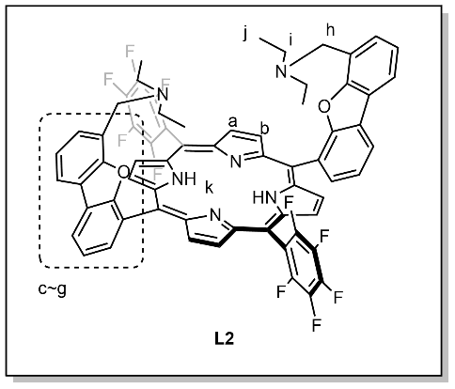
A 50-mL round bottomed flask equipped with a PTFE-coated magnetic stir bar was charged with S6 (0.1 g, 0.09 mmol, 1 equiv), diethylamine (0.13 g, 1.8 mmol, 20 equiv), K₂CO₃ (0.25 g, 1.8 mmol, 20 equiv), and CH₃CN (20 mL). The mixture was stirred at 80 ℃ for 20 h while protected from light by wrapping the flask in aluminum foil. The reaction mixture was then concentrated under reduced pressure to remove the solvent. The resulting residue was extracted with CH₂Cl₂ (3 × 30 mL) and H₂O (30 mL). The combined organic layers were dried over anhydrous Na₂SO₄, filtrated and evaporated under reduced pressure. The resulting residue was mixed with 1.0 g of silica gel in CH₂Cl₂ and dried under reduced pressure to prepare a dry load for flash column chromatography and purified by chromatography with elution of 1% of triethylamine in EtOAc to afford analytically pure L2 (49 mg, 0.043 mmol, 48%).
¹H NMR (500 MHz, CDCl₃, 23 ℃): δ 8.91 (d, J = 4.9 Hz, 4H_{a}), 8.76 (d, J = 5.0 Hz, 4H_{b}), 8.43 (d, J = 7.8 Hz, 2H_{c}), 8.25 (t, J = 6.5 Hz, 2H_{d}), 8.09 (d, J = 7.2 Hz, 2H_{e}), 7.81 (t, J = 7.6 Hz, 2H_{f}), 7.54 – 7.33 (m, 4H_{g}), 3.22 (s, 4H_{h}), 2.16 – 1.99 (m, 8H_{i}), 0.43 (dt, J = 13.4, 7.0 Hz, 13H_{j}), –2.65 (s, 2H_{k}).

Synthesis of TpOMePP
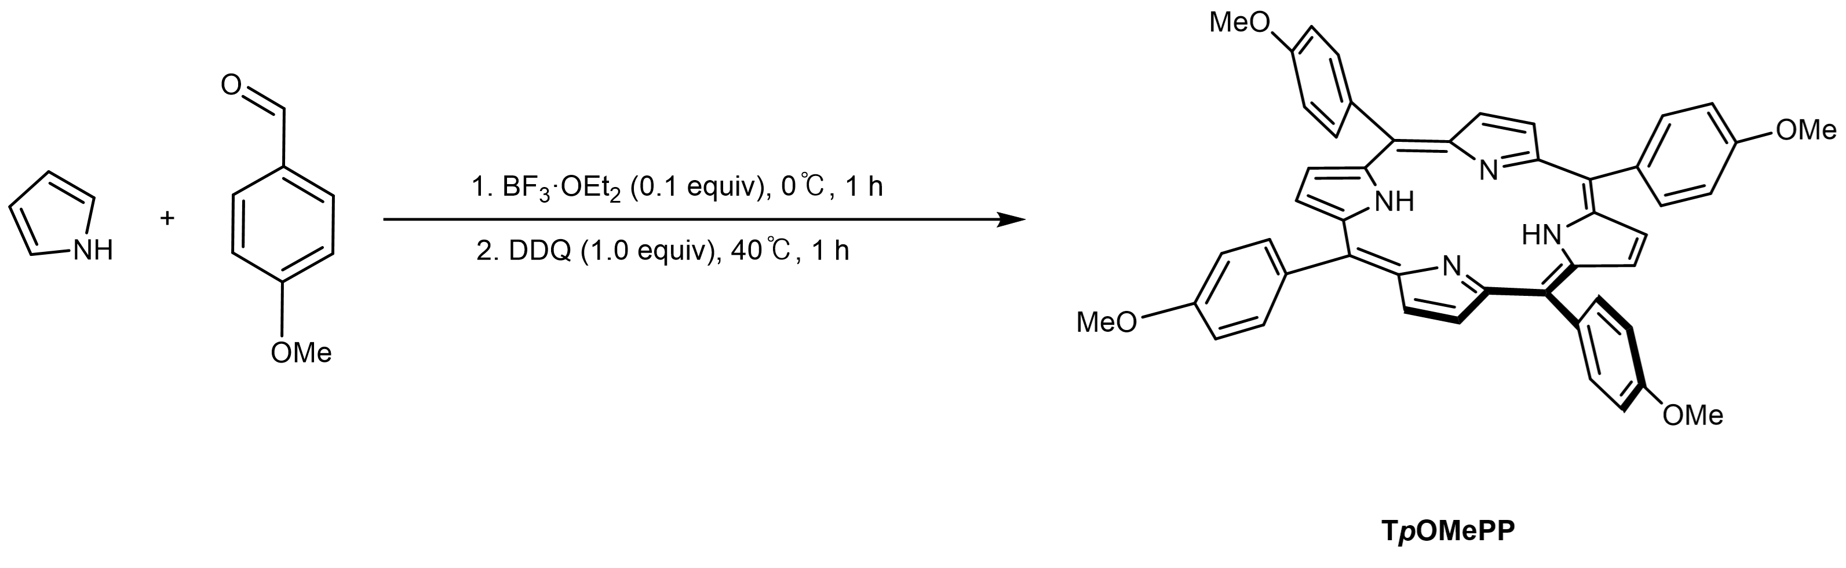
Supplementary Scheme 4. Synthesis of TpOMePP
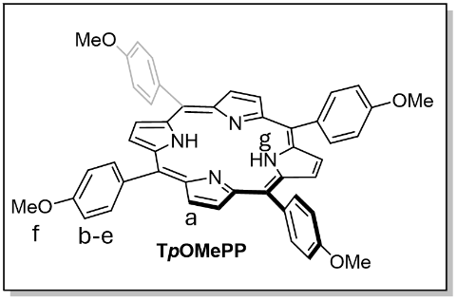
A three-neck 500-mL round bottomed flask equipped with a PTFE-coated magnetic stir bar was charged with pyrrole (0.21 mL, 3.0 mmol, 1.0 equiv), p-methoxybenzaldehyde (0.37 mL, 3.0 mmol, 1.0 equiv), and anhydrous CH₂Cl₂ (300 mL) under N₂. While stirring the reaction mixture at 0 ℃ under N₂, BF₃·OEt₂ (38 µL, 0.30 mmol, 0.10 equiv) was added dropwise via syringe and the mixture was stirred for an hour. Subsequently, 2,3-dichloro-5,6-dicyano-1,4-benzoquinone (0.68 g, 3.0 mmol, 1.0 equiv) was added in one portion, and the reaction mixture was reflux at 40 ℃ for an hour. The reaction was quenched with 1 N NaOH solution (150 mL) and extracted with H₂O (150 mL). The combined organic layers were dried over anhydrous Na₂SO₄, filtered and concentrated under reduced pressure. Then the resulting residue was purified by flash column chromatography over silica gel with elution of CHCl₃ and CH₂Cl₂ mixture (1:6) to afford analytically pure TpOMePP (93 mg, 0.13 mmol, 8.4%) as a solid.
¹H NMR (500 MHz, CDCl₃, 23 ℃): δ 8.89 (s, 8H_{a}), 8.16 (d, J = 2.0 Hz, 4H_{b}), 8.15 (d, J = 2.1 Hz, 4H_{c}), 7.32 (d, J = 2.0 Hz, 4H_{d}), 7.31 (d, J = 2.1 Hz, 4H_{e}), 4.13 (s, 12H_{f}), –2.72 (s, 2H_{g}).

Synthesis of TF₂₀PP
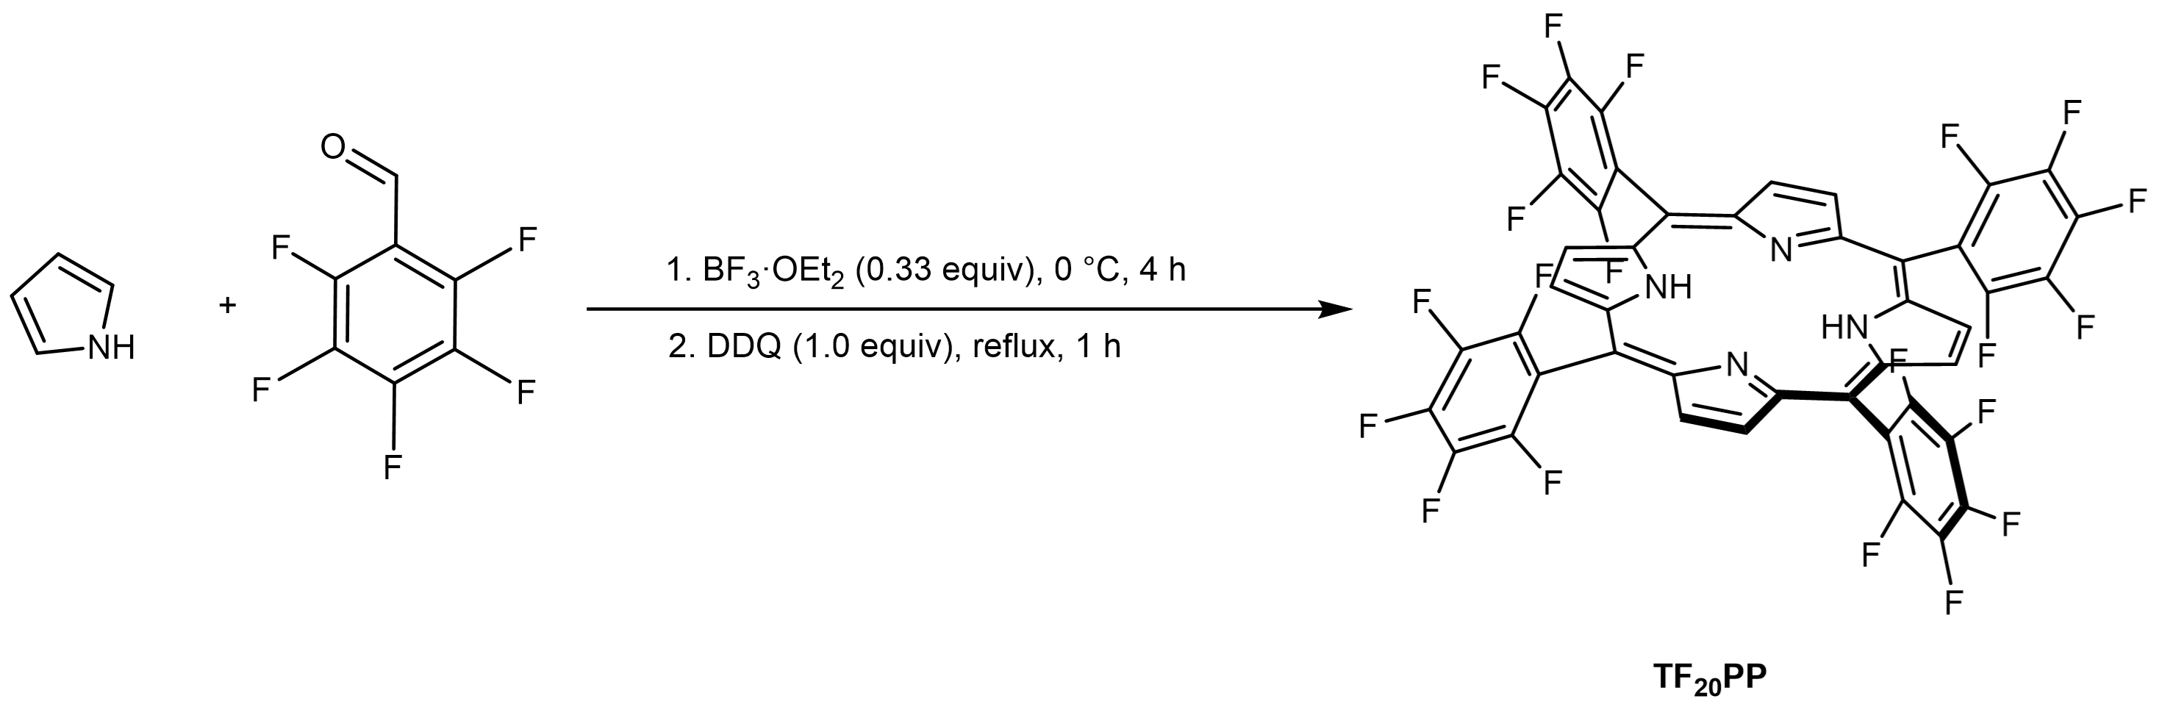
Supplementary Scheme 5. Synthesis of TF₂₀PP
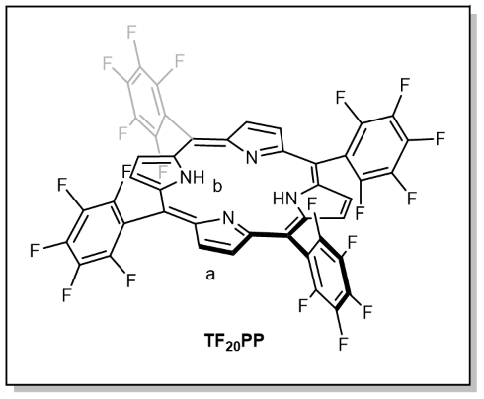
A three-neck 500-mL round bottomed flask equipped with a PTFE-coated magnetic stir bar was charged with pyrrole (0.35 mL, 5.1 mmol, 1.0 equiv), pentafluorobenzaldehyde (1.0 g, 5.1 mmol, 1.0 equiv), and anhydrous CH₂Cl₂ (240 mL) under N₂. While stirring the reaction mixture at 0 ℃, BF₃·OEt₂ (210 µl, 1.7 mmol, 0.33 equiv) was added dropwise via syringe and the reaction mixture was stirred and heated to reflux for 4 h. Then 2,3,5,6-tetrachloro-1,4-benzoquinone (1.3 g, 5.1 mmol, 1.0 equiv) was added in one portion to the reaction mixture and heated to reflux for 1 h. The reaction was quenched with 1 N NaOH solution (150 mL) and extracted with H₂O (150 mL). The combined organic layers were dried over anhydrous Na₂SO₄, filtered and concentrated under reduced pressure. Then the resulting residue was purified by flash column chromatography over silica gel with elution of n-hexane and CH₂Cl₂ mixture (1:6) to afford analytically pure TF₂₀PP (470 mg, 0.49 mmol, 19%) as a solid.
¹H NMR (300 MHz, CDCl₃, 23 ℃): δ 8.95 (s, 8H_{a}), –2.90 (s, 2H_{b}).

Synthesis of TF₁₀PP
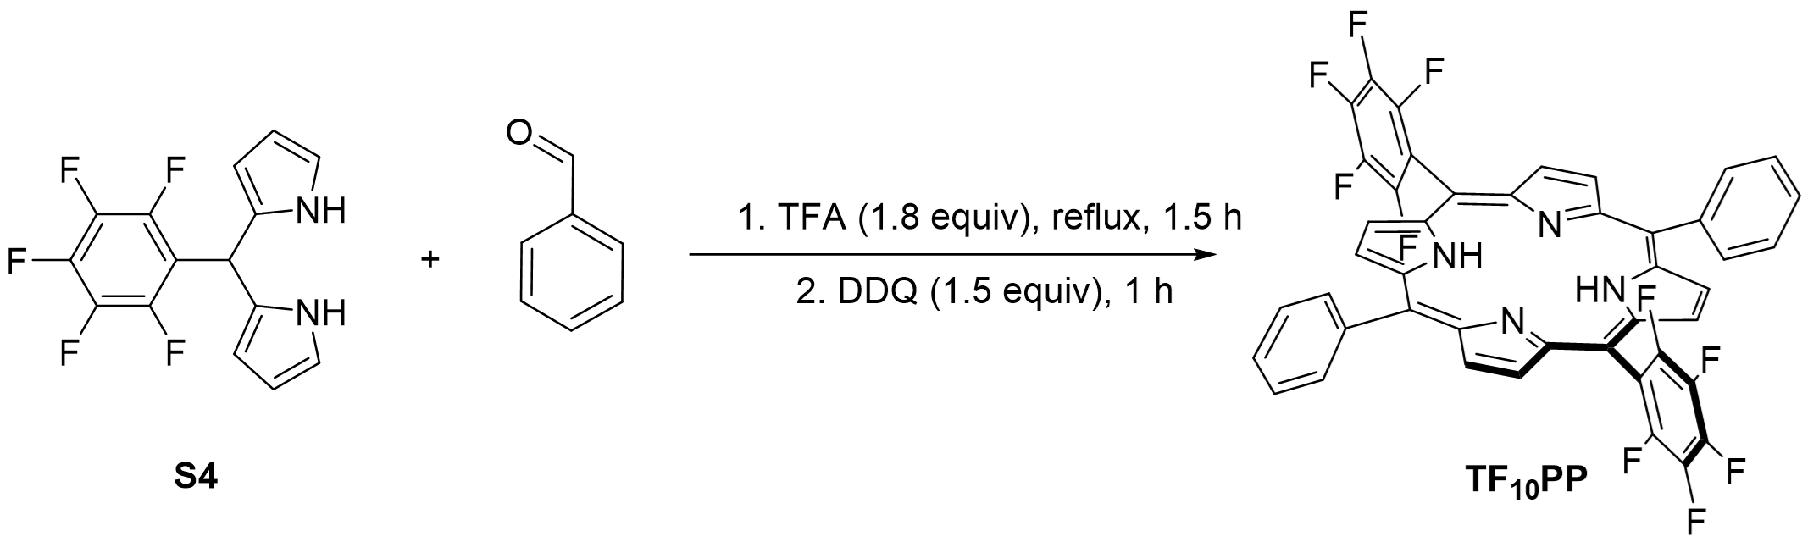
Supplementary Scheme 6. Synthesis of TF₁₀PP
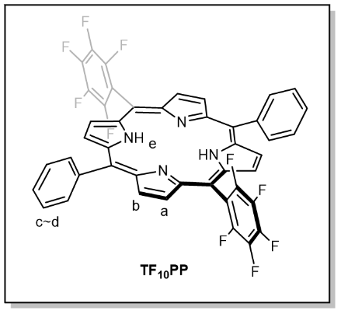
A three-neck 100-mL round bottomed flask equipped with a PTFE-coated magnetic stir bar was charged with benzaldehyde (50 mg, 0.50 mmol, 1.0 equiv), S5 (0.16 g, 0.50 mmol, 1.0 equiv), and anhydrous CH₂Cl₂ (50 mL) under N₂. While stirring the reaction mixture, trifluoroacetic acid (69 µL, 0.90 mmol, 1.8 equiv) was added and the mixture was reflux at 40 ℃ for 90 min. Then 2,3-dichloro-5,6-dicyano-1,4-benzoquinone (0.17 g, 0.75 mmol, 1.5 equiv) was added in one portion, and the reaction mixture was stirred for an hour. The reaction was quenched with triethylamine (0.50 mL) and stirred for 15 min. The mixture was extracted with CH₂Cl₂ (250 mL + 2 × 300 mL) and H₂O (150 mL). The combined organic layers were dried over anhydrous Na₂SO₄, filtered and concentrated under reduced pressure. The resulting residue was recovered and purified by flash column chromatography over silica gel with elution of n-pentane-CH₂Cl₂ mixture (3:1) to afford analytically pure TF₁₀PP (46 mg, 0.058 mmol, 23%) as a solid.
¹H NMR (500 MHz, C₆D₆, 23 ℃): δ 8.98 (d, J = 4.9 Hz, 4H_{a}), 8.83 (d, J = 4.9 Hz, 4H_{b}), 8.25 (dd, J = 7.6, 1.8 Hz, 4H_{c}), 7.87 – 7.73 (m, 6H_{d}), –2.81 (s, 2H_{e}).

Synthesis of ZnL1
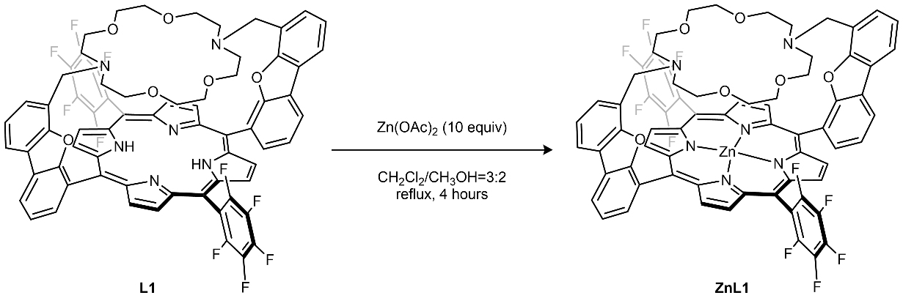
Supplementary Scheme 7. Synthesis of ZnL1
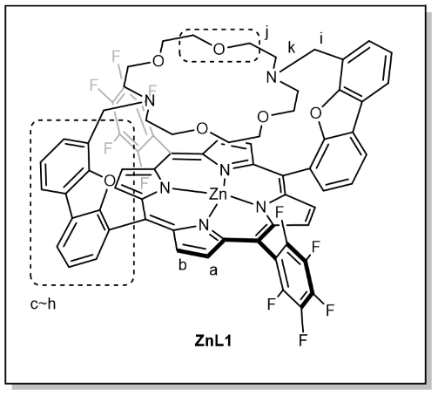
In a 20 mL vial equipped with a PTFE-coated magnetic stir bar was charged with S8 (80 mg, 60 µmol, 1.0 equiv), zinc acetate (118 mg, 600 µmol, 10.0 equiv) and CH₂Cl₂ (9 mL)/CH₃OH (6 mL) mixture. The reaction was heated at 65 ℃ for 4 h, during which the color changed from dark purple to pink-purple. After removal of volatiles under reduced pressure, the resulting pink residue was filtered through a plug of silica gel, eluting with a 2:3 mixture of n-hexane and EtOAc with 2% of triethylamine. The solvent was evaporated, and the residue was washed sequentially with n-hexane (3 × 5 mL) and Et₂O (3 × 5 mL). A dark pink powdery solid of ZnL1 (72 mg, 50 µmol, 87%) was obtained. Pink crystals suitable for X-ray diffraction were obtained by slow evaporation in a mixture of n-hexane, CH₂Cl₂, and Et₂O.
¹H NMR (500 MHz, CD₃CN, 23 ℃): δ 8.98 (d, J = 4.6 Hz, 4H_{a}), 8.94 (d, J = 4.8 Hz, 4H_{b}), 8.67 (d, J = 7.3 Hz, 2H_{c}), 8.50 (d, J = 7.9 Hz, 2H_{d}), 8.13 (d, J = 7.9 Hz, 2H_{e}), 7.94 (t, J = 7.7 Hz, 2H_{f}), 7.30 (t, J = 7.6 Hz, 2H_{g}), 7.14 (d, J = 7.3 Hz, 2H_{h}), 2.99 (s, 4H_{i}), 1.89 – 1.53 (m, 16H_{j}), 0.96 (s, 8H_{k}).
¹³C{¹H} NMR (126 MHz, CDCl_{3,} 23 ℃): δ 157.5, 155.3, 150.9, 149.5, 133.1, 132.1, 130.0, 127.1, 125.5, 124.7, 123.4, 122.7, 121.7, 120.8, 115.3, 102.3, 67.9, 51.8, 30.4, 29.7.
HRMS (ESI/Q-TOF) m/z: [M]⁺ Calcd. for C₇₀H₄₈F₁₀N₆O₆Zn 1322.2767; found 1323.2777

Synthesis of ZnL1-CN_K
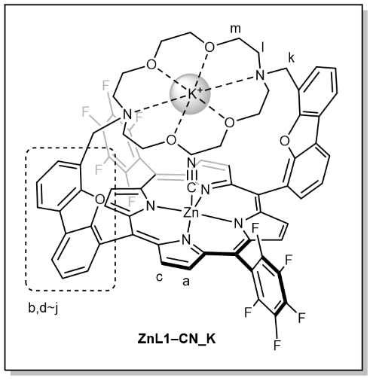
In a 20 mL vial equipped with a PTFE-coated magnetic stir bar were charged with ZnL1(17 mg, 13 µmol, 1.0 equiv), potassium cyanide (13 mg, 190 µmol, 15 equiv) and chlorobenzene (10 mL). The reaction mixture was stirred at 40 ℃ for 6 h, during which the color changed from pink to blue-purple. Upon completion, the reaction mixture was filtered to remove excess KCN salts, and the volatiles were removed under reduced pressure. The resulting residue was washed with n-hexane (3 × 5 mL) and Et₂O (3 × 5 mL). A dark blue-pink powdery solid of ZnL1–CN_K (12 mg, 8.6 µmol, 66%) was obtained. Purple crystals suitable for X-ray diffraction were obtained by slow evaporation in a mixture of CH₂Cl₂ and Et₂O.

¹H NMR (500 MHz, CDCl₃, 23 ℃): δ 8.79 (d, J = 4.5 Hz, 4H_{a}), 8.74 (d, J = 7.2 Hz, 2H_{b}), 8.59 (d, J = 4.4 Hz, 4H_{c}), 8.31 (d, J = 7.9 Hz, 2H_{d}), 7.89 (dd, J = 8.7, 5.3 Hz, 4H_{e}), 7.35 (d, J = 7.9 Hz, 1H_{f}), 7.30 (t, J = 7.5 Hz, 1H_{g}), 7.05 (t, J = 7.3 Hz, 2H_{h}), 6.60 (d, J = 6.6 Hz, 2H_{i}), 2.92 (s, 4H_{j}), 2.51 (s, 4H_{k}), 2.41 (s, 8H_{l}), 1.84 (s, 12H_{m}).
¹³C{¹H} NMR (126 MHz, CDCl_{3,} 23 ℃): δ 157.2, 155.9, 151.0, 149.5, 132.8, 132.7, 129.6, 129.3, 128.4, 125.7, 124.3, 124.0, 123.1, 122.8, 121.7, 120.5 120.0, 114.7, 66.8 66.2, 52.5, 51.8, 30.5 29.9

Synthesis of ZnL2
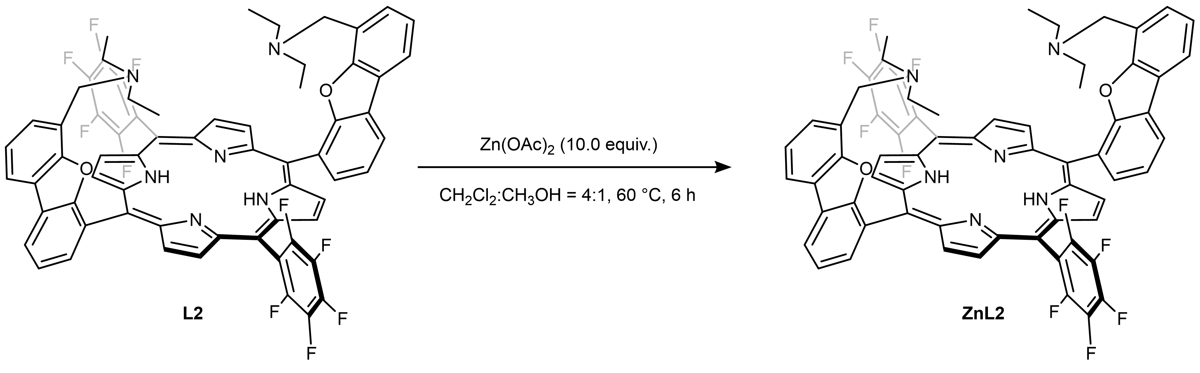
Supplementary Scheme 8. Synthesis of ZnL2
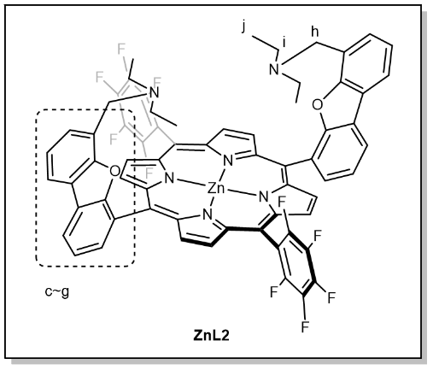
In a 20 mL vial equipped with a PTFE-coated magnetic stir bar were charged with L2 (69 mg, 0.060 mmol, 1.0 equiv), zinc acetate (118 mg, 60.0 µmol, 10.0 equiv) and CH₂Cl₂ (12 mL)/CH₃OH (3 mL) mixture. The reaction was heated at 60 ℃ for 6 h, during which the color changed from dark purple to pink-purple. After removal of volatiles under reduced pressure, the resulting pink residue was filtered through a plug of silica gel, eluting with a 1:1 mixture of n-hexane and EtOAc with 1% of triethylamine. The solvent was evaporated, and the residue was washed with n-hexane (3 × 5 mL) and Et₂O (3 × 5 mL). A dark pink powder of ZnL2 (48 mg, 40 µmol, 67%) was obtained.
¹H NMR (500 MHz, CDCl₃, 23 ℃): δ 8.96 (dd, J = 7.8, 4.7 Hz, 4H_{a}), 8.82 (t, J = 4.8 Hz, 4H_{b}), 8.40 (dd, J = 7.9, 3.4 Hz, 2H_{c}), 8.24 (t, J = 7.8 Hz, 2H_{d}), 8.14 – 8.04 (m, 2H_{e}), 7.85 – 7.73 (m, 2H_{f}), 7.46 – 7.31 (m, 4H_{g}), 3.12 (d, J = 32.5 Hz, 4H_{h}), 1.94 (d, J = 29.4 Hz, 8H_{i}), 0.27 (d, J = 38.0 Hz, 12H_{j}).
HRMS (ESI/Q-TOF) m/z: [M]⁺ Calcd. for C₆₆H₄₄F₁₀N₆O₂Zn 1145.; found 1145.53352

Synthesis of ZnTF₁₀PP
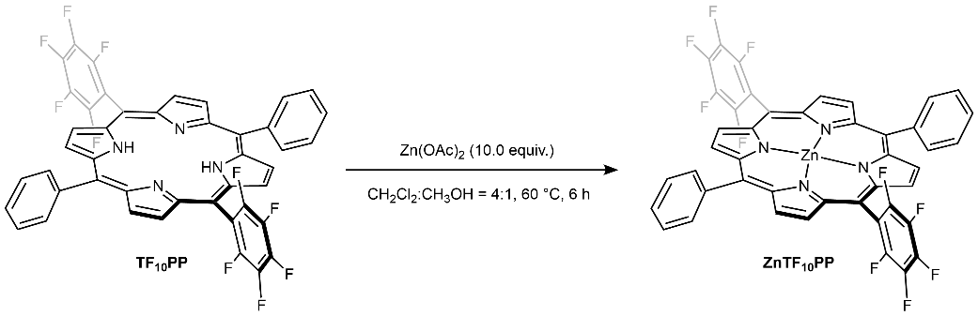
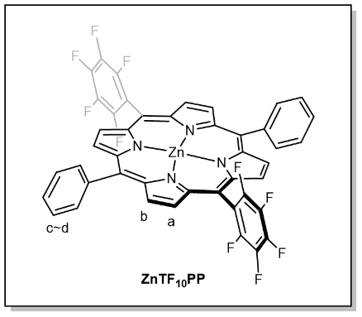
Supplementary Scheme 9. Synthesis of ZnTF₁₀PP
In a 20 mL vial equipped with a PTFE-coated magnetic stir bar were charged TF₁₀PP (50 mg, 60 µmol, 1.0 equiv), zinc acetate (120 mg, 630 µmol, 10 equiv) and a CH₂Cl₂ (12 mL)/CH₃OH (3 mL) mixture. The reaction was heated at 60 ℃ for 6 h, during which the color changed from dark purple to pink. After removal of volatiles under reduced pressure, the resulting pink residue was filtered through a plug of silica gel, eluting with a 1:1 mixture of n-hexane and EtOAc with 1% of triethylamine. The solvent was evaporated, and the residue was washed with n-hexane (3 × 5 mL) and Et₂O (3 × 5 mL). A dark pink powdery solid of ZnTF₁₀PP (36 mg, 40 µmol, 67%) was obtained.
¹H NMR (500 MHz, C₆D₆, 23 ℃):¹H NMR (300 MHz, Chloroform-d) δ 9.05 (d, J = 4.7 Hz, 4H_{a}), 8.89 (d, J = 4.7 Hz, 4H_{b}), 8.33 – 8.14 (m, 4H_{c}), 7.89 – 7.66 (m, 6H_{d}).

Synthesis of FeL1–Cl
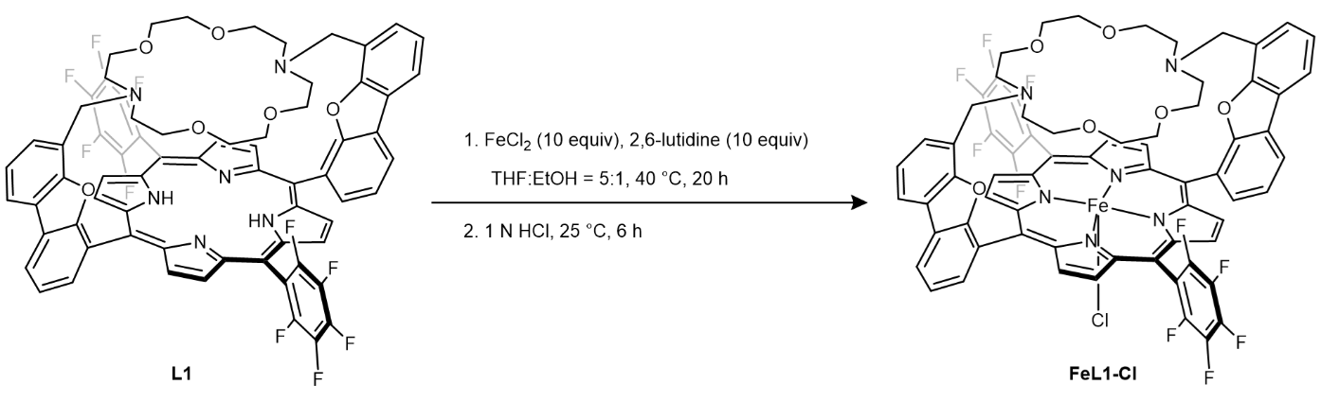
Supplementary Scheme 10. Synthesis of FeL1–Cl
In an N₂ filled glove box, a 20 mL vial equipped with a PTFE-coated magnetic stir bar was charged with L1 (63 mg, 50 µmol, 1.0 equiv), FeCl₂ (63 mg, 0.50 mmol, 10 equiv) and 2,6-lutidine (54 mg, 0.50 mmol, 10 equiv) with a mixture of THF/EtOH in a 5:1 ratio. The reaction was heated at 40 ℃ for 20 h, which the color changed from dark purple to red-purple. Then the reaction mixture was exposed to air, and the solution turned brown. 25 mL of 1 N HCl was added to the reaction mixture and stirred at 25 ℃ for 6 h. The resulting residue was extracted with CH₂Cl₂ (3 × 50 mL). The combined organic layers were dried over anhydrous Na₂SO₄, filtered, and concentrated under reduced pressure. The residue was washed with n-hexane (3 × 5 mL) and Et₂O (3 × 5 mL) to afford FeL1–Cl as a dark brown solid (48 mg, 36 µmol, 72%). The product was characterized by UV-vis spectroscopy and HRMS.
HRMS (ESI/Q-TOF) m/z: [M]⁺ Calcd. for C₃₄H₄₁N₃ 492.3378; found 492.3373.
UV-vis (CH₂Cl₂): 361 nm (ε = 4.36×10⁴ L mol^{–1} cm^{–1}), 416 nm (ε = 9.41×10⁴ L mol^{–1} cm^{–1}), 506 nm (ε = 8.98×10³ L mol^{–1} cm^{–1}), 642 nm (ε = 2.73×10³ L mol^{–1} cm^{–1})

Synthesis of FeL1–Im₂
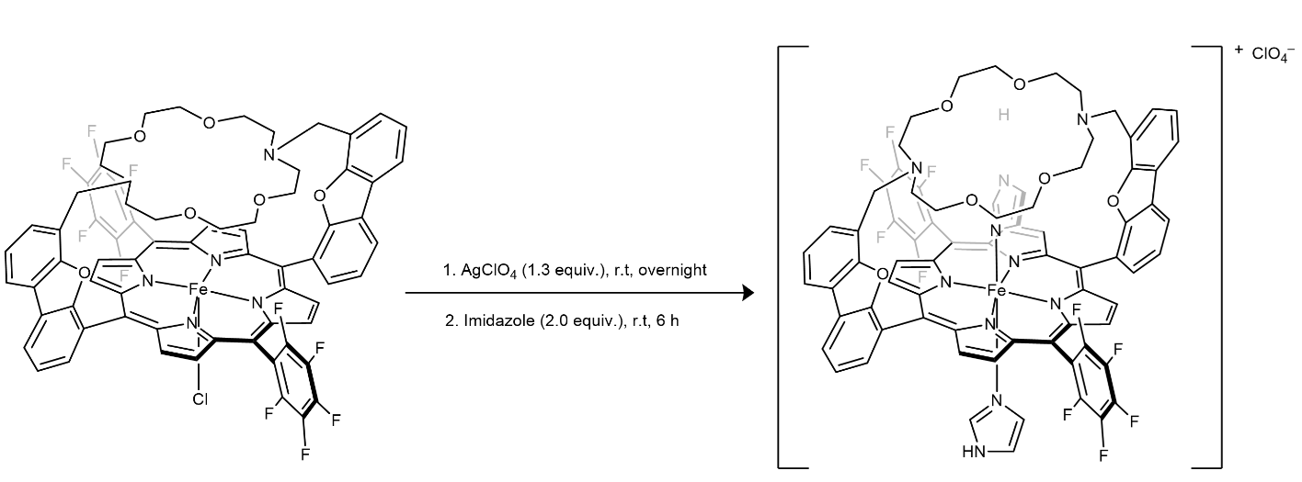
Supplementary Scheme 11. Synthesis of FeL1–Im₂
In an N₂ filled glove box, a 20 mL vial equipped with a PTFE-coated magnetic stir bar was charged with FeL1–Cl (63 mg, 50 µmol, 1.0 equiv), AgClO₄ (14 mg, 65 µmol, 1.3 equiv) and CH₂Cl₂ (4.0 mL). The reaction was stirred at 25 ℃ for overnight. Then imidazole (9 mg, 0.1 mmol, 2 equiv) was added to the reaction mixture and stirred at 25 ℃ for 6 hours. The reaction mixture was filtered with glass fiber to remove excess AgClO₄ and AgCl salts, and collected organic layers were concentrated under reduced pressure. The dark brown solid of FeL1–Im₂ (38 mg, 26 µmol, 56%) was obtained. Red crystals suitable for X-ray diffraction were obtained by slow evaporation in CH₂Cl₂ and checked by UV-vis and NMR.
¹H NMR (500 MHz, CDCl₃, 23 ℃): δ 9.89 (s, 1H_{a}), 7.99 (d, J = 8.5 Hz, 1H_{b}), 7.36 (d, J = 8.6 Hz, 1H_{c}), 7.34 – 7.29 (m, 1H_{g}), 7.26 (d, J = 7.6 Hz, 2H_{g'}), 7.12 (d, J = 7.3 Hz, 3H_{g''}), 6.96 (t, J = 8.0 Hz, 1H_{e}), 6.62 (d, J = 8.3 Hz, 1H_{d}), 6.13 (d, J = 7.6 Hz, 1H_{f}), 3.90 (sep, J = 6.6 Hz, 2H_{h}), 3.34 (sep, J = 6.7 Hz, 2H_{h'}), 1.50 (d, J = 6.6 Hz, 6H_{i}), 1.29 (d, J = 6.8 Hz, 12H_{i''}), 1.10 (d, J = 6.9 Hz, 6H_{i'''}).
HRMS (ESI/Q-TOF) m/z: [M+H]⁺ Calcd. for C₃₄H₄₁N₃ 492.3378; found 492.3373
UV-vis (CH₂Cl₂): 415 nm (ε = 7.70×10⁴ L mol^{–1} cm^{–1}), 549 nm (ε = 6.68×10³ L mol^{–1} cm^{–1})

Synthesis of FeTpOMePP–Cl
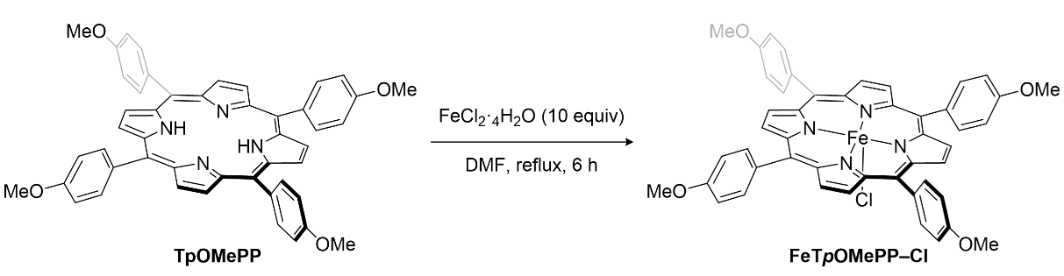
Supplementary Scheme 12. Synthesis of FeTpOMePP–Cl
In an N₂ filled glove box, a 20 mL vial equipped with a PTFE-coated magnetic stir bar was charged with TpOMePP (68 mg, 68 µmol, 1.0 equiv), FeCl₂.4H₂O (140 mg, 0.68 mmol, 10 equiv), and DMF (5 mL). The reaction was heated to reflux for 6 hours. Then the reaction mixture was diluted with CHCl₃ (30 mL), the solution was washed with 25 mL of 1 N HCl and the mixture was extracted with CH₂Cl₂ (3 × 50 mL). The combined organic layers were dried over anhydrous Na₂SO₄, filtered and the organic layers were concentrated under reduced pressure. The resulting residue was washed with n-hexane (3 × 5 mL) and Et₂O (3 × 5 mL) the dark brown powdery solids of FeTpOMePP–Cl (48 mg, 58 µmol, 86%) was obtained and checked by UV-vis and HRMS.
HRMS (ESI/Q-TOF) m/z: [M+H]⁺ Calcd. for C₄₈H₃₆ClN₄O₄Fe 823.1769; found 823.1688

Synthesis of FeTF₁₀PP–Cl
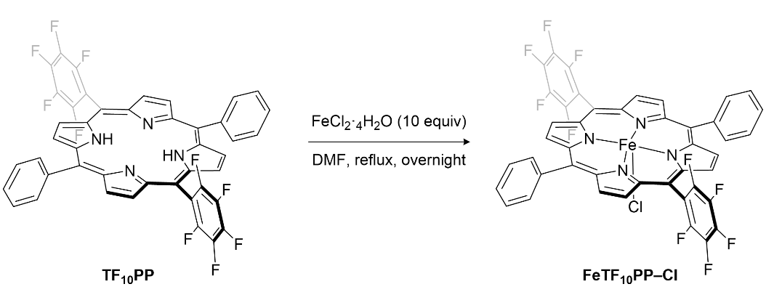
Supplementary Scheme 13. Synthesis of FeTF₁₀PP–Cl
In an N₂ filled glove box, a 20 mL vial equipped with a PTFE-coated magnetic stir bar was charged with TF₁₀PP (49 mg, 50 µmol, 1.0 equiv), FeCl₂.4H₂O (99 mg, 0.50 mmol, 10 equiv), and DMF (5 mL). The reaction was heated to reflux for overnight. Then the reaction mixture was diluted with CHCl₃ (30 mL), the solution was washed with 25 mL of 1 N HCl and the mixture was extracted with CH₂Cl₂ (3 × 50 mL). The combined organic layers were dried over anhydrous Na₂SO₄, filtered and the organic layers were concentrated under reduced pressure. The resulting residue was washed with n-hexane (3 × 5 mL) and Et₂O (3 × 5 mL) the dark brown powdery solids of FeTF₁₀PP–Cl (38 mg, 45 µmol, 89%) was obtained and checked by UV-vis and HRMS.
HRMS (ESI/Q-TOF) m/z: [M+H]⁺ Calcd. for C₄₄H₁₈F₁₀N₄Fe 849.0794; found 849.0782

Synthesis of FeTF₂₀PP–Cl
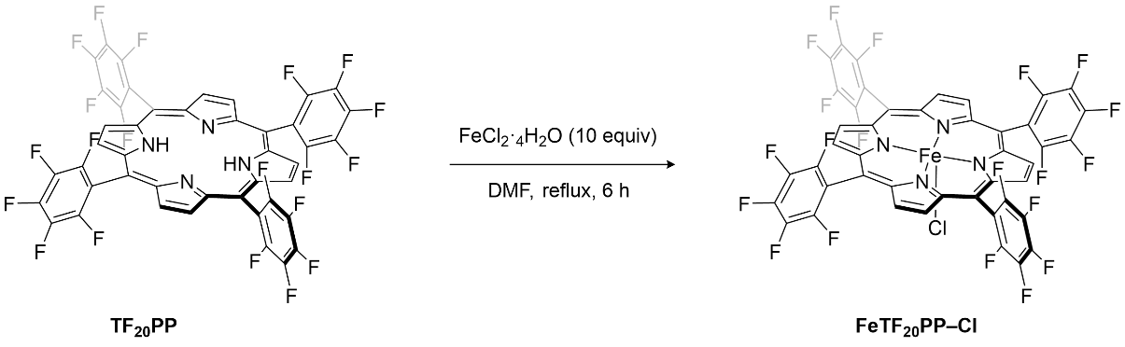
Supplementary Scheme 14. Synthesis of FeTF₂₀PP–Cl
In an N₂ filled glove box, a 20 mL vial equipped with a PTFE-coated magnetic stir bar was charged with TF₂₀PP (50 mg, 50 µmol, 1.0 equiv), FeCl₂.4H₂O (0.10 g, 0.50 mmol, 10 equiv) and DMF (5.0 mL). The reaction was heated to reflux for 6 hours. Then the reaction mixture was diluted with 30 mL of CHCl₃, the solution was washed with 25 mL of 1 N HCl and the mixture was extracted with CH₂Cl₂ (3 × 50 mL). The combined organic layers were dried over anhydrous Na₂SO₄, filtered and the collected organic layers were concentrated under reduced pressure. The resulting residue was washed with n-hexane (3 × 5 mL) and Et₂O (3 × 5 mL). The glossy dark-brown powdery solid of FeTF₂₀PP–Cl (29 mg, 27 µmol, 54%) was obtained and checked by UV-vis and HRMS.
HRMS (ESI/Q-TOF) m/z: [M+OH]– Calcd. for C₄₄H₁₉F₁₀N₄FeClO 1079.9489; found 1079.9795

X-ray Crystallographic Data for L1
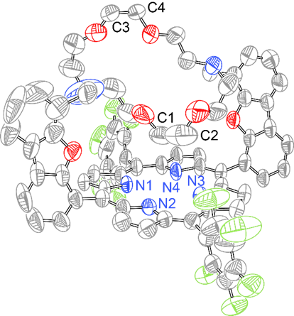
Supplementary Fig 2. Thermal ellipsoid plot of L1 drawn at the 50% probability.
Table S1. Crystal data and structure refinement for L1 (CCDC 2443508)
Detector | Pilatus 3 6M
Empirical (moiety) formula | C₇₀N₆O₆F₁₀H₅₀
Formula weight | 1261.19
Temperature/K | 100.00
Crystal system | orthorhombic
Space group | P2₁2₁2₁
a, b, c/Å | 14.504(3), 14.912(3), 31.237(6)
α, β, γ/° | 90, 90, 90
Volume/Å³ | 6756(2)
Z | 4
ρ_{calc}mg/m³ | 1.242
μ/mm⁻¹ | 0.096
F(000) | 2604.0
Crystal size/mm³ | 0.28 × 0.07 × 0.04
Radiation | Synchrotron (PLS-II 11C Bending magnet, λ = 0.70000)
2Θ range for data collection/° | 2.98 to 59.972
Index ranges | –18≤ h ≤18, –21≤ k ≤21, –42≤ l ≤41
Reflections collected | 15616
Independent reflections | 15616 [R_{int} = 0.1120, R_{sigma} = 0.0233]
Data/restraints/parameters | 15616/0/830
Goodness-of-fit on F² | 1.343
Final R indexes [I>=2σ (I)] | R₁ = 0.1002, wR₂ = 0.3010
Final R indexes [all data] | R₁ = 0.1172, wR₂ = 0.3272
Largest diff. peak/hole / e Å^{–3} | 0.36/−0.37

X-ray Crystallography Data of L1_K
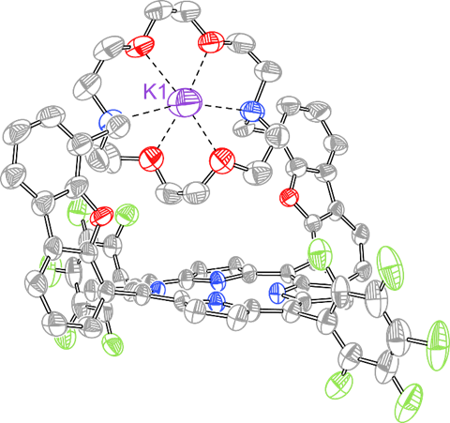
Supplementary Fig 3. Thermal ellipsoid plot of L1_K drawn at the 50% probability.
Table S2. Crystal data and structure refinement for L1_K (CCDC 2443504)
Detector | Rayonix MX225HS CCD
Empirical (moiety) formula | C₁₀₂H₆₂BF₃₄KN₆O₆
Formula weight | 2163.48
Temperature/K | 101(2)
Crystal system | Monoclinic
Space group | P2₁
a, b, c/Å | 15.145(3), 15.000(3), 25.204(5)
α, β, γ/° | 90, 106.40(3), 90
Volume/Å³ | 5493(2)
Z | 2
ρ_{calc}mg/m³ | 1.308
μ/mm⁻¹ | 0.150
F(000) | 2188
Crystal size/mm³ | 0.114 × 0.072 × 0.019
Radiation | Synchrotron (PLS-II 2D Bending magnet, λ = 0.70000)
2Θ range for data collection/° | 1.380 to 27.039
Index ranges | –19≤ h ≤19, –19≤ k ≤19, –32≤ l ≤32
Reflections collected | 50341
Independent reflections | 25208 [R_{int} = 0.0722]
Data/restraints/parameters | 25208/4297/1595
Goodness-of-fit on F² | 0.945
Final R indexes [I>=2σ (I)] | R₁ = 0.0922, wR₂ = 0.2349
Final R indexes [all data] | R₁ = 0.1597, wR₂ = 0.2836
Largest diff. peak/hole / e Å^{–3} | 0.447/−0.772

X-ray Crystallographic Data for L1_Na
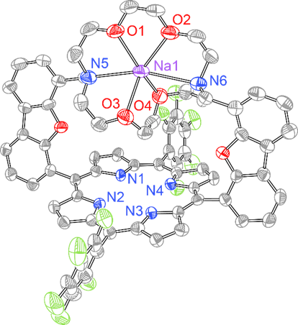
Supplementary Fig 4. Thermal ellipsoid plot of L1_Na drawn at the 50% probability.
Table S3. Crystal data and structure refinement for L1_Na (CCDC 2443509)
Detector | Bruker APEX-II
Empirical (moiety) formula | C₁₀₂H₆₂BF₃₄N₆NaO₆
Formula weight | 2202.61
Temperature/K | 100.00
Crystal system | monoclinic
Space group | P2₁
a, b, c/Å | 15.2007(7), 15.0549(7), 25.3769(12)
α, β, γ/° | 90, 106.412(3), 90
Volume/Å³ | 5570.8(5)
Z | 2
ρ_{calc}mg/m³ | 1.280
μ/mm⁻¹ | 1.084
F(000) | 2172.0
Crystal size/mm³ | 0.18 × 0.12 × 0.08
Radiation | CuKα (λ = 1.54178)
2Θ range for data collection/° | 3.63 to 133.862
Index ranges | –17≤h≤18, –17≤k≤17, –29≤l≤25
Reflections collected | 163761
Independent reflections | 19188 [R_{int} = 0.0577, R_{sigma} = 0.0271]
Data/restraints/parameters | 19188/1762/1512
Goodness-of-fit on F² | 1.042
Final R indexes [I>=2σ (I)] | R₁ = 0.0794, wR₂ = 0.2247
Final R indexes [all data] | R₁ = 0.0867, wR₂ = 0.2342
Largest diff. peak/hole / e Å^{–3} | 0.48/−0.36

X-ray Crystallographic Data for ZnL1
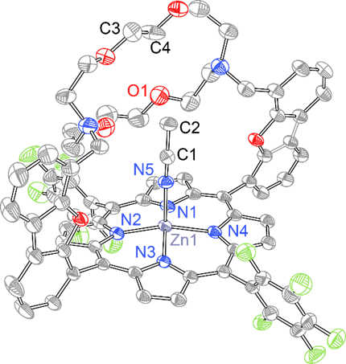
Supplementary Fig 5. Thermal ellipsoid plot of ZnL1 drawn at the 50% probability.
Table S4. Crystal data and structure refinement for ZnL1 (CCDC 2443506)
Detector | Bruker APEX-II
Empirical (moiety) formula | C₇₆H₅₇F₁₀N₉O₆Zn
Formula weight | 1447.67
Temperature/K | 100(2)
Crystal system | monoclinic
Space group | C2/c
a, b, c/Å | 28.7437(4), 13.7039(2), 33.1753(5)
α, β, γ/° | 90, 99.2485(8), 90
Volume/Å³ | 12897.9(3)
Z | 8
ρ_{calc}mg/m³ | 1.491
μ/mm⁻¹ | 1.336
F(000) | 5952.0
Crystal size/mm³ | 0.1 × 0.04 × 0.02
Radiation | CuKα (λ = 1.54178)
2Θ range for data collection/° | 5.398 to 133.538
Index ranges | –27≤h≤34, –16≤k≤16, –39≤l≤38
Reflections collected | 157360
Independent reflections | 11369 [R_{int} = 0.0417, R_{sigma} = 0.0165]
Data/restraints/parameters | 11369/274/997
Goodness-of-fit on F² | 1.028
Final R indexes [I>=2σ (I)] | R₁ = 0.0564, wR₂ = 0.1557
Final R indexes [all data] | R₁ = 0.0643, wR₂ = 0.1649
Largest diff. peak/hole / e Å^{–3} | 1.05/–0.53

X-ray Crystallographic Data for ZnL1–CN_K
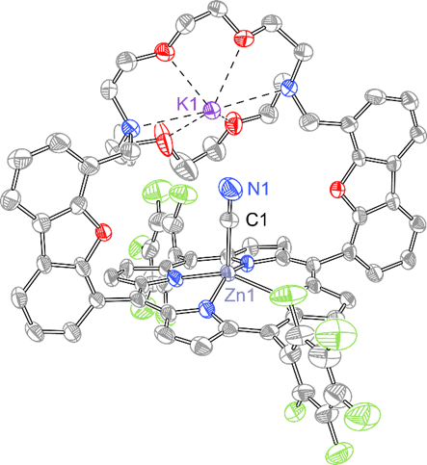
Supplementary Fig 6. Thermal ellipsoid plot of ZnL1–CN_K drawn at the 50% probability.
Table S5. Crystal data and structure refinement for ZnL1–CN_K (CCDC 2443503)
Detector | Pilatus 3 6M
Empirical (moiety) formula | C₇₁H₄₈F₁₀KN₇O₆Zn
Formula weight | 1389.65
Temperature/K | 101(2)
Crystal system | monoclinic
Space group | P2₁/n
a, b, c/Å | 17.276(3), 15.139(3), 30.387(6)
α, β, γ/° | 90, 99.2485(8), 90
Volume/Å³ | 7947(3)
Z | 4
ρ_{calc}mg/m³ | 1.162
μ/mm⁻¹ | 0.414
F(000) | 2840
Crystal size/mm³ | 0.050 × 0.040 × 0.030
Radiation | Synchrotron (PLS-II 11C Bending magnet, λ = 0.70000)
2Θ range for data collection/° | 1.480 to 24.831
Index ranges | –20≤h≤20, –18≤k≤18, –36≤l≤36
Reflections collected | 52440
Independent reflections | 14345 [R_{int} = 0.0913]
Data/restraints/parameters | 14345/216/1029
Goodness-of-fit on F² | 1.058
Final R indexes [I>=2σ (I)] | R₁ = 0.1210, wR₂ = 0.3154
Final R indexes [all data] | R₁ = 0.1347, wR₂ = 0.3256
Largest diff. peak/hole / e Å^{–3} | 1.553/–0.822

X-ray Crystallographic Data for FeL1–Im₂
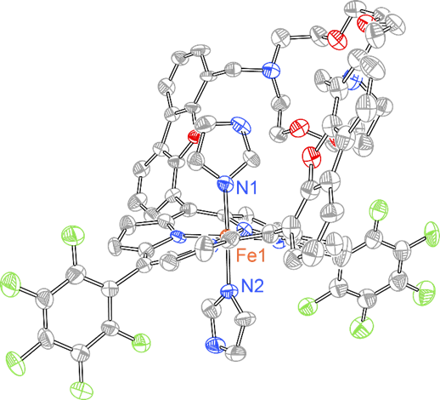
Supplementary Fig 7. Thermal ellipsoid plot of FeL1–Im₂ drawn at the 50% probability.
Table S6. Crystal data and structure refinement for FeL1–Im₂ (CCDC 2443505)
Detector | Bruker APEX-II
Empirical (moiety) formula | C₇₆H₅₇N₁₀O₁₈F₁₀Cl₃Fe
Formula weight | 1750.51
Temperature/K | 173(2)
Crystal system | orthorhombic
Space group | P2₁2₁2₁
a, b, c/Å | 15.3413(10), 21.2431(14), 27.9337(19)
α, β, γ/° | 90, 90, 90
Volume/Å³ | 9103.5(10)
Z | 4
ρ_{calc}mg/m³ | 1.277
μ/mm⁻¹ | 0.340
F(000) | 3576.0
Crystal size/mm³ | 0.192 × 0.137 × 0.039
Radiation | MoKα (λ = 0.71073)
2Θ range for data collection/° | 4.776 to 56.112
Index ranges | –20 ≤ h ≤ 18, –27 ≤ k ≤ 27, –36 ≤ l ≤ 27
Reflections collected | 110910
Independent reflections | 21956 [R_{int} = 0.0985, R_{sigma} = 0.0616]
Data/restraints/parameters | 21956/696/1195
Goodness-of-fit on F² | 1.042
Final R indexes [I>=2σ (I)] | R₁ = 0.0783, wR₂ = 0.1871
Final R indexes [all data] | R₁ = 0.1002, wR₂ = 0.1984
Largest diff. peak/hole / e Å^{–3} | 0.64/−0.65

UV-vis Spectrum Data for L1 and ZnL1
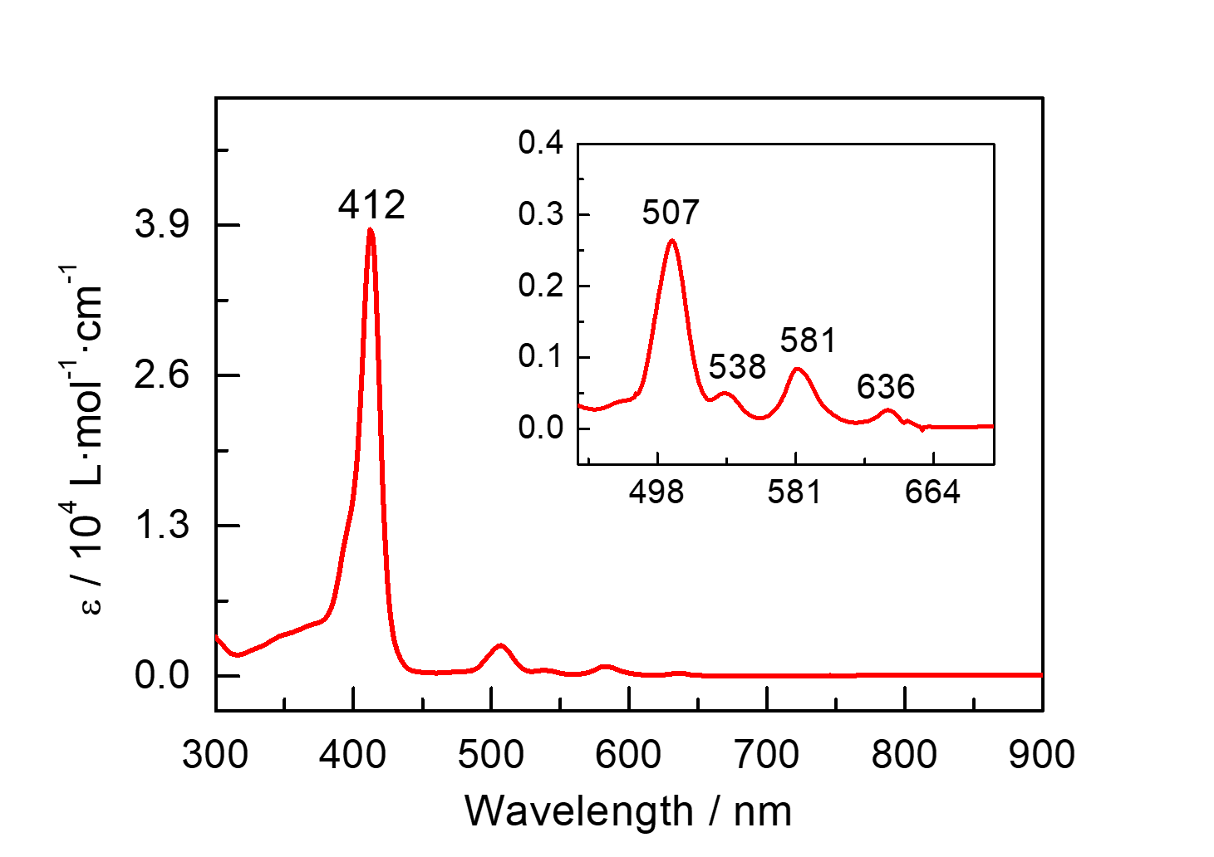
Supplementary Fig 8. UV-vis spectra of 2.5 µM L1 (▬, red) in CH₃CN at 23 ℃
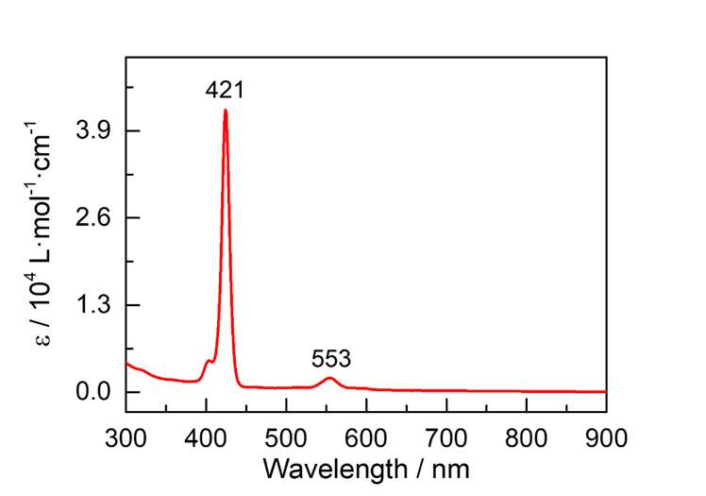
Supplementary Fig 9. UV-vis spectra of 1.25 µM ZnL1 (▬, red) in CH₃CN at 23 ℃

UV-vis Spectrum Data for FeL1–Cl and FeL1–Im₂
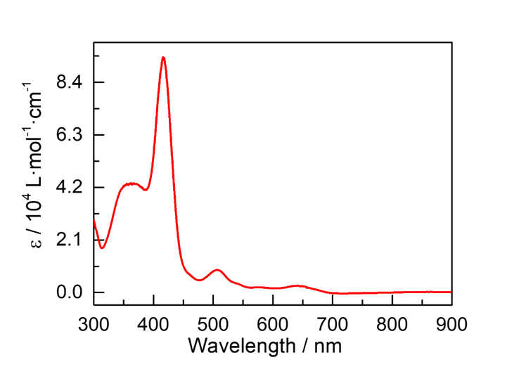
Supplementary Fig 10. UV-vis spectra of 14.3 µM FeL1–Cl (▬, red) in CH₂Cl₂ at 23 ℃ under N₂
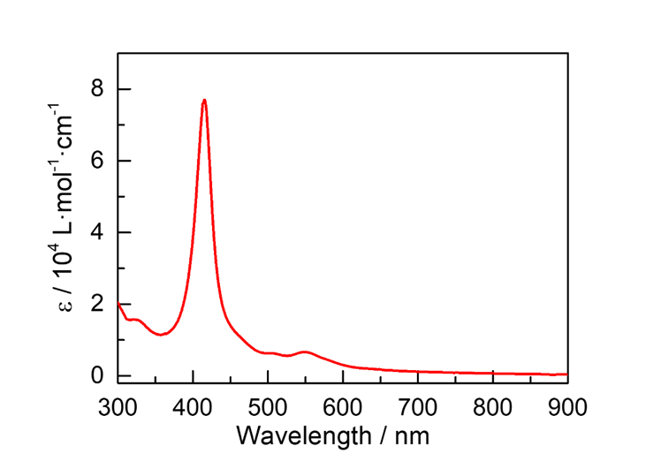
Supplementary Fig 11. UV-vis spectra of 14.3 µM FeL1–Im₂ (▬, red) in CH₂Cl₂ at 23 ℃ under N₂

UV-vis Spectrum Data for Fe-incorporated Derivatives of the Control Ligands
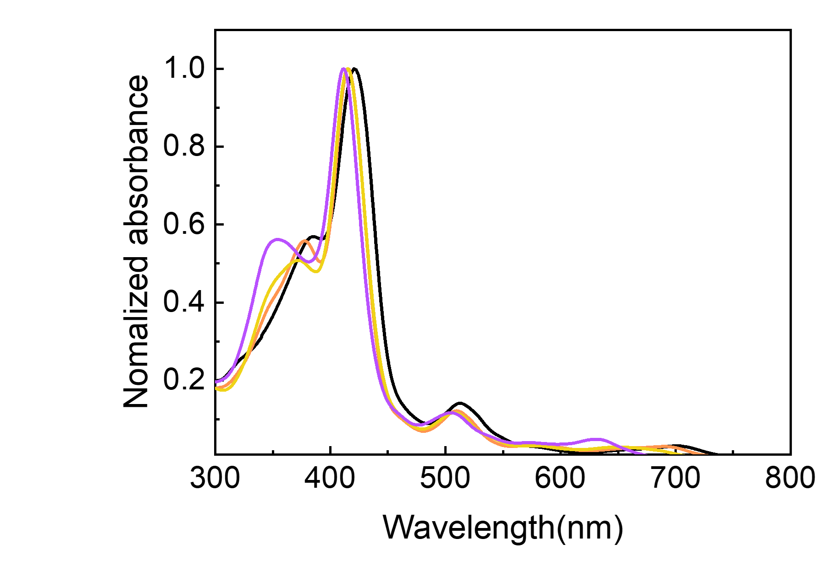
Supplementary Fig 12. UV-vis spectra of FeTpOMePP–Cl (▬, black), FeTPP–Cl (▬, yellow), FeTF₁₀PP–Cl (▬, purple), and FeTF₂₀PP–Cl (▬, orange) in CH₂Cl₂ (include 1% DMF) containing 0.1 M TBAPF₆ at 23 °C, under the same conditions as electrochemical measurements.

ESI-MS Spectrum of the Selected Compounds
The following are comparisons of High-Resolution Mass Spectrum (HRMS) measurements (▬, black solid line) and simulated results (▬, red solid line) for each major compound.
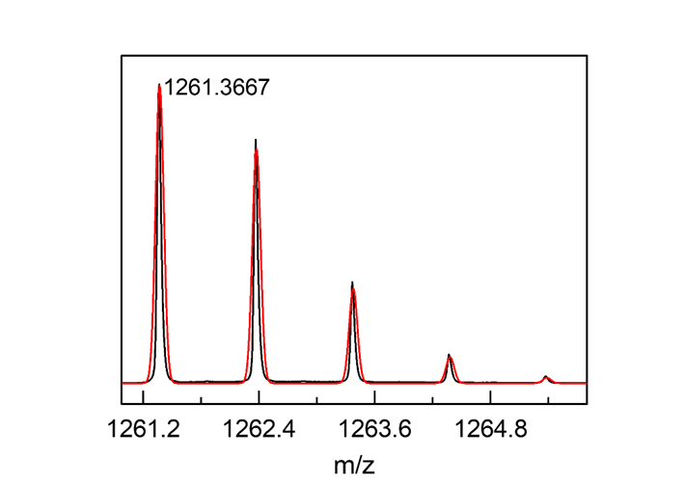
Supplementary Fig 13. HRMS scan of a CH₂Cl₂ solution of L1 mixture was obtained. Observed mass and isotope pattern at 1261.3667 m/z matches the predicted mass (1261.3705 m/z) for [L1+H]⁺.
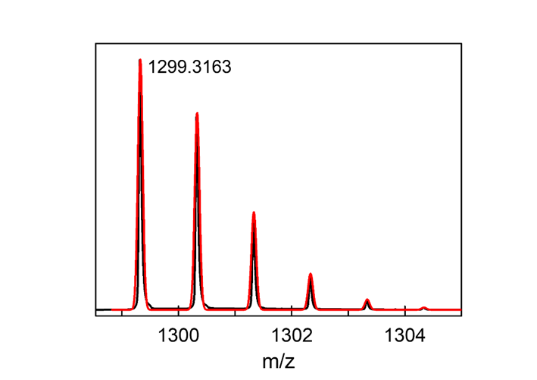
Supplementary Fig 14. HRMS scan of a CH₂Cl₂ solution of L1_K mixture was obtained. Observed mass and isotope pattern at 1299.3163 m/z matches the predicted mass (1299.3269 m/z) for [L1+K]⁺.

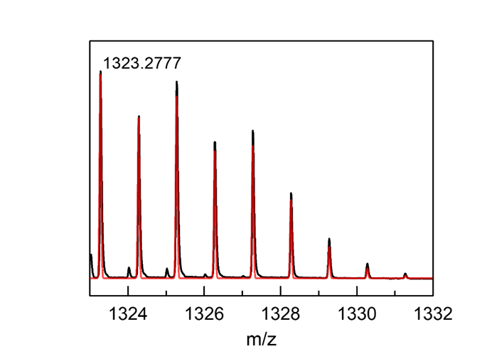
Supplementary Fig 15. HRMS scan of a CH₂Cl₂ solution of ZnL1 mixture was obtained. Observed mass and isotope pattern at 1323.2777 m/z matches the predicted mass (1324.2840 m/z) for [ZnL1+H]⁺.

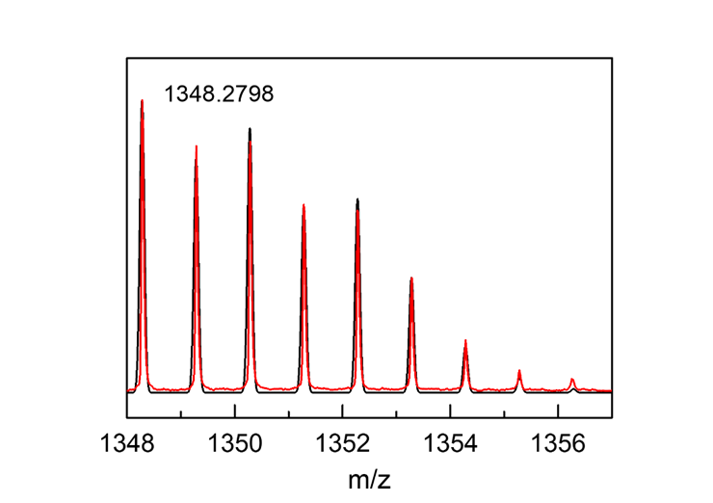
Supplementary Fig 16. HRMS scan of a CH₂Cl₂ solution of ZnL1–CN_K mixture was obtained. Observed mass and isotope pattern at 1348.2798 m/z matches the predicted mass (1348.28 m/z) for [ZnL1–CN+H]⁺.

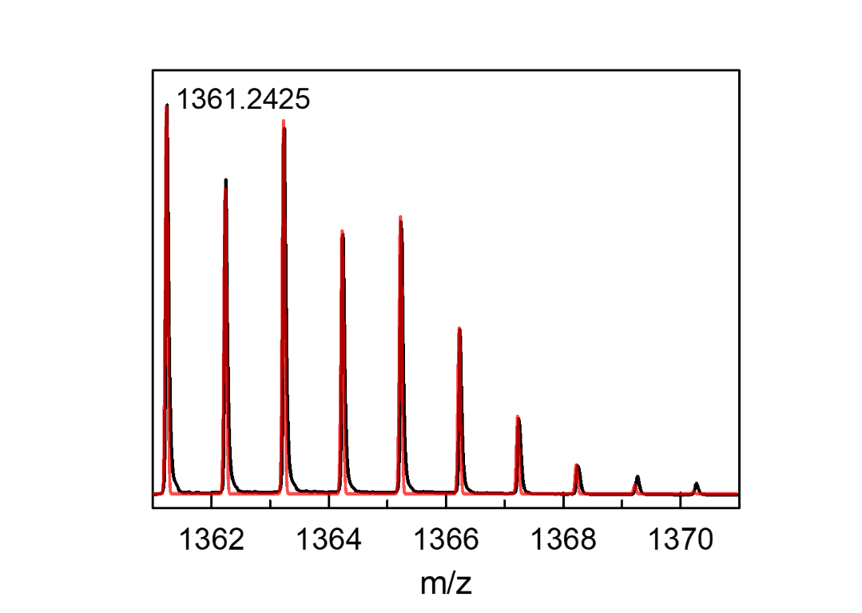
Supplementary Fig 17. HRMS scan of a CH₃CN solution of ZnL1 with KOTf (5.0 equiv) mixture for ZnL1_K was obtained. Observed mass and isotope pattern at 1361.2425 m/z matches the predicted mass (1361.2403 m/z) for [ZnL1_K]⁺.

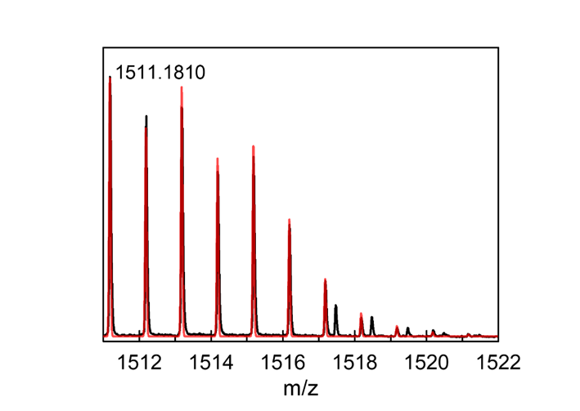
Supplementary Fig 18. HRMS scan of a CH₃CN solution of ZnL1 with Ca(OTf)₂ (5.0 equiv) mixture for ZnL1_Ca was obtained. Observed mass and isotope pattern at 1511.1810 m/z matches the predicted mass (1511.1908 m/z) for [ZnL1+CaOTf]⁺.

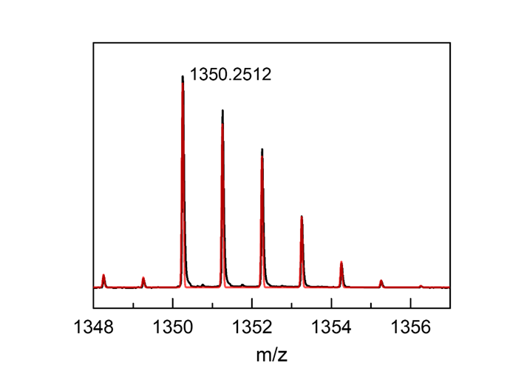
Supplementary Fig 19. HRMS scan of a CH₃CN solution of FeL1–Cl mixture was obtained. Observed mass and isotope pattern at 1350.2512 m/z matches the predicted mass (1350.2581m/z) for [FeL1–Cl+H]⁺.

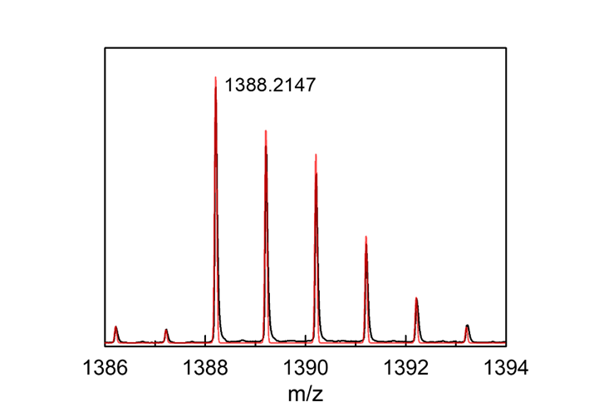
Supplementary Fig 20. HRMS scan of a CH₃CN solution of FeL1–Cl with KOTf (5.0 equiv) mixture for FeL1–Cl_K was obtained. Observed mass and isotope pattern at 1388.2147 m/z matches the predicted mass (1388.2145 m/z) for [FeL1–Cl_K]⁺.

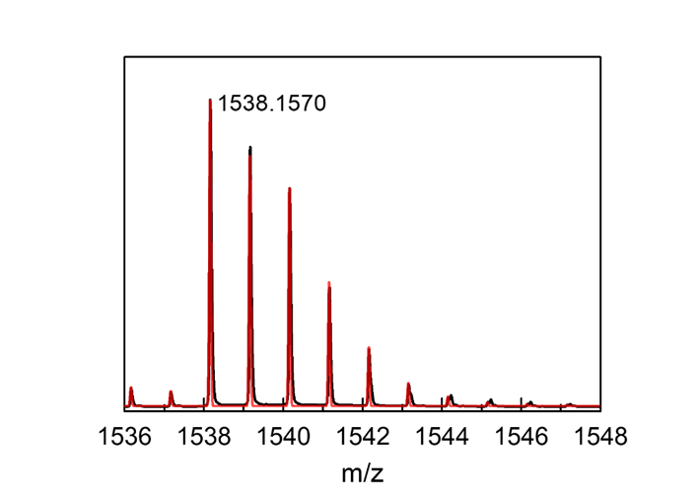
Supplementary Fig 21. HRMS scan of a CH₃CN solution of FeL1–Cl with Ca(OTf)₂ (5.0 equiv) mixture for FeL1–Cl_Ca was obtained. Observed mass and isotope pattern at 1538.1570 m/z matches the predicted mass (1538.1564 m/z) for [FeL1–Cl+CaOTf]⁺.

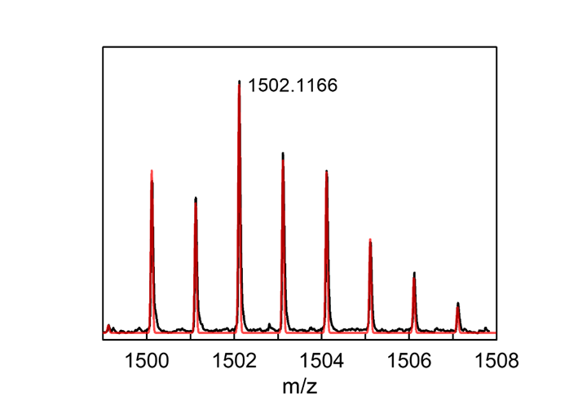
Supplementary Fig 22. HRMS scan of a CH₃CN solution of FeL1–Cl with ScCl₃ (5.0 equiv) mixture for FeL1–Cl_Sc was obtained. Observed mass and isotope pattern at 1502.1166 m/z matches the predicted mass (1502.1176 m/z) for [FeL1–Cl+ScCl₃+H]⁺.

Investigation of Field Effects in Model Complexes through Spectroscopic Analysis

Job Plot Analysis for Demonstrating the 1:1 Binding of L1 and Cation
Stock solutions of [H]₀ = 10.0 mM and [G]₀ = 10.0 mM were prepared in DMSO-d₆ ([H] = concentration of L1, [G] = concentration of KBAr^{F}). By combining these stock solutions in different ratios of [H]/([H]+[G]) NMR samples were prepared as Table S6. Based on the ¹H NMR chemical shifts observed from L1 (H of β-pyrrole, N−H_{1a}, N−H_{1b,} N−H₂ of diaza-crown ether moiety of L1) with different mole fractions, Job plot analysis shown in Supplementary Fig 23 was prepared and analyzed to show 1:1 binding between L1 and KBAr^{F}.
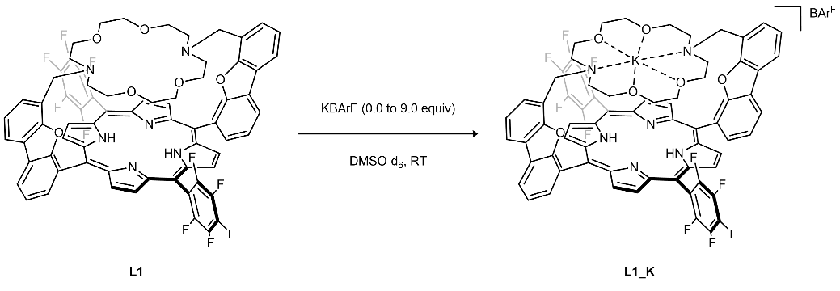
Supplementary Scheme 15. Synthesis of L1_K
Table S6. The preparation of the solution for the Job plot
Mole fraction | Solution A (µL)ª | Solution B (µL)^{b}
0.1 | 100 | 900
0.2 | 200 | 800
0.4 | 200 | 300
0.5 | 500 | 500
0.6 | 500 | 333
0.8 | 500 | 125
1.0 | 500 | 0
ª A 20 mM solution of L1 was prepared by dissolving 13 mg (10 µmol) in 0.5 mL DMSO-d₆
^{b} A 20 mM solution of KBAr^{F} was prepared by dissolving 27 mg (30 µmol) in 1.5 mL DMSO-d₆
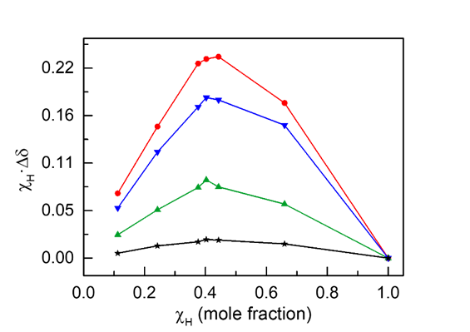
Supplementary Fig 23. Results of Job’s plot analysis about proton NMR shifts for H of β pyrrole (▬, black), N-H_{1a} of diaza (▬, red), N-H_{1b} of diaza (▬, blue), and N-H₂ of diaza (▬, green).

After establishing 1:1 binding between L1 and KBAr^{F}, binding affinity of K⁺ cation as a guest to the L1 was investigated using derived equation (13)² based on concentrations of the host-guest complex ([HG]) determined by equation (1) from the observed chemical shifts (δ) by varying the amount of KBAr^{F}, where δ₀ indicates in the absence of KBAr^{F} and δ_{max} indicates where no further change in δ was observed (Supplementary Fig 24).
 | $$\left[HG\right]= \frac{δ-δ_{0}}{δ_{max}-δ_{0}} × \frac{\left[H\right]}{\left[H\right]+\left[G\right]}$$ | ( 1 )
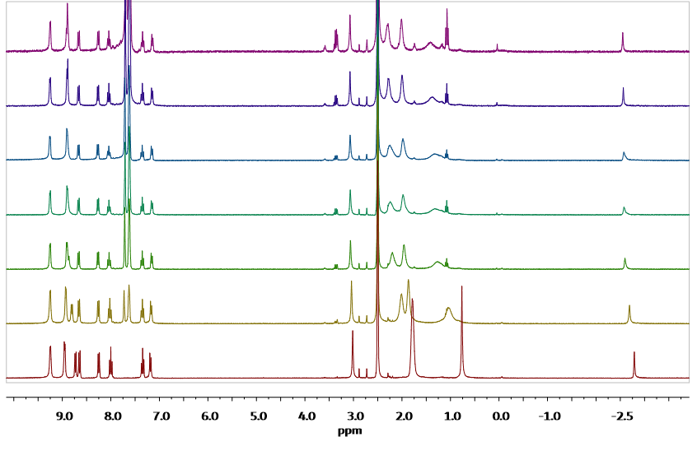
Supplementary Fig 24. ¹H NMR results, measured in DMSO-d₆, correspond to [L1]/([L1] + [KBAr^{F}]) = 1.0, 0.8, 0.6, 0.5, 0.4, 0.2, and 0.1, in an upward direction.
 | $$H+G ⇄HG$$ | ( 2 )
 | $$\frac{\left[HG\right]}{\left[H\right]\left[G\right]}= K_{a}$$ | ( 3 )
 | $$\left[H\right]={\left[H\right]}_{0}-\left[HG\right]$$ | ( 4 )
 | $$\left[G\right]= {\left[G\right]}_{0}-\left[HG\right]$$ | ( 5 )
 | ${\left[H\right]}_{0}+{\left[G\right]}_{0}=C \left(C is a constant\right)$ | ( 6 )
Then, the physical change (Y, ¹H NMR shift) being monitored can usually be described as the aggregate of the individual components according to equation (7) as a function of concentration or as a function of mole fractions. Y means observed ¹H NMR shifts during titration, Y_{H} is the ¹H NMR shifts of host (L1), and Y_{HG} is the ¹H NMR shifts of L1_K which will be fitted by these equations
 | $Y= \frac{\left[H\right]}{{\left[H\right]}_{0}}∙Y_{H}+ \frac{\left[HG\right]}{{\left[H\right]}_{0}}∙Y_{HG}$ | ( 7 )
With the equations above, it is able to obtain the function of Y with respect to χ($=\frac{n_{H_{0}}}{n_{H_{0}}+n_{G_{0}}}$), the mole fraction of H₀. By substituting equation (4) into equation (7), we can derive the following equations.
 | $$Y= \frac{\left({\left[H\right]}_{0}-\left[HG\right]\right)}{{\left[H\right]}_{0}}∙Y_{H}+\frac{\left[HG\right]}{{\left[H\right]}_{0}}∙Y_{HG}=\frac{\left[HG\right]}{{\left[H\right]}_{0}}∙\left(Y_{HG}-Y_{H}\right)+Y_{H}$$ | ( 8 )
As, substituting equation (3) for K_{a} into the above equation,
 | $K_{a}∙\left({\left[HG\right]}^{2}-\left({\left[H\right]}_{0}+{\left[G\right]}_{0}\right)\left(\left[HG\right]\right)\right)+{\left[H\right]}_{0}{\left[G\right]}_{0})=[HG]$ | ( 9 )
 | $K_{a}{\left[HG\right]}^{2}-\left\{\left({\left[H\right]}_{0}+{\left[G\right]}_{0}\right)∙K_{a}+1\right\}∙\left[HG\right]+K_{a}∙{\left[H\right]}_{0}{\left[G\right]}_{0}=0$ | ( 10 )
 | $\frac{[HG]}{{[H]}_{0}}=\frac{1}{2}\left\{\left(\frac{{[G]}_{0}}{{[H]}_{0}}+1+\frac{1}{K_{a}∙{[H]}_{0}}\right)-\sqrt{{\left(\frac{{[G]}_{0}}{{[H]}_{0}}+1+\frac{1}{K_{a}∙{[H]}_{0}}\right)}^{2}-\frac{4{[G]}_{0}}{{[H]}_{0}}}\right\}$ | ( 11 )
Let $\frac{{[G]}_{0}}{{[H]}_{0}}=\frac{n_{G_{0}}}{n_{H_{0}}}=\frac{1}{χ}-1$ with a mole fraction parameter (χ) and apply it to equation (11), it can be simplified as follows;
 | $\frac{[HG]}{{[H]}_{0}}=\frac{1}{2}\left\{\left(\frac{1}{χ}+\frac{1}{K_{a}∙C∙χ}\right)-\sqrt{{\left(\frac{1}{χ}+\frac{1}{K_{a}∙C∙χ}\right)}^{2}-4∙\left(\frac{1}{χ}-1\right)}\right\}$ | ( 12 )
Finally, the equation for the ¹H NMR shifts measured in this experiment can be expressed as follows, as shown in equation (7). By substituting this, we can derive the equation for the relationship between the mole fraction and the ¹H NMR shift as shown below. This relationship was then used to fit the data, as illustrated in Supplementary Fig 21, to determine the binding constant.
 | $$Y=\frac{1}{2}\left\{\left(\frac{1}{χ}+\frac{1}{K_{a}∙C∙χ}\right)-\sqrt{{\left(\frac{1}{χ}+\frac{1}{K_{a}∙C∙χ}\right)}^{2}-4\left(\frac{1}{χ}-1\right)}\right\}∙\left(Y_{HG}-Y_{H}\right)+Y_{H}$$ | ( 13 )
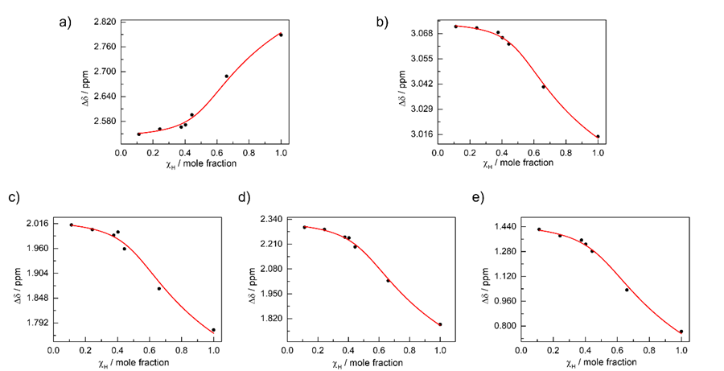
Supplementary Fig 25. ¹H-NMR titration curves between L1 and KBAr^{F} in DMSO-d₆. Based on the results obtained from the plots corrected using equation (13), it can be concluded that the binding constant (K_{a}) between L1 and KBAr^{F} is 1556.04 M⁻¹. The specific findings for each plot are as follows: a) for pyrrolic NH, K_{a}=1813.0275 (R²=0.98948); b) for aromatic 4H, K_{a}=2028.46663 (R²=0.9962); c) for diaza H_{1a}, K_{a}=1158.70592 (R²=0.99291); d) for diaza H_{1b}, K_{a}=1484.14705 (R²=0.9871); e) for diaza H₂, K_{a}=1295.83212 (R²=0.9965).

NMR Study Using the TF₁₀PP Ligand System as a Control for Non-Electric Field Effect
To compare in the experimental result obtained using L1 with the control ligand TF₁₀PP following experiments were conducted. As shown in Supplementary Scheme 16, KOTf was added in increasing equivalents to TF₁₀PP, a form in which cation binding is not possible, and the observed chemical shifts of TF₁₀PP were presented in Supplementary Fig 26.
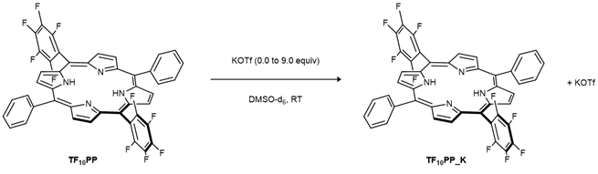
Supplementary Scheme 16. Synthesis of TF₁₀PP_K
Stock solutions of [TF₁₀PP]₀ = 20 mM and [KOTf]₀ = 20 mM were prepared in DMSO-d₆. By combining the stock solutions in different ratios [TF₁₀PP]/([TF₁₀PP]+[KOTf]) of NMR samples were prepared as Table S7., and their chemical shifts of proton signals were measured by ¹H NMR spectroscopy. Unlike the observed changes in chemical shifts in L1, no change in chemical shifts of TF₁₀PP were observed.
Table S7. The preparation of the solution for the Job plot
Mole fraction | Solution A (µL)ª | Solution B (µL)^{b}
0.1 | 100 | 900
0.2 | 200 | 800
0.4 | 200 | 300
0.5 | 500 | 500
0.6 | 500 | 333
0.8 | 500 | 125
1.0 | 500 | 0
ª A 20 mM solution of TF₁₀PP was prepared by dissolving 10 mg (10 µmol) in 0.5 mL DMSO-d₆
^{b} A 20 mM solution of KOTf was prepared by dissolving 5 mg (30 µmol) in 1.5 mL DMSO-d₆

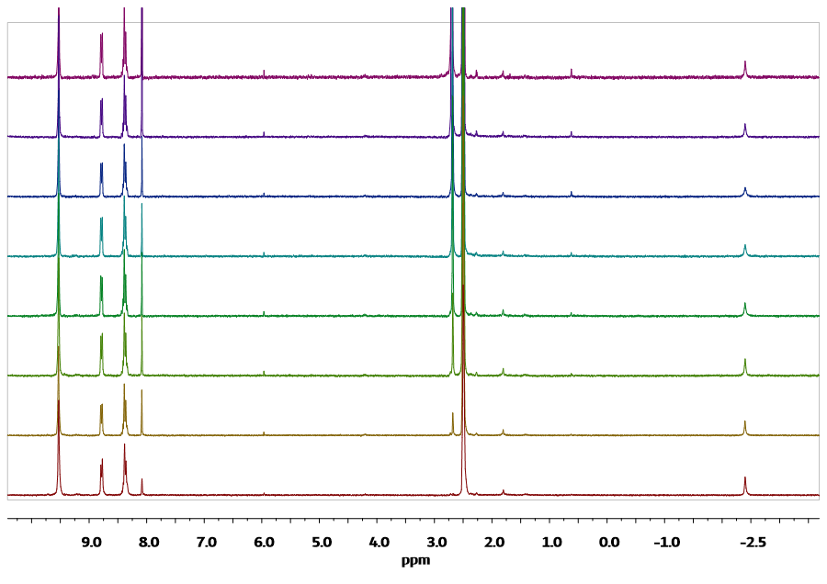
Supplementary Fig 26. ¹H-NMR results, measured in DMSO-d₆, correspond to [TF₁₀PP]/([TF₁₀PP]+[KOTf]) = 1.0, 0.8, 0.6, 0.5, 0.4, 0.3, 0.2, and 0.1, in an upward direction.

Job Plot Analysis for Demonstrating the 1:1 Binding of ZnL1 and Cation
As in 2.1., the stoichiometry and binding constant for ZnL1 and KBAr^{F} were measured. Stock solutions of [H]₀ = 10.0 mM and [G]₀ = 10.0 mM were prepared in DMSO-d₆ ([H] = concentration of ZnL1, and [G] = concentration of KBAr^{F}). By combining the stock solutions in different ratios [ZnL1]/([ZnL1]+[KBAr^{F}]) of NMR samples were prepared as Table S8., and their chemical shifts of proton signals were measured by ¹H-NMR spectroscopy. Based on the ¹H NMR chemical shifts observed from ZnL1 (H of β-pyrrole, N−H_{1a}, N−H_{1b,} N−H₂ of diaza-crown ether moiety of ZnL1) with different mole fractions, Job plot analysis shown in Supplementary Fig 27 was prepared and analyzed to show 1:1 binding between ZnL1 and KBAr^{F}.

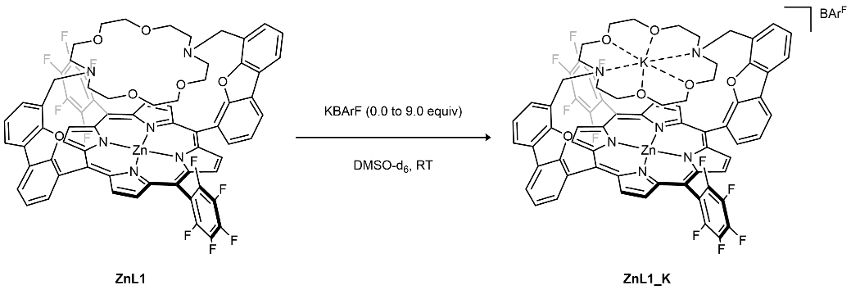
Supplementary Scheme 17. Synthesis of ZnL1_K
Table S8. The preparation of the solution for the Job plot
Mole fraction | Solution A (µL)ª | Solution B (µL)^{b}
0.1 | 100 | 900
0.2 | 200 | 800
0.4 | 200 | 300
0.5 | 500 | 500
0.6 | 500 | 333
0.8 | 500 | 125
1.0 | 500 | 0
ª A 20.0 mM solution of ZnL1 was prepared by dissolving 13 mg (10 µmol) in 0.5 mL DMSO-d₆
^{b} A 20.0 mM solution of KBAr^{F} was prepared by dissolving 27 mg (30 µmol) in 1.5 mL DMSO-d₆
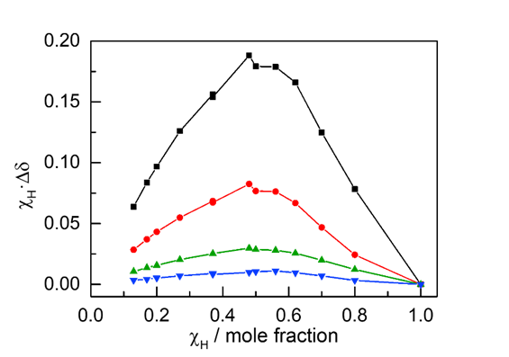
Supplementary Fig 27. Results of Job plot analysis about proton NMR shifts for NH of diaza (▬, black), NH of diaza (▬, red), H of β-pyrrole (▬, green), and H of benzofuran (▬, blue).

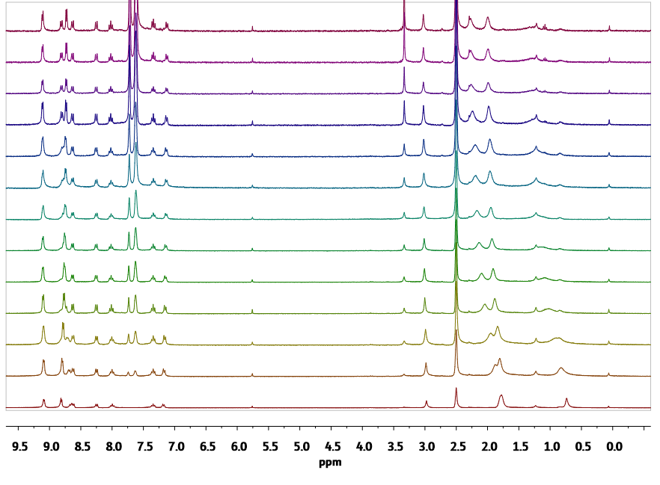
Supplementary Fig 28. ¹H NMR results, measured in DMSO-d₆, correspond to [ZnL1]/([ZnL1] + [KBAr^{F}]) = 1.0, 0.9, 0.8, 0.7, 0.6, 0.5, 0.4, 0.3, 0.2, and 0.1, in an upward direction

After establishing 1:1 binding between ZnL1 and KBAr^{F}, the binding affinity of the K⁺ cation as a guest to ZnL1 was investigated using the derived equations, as described in 2.1. The binding constant was subsequently calculated. Similar to the L1_K system, the binding affinity between ZnL1 and KBAr^{F} was determined using equation (13), and the results are presented in Supplementary Fig 29.

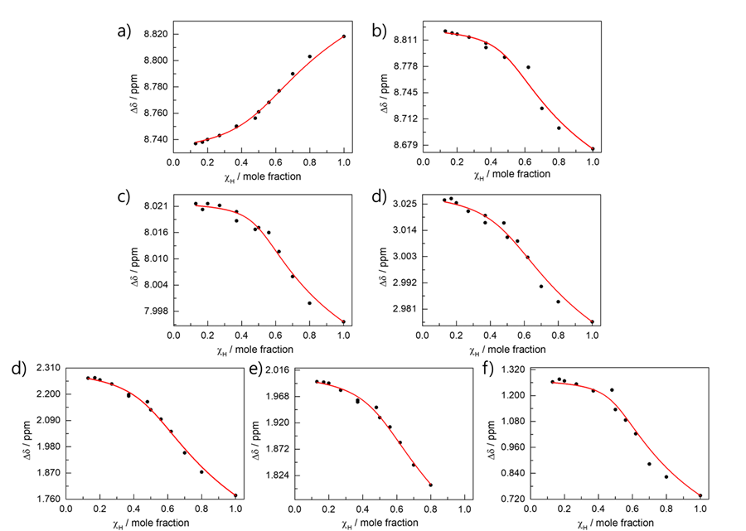
Supplementary Fig 29. ¹H-NMR titration curves between ZnL1 and KBAr^{F} in DMSO-d₆. Based on the results obtained from the plots corrected by equation (13), it can be concluded that the binding constant (K_{a}) between ZnL1 and KBAr^{F} is 1709.02 M⁻¹. The specific findings for each plot are as follows: a) for pyrrolic NH, K_{a}=804.2768 (R²=0.99461); b) for aromatic H_{a}, K_{a}=1954.0458 (R²=0.98286); c) for aromatic H_{d}, K_{a}=2885.5900 (R²=0.98102); d) for benzylic 4H, K_{a}=1032.7709 (R²=0.98716); e) for diaza H_{a}, K_{a}=1108.25788 (R²=0.99397); f) for diaza H_{b}, K_{a}=1285.2447 (R²=0.99107); and g) for diaza H_{c}, K_{a}=2892.9837 (R²=0.98109).

Cyclic Voltammetry Study in Electric Field Effect with ZnL1
In an N₂-filled glove box, tetrabutylammonium hexafluorophosphate (TBAPF₆, 155 mg, 400 µmol) was dissolved in 4.0 mL of dry acetonitrile to give a 0.10 M TBAPF₆ solution. After scanning the solvent window to ensure the absence of any possible impurities, 1.0 mM of ZnL1 solution was prepared for cyclic voltammetry. All scans were referenced to the ferrocenium/ferrocene (Fc^{+/0}) couple at 0.0 V after adding an equimolar amount of ferrocene to the solution for all samples measured below.
The cyclic voltammogram of ZnL1 was measured at various scan rates (100, 200, 400, 600, 800, 1000 mV/s) in a 0.10 M TBAPF₆ solution in anhydrous CH₃CN under N₂.
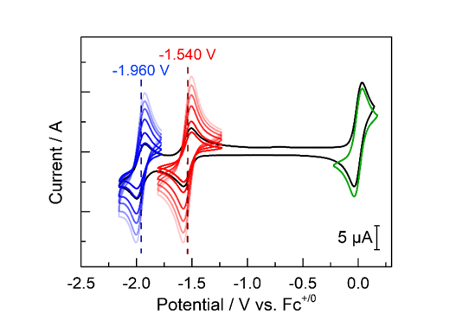
Supplementary Fig 30. Cyclic Voltammogram of ZnL1 in various scan rates (gradient-colored lines from dark to light; 100 mV/s to 1 V/s, respectively). Two reversible reductive features associated with the ligand-based reduction were observed at –1.960 V vs Fc^{+/0} (ZnL1/ZnL1–) (▬, blue) and –1.540 V vs Fc^{+/0} (ZnL1–/ZnL1^{2–}) (▬, red). Scan-rate-dependent cyclic voltammetry of ZnL1 showing porphyrin-ring-centered reduction waves along with the electroactivity of the complexed metal cation for redox-active metal centers. Fc^{+/0} reductive feature (▬, green) was also observed by adding an additional amount to ZnL1 (▬, black) at a scan rate of 100 mV/s.

To observe the changes in redox potential of the system due to the electric field effect, we subsequently added various metal triflate salts (M= Li⁺, Na⁺, K⁺, Ca²⁺, Ba²⁺, Sr²⁺, Y³⁺, Eu³⁺ and La³⁺) in 5 equivalents to the ZnL1 solution shown in Supplementary Fig 30. Each metal triflate salt was prepared by dissolving 4.0 µmol in 0.2 mL of a 0.1 M TBAPF₆ electrolyte stock solution and then added to the ZnL1. Before conducting each experiment of adding cations, the voltammogram of ZnL1 in CH₃CN (1.0 mM) was measured at variable scan rates (100, 200, 400, 600, 800, and 1000 mV/s) in 0.10 M TBAPF₆ solution.
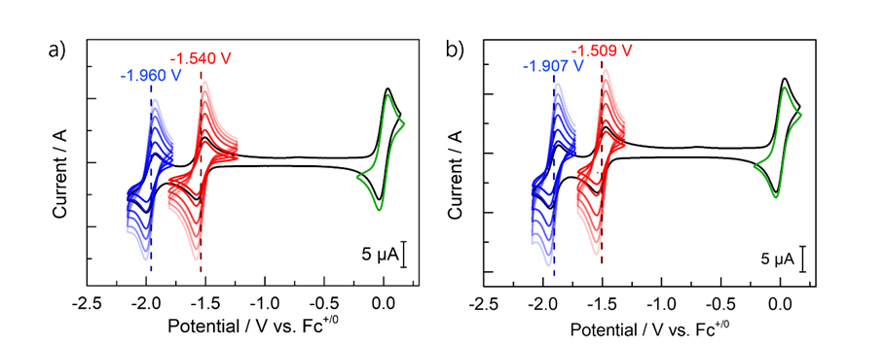
Supplementary Fig 31. a) Cyclic Voltammogram of ZnL1 in various scan rates (gradient-colored lines from dark to light; 100 mV/s to 1 V/s, respectively) as same as with Supplementary Fig 31.; and b) Cyclic Voltammogram of ZnL1_K in various scan rates (gradient-colored lines from dark to light; 100 mV/s to 1 V/s, respectively) by adding 5 equivalents of KOTf to ZnL1. Two reversible reductive features associated with the ligand-based reduction were observed at –1.907 V vs Fc^{+/0} (ZnL1/ZnL1–) (▬, blue) and –1.509 V vs Fc^{+/0} (ZnL1–/ZnL1^{2–}) (▬, red). Fc^{+/0} reductive feature (▬, green) was also observed by adding an additional to ZnL1_K (▬, black) at a scan rate of 100 mV/s.

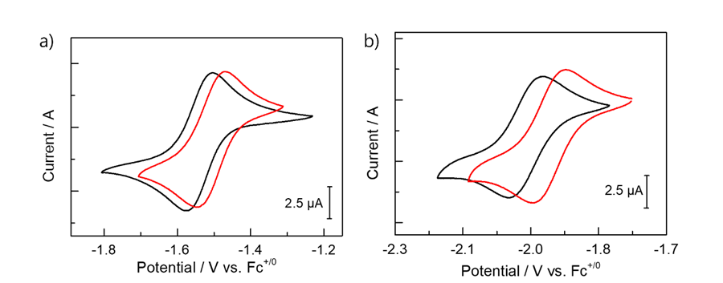
Supplementary Fig 32. Cyclic Voltammograms of ZnL1_K (▬, red) are overlayed with ZnL1 (▬, black) to show the shifts of redox potential by adding 5 equivalents of KOTf. a) The first reversible redox couple for ZnL1/ZnL1– shows an anodic shift of 31 mV after addition of KOTf from –1.540 V vs Fc^{+/0} (▬, black) to –1.509 V vs Fc^{+/0}(▬, red); b) the second redox couple for ZnL1–/ZnL1^{2–} shows anodic shifts of 53 mV, from –1.960 V vs Fc^{+/0} (▬, black) to –1.907 V vs Fc^{+/0} (▬, red).

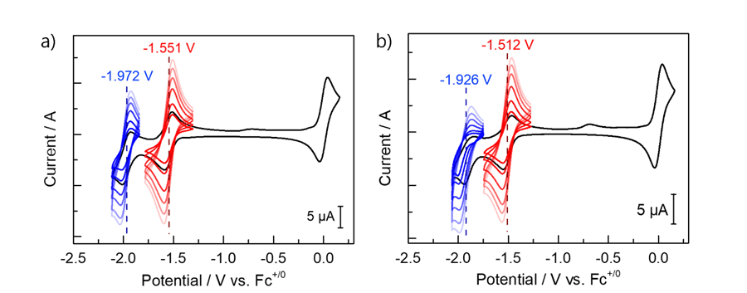
Supplementary Fig 33. a) Cyclic Voltammogram of ZnL1 in various scan rates (gradient-colored lines from dark to light; 100 mV/s to 1 V/s, respectively). Two reversible reductive features associated with the ligand-based reduction were observed at –1.972 V vs Fc^{+/0} (ZnL1/ZnL1–) (▬, blue) and –1.551 V vs Fc^{+/0} (ZnL1–/ZnL1^{2–}) (▬, red). Fc^{+/0} reductive feature observed (▬, green) was also by adding an additional amount to ZnL1 (▬, black) at a scan rate of 100 mV/s.; and b) Cyclic Voltammogram of ZnL1_Na in various scan rates (gradient-colored lines from dark to light; 100 mV/s to 1 V/s, respectively) by adding 5 equivalents of NaOTf to ZnL1. Two reversible reductive features associated with the ligand-based reduction were observed at –1.926 V vs Fc^{+/0} (ZnL1/ZnL1–) (▬, blue) and –1.512 vs Fc^{+/0} (ZnL1–/ZnL1^{2–}) (▬, red) for ZnL1_Na.

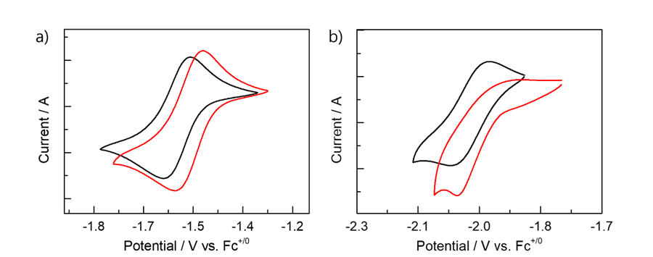
Supplementary Fig 34. Cyclic Voltammograms of ZnL1_Na (▬, red) are overlayed with ZnL1 (▬, black) to show the shifts of redox potential after adding 5 equivalents of NaOTf. a) The first reversible redox couple for ZnL1/ZnL1– shows an anodic shift by 39 mV after addition of NaOTf from –1.551 V vs Fc^{+/0}(▬, black) to –1.512 V vs Fc^{+/0}(▬, red); b) the second redox couple for ZnL1–/ZnL1^{2–} shows anodic shifts of 46 mV, from –1.972 V vs Fc^{+/0}(▬, black) to –1.926 V vs Fc^{+/0} (▬, red). Unexpectedly, upon the addition of NaOTf, the electrochemically reversible redox couple for ZnL1–/ZnL1^{2–} changes into an irreversible redox couple. Subsequently, the same phenomenon was observed with the addition of other cations, suggesting that the effect was induced by triflate.

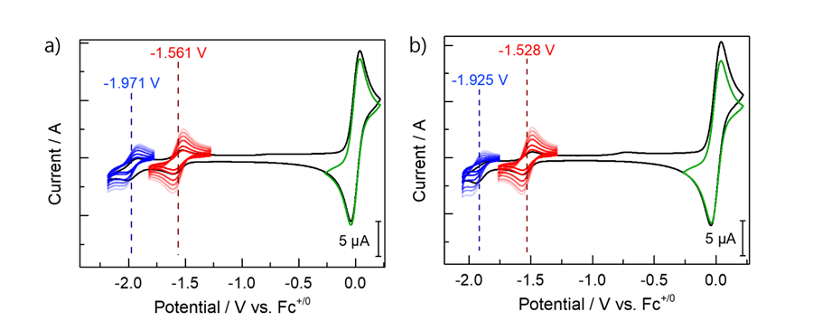
Supplementary Fig 35. a) Cyclic Voltammogram of ZnL1 in various scan rates (gradient-colored lines from dark to light; 100 mV/s to 1 V/s, respectively). Two reversible reductive features associated with the ligand-based reduction were observed at –1.971 V vs Fc^{+/0} (ZnL1/ZnL1–) (▬, blue) and –1.561 V vs Fc^{+/0} (ZnL1–/ZnL1^{2–}) (▬, red). Fc^{+/0} reductive feature (▬, green) was also observed by adding an additional amount to ZnL1 (▬, black) at a scan rate of 100 mV/s.; and b) Cyclic Voltammogram of ZnL1_Li in various scan rates (gradient-colored lines from dark to light; 100 mV/s to 1 V/s, respectively) by adding 5 equivalents of LiOTf to ZnL1. Two reversible reductive features associated with the ligand-based reduction were observed at –1.925 V vs Fc^{+/0} (ZnL1/ZnL1–) (▬, blue) and –1.528 vs Fc^{+/0} (ZnL1–/ZnL1^{2–}) (▬, red) for ZnL1_Li. Fc^{+/0} reductive feature (▬, green) was also observed by adding an additional amount to ZnL1_Li (▬, black) at a scan rate of 100 mV/s.

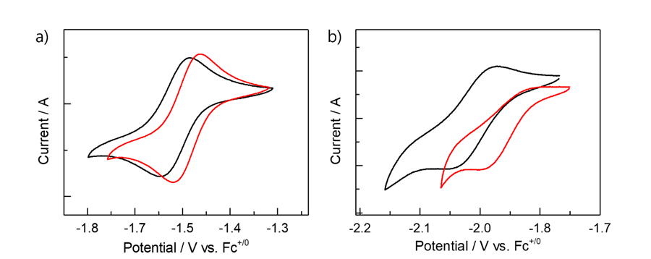
Supplementary Fig 36. Cyclic Voltammograms of ZnL1_Li (▬, red) are overlayed with ZnL1 (▬, black) to show the shifts of redox potential after adding 5 equivalents of LiOTf. a) first reversible redox couple for ZnL1/ZnL1– shows an anodic shift of 33 mV after addition of LiOTf from –1.561 V vs Fc^{+/0} (▬, black) to –1.528 V vs Fc^{+/0} (▬, red); and b) the second redox couple for ZnL1–/ZnL1^{2–} also shows anodic shifts but unexpectedly, upon the addition of LiOTf, the electrochemically reversible redox couple for ZnL1–/ZnL1^{2–} changes into an irreversible redox couple.

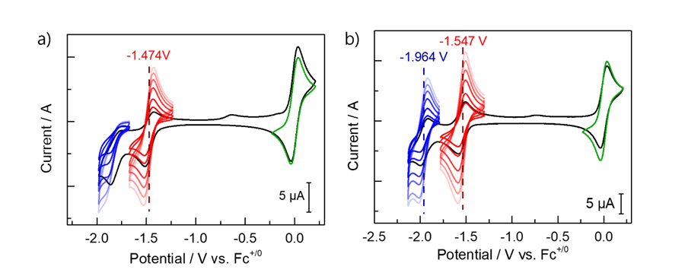
Supplementary Fig 37. a) Cyclic Voltammogram of ZnL1 in various scan rates (gradient-colored lines from dark to light; 100 mV/s to 1 V/s, respectively). Two reversible reductive features associated with the ligand-based reduction were observed at –1.964 V vs Fc^{+/0} (ZnL1/ZnL1–) (▬, blue) and –1.547 V vs Fc^{+/0} (ZnL1–/ZnL1^{2–}) (▬, red). Fc^{+/0} reductive feature (▬, green) was also observed by adding an additional amount to ZnL1 (▬, black) at a scan rate of 100 mV/s.; and b) Cyclic Voltammogram of ZnL1_Ba in various scan rates (gradient-colored lines from dark to light; 100 mV/s to 1 V/s, respectively) by adding 5 equivalents of Ba(OTf)₂ to ZnL1. The first redox couple for ZnL1_Ba was observed at –1.447 V vs Fc^{+/0} (ZnL1–/ZnL1^{2–}) (▬, red) in electrochemically reversible feature, but the second redox couple (ZnL1/ZnL1–) (▬, blue) was changed into irreversible couple after anodic shift from ZnL1. Fc^{+/0} reductive feature (▬, green) was also observed by adding an additional amount to ZnL1_Ba (▬, black) at a scan rate of 100 mV/s.

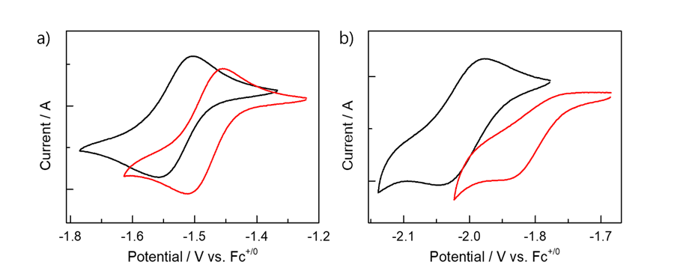
Supplementary Fig 38. Cyclic Voltammograms of ZnL1_Ba (▬, red) are overlayed with ZnL1 (▬, black) to show the shifts of redox potential after adding 5 equivalents of Ba(OTf)₂. a) The first reversible redox couple for ZnL1/ZnL1– shows an anodic shift by 73 mV after addition of Ba(OTf)₂ from –1.547 V vs Fc^{+/0} (▬, black) to –1.474 V vs Fc^{+/0} (▬, red); and b) the second redox couple for ZnL1–/ZnL1^{2–} also shows anodic shifts but unexpectedly, upon the addition of Ba(OTf)₂, the electrochemically reversible redox couple for ZnL1–/ZnL1^{2–} changes into an irreversible redox couple.

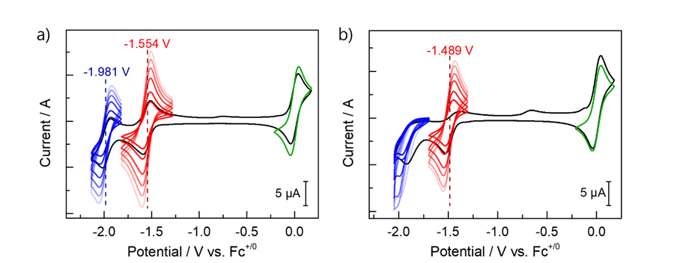
Supplementary Fig 39. a) Cyclic Voltammogram of ZnL1 in various scan rates (gradient-colored lines from dark to light; 100 mV/s to 1 V/s, respectively). Two reversible reductive features associated with the ligand-based reduction were observed at –1.981 V vs Fc^{+/0} (ZnL1/ZnL1–) (▬, blue) and –1.554 V vs Fc^{+/0} (ZnL1–/ZnL1^{2–}) (▬, red). Fc^{+/0} reductive feature (▬, green) was also observed after adding an additional amount to ZnL1 (▬, black) at a scan rate of 100 mV/s.; and b) Cyclic Voltammogram of ZnL1_Ca in various scan rates (gradient-colored lines from dark to light; 100 mV/s to 1 V/s, respectively) by adding 5 equivalents of Ca(OTf)₂ to ZnL1. The first redox couple for ZnL1_Ca was observed at –1.489 V vs Fc^{+/0} (ZnL1–/ZnL1^{2–}) (▬, red) in electrochemically reversible feature, but the second redox couple (ZnL1/ZnL1–) (▬, blue) was changed into irreversible couple after anodic shift from ZnL1. Fc^{+/0} reductive feature (▬, green) was also observed by adding an additional amount to ZnL1_Ca (▬, black) at a scan rate of 100 mV/s.

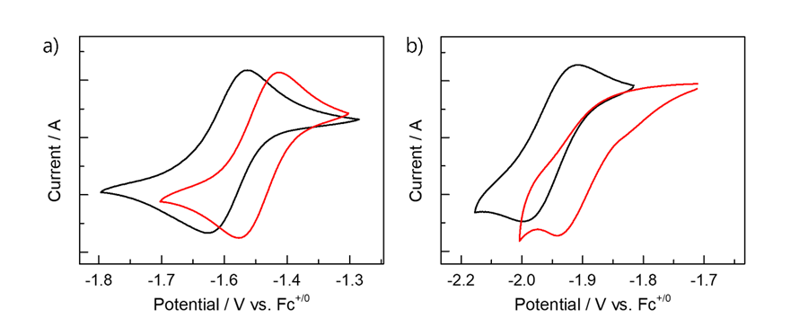
Supplementary Fig 40. Cyclic Voltammograms of ZnL1_Ca (▬, red) are overlayed with ZnL1 (▬, black) to show the shifts of redox potential by adding 5 equivalents of Ca(OTf)₂. a) The first reversible redox couple for ZnL1/ZnL1– shows an anodic shift by 65 mV after addition of Ca(OTf)₂ from –1.554 V vs Fc^{+/0} (▬, black) to –1.489 V vs Fc^{+/0} (▬, red); and b) the second redox couple for ZnL1–/ZnL1^{2–} also shows anodic shifts but unexpectedly, upon the addition of Ba(OTf)₂, the electrochemically reversible redox couple for ZnL1–/ZnL1^{2–} changes into ab irreversible redox couple.

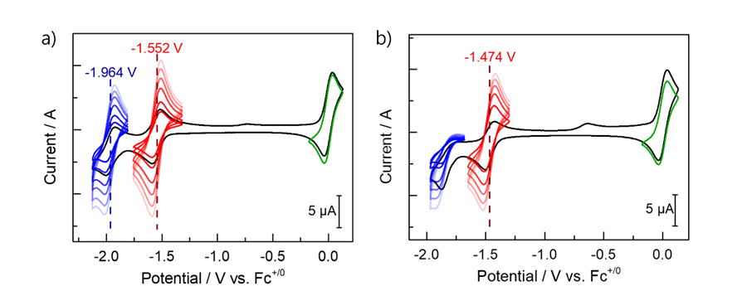
Supplementary Fig 41. a) Cyclic Voltammogram of ZnL1 in various scan rates (gradient-colored lines from dark to light; 100 mV/s to 1 V/s, respectively). Two reversible reductive features associated with the ligand-based reduction were observed at –1.971 V vs Fc^{0/+} (ZnL1/ZnL1–) (▬, blue) and –1.561 V vs Fc^{+/0} (ZnL1–/ZnL1^{2–}) (▬, red). Fc^{+/0} reductive feature (▬, green) was also observed after adding an additional amount to ZnL1 (▬, black) at a scan rate of 100 mV/s.; and b) Cyclic Voltammogram of ZnL1_Sr in various scan rates (gradient-colored lines from dark to light; 100 mV/s to 1 V/s, respectively) by adding 5 equivalents of Sr(OTf)₂ to ZnL1. The first redox couple for ZnL1_Sr was observed at –1.474 V vs Fc^{+/0} (ZnL1–/ZnL1²) (▬, red) in electrochemically reversible feature, but the second redox couple (ZnL1/ZnL1–) (▬, blue) was changed into irreversible couple after anodic shift from ZnL1. Fc^{+/0} reductive feature (▬, green) was also observed after adding an additional amount to ZnL1_Sr (▬, black) at a scan rate of 100 mV/s.

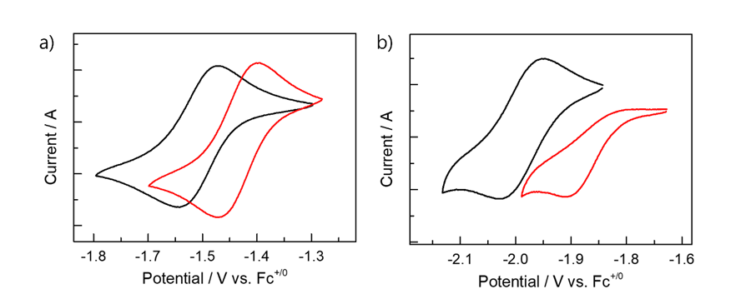
Supplementary Fig 42. Cyclic Voltammograms of ZnL1_Sr (▬, red) are overlayed with ZnL1 (▬, black) to show the shifts of redox potential by adding 5 equivalents of Sr(OTf)₂. a) The first reversible redox couple for ZnL1/ZnL1– shows an anodic shift by 78 mV after addition of Sr(OTf)₂ from –1.552 V vs Fc^{+/0}(▬, black) to –1.474 V vs Fc^{+/0}(▬, red); and b) the second redox couple for ZnL1–/ZnL1^{2–} also shows anodic shifts but unexpectedly, upon the addition of Sr(OTf)₂, the electrochemically reversible redox couple for ZnL1–/ZnL1^{2–} changes into an irreversible redox couple.

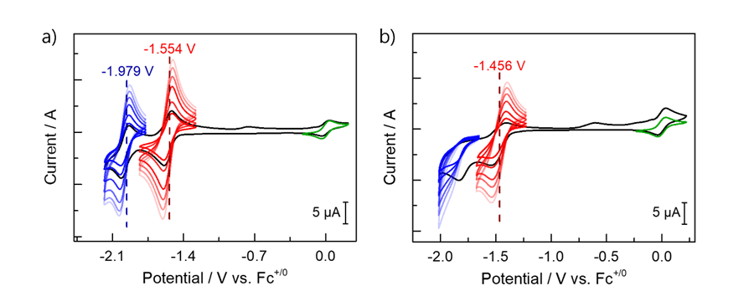
Supplementary Fig 43. a) Cyclic Voltammogram of ZnL1 in various scan rates (gradient-colored lines from dark to light; 100 mV/s to 1 V/s, respectively). Two reversible reductive features associated with the ligand-based reduction were observed at –1.979 V vs Fc^{+/0} (ZnL1/ZnL1–) (▬, blue) and –1.554 V vs Fc^{+/0} (ZnL1–/ZnL1^{2–}) (▬, red). Fc^{+/0} reductive feature (▬, green) was also observed by adding an additional amount to ZnL1 (▬, black) at a scan rate of 100 mV/s.; and b) Cyclic Voltammogram of ZnL1_La in various scan rates (gradient-colored lines from dark to light; 100 mV/s to 1 V/s, respectively) by adding 5 equivalents of La(OTf)₃ to ZnL1. The first redox couple for ZnL1_La was observed at –1.456 V vs Fc^{+/0} (ZnL1–/ZnL1^{2–}) (▬, red) in electrochemically reversible feature, but the second redox couple (ZnL1/ZnL1–) (▬, blue) was changed into irreversible couple after anodic shift from ZnL1. Fc^{+/0} reductive feature (▬, green) was also observed by adding an additional amount to ZnL1_La (▬, black) at a scan rate of 100 mV/s.

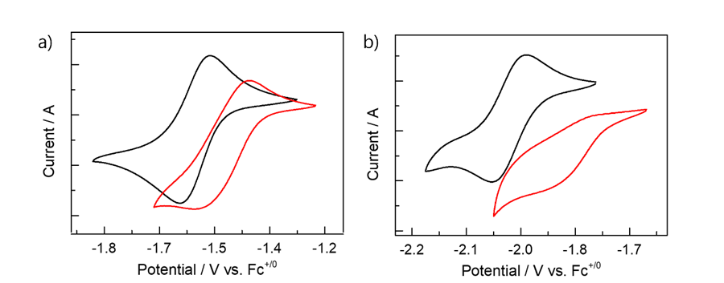
Supplementary Fig 44. Cyclic Voltammograms of ZnL1_La (▬, red) are overlayed with ZnL1 (▬, black) to show the shifts of redox potential by adding 5 equivalents of La(OTf)₃. a) The first reversible redox couple for ZnL1/ZnL1– shows an anodic shift of 98 mV after addition of La(OTf)₃ from –1.554 V vs Fc^{+/0}(▬, black) to –1.456 V vs Fc^{+/0}(▬, red); and b) the second redox couple for ZnL1–/ZnL1^{2–} also shows anodic shifts but unexpectedly, upon the addition of La(OTf)₃, the electrochemically reversible redox couple for ZnL1–/ZnL1^{2–} changes into an irreversible redox couple.

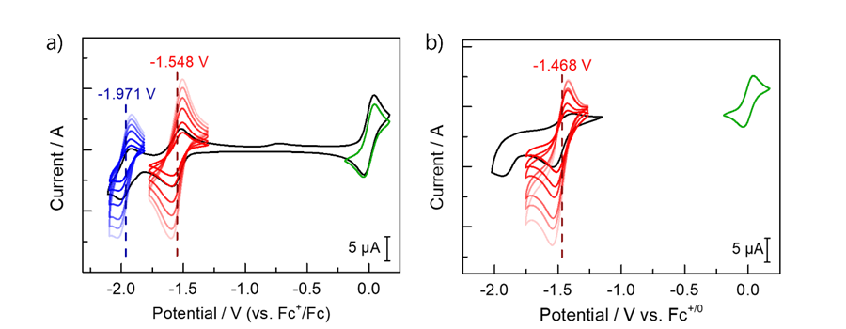
Supplementary Fig 45. a) Cyclic Voltammogram of ZnL1 in various scan rates (gradient-colored lines from dark to light; 100 mV/s to 1 V/s, respectively). Two reversible reductive features associated with the ligand-based reduction were observed at –1.971 V vs Fc^{+/0}(ZnL1/ZnL1–) (▬, blue) and –1.548 V vs Fc^{+/0}(ZnL1–/ZnL1^{2–}) (▬, red). Fc^{+/0} reductive feature (▬, green) was also observed by adding an additional amount to ZnL1 (▬, black) at a scan rate of 100 mV/s.; and b) Cyclic Voltammogram of ZnL1_Eu in various scan rates (gradient-colored lines from dark to light; 100 mV/s to 1 V/s, respectively) by adding 5 equivalents of Eu(OTf)₃ to ZnL1. The first redox couple for ZnL1_Eu was observed at –1.468 V vs Fc^{+/0}(ZnL1–/ZnL1^{2–}) (▬, red) in electrochemically reversible feature, but the second redox couple (ZnL1/ZnL1–) (▬, blue) was changed into irreversible couple after anodic shift from ZnL1. Fc^{+/0} reductive feature (▬, green) was also observed by adding an additional amount to ZnL1_Eu (▬, black) at a scan rate of 100 mV/s.

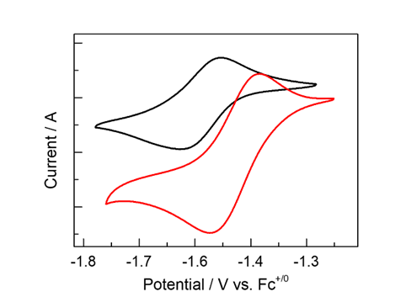
Supplementary Fig 46. Cyclic Voltammograms of ZnL1_Eu (▬, red) are overlayed with ZnL1 (▬, black) to show the shifts of redox potential after adding 5 equivalents of Eu(OTf)₃. First reversible redox couple for ZnL1/ZnL1– shows an anodic shift of 80 mV after addition of Eu(OTf)₃ from –1.548 V vs Fc^{+/0}(▬, black) to –1.468 V vs Fc^{+/0}(▬, red). And unexpectedly, upon the addition of Eu(OTf)₃, the electrochemically reversible redox couple for ZnL1–/ZnL1^{2–} changes into an irreversible redox couple.

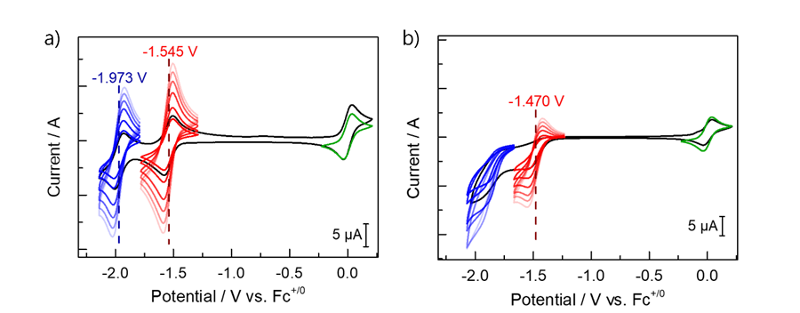
Supplementary Fig 47. a) Cyclic Voltammogram of ZnL1 in various scan rates (gradient-colored lines from dark to light; 100 mV/s to 1 V/s, respectively). Two reversible reductive features associated with the ligand-based reduction were observed at –1.973 V vs Fc^{+/0}(ZnL1/ZnL1–) (▬, blue) and –1.545 V vs Fc^{+/0}(ZnL1–/ZnL1^{2–}) (▬, red). Fc^{+/0} reductive feature (▬, green) was also observed by adding an additional amount to ZnL1 (▬, black) at a scan rate of 100 mV/s.; and b) Cyclic Voltammogram of ZnL1_Y in various scan rates (gradient-colored lines from dark to light; 100 mV/s to 1 V/s, respectively) by adding 5 equivalents of Y(OTf)₃ to ZnL1. The first redox couple for ZnL1_Y was observed at –1.470 V vs Fc^{+/0}(ZnL1–/ZnL1^{2–}) (▬, red) in electrochemically reversible feature, but the second redox couple (ZnL1/ZnL1–)(▬, blue) was changed into irreversible couple after anodic shift from ZnL1. Fc^{+/0} reductive feature (▬, green) was also observed by adding an additional amount to ZnL1_Y (▬, black) at a scan rate of 100 mV/s.
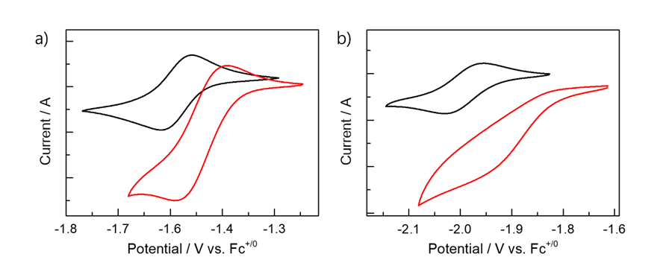
Supplementary Fig 48. Cyclic Voltammograms of ZnL1_Y (▬, red) are overlayed with ZnL1 (▬, black) to show the shifts of redox potential after adding 5 equivalents of Y(OTf)₃. a) first reversible redox couple for ZnL1/ZnL1– shows an anodic shift of 75 mV after addition of Y(OTf)₃ from –1.545 V vs Fc^{+/0}(▬, black) to –1.470 V vs Fc^{+/0}(▬, red); and b) second redox couple for ZnL1–/ZnL1^{2–} also shows anodic shifts but unexpectedly, upon the addition of La(OTf)₃, the electrochemically reversible redox couple for ZnL1–/ZnL1^{2–} changes into an irreversible redox couple.

Table S9. Summary of Electrochemical Data for ZnL1
metal ions | Observed E_{1/2} for L1/L1– (V)
Li⁺ | 0.033
Na⁺ | 0.039
K⁺ | 0.031
Ca²⁺ | 0.065
Ba²⁺ | 0.073
Sr²⁺ | 0.078
Y³⁺ | 0.075
Eu³⁺ | 0.080
La³⁺ | 0.098

Cyclic Voltammetry Study in ZnL2 with Cation
In an N₂-filled glove box, TBAPF₆(155 mg, 400 µmol) was dissolved in 4.0 mL of anhydrous CH₃CN to give a 0.10 M TBAPF₆ solution. After scanning the solvent window to ensure the absence of any possible impurities, a 1.0 mM of ZnL2 solution was prepared for cyclic voltammetry. All scans were referenced to the Fc^{+/0} couple at 0.0 V after adding an equimolar amount of Fc to the solution for all samples measured below. The cyclic voltammogram of ZnL2 was measured at various scan rates (100, 200, 400, 600, 800, 1000 mV/s) in a 0.10 M TBAPF₆ solution in dry acetonitrile under N₂.
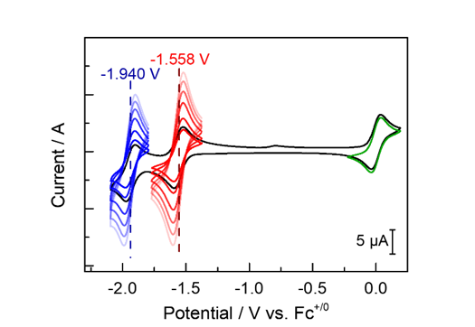
Supplementary Fig 49. Cyclic Voltammogram of ZnL2 at various scan rates (gradient-colored lines from dark to light; 100 mV/s to 1 V/s, respectively). Two reversible reductive features associated with the ligand-based reduction were observed at –1.940 V vs Fc^{+/0} (ZnL2/ZnL2–) (▬, blue) and –1.548 V vs Fc^{+/0} (ZnL2–/ZnL2^{2–}) (▬, red). Scan-rate dependent cyclic voltammetry of ZnL2 also showing a porphyrin-ring-centered reduction waves upon incorporation of redox-inactive metal, similar to that observed in ZnL1. Fc^{+/0} reductive feature (▬, green) was also observed by adding an additional amount of ferrocene to ZnL2 (▬, black) at a scan rate of 100 mV/s. When compared with the average values obtained from a total of 9 measurements of ZnL1, the first reduction potential consistently appears at nearly the same position as ZnL1(; –1.550 V vs Fc^{+/0}), and the second reduction potential exhibits an anodic shift of approximately 30 mV compared to ZnL1(; –1.970 V vs Fc^{+/0}).

To observe the changes in redox potential of the system compared with ZnL1, 5- equivalent amounts of KOTf was added subsequently to the ZnL2 solution shown in Supplementary Fig 49. KOTf was prepared by dissolving it (4.0 µmol) in 0.2 mL of a 0.1 M TBAPF₆ electrolyte stock solution and then adding it to the ZnL2 solution.
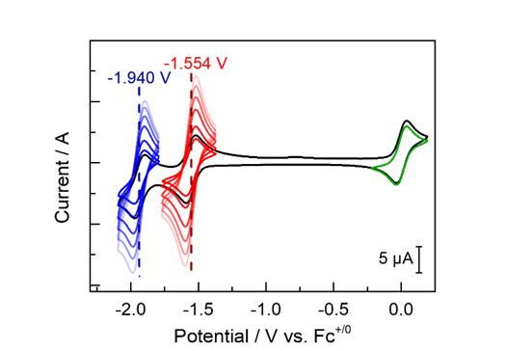
Supplementary Fig 50. Cyclic Voltammogram of ZnL2_K at various scan rates (gradient-colored lines from dark to light; 100 mV/s to 1 V/s, respectively) after adding 5 equivalents of KOTf to ZnL2. Two reversible reductive features associated with the ligand-based reduction were observed at –1.925 V vs Fc^{+/0} (ZnL2/ZnL2–) (▬, blue) and –1.528 V vs Fc^{+/0} (ZnL2–/ZnL2^{2–}) (▬, red). Fc^{+/0} reductive feature (▬, green) was also observed by adding an additional amount of ferrocene to ZnL2_K (▬, black) at a scan rate of 100 mV/s.
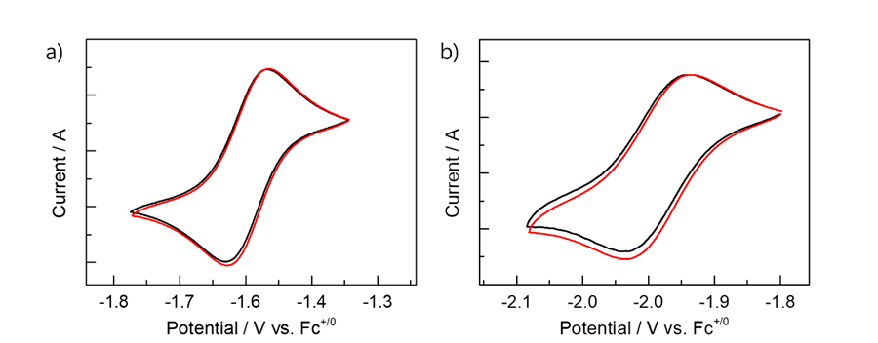
Supplementary Fig 51. Cyclic Voltammograms of ZnL2_K (▬, red) are overlayed with ZnL2 (▬, black) to show the shifts of redox potential after adding 5 equivalents of KOTf. a) The first reversible redox couple for ZnL2/ZnL2– shows almost no shift after addition of KOTf from –1.548 V vs Fc^{+/0} (▬, black) to –1.528 V vs Fc^{+/0} (▬, red); b) the second redox couple for ZnL2–/ZnL2^{2–} also shows almost no shifts, from –1.940 V vs Fc^{+/0} (▬, black) to –1.925 V vs Fc^{+/0} (▬, red).

Cyclic Voltammetry Study in ZnTF₁₀PP with Cation
In an N₂-filled glove box, TBAPF₆ (155 mg, 400 µmol) was dissolved in 4.0 mL of anhydrous CH₃CN to give a 0.10 M TBAPF₆ solution. After scanning the solvent window to ensure the absence of any possible impurities, a 1.0 mM of ZnTF₁₀PP solution was prepared for cyclic voltammetry. All scans were referenced to the Fc^{+/0} couple at 0.0 V after adding an equimolar amount of Fc to the solution for all samples measured below. The cyclic voltammogram of ZnTF₁₀PP was measured at various scan rates (100, 200, 400, 600, 800, 1000 mV/s) in a 0.10 M TBAPF₆ solution in anhydrous CH₃CN under N₂.
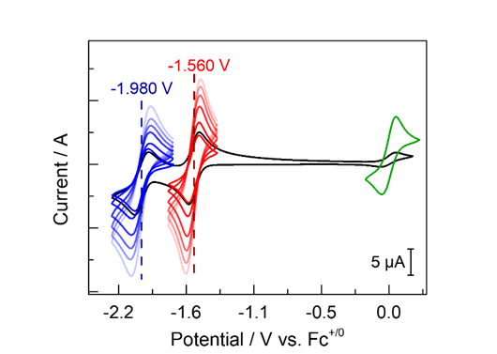
Supplementary Fig 52. Cyclic Voltammogram of ZnTF₁₀PP at various scan rates (gradient-colored lines from dark to light; 100 mV/s to 1 V/s, respectively). Two reversible reductive features associated with the ligand-based reduction were observed at –1.980 V vs Fc^{+/0} (ZnTF₁₀PP/ZnTF₁₀PP–) (▬, blue) and –1.560 V vs Fc^{+/0} (ZnTF₁₀PP–/ZnTF₁₀PP^{2–}) (▬, red). Scan-rate-dependent cyclic voltammetry of ZnTF₁₀PP shows porphyrin-ring-centered reduction waves along with the electroactivity of the complexed metal cation for redox-active metal centers. Fc^{+/0} reductive feature (▬, green) was also observed by adding an additional amount of ferrocene to ZnTF₁₀PP (▬, black) at a scan rate of 100 mV/s. When compared with the average values obtained from a total of 9 measurements of ZnL1, the first and the second reduction potentials both show a difference within 10 mV, indicating that they are almost identical with ZnL1 which means TF₁₀PP has similar electronic properties to L1.

To observe the changes in redox potential of the system compared with ZnL1, we subsequently added KOTf in 5 equivalents to the ZnLTF₁₀PP solution shown in Supplementary Fig 52. KOTf was prepared by dissolving 4.0 µmol in 0.2 mL of a 0.1 M TBAPF₆ electrolyte stock solution and then added to the ZnTF₁₀PP.
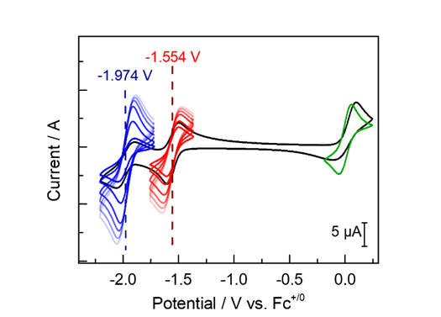
Supplementary Fig 53. Cyclic Voltammogram of ZnTF₁₀PP_K at various scan rates (gradient-colored lines from dark to light; 100 mV/s to 1 V/s, respectively) after adding 5 equivalents of KOTf to ZnTF₁₀PP. Two reversible reductive features associated with the ligand-based reduction were observed at –1.974 V vs Fc^{+/0} (ZnTF₁₀PP/ZnTF₁₀PP–) (▬, blue) and –1.554 V vs Fc^{+/0} (ZnTF₁₀PP–/ZnTF₁₀PP^{2–}) (▬, red). Fc^{+/0} reductive feature (▬, green) was also observed by adding an additional amount of ferrocene to ZnTF₁₀PP_K (▬, black) at a scan rate of 100 mV/s.

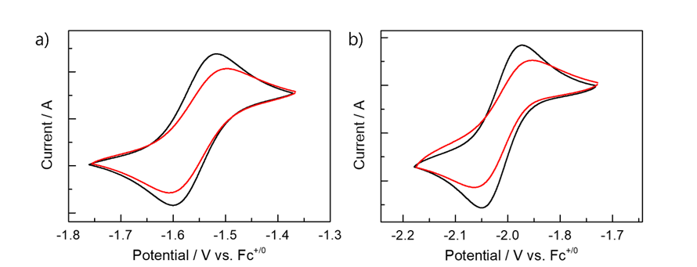
Supplementary Fig 54. Cyclic Voltammograms of ZnTF₁₀PP_K (▬, red) is overlayed with ZnTF₁₀PP (▬, black) to show the shifts of redox potential after adding 5 equivalents of KOTf. a) The first reversible redox couple for ZnTF₁₀PP/ZnTF₁₀PP– shows almost no shift after addition of KOTf from –1.560 V vs Fc^{+/0} (▬, black) to –1.554 V vs Fc^{+/0} (▬, red); b) the second redox couple for ZnTF₁₀PP–/ZnTF₁₀PP^{2–} also shows almost no shifts, from –1.980 V vs Fc^{+/0} (▬, black) to –1.974 V vs Fc^{+/0} (▬, red).

Inductive Effect Study in UV-vis Experiments with L1 and ZnL1
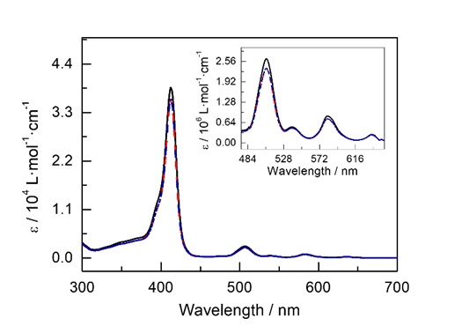
Supplementary Fig 55. UV-vis spectra were recorded for 5.0 μM L1 (▬, black) in CH₃CN at 23 ℃. The spectra were then measured after the addition of 20 equivalents of KOTf (▬, red), and Ca(OTf)₂ (▬, blue).

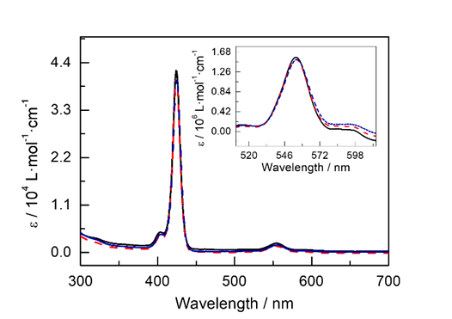
Supplementary Fig 56. UV-vis spectra were recorded for 5.0 μM ZnL1 (▬, black) in CH₃CN at 23 ℃. The spectra were then measured after the addition of 20 equivalents of KOTf (▬, red), and Ca(OTf)₂ (▬, blue) .

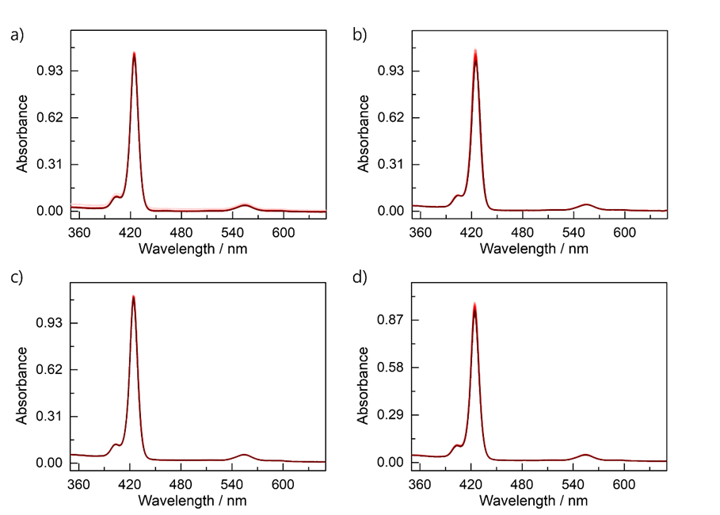
Supplementary Fig 57. UV-vis spectra of 2.5 μM ZnL1 (▬, black) in N,N-dimethylformamide at 23 ℃ were recorded. Spectral changes were monitored following the addition of various cations in concentrations ranging from 0.1 to 20 equivalents (0.10, 1.0, 2.0, 5.0, 10, and 20 equiv): a) KOTf, b) Ba(OTf)₂ c), Eu(OTf)₃ and d) KBAr^{F}.

Stark Effect Study using IR spectroscopy with ZnL1–CN_K by Adding Cryptand-[2,2,2] and Cations
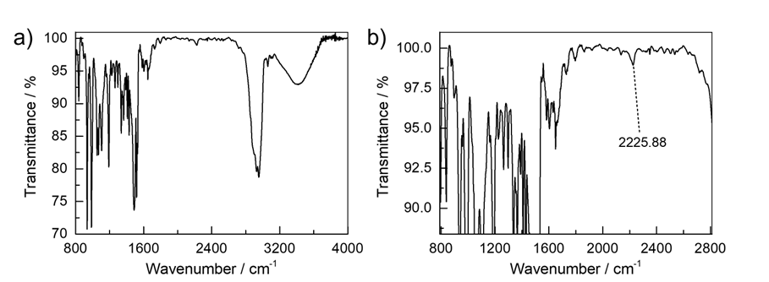
Supplementary Fig 58. The IR spectrum of ZnL1–CN_K (▬, black), for which the crystal structure was obtained, shows a C≡N stretching vibration at 2225.88 cm⁻¹.
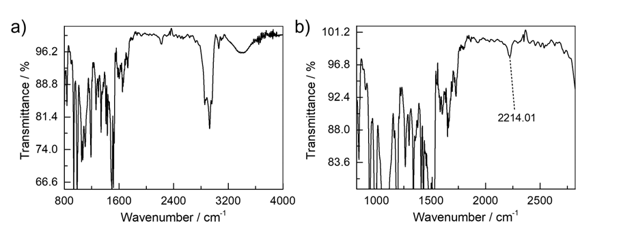
Supplementary Fig 59. The IR spectrum of ZnL1–CN (▬, black) was measured after adding 2 equivalents of cryptand-[2,2,2] to ZnL1–CN_K. The C≡N stretching was observed at 2214.01 cm⁻¹.
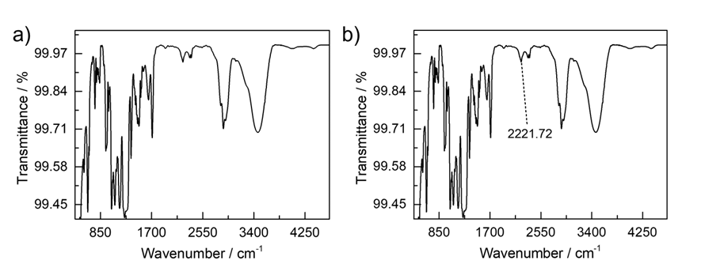
Supplementary Fig 60. The IR spectrum of ZnL1–CN_Ca(OTf)₂ (▬, black) was measured after adding 2 equivalents of Ca(OTf)₂ to ZnL1–CN_K with 2 equivalents of cryptand-[2,2,2]. The C≡N stretching was observed at 2221.72 cm⁻¹.

Optical Kinetic Data: UV-vis Spectroscopic Experimental Results

Catalytic Oxygen Reduction Kinetics by UV-vis Spectroscopic Experiments
In an N₂-filled glove box, a solution of FeL1–Cl (20 µM in CH₂Cl₂ containing 1% (v/v) DMF) was prepared for UV-vis spectroscopy. A 4-mL air-tight UV-vis cuvette was charged with 3.0 mL of the FeL1–Cl solution (20 µM, 60 nmol, 1.0 equiv), and sealed tightly with an air-tight rubber septum. The cuvette was brought out of the glove box, and placed in a UNISOKU device, set to maintain the temperature at –80 °C. After reaching thermal equilibrium, a 50 µL solution of decamethylferrocene (Fc*) solution (3.6 mM in CH₂Cl₂, 0.18 µmol, 3.0 equiv) was prepared in a N₂-filled glove box, and injected to the FeL1–Cl solution via an N₂-purged syringe. After 30 min, complete conversion to Fe^{II}L1 was observed (Supplementary Fig. 61). When the same reaction was conducted at –40 °C, full conversion was achieved within 1-2 min.
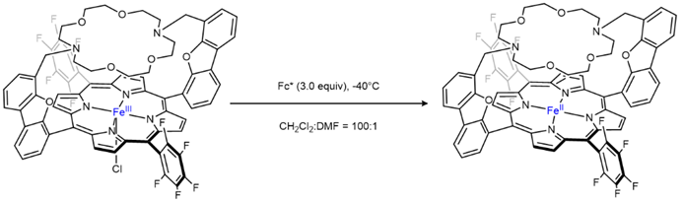
Supplementary Scheme 18. Preparation of Fe^{II}L1 via reduction of FeL1–Cl with 3.0 equivalents of Fc*.

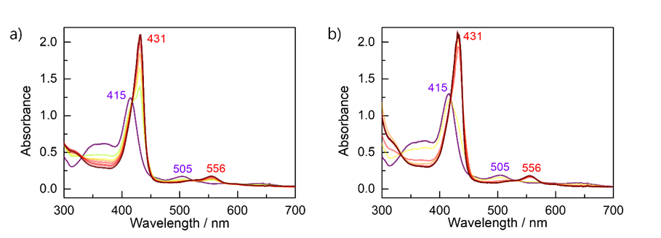
Supplementary Fig 61. Optical spectra showing the reaction forming Fe^{II}L1 (▬, dark red) from FeL1–Cl (▬, purple) upon the addition of 3 equivalents of Fc* a) at –80 °C and b) at –40 °C with both conditions yielding identical results. The reaction time course is represented by a rainbow gradient. The Soret band exhibits a red shift from 415 nm to 431 nm, while the Q-band shifts from 506 nm to 556 nm. These spectral shifts indicate the formation of Fe^{II}L1, following a trend consistent with the reference data.

Anhydrous O₂ (dried for 4 h by CaCl₂, specified volume, standard = 1.0 mL, 41 µmol, 680 equiv) was delivered via syringe to the Fe^{II}L1 solution shown in Supplementary Fig. 61 at –40 °C, generating bubbles to facilitate rapid equilibrium between the headspace and the solution. To investigate the O₂ dependence of the reaction, UV-vis traces were recorded under different conditions following the addition of O₂ in volumes ranging from 1.0 to 2.5 mL. Kinetic data was obtained by monitoring the absorption band at 433 nm, and k_{obs} values were determined using a pseudo-first order fit of the data. Each experiment was repeated three times and the k_{obs} values were calculated based on the average results.
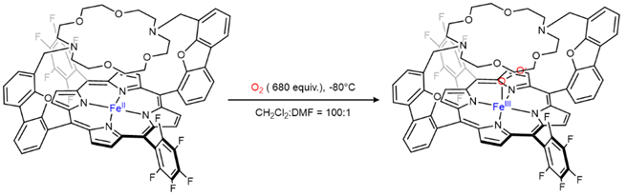
Supplementary Scheme 19. Formation of Fe^{III}L1–OO from Fe^{II}L1 by adding an excess of O₂ to Fe^{II}L1 at –80 °C.
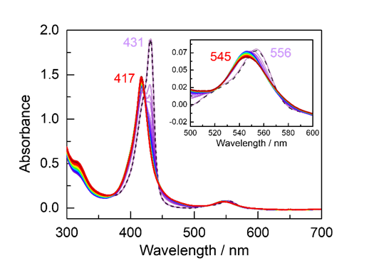
Supplementary Fig 62. Optical spectra showing the reaction forming Fe^{III}L1–OO (▬, dark red) from Fe^{II}L1 (▬, purple) upon the addition of 1.0 mL of O₂ at –80 °C. The reaction time course is represented by a gradient. The Soret band exhibits a blue shift from 431 nm to 417 nm, while the Q-band shifts from 556 nm to 545 nm, as depicted in the inset graph. These spectral shifts indicate the formation of Fe^{III}L1–OO, following a trend consistent with the reference data.

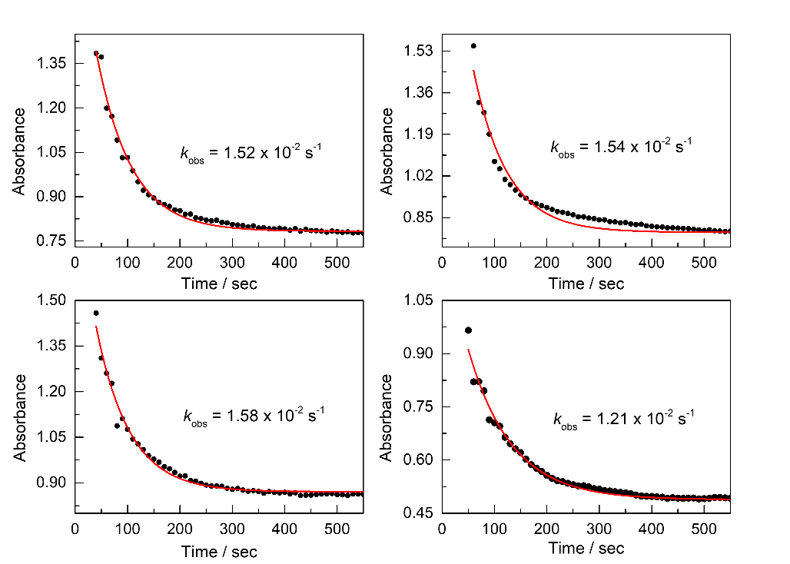
Supplementary Fig 63. Representative time course of the reaction between Fe^{II}L1 and 1.0 mL of O₂ at –80 °C. The experiment was repeated three times to obtain the average value of k_{obs} for the reaction (k_{obs} = 1.5(2) × 10^{–2} s^{–1}).
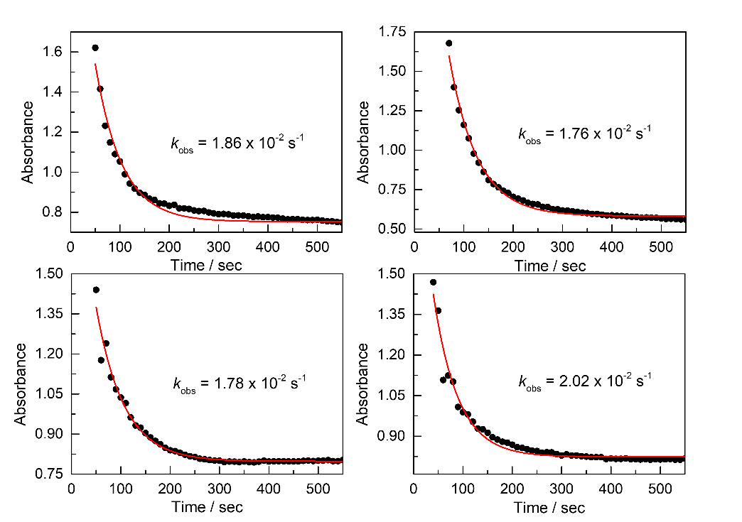
Supplementary Fig 64. Representative time course of the reaction between Fe^{II}L1 and 1.5 mL of O₂ at –80 °C. The experiment was repeated three times and obtained the average value of k_{obs} for the reaction (k_{obs} = 1.9(1) × 10^{–2} s^{–1}).

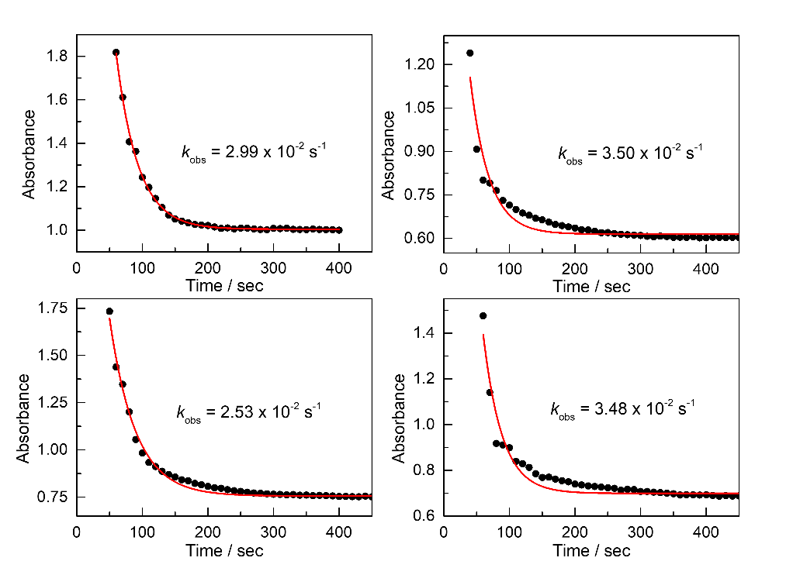
Supplementary Fig 65. Representative time course of the reaction between Fe^{II}L1 and 2.0 mL of O₂ at –80 °C. The experiment was repeated three times and obtained the average value of k_{obs} for the reaction (k_{obs} = 3.1(5) × 10^{–2} s^{–1}).
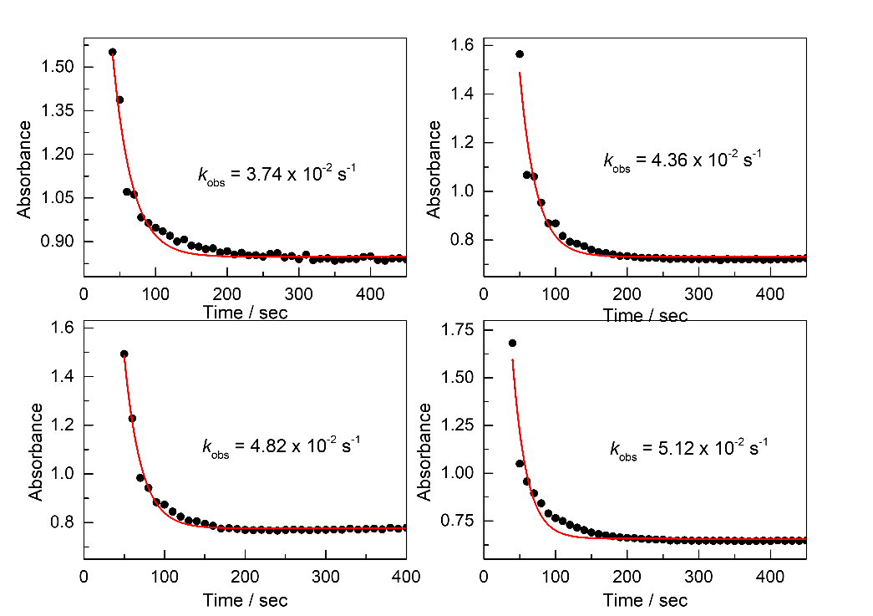
Supplementary Fig 66. Representative time course of the reaction between Fe^{II}L1 and 2.5 mL of O₂ at –80 °C. The experiment was repeated three times and obtained the average value of k_{obs} for the reaction (k_{obs} = 4.5(6) × 10^{–2} s^{–1}).

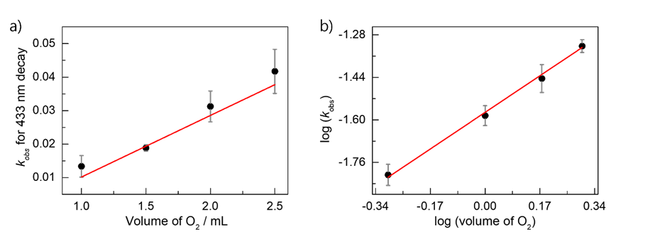
Supplementary Fig 67. a) The relationship between the volume of O₂ (V_{O2}) added to Fe^{II}L1 and the reaction rate constant(k_{obs}) indicates a proportional correlation. b) The plot of log(V_{O2}) versus log(k_{obs}) shows a slope of approximately 0.88 (R²=0.996), confirming that the reaction follows first-order kinetics with respect to V_{O2}.
Subsequently, to investigate the O₂ dependence in the presence of a cation, the same experiments were repeated under identical conditions with the addition of Sc(OTf)₃. As in the previous experiments, the FeL1–Cl was confirmed at –80 °C. Then after reaching temperature equilibrium, a 50 µL solution of Sc(OTf)₃ (6.0 mM in N,N-dimethylformamide, 0.30 µmol, 5.0 equiv.) was prepared in an N₂-filled glove box, and delivered to the solution via an N₂-purged syringe. These conditions are identical to the composition of the electrocatalytic ORR experimental setup. The equilibrium binding of Sc(OTf)₃ to FeL1–Cl was confirmed by the stabilization of the UV-vis spectrum. Subsequently, Fc* was added to generate the Fe^{II}L1 under the same conditions as the previous study, followed by the addition of O₂ to perform kinetic experiments on O₂ binding. In the presence of Sc(OTf)₃, the O₂ binding reaction proceeded at a significantly faster rate compared to the reaction without a cation, making it difficult to obtain reliable kinetic data when more than 2.5 mL of O₂ was added. As a result, O₂ addition was limited to a range of 0.50 to 2.0 mL.
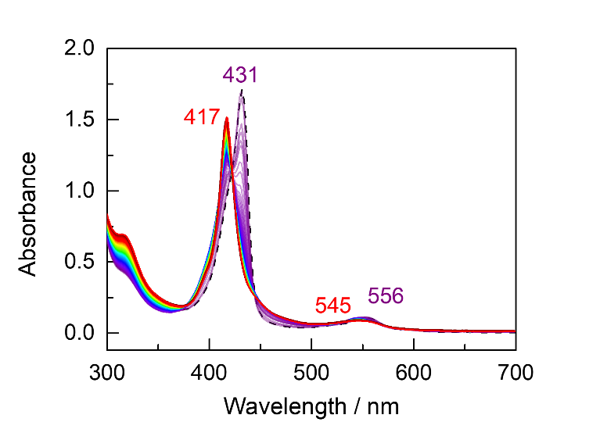
Supplementary Fig 68. Optical spectra of the reaction forming Fe^{III}L1–OO (▬, dark red) from Fe^{II}L1 (▬, purple) with 5.0 equivalents of Sc(OTf)₃ upon the addition of 1.0 mL of O₂ at –80 °C. The reaction time course is represented by a rainbow gradient. The Soret band exhibits a red shift from 431 nm to 417 nm, while the Q-band shifts from 556 nm to 545 nm. These spectral shifts indicate the formation of the Fe^{III}L1–OO, following a trend consistent with the Supplementary Fig 62.

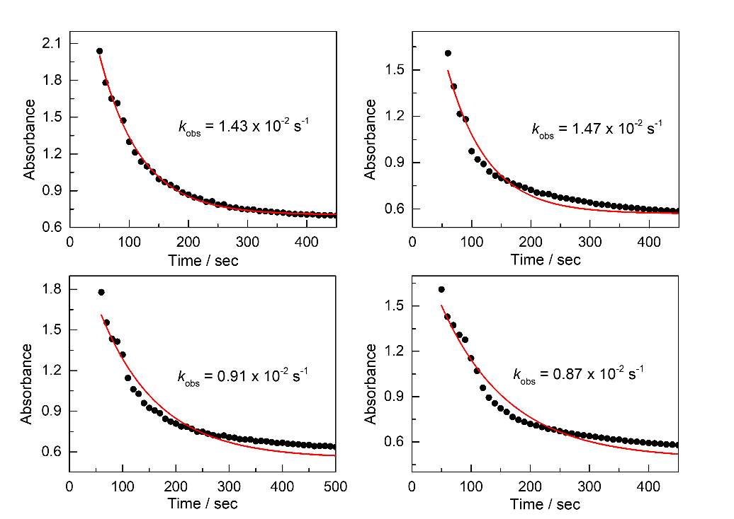
Supplementary Fig 69. Representative time course of the reaction between Fe^{II}L1 in the presence of Sc(OTf)₃ and 0.5 mL of O₂ at –80 °C. The experiment was repeated three times and obtained the average value of k_{obs} for the reaction (k_{obs} = 1.2(3) × 10^{–2} s^{–1}).
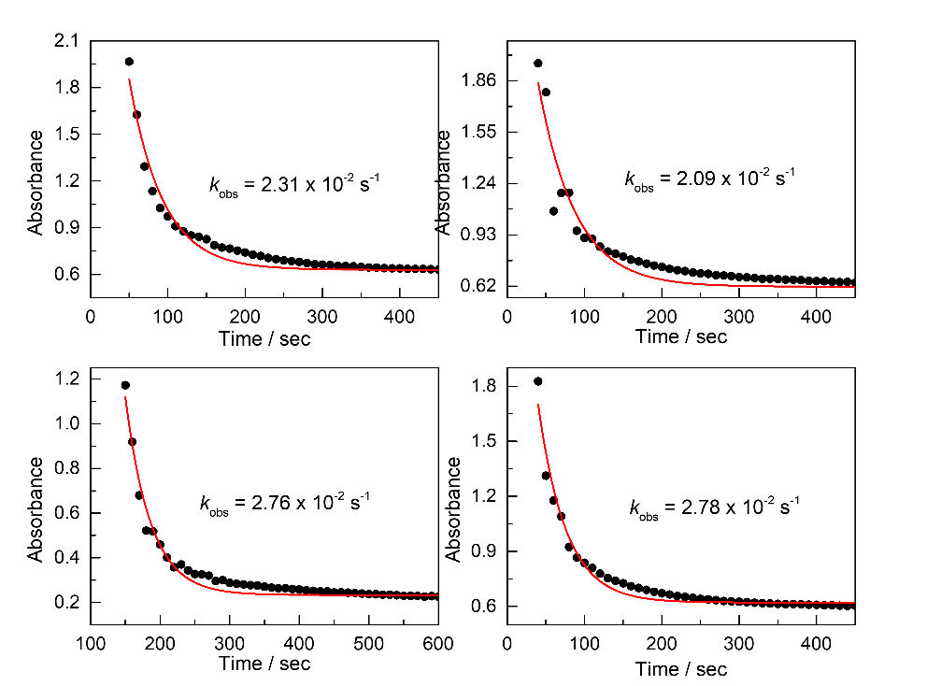
Supplementary Fig 70. Representative time course of the reaction between Fe^{II}L1 in the presence of Sc(OTf)₃ and 1.0 mL of O₂ at –80 °C. The experiment was repeated three times and obtained the average value of k_{obs} for the reaction (k_{obs} = 2.5(3) × 10^{–2} s^{–1}).

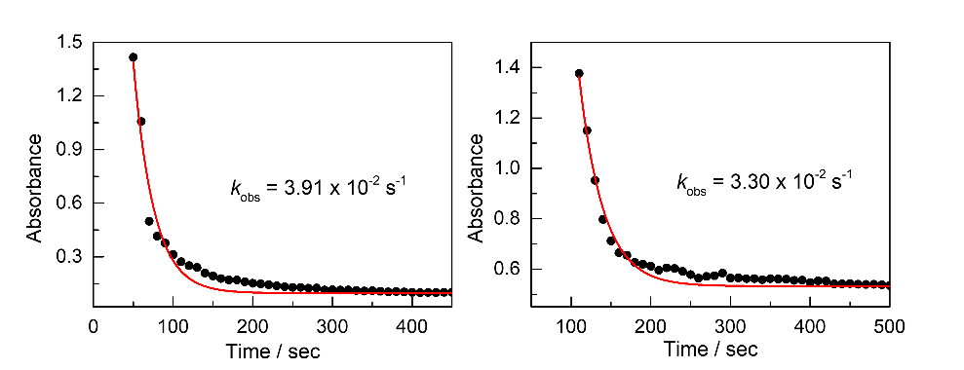
Supplementary Fig 71. Representative time course of the reaction between Fe^{II}L1 in the presence of Sc(OTf)₃ and 1.5 mL of O₂ at –80 °C. The experiment was repeated three times and obtained the average value of k_{obs} for the reaction (k_{obs} = 3.6(4) × 10^{–2} s^{–1}).
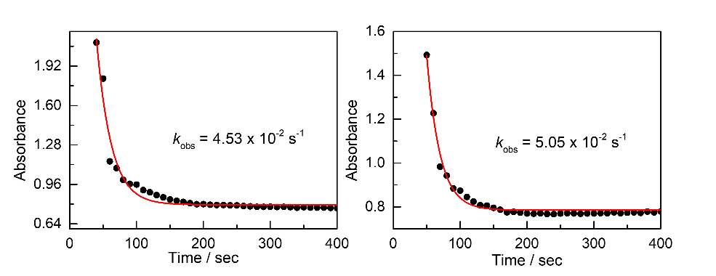
Supplementary Fig 72. Representative time course of the reaction between Fe^{II}L1 in the presence of Sc(OTf)₃ and 2.0 mL of O₂ at –80 °C. The experiment was repeated three times and obtained the average value of k_{obs} for the reaction (k_{obs} = 4.8(3) × 10^{–2} s^{–1}).
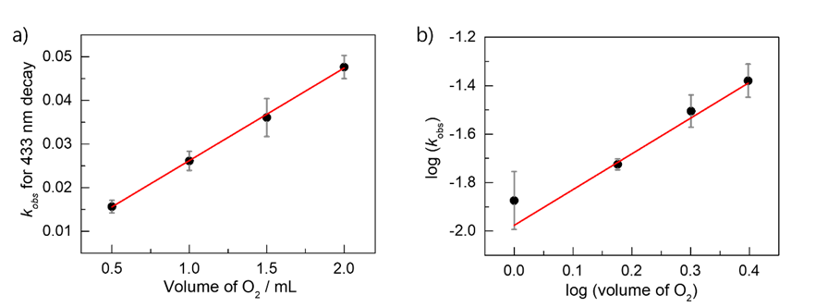
Supplementary Fig 73. a) The relationship between the volume of O₂ added to Fe^{II}L1 in the presence of Sc(OTf)₃ and the reaction rate constant(k_{obs}) indicates a proportional correlation. b) The plot of log(V_{O2}) versus log(k_{obs}) shows a slope of approximately 1.26 (R²=0.998), confirming that the reaction follows first-order kinetics with respect to V_{O2} as same as in the absence of Sc³⁺.

Investigation of ORR Intermediates Through Stoichiometric UV-vis Experiments.
A follow-up experiment was conducted to further investigate the reaction of Fe^{III}L1–OO converting to Fe^{III}L1–OOH and analyzed by UV-vis spectroscopy (Supplementary Scheme 20). To remove excess O₂ remaining in the cuvette headspace after the reaction, N₂ bubbling was performed for approximately 30 minutes at –80 °C. After confirming that the initial Fe^{III}L1–OO UV-vis features remained unchanged (Supplementary Fig 74. a), 50 µL of MeOH (12.3 µmol, 205 equiv) was added as a proton source. The results confirmed that Fe^{III}L1–OO underwent protonation upon the addition of the reductant, a 50 µL solution of CoCp₂ (6.0 mM in CH₂Cl₂, 0.30 µmol, 5.0 equiv) at –80 °C, leading to the formation of Fe^{III}L1–OOH (Supplementary Fig 74. c).
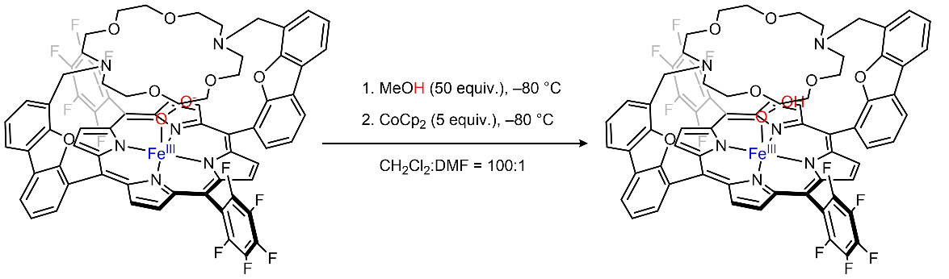
Supplementary Scheme 20. Formation of Fe^{III}L1–OOH from Fe^{III}L1–OO by adding an excess of MeOH as a proton source and CoCp₂ as a reductant at –80 °C.

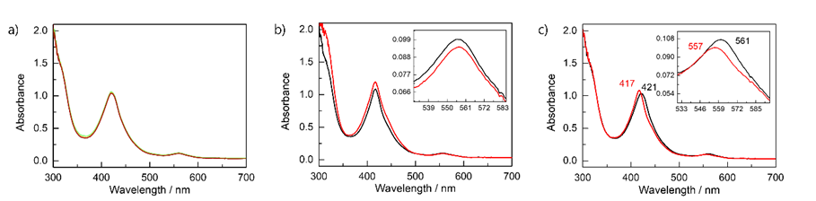
Supplementary Fig 74. a) Optical spectra showing results after N₂ bubbling for 30 min to remove the excess O₂ at –80 °C from Fe^{III}L1–OO (▬, green) with no changes observed (▬, purple to red gradient). b) After the addition of MeOH at –80 °C (▬, red), no changes were observed in the optical spectrum, indicating that no reaction occurred and Fe^{III}L1–OO (▬, black) remained stable. c) After the addition of CoCp₂ at –80 °C (▬, red) to the Fe^{III}L1–OO in the presence of MeOH (▬, black), the Soret band exhibits a blue shift from 421 nm to 417 nm, while the Q-band shifts from 561 nm to 557 nm. These spectral shifts indicate the formation of Fe^{III}L1–OOH, following a trend consistent with the reference data.

Quantitative Analysis of H₂O₂ Formed by UV-vis Spectroscopy
Complementary to the rotating ring-disk voltammetry (RRDV) studies presented in Section 9.3, stoichiometric, non-electrochemical investigations were conducted using UV-vis spectroscopy to further corroborate the finding that cationic species significantly influence H₂O₂ production pathways and thereby modulate the overall selectivity of oxygen reduction. In these controlled experiments, potassium superoxide (KO₂) was strategically introduced to FeL1–Cl in the presence of excess decamethylferrocene (Fc*), generating the key Fe^{III}L1–OO intermediate. Trifluoroethanol was employed as the proton source to maintain consistency with the conditions utilized in our electrochemical ORR studies.
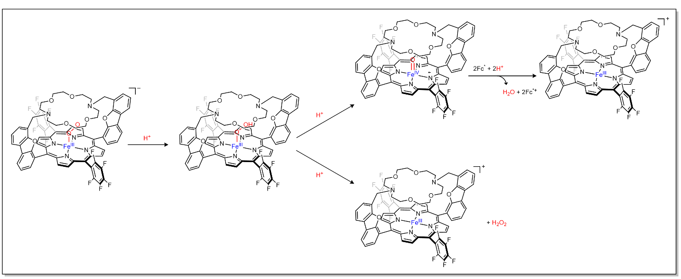
Supplementary Scheme 21. The proposed mechanism in the addition of acid to Fe^{III}L1–OO– leads to the formation of Fe^{IV}L1=O and Fe^{III}L1⁺, with the release of H₂O and H₂O₂.

Stoichiometric UV-vis Experiments from Iron Peroxo Complex
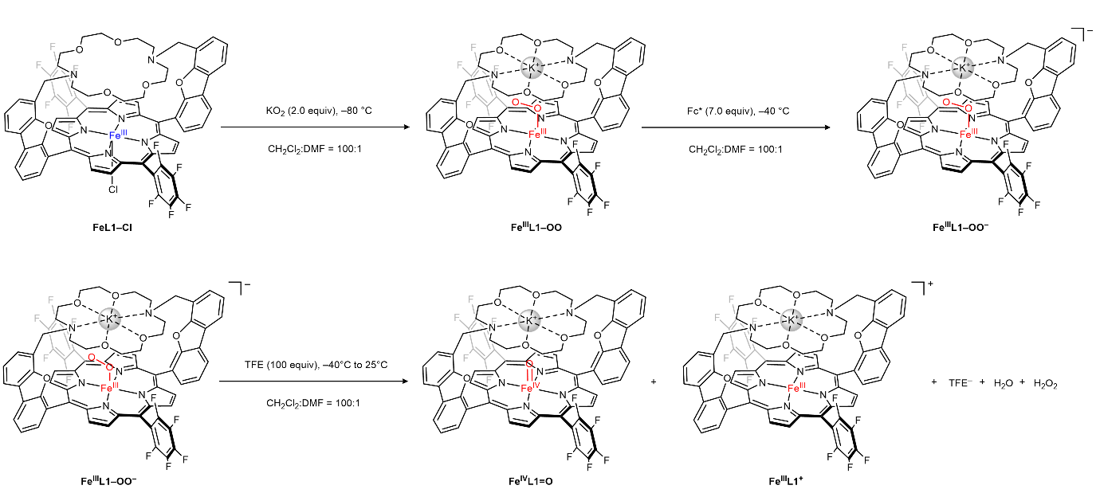
Supplementary Scheme 22. The reaction equation was conducted to analyze the %H₂O₂ selectivity of the stoichiometric oxygen reduction reaction via UV–vis spectroscopy for FeL1–Cl.

In an N₂-filled glove box, a 4-mL air-tight UV-vis cuvette was charged with 3.0 mL of FeL1–Cl solution (20 µM, 60 mmol, 1.0 equiv) and sealed with an air-tight rubber septum. The cuvette was transferred to a UNISOKU temperature control apparatus maintained at –80 °C. After reaching thermal equilibrium, 50 µL of KO₂ solution (3.0 mM in DMF, 0.12 µmol, 2.0 equiv), prepared under anaerobic conditions, was injected via a N₂-purged syringe. Complete conversion to Fe^{III}L1–OO was observed after 15 minutes, as confirmed by UV-vis spectroscopy (Supplementary Fig 75. a).
Fe^{III}L1–OO species was then reduced by adding 60 µL of Fc* solution (7.0 mM in CH₂Cl₂, 0.42 µmol, 7.0 equiv) at –40 °C, generating Fe^{III}L1–OO– (Supplementary Fig 75. b). Subsequently, addition of 60 µL trifluoroethanol (TFE) (0.10 M, 6.0 µmol, 100 equiv) at –40 °C caused the characteristic spectroscopic features of Fe^{III}L1–OO– to rapidly disappear. Upon gradual warming to 25 °C, the reaction proceeded through an Fe^{IV}L1=O intermediate before ultimately converting to Fe^{III}L1⁺ (Supplementary Fig. 76).
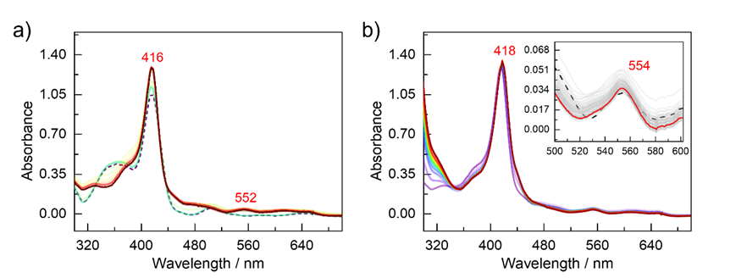
Supplementary Fig 75. a) Optical spectra showing the reaction forming Fe^{III}L1–OO (▬, dark red) from FeL1–Cl (▬, purple, dash) upon the addition of 2 equivalents of KO₂. The Soret band at 416 nm increased, while the Q-band shifted from 505 to 552 nm. These spectral shifts indicate the formation of the side-on peroxo complex, Fe^{III}L1–OO, following a trend consistent with the reference data. b) Optical spectra showing the reaction forming Fe^{III}L1–OO– (▬, dark red) from the peroxo complex, Fe^{III}L1–OO (▬, purple), upon the addition of 7 equivalents of Fc*. The reaction time course is represented by a gradient. The Soret band exhibits a red shift from 416 to 418 nm, while the Q-band changed shown in the inset graph. No distinct optical changes were observed; however, the spectral trend remains consistent with reference data, thereby supporting the formation of Fe^{III}L1–OO–.

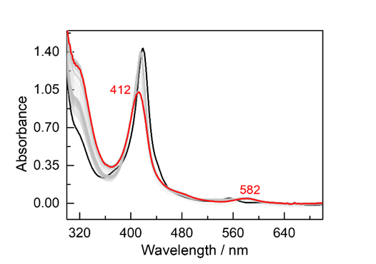
Supplementary Fig 76. Optical spectra showing the reaction forming Fe^{IV}L1=O (▬, dark red) from Fe^{III}L1–OO– (▬, black) upon the addition of 60 µL of TFE. The Soret band at 416 nm decreased and shifted to 412 nm, while the Q-band shifted from 552 to 582 nm. These spectral shifts indicate the formation of Fe^{IV}L1=O with TFE, following a trend consistent with the reference data.

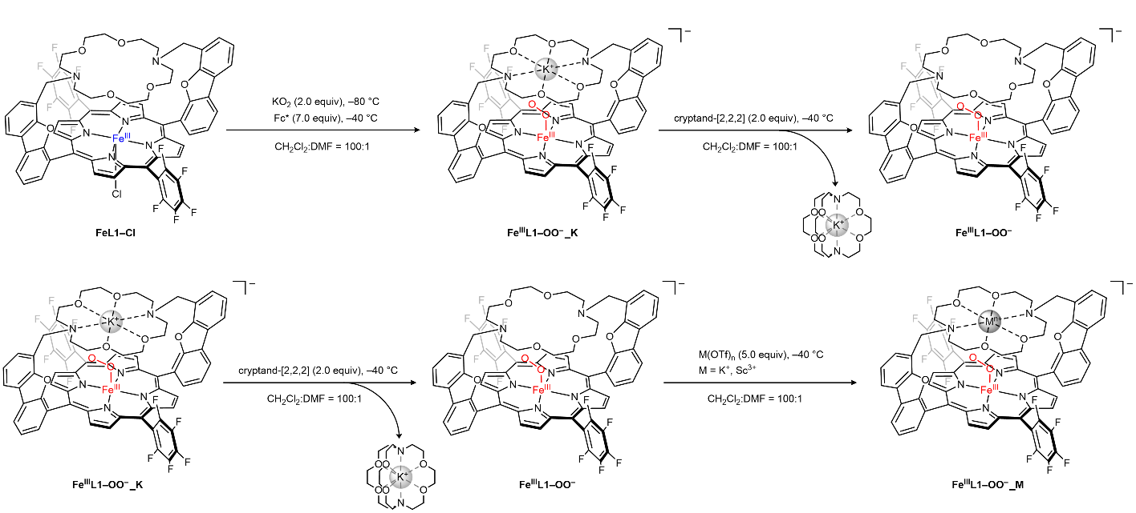
Supplementary Scheme 23. A stoichiometric reaction study was conducted to analyze the %H₂O₂ selectivity of the stoichiometric oxygen reduction reaction via UV–vis spectroscopy for FeL1–Cl with cryptand-[2,2,2] and triflate salts (KOTf, and Sc(OTf)₃) to investigate the cation-induced effect.

Having established optimal conditions for monitoring H₂O and H₂O₂ generation from the reaction of TFE with Fe^{III}L1–OO species, we next investigated the influence of cations on reaction selectivity. Two parallel experimental protocols were developed:
- Cation-free conditions: After forming Fe^{III}L1–OO, 50 µL of cryptand-[2,2,2] (3.0 mM in CH₂Cl₂, 0.15 µmol, 2.0 equiv) was added at –40 °C. The resulting Fe^{III}L1–OO– complex (Supplementary Scheme 23) exhibited remarkable stability at –40 °C, remaining unchanged for over an hour (Supplementary Fig. 77a). Addition of TFE under these conditions triggered the decomposition reaction pathway previously characterized (Supplementary Fig. 76), as demonstrated in Supplementary Fig. 77b.
- Cation-influenced conditions: For comparison, 50 µL of triflate salt solutions (KOTf, or Sc(OTf)₃) (7.5 mM in DMF, 0.38 μmol, 5.0 equiv) was introduced at –80 °C to the Fe^{III}L1–OO– species in the presence of cryptand-[2,2,2]. The Fe^{III}L1–OO– complex maintained its stability under these conditions as well (Supplementary Fig. 78a). When TFE was subsequently added at –40 °C and the mixture gradually warmed to room temperature, the reaction proceeded to form products identical to those observed under cation-free conditions (Supplementary Fig.78b).
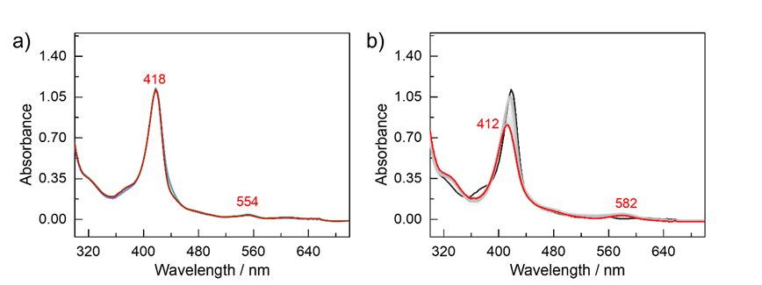
Supplementary Fig 77. a) Optical spectra after adding cryptand-[2,2,2] to Fe^{III}L1–OO (▬, purple) showing no changes (▬, purple to red gradient). b) Optical spectra showing the reaction forming Fe^{III}L1 (▬, dark red) from Fe^{III}L1–OO– (▬, black) upon the addition of 60 µL of TFE. The Soret band at 418 nm decreased and shifted to 412 nm, while the Q-band shifted from 554 to 582 nm. These spectral shifts indicate the formation of Fe^{IV}L1=O with TFE, following a trend consistent with the reference data and identical with Supplementary Fig 76.

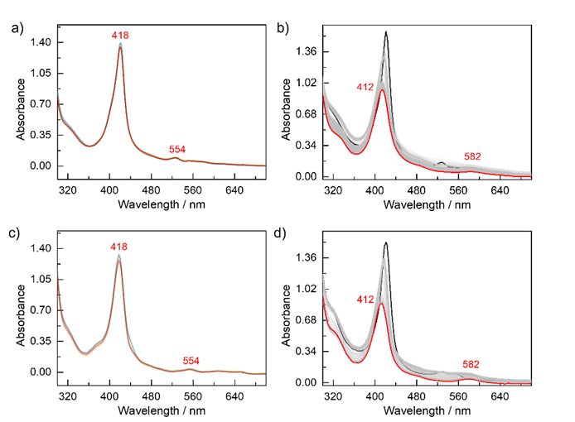
Supplementary Fig 78. a) Optical spectra after adding KOTf to Fe^{III}L1–OO– (▬, green) showing no changes (▬, green to red gradient). b) After adding of TFE to Fe^{III}L1–OO– with K⁺ (▬, black), the reaction goes to Fe^{IV}L1=O (▬, dark red) as same as Supplementary Fig 76 and 77b. c) After adding Sc(OTf)₃ to Fe^{III}L1–OO– (▬, green) showing no changes (▬, green to red gradient) as a). d) After adding of TFE to Fe^{III}L1–OO– with Sc³⁺ (▬, black), the reaction goes to Fe^{IV}L1=O (▬, dark red) as c).

Stoichiometric UV-vis Experiments from Fe^{III}–OO–: Control Exp I with FeTF₁₀PP–Cl
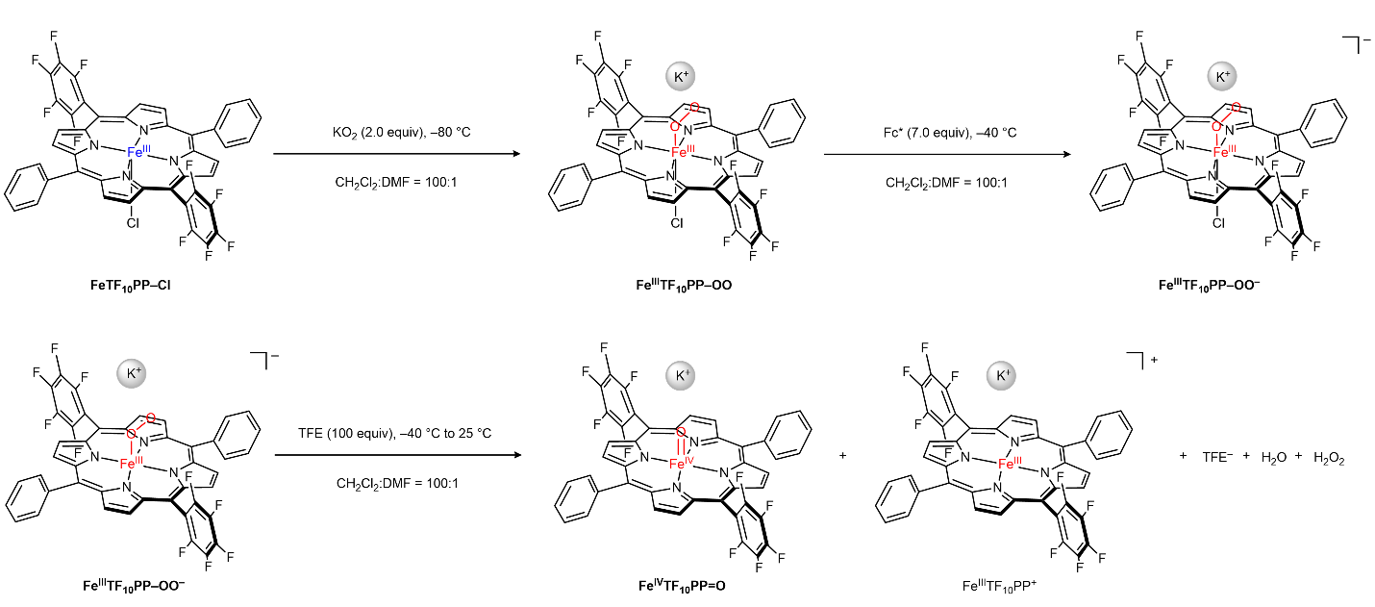
Supplementary Scheme 24. The reaction equation was conducted to analyze the %H₂O₂ selectivity of the stoichiometric oxygen reduction reaction via UV–vis spectroscopy for FeTF₁₀PP–Cl.

In this section, experiments were conducted using a control ligand system (TF₁₀PP) that lacks the diaza-crown-ether moiety while maintaining electronic properties similar to L1. This approach was designed to distinguish between effects arising from direct Lewis acid coordination versus electrostatic field effects. All experimental procedures followed protocols identical to those described in Section 4.1, with FeTF₁₀PP–Cl serving as the starting material.
The reaction sequence was performed as follows: In an N₂-filled glove box, a 4-mL air-tight UV-vis cuvette was charged with 3.0 mL of FeTF₁₀PP–Cl solution (20 µM, 60 nmol, 1.0 equiv) and sealed with an air-tight rubber septum. The cuvette was transferred from the glove box to a UNISOKU temperature-controlled chamber maintained at –80 °C. After temperature equilibrium, 50 µL of KO₂ solution (3.0 mM in DMF, 0.15 µmol, 2.0 equiv), prepared in an N₂-filled glove box, was introduced into the reaction mixture via an N₂-purged syringe.
Complete conversion to Fe^{III}TF₁₀PP–OO was observed after 15 min (Supplementary Fig 79. a). Subsequently, 60 µL of Fc* solution (7.0 mM in CH₂Cl₂, 0.42 µmol, 7.0 equiv) was added to the Fe^{III}TF₁₀PP–OO complex, generating Fe^{III}TF₁₀PP–OO– at –40 °C (Supplementary Fig 79. b). Upon addition of 60 µL of trifluoroethanol (TFE) (1.0 M, 60 µmol, 100 equiv) at –40 °C, the spectroscopic features characteristic of Fe^{III}TF₁₀PP–OO– rapidly disappeared. As the temperature was gradually increased to 25 °C, the reaction proceeded through an Fe^{IV}TF₁₀PP=O intermediate species before ultimately converting to Fe^{III}TF₁₀PP⁺ (Supplementary Fig. 80).
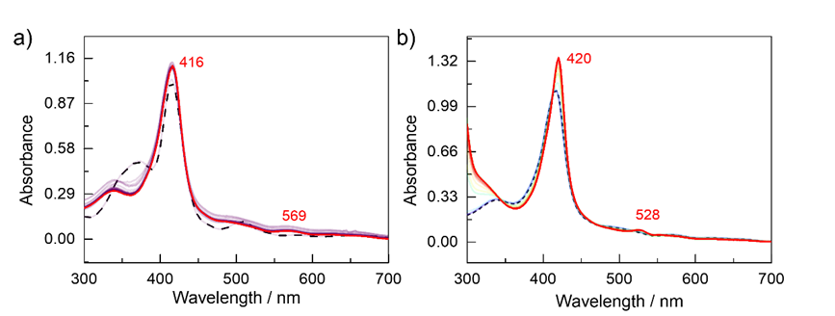
Supplementary Fig 79. a) Optical spectra of the reaction forming Fe^{III}TF₁₀PP–OO (▬, dark red) from FeTF₁₀PP–Cl (▬, purple, dash) after the adding of 2 equivalents of KO₂. The Soret band at 416 nm increased, while the Q-band shifted from 508 to 569 nm. These spectral shifts indicate the formation of the side-on peroxo complex, Fe^{III}TF₁₀PP–OO, following a trend consistent with the reference data. b) Optical spectra of the reaction forming Fe^{III}TF₁₀PP–OO– (▬, dark red) from the side-on peroxo complex, Fe^{III}TF₁₀PP–OO (▬, purple), after the adding of 7 equivalents of Fc*. The reaction time course is represented by a rainbow gradient. The Soret band exhibits a red shift from 416 to 420 nm, while the Q-band also shifted from 569 nm to 528 nm. These changes supporting the formation of Fe^{III}TF₁₀PP–OO–.
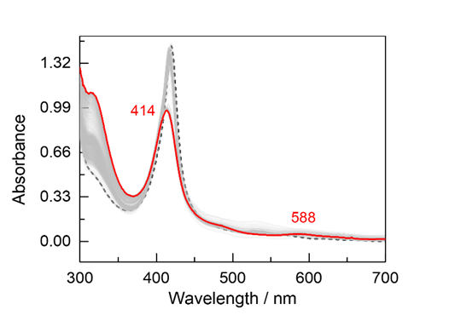
Supplementary Fig 80. Optical spectra showing the reaction forming Fe^{III}TF₁₀PP–Cl (▬, dark red) from Fe^{III}TF₁₀PP–OO– (▬, black, dash) upon the addition of 60 µL of TFE. The Soret band at 416 nm decreased and shifted to 414 nm, while the Q-band shifted from 528 to 588 nm. These spectral shifts indicate the formation of Fe^{IV}TF₁₀PP=O with TFE, following a trend consistent with the reference data.

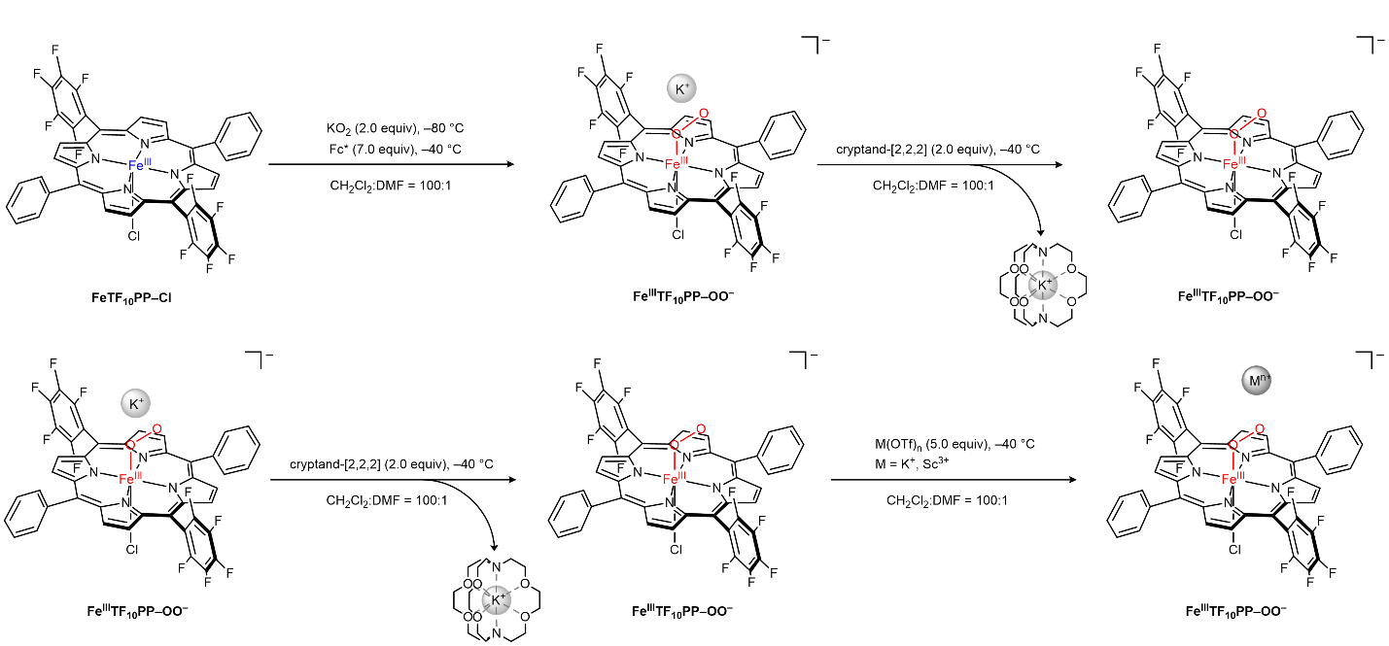
Supplementary Scheme 25. The reaction was conducted to analyze the %H₂O₂ selectivity of the stoichiometric oxygen reduction reaction via UV–vis spectroscopy for FeTF₁₀PP–Cl with cryptand-[2,2,2] and triflate salts (KOTf, and Sc(OTf)₃) to investigate the induced cation effect.

The experiments were carried out under the same conditions as depicted in Supplementary Scheme 25 as in Section 4.1. Based on these observations, the conditions for UV–vis spectroscopic analysis of the reaction in which H₂O and H₂O₂ are generated by adding TFE to the Fe^{III}TF₁₀PP–OO species derived from the FeTF₁₀PP–Cl complex was also well established. Next, to verify the cation-induced selectivity changes observed in electrochemical ORR under UV-vis spectroscopic analysis conditions, new conditions were optimized that allows introduction of cations. Under cation-free conditions, Fe^{III}TF₁₀PP–OO was formed, then a 50 µL solution of cryptand-[2,2,2] (3.0 mM in CH₂Cl₂, 0.12 µmol, 2.0 equiv) were added at –40 °C. As a result, the Fe^{III}TF₁₀PP–OO– in Supplementary Scheme 25 remained stable at –40 °C for over an hour (Supplementary Fig 81. a). Under these conditions, when TFE was added at –40 °C, the decomposition reaction of Fe^{III}L1–OO– was observed as Supplementary Fig 80 (Supplementary Fig 81. b). Meanwhile, for the cation-introducing conditions, a 50 µL solution of the triflate salts (KOTf, and Sc(OTf)₃) (7.5 mM in DMF, 0.30 μmol, 5.0 equiv) was added at –80 °C to Fe^{III}TF₁₀PP–OO– in the presence of cryptand-[2,2,2]. In this condition, Fe^{III}TF₁₀PP–OO– also remained stable (Supplementary Fig 82. a and c). Subsequently, as shown previously in Supplementary Fig 81, TFE was added at –40 °C and the mixture was warmed to room temperature to allow the reaction to proceed, resulting in the formation of the same product as in the cation-free condition (Supplementary Fig 82. b and d).
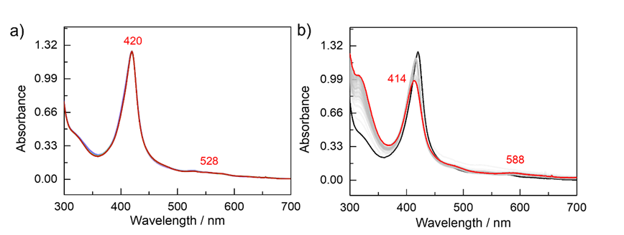
Supplementary Fig 81. a) Optical spectra after adding of cryptand-[2,2,2] to Fe^{III}TF₁₀PP–OO (▬, purple) showing no changes (▬, purple to red gradient). b) Optical spectra showing the reaction forming Fe^{III}TF₁₀PP–OOH (▬, dark red) from Fe^{III}TF₁₀PP–OO– (▬, black) after adding of 60 µL of TFE. The Soret band at 420 nm decreased and shifted to 414 nm, while the Q-band shifted from 528 to 582 nm. These spectral shifts indicate the formation of Fe^{IV}TF₁₀PP=O with TFE, following a trend consistent with the reference data and identical with Supplementary Fig 80.
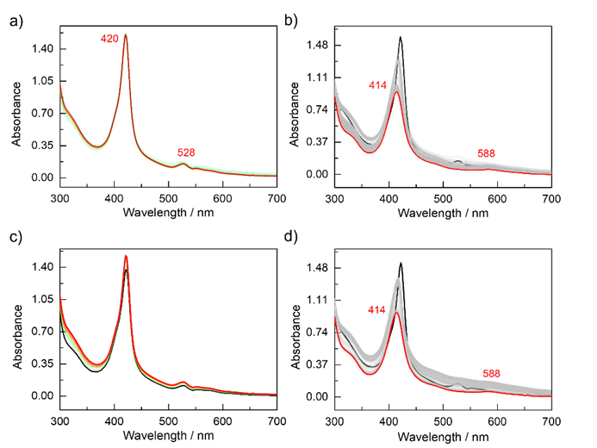
Supplementary Fig 82. a) Optical spectra after adding KOTf to Fe^{III}TF₁₀PP–OO– (▬, green) showing no changes (▬, green to red gradient). b) After adding of TFE to Fe^{III}TF₁₀PP–OO– with K⁺ (▬, black), the reaction goes to Fe^{IV}TF₁₀PP=O (▬, dark red) as same as Supplementary Fig 84 and 77b. c) After adding Sc(OTf)₃ to Fe^{III}TF₁₀PP–OO– (▬, green) showing no changes (▬, green to red gradient) as a). d) After adding of TFE to Fe^{III}TF₁₀PP–OO– with Sc³⁺ (▬, black), the reaction goes to Fe^{IV}TF₁₀PP=O (▬, dark red) as c).

Quantification of H₂O₂ Production during Oxygen Reduction Reactions via Iodometric Titrations
H₂O₂ yields during oxygen reduction reactions (Sections 4.1. to 4.2.) were determined using spectrophotometric detection. The post-catalytic mixtures in N,N-dimethylformamide (DMF) were titrated into an iodide-containing aqueous solution, and the formation of triiodide (I₃⁻) was monitored at 351 nm, following the reaction shown in Supplementary Scheme 26.
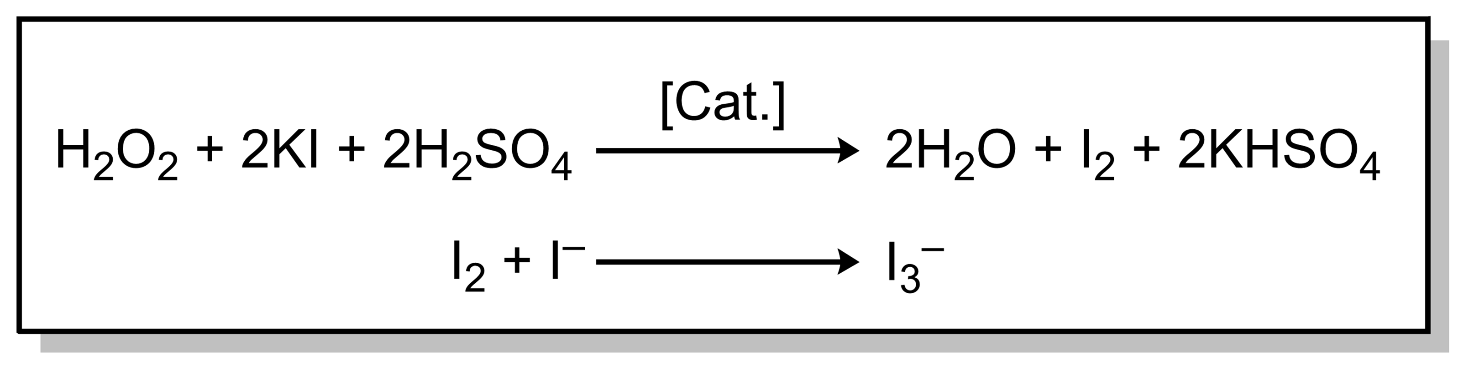
Supplementary Scheme 26. Quantification of H₂O₂ via the stoichiometric production of I₃⁻ by the iodometric titration as this reaction equation.
For the titration analysis, an aqueous iodide solution was prepared by dissolving 44 mg of KI in 2 mL of a 0.5 mM (NH₄)₂Mo₇O₂₄ catalyst solution in 0.5 N sulfuric acid. The titrations were performed at 25 °C in the same cuvette used for previous UV-vis experiments, equipped with a magnetic stir bar under an N₂ atmosphere. All solutions were prepared under strictly anaerobic conditions to prevent auto-oxidation. Method validation was first performed using standard solutions with known H₂O₂ content. Based on the standard calibration curve at 351 nm, the molar extinction coefficient (ε) of I₃– was determined to be 24,805.2 L mol^{–1} cm^{–1} (Supplementary Fig 83). Subsequently, aliquots from the reactions conducted in Sections 4.1 to 4.2 were titrated with the iodide solution. The H₂O₂ yield was calculated by comparing the titration results with the amount of Fc*⁺ formed due to the auto-oxidation of Fc*, according to:
%H₂O₂ = (2 x moles of H₂O₂)/(moles of Fc*).
Using this analytical approach, the H₂O₂ selectivity for each reaction system described in Sections 4.1 and 4.2 was determined (Supplementary Fig. 83).
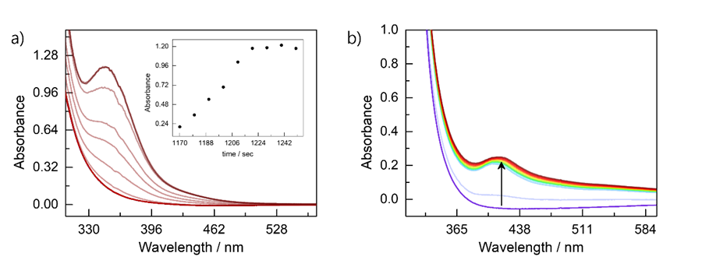
Supplementary Fig 83. a) Calculated I₃– extinction coefficient by iodometric titration with standard H₂O₂ solution and the example of iodometric titration from Supplementary Fig 77 a. b) An aliquot taken from the reaction sample showed that the I₃⁻ absorbance band appeared at a red-shifted to 415 nm in compared to that in the standard solution.

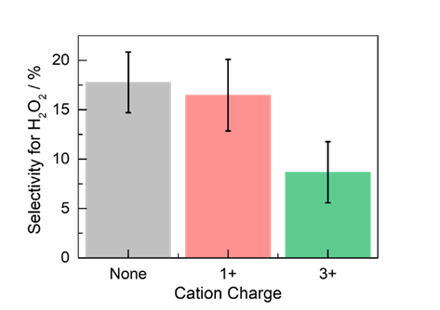
Supplementary Fig 84. Final selectivity for %H₂O₂ calculated results of FeL1–Cl after iodometric titration in the presence of cation and non-cation conditions. In each bar graph, from left to right, the bars correspond to: only cryptand-[2,2,2] (▬, gray), addition of KOTf(▬, red), and Sc(OTf)₃(▬, green).
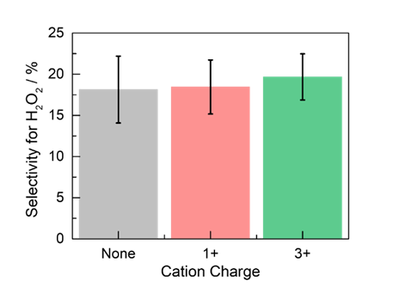
Supplementary Fig 85. Final %H₂O₂ calculated results of FeTF₁₀PP–Cl after iodometric titration in the presence of cation and non-cation conditions. In each bar graph, from left to right, the bars correspond to: only cryptand-[2,2,2] (▬, gray), addition of KOTf(▬, red), and Sc(OTf)₃(▬, green).
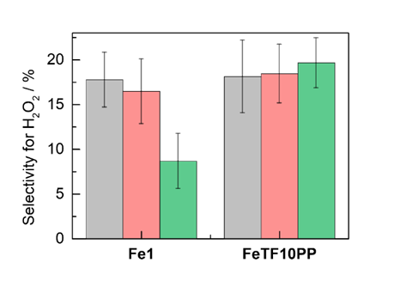
Supplementary Fig 86. A comparison of the selectivity for %H₂O₂ generated in reactions using FeL1–Cl and FeTF₁₀PP–Cl under both cation and non-cation conditions is presented. In each bar graph, from left to right, the bars correspond to: only cryptand-[2,2,2] (▬, gray), addition of KOTf(▬, red), and Sc(OTf)₃(▬, green).

X-ray Absorption Spectroscopy Analysis of FeL1–Cl and Fe^{III}L1–OO Complexes
: Comparative Study of Sc(OTf)₃ Effects
In an N₂-filled glove box, a solution of FeL1–Cl (20 mM in anhydrous DMF) was prepared for X-ray absorption near edge structure (XANES) analysis. The sample was maintained at –40 °C throughout data collection to ensure structural integrity. As illustrated in Supplementary Fig 77, an excess of KO₂ (10 equiv) was added in-situ to generate the Fe^{III}L1–OO species, enabling direct XANES characterization of this key intermediate. To investigate the influence of cations, 5 equivalents of Sc(OTf)₃ were similarly introduced in-situ to both FeL1–Cl and Fe^{III}L1–OO under identical temperature conditions. The resulting XANES spectra were collected and analyzed, with the comparative spectroscopic data presented below.

Comparison of the XANES Data for FeL1–Cl Before and After the Addition of Sc(OTf)₃
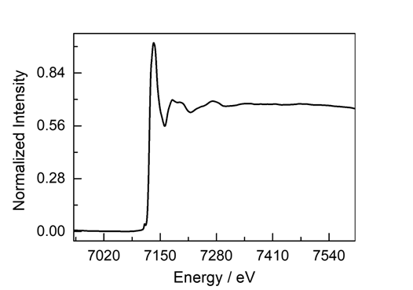
Supplementary Fig 87. Full Fe K-edge XANES spectrum of a 20 mM FeL1–Cl solution in N,N-Dimethylformamide (DMF) (▬, black).
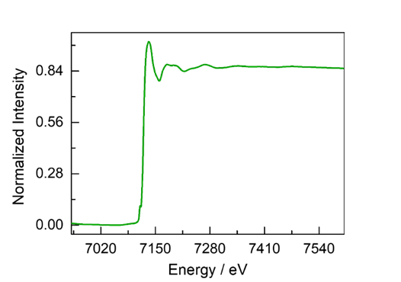
Supplementary Fig 88. Full Fe K-edge XANES spectrum of a 20 mM FeL1–Cl solution in N,N-Dimethylformamide (DMF) after the addition of 5 equivalents of Sc(OTf)₃ (▬, green).

Comparison of the XANES data for Fe^{III}L1–OO Before and After the Addition of Sc(OTf)₃
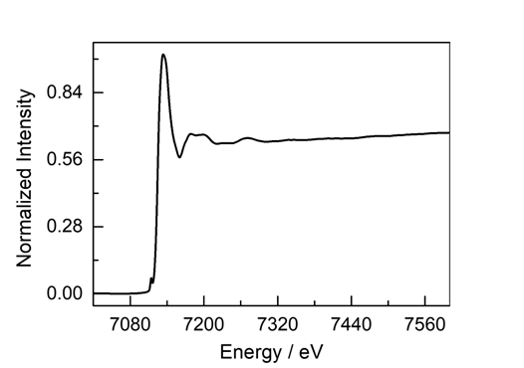
Supplementary Fig 89. Full Fe K-edge XANES spectrum of the Fe^{III}L1–OO species formed by adding 10 equivalents of KO₂ to a 20 mM FeL1–Cl solution in DMF (▬, black).
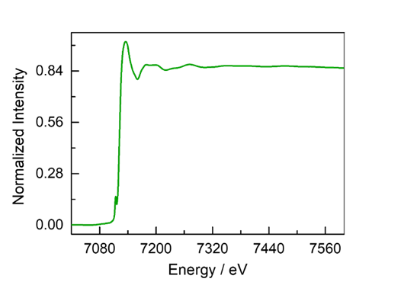
Supplementary Fig 90. Full Fe K-edge XANES spectrum of the Fe^{III}L1–OO species formed by adding 10 equivalents of KO₂ to a 20 mM FeL1–Cl solution DMF in after the addition of 5 equivalents of Sc(OTf)₃ (▬, green).

Cleavage of Fe^{III}L1–OOH by the Addition of a Chemical Reductant
To compare the potential of the Fe^{III}L1–OOH to Fe^{IV}L1=O electron transfer step under the influence of cation addition, experiments were conducted to identify a suitable reductant capable of cleaving Fe^{III}L1–OOH, and the reaction progress was analyzed using UV-vis spectroscopy.
In an N₂-filled glove box, a solution of FeL1–Cl (20 μM in CH₂​Cl₂ containing 1% (v/v) DMF) was prepared for UV-vis measurements. A 4 mL air-tight UV-vis cuvette was charged with 3.0 mL of FeL1–Cl solution (20 μM, 80 nmol, 1.0 equiv) and sealed with an air-tight rubber septum. Following the procedure described in Section 4, the Fe^{III}L1–OO​ species was generated, and the cuvette was maintained at –40 °C while bubbling N₂​ to remove any excess O₂​. As confirmed in Supplementary Fig 74. a, the Fe^{III}L1–OO​ species remained intact under these conditions. Subsequently, methanol (50 μL, 1.6 μmol, 20 equiv) was added as a proton source at –80 °C, resulting in the the Fe^{III}L1–OOH​ species within 15 minutes, which remained stable for 30 minutes (Supplementary Fig. 74c). Finally, reductant (Fc* or cobaltocene (CoCp₂), 50 μL of 6.0 mM in CH₂Cl₂​, 0.40 μmol, 5.0 equiv) were added at –80 °C and the resulting reactivity was examined.

UV-vis Spectral Analysis of Fe^{III}L1–OOH to Fe^{IV}L1=O Cleavage Reaction without Cation
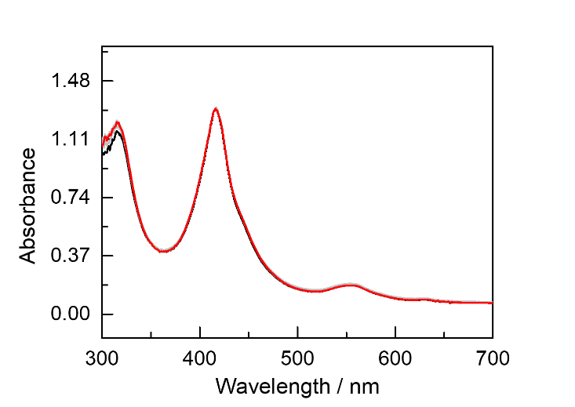
Supplementary Fig 91. Optical spectra and the Q-band region (inset) showing the reaction between 5 equivalents of Fc* and a 20 µM [Fe^{III}L1–OOH] solution at –80 °C. Initial spectrum of [Fe^{III}L1–OOH] in CH₂Cl₂ (▬, black). The final spectrum after 5 equivalents of Fc* to the [Fe^{III}L1–OOH] solution (▬, red) is identical to the initial spectrum, indicating that no electron transfer reaction occurs. Gray traces (▬, gray) show the time course of the reaction between Fe^{III}L1–OOH and Fc*.

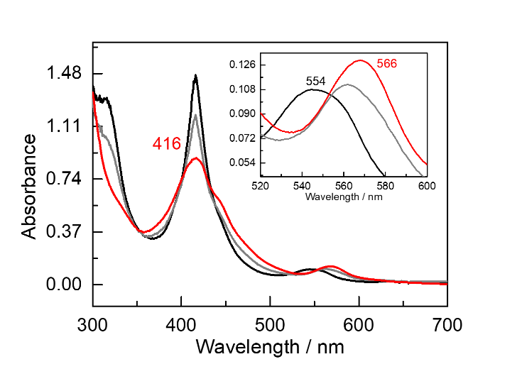
Supplementary Fig 92. Optical spectra and the Q-band region (inset) showing the reaction between 5 equivalents of a CoCp₂ and a 20 µM [Fe^{III}L1–OOH] solution at –80 °C. Initial spectrum of [Fe^{III}L1–OOH] in CH₂Cl₂ (▬, black). The final spectrum after addition of 5 equivalents of CoCp₂ to the [Fe^{III}L1–OOH] solution (▬, red). Gray traces (▬, gray) show the time course of the reaction between [Fe^{III}L1–OOH] and CoCp₂.

UV-vis Spectral Analysis of Fe^{III}L1–OOH to Fe^{IV}L1=O Cleavage Reaction with Sc(OTf)₃
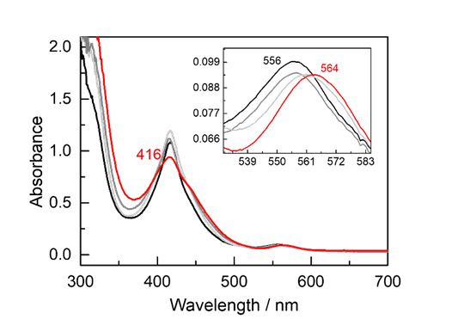
Supplementary Fig 93. Optical spectra and the Q-band region (inset) showing the reaction between 5 equivalents of a Fc* and a 20 µM [Fe^{III}L1–OOH] solution in the presence of 5 equivalents of Sc(OTf)₃ solution at –80 °C. Initial spectrum of [Fe^{III}L1–OOH] with 5 equivalents of Sc(OTf)₃ in CH₂Cl₂ containing 1% (v/v) DMF (▬, black). The final spectrum after addition of 5 equivalents of Fc* to the [Fe^{III}L1–OOH] solution (▬, red) is identical to the results of Supplementary Fig 92, indicating the electron transfer reaction occurred. Gray traces (▬) show the time course of the reaction between [Fe^{III}L1–OOH] and Fc*.

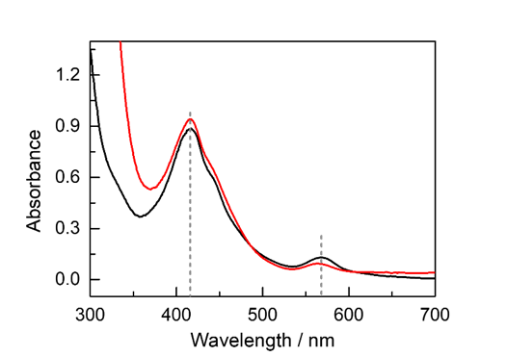
Supplementary Fig 94. The overlaid spectra comparing the reaction outcomes of Fe^{III}L1–OOH with CoCp₂ in the absence of Sc³⁺ (▬, black) and the reaction with FeCp*₂ in the presence of Sc³⁺ (▬, red). The identical spectral profiles, demonstrate that the addition of Sc³⁺ enables Fe^{III}L1–OOH to react with Fc*, a weaker reductant than CoCp₂.

RDE&RRDE Set-up

Materials and Preparation of Electrochemistry Set-up
TBAPF_{6,} ferrocene, dichloromethane (CH₂Cl₂) (1 L SureSeal® Bottle), N,N-dimethylformamide (DMF) (1 L SureSeal® Bottle), trifluoroethanol (TFE), potassium triflate (KOTf), calcium triflate (Ca(OTf)₂), and scandium triflate (Sc(OTf)₃) were purchased from Sigma Aldrich. Prior to use, TBAPF₆ was recrystallized twice from ethanol. Additional details regarding general electrochemical measurements are described in the Methods section of the main text.
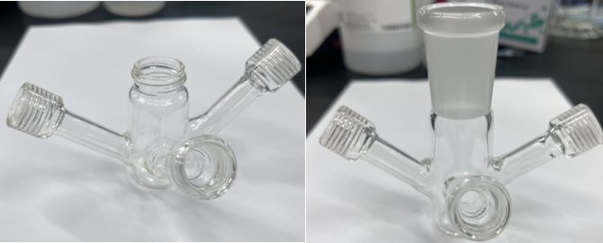
Supplementary Fig 95. Experimental setup for electrochemical measurements: (left) Customized rotating disk electrode (RDE) cell; (right) Customized rotating ring-disk electrode (RRDE) cell.

RDE (Rotating Disk Electrode) Measurement

Standard Condition for O₂ Reduction at Various rpm with FeL1–Cl
Linear sweep voltammetry data were collected under the same solution condition described below at 0.05 V/s scan rates. Solutions were prepared in CH₂Cl₂ (include 1% DMF) with 3 mM TFE, 0.1 M TBAPF₆ and 5 equivalents of the following metal triflate salt (M^{n+} = K⁺, Ca²⁺, Sc³⁺) Voltammograms were internally referenced to ferrocene, which was added at the end of each experiment to avoid interference with the foot-of-the-wave analysis.
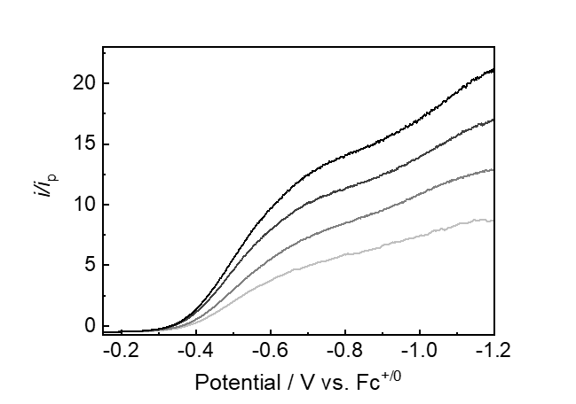
Supplementary Fig 96. Linear sweep voltammograms (LSVs) of FeL1–Cl under 1 atm O₂, measured at rotation rates of 400, 900, 1600, and 2500 rpm in the absence of triflate salt Data are presented using a color gradient from light to dark corresponding to increasing rotation speed from 400 to 2500 rpm.

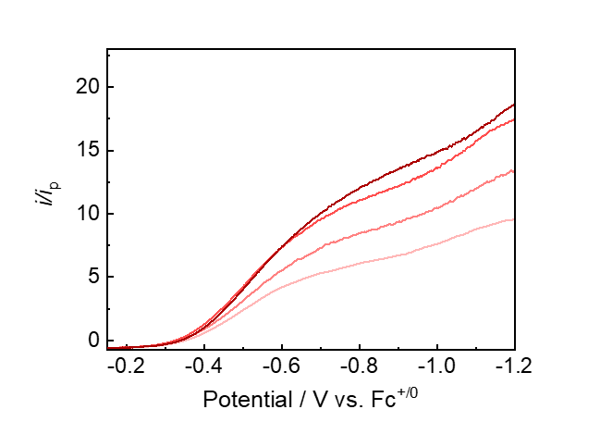
Supplementary Fig 97. Linear sweep voltammograms (LSVs) of FeL1–Cl under 1 atm O₂, measured at rotation rates of 400, 900, 1600, and 2500 rpm in the presence of KOTf. Data are present using a color gradient from light to dark corresponding to increasing rotation speed from 400 to 2500 rpm

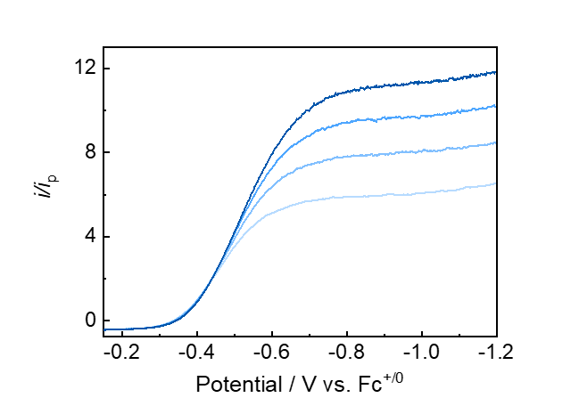
Supplementary Fig 98. Linear sweep voltammograms (LSVs) of FeL1–Cl under 1 atm O₂, measured at rotation rates of 400, 900, 1600, and 2500 rpm in the presence of Ca(OTf)₂. Data are present using a color gradient from light to dark corresponding to increasing rotation speed from 400 to 2500 rpm.

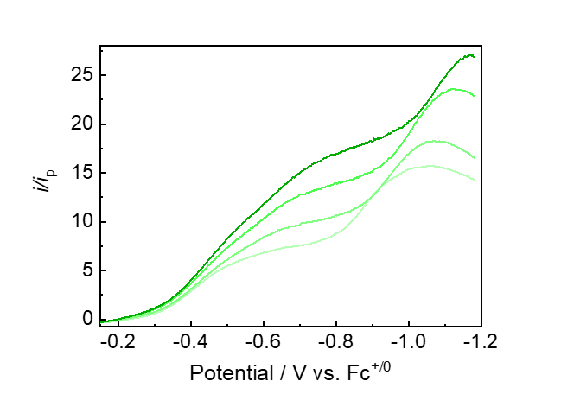
Supplementary Fig 99. Linear sweep voltammograms (LSVs) of FeL1–Cl under 1 atm O₂, measured at rotation rates of 400, 900, 1600, and 2500 rpm in the presence of Sc(OTf)₃. Data are present using a color gradient from light to dark corresponding to increasing rotation speed from 400 to 2500 rpm.

O₂ Reduction with Control Ligand FeTF₁₀PP–Cl
Linear sweep voltammetry data were collected under the same solution condition described below at 0.05 V/s scan rates. Solutions were prepared in CH₂Cl₂ (include 1% DMF) with 3 mM TFE, 0.1 M TBAPF₆ and 5 equivalents Sc(OTf)_{3.} Voltammograms were internally referenced to ferrocene, which was added at the end of each experiment to avoid interference with the foot-of-the-wave analysis
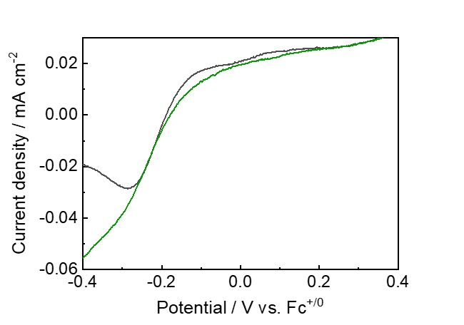
Supplementary Fig 100. Linear sweep voltammograms (LSVs) of FeTF₁₀PP–Cl under 1 atm O₂, measured under identical conditions, showing similar electrochemical responses in the presence of 5 equivalents of Sc(OTf)₃ (▬, green solid line) and absence of Sc(OTf)₃ (▬, black solid line).

RRDE (Rotating Ring Disk Electrode) Measurement

Collection Efficiency (N_{c})
RRDE experiments were conducted with an Autolab potentiostat and a Pine Instruments rotator using a 5.61 mm glassy carbon disk electrode, Pt ring secondary working electrode, carbon rod counter electrode and leakless Ag/AgCl reference electrode. Solutions were analyzed in a customized cell made from a 20 mL vial (Section 7.1). All electrochemical cells were thoroughly rinsed with water, acetone, and CH₂Cl₂ and then dried in a 65 ℃ oven prior to use. The glassy carbon disk and Pt ring were polished on Buehler felt pads with mixed 0.03- 0.05 micron size alumina. Carbon rods were sonicated in water, acetone and CH₂Cl₂ and then dried in a 65 ℃ oven prior to use. The collection efficiency was calculated to be 36.7% using ferrocene in CH₂Cl₂ (containing 1% DMF) (Supplementary Fig 101).
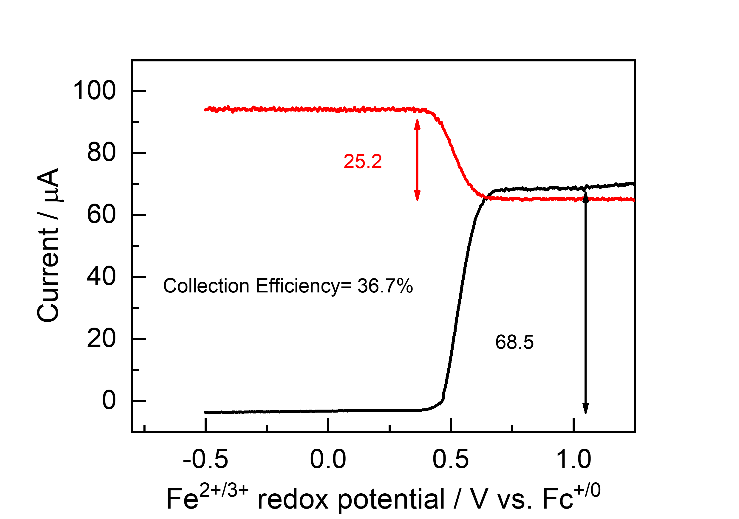
Supplementary Fig 101. RRDE traces for ferrocene dissolved in CH₂Cl₂ (containing 1% DMF) at 400 rpm. The disk was swept toward negative potential, while the ring was held at +0.8 V vs Ag/AgCl to re-oxidize ferrocene reduced at the disk electrode.

Standard Conditions for O₂ Reduction at Various rpm with FeL1–Cl
All linear sweep voltammetry data for O₂ reduction were collected under identical solution conditions at 0.01 V/s scan rates. Solutions were prepared in CH₂Cl₂ (containing 1% DMF) with 10 mM TFE, 0.1 M TBAPF₆and 5 equivalents of each triflate salt. Voltammograms were internally referenced to ferrocene, which was added at the end of each experiment. The collection efficiency was calculated to be 36.7 using ferrocene under the same solvent conditions (Supplementary Fig 101).
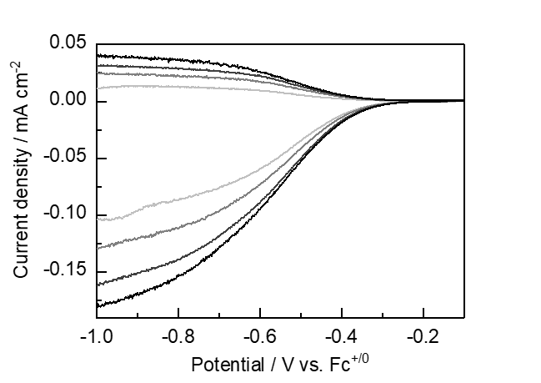
Supplementary Fig 102. Rotating ring-disk voltammograms of FeL1–Cl under 1 atm O₂ in the absence of triflates salts, recorded at rotation rates of 400, 900, 1600, and 2500 rpm. Data are represented using a gradient from light to dark corresponding to increasing rotation speed from 400 to 2500 rpm.
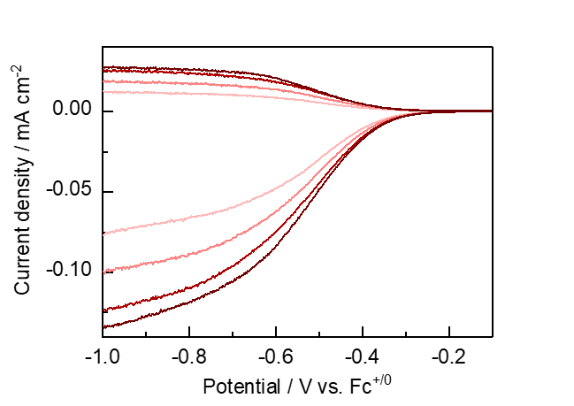
Supplementary Fig 103. Rotating ring-disk voltammograms of FeL1–Cl under 1 atm O₂ in the presence of KOTf, recorded at rotation rates of 400, 900, 1600, and 2500 rpm. Data are represented using a gradient from light to dark corresponding to increasing rotation speed from 400 to 2500 rpm.

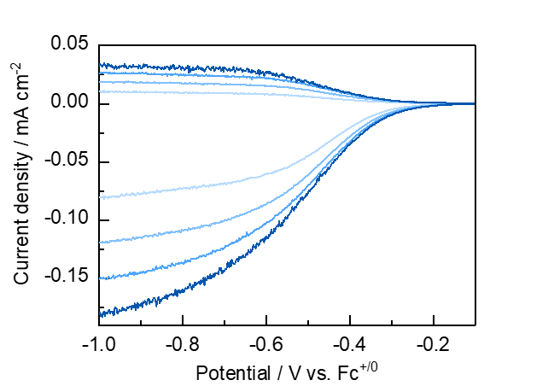
Supplementary Fig 104. Rotating ring-disk voltammograms of FeL1–Cl under 1 atm O₂ in the presence of Ca(OTf)₂, recorded at rotation rates of 400, 900, 1600, and 2500 rpm. Data are represented using a gradient from light to dark corresponding to increasing rotation speed from 400 to 2500 rpm.
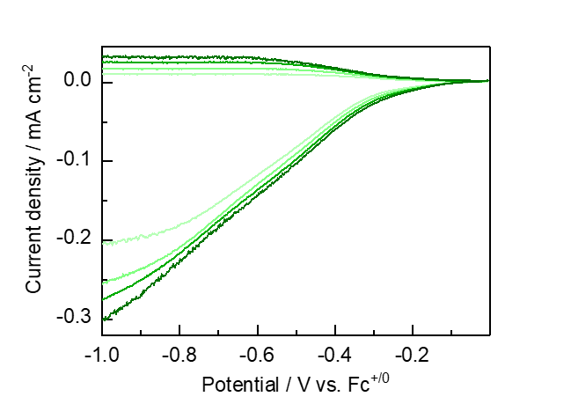
Supplementary Fig 105. Rotating ring-disk voltammograms of FeL1–Cl under 1 atm O₂ in the presence of Sc(OTf)₃, recorded at rotation rates of 400, 900, 1600, and 2500 rpm. Data are represented using a gradient from light to dark corresponding to increasing rotation speed from 400 to 2500 rpm.

Determination of H₂O₂ Selectivity from RRDE Measurements with FeL1–Cl
The %H₂O₂ was calculated using equation (14), expressed as an average across all rotation rates. This calculation was based on i_{disk} and i_{ring} currents measured between the catalytic onset and plateau potentials (approximately –0.6 to –0.8 V vs Fc^{+/0}). We note that although this equation was originally derived for heterogeneous dioxygen reduction, it has been widely adopted for homogeneous systems.
$$\%H_{2}O_{2}= \frac{100(\frac{2i_{ring}}{N_{c}})}{i_{disk}+\frac{i_{ring}}{N_{c}}}$$ | ( 14 )
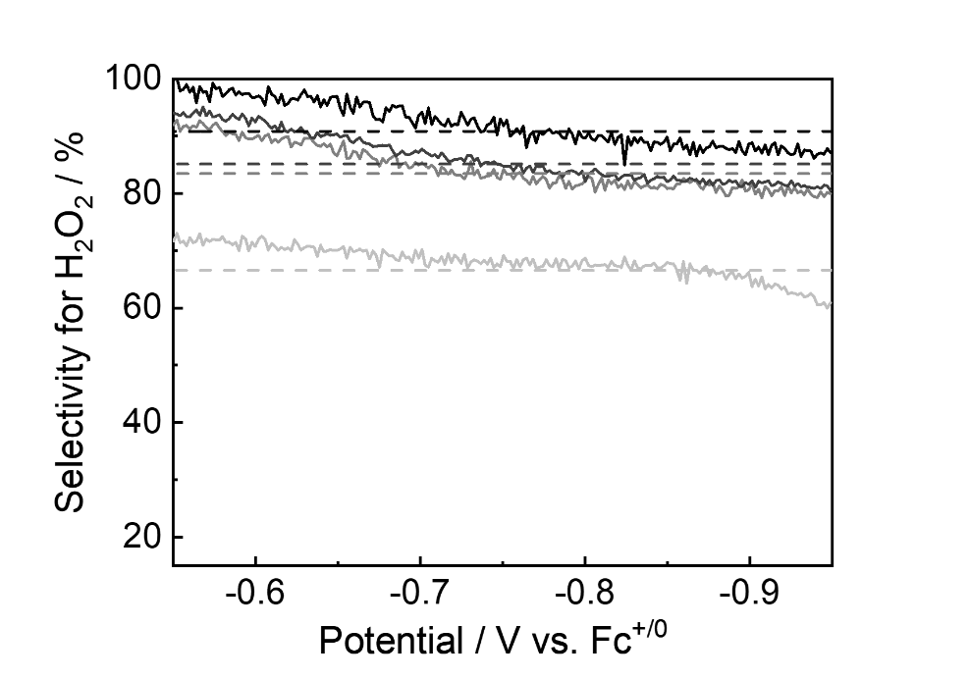
Supplementary Fig 106. H₂O₂ selectivity measured with FeL1–Cl as a function of the disk potential at rotation rates of 400, 900, 1600, and 2500 rpm in the absence of triflate salts, yielding approximately 67%, 83%, 85%, and 91%, respectively. Color intensity transitions from light to dark with an increasing rotation rate from 400 to 2500 rpm.

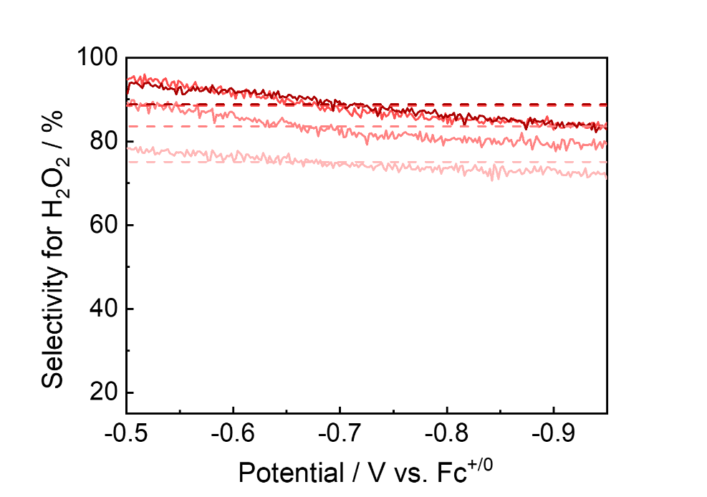
Supplementary Fig 107. H₂O₂ selectivity measured with FeL1–Cl as a function of the disc potential at rotation rates of 400, 900, 1600, and 2500 rpm with 5 equivalents of KOTf, yielding approximately 75%, 84%, 89%, and 89%, respectively. Color intensity transitions from light to dark with an increasing rotation rate 400 to 2500 rpm.

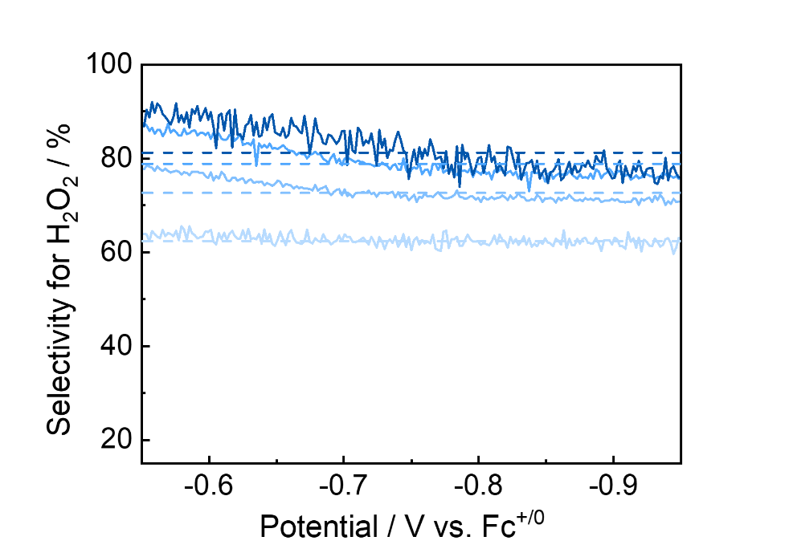
Supplementary Fig 108. H₂O₂ selectivity measured with FeL1–Cl as a function of the disc potential at rotation rates of 400, 900, 1600, and 2500 rpm with 5 equivalents of Ca(OTf)₂, yielding approximately 62%, 73%, 79%, and 81%, respectively. Color intensity transitions from light to dark with an increasing rotation rate 400 to 2500 rpm.

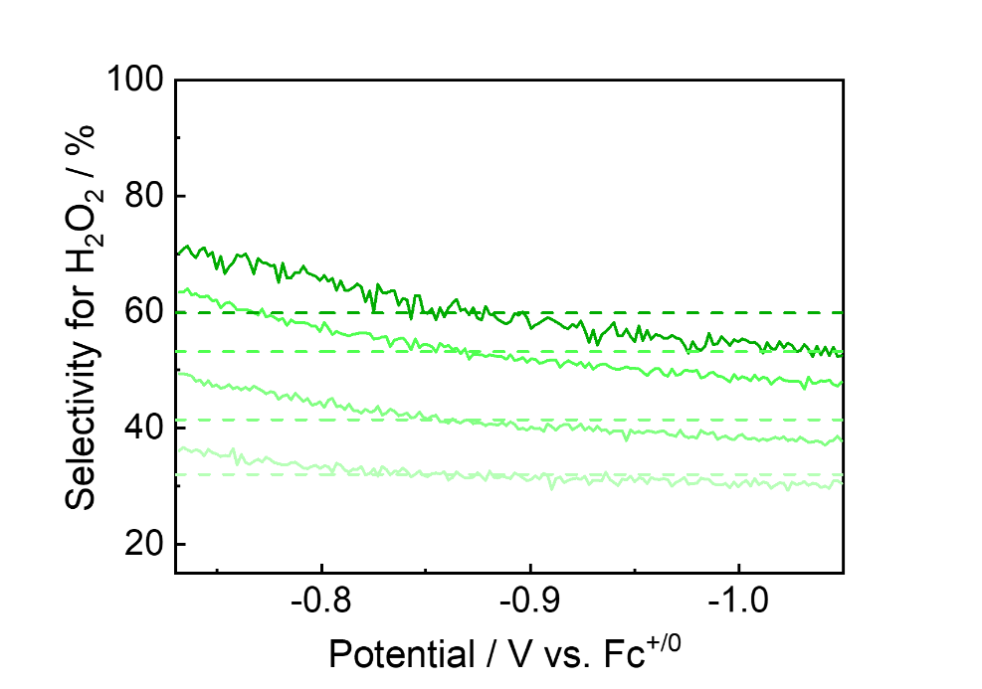
Supplementary Fig 109. H₂O₂ selectivity measured with FeL1–Cl as a function of the disc potential at rotation rates of 400, 900, 1600, and 2500 rpm with 5 equivalents of Sc(OTf)₃, yielding approximately 32%, 41%, 53%, and 60%, respectively. Color intensity transitions from light to dark with an increasing rotation rate 400 to 2500 rpm.

Determination of H₂O₂ Selectivity from RRDE Measurements with Fe-incorporated Derivatives of the Control Ligands
The %H₂O₂ was calculated using equation (14), expressed as an average across all rotation rates. This calculation was based on i_{disk} and i_{ring} currents measured between the catalytic onset and plateau potentials (approximately 0.2 to 0.3 V vs Ag/AgCl). We note that although this equation was originally derived for heterogeneous dioxygen reduction, it has been widely adopted for homogeneous systems.

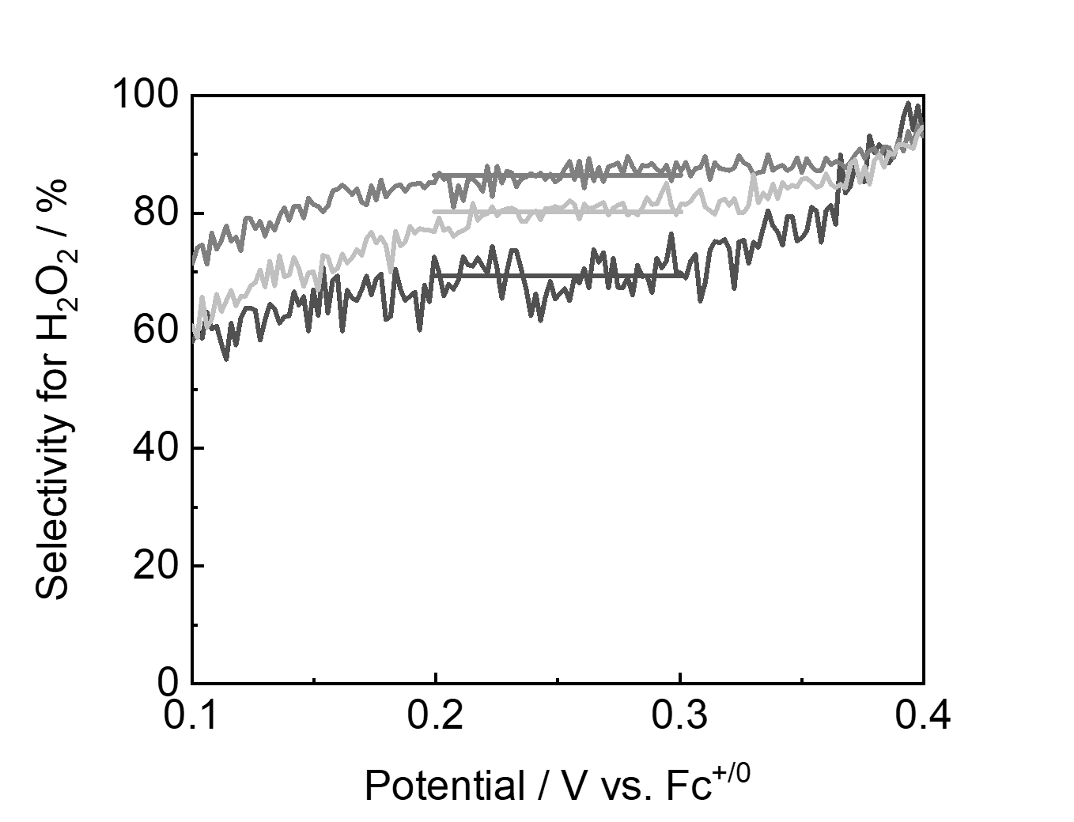
Supplementary Fig 110. H₂O₂ selectivity measured with FeTPP–Cl as a function of the disc potential at 1600 rpm in the absence of added cations. Data are from three independent experiments; the average selectivity is 79%.

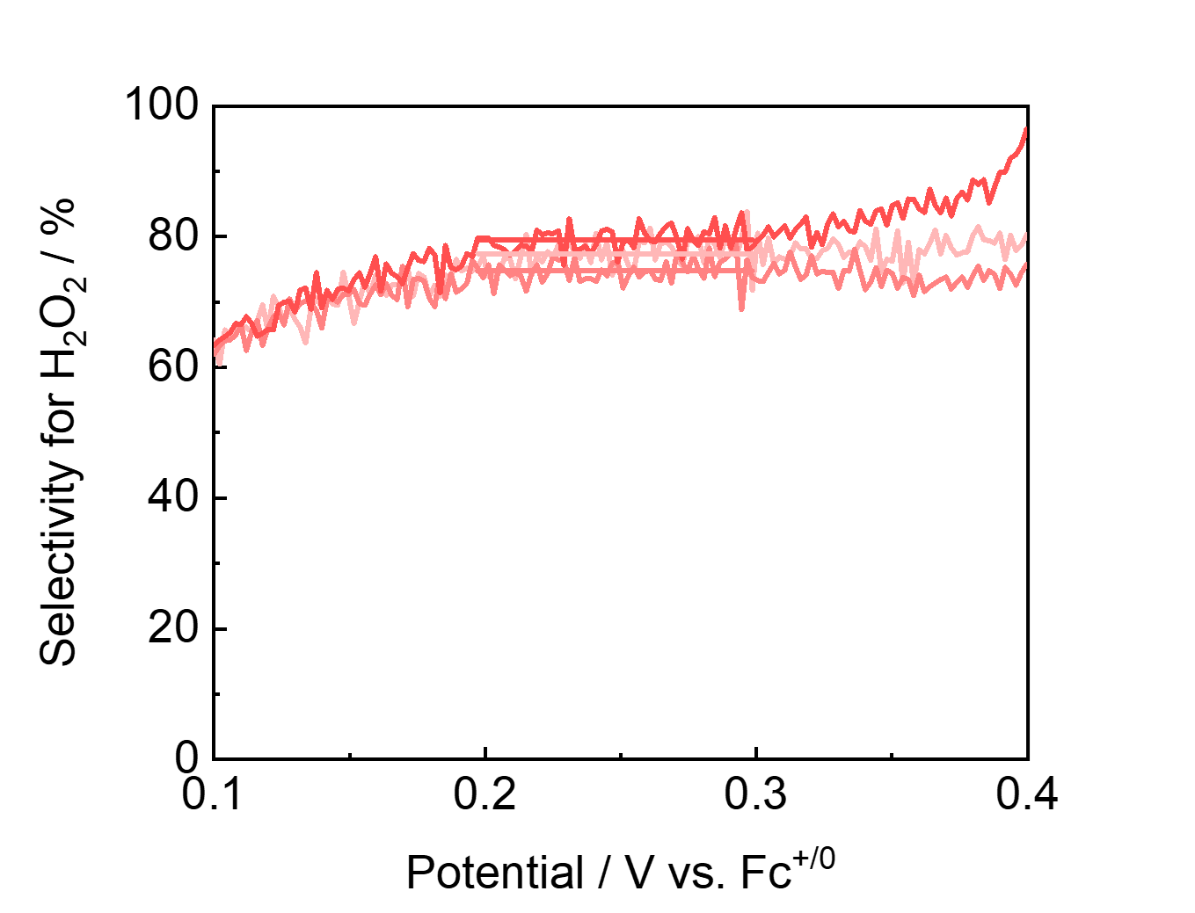
Supplementary Fig 111. H₂O₂ selectivity measured with FeTPP–Cl as a function of the disc potential at 1600 rpm with KOTf. Data are from three independent experiments; the average selectivity is 77%.
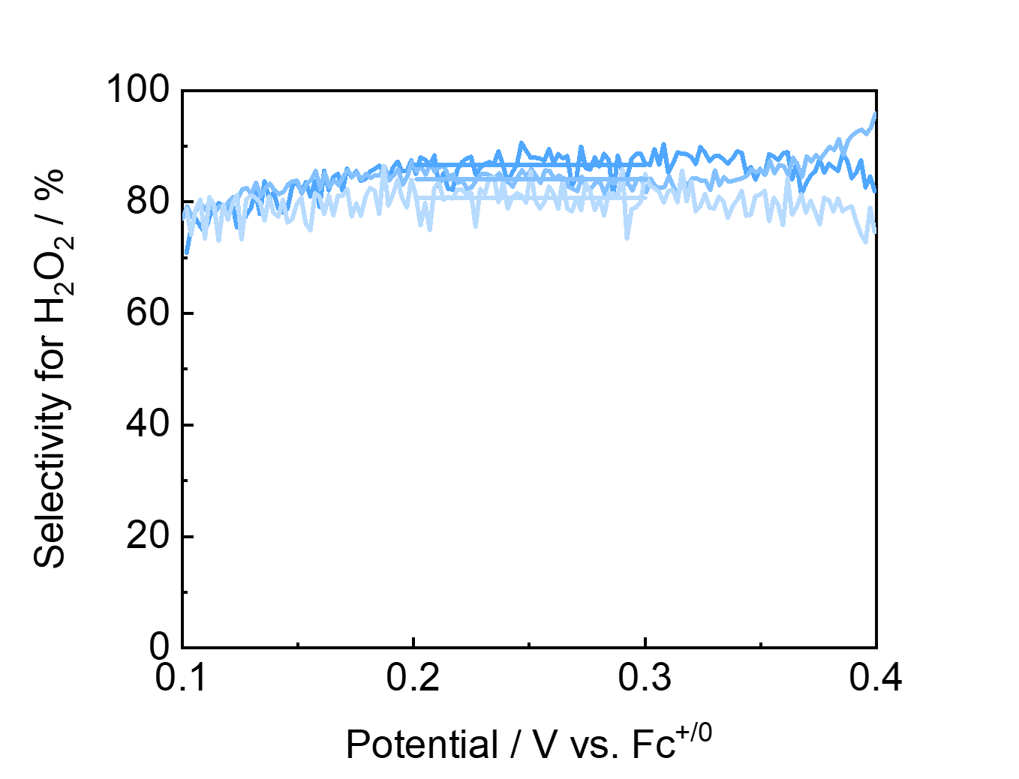
Supplementary Fig 112. H₂O₂ selectivity measured with FeTPP–Cl as a function of the disc potential at 1600 rpm with Ca(OTf)₂. Data are from three independent experiments; the average selectivity is 84%.

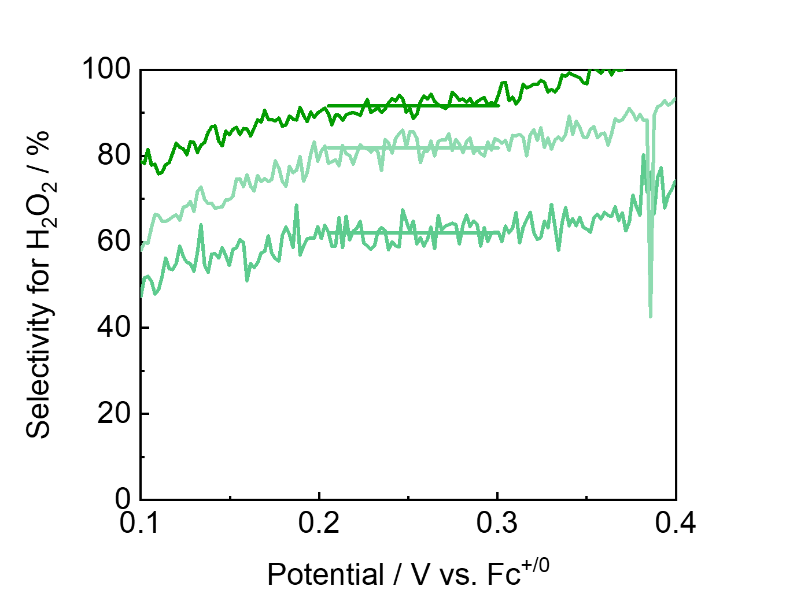
Supplementary Fig 113. H₂O₂ selectivity measured with FeTPP–Cl as a function of the disc potential at 1600 rpm with Sc(OTf)₃. Data are from three independent experiments; the average selectivity is 79%.
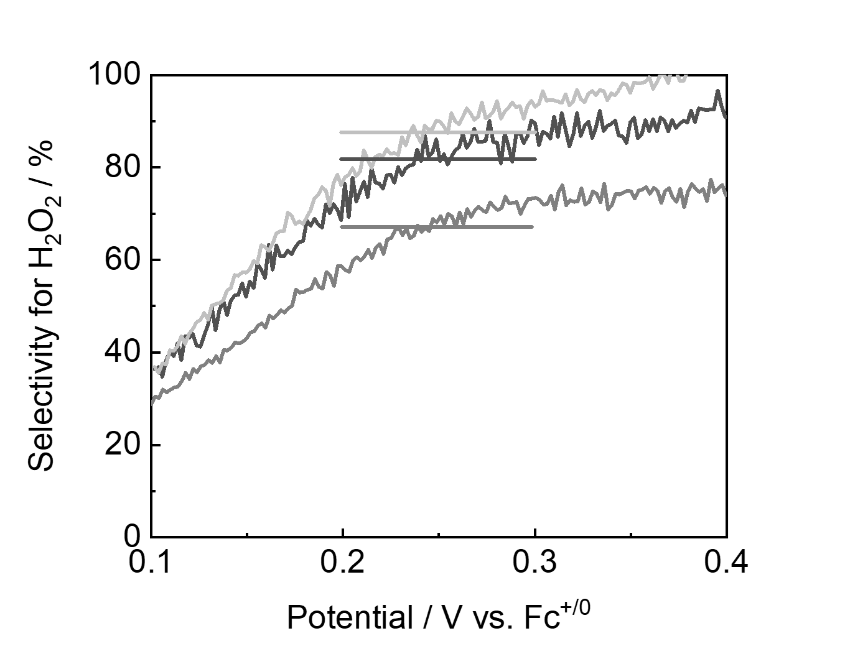
Supplementary Fig 114. H₂O₂ selectivity measured with FeTF₁₀PP–Cl as a function of the disc potential at 1600 rpm in the absence of added cations. Data are from three independent experiments; the average selectivity is 83%.

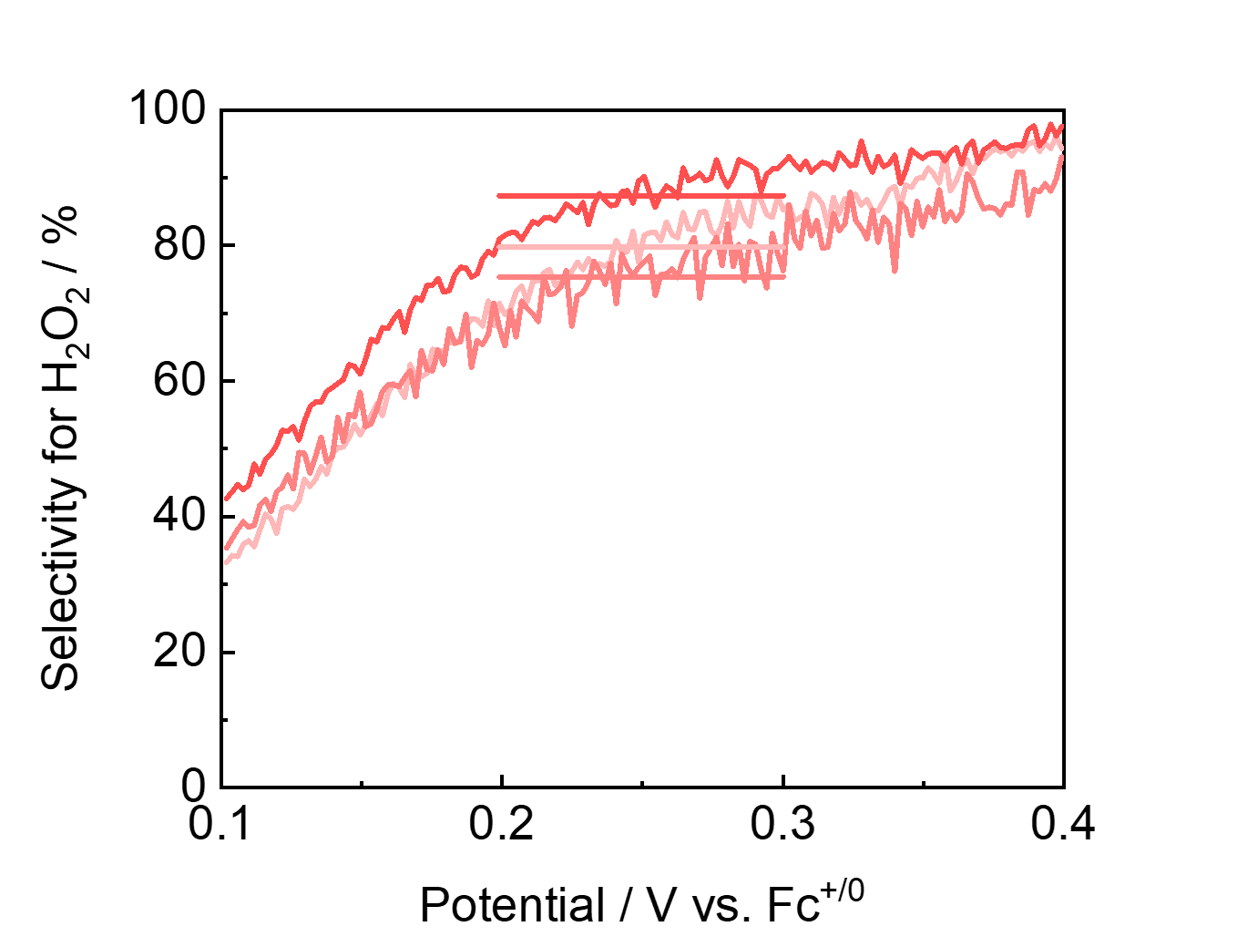
Supplementary Fig 115. H₂O₂ selectivity measured with FeTF₁₀PP–Cl as a function of the disc potential at 1600 rpm with KOTf. Data are from three independent experiments; the average selectivity is 85%.
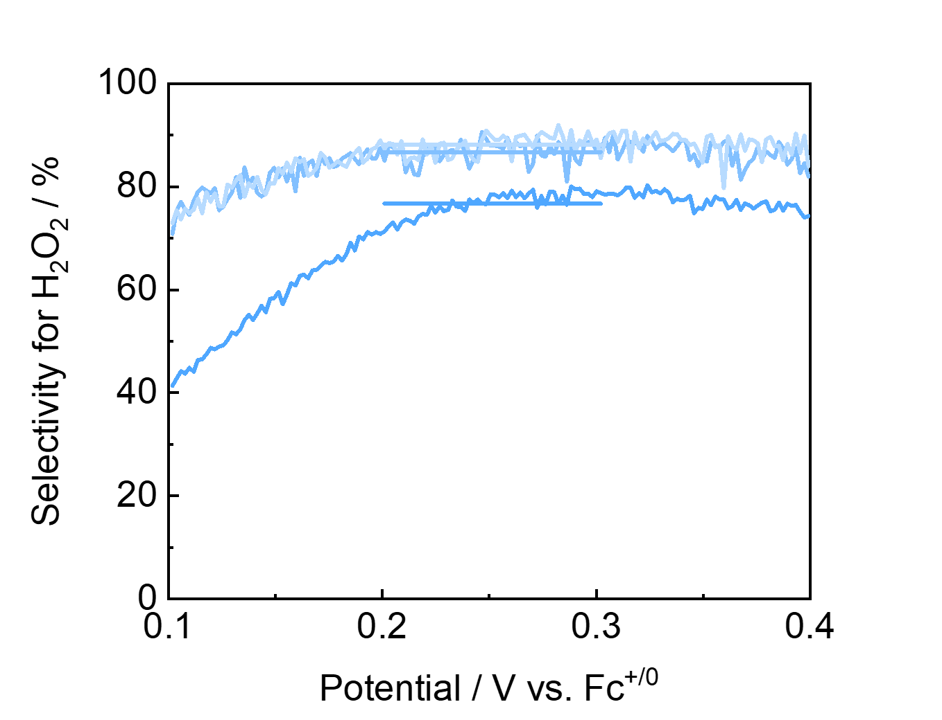
Supplementary Fig 116. H₂O₂ selectivity measured with FeTF₁₀PP–Cl as a function of the disc potential at 1600 rpm with Ca(OTf)₂. Data are from three independent experiments; the average selectivity is 84%.

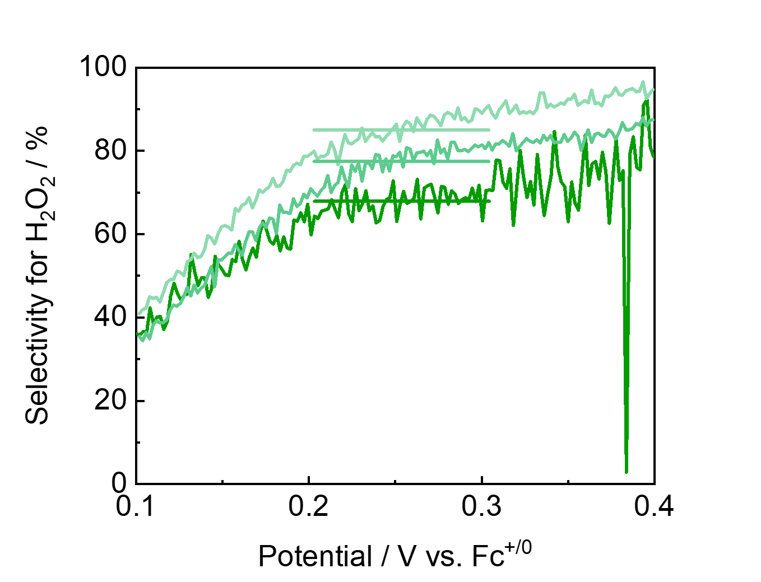
Supplementary Fig 117. H₂O₂ selectivity measured with FeTF₁₀PP–Cl as a function of the disc potential at 1600 rpm with Sc(OTf)₃. Data are from three independent experiments; the average selectivity is 79%.
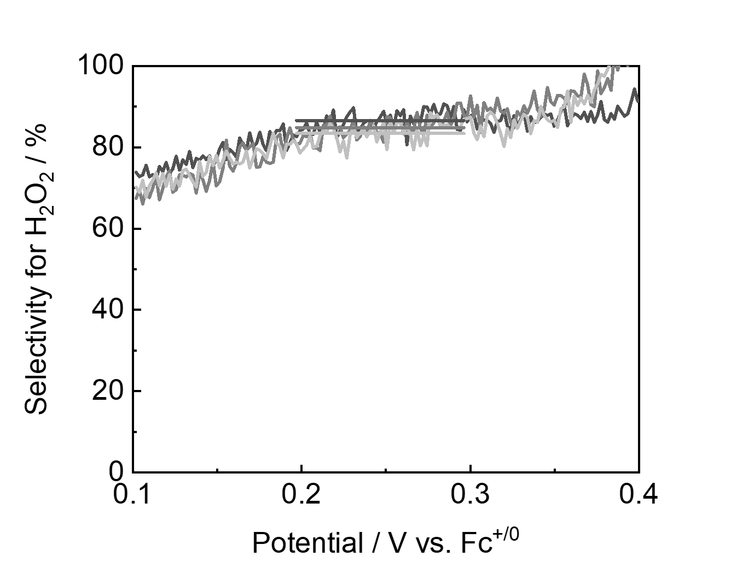
Supplementary Fig 118. H₂O₂ selectivity measured with FeTF₂₀PP–Cl as a function of the disc potential at 1600 rpm with Sc(OTf)₃. Data are from three independent experiments; the average selectivity is 86%.

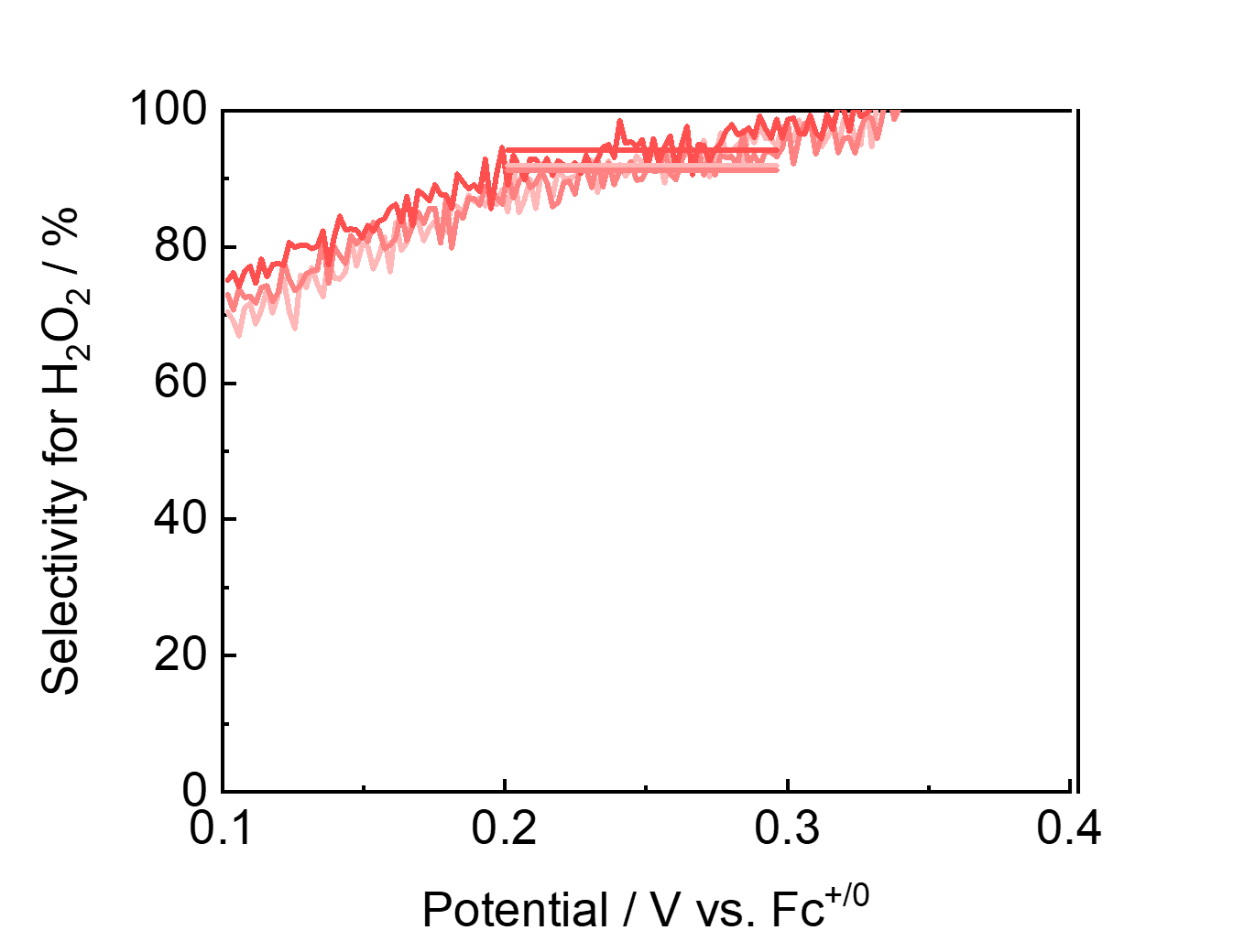
Supplementary Fig 119. H₂O₂ selectivity measured with FeTF₂₀PP–Cl as a function of the disc potential at 1600 rpm with KOTf. Data are from three independent experiments; the average selectivity is 94%.
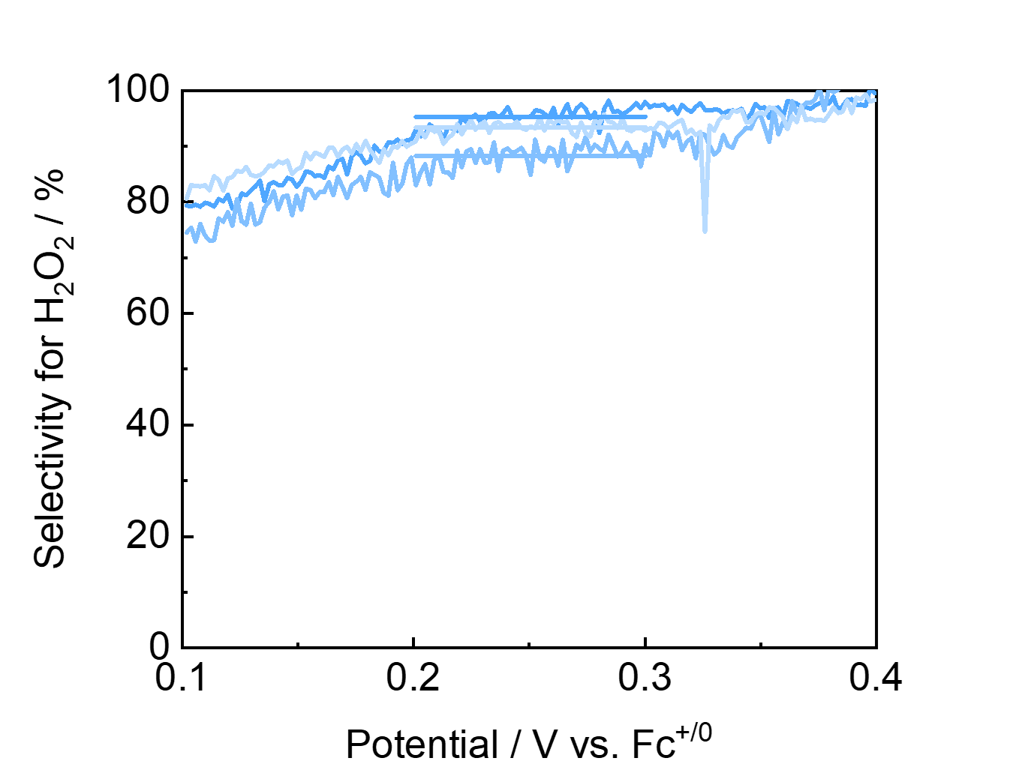
Supplementary Fig 120. H₂O₂ selectivity measured with FeTF₂₀PP–Cl as a function of the disc potential at 1600 rpm with Ca(OTf)₂. Data are from three independent experiments; the average selectivity is 93%.

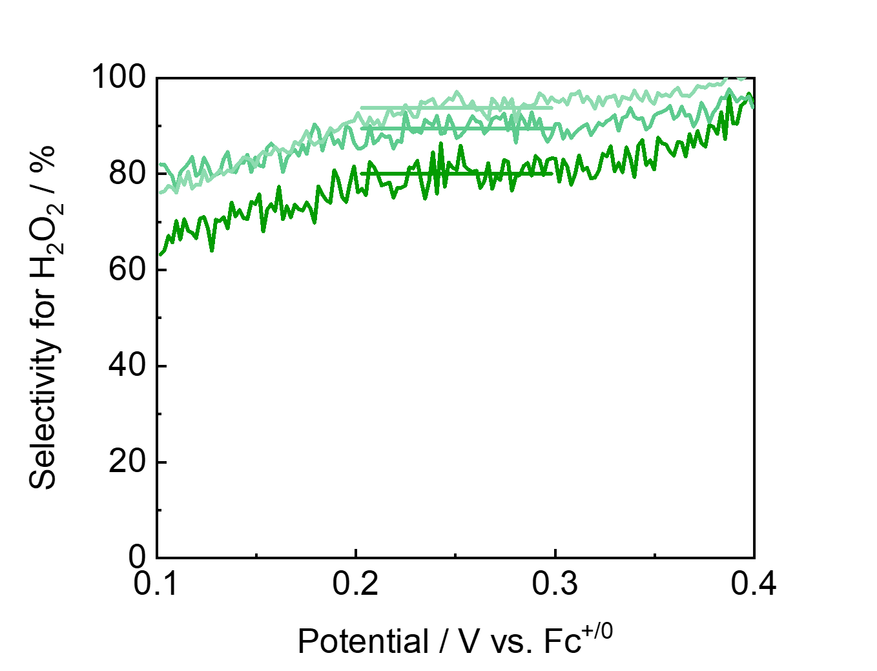
Supplementary Fig 121. H₂O₂ selectivity measured with FeTF₂₀PP–Cl as a function of the disc potential at 1600 rpm with Sc(OTf)₃. Data are from three independent experiments; the average selectivity is 88%.

Tafel Analysis from Current
RRDE data collected under standard conditions described in Section 9.2 at rotation speeds of 400, 900, 1600, and 2500 rpm. Using this current value, a Tafel plot was constructed and the Tafel slope was determined from the linear region at potentials near the catalytic onset (commonly referred to as the “foot region”).
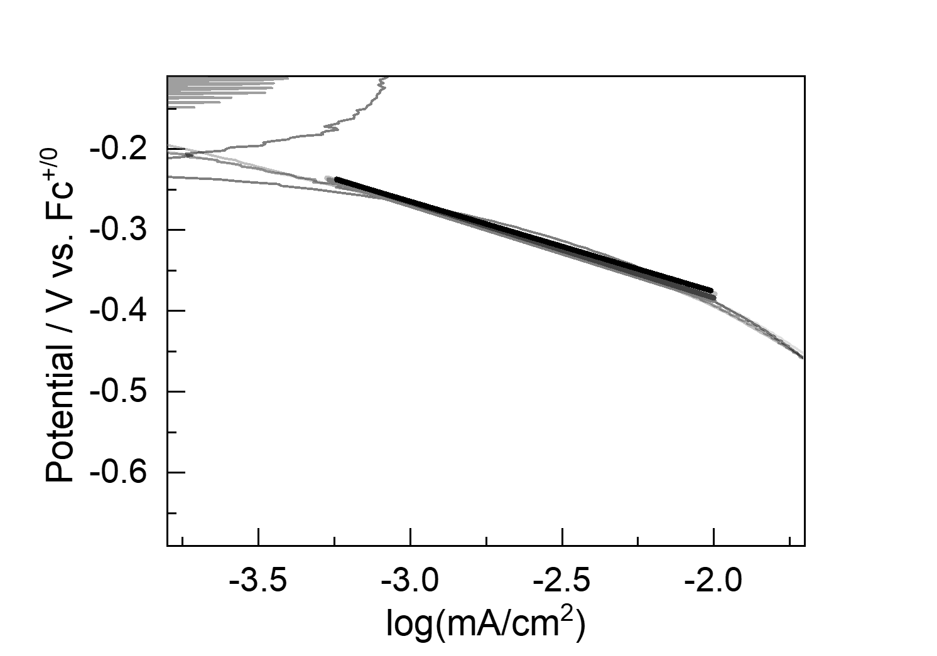
Supplementary Fig 122. Tafel plots derived from the current at rotation rates of 400, 900, 1600, and 2500 rpm in the absence of triflate salts, yielding Tafel slopes of approximately 112, 117, 118, and 111 mV/dec, respectively. Color intensity transitions from light to dark with an increasing rotation rate from 400 to 2500 rpm.

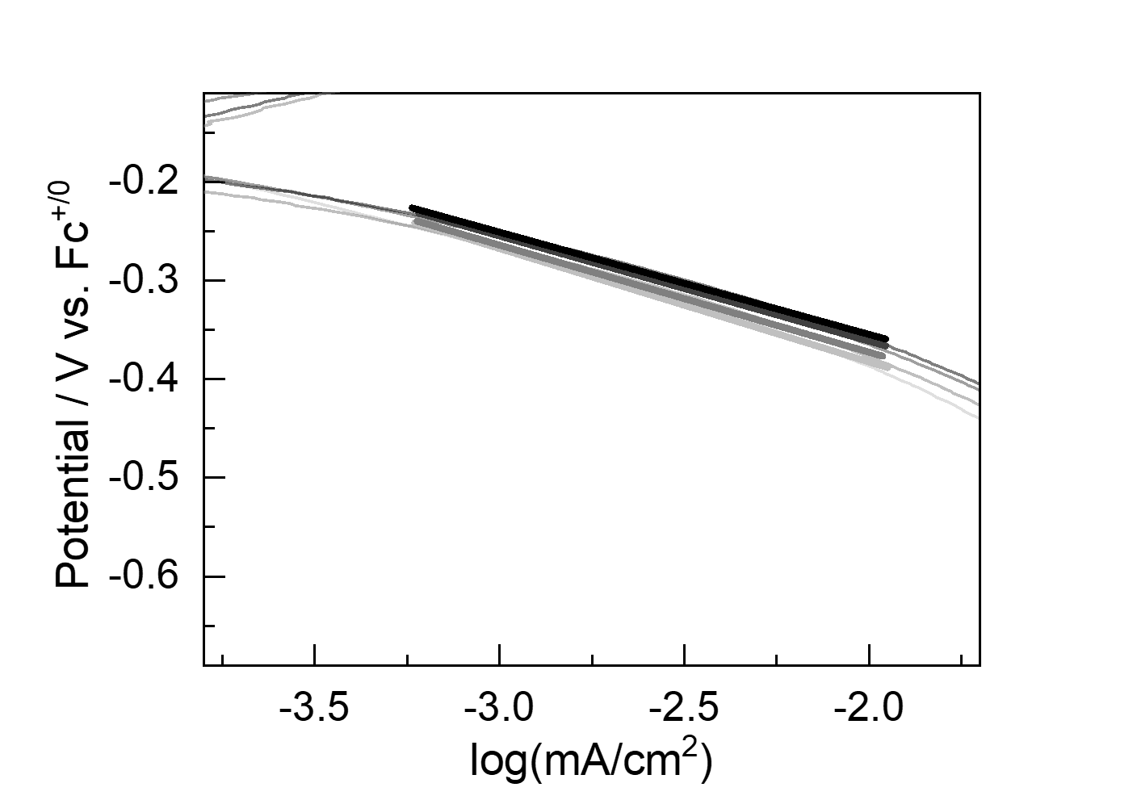
Supplementary Fig 123. Tafel plots derived from the current at rotation rates of 400, 900, 1600, and 2500 rpm in the absence of triflate salts, yielding Tafel slopes of approximately 115, 109, 107, and 104 mV/dec, respectively. Color intensity transitions from light to dark with an increasing rotation rate from 400 to 2500 rpm.

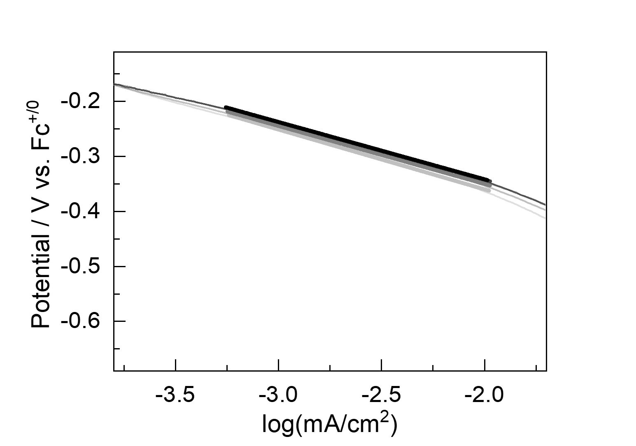
Supplementary Fig 124. Tafel plots derived from the current at rotation rates of 400, 900, 1600, and 2500 rpm in the absence of triflate salts, yielding Tafel slopes of approximately 109, 105, 105, and 104 mV/dec, respectively. Color intensity transitions from light to dark with an increasing rotation rate from 400 to 2500 rpm.

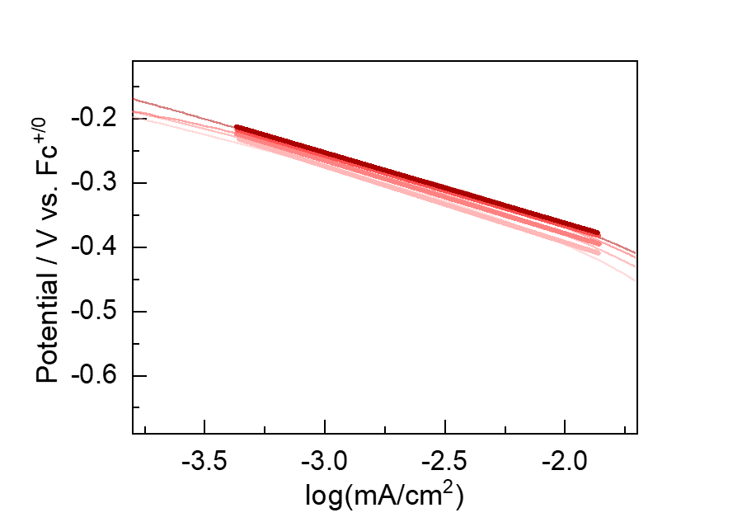
Supplementary Fig 125. Tafel plots derived from the current at rotation rates of 400, 900, 1600, and 2500 rpm with 5 equivalents of KOTf, yielding Tafel slopes of approximately 119, 114, 110, and 110 mV/dec, respectively. Color intensity transitions from light to dark with an increasing rotation rate from 400 to 2500 rpm.
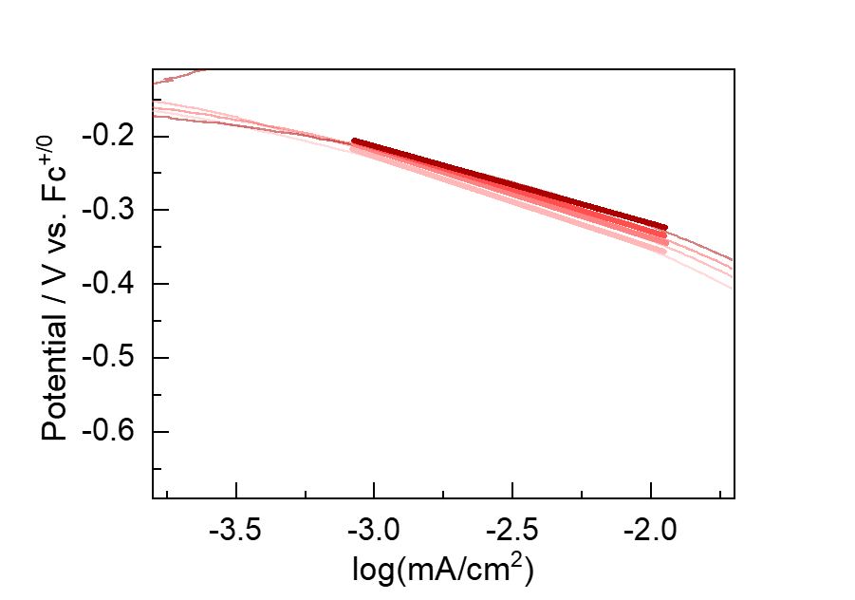
Supplementary Fig 126. Tafel plots derived from the current at rotation rates of 400, 900, 1600, and 2500 rpm with 5 equivalents of KOTf, yielding Tafel slopes of approximately 123, 119, 114, and 105 mV/dec, respectively. Color intensity transitions from light to dark with an increasing rotation rate from 400 to 2500 rpm.

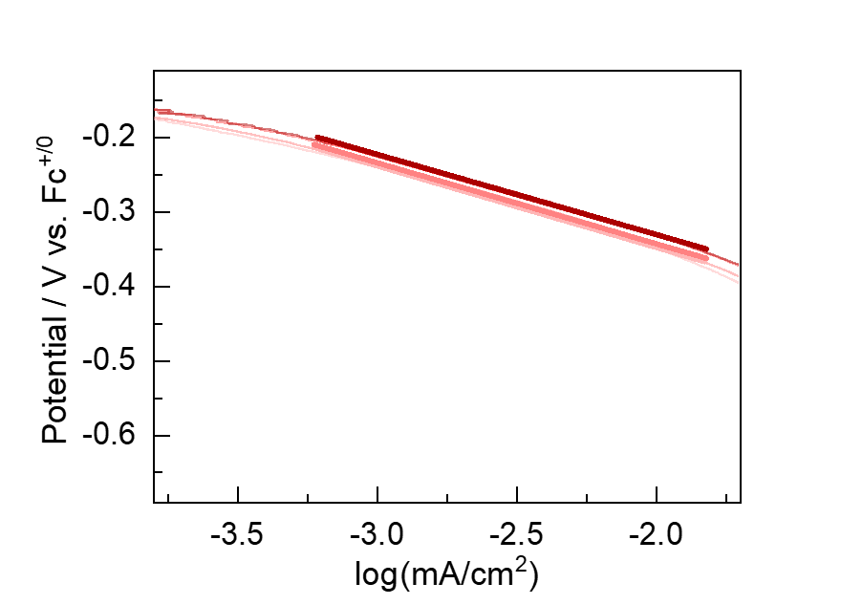
Supplementary Fig 127. Tafel plots derived from the current at rotation rates of 400, 900, 1600, and 2500 rpm with 5 equivalents of KOTf, yielding Tafel slopes of approximately 109, 109, 107, and 108 mV/dec, respectively. Color intensity transitions from light to dark with an increasing rotation rate from 400 to 2500 rpm.
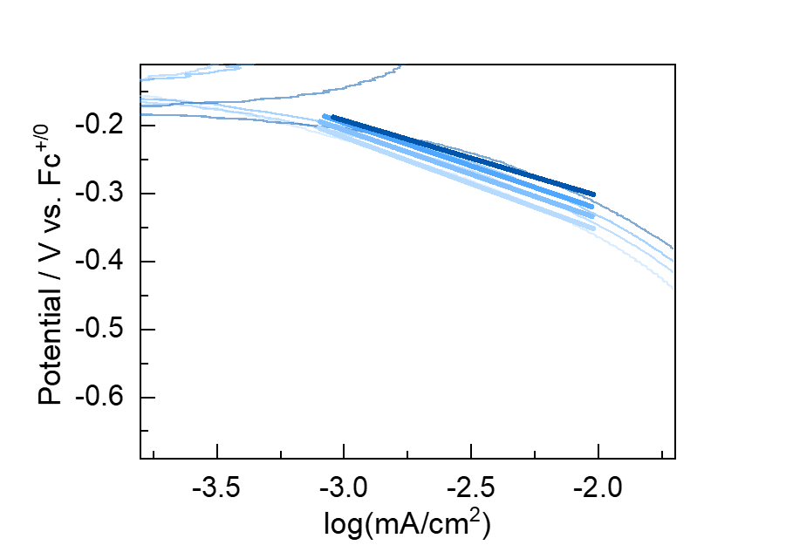
Supplementary Fig 128. Tafel plots derived from the current at rotation rates of 400, 900, 1600, and 2500 rpm with 5 equivalents of Ca(OTf)₂, yielding Tafel slopes of approximately 137, 130, 126, and 111 mV/dec, respectively. Color intensity transitions from light to dark with an increasing rotation rate from 400 to 2500 rpm.

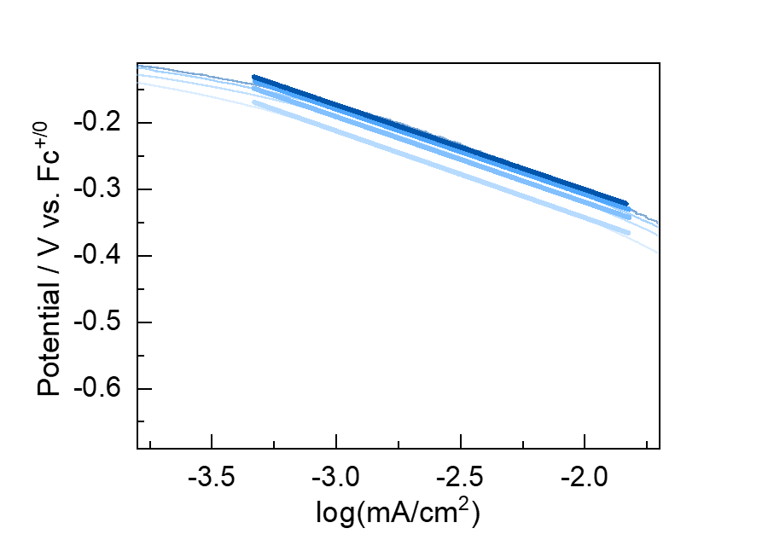
Supplementary Fig 129. Tafel plots derived from the current at rotation rates of 400, 900, 1600, and 2500 rpm with 5 equivalents of Ca(OTf)₂, yielding Tafel slopes of approximately 130, 129, 128, and 127 mV/dec, respectively. Color intensity transitions from light to dark with an increasing rotation rate from 400 to 2500 rpm.
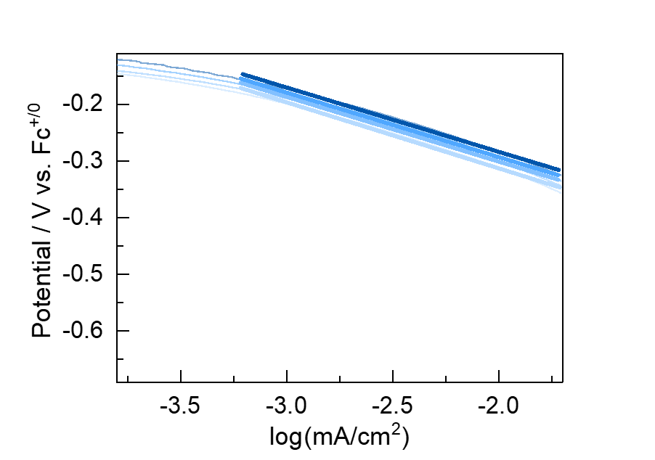
Supplementary Fig 130. Tafel plots derived from the current at rotation rates of 400, 900, 1600, and 2500 rpm with 5 equivalents of Ca(OTf)₂, yielding Tafel slopes of approximately 117, 114, 114, and 113 mV/dec, respectively. Color intensity transitions from light to dark with an increasing rotation rate from 400 to 2500 rpm.

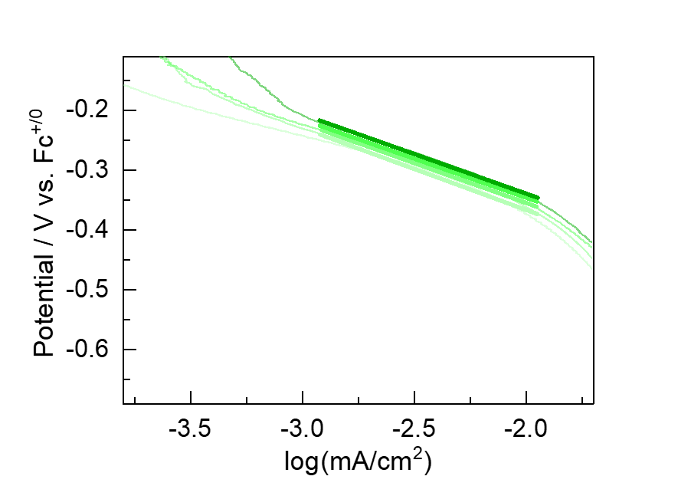
Supplementary Fig 131. Tafel plots derived from the current at rotation rates of 400, 900, 1600, and 2500 rpm with 5 equivalents of Sc(OTf)₃, yielding Tafel slopes of approximately 137, 133, 130, and 132 mV/dec, respectively. Color intensity transitions from light to dark with an increasing rotation rate from 400 to 2500 rpm.
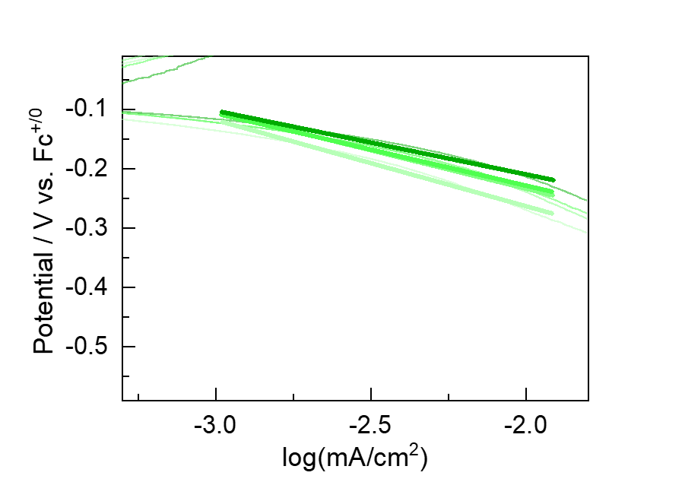
Supplementary Fig 132. Tafel plots derived from the current at rotation rates of 400, 900, 1600, and 2500 rpm with 5 equivalents of Sc(OTf)₃, yielding Tafel slopes of approximately 145, 129, 122, and 107 mV/dec, respectively. Color intensity transitions from light to dark with an increasing rotation rate from 400 to 2500 rpm.

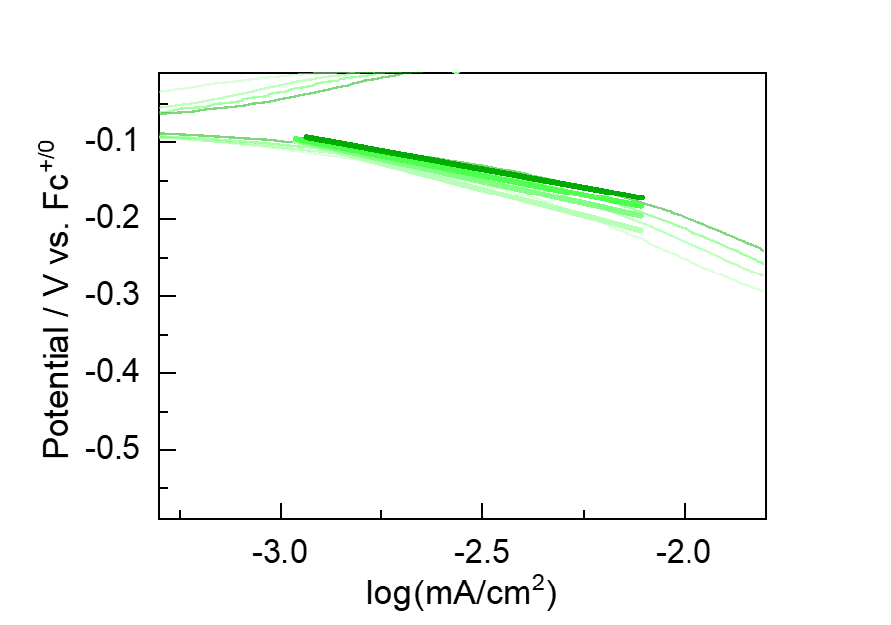
Supplementary Fig 133. Tafel plots derived from the current at rotation rates of 400, 900, 1600, and 2500 rpm with 5 equivalents of Sc(OTf)₃, yielding Tafel slopes of approximately 136, 115, 102, and 95 mV/dec, respectively. Color intensity transitions from light to dark with an increasing rotation rate from 400 to 2500 rpm.

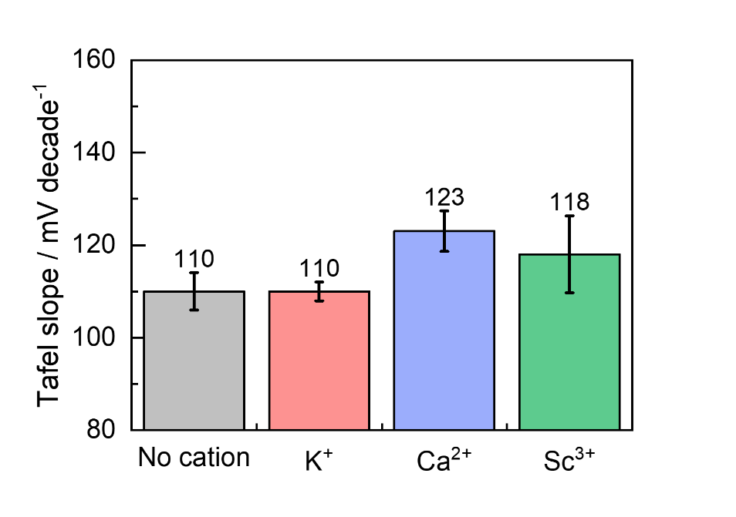
Supplementary Fig 134. Bar graph comparing the averaged Tafel slopes obtained from above three independent measurements conducted under different cation conditions: absence of triflate salts, and presence of 5 equivalents of KOTf, Ca(OTf)₂, and Sc(OTf)₃. Error bars represent the standard error of the mean.

Tafel Analysis from Kinetic Current
A Koutecky-Levich (K–L) plot was constructed using RRDE data collected under standard conditions described in Section 9.2 at rotation speeds of 400, 900, 1600, and 2500 rpm. The plot was generated with ω^{–1}/² on the x-axis and i^{–1} on the y-axis. The kinetic current (iₖ) was determined from the y-intercept (1/iₖ) of the linear regression. Using this kinetic current value, a Tafel plot was constructed and the Tafel slope was determined from the linear region at potentials near the catalytic onset (commonly referred to as the “foot region”).
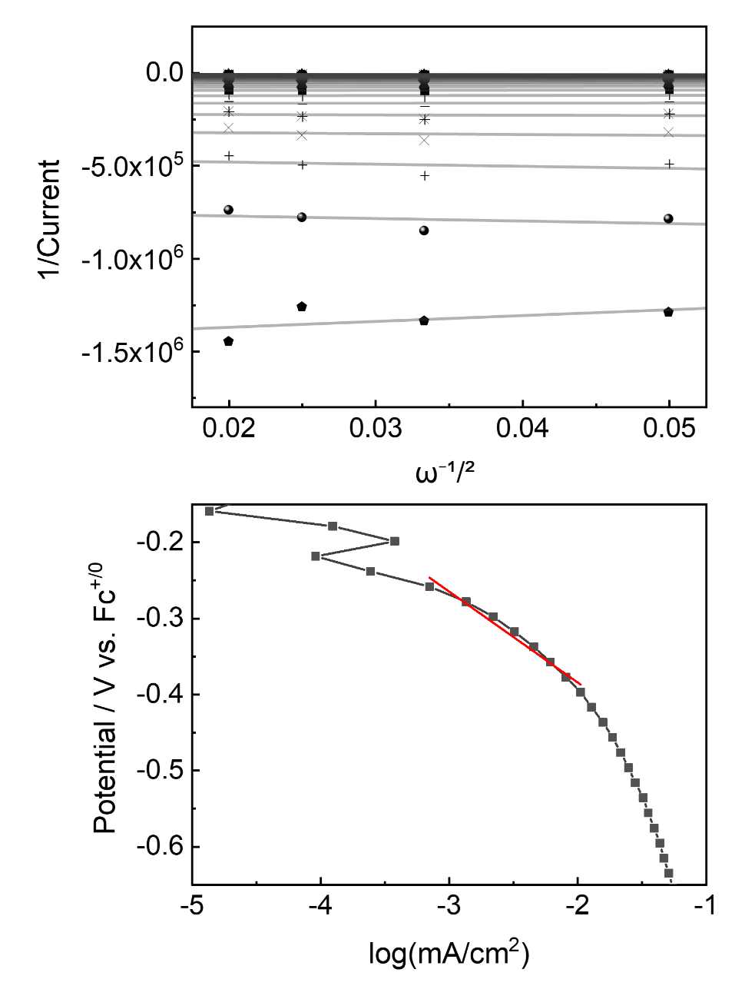
Supplementary Fig 135. (Top) Koutecky–Levich (K–L) plots obtained in the absence of triflate salts at rotation rates of 400, 900, 1600, and 2500 rpm. (Bottom) Tafel plot derived from the kinetic current extracted from K–L analysis, yielding a Tafel slope of 119 mV/dec. All measurements were conducted under standard conditions described in Section 9.2. Data represents the first of three independent experiments used for statistical analysis.

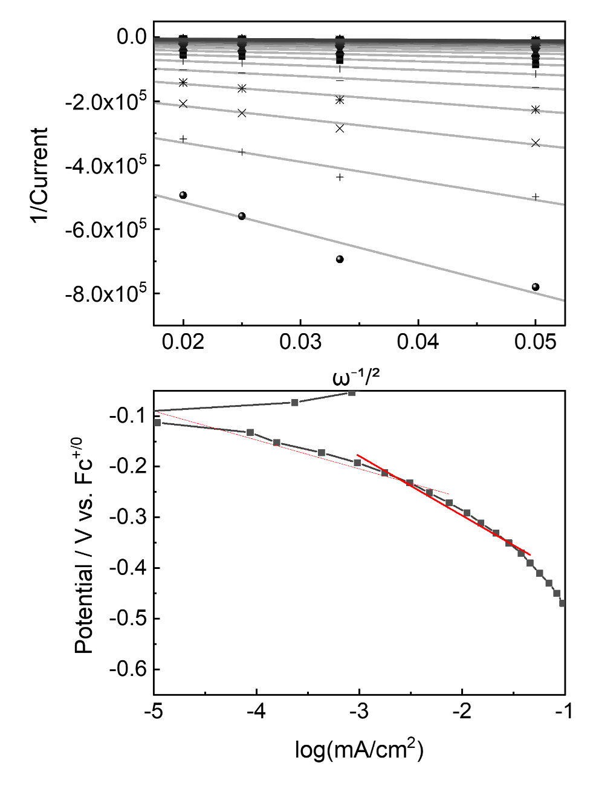
Supplementary Fig 136. (Top) Koutecky–Levich (K–L) plots obtained in the absence of triflate slats, at rotation rates of 400, 900, 1600, and 2500 rpm. (Bottom) Tafel plot derived from the kinetic current extracted from K–L analysis, yielding a Tafel slope of 117 mV/dec. All measurements were conducted under standard conditions described in Section 9.2. A representative plot from a triplicate experiment is shown above. Data represents the second of three independent experiments used for statistical analysis.

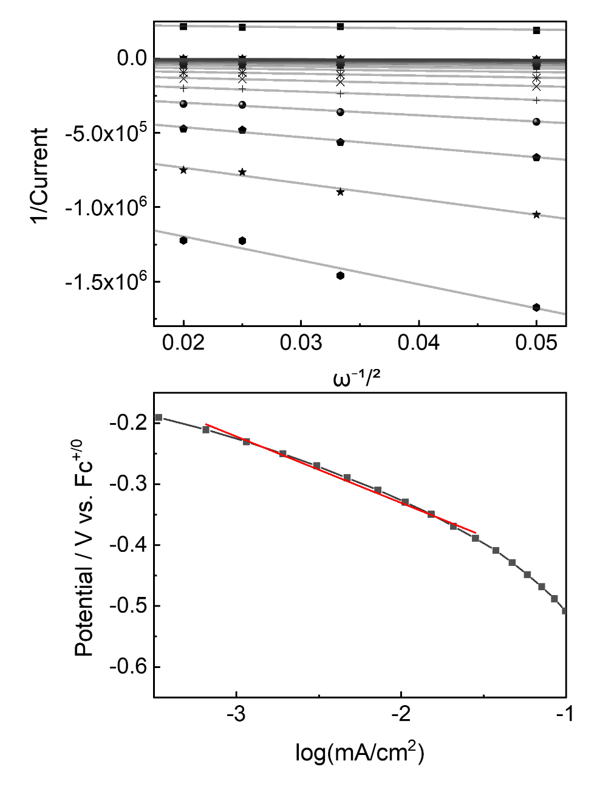
Supplementary Fig 137. (Top) Koutecky–Levich (K–L) plots obtained in the absence of triflate salts, at rotation rates of 400, 900, 1600, and 2500 rpm. (Bottom) Tafel plot derived from the kinetic current extracted from K–L analysis, yielding a Tafel slope of 109 mV/dec. All measurements were conducted under standard conditions described in Section 9.2. Data represents the third of three independent experiments used for statistical analysis.

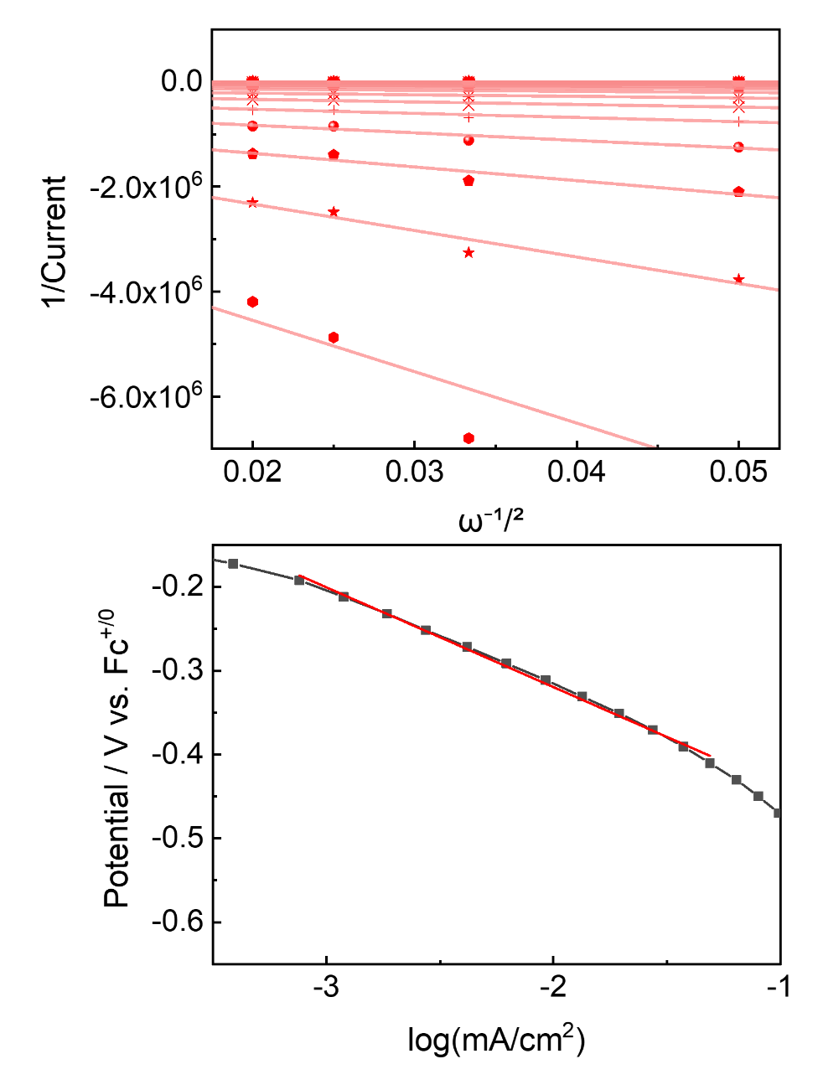
Supplementary Fig 138. (Top) Koutecky–Levich (K–L) plots obtained in the presence of 5 equivalents of KOTf, at rotation rates of 400, 900, 1600, and 2500 rpm. (Bottom) Tafel plot derived from the kinetic current extracted from K–L analysis, yielding a Tafel slope of 119 mV/dec. All measurements were conducted under standard conditions described in Section 9.2. Data represents the first of three independent experiments used for statistical analysis.

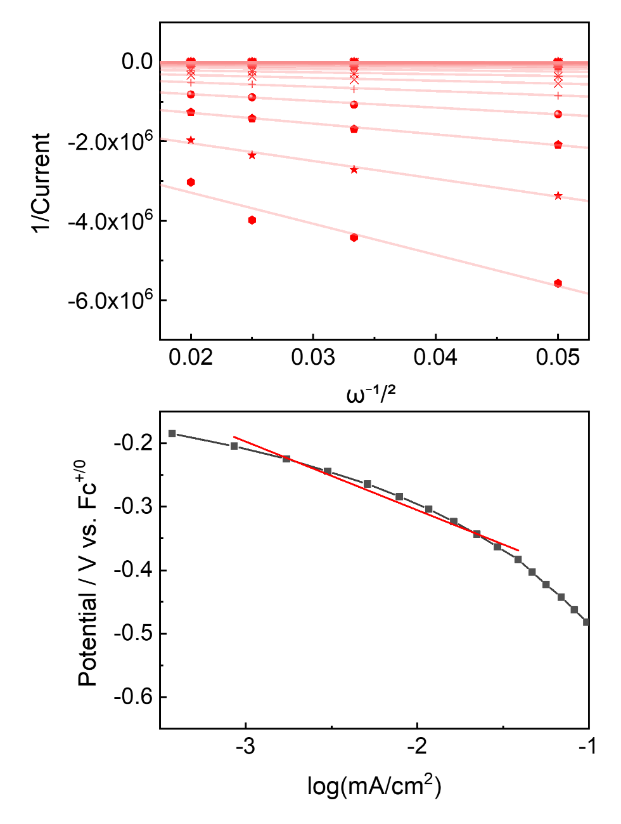
Supplementary Fig 139. (Top) Koutecky–Levich (K–L) plots obtained in the presence of 5 equivalents of KOTf, at rotation rates of 400, 900, 1600, and 2500 rpm. (Bottom) Tafel plot derived from the kinetic current extracted from K–L analysis, yielding a Tafel slope of 108 mV/dec. All measurements were conducted under standard conditions described in Section 9.2. Data represents the second of three independent experiments used for statistical analysis.

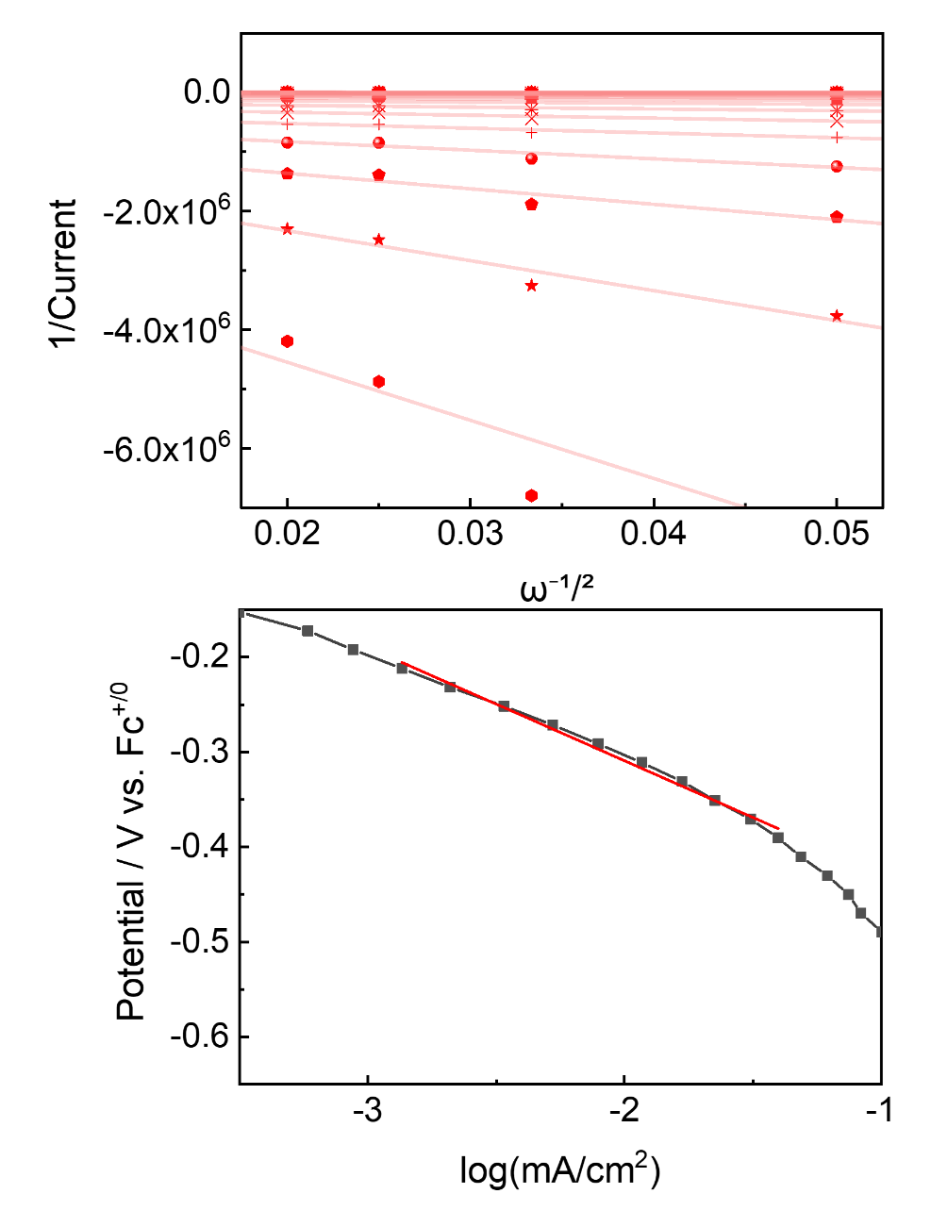
Supplementary Fig 140. (Top) Koutecky–Levich (K–L) plots obtained in the presence of 5 equivalents of KOTf, at rotation rates of 400, 900, 1600, and 2500 rpm. (Bottom) Tafel plot derived from the kinetic current extracted from K–L analysis, yielding a Tafel slope of 119 mV/dec. All measurements were conducted under standard conditions described in Section 9.2. Data represents the third of three independent experiments used for statistical analysis.

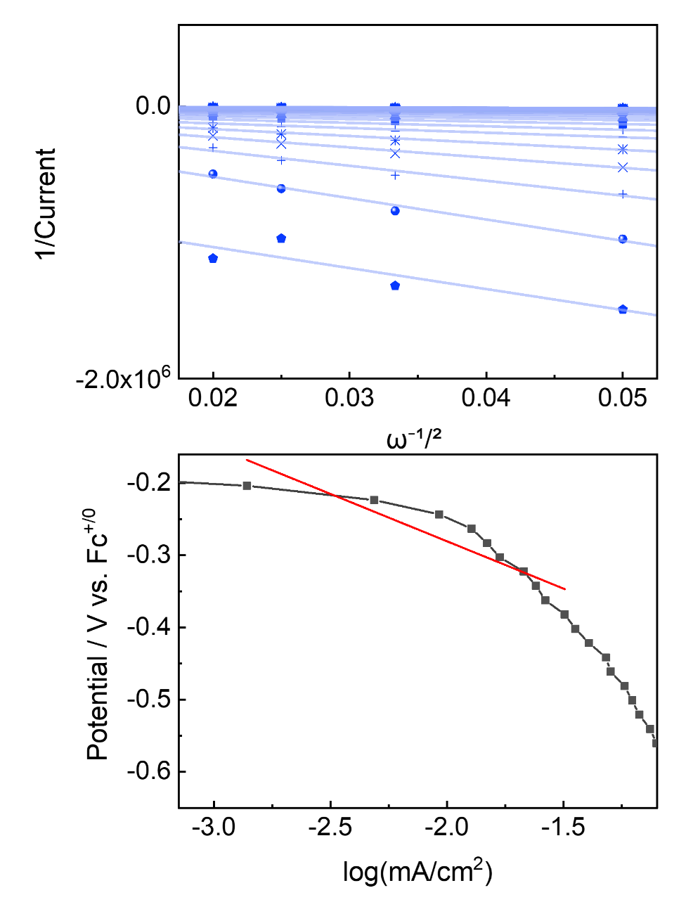
Supplementary Fig 141. (Top) Koutecky–Levich (K–L) plots obtained in the presence of 5 equivalents of Ca(OTf)₂, at rotation rates of 400, 900, 1600, and 2500 rpm. (Bottom) Tafel plot derived from the kinetic current extracted from K–L analysis, yielding a Tafel slope of 131 mV/dec. All measurements were conducted under standard conditions described in Section 9.2. Data represents the first of first independent experiments used for statistical analysis.

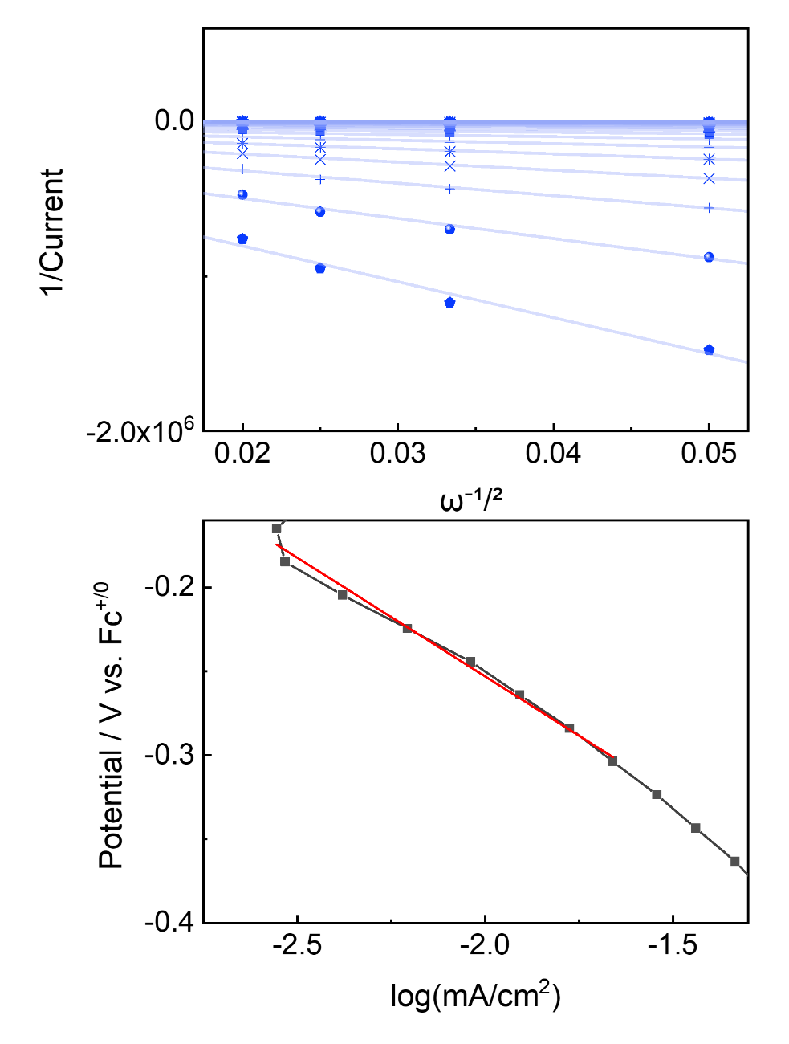
Supplementary Fig 142. (Top) Koutecky–Levich (K–L) plots obtained in the presence of 5 equivalents of Ca(OTf)₂, at rotation rates of 400, 900, 1600, and 2500 rpm. (Bottom) Tafel plot derived from the kinetic current extracted from K–L analysis, yielding a Tafel slope of 123 mV/dec. All measurements were conducted under standard conditions described in Section 9.2. Data represents the first of second independent experiments used for statistical analysis.

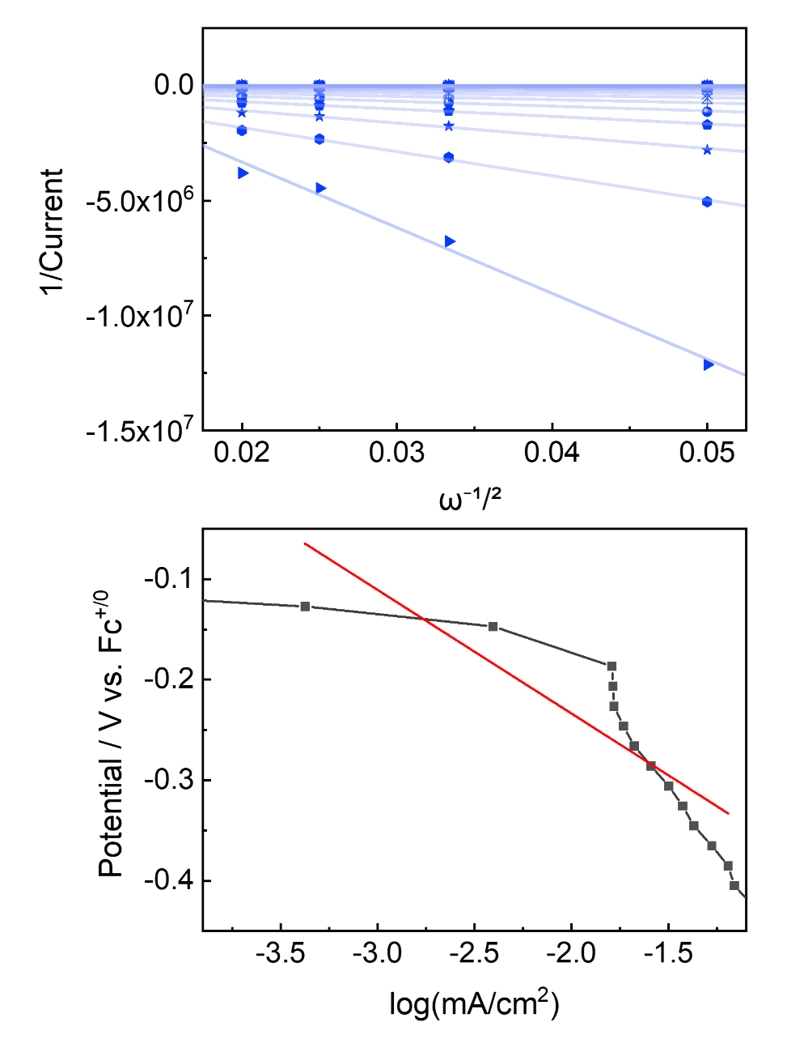
Supplementary Fig 143. (Top) Koutecky–Levich (K–L) plots obtained in the presence of 5 equivalents of Ca(OTf)₂, at rotation rates of 400, 900, 1600, and 2500 rpm. (Bottom) Tafel plot derived from the kinetic current extracted from K–L analysis, yielding a Tafel slope of 141 mV/dec. All measurements were conducted under standard conditions described in Section 9.2. Data represents the first of third independent experiments used for statistical analysis.

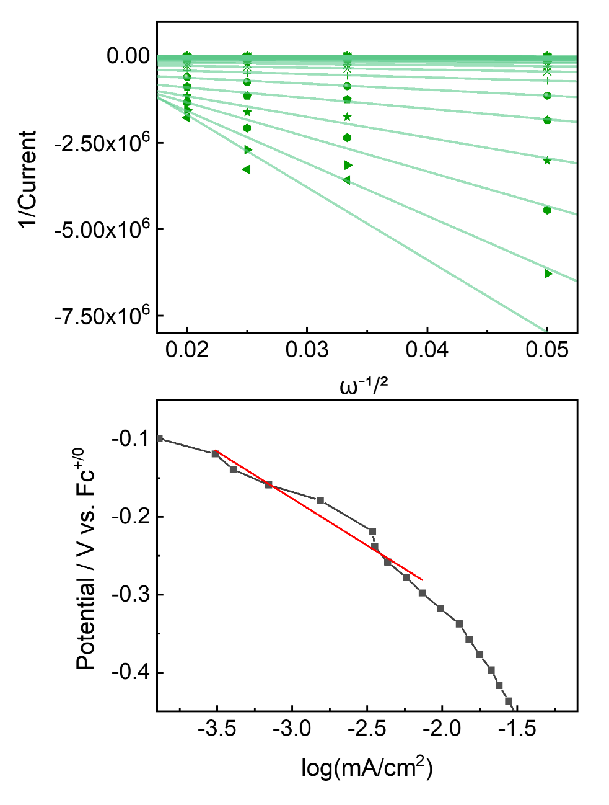
Supplementary Fig 144. (Top) Koutecky–Levich (K–L) plots obtained in the presence of 5 equivalents of Sc(OTf)₃, at rotation rates of 400, 900, 1600, and 2500 rpm. (Bottom) Tafel plot derived from the kinetic current extracted from K–L analysis, yielding a Tafel slope of 121 mV/dec. All measurements were conducted under standard conditions described in Section 9.2. Data represents the first of first independent experiments used for statistical analysis.

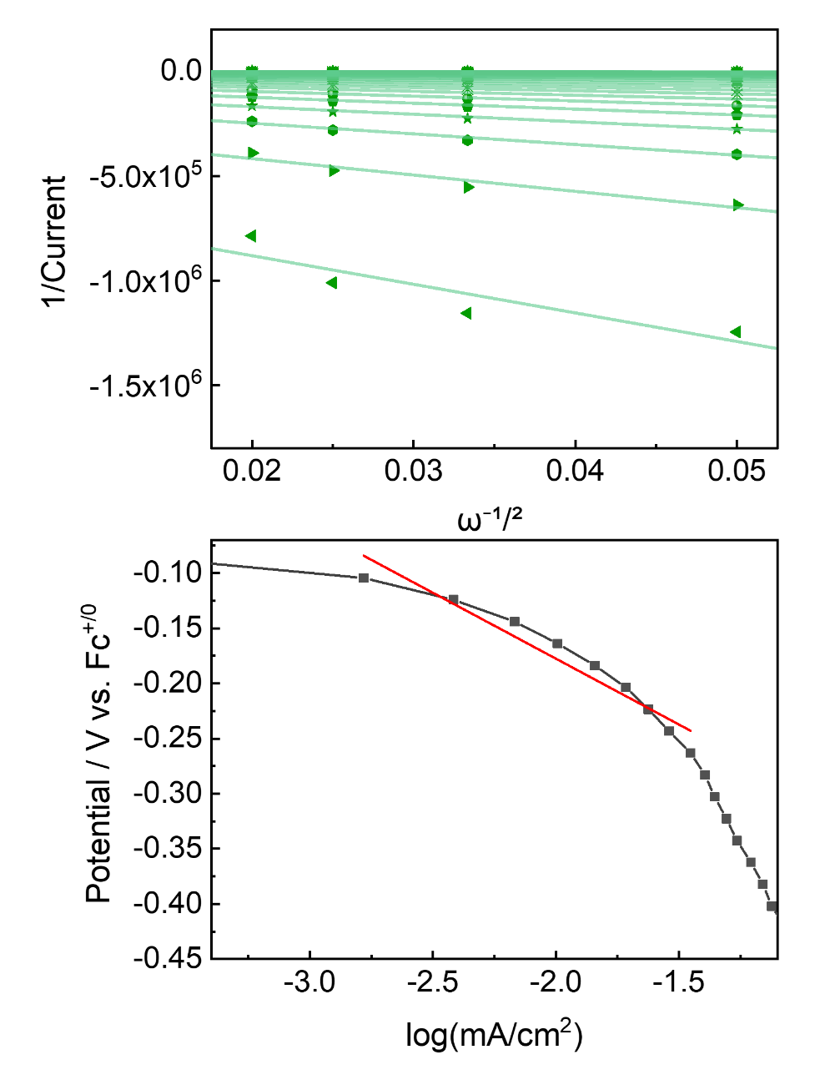
Supplementary Fig 145. (Top) Koutecky–Levich (K–L) plots obtained in the presence of 5 equivalents of Sc(OTf)₃, at rotation rates of 400, 900, 1600, and 2500 rpm. (Bottom) Tafel plot derived from the kinetic current extracted from K–L analysis, yielding a Tafel slope of 119 mV/dec. All measurements were conducted under standard conditions described in Section 9.2. Data represents the second of first independent experiments used for statistical analysis.
_s
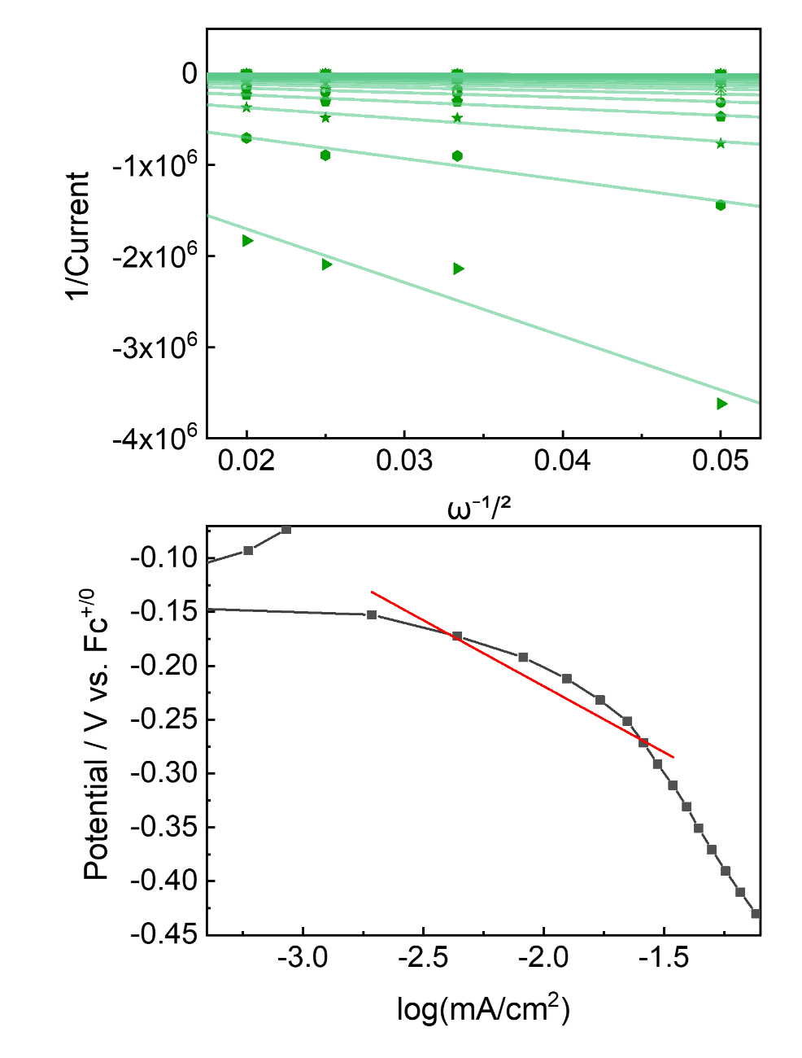
Supplementary Fig 146. (Top) Koutecky–Levich (K–L) plots obtained in the presence of 5 equivalents of Sc(OTf)₃, at rotation rates of 400, 900, 1600, and 2500 rpm. (Bottom) Tafel plot derived from the kinetic current extracted from K–L analysis, yielding a Tafel slope of 123 mV/dec. All measurements were conducted under standard conditions described in Section 9.2. Data represents the third of first independent experiments used for statistical analysis.

Solvent-Dependent Correlations Between Fe^{II/III} Redox Potentials and H₂O₂ Selectivity
All linear sweep voltammetry data for O₂ reduction were collected at a scan rate of 0.01 V/s under identical solution conditions. Solutions were prepared in three solvents—CH₂Cl₂ (containing 1% DMF, as shown in the Supplementary Fig 135.), DMF, and DMSO—by adding 0.3 mM Fe catalyst, 10 mM TFE or 10 mM p-toluenesulfonic acid (pTsOH), 0.1 M TBAPF₆, and 5 equivalents of each triflate salt. Voltammograms were internally referenced to Fc, which was added at the end of each experiment.
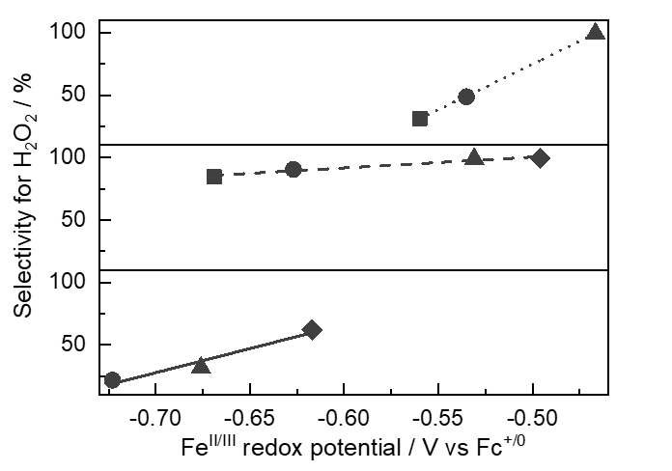
Supplementary Fig 147. Linear correlations between Fe^{II/III} redox potentials and H₂O₂ selectivity for FeTpOMePP (■, black square), FeTPP (▲, black upward triangle), FeTF₁₀PP (▼, black downward triangle), and FeTF₂₀PP (◆, black diamond) measured under standard RRDE conditions. (Top) In DMSO (···, dotted line), H₂O₂ selectivity values were 31%, 49%, and 99% from left to right. (Middle) In DMF (---, dashed line), H₂O₂ selectivity increased to 85%, 91%, 99%, and 99%. (Bottom) In CH₂Cl₂ containing 1% DMF (▬, solid line), H₂O₂ selectivity values were 22%, 32%, and 62%. Data points were excluded when complexes exhibited no measurable ORR activity in the corresponding solvent. Across all solvents, a positive correlation was observed, with anodic shifts in Fe^{II/III} redox potentials consistently associated with increased H₂O₂ selectivity.
Table S8.
 | Fe^{II/III} redox potential / V vs. Fc^{+/0} (ΔRedox potential vs. previous / mV)
Complex | DMSO | DMF | CH₂Cl₂
FeTpOMePP | –0.560 | - | -
FeTPP | –0.535 (25) | –0.627 (42) | –0.723
FeTF₁₀PP | –0.467 (68) | –0.531 (96) | –0.676 (47)
FeTF₂₀PP | - | –0.496 (35) | –0.617 (59)

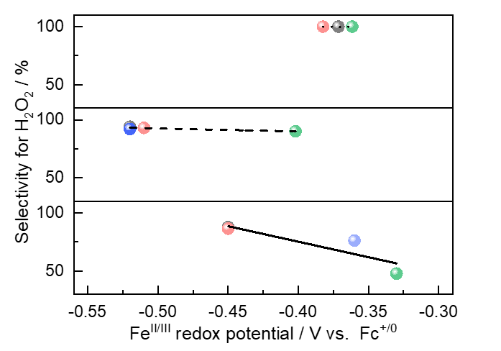
Supplementary Fig 148. Linear correlations between Fe^{II/III} redox potentials and H₂O₂ selectivity for FeL1–Cl under various conditions: absence of added cations (●, black sphere), and presence of 5 equivalents of KOTf (●, red sphere), Ca(OTf)₂ (●, blue sphere), and Sc(OTf)₃ (●, green sphere). (Top) In DMSO (···, dotted line), all conditions yielded nearly exclusive H₂O₂ formation. (Middle) In DMF (---, dashed line), H₂O₂ selectivity decreased to 94%, 93%, 92%, and 89% from left to right. (Bottom) In CH₂Cl₂ containing 1% DMF (▬, solid line), H₂O₂ selectivity values were 88%, 86%, 76%, and 48%. Across all solvents, a negative correlation was observed, with cathodic shifts in Fe^{II/III} redox potentials consistently associated with decreased H₂O₂ selectivity.
Table S9.
 | Fe^{II/III} redox potential / V vs. Fc^{+/0} (ΔRedox potential vs. FeL1–Cl / mV)
Complex | DMSO | DMF | CH₂Cl₂
FeL1–Cl | –0.372 | 0.516 | 0.450
FeL1–Cl _K⁺ | –0.383 (11) | 0.511 (5) | 0.450 (0)
FeL1–Cl _Ca²⁺ | –0.382 (10) | 0.518 (2) | 0.360 (90)
FeL1–Cl _Sc³⁺ | –0.362 (10) | 0.402 (114) | 0.330 (120)

Mechanistic Study

Electrochemical UV–vis Spectroscopy
Spectroelectrochemical experiments were conducted using a custom-designed spectroelectrochemical cell equipped with a quartz window. The measurements were performed at room temperature under an atmospheric pressure of O₂ to monitor the reaction between FeL1–Cl and O₂ in real time. A three-electrode system was employed, comprising a honeycomb working electrode (Pine Ins.) and an Ag/AgCl reference electrode (3 M NaCl). The electrolyte solution contained 0.1 M TBAPF₆ in CH₂Cl₂ containing 1% DMF, which was deoxygenated by purging with argon before introducing O₂. The electrochemical potential was controlled using a potentiostat (WaveNowXV Potentiostat Bundle, FC International), and UV–vis spectra were recorded simultaneously using a UV–vis spectrophotometer (Avantes spectrometer, FC International). Spectra were collected at—1000mV applied potentials to monitor the formation of the Fe^{III}L1–OO species.
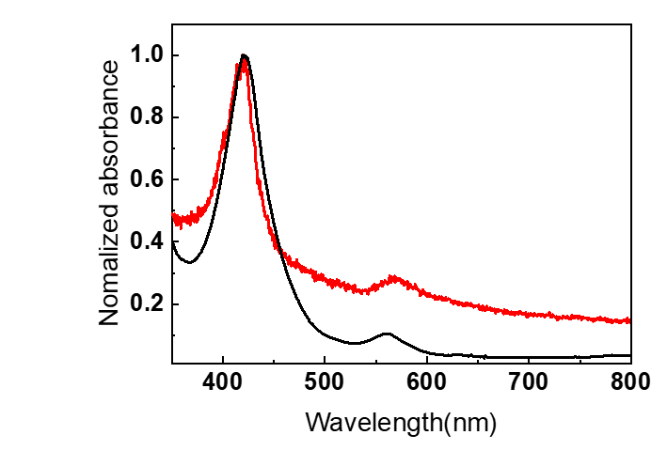
Supplementary Fig 149. Comparison between the UV–vis spectrum of chemically synthesized Fe^{III}L1–OO species (▬, black solid line), referenced in Supplementary Fig 91 in Section 6.1, and the in situ spectroelectrochemical spectrum obtained during the reaction of FeL1–Cl with O₂ at room temperature (▬, red solid line). Both spectra exhibit matching profiles with the chemically generated species showing a Soret band at 421 nm and Q-band at 561 nm (▬, black solid line), while the electrochemically generated species displays a Soret band at 420 nm and Q-band at 565 nm (▬, red solid line).
For comparison, a UV-vis spectrum was recorded under chronoamperometric conditions at –1000 mV in the absence of a proton source. The spectral profiles and λ_{max} values of this spectrum and the chemically synthesized Fe^{III}L1–OO species were found to be in close agreement, confirming the formation of an identical species under electrochemical conditions. Upon subsequent addition of the proton source TFE, the Fe^{III}L1–OO species rapidly transformed to un unidentified species.
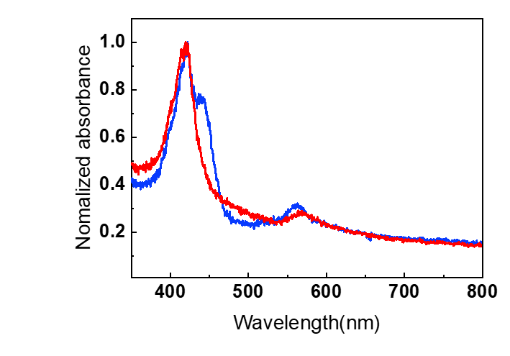
Supplementary Fig 150. In situ UV-vis spectra were recorded during the electrochemical reaction between compound FeL1–Cl and O₂ at 25 °C (▬, red solid line). Upon addition of the proton source TFE, the Fe^{III}L1–OO species rapidly transformed into a different species (▬, blue solid line).

Derivations for the Diagnostic Criteria Presented in Table S10.
Table S10. Diagnostic Criteria of Proposed Paths for O₂ Reduction¹
 | Rate-limiting step of proposed mechanism | Expected tafel slope calculated at 298K | Expected [H⁺] reaction order | Expected O₂ reaction order
A.1 | $$θ_{M^{II}}+O_{2}+e^{-}\text{⇌} θ_{M^{III}{O2}^{-}}$$ | 59/β | 0 | 1
A.2 | $$θ_{M^{III}{O2}^{-}}+H^{+}\text{⇌} θ_{M^{III}O2H}$$ | 59 | 1 | 1
B.1 | $$θ_{M^{II}}+O_{2} \text{⇌} θ_{M^{III}O2}$$ | ∞ | 0 | 1
B.2 | $$θ_{M^{III}O2}+H^{+}+e^{-}\text{⇌}{ θ}_{M^{III}O2H}$$ | 59/β | 1 | 1
C.1 | $$θ_{M^{II}}+O_{2}\text{⇌} θ_{M^{III}O2}$$ | ∞ | 0 | 1
C.2 | $$θ_{M^{III}O2}+e^{-}\text{⇌} θ_{M^{III}{O2}^{-}}$$ | 59/β | 0 | 1
C.3 | $$θ_{M^{III}{O2}^{-}}+H^{+}\text{⇌} θ_{M^{III}O2H}$$ | 59 | 1 | 1

Since O₂ reduction is an electrochemical reduction process, decreasing the potential to more negative values on an absolute scale led to an increased reaction rate. Therefore, to maintain consistency in the sign convention, all rate laws are expressed in terms of –E.
Pathway A.
If A.1 is the rate-limiting step, applying the Butler-Volmer equation to an irreversible electron transfer leads to the following rate law for the reaction velocity (v):
 | $$A.1. θ_{M^{II}}+O_{2}+e^{-}\text{⇌} θ_{M^{III}{O_{2}}^{-}} (RLS)$$ | (15)
 | $$v=k θ_{M^{II}}a_{O_{2}}\exp^{\frac{βF(-E)}{RT}}$$ | (16)
Here, β represents the transfer coefficient, while all other terms (F, E, R, and T) retain their standard meanings. If the number of vacant active sites ($θ_{M^{II}}$) is high, the effect of potential changes on this value can be ignored, allowing it to be treated as a constant. Consequently, from the above equation, the Tafel slope is 2.3RT/βF, approximately 120 mV/dec, and the reaction exhibits first-order dependence on O₂.
If A.2 is the rate-limiting step, the reaction rate would follow the expression given below:
 | $$A.2.θ_{M^{III}{O_{2}}^{-}}+H^{+}\text{⇌} θ_{M^{III}O_{2}H} (RLS)$$ | (17)
 | $$v=k θ_{M^{III}{O_{2}}^{-}}a_{H}$$ | (18)
If $θ_{M^{III}{O2}^{-}}$ approaches 1 within the reaction, the Tafel slope becomes infinite, and the reaction follows first-order dependence on protons. However, if the initial $θ_{M^{III}{O2}^{-}}$is close to 0 and $θ_{M^{II}}$approaches 1, step A.1 can be formulated as a pre-equilibrium step based on the Nernst equation:
 | $$\frac{θ_{M^{III}{O_{2}}^{-}}}{θ_{M^{II}}}=K_{A_{1}}a_{O_{2}}\exp^{\frac{F(-E)}{RT}}$$ | (19)
By combining this expression with the rate law for step A.2 derived above, we obtain the following expression:
 | $$v=k K_{A_{1}}θ_{M^{II}}a_{H}a_{O_{2}}\exp^{\frac{F(-E)}{RT}}$$ | (20)
Therefore, the Tafel slope is approximately 60 mV/dec, and the reaction exhibits first-order dependence on both O₂ and protons.
Pathway B.
If the elementary step B.1 were rate-limiting, the rate law would be as follows:
 | $$B.1. θ_{M^{II}}+O_{2} \text{⇌} θ_{M^{III}O_{2}} (RLS)$$ | (21)
 | $$v=k a_{O_{2}}$$ | (22)
One would expect an infinite Tafel slope since this equation does not contain a potential-dependent term, and it exhibits first-order dependence on O₂.
If B.2 is the rate-limiting step, the reaction rate would follow the expression given below:
 | $$B.2. θ_{M^{III}O_{2}}+H^{+}+e^{-}\text{⇌}{ θ}_{M^{III}O_{2}H} (RLS)$$ | (23)
 | $$v=k θ_{M^{III}O_{2}}a_{H^{+}}\exp^{\frac{βF(-E)}{RT}}$$ | (24)
If step B.1 is assumed to be in quasi-equilibrium, the following relationship can be applied:
 | $$\frac{ θ_{M^{III}O_{2}}}{θ_{M^{II}}a_{O_{2}}}=K_{B_{1}}$$ | (25)
By substituting this back into the previously derived rate equation, we obtain the following result:
 | $$v=kK_{B_{1}} θ_{M^{II}}a_{O_{2}}a_{H^{+}}\exp^{\frac{βF(-E)}{RT}}$$ | (26)
This would yield a Tafel slope of 2.3RT/βF, approximately 120 mV/dec, along with first-order dependence on protons and first-order dependence on O₂.
Pathway C.
If the elementary step C.1 were rate-limiting, the rate law would be as follows:
 | $$C.1. θ_{M^{II}}+O_{2} \text{⇌} θ_{M^{III}O_{2}} (RLS)$$ | (27)
 | $$v=k a_{O_{2}}$$ | (28)
One would expect an infinite Tafel slope since this equation does not contain a potential-dependent term, and it exhibits first-order dependence on O₂.
If C.2 is the rate-limiting step, applying the Butler-Volmer equation to an irreversible electron transfer leads to the following rate law for the reaction velocity (v):
 | $$C.2. θ_{M^{III}O2}+e^{-}\text{⇌} θ_{M^{III}{O_{2}}^{-}} (RLS)$$ | (29)
 | $$v=k θ_{M^{III}O_{2}}\exp^{\frac{βF(-E)}{RT}}$$ | (30)
If step C.1 is assumed to be in quasi-equilibrium, the following relationship can be applied:
 | $$\frac{ θ_{M^{III}O_{2}}}{θ_{M^{II}}a_{O_{2}}}=K_{C_{1}}$$ | (31)
By substituting this back into the previously derived rate equation, we obtain the following result:
 | $$v=kK_{C_{1}} θ_{M^{II}}a_{O_{2}}\exp^{\frac{βF(-E)}{RT}}$$ | (32)
This would yield a Tafel slope of 2.3RT/βF, approximately 120 mV/dec, along with first-order dependence on O₂.
Finally, if step C.3 is the rate-determining step, the reaction rate follows the equation below:
 | $$C.3. θ_{M^{III}{O_{2}}^{-}}+H^{+}\text{⇌} θ_{M^{III}O_{2}H} (RLS)$$ | (33)
 | $$v=k θ_{M^{III}{O_{2}}^{-}}a_{H^{+}}$$ | (34)
If $θ_{M^{III}{O2}^{-}}$​ approaches 1, the Tafel slope is expected to be infinite, with zero-order dependence on O₂ and first-order dependence on protons. However, if $θ_{M^{III}{O2}^{-}}$ approaches 0 and correspondingly $θ_{M^{III}O2}$ approaches 1, step C.2 can be rewritten as a pre-equilibrium step:
 | $$\frac{θ_{M^{III}{O_{2}}^{-}}}{θ_{M^{III}O_{2}}}=K_{C_{2}}\exp^{\frac{F(-E)}{RT}}$$ | (35)
Since the equilibrium expression for $K_{C_{1}}$​ is as follows:
 | $$\frac{ θ_{M^{III}O_{2}}}{θ_{M^{II}}a_{O_{2}}}=K_{C_{1}}$$ | (36)
Combining the two equilibrium expressions and substituting them into the rate law yields the following equation:
 | $$v=k K_{C_{2}}θ_{M^{III}O_{2}}a_{H^{+}}\exp^{\frac{F(-E)}{RT}}$$ | (37)
 | $$v=k K_{C_{1}}K_{C_{2}}θ_{M^{II}}a_{O_{2}}a_{H^{+}}\exp^{\frac{F(-E)}{RT}}$$ | (38)
Using this rate law, the anticipated reaction orders are first order in O₂ and protons, with a Tafel slope of approximately 60 mV/dec.
Our reaction exhibits first-order dependence on protons, follows a pre-equilibrium with O₂, and has a Tafel slope of approximately 120 mV/dec. Based on the results derived under these assumptions, the reaction follows Pathway B mechanism, with the rate-limiting step (RLS) identified as the B.2 step, corresponding to the concerted proton-electron transfer (CPET) step.

Computational Analysis

Stark Effect Study in IR with ZnL1−CN upon Oriented Electric Field Effect
IR shifts in ZnL1−CN and ZnTF₁₀PP−CN upon binding of positively charged cations and under an oriented electric field was examined using the Gaussian 16 program package. The internal coordinate system (Z-matrix) to align the electric field with the cyanide (CN) bond axis was employed by following the computational procedure described in Hanaway et al.³ Gas-phase geometry optimization was performed using B3LYP as functional with D3(BJ) dispersion correlation and def2-SVP as basis set under the applied electric field without geometry contratints. The electric field direction matched that generated at ZnL1−CN_K by the potassium cation, and its strength was systematically varied from 0.000 to 0.0210 atomic units (au) as described in Table S11. Assuming the monovalent cation as a point charge, the electric field at the nitrile bond center was estimated using a simplified equation with charge $Q$ and distance $r$ from the charge (equation (39)), yielding 0.020 au without accounting for medium permittivity.
 | $$F=\frac{kQ}{r^{2}}$$ | (39)
The applied electric field modulated both the equilibrium bond length and the C–N stretching frequency. Previous studies on the vibrational Stark effect indicate that a monovalent cation aligned with our system induces a red shift of less than 10 cm^{–1} in the vibrational stretch.⁴ While our computational results align with the direction of this shift, the magnitude was significantly larger than the reported range. This discrepancy can be attributed to three factors: 1) The computational model applied a uniform parallel electric field, whereas the field generated by a cation decay with distance (field strength variation). 2) The permittivity of the environment differs from that of a vacuum due to electron density distributed between the cation and the nitrile bond (medium permittivity). 3) The high dielectric constant of the surrounding solvent cage contributes additional electric field effects (solvent cage effects).

DFT Analysis of the Spin State of the Fe Porphyrin Catalytic Intermediates
Table S11. Equilibrium bond length and IR stretching frequency of ZnTF₁₀PP–CN under applied parallel electric field.
Field / au | Zn–C / Å | C–N / Å | C–N / cm⁻¹
0.0000 | 2.039 | 1.166 | 2276.04
0.0007 | 2.040 | 1.167 | 2274.69
0.0014 | 2.041 | 1.167 | 2273.25
0.0021 | 2.042 | 1.167 | 2271.81
0.0070 | 2.134 | 1.171 | 2235.18
0.0140 | 2.132 | 1.170 | 2236.14
0.0210 | 2.210 | 1.174 | 2209.07

We assumed that a nucleophilic solvent molecule coordinates to the Fe porphyrin system as an axial ligand, consistent with previously reported solvent-involved systems.⁵ Our porphyrin platform features two distinct faces: one facing the diaza-crown-ether moiety and the other opposite to it. Given the greater steric hindrance of N,N-dimethylformamide (DMF) compared to smaller molecules like O₂, we positioned DMF on the side opposite to the crown ether moiety in the hexacoordinated intermediates. For scandium-bound complexes, an additional triflate anion was required to fully encapsulate the scandium ion within the crown ether moiety. This is supported by reported single-crystal structures of scandium-bound crown ether complexes, which typically exhibit a hepta- or octa-coordinated scandium center.⁶⁻⁹ However, our crown ether moiety provides only six Lewis-basic sites, necessitating the additional coordination of a triflate ion to achieve full encapsulation.
 | $$ΔG=ΔE_{Electronic}+ZPE+ΔH_{Thermal}-TΔS+{ΔE}_{solvation}$$ | (40)
The spin state of the Fe porphyrin species varies depending on the electronic properties of the coordination sphere. Intermediate or high spin species are observed for synthetic Fe porphyrin species.¹⁰ We individually optimized geometries and calculated relative free energies for three potential spin states, S = 0, 1, 2 or S = 1/2, 3/2, 5/2, depending on the number of electrons in the molecular system to investigate the most plausible spin state of the catalytic intermediates as described in Table S12. We used a simplified Fe porphyrin model, FeTF₁₀PP, to maintain the electronic properties of the complexes to reduce computational cost associated with calculating the flexible crown-ether moiety. We calculated eight catalytic intermediates, most of which exhibited intermediate spin states as the most stable configurations.
Two exceptions were the Fe^{III}TF₁₀PP−OOH species, and the Fe^{II}TF₁₀PP−OOH⁻ species. The Fe^{III}TF₁₀PP−OOH species was most stable in the doublet (S = 1/2) spin state, consistent with literature reports.¹¹⁻¹³ The Fe^{II}TF₁₀PP−OOH species were most stable in the quintet (S = 2) spin state. Since the Fe^{IV}TF₁₀PP=O, formed after the heterolysis of the O–O bond was most stable in the triplet (S = 1) spin state, we selected the triplet spin state for the Fe^{II}TF₁₀PP−OOH to ensure spin conservation during the heterolysis process.
The Fe^{II}TF₁₀PP, was most stable in the triplet spin state, with the quintet spin state demonstrating almost identical free energies. Fe^{II}TF₁₀PP in the triplet spin state forms an unstable singlet or quintet Fe^{III}TF₁₀PP−OO•, when reacted with triplet O₂, so we selected the quintet spin state for the Fe^{II}TF₁₀PP species. For the Fe^{IV}TF₁₀PP=O^{•+}, though the complex is most stable in the quartet (S = 3/2) spin state, we used the doublet (S = 1/2) spin state to calculate the ORR mechanism to conserve the spin state of the Fe^{III}TF₁₀PP−OOH during the heterolysis of an H₂O molecule in the presence of an extra proton. The qualitative nature of the mechanism pathway did not change even when considering the difference of approximately 10 kcal mol⁻¹ between the two spin states.

Table S12. Relative Gibbs free energies (in kcal mol⁻¹) of catalytic intermediates in the FeTF₁₀PP system containing an odd number of electrons for different spin states. Values used for calculating the ORR mechanism are shown in bold.
Species | Doublet (S = 1/2) | Quartet (S = 3/2) | Sextet (S = 5/2)
Fe^{III}TF₁₀PP⁺ | 14.4 | 0.0 | 4.3
Fe^{III}TF₁₀PP−OOH | −3.0 | 0.0 | −1.5
Fe^{III}TF₁₀PP−TFE_{deproton} | 0.7 | 0.0 | 1.0
Fe^{IV}TF₁₀PP=O^{•+} | 9.6 | 0.0 | 31.1

Table S13. Relative Gibbs free energy (in kcal mol⁻¹) of catalytic intermediates of FeTF₁₀PP system with an even number of electrons with different spin states. The spin state used for calculating the ORR mechanism is highlighted in bold.
Species | Singlet (S = 0) | Triplet (S = 1) | Quintet (S = 2)
Fe^{II}TF₁₀PP | 13.4 | 0.0 | −0.2
Fe^{III}TF₁₀PP−OO• | 21.3 | 0.0 | Dissociate
Fe^{III}TF₁₀PP−OOH | −0.6 | 0.0 | −2.4
Fe^{IV}TF₁₀PP=O | 31.1 | 0.0 | 8.7

General DFT Analysis of the Redox Thermochemistry and the Bifurcation in the ORR Mechanism in the Fe Porphyrin Catalyst
The mechanism for the bifurcation in the ORR catalyzed by our Fe porphyrin system was computationally explored using density functional theory (DFT) following previously proposed mechanisms⁵ The reduction potentials of chemical species were calculated from the electron transfer process from ferrocene (Fc) to form ferrocenium ion (Fc⁺). The thermochemistry of the electron transfer process from the electrode was calculated. Here, we set the electrode potential to –0.4 V vs Fc^{+/0} to examine the reaction mechanism. A detailed mathematical treatment for calculation of the thermochemistry of the oxidized (O) and reduced (R) species with respect to the electronic potential of the electrode is provided below (equation (41)~(44)). We also calculated the energy of the electron required to achieve a thermoneutral reaction for proton-coupled electron transfer (PCET) processes using trifluoroethanol (TFE) as a proton donor.
 | $$O+Fc→R+{Fc}^{+}$$ | (41)
 | $$ΔG_{redox, vs {Fc}^{0/+}}^{°}=ΔG_{R}^{°}+ΔG_{{Fc}^{+}}^{°}-(ΔG_{O}^{°}+ΔG_{Fc}^{°})$$ | (42)
 | $$ΔG_{redox, vs electrode}^{°}-ΔG_{redox. vs {Fc}^{0/+}}^{°}=-\{(-nFE_{electrode}^{°})-(-nFE_{{Fc}^{+/0}}^{°})\}$$ | (43)
 | $$ΔG_{redox, vs electrode}^{°}=ΔG_{redox, vs {Fc}^{+/0}}^{°}+nFE_{electrode, vs {Fc}^{+/0}}^{°}$$ | (44)
The selectivity of the ORR between H₂O and H₂O₂ is known to be determined by the protonation site of the Fe^{III}-OOH species.^{14,15} We attempted to optimize the structures of protonated Fe^{III}-OOH species at both the distal and proximal oxygen sites without structural restrictions. However, during the optimization process, the proton consistently transferred to the oxygen of the crown ether moiety, preventing the desired structures from being obtained. To address this, we optimized the structures by placing trifluoroethanol (TFE) near the distal (TFE_{dis}) or proximal (TFE_{prox}) oxygen to form a hydrogen bond. Notably, when TFE was placed near the distal oxygen in the presence of scandium ion (Sc³⁺), it coordinated to the metal center, whereas no such coordination was observed with the proximal oxygen.

DFT Analysis of the Impact of Cations on the ORR Catalytic Cycle
We investigated the influence of Sc³⁺ on the selectivity of the ORR to elucidate the origin of the selectivity change induced by the addition of a redox-inactive metal salt (Section 9.). The thermochemistry of the ORR catalytic cycle was calculated, starting from the FeᴵᴵᴵL1−Cl state and proceeding to the final species of the Fe porphyrin catalyst, FeᴵᴵᴵL1-TFE_{deproton}, after the release of product molecules. Without coordination of the deprotonated TFE (generated after proton transfer to the catalytic intermediate), the final step to close the catalytic cycle was highly endothermic, rendering the catalysis non-viable due to the loss of binding energy of the axial ligand. The binding energy of the deprotonated TFE to the FeᴵᴵᴵL1 species was calculated to be −28.6 kcal/mol in the presence of Sc³⁺ and −29.0 kcal/mol in its absence. Notably, the proton of TFE in the Fe^{III}L1–OOH + TFE_{dis} species transferred to the distal oxygen upon reduction with an electron in the presence of Sc³⁺, suggesting a multi-site proton-coupled electron transfer mechanism (Table S14).
Table S14. Mulliken spin density at the Fe center obtained from single point calculations and geometric parameters of the Fe-hydroperoxo species with hydrogen bonding between the distal oxygen and TFE in the optimized structures.
Cation | Species | O_{distal}–H / Å | O_{TFE}–H / Å | ρ_{Fe}
X | [Fe^{III}L1–OOH]+TFE_{dis} | 1.788 | 0.983 | 0.881
X | [Fe^{II}L1–OOH] +TFE_{dis} | 1.660 | 0.997 | 2.188
Sc³⁺ | [Fe^{III}L1–OOH]+TFE_{dis} | 1.472 | 1.036 | 0.974
Sc³⁺ | [Fe^{II}L1–OOH] +TFE_{dis} | 1.041 | 1.445 | 2.132

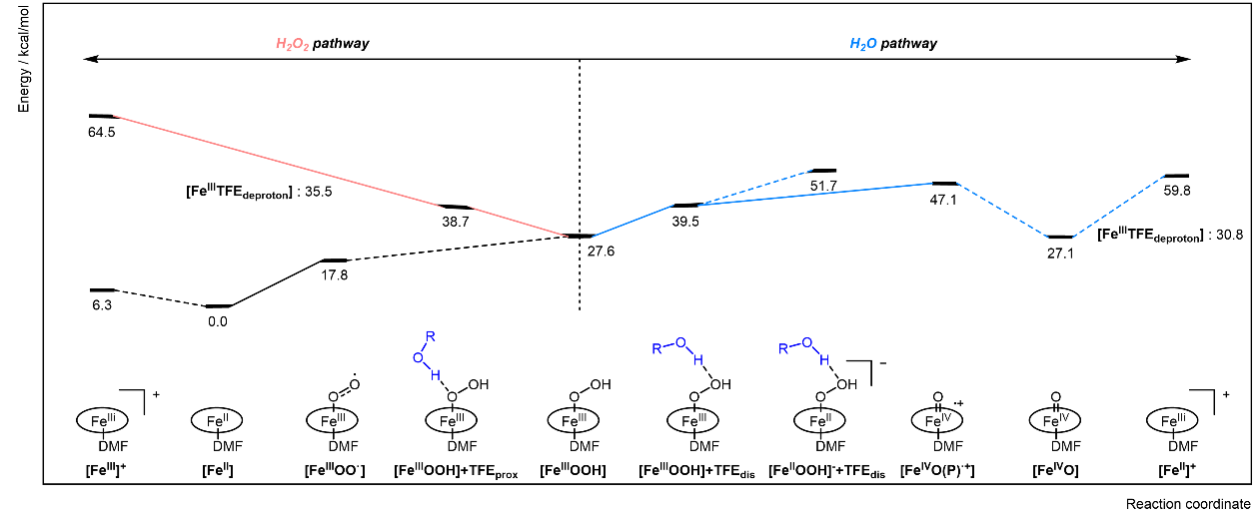
Supplementary Fig 151. Relative Gibbs free energy diagram (in kcal mol^{–1}) for ORR catalytic intermediates using Fe^{III}L1 porphyrin catalyst in the absence of Sc³⁺: Comparison of catalytic pathways to H₂O (▬, blue) or H₂O₂ (▬, pink) in CH₂Cl₂. Elementary steps involving electron transfer processes are indicated by dotted lines, and the thermochemistry was calculated relative to a potential of –0.4 V versus the Fc^{+/0} reference.

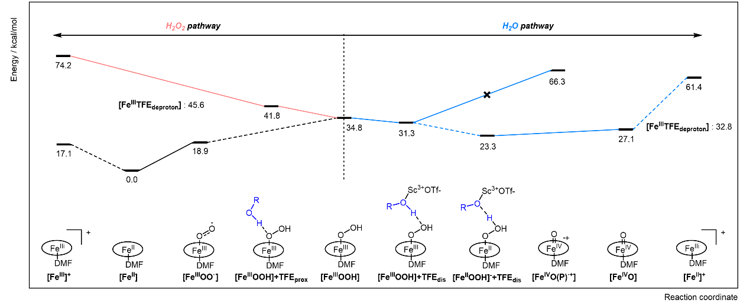
Supplementary Fig 152. Relative Gibbs free energy diagram (in kcal mol^{–1}) for ORR catalytic intermediates on Fe porphyrin catalyst in presence of Sc³⁺: Comparison of catalytic pathways to H₂O (▬, blue) or H₂O₂ (▬, pink) solvated in CH₂Cl₂. Elementary steps involving electron transfer processes are indicated by dotted lines, and the thermochemistry was calculated relative to a potential of –0.4 V versus the Fc^{+/0} reference.

DFT analysis of the Impact of Solvent on the Selectivity of the ORR Catalytic Cycle
We investigated the solvation and coordination effects of solvents—CH₂Cl₂, DMF, and DMSO—on the selectivity of the ORR to understand how different solvent conditions influence ORR selectivity (Supplementary Fig 147). Our experimental ORR studies were conducted in three solvent systems: CH₂Cl₂ with 1% DMF, pure DMF, and pure DMSO. The thermochemistry for the CH₂Cl₂ solvent system was redrawn based on the analysis of 1.3. For the DMF solvent system, the SMD solvation model was applied using DMF as the solvent. The structures of catalytic intermediates were optimized with a DMSO molecule coordinated to the metal center instead of DMF, unlike the other solvent systems. We calculated a portion of the catalytic cycle for three solvent systems starting from the key selectivity-determining intermediate, [Fe^{III}L1–OOH], to the final species of the Fe porphyrin catalyst after releasing product molecules, [Fe^{III}L1–OOH] + TFE_{dis.}
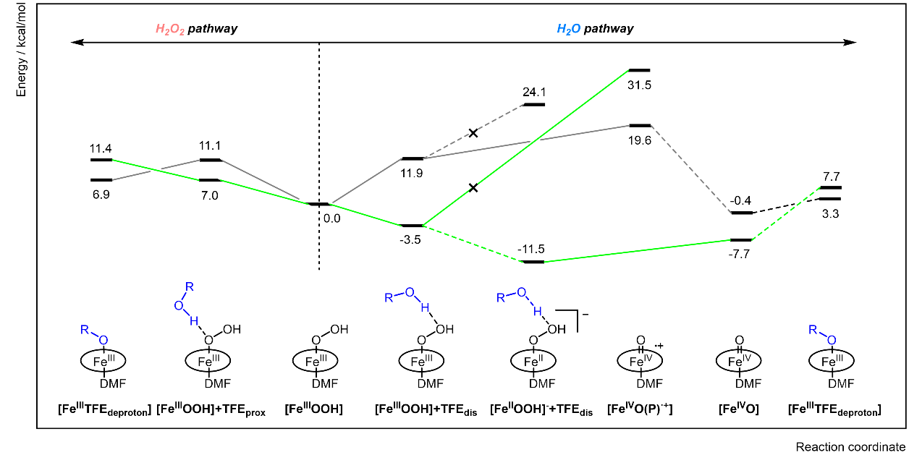
Supplementary Fig 153. Relative Gibbs free energy diagram (in kcal mol^{–1}) for ORR catalytic intermediates on Fe porphyrin catalyst: Comparison of systems with (▬, green) and without (▬, gray) Sc³⁺ solvated in CH₂Cl₂. Elementary steps involving electron transfer processes are indicated by dotted lines, and the thermochemistry was calculated relative to a potential of –0.4 V versus the Fc^{+/0} reference.

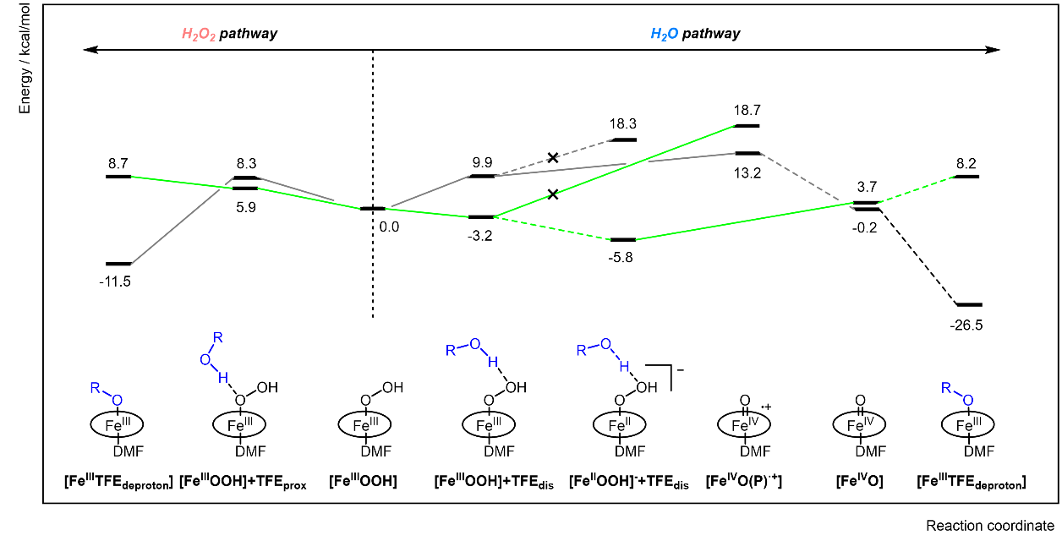
Supplementary Fig 154. Relative Gibbs free energy diagram (in kcal mol^{–1}) for ORR catalytic intermediates on Fe porphyrin catalyst: Comparison of systems with (▬, green) and without (▬, gray) Sc³⁺ solvated in DMF. Elementary steps involving electron transfer processes are indicated by dotted lines, and the thermochemistry was calculated relative to a potential of –0.4 V versus the Fc^{+/0} reference.

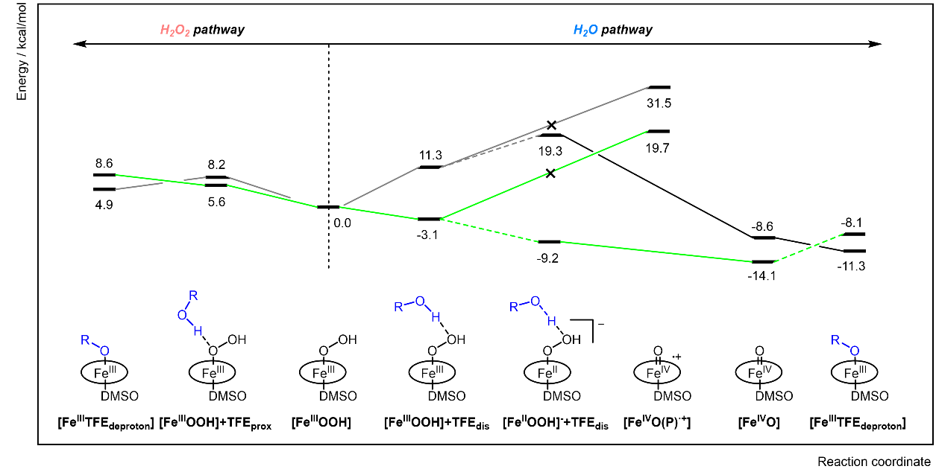
Supplementary Fig 155. Relative Gibbs free energy diagram (in kcal mol^{–1}) for ORR catalytic intermediates on Fe porphyrin catalyst: Comparison of systems with (▬, green) and without (▬, gray) Sc³⁺ ion solvated in DMSO. Elementary steps involving electron transfer processes are indicated by dotted lines, and the thermochemistry was calculated relative to a potential of –0.4 V versus the Fc^{+/0} reference.

We investigated the influence of Sc³⁺ on the selectivity of the ORR to elucidate the origin of the selectivity change induced by the addition of a redox-inactive metal salt (Section 9.). The thermochemistry of the ORR catalytic cycle was calculated, starting from the FeᴵᴵᴵL1 state and proceeding to the final species of the Fe porphyrin catalyst, FeᴵᴵᴵL1 –TFE_{deproton}, after the release of product molecules. Without coordination of the deprotonated TFE (generated after proton transfer to the catalytic intermediate), the final step to close the catalytic cycle was highly endothermic, rendering the catalysis non-viable due to the loss of binding energy of the axial ligand. The binding energy of the deprotonated TFE to the FeᴵᴵᴵL1 species was calculated to be −28.6 kcal mol⁻¹ in the presence of Sc³⁺ and −29.0 kcal mol⁻¹ in its absence. Notably, the proton of TFE in the [Fe^{III}L1–OOH] + TFE_{dis} species transferred to the distal oxygen upon reduction with an electron in the presence of Sc³⁺, suggesting a multi-site proton-coupled electron transfer mechanism (Table S16).
Table S16. Mulliken spin density at the Fe center obtained from single point calculations and geometric parameters of the Fe-hydroperoxo species with hydrogen bonding between the distal oxygen and TFE in the optimized structures.
Cation | Species | O_{distal}–H / Å | O_{TFE}–H / Å | ρ_{Fe}
X | [Fe^{III}L1–OOH]+TFE_{dis} | 1.788 | 0.983 | 0.881
X | [Fe^{II}L1–OOH] +TFE_{dis} | 1.660 | 0.997 | 2.188
Sc³⁺ | [Fe^{III}L1–OOH]+TFE_{dis} | 1.472 | 1.036 | 0.974
Sc³⁺ | [Fe^{II}L1–OOH] +TFE_{dis} | 1.041 | 1.445 | 2.132

Fe K-edge pre-edge Spectra
The Fe K-edge pre-edge XAS spectra were analyzed using the TD-DFT approach within the ORCA program package. Two Fe porphyrin species, [Fe^{III}L1]⁺ and [Fe^{III}L1–OO•], were analyzed in the presence and absence of Sc³⁺. Since the experimental generation of [Fe^{III} L1–OO•] involved the use of potassium superoxide (KO₂), a potassium ion (K⁺) was encapsulated in the crown ether to model [Fe^{III} L1–OO•] in the absence of Sc³⁺. The geometries used for these calculations were derived from structures optimized with the B3LYP functional, as described earlier. The BP86 functional^{16,17} was employed specifically for calculating the Fe K-edge pre-edge spectra. A combination of the CP(PPP) basis set¹⁸ for Fe and the TZVP basis set¹⁹ for all other atoms was utilized, as this combination of functional and basis set has been shown to effectively reproduce experimental Fe K-edge pre-edge spectra.²⁰ Following ground-state DFT calculations, TD-DFT calculations were performed, restricting excitations from the Fe 1s orbital. For scandium-bound complexes, two additional anionic point charges were introduced to maintain charge balance relative to Sc³⁺-free complexes, utilizing the ORCA implementation. This charge balancing was essential to accurately reproduce the changes in relative intensities of the Fe K-edge pre-edge spectra for systems with and without Sc³⁺. The absorption bands were broadened by 2 eV to simulate the spectrum. The calculated spectra shifted by 181.9 eV to compensate for the systematic error of the computation.
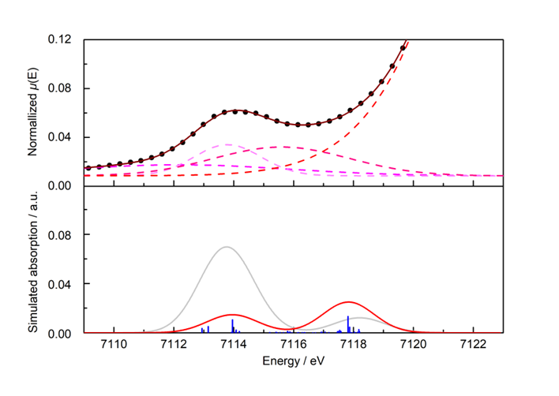
Supplementary Fig 156. Comparison of experimental and calculated Fe K-edge pre-edge XAS spectra of [Fe^{III}L1]⁺ in the absence of Sc³⁺. The experimental spectrum was deconvoluted using a large Gaussian function to simulate the rising edge and three additional Gaussian functions to simulate the pre-edge features. The quartet (S = 3/2) spin state (▬, red) and the sextet (S = 5/2) spin state (▬, gray) are shown. A stick diagram of the absorption bands with relative oscillator strengths (▬, blue) is also included.

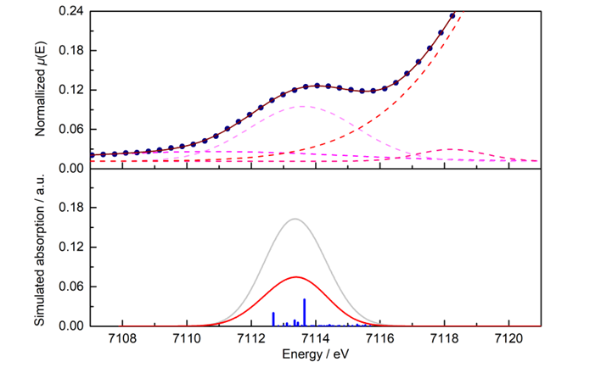
Supplementary Fig 157. Comparison of the experimental and calculated Fe K-edge pre-edge XAS spectra of [Fe^{III}L1]⁺ in the presence of Sc³⁺. The experimental spectrum was deconvoluted using a large Gaussian function to simulate the rising edge and three additional Gaussian functions to simulate the pre-edge portion. The quartet (S = 3/2) spin state (▬, red) and the sextet (S = 5/2) spin state (▬, gray) are displayed. A stick diagram of the absorption bands with relative oscillator strengths (▬, blue) is also included.

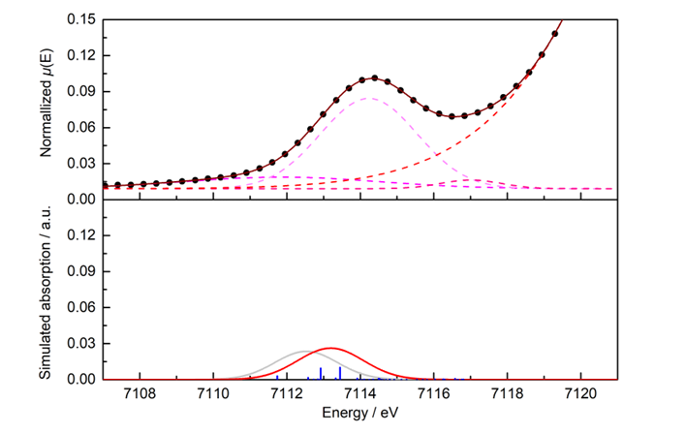
Supplementary Fig 158. Comparison of the experimental and calculated Fe K-edge pre-edge XAS spectra of [Fe^{III}L1–OO•] in the presence of K⁺. The experimental spectrum was deconvoluted using a large Gaussian function to simulate the rising edge and three additional Gaussian functions to simulate the pre-edge portion. The triplet (S = 1) spin state (▬, red) and the quintet (S = 2) spin state (▬, gray) are displayed. A stick diagram of the absorption bands with relative oscillator strengths (▬, blue) is also included.
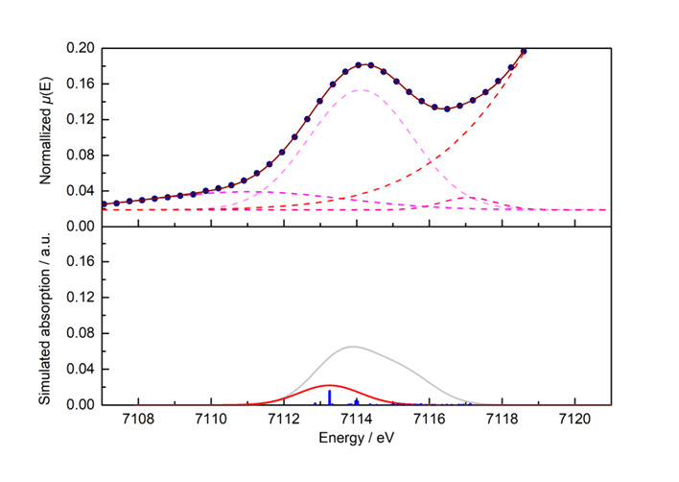
Supplementary Fig 159. Comparison of the experimental and calculated Fe K-edge pre-edge XAS spectra of [Fe^{III}L1–OO•] in the presence of Sc³⁺. The experimental spectrum was deconvoluted using a large Gaussian function to simulate the rising edge and three additional Gaussian functions to simulate the pre-edge portion. The triplet (S = 1) spin state (▬, red) and the quintet (S = 2) spin state (▬, gray) are displayed. A stick diagram of the absorption bands with relative oscillator strengths (▬, blue) is also included.

Copies of NMR spectra

NMR spectra of S6

NMR spectra of L1

NMR spectra of L2

NMR spectra of TpOMePP
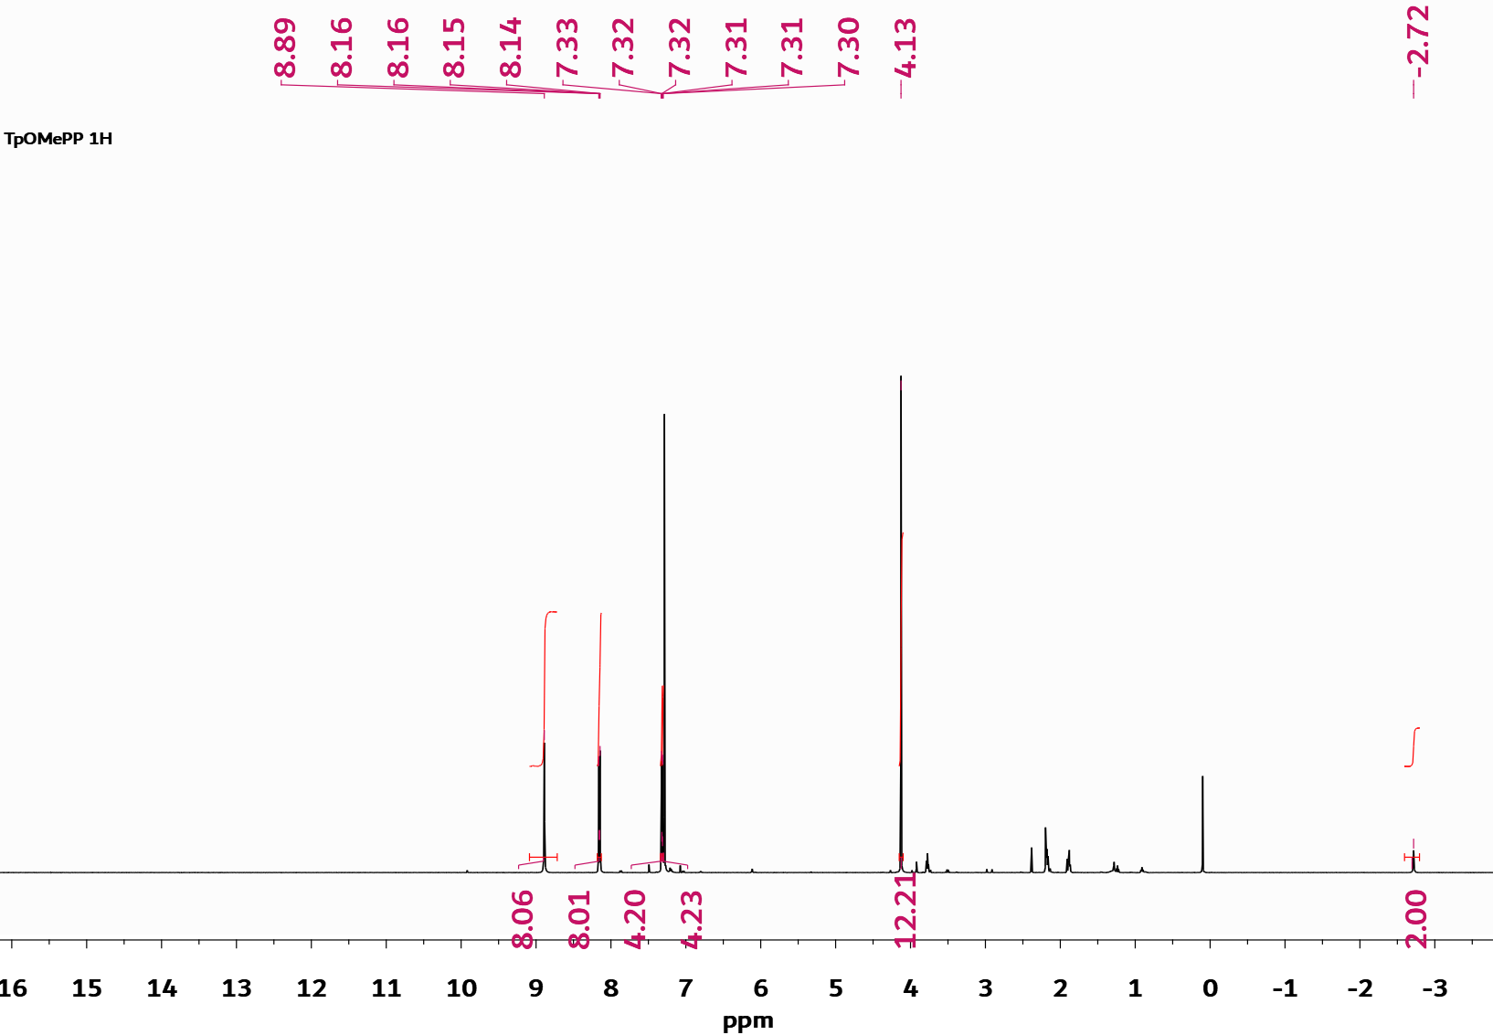

NMR spectra of TF₁₀PP
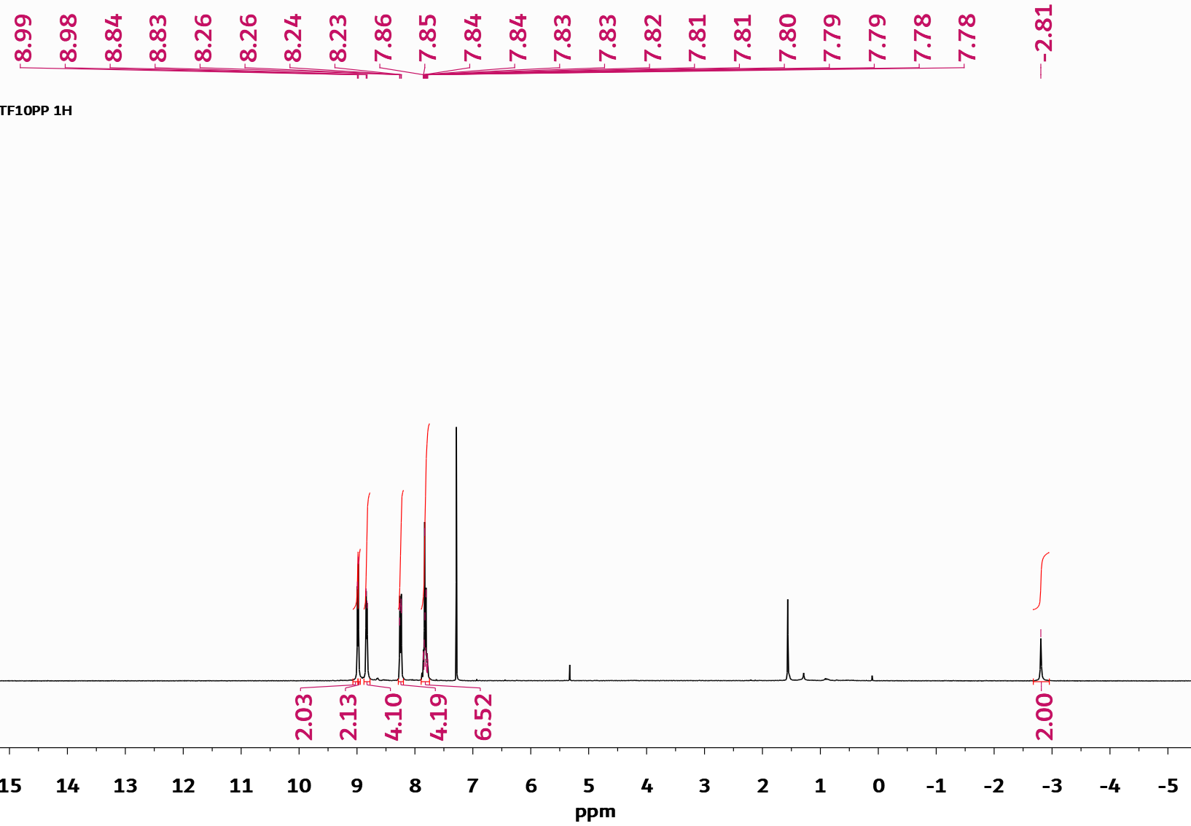

NMR spectra of TF₂₀PP
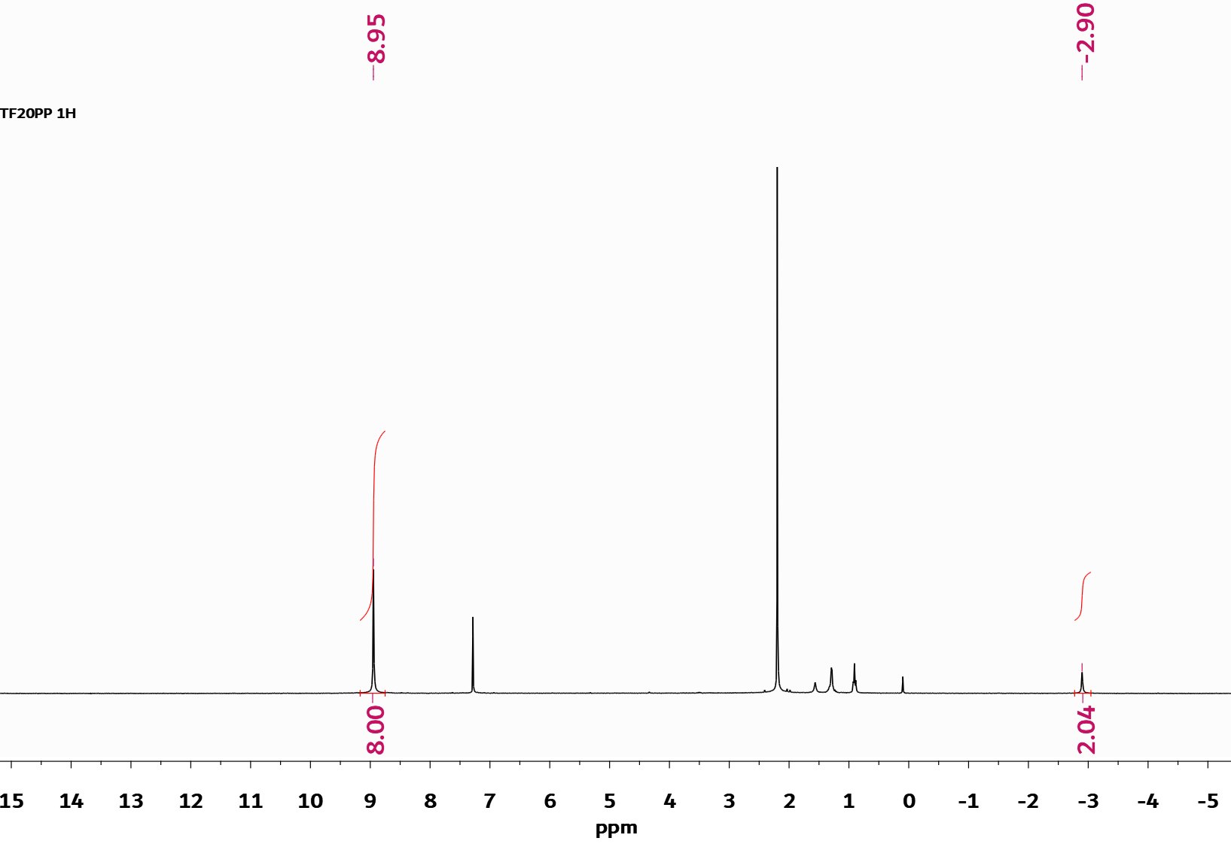

NMR spectra of ZnL1

NMR spectra of ZnL1-CN_K
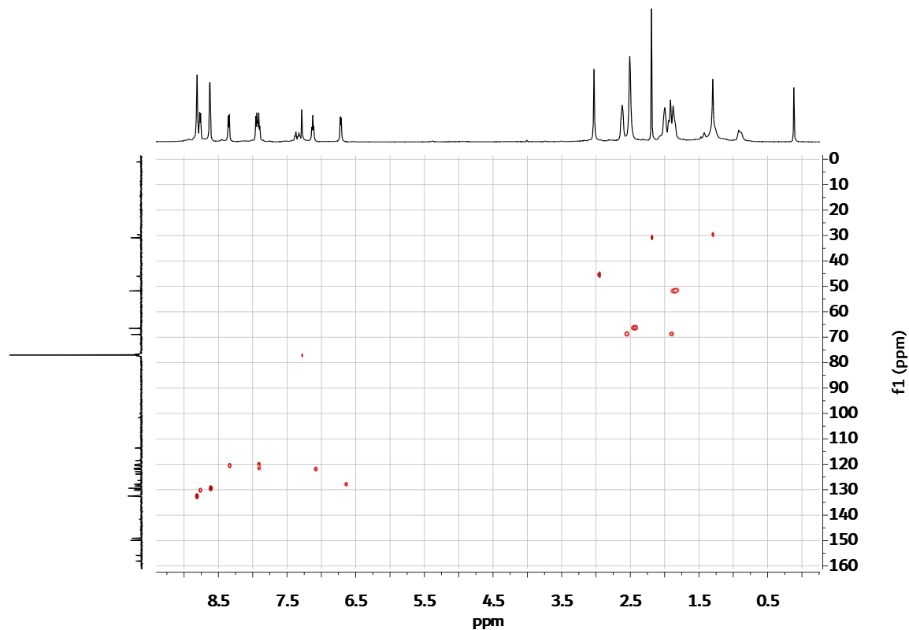

NMR spectra of ZnL2

NMR spectra of FeL1-Cl

NMR spectra of FeL1-Im₂

Reference
1 Wuttig, A., Yoon, Y., Ryu, J. & Surendranath, Y. Bicarbonate Is Not a General Acid in Au-Catalyzed CO₂ Electroreduction. J. Am. Chem. Soc. 139, 17109-17113 (2017).
2 Thordarson, P. Determining association constants from titration experiments in supramolecular chemistry. Chem. Soc. Rev. 40, 1305-1323 (2011).
3 Hanaway, D. J. & Kennedy, C. R. Automated Variable Electric-Field DFT Application for Evaluation of Optimally Oriented Electric Fields on Chemical Reactivity. J. Org. Chem. 88, 106-115 (2023).
4 Maitra, A., Das, P., Thompson, B. C. & Dawlaty, J. M. Distinguishing between the Electrostatic Effects and Explicit Ion Interactions in a Stark Probe. J. Chem. Phys. B 127, 2511-2520 (2023).
5 Brezny, A. C., Johnson, S. I., Raugei, S. & Mayer, J. M. Selectivity-Determining Steps in O₂ Reduction Catalyzed by Iron(tetramesitylporphyrin). J. Am. Chem. Soc. 142, 4108-4113 (2020).
6 Brown, M. D. et al. Primary and secondary coordination of crown ethers to scandium(iii). Synthesis, properties and structures of the reaction products of ScCl₃(thf)₃, ScCl₃·6H₂O and Sc(NO₃)₃·5H₂O with crown ethers. Dalton Trans., 857-865 (2003).
7 Champion, M. J. D., Farina, P., Levason, W. & Reid, G. Trivalent scandium, yttrium and lanthanide complexes with thia-oxa and selena-oxa macrocycles and crown ether coordination. Dalton Trans. 42, 13179-13189 (2013).
8 Willey, G. R., Lakin, M. T. & Alcock, N. W. Crown ether complexation of scandium(III), yttrium(III) and lanthanum(III) halides. Synthesis and spectroscopic characterisation of anhydrous cationic metal-oxacrown species and crystal structure of a scandium benzocrown. J. Chem. Soc., Dalton Trans., 3407-3411 (1993).
9 Willey, G. R., Meehan, P. R., Rudd, M. D. & Drew, M. G. B. Crown ether complexation of scandium(III). Formation and spectroscopic characterisation of ScCl²⁺–oxacrown species and crystal structures of two scandium dibenzocrowns. J. Chem. Soc., Dalton Trans., 811-817 (1995).
10 Huang, X. & Groves, J. T. Oxygen Activation and Radical Transformations in Heme Proteins and Metalloporphyrins. Chem. Rev. 118, 2491-2553 (2018).
11 de Visser, S. P., Valentine, J. S. & Nam, W. A Biomimetic Ferric Hydroperoxo Porphyrin Intermediate. Angew. Chem. Int. Ed. 49, 2099-2101 (2010).
12 Liu, J.-G. et al. Spectroscopic Characterization of a Hydroperoxo–Heme Intermediate: Conversion of a Side-On Peroxo to an End-On Hydroperoxo Complex. Angew. Chem. Int. Ed. 48, 9262-9267 (2009).
13 Garcia-Serres, R. et al. Distinct Reaction Pathways Followed upon Reduction of Oxy-Heme Oxygenase and Oxy-Myoglobin as Characterized by Mössbauer Spectroscopy. J. Am. Chem. Soc. 129, 1402-1412 (2007).
14 Meunier, B., de Visser, S. P. & Shaik, S. Mechanism of Oxidation Reactions Catalyzed by Cytochrome P450 Enzymes. Chem. Rev. 104, 3947-3980 (2004).
15 Zhang, W., Lai, W. & Cao, R. Energy-Related Small Molecule Activation Reactions: Oxygen Reduction and Hydrogen and Oxygen Evolution Reactions Catalyzed by Porphyrin- and Corrole-Based Systems. Chem. Rev. 117, 3717-3797 (2017).
16 Becke, A. D. Density-functional exchange-energy approximation with correct asymptotic behavior. Phys. Rev. A 38, 3098-3100 (1988).
17 Perdew, J. P. Density-functional approximation for the correlation energy of the inhomogeneous electron gas. Phys. Rev. B 33, 8822-8824 (1986).
18 Neese, F. Prediction and interpretation of the ⁵⁷Fe isomer shift in Mössbauer spectra by density functional theory. Inorg. Chim. Acta 337, 181-192 (2002).
19 Schäfer, A., Huber, C. & Ahlrichs, R. Fully optimized contracted Gaussian basis sets of triple zeta valence quality for atoms Li to Kr. J. Chem. Phys 100, 5829-5835 (1994).
20 DeBeer George, S., Petrenko, T. & Neese, F. Prediction of Iron K-Edge Absorption Spectra Using Time-Dependent Density Functional Theory. J. Chem. Phys. A 112, 12936-12943 (2008).

