Appendix (Supplementary Materials)

Impact of COVID-19 endemicity on the landscape of myocardial infarction and risk factors from 2025 to 2040: A population-based forecast

Address for Correspondence:
Dr Nicholas WS Chew
Department of Cardiology, National University Heart Centre
National University Health System, Singapore
5 Lower Kent Ridge Road, Singapore 119074
Email: nicholas_ws_chew@nuhs.edu.sg
Tel: (65) 6779 5555
Fax: (65) 6872 2998
ORCID-ID: 0000-0002-0640-0430

Associate Professor Mark Y Chan
Department of Medicine
Yong Loo Lin School of Medicine
National University of Singapore
1E Kent Ridge Road s119228
Email: mark.chan@nus.edu.sg

CONTENTS

 | Page
Supplementary Material 1: Poisson regression model | 3
Supplementary Material 2: Goodness-of-fit for Poisson regression model | 4
Supplementary Material 3: Assessment of regression model performance with and without perturbation | 5
Supplementary Table 1: Comparison of AMI mortality compound annual growth rate between actual historical trends from 2007 to 2018, COVID-free projection from 2025 to 2040, and post-COVID projection from 2025 to 2040 | 6
Supplementary Table 2: Excess mortality rate in 2020 and 2021 comparing COVID-free projections against actual mortality data; excess mortality rate in 2025 and 2040 comparing COVID-free and post-COVID projections | 9
Supplementary Table 3: COVID-free and post-COVID projected crude mortality of acute myocardial infarction from 2025 to 2040, stratified by sex, age groups, AMI type, and risk factors. | 12
Supplementary Table 4: Proportion of projected crude mortality of acute myocardial infarction from 2025 to 2040 in subgroups out of total AMI, stratified by sex, age groups, AMI type, and risk factors. | 14
Supplementary Figure 1: Proportion of projected mortality of acute myocardial infarction from 2025 to 2040, stratified by sex. | 15
Supplementary Figure 2: Proportion of projected mortality of acute myocardial infarction from 2025 to 2040, stratified by age groups. | 16
Supplementary Figure 3 Proportion of projected mortality of acute myocardial infarction from 2025 to 2040, stratified by AMI type. | 17
Supplementary Figure 4: Proportion of projected mortality of acute myocardial infarction from 2025 to 2040, stratified by presence/ absence of diabetes mellitus. | 18
Supplementary Figure 5: Proportion of projected mortality of acute myocardial infarction from 2025 to 2040, stratified by presence/ absence of hypertension. | 19
Supplementary Figure 6: Proportion of projected mortality of acute myocardial infarction from 2025 to 2040, stratified by presence/ absence of hyperlipidaemia. | 20
Supplementary Figure 7: Proportion of projected mortality of acute myocardial infarction from 2025 to 2040, stratified by presence/ absence of smoking. | 21
Supplementary Figure 8: Proportion of projected mortality of acute myocardial infarction from 2025 to 2040, stratified by presence/ absence of obesity/overweight. | 22

Supplementary Material 1: Poisson regression model

The Poisson regression was formulated as follows:

$$log \left(λ_{l,s,y}\right) ={β0}_{l,s}+β1 × year$$
Where:
log (λ _{l,s,y}) = logarithm value of the dependent variable (death, DALY, or prevalence); l, s, and y represent location-specific, sex-specific, and year-specific
β0_{l,s} = location-sex-specific random intercept
β1 = regression coefficient on Year
Year = the year corresponding to the dependent variable

Supplementary Material 2: Goodness-of-fit for Poisson regression model
The goodness-of-fit of the forecast Poisson model was rigorously evaluated using both the Pearson chi-square statistic and the deviance statistic. These statistics assess the fit of the model by comparing observed values with those expected under the model.
Specifically, the Pearson chi-square statistic is given by:
$$χ^{2}= ∑_{i=1}^{n}\frac{{(O_{i}-E_{i})}^{2}}{E_{i}}$$
Where:
O_{i} represents the observed frequency for the i-th category.
E_{i}​ denotes the expected frequency under the model for the i-th category.

The deviance statistic is computed as:
$$D=2{ ∑}_{i=1}^{n}\left[O_{i}\log{(\frac{O_{i}}{E_{i}}}\right)-(O_{i}-E_{i})]$$
Both statistics are approximately chi-square distributed with n – k – 1 degrees of freedom, where n is the number of observations and k is the number of estimated parameters. A p-value greater than 0.05 suggests no significant lack of fit, indicating that the model adequately captures the data structure. High p-values observed in the forecast models indicated no evidence of lack-of-fit, thus confirming the robustness of our models, as follows:
Goodness-of-fit values and p-values of the Pearson chi-squared statistic and Deviance statistic of the forecast Poisson model used for COVID-free AMI and post-COVID AMI crude mortality
 | Deviance |  | Pearson
 | Goodness-of-fit | p-value | Goodness-of-fit | p-value
COVID-free AMI crude mortality | 3.757668 | p= 0.9576 | 3.788927 | p= 0.9564
Post-COVID AMI crude mortality | 6.075775 | p= 0.9434 | 6.088048 | p= 0.9429

Abbreviations: COVID – coronavirus disease, AMI – acute myocardial infarction

Supplementary Material 3: Assessment of regression model performance with and without perturbation

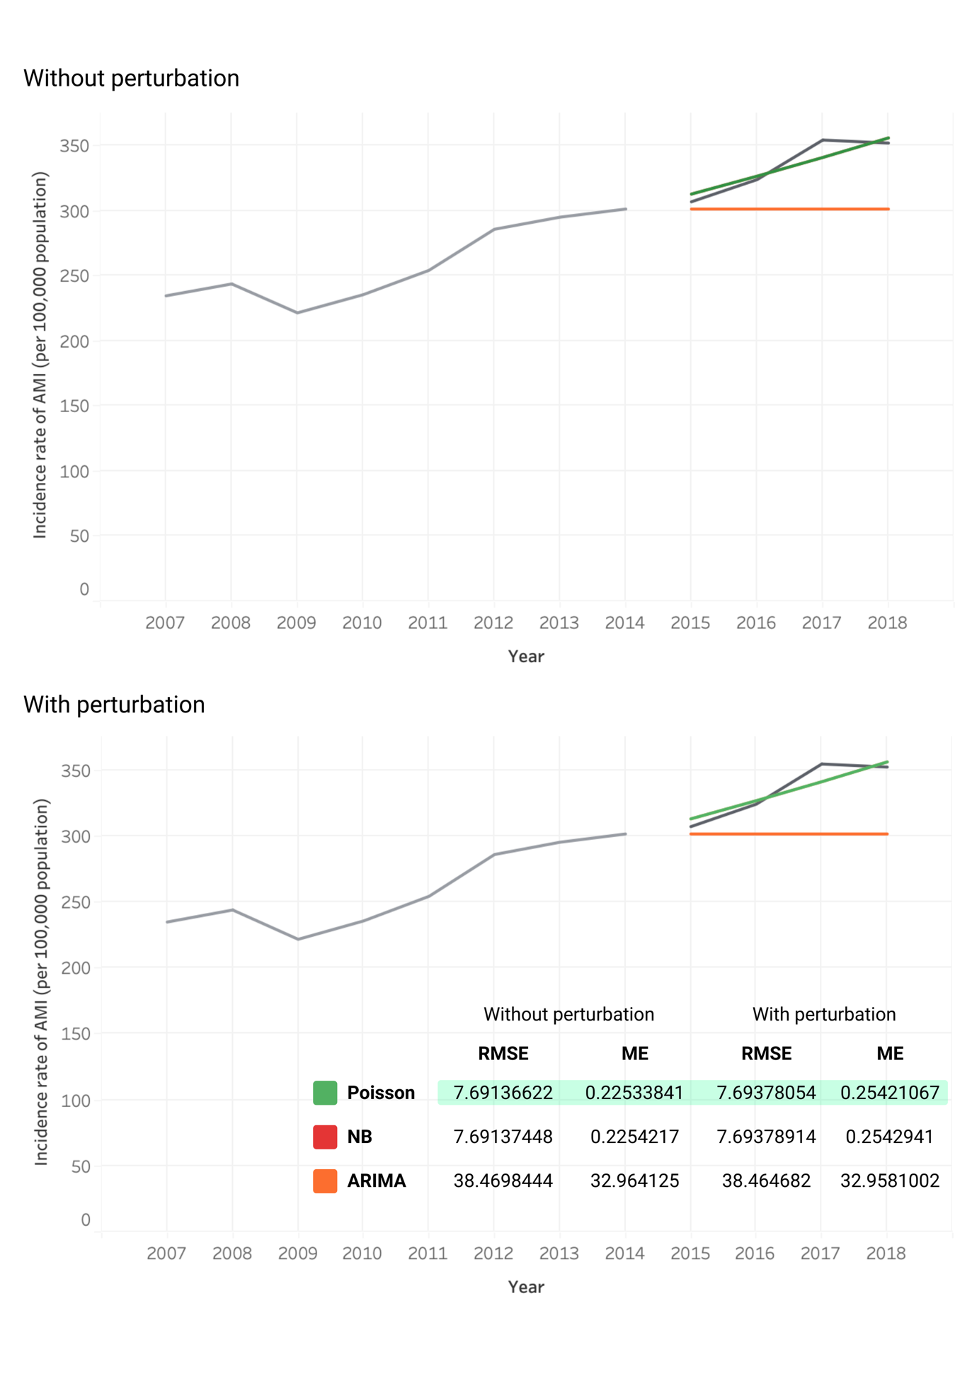
This figure demonstrates the performance of the Poisson regression model compared to the ARIMA (0,1,0) model and Negative Binomial model, all of which are widely used as time series forecast models for the SMIR data. The ARIMA (p,d,q) model parameters were determined by conducting differencing followed by the Augmented Dickey-Fuller test to check for stationarity, and using the partial auto correlation function (PACF) to determine the p value and the auto correlation function (ACF) to determine the q value. Internal validation was conducted using 2007 to 2014 data as the training set to project 2015 to 2018 data, which was then compared to actual incidence data from SMIR over this period. Additionally, small random perturbations were introduced into the 2007 to 2014 training dataset by adding random variations, each drawn from a uniform distribution within ±5% of each data point, to simulate uncertainty and variability in the data. The models were then re-fitted and used to forecast the incidence rates to 2018. Both the original and perturbed forecasts were compared against actual values, and model accuracy was evaluated using the root-mean-squared error (RMSE) and mean error (bias), calculated as the average of the difference between the actual data and forecasted values.
In the assessment of forecast model performance, the RMSE and mean error of the Poisson regression model were lower than those of the ARIMA and Negative Binomial models, both with and without perturbation, indicating that the Poisson regression model exhibited superior accuracy, lower bias, and reasonable robustness.

Supplementary Table 1: Comparison of AMI mortality compound annual growth rate between actual historical trends from 2007 to 2018, COVID-free projection from 2025 to 2040, and post-COVID projection from 2025 to 2040

 | 2007 to 2018  historical CAGR (%) | 2025-2040 COVID-free  projection CAGR (%) | 2025-2040 post-COVID  projection CAGR (%)
Overall Mortality | -1.6 | -2.3 | -0.9

Abbreviations: AMI – acute myocardial infarction, COVID – coronavirus disease
* Compound annual growth rate (CAGR) calculated using formula: $CAGR=\left({\left(\frac{EV}{BV}\right)}^{\frac{1}{n}}-1\right)×100$ where EV=ending value, BV=beginning value and n=number of years.

Supplementary Table 2: Excess mortality rate in 2020 and 2021 comparing COVID-free projections against actual mortality data; excess mortality rate in 2025 and 2040 comparing COVID-free and post-COVID projections
2020
 | COVID-free  projection MR | Actual MR | Estimated  excess MR | % Excess MR | Estimated excess deaths
Overall | 23.5 [22.2, 24.7] | 30.0 [28.2, 31.8] | 6.5 [4.3, 8.8] | 21.8 [21.4, 22.1] | 226
Male | 27.7 [26.5, 29.0] | 37.1 [34.2, 40.0] | 9.4 [6.2, 12.5] | 25.2 [24.9, 25.9] | 157
Female | 19.4 [18.1, 20.7] | 23.3 [21.0, 25.5] | 3.9 [1.3, 6.4] | 16.6 [15.9, 17.2] | 69
Age 15-39 years | 0.4 [-0.9, 1.6] | 0.2 [0, 0.5] | -0.2 [-1.4, 1.1] | -62.2 [-71.3, -53.2] | -2
Age 40-64 years | 11.6 [10.4, 12.9] | 13.2 [11.4, 15.1] | 1.6 [-0.6, 3.8] | 11.9 [10.5, 13.3] | 23.4
Age ≥65 years | 103.1 [101.8, 104.4] | 135.9 [126.7, 145.1] | 32.8 [23.5, 42.2] | 24.2 [23.9, 24.5] | 202
STEMI | 6.7 [5.3, 8.0] | 8.6 [7.6, 9.5] | 1.9 [0.3, 3.6] | 22.2 [21.4, 23.1] | 66
NSTEMI | 9.0 [7.7, 10.2] | 11.5 [10.4, 12.6] | 2.5 [0.9, 4.2] | 22.0 [21.3, 22.6] | 87
Diabetes mellitus | 10.5 [9.2, 11.8] | 12.0 [10.9, 13.2] | 1.5 [-0.2, 3.3] | 13.1 [12.0, 14.2] | 54
Hypertension | 15.8 [14.5, 17.2] | 19.1 [17.6, 20.6] | 3.3 [1.3, 5.2] | 17.0 [16.4, 17.6] | 112
Hyperlipidaemia | 13.8 [12.5, 15.2] | 16.8 [15.4, 18.2] | 3.0 [1.1, 4.9] | 17.7 [17.0, 18.3] | 103
Smoking | 6.2 [5.0, 7.5] | 6.6 [5.7, 7.5] | 0.4 [-1.2, 1.9] | 5.7 [1.7, 9.8] | 13
Overweight/Obesity | 9.3 [7.8, 10.9] | 7.5 [6.6, 8.4] | -1.8 [-3.6, 0] | -24.5 [-25.6, -23.6] | -64
2021
 | COVID-free  projection MR | Actual MR | Estimated  excess MR | % Excess MR | Estimated excess deaths
Overall | 23.2 [22, 24.8] | 29.3 [27.5, 31.1] | 6.1 [3.8, 8.4] | 20.8 [20.4, 21.2] | 208
Male | 27.3 [26.3, 29.1] | 35.3 [32.4, 38.1] | 8.0 [4.8, 11.1] | 22.5 [22.1, 22.9] | 132
Female | 19.3 [18.0, 20.8] | 23.7 [21.4, 26.0] | 4.4 [1.7, 7.0] | 18.4 [17.8, 19.0] | 76
Age 15-39 years | 0.4 [-1.0, 1.7] | 0.5 [0.1, 0.8] | 0.1 [-1.3, 1.5] | 23.4 [10.6, 36.3] | 1
Age 40-64 years | 11.5 [10.3, 13] | 12.4 [10.6, 14.2] | 0.9 [-1.3, 3.2] | 7.5 [5.1, 9.9] | 14
Age ≥65 years | 97.4 [101.6, 104.5] | 127.2 [118.5, 136] | 29.8 [21.0, 38.7] | 23.4 [23.1, 23.7] | 190
STEMI | 6.7 [5.2, 8.1] | 8.3 [7.3, 9.2] | 1.6 [-0.2, 3.3] | 19.0 [17.9, 20.1] | 54
NSTEMI | 8.8 [7.6, 10.3] | 10.8 [9.7, 11.9] | 2.0 [0.2, 3.7] | 18.4 [17.5, 19.3] | 68
Diabetes mellitus | 10.4 [9.0, 11.9] | 12.0 [10.9, 13.2] | 1.6 [-0.3, 3.4] | 13.2 [12.0, 14.4] | 54
Hypertension | 15.8 [14.4, 17.3] | 17.5 [16.1, 18.9] | 1.7 [-0.3, 3.7] | 9.6 [8.4, 10.8] | 57
Hyperlipidaemia | 14.0 [12.4, 15.3] | 16.0 [14.7, 17.4] | 2.0 [0.1, 4.1] | 13.0 [12.0, 14.0] | 71
Smoking | 6.1 [4.8, 7.6] | 6.0 [5.2, 6.9] | -0.1 [-1.7, 1.5] | -1.5 [-19.3, 16.3] | -3
Overweight/Obesity | 9.7 [7.6, 11.1] | 7.7 [6.8, 8.6] | -2.0 [-4.1, 0] | -26.7 [-27.6, -25.7] | -70
2025
 | COVID-free  projection MR | Post-COVID  projection MR | Estimated  excess MR | % Excess MR | Difference  in deaths
Overall | 19.6 [17.8, 21.5] | 24.0 [23.9, 24.1] | 4.4 [2.5, 6.3] | 18.2 [-3.6, 3.3] | 161
Male | 23.0 [21.2, 24.9] | 28.6 [28.5, 28.6] | 5.6 [3.7, 7.4] | 19.4 [19.1, 19.7] | 98
Female | 16.5 [14.6, 18.4] | 19.8 [19.7, 19.8] | 3.3 [1.3, 5.2] | 16.5 [15.9, 17.1] | 62
Age 15-39 years | 0.3 [-1.5, 2.0] | 0.3 [-0.4, 0.9] | 0 [-1.9, 1.8] | 0 [-104.6, 89.5] | 0
Age 40-64 years | 8.9 [7.2, 10.6] | 9.7 [9.6, 9.8] | 0.8 [-0.9, 2.6] | 8.6 [6.6, 10.7] | 13
Age ≥65 years | 72.0 [70.1, 73.9] | 90.8 [90.7, 90.9] | 18.8 [16.8, 20.7] | 20.7 [20.6, 20.8] | 152
STEMI | 6.0 [4.0, 8.1] | 7.4 [7.3, 7.5] | 1.4 [-0.7, 3.4] | 18.4 [16.9, 19.9] | 50
NSTEMI | 7.0 [5.3, 8.8] | 8.1 [8.1, 8.2] | 1.1 [-0.7, 2.8] | 13.4 [11.8, 15] | 40
Diabetes mellitus | 9.1 [7.1, 11.0] | 10.0 [9.9, 10.1] | 0.9 [-1.0, 2.9] | 9.4 [7.3, 11.5] | 35
Hypertension | 13.9 [11.9, 15.9] | 15.4 [15.3, 15.5] | 1.5 [-0.4, 3.5] | 10.1 [8.9, 11.4] | 58
Hyperlipidaemia | 12.7 [10.6, 14.8] | 14.3 [14.2, 14.4] | 1.6 [-0.5, 3.7] | 11.2 [10.0, 12.5] | 59
Smoking | 5.1 [3.3, 6.9] | 5.1 [5.0, 5.2] | 0 [-1.8, 1.9] | 0 [-50.5, 51.9] | 0
Overweight/Obesity | 8.5 [5.0, 11.9] | 8.3 [8.2, 8.5] | -0.2 [-3.6, 3.3] | -1.48 [-29.5, 26.6] | -5
2040
 | COVID-free  projection MR | Post-COVID  projection MR | Estimated  excess MR | % Excess MR | Difference  in deaths
Overall | 11.7 [8.3, 15.1] | 17.6 [17.5, 17.8] | 5.9 [5.9, 6.1] | 33.7 [33.7, 33.7] | 260
Male | 13.4 [10.1, 16.7] | 20.9 [20.7, 21.0] | 7.5 [7.3, 7.6] | 35.8 [35.8, 35.8] | 156
Female | 10.2 [6.7, 13.7] | 14.7 [14.6, 14.9] | 4.5 [4.4, 4.7] | 31.0 [31.0, 31.0] | 104
Age 15-39 years | 0.1 [-3.2, 3.4] | 0.1 [-1.5, 1.7] | 0 [-1.6, 1.6] | -15.4 [-77.3, 56.8] | 0
Age 40-64 years | 4.2 [1.5, 6.8] | 5.0 [4.8, 5.2] | 0.8 [0.6, 1.0] | 16.8 [16.5, 17.0] | 16
Age ≥65 years | 23.9 [20.3, 27.5] | 38.5 [38.4, 38.6] | 14.6 [14.5, 14.7] | 38.0 [37.9, 38.0] | 276
STEMI | 4.5 [0.4, 8.6] | 6.8 [6.6, 7] | 2.3 [2.1, 2.5] | 34.3 [34.2, 34.3] | 102
NSTEMI | 3.4 [0.6, 6.3] | 4.6 [4.5, 4.8] | 1.2 [1.0, 1.3] | 25.6 [25.5, 25.7] | 52
Diabetes mellitus | 6.0 [2.3, 9.7] | 7.4 [7.2, 7.6] | 1.4 [1.2, 1.5] | 18.5 [18.4, 18.6] | 60
Hypertension | 9.4 [5.7, 13.2] | 11.8 [11.6, 11.9] | 2.4 [2.2, 2.5] | 19.8 [19.7, 19.8] | 102
Hyperlipidaemia | 9.9 [5.6, 14.2] | 12.7 [12.6, 12.8] | 2.8 [2.6, 2.9] | 21.9 [21.9, 22.0] | 121
Smoking | 2.8 [-0.4, 6.0] | 2.9 [2.7, 3.1] | 0.1 [-0.2, 0.2] | 1.44 [-3.4, 6.2] | 2
Overweight/Obesity | 8.3 [3.5, 13.1] | 9.9 [9.6, 10.1] | 1.6 [1.3, 1.8] | 15.9 [15.7, 16.0] | 58

Abbreviations: AMI – acute myocardial infarction, COVID – coronavirus disease, MR – mortality rate, NSTEMI – non-ST elevation myocardial infarction, STEMI – ST-elevation myocardial infarction
* Compound annual growth rate (CAGR) calculated using formula: $CAGR=\left({\left(\frac{EV}{BV}\right)}^{\frac{1}{n}}-1\right)×100$ where EV=ending value, BV=beginning value and n=number of years.

Supplementary Table 3: COVID-free and post-COVID projected crude mortality of acute myocardial infarction from 2025 to 2040, stratified by sex, age groups, AMI type, and risk factors.

 | 2025 | 2030 | 2035 | 2040 | CAGR (%)*
Post-COVID
Overall | 883 [844, 923] | 844 [793, 899] | 807 [744, 875] | 772 [698, 852] | -0.9
Male | 508 [479, 539] | 482 [444, 524] | 458 [412, 510] | 435 [382, 496] | -1.0
Female | 375 [350, 402] | 362 [328, 399] | 349 [308, 396] | 337 [289, 393] | -0.7
Age 15-39 years | 3 [2, 6] | 2 [1, 6] | 2 [1, 5] | 1 [0, 5] | -6.1
Age 40-64 years | 156 [141, 172] | 131 [115, 150] | 110 [93, 131] | 93 [75, 115] | -3.4
Age ≥65 years | 733 [697, 772] | 731 [681, 785] | 729 [664, 799] | 727 [648, 814] | -0.1
STEMI | 271 [249, 296] | 280 [248, 316] | 289 [247, 338] | 299 [246, 362] | 0.6
NSTEMI | 299 [299, 278] | 263 [263, 238] | 231 [231, 203] | 202 [202, 173] | -2.6
Diabetes mellitus | 369 [369, 344] | 353 [353, 320] | 338 [338, 298] | 323 [323, 277] | -0.9
Hypertension | 568 [568, 536] | 549 [549, 507] | 531 [531, 479] | 514 [514, 453] | -0.7
Hyperlipidaemia | 526 [494, 559] | 535 [491, 583] | 545 [487, 609] | 554 [483, 636] | 0.4
Smoking | 189 [172, 207] | 165 [145, 187] | 144 [123, 169] | 126 [103, 154] | -2.7
Overweight/Obesity | 306 [256, 256] | 329 [265, 395] | 348 [270, 427] | 363 [273, 453] | 1.1
COVID-free
Overall | 722 [673, 774] | 644 [584, 708] | 574 [507, 647] | 512 [440, 592] | -2.3
Male | 409 [374, 449] | 360 [318, 409] | 317 [271, 372] | 279 [271, 372] | -2.5
Female | 313 [281, 349] | 283 [244, 329] | 257 [213, 310] | 232 [185, 292] | -2.0
Age 15-39 years | 4 [2, 8] | 3 [1, 8] | 2 [1, 8] | 2 [0, 8] | -5.6
Age 40-64 years | 142 [123, 164] | 116 [96, 141] | 95 [74, 122] | 77 [57, 105] | -4.0
Age ≥65 years | 582 [537, 630] | 534 [478, 597] | 491 [426, 565] | 451 [380, 535] | -1.7
STEMI | 221 [193, 254] | 213 [176, 257] | 204 [161, 260] | 196 [147, 263] | -0.8
NSTEMI | 259 [232, 289] | 216 [186, 251] | 180 [149, 218] | 151 [120, 189] | -3.6
Diabetes mellitus | 334 [300, 372] | 309 [267, 357] | 285 [237, 343] | 263 [210, 330] | -1.6
Hypertension | 510 [467, 556] | 475 [421, 535] | 442 [380, 515] | 412 [342, 496] | -1.4
Hyperlipidaemia | 466 [424, 513] | 455 [399, 519] | 444 [375, 525] | 433 [353, 531] | -0.5
Smoking | 187 [164, 214] | 163 [136, 196] | 142 [113, 180] | 124 [94, 165] | -2.7
Overweight/Obesity | 310 [250, 371] | 317 [245, 389] | 314 [236, 393] | 305 [222, 389] | -0.1

Abbreviations: AMI – acute myocardial infarction, COVID – coronavirus disease, NSTEMI – non-ST elevation myocardial infarction, STEMI – ST-elevation myocardial infarction
* Compound annual growth rate (CAGR) calculated using formula: $CAGR=\left({\left(\frac{EV}{BV}\right)}^{\frac{1}{n}}-1\right)×100$ where EV=ending value, BV=beginning value and n=number of years.

Supplementary Table 4: Proportion of projected crude mortality of acute myocardial infarction from 2025 to 2040 in subgroups out of total AMI, stratified by sex, age groups, AMI type, and risk factors.

 | 2025 | 2030 | 2035 | 2040 | CAGR (%)*
Post-COVID
Male | 57.5 | 57.2 | 56.8 | 56.4 | -0.1
Female | 42.5 | 42.8 | 43.2 | 43.6 | 0.2
Age 15-39 years | 0.4 | 0.3 | 0.2 | 0.2 | -5.5
Age 40-64 years | 17.5 | 15.2 | 13.1 | 11.3 | -2.8
Age ≥65 years | 82.2 | 84.5 | 86.7 | 88.5 | 0.5
STEMI | 47.5 | 51.6 | 55.6 | 59.6 | 1.5
NSTEMI | 52.5 | 48.4 | 44.4 | 40.4 | -1.7
Diabetes mellitus | 41.8 | 41.8 | 41.8 | 41.8 | 0.0
Hypertension | 64.3 | 65.0 | 65.8 | 66.5 | 0.2
Hyperlipidaemia | 59.5 | 63.4 | 67.5 | 71.8 | 1.3
Smoking | 21.4 | 19.5 | 17.9 | 16.3 | -1.8
Overweight/Obesity | 34.7 | 39.1 | 43.2 | 47.1 | 2.1
COVID-free
Male | 56.7 | 56.0 | 55.3 | 54.6 | -0.3
Female | 43.3 | 44.0 | 44.7 | 45.4 | 0.3
Age 15-39 years | 0.5 | 0.4 | 0.3 | 0.3 | -3.6
Age 40-64 years | 19.6 | 17.8 | 16.1 | 14.6 | -1.9
Age ≥65 years | 79.9 | 81.8 | 83.5 | 85.1 | 0.4
STEMI | 46.1 | 49.6 | 53.1 | 56.6 | 1.4
NSTEMI | 53.9 | 50.4 | 46.9 | 43.4 | -1.4
Diabetes mellitus | 46.2 | 47.9 | 49.7 | 51.4 | 0.7
Hypertension | 70.6 | 73.8 | 77.1 | 80.5 | 0.9
Hyperlipidaemia | 64.6 | 70.7 | 77.3 | 84.6 | 1.8
Smoking | 25.9 | 25.4 | 24.8 | 24.3 | -0.4
Overweight/Obesity | 43.0 | 49.3 | 54.9 | 59.9 | 2.2

Abbreviations: AMI – acute myocardial infarction, COVID – coronavirus disease, NSTEMI – non-ST elevation myocardial infarction, STEMI – ST-elevation myocardial infarction
* Compound annual growth rate (CAGR) calculated using formula: $CAGR=\left({\left(\frac{EV}{BV}\right)}^{\frac{1}{n}}-1\right)×100$ where EV=ending value, BV=beginning value and n=number of years.

Supplementary Figure 1: Proportion of projected mortality of acute myocardial infarction from 2025 to 2040, stratified by sex.

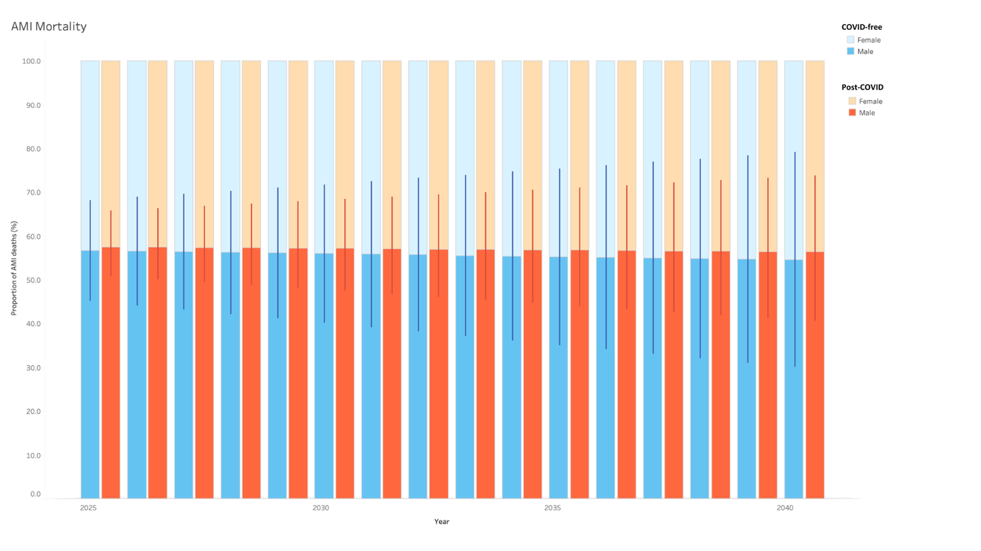

Abbreviations: AMI – acute myocardial infarction, COVID – coronavirus disease

Supplementary Figure 2: Proportion of projected mortality of acute myocardial infarction from 2025 to 2040, stratified by age groups.

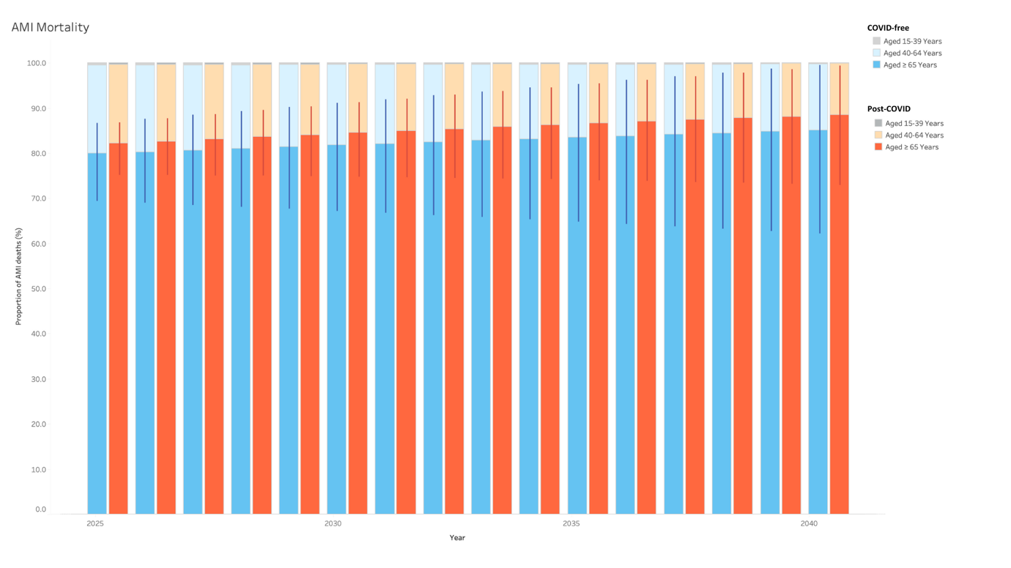

Abbreviations: AMI – acute myocardial infarction, COVID – coronavirus disease

Supplementary Figure 3: Proportion of projected mortality of acute myocardial infarction from 2025 to 2040, stratified by AMI type.

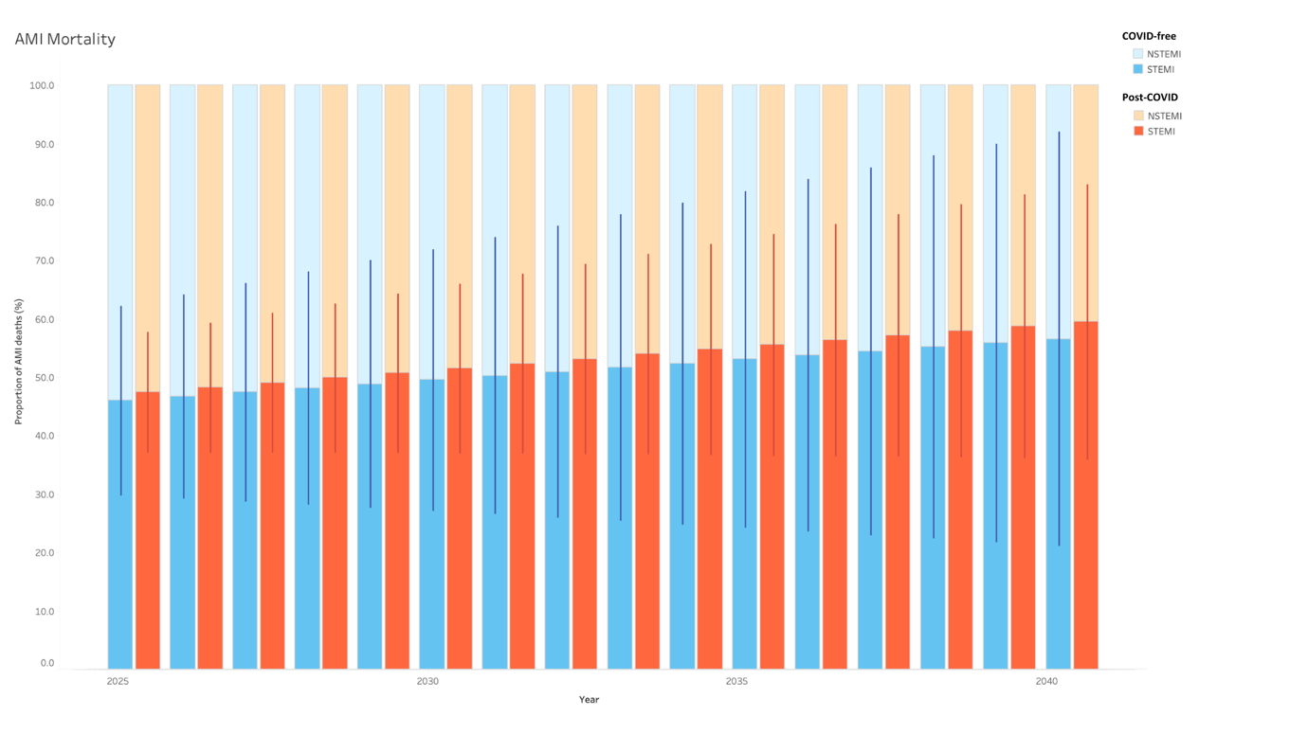

Abbreviations: AMI – acute myocardial infarction, COVID – coronavirus disease, STEMI – ST-elevation myocardial infarction, NSTEMI – non-ST elevation myocardial infarction

Supplementary Figure 4: Proportion of projected mortality of acute myocardial infarction from 2025 to 2040, stratified by presence/ absence of diabetes mellitus.

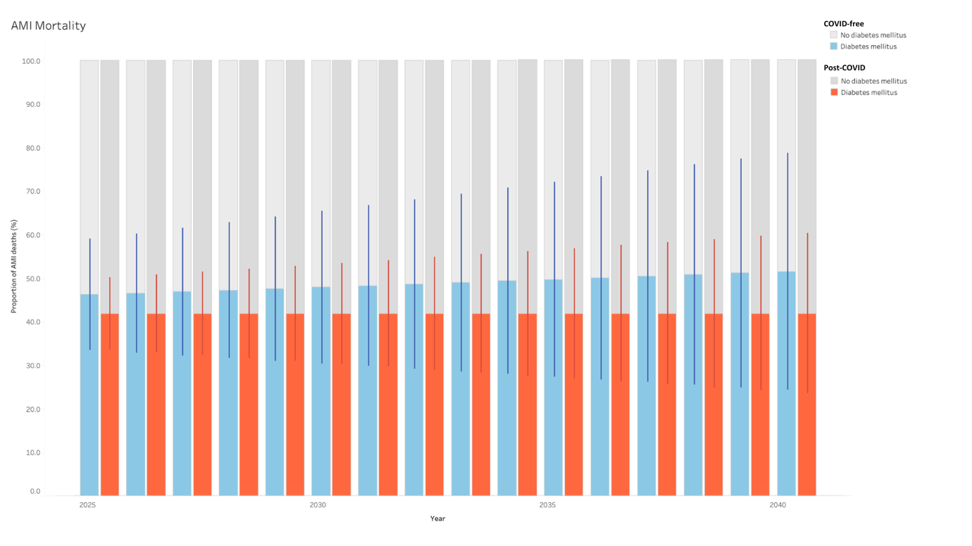

Abbreviations: AMI – acute myocardial infarction, COVID – coronavirus disease

Supplementary Figure 5: Proportion of projected mortality of acute myocardial infarction from 2025 to 2040, stratified by presence/ absence of hypertension.

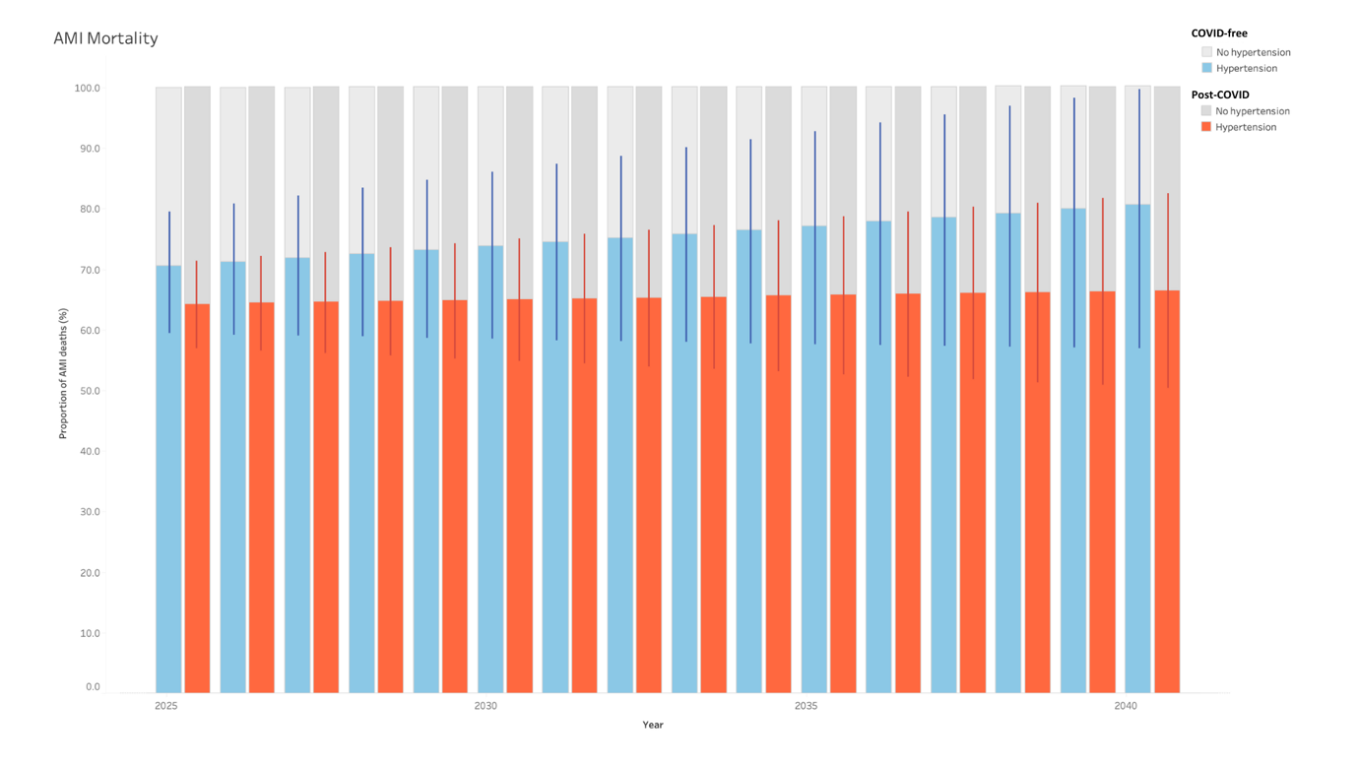

Abbreviations: AMI – acute myocardial infarction, COVID – coronavirus disease

Supplementary Figure 6: Proportion of projected mortality of acute myocardial infarction from 2025 to 2040, stratified by presence/ absence of hyperlipidaemia.

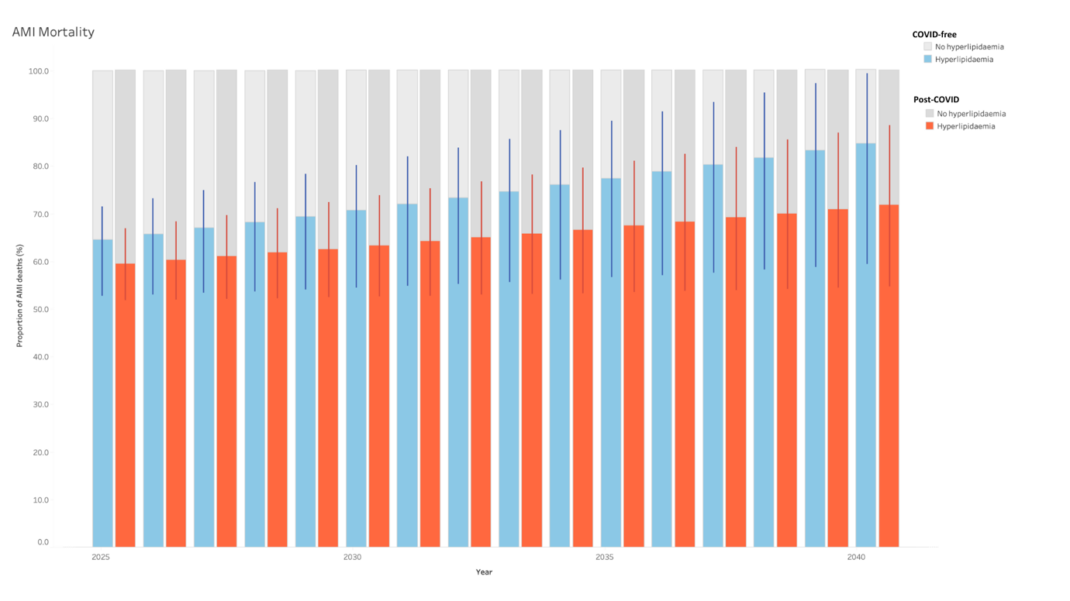

Abbreviations: AMI – acute myocardial infarction, COVID – coronavirus disease

Supplementary Figure 7: Proportion of projected mortality of acute myocardial infarction from 2025 to 2040, stratified by presence/ absence of smoking.

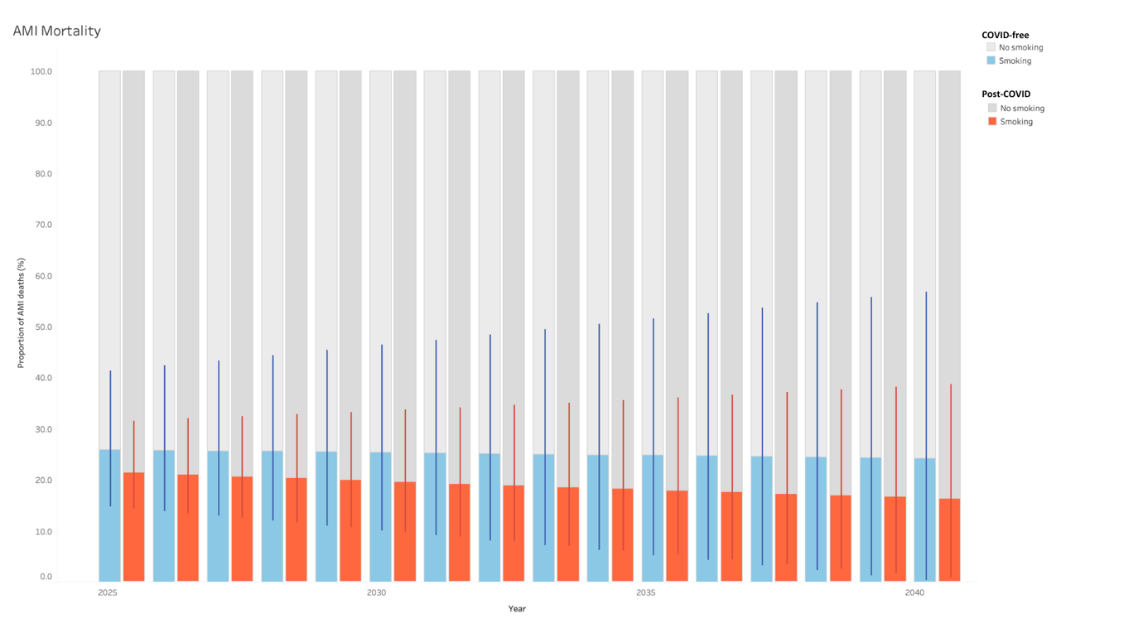

Abbreviations: AMI – acute myocardial infarction, COVID – coronavirus disease

Supplementary Figure 8: Proportion of projected mortality of acute myocardial infarction from 2025 to 2040, stratified by presence/ absence of overweight/obesity.

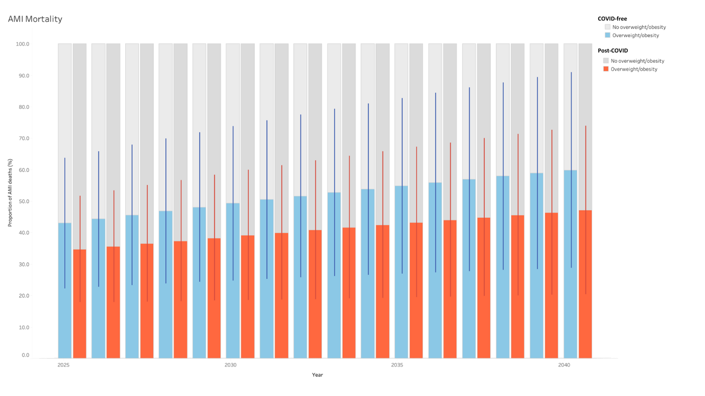

Abbreviations: AMI – acute myocardial infarction, COVID – coronavirus disease

