SUPPLEMENTARY FIGURES
FIGURE S1. Brain maps of W-scores associated with deep brain regions and regional weights of the significant latent variables of the PLS.
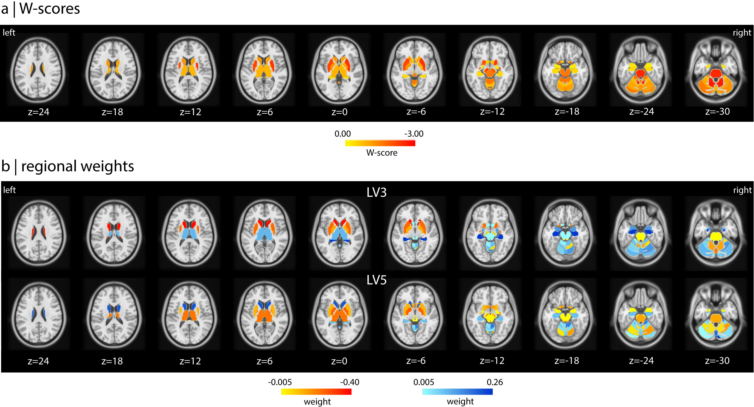

Brain maps of W-scores associated with deep brain regions in MSA patients (a) and spatial distribution of the regional weights associated with LV3 and LV5 (b). Coordinates along the z axis in the Montreal Neurological Institute (MNI) template are given for each slice level.
Abbreviations: LV, latent variable; PLS, partial least squares.

Figure S2: Specificity analysis: comparison with PD

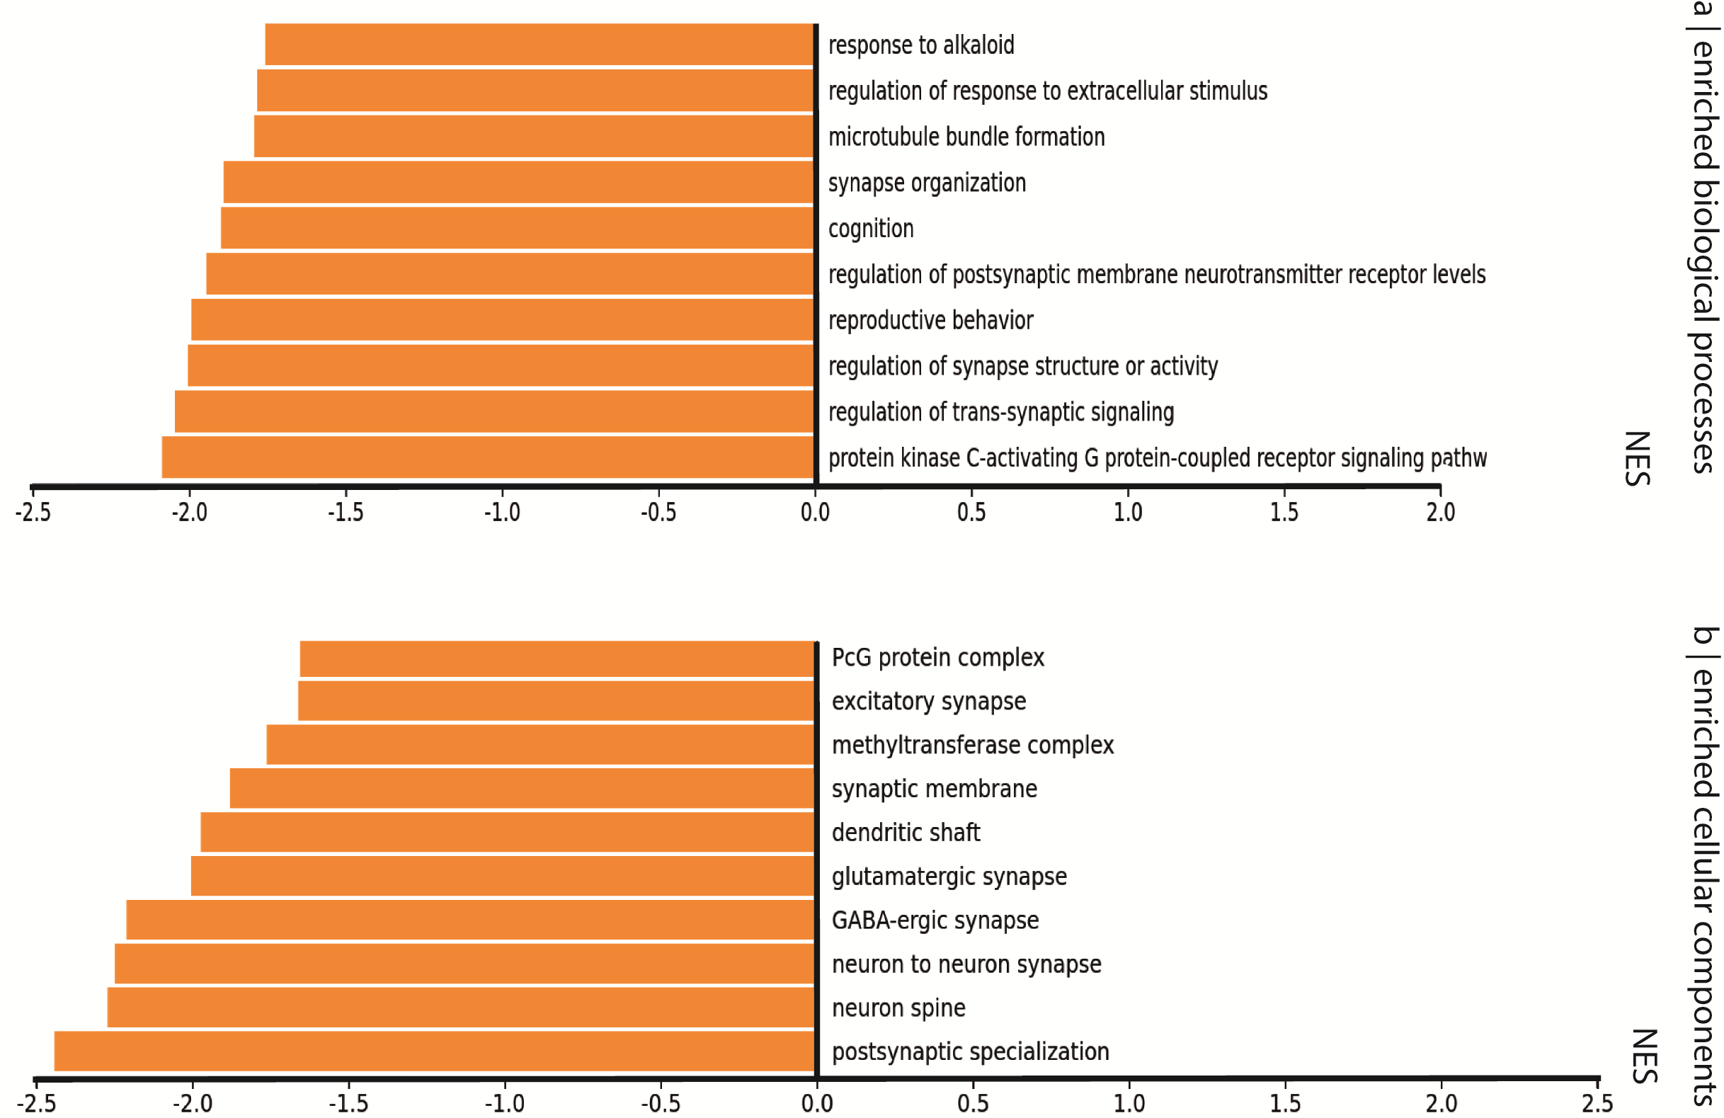

To test whether our gene enrichment findings in MSA were disease-specific, we replicated the same analysis on a sample of 57 patients with PD and 57 age- and sex-matched healthy controls recruited through the Quebec Parkinson Network (QPN), and scanned on a 3T Siemens PRISMA machine at the Montreal Neurological Institute-MNI, Montreal.²⁴ These participants were age- and sex-matched with MSA patients. Each participant’s T1-weighted image was segmented using the same image processing pipeline than described previously. A W-scoring approach was applied to the extracted values to remove the effects of age and sex using data from the control group. There was no significant deep brain atrophy in PD patients compared to controls (P>0.05).
PLS regression was performed between the two matrices: a matrix X of atrophy (57 patients by 50 regions) and a matrix Y of regional gene expression (15,611 genes by 50 regions). Of the 5 gene expression latent variables returned, two showed significance and explained 12.4% (LV4) and 7.6% (LV5) of the covariance in atrophy against random (LV4: P=0.06; LV5: P=0.02) and spatial null models (LV3: P=0.04; LV5: P=0.01). For both variables, regions with lower W-scores (more atrophy) had lower weights (LV4: r=0.35, P=0.01; LV5: r=0.28, P=0.05).
In terms of biological processes, regions associated with negatively-weighted genes in MSA were enriched for processes related to synaptic functions including protein kinase C-activating G protein-coupled receptor signaling pathway, regulation of transynaptic signaling, regulation of synapse structure or activity, regulation of postsynaptic membrane neurotransmitter receptor levels, and synapse organization. In terms of cellular components, we also found terms related to synapses, such as postsynaptic specialization, neuron spine, neuron-to-neuron synapse, GABA-ergic synapse. There was no significant enrichment of cell types, including oligodendrocytes.
Abbreviations: NES, normalized enrichment score.

FIGURE S3. Neurotransmitter mapping

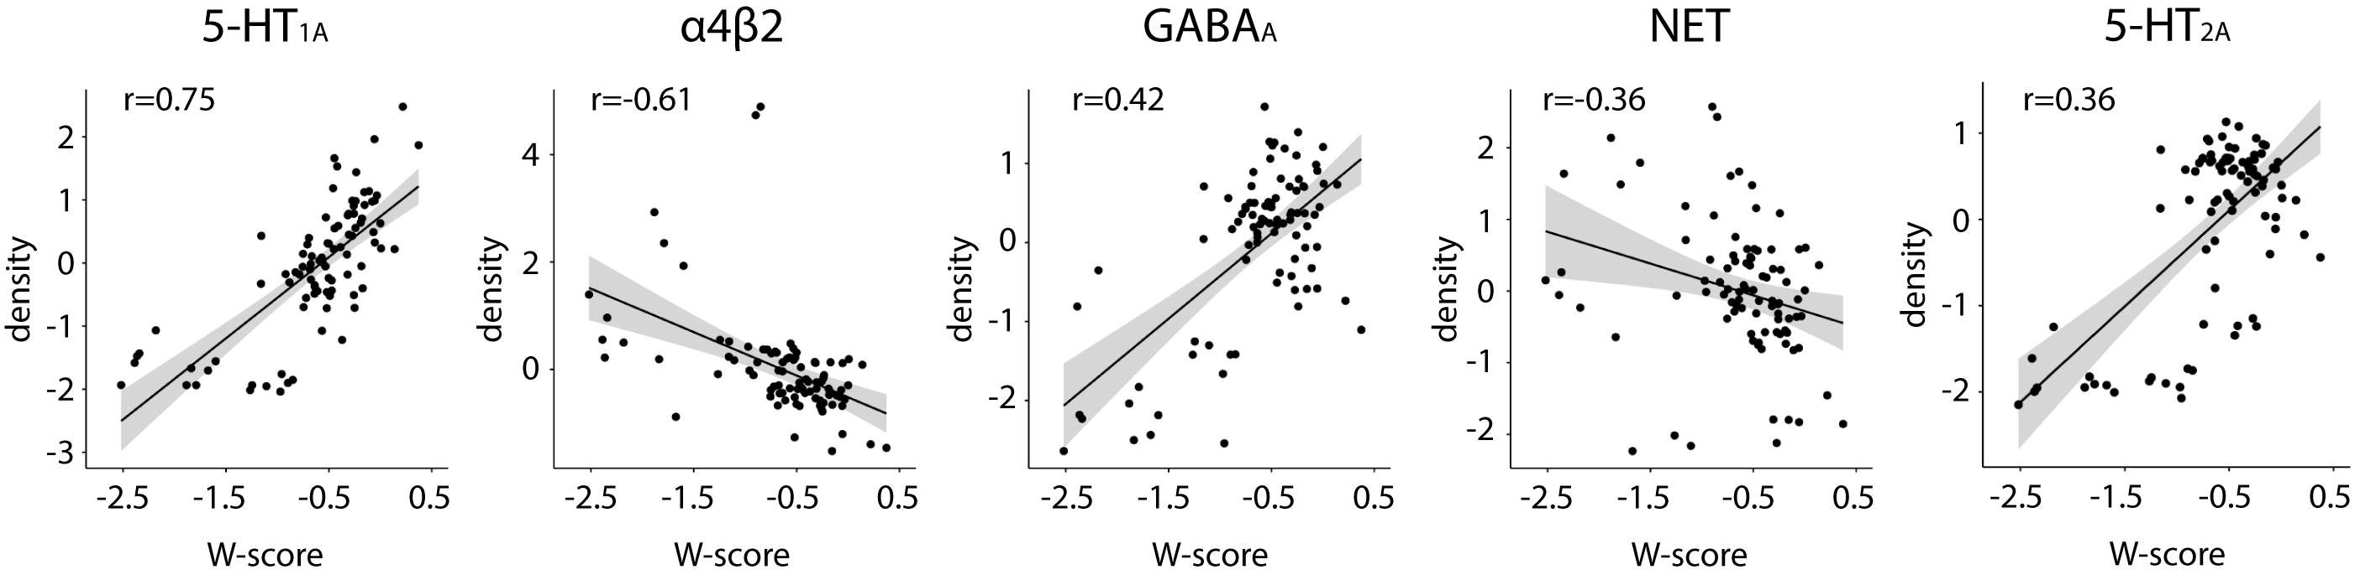

Scatterplots with linear regression lines between regional W-scores and density values of receptors in cortical and deep brain regions. Only significant correlations are plotted. A correlation was considered significant when the P value was below the Bonferroni-corrected threshold of P<0.003.
Abbreviations: FDR, false discovery rate

