Telephone Log Day 2 of the diet
Well-being in the last two days?
Please state a number between 1 and 10, 1 representing a very bad and 10 an excellent well-being.

______

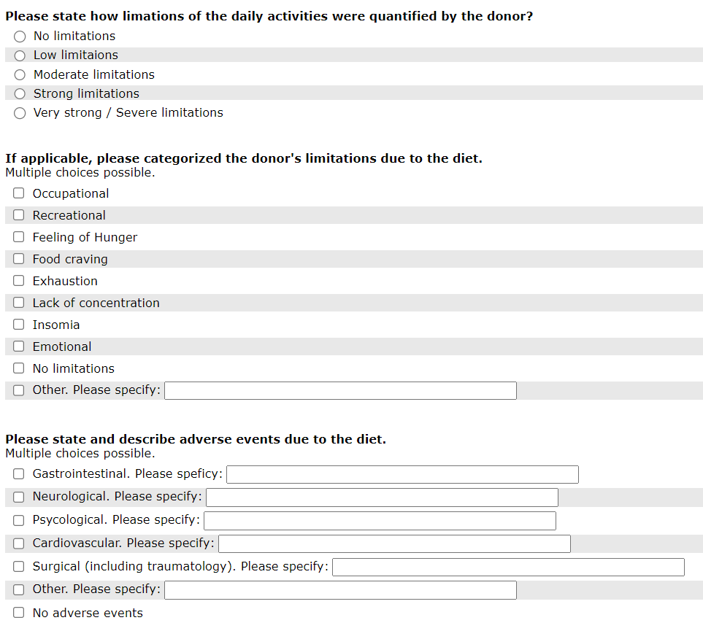

Telephone Log Day 4 of the diet
Well-being in the last two days?
Please state a number between 1 and 10, 1 representing a very bad and 10 an excellent well-being.

______

Telephone Log Day 6 of the diet
Well-being in the last two days?
Please state a number between 1 and 10, 1 representing a very bad and 10 an excellent well-being.

______

