

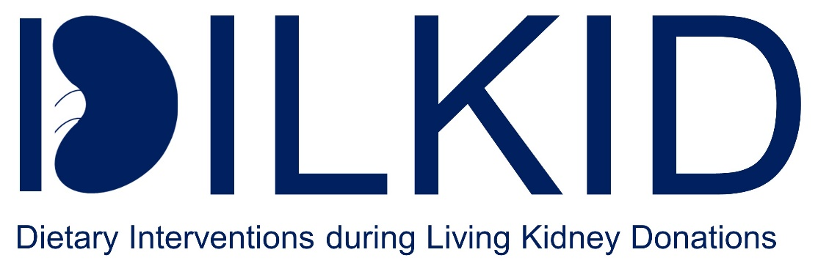

Diet diary
Control group

from

Name:___________________________

Study ID:_______________________
Dear study participant,

This diary is intended to support you in the seven days, when you adhering to your diet prior your kidney donation. You are randomized to a balanced control diet. To ensure consistency to the other diets, you will be given a special formula diet. Thus, you must mix the provided powder with water to create a formula diet that replace your meals.

Please remember, that during the diet you should only consume drinks such as water, tea and coffee - without added milk or sugar. Please do NOT consume calorie-containing drinks such as milk, soft drinks (Coca-Cola, Fanta, Sprite etc.) or juices. Please also DO NOT consume drinks with sweeteners (Coca-Cola Light, Coca-Cola Zero, Sprite Zero etc.)

To record the possible effects of the diet, it is important that you follow our guidelines as closely as possible!

We know that changing your lifestyle and diet requires a certain amount of effort. Perhaps, the prospect of doing something not only for your body and health, but also potentially increasing your safety during the upcoming operation, will help motivate you. Furthermore, this diet may protect the donated kidney and improve its function in the recipient.

In addition, you should always record at the end of a diet day whether you felt good or bad during the day. We also ask you to enter every day, whether you felt hungry during the diet, and whether you are limited in your everyday life.

We will contact you by telephone during your diet to help and answer any questions you may have. We will call you on days 2, 4 and 6 in response to the first day of your diet. If you have any questions or complaints, you can call the study centre on 0221 478 97222 daily between 8:00 and 17:00.

If, for any reason, you are unable to adhere to the diet and consume additional foods or beverages besides those provided by us, please ensure you record these, along with the accompanying foods, on the corresponding date and time on the provided page. The quantities should be as precise as possible (e.g. 200 ml of milk, one slice of wholemeal bread).

This is the only way we can properly evaluate the results of this study.

You will be admitted to the transplant surgery ward at the University Hospital of Cologne on day 6 of your preoperative diet. Please take the sample containers of drinking powder with you to the ward to meet your nutritional needs.

In order to determine the possible effectiveness of the diet tested in this study in protecting the body and the donated kidneys and to achieve a high degree of standardization in the DILKID study, we would like to ask you once again to adhere as strictly as possible to the prescribed diet plan. Only with your help can we meaningfully evaluate the results of the DILKID study.

Thank you for your cooperation!
Control diet – Day 1:

Date: _________________________

Dear study participant,

We kindly remind you that, to you follow the prescribed diet as closely as possible. This is essential for a proper evaluation of this study.

If you consume anything in addition to your diet (apart from water, tea or coffee without milk and sugar), please record it in the table below. This documentation is crucial for us to accurately interpret the results of the DILKID study.

After completing the first day of this diet, we kindly ask you to fill out the food diary questionnaire below, which should take approximately five minutes.

Diet diary – Day 1

How did you feel overall today? (Please mark your state of health with an X on the line).



Were you limited in your daily activities? (If applicable, please mark the extent of the limitations with an X on the line).

How strong was your feeling of hunger during the day? (Please mark your feeling of hunger today with an X on the line).

How satiating were the meals you consumed today? (Please mark the satiation level with an X in the line).

Ketone bodies in urine: ______

Ketone bodies blood (mmol/l): ______
Additional foods / foods that deviate from the diet plan consumed on day 1:

Time | Food | Amount of food

Control diet - Day 2

Six days to go until your living kidney donatio

Date: _________________________

We kindly remember your again that you are only allowed to consume your formula diet! Please only drink beverages such as water, tea or coffee (without milk and sugar)!

Diet diary – Day 2

You have made it through the second day of the diet! Congratulations!

How did you feel overall today? (Please mark your state of health with an X on the line).



Were you limited in your daily activities? (If applicable, please mark the extent of the limitations with an X on the line).
How strong was your feeling of hunger during the day? (Please mark your feeling of hunger today with an X on the line).

How satiating were the meals you consumed today? (Please mark the satiation level with an X in the line).

Ketone bodies in urine: ______

Ketone bodies blood (mmol/l): ______

Additional foods / foods that deviate from the diet plan consumed on day 2:

Time | Food | Amount of food

Control diet – Day 3

Five days before your living kidney donation

Date: _________________________

Dear participant,

We kindly remind you that, to you follow the prescribed diet as closely as possible. This is essential for a proper evaluation of this study.

If you do eat or drink something extra (apart from water, tea and coffee without milk and sugar), you must document these foods in the table below. This is the only way we can make a meaningful evaluation of this study.

Diet diary - Day 3:

Please complete this short questionnaire again at the end of the day and tell us how you feel today and how the diet is making you feel.

You have made it through the third day of the diet! Congratulations!

How did you feel overall today? (Please mark your state of health with an X on the line).

Were you limited in your daily activities? (If applicable, please mark the extent of the limitations with an X on the line).

How strong was your feeling of hunger during the day? (Please mark your feeling of hunger today with an X on the line).

How satiating were the meals you consumed today? (Please mark the satiation level with an X in the line).

Ketone bodies in urine: ______

Ketone bodies blood (mmol/l): ______

Additional foods / foods that deviate from the diet plan consumed on day 3:

Time | Food | Amount of food

Control diet – Day 4

Four days before your living kidney donation

Date _________________________

Well done- you’re almost halfway there!

Keep going! You might be doing the donated kidney a big favour!

If you eat or drink anything other than water, tea or coffee without milk or sugar, please document these beverages in the table opposite. This is essential for us to evaluate the clinical study.

Diet diary – Day 4

At the end of the day, as always, please tick this little questionnaire and report us, whether you felt good or bad today, and how the diet is going for you.

How did you feel overall today? (Please mark your state of health with an X on the line).

Were you limited in your daily activities? (If applicable, please mark the extent of the limitations with an X on the line).

How strong was your feeling of hunger during the day? (Please mark your feeling of hunger today with an X on the line).

How satiating were the meals you consumed today? (Please mark the satiation level with an X in the line).

Ketone bodies in urine: ______

Ketone bodies blood (mmol/l): ______

Additional foods / foods that deviate from the diet plan consumed on day 4:

Time | Food | Amount of food

Control diet – Day 5

Only three more days to go until surgery

Date _________________________

By now you are probably very experienced in following your diet. If you do eat or drink something extra (apart from water, tea and coffee without milk and sugar), you must document these foods in the table below. This is the only way we can make a meaningful evaluation of the clinical study.

Diet diary – Day 5

As always, please complete this short questionnaire at the end of the day to tell us how you felt today and how you are finding the diet.

How did you feel overall today? (Please mark your state of health with an X on the line).

Were you limited in your daily activities? (If applicable, please mark the extent of the limitations with an X on the line).

How strong was your feeling of hunger during the day? (Please mark your feeling of hunger today with an X on the line).

How satiating were the meals you consumed today? (Please mark the satiation level with an X in the line).

Ketone bodies in urine ______

Ketone bodies blood (mmol/l) ______

Additional foods / foods that deviate from the diet plan consumed on day 5:

Time | Food | Amount of food

Control diet – Day 6

Two more days before your living kidney donation

Date: _________________________

You will soon have completed the diet, and we hope that you will continue to follow our guidelines. Please remember to record any additional foods you have eaten in the table.

Diet diary – Day 6

Please answer the following questions today:

How did you feel overall today? (Please mark your state of health with an X on the line).

Were you limited in your daily activities? (If applicable, please mark the extent of the limitations with an X on the line).

How strong was your feeling of hunger during the day? (Please mark your feeling of hunger today with an X on the line).

How satiating were the meals you consumed today? (Please mark the satiation level with an X in the line).

Ketone bodies in urine: ______

Ketone bodies blood (mmol/l): ______

Additional foods / foods that deviate from the diet plan consumed on day 6:

Time | Food | Amount of food

Control diet – Day 7

The day before your living kidney donation!

Date: _________________________

Now you’ve almost finished the diet!
You only have one more day to go. Please come to our study centre for your appointment this afternoon.

Please bring this diary with you!

Today is the last day of your diet. Please make sure you only eat this diet today and avoid any other foods.

After your appointment, you will be admitted to the surgical department. You may undergo tests arranged by the surgeons, which are independent of this study.

We have informed the ward staff about this study ahead of the clinical trial.

However, if you are offered food by nurses, carers or doctors on the ward, explain that you are participating in the DILKID study and can only consume your study-related formula diet.

You will also be seen by an anaesthetist today in preparation for your operation tomorrow. They will inform you of the time, from which onwards you will not be allowed to eat or drink before the operation.

It is very important that you follow the anaesthetist's instructions exactly, to ensure that your safety and the success of the operation are not put at a risk.

Please also show your current medication list to your surgeon and anaesthetist.

If you have diabetes and your medication (e.g. insulin) has been changed as part of this study, please present this list as well.

We would also like to take this opportunity to thank you once again for participating in the DILKID study. We wish you all the best for tomorrow and a fast recovery!

Diet diary – Day 7:

As always, please complete this short questionnaire at the end of the day to tell us how you feel today and how the diet is going.

How did you feel overall today? (Please mark your state of health with an X on the line).

Were you limited in your daily activities? (If applicable, please mark the extent of the limitations with an X on the line).

How strong was your feeling of hunger during the day? (Please mark your feeling of hunger today with an X on the line).

How satiating were the meals you consumed today? (Please mark the satiation level with an X in the line).

Ketone bodies in urine: ______

Ketone bodies blood (mmol/l): ______

Additional foods/ foods that deviate from the diet consumed on day 7:

Date | Food | Amount of food

