Deterministically selected rare taxa drive changes in community composition in drinking water biological activated carbon Filters

Dominic Quinnª, Marta Vignolaª Jeanine Lenselinkª, Graeme Moore^{b}, Stephanie Connellyª, Caroline Gauchotte-Lindsayª, Umer Ijazª, William Sloanª, Cindy J. Smithª

a*University of Glasgow – James Watt School of Engineering, G12 8QQ, United Kingdom
b* Scottish Water, 6 Castle Drive, Dunfermline, KY11 8GG, United Kingdom

Supplementary materials and methods

S1 Biofilter construction

Each individual filter column was constructed from PE80 pipe and MDPE fittings. The main column length was cut from 32mm PE80 pipe. The length cut was the specified filter bed length (30cm, 60cm or 90cm) plus an additional 370mm. A 32mm MDPE pipe insert was wrapped in stainless steel mesh (aperture 75µm) and inserted to the end of the pipe. This end was fit to a 32mm x 25mm x 32mm MDPE reducing T. The other 32mm end of the reducing T was occupied by a 180mm length of PE80 pipe and 32mm MDPE terminal cap. The 25mm are of the reducing T was occupied by a 160mm length of PE80 pipe and 15mm to 25mm MDPE reducing stop cock. A 200mm length of 15mm BRAND® laboratory tubing and 15mm MDPE pipe insert was added to the stop cock. A 6mm-15mm reducer connected the 15mm tubing to 6mm hydrolysis resistant tubing and a 2mm – 5mm reducer connected this to 2mm PVC tubing. This tubing was connected to a Watson Marlow 300 series peristaltic pump with a 5 channel microcassette pump head. The filter columns were attached upright to a plywood frame with 32mm pipe clips. An 8mm hole was drilled 50mm down from the top of the filter column and 8mm hydrolysis resistant tubing was added as an overflow. 260g dry weight Cabot Norrit GAC 1240 W was added to a 1L glass bottle. The GAC was rinsed with 260ml Milli-Q water until the water became clear. Once clear the GAC and 260ml of Milli-Q water were sonicated for 10 minutes in an ultrasonic bath. The GAC was left to settle in water for 48 hours. The GAC was then added to the filter columns in small batches with Milli-Q water and pushed down until tightly packed. This continued until the filter bed was the desired length. The biofilters were then allowed to cycle with Milli-Q water for 2 weeks to ensure the GAC was fully settled. Influent water was collected from a Scottish Water surface reservoir, filtered on site through 10µm using a submersible pump. Approximately 500L was collected every 2 weeks and stored at room temperature. Influent was fed into the filter from a 20L jerrycan using a Watson Marlow 300 series peristaltic pump and 6mm hydrolysis resistant tubing until flowing freely from the overflow tubing. A single jerrycan of influent fed each set of triplicate reactors and was replaced at the start of each week. The peristaltic pump at the effluent end of the filter was set at a consistent flow rate of 1ml/min across all biofilters.

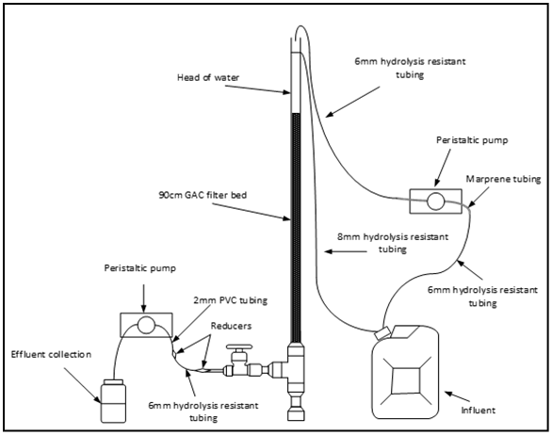
Supplementary Figure 1. Diagram of biofilters operated in this study with 90cm GAC bed.

Supplementary Figure 2. Visual representation of sampling for the mass balance analysis. Total cell counts by flow cytometry of the influent and effluent water were measured weekly between each deconstruction timepoint. Cells estimated by ATP analysis were analysed from GAC collected at each deconstruction timepoint. For sections of the filter bed which were not sampled (e.g. 30-58cm) cell numbers were extrapolated upwards from the lower section of the filter bed (e.g. 58-60cm).

Supplementary Results

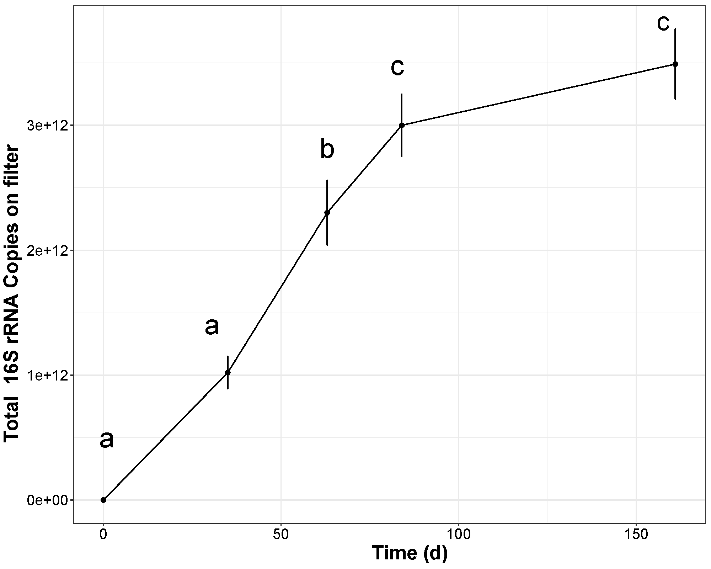

Supplementary Figure 3. Biomass found on the entirety of the filter column over time measured by QPCR 16S rRNA gene copy numbers per filter. Error bars show standard deviation and letters of significance were generated by one way ANOVA and Tukey HSD.

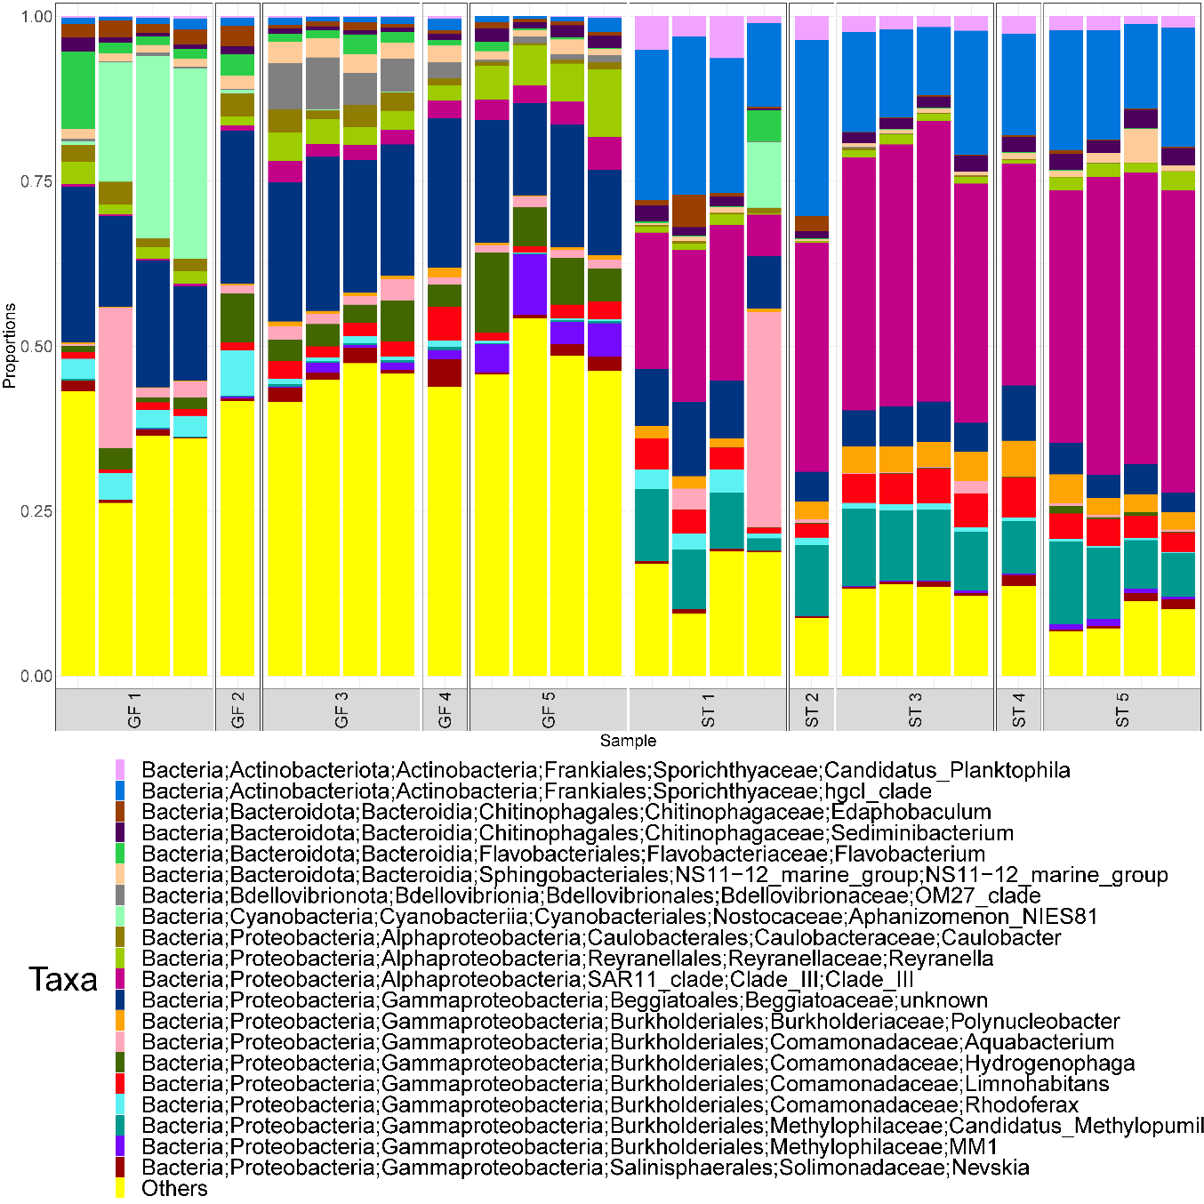
Supplementary Figure 4. The 20 most relatively abundant taxa at Genus level of the seeding community by sampling week (1, 2, 3, 4, 5) and size fractionation (GF – glass fibre 1.2µm retention, ST – Sterivex filter 0.22µm retention)

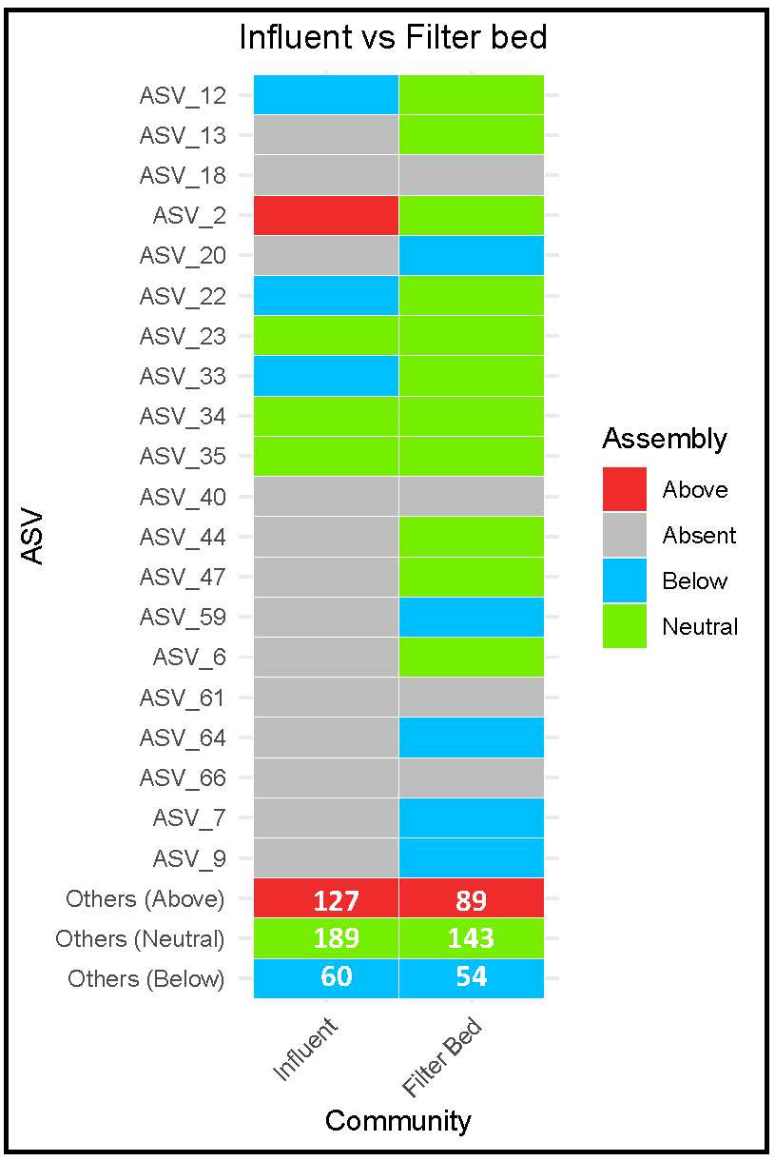
Supplementary Figure 5. Comparison of the core microbiome of the filter bed at week 34 and the seeding community (influent water sampled weekly till day 34). Values in “Other” taxa boxes reflect the number of ASVs in the core microbiome assigned to each mode of assembly

