EXTENDED CONTENT
TABLE OF CONTENT
- METHODS
- Extended Table 1: Inclusion/Exclusion criteria
- Extended Table 2: clinical and biological outcomes in patients with successful pregnancy and pregnancy loss.
- Extended Table 3: Safety
- Extended Figure 1: Biological response (Individual Treg response)

METHODS
FACIL-2 study design, participants and treatment
FACIL-2 was an open monocentric proof-of-concept trial evaluating the tolerance and the efficacy of IL-2_{LD} in women with REPL. The study was approved by the institutional review board CPP Ile de France III and performed in accordance with the Declaration of Helsinki and good clinical practices. FACIL-2 is registered as “Low-dose Interleukin-2 in Women With Unexplained Miscarriages” with ClinicalTrials number NCT03970954.
Patients were recruited from January 2021 to July 2023 and were treated and followed up at the Saint Antoine hospital in Paris. The main inclusion criteria were: women from 18 to 40 years old with at least 5 consecutive recurrent early pregnancy loss before 14 weeks of amenorrhea and unexplained after the usual check-up; volunteer to participate in the trial and having given written consent after appropriate information. The main exclusion criteria were: uterine or pelvic abnormality: uterine malformation, intracavitary fibroid, synechiae, polyp, hydrosalpinx; balanced translocations in both spouses; type I or II diabetes; Sickle cell disease; constitutional or acquired thrombophilia or autoimmunity (protein deficit C, S, ATIII, homozygous factor V or II deficiency, antiphospholipid syndrome, antithyroid antibodies positive, celiac disease, hyperhomocysteinemia); decreased ovarian reserve (anti-mullerian hormone (AMH) <1 ng/ml); antral follicular counts (AFC) < 4 (Extended Table 1)
Among 18 included patients for the study, 15 were treated with IL-2_{LD} (Fig.1). Written informed consent was obtained from all participants before enrolment in the study. Patients received IL-2_{LD} in the form of Aldesleukin (Proleukin® 18 MIU, Novartis Pharma SAS, Rueil-Malmaison, France) provided by the central pharmacy of the Assistance Publique-Hôpitaux de Paris and diluted to the dose of 3MIU/injection (or lower in case of dose reduction) by a pharmacist.
Participants were first monitored and immunophenotyped during an untreated cycle. For the next cycle, they were administered 3 million international units (MIU) of IL-2 daily for 5 consecutive days, starting 10 days after the onset of menses (day 1) (Extended Fig. 1). At this dose, a 5-day injection course maintains a Treg expansion for about a month ¹. This regimen was timed so that IL-2 would be cleared by the potential time of embryo implantation, given a half-life of subcutaneaous IL-2 of about 4 hours and an embryo implantation at 6 to 10 days after ovulation, corresponding to days 20 to 24 of the standard menstrual cycle. If pregnancy was not achieved (β-HCG negative on day 29), a new treatment cycle was started, with a maximum of 5 cycles (Extended Fig. 1). Treatment cycles were planned as consecutive, but an interruption of up to two cycles was allowed. The dose of IL-2 could be decreased in case of side effects, but to no less than 1MIU/day.
Outcomes
The primary endpoint of the study was the increase in Treg count on day 14 of the first treatment cycle compared to baseline (day 10 of the untreated cycle). The secondary endpoints were the number of full-term pregnancies and safety assessed by the biological and clinical adverse events of the mother, fetus and newborn up to 6 weeks of age.
Immunomonitoring
The immune status of the FACIL-2 patients was assessed during the first untreated cycle and the subsequent IL-2_{LD} cycles. Blood samples were obtained for immunological tests immediately before the administration of IL-2_{LD}. Sample were obtained daily from day 10 to day 14, and at day 17 and day 29 of each cycle. All the immunomonitoring procedures were performed as previously described ^{2–5}. Blood samples were collected in EDTA tubes according to the planned protocol: absolute numbers of lymphocyte subsets and Tregs were monitored at each patient visit: day-10, day 17 and day 29 of the first of the cycle without treatment, for the other cycles at day 10 before treatment (baseline) at day 14 just before the fifth infusion of IL-2LD, day 17 and day 29 (at the end of the cycle).
Blood subsets (CD3⁺, CD4⁺, CD8⁺ T lymphocytes, CD19⁺ B lymphocytes and CD3⁻CD56⁺ NK cells) counts (cells/μl) were established from fresh blood samples using CYTO-STAT tetraCHROME kits with Flowcount fluorescents beads and tetra CXP software with a FC500 cytometer (Beckman Coulter) according to manufacturer’s instructions. Foxp3 labeling was performed with custom designed dry tubes (duraclone from Beckman Coulter) containing CD3-FITC, CD25-PE, CD127-PE-Cy7, Foxp3-AF647, CD8-KRO, CD8-PB antibodies as described already described². Total blood (60 µL) sampled with anticoagulant was mixed with 6 µL of Perfix-NC R1 buffer, vortexed immediately for 2-3 seconds and incubated for 15 min at room temperature in the dark. Perfix-NC R2 buffer (360 µL) was added and, after homogenization, a 360 µL aliquot was transferred to a Duraclone tube. After vortexing for 10 seconds, tubes were incubated for 60 min at room temperature in the dark. PBS 1X (3 mL) was added to the tubes, incubated for 5 min at room temperature in the dark before centrifugation for 6 min at 250g. The supernatant was removed to leave the pellet dried and the cells were resuspended in 3 mL of 1X Perfix-NC R3 buffer prior to another 6-min centrifugation at 250g. The pellet was dried and resuspended in 300 µL of 1X R3 buffer. Tubes were protected from light and stored at 4°C until the acquisition on a cytometer within the next 24 h. Acquisition was performed on a Navios cytometer (Beckman Coulter) maintained daily according to the manufacturer’s recommendations with Flow Check Pro and Flow Set Pro fluorospheres. Acquisitions were performed, respectively, using Navios software, and all analyses were done with Kaluza 1.3 software (Beckman Coulter)².
Statistical analysis
Changes in Tregs between baseline and the other follow up timepoint were analyzed throughout the treatment period by non-parametric ANCOVA for repeated measurements, using baseline values as covariable (Conover method). Data are presented as mean ± SEM. Normal distribution of each set of variables was analysed by D'Agostino & Pearson omnibus normality test. Student’s t-test for normally distributed data and non-parametric Mann–Whitney were used to compare variables as appropriate. Paired data comparing follow-up time points to baseline value were analysed using Student’s t-test for normally distributed data and paired Wilcoxon signed-rank test for nonparametric. A p value < 0.05 was considered significant. Statistical analyses were performed using GraphPad Prism version 10.0 (GraphPad Software, San Diego, CA, USA).

Compassionate use of IL-2_{LD} in REPL
During the same period, nine additional women who were unable or unwilling to participate in the FACIL-2 trial received the same IL-2_{LD} treatment on a compassionate use. They also had a history of at least 5 uREPLs before 14 weeks of gestation. These patients did not have the planned visits of the FACIL-2 study and had no biological follow up nor enforced safety follow up.
All patients treated at any AP-HP hospital (the body that oversees all public hospitals in the Paris region) are informed that data obtained during their care may be used for research purposes. Patients have the right to opt out if they wish. The nine additional patients mentioned did not opt out and are not included in a research protocol. The pregnancy outcome results that we report are from their care.

Extended Table 1: Inclusion/Exclusion criteria
PATIENTS  Main inclusion criteria | - Female aged [18-40] years  - Woman with at least 5 consecutive early miscarriages less than 14 weeks of amenorrhea and unexplained after the usual check-up;  - Volunteer to participate in the trial and having given written consent after appropriate information.
Main non-inclusion criteria | - Uterine or pelvic abnormality: uterine malformation, intracavitary fibroid, synechiae, polyp, hydrosalpinx;  - Balanced translocations in both spouses;  - Diabetes type I or II;  - Sickle cell disease;  - Contraindication to pregnancy;  - Constitutional or acquired thrombophilia (protein deficit C, S, ATIII, homozygous factor V or II deficiency, antiphospholipid syndrome, antithyroid antibodies positive, celiac disease, hyperhomocysteinemia);  - Decreased ovarian reserve (AMH <1 ng/ml); AFC < 4  - Significant spermogram abnormalities and DNA fragmented more than 30%  - Active HIV or HCV infection;  - Main known contraindications to treatment with IL-2:  - Hypersensitivity to the active substance or to any of the excipients;  - Signs of progressive infection requiring antibiotic therapy;  - History of organ allograft;  - Pre-existing autoimmune disease;  - Leukocytes <4000 / mm3; platelets <100,000 / mm3; hematocrit <30%;  - hepatic or renal insufficiency;  - depression;  - significant history or existence of a serious heart disease (in doubtful cases, perform a stress test);  - patients with autoimmune disease;  - patients with an infection (septicemia, bacterial endocarditis, septic thrombophlebitis, peritonitis and pneumonia);  - pregnancy;  - Treatment with immunomodulators, immunosuppressants (class L04A of the ATC classification), in particular systemic corticosteroids, as well as aspirin and low molecular weight heparin;  - No affiliation to a social security;  - Person who has already been included in this study or in another at the same time;  - Major incapacitated patient (tutorship / curatorship);  - Patient with an allergy to taking IL2-fd;  - Participants who would present professional risk factors (eg ionizing exposure);

Extended Table 2: clinical and biological outcomes in patients with successful pregnancy and pregnancy loss.
Pregnancy | < 14 Week (N = 4) | ≥ 14 Week (N = 4) | p-values
Age at the pregnancy | 33.28±0.66 | 35.35±1.97 | ns
AFC | 31.0 ±18.02 | 11.5 ± 6.34 (n=2) | ns
AMH | 3.25±1.64 | 3.02±1.60 | ns
Number of previous early pregnancy loss | 7.25 | 6.75 | ns
Number of cycles of IL2 received: mean  (range) | 1.75±0.5  (1-2) | 1.75±0.5  (1-2) | ns
Total dose of IL2 received (MIU): mean  (range) | 17.13±9.06  (9-30) | 24.0 ±7.3  (15-30) | ns
Tregs at Baseline (mean ± sd; range) | 8.16±2.82  (5.07-9.91) | 7.41±1.19  (6.0-8.89) | ns
Tregs at entry in the first IL-2 cycle  (mean ± sd; range) | 8.43±1.58  (6.64-10.47) | 7.32±1.33  (5.61-8.67) | ns
Tregs fold increase at day-8 of the first and second cycle (pooled values) | 1.81±0.51 | 2.84±0.51 | 0.03
Tregs fold increase at day-29 of the first and second cycle (pooled value) | 1.24±0.09 | 1.71±0.34 | 0.008

Extended Table3: Safety
*hypokalemia corresponding to grade 3NSAE

Extended Figure 1: Individual Treg response (A) during the first treatment-free cycle, with the red line representing the mean across all patients;; (B) all along the follow up from the first cycle to the fifth cycle ( C1 n=15; C2 n=9 ; C3 n=3 ; C4 n=2; C5 n=1)
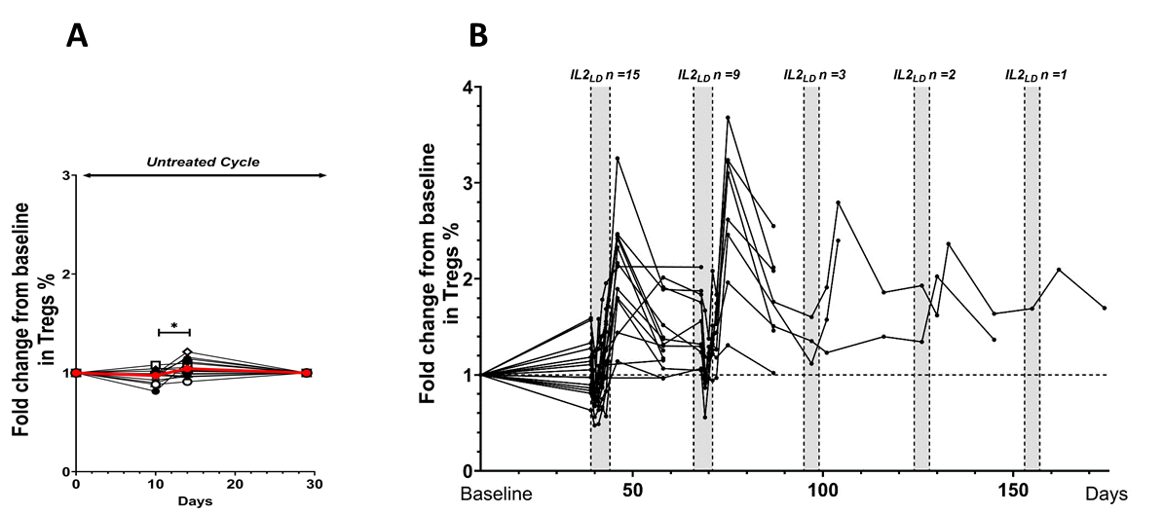
REFERENCES
1. Saadoun, D. et al. N Engl J Med 365, 2067–77 (2011).
2. Pitoiset, F. et al. Cytometry B Clin Cytom (2018).doi:10.1002/cyto.b.21622
3. Pitoiset, F. et al. Cytometry A 93, 793–802 (2018).
4. Rosenzwajg, M. et al. Ann. Rheum. Dis. 78, 209–217 (2019).
5. Louapre, C. et al. European Journal of Neurology n/a,

