Year | Brazil, Goiania : Male | Brazil, Goiania : Female | Chile, Valdivia : Male | Chile, Valdivia : Female | Colombia, Cali : Male | Colombia, Cali : Female | Ecuador, Quito : Male | Ecuador, Quito : Female
1983 | - | - | - | - | 23.59 | 9.83 | - | -
1984 | - | - | - | - | 22.59 | 7.41 | - | -
1985 | - | - | - | - | 18.40 | 6.03 | 8.52 | 2.13
1986 | - | - | - | - | 23.43 | 12.58 | 9.31 | 5.39
1987 | - | - | - | - | 25.00 | 10.72 | 7.88 | 3.85
1988 | - | - | - | - | 22.51 | 9.57 | 7.49 | 2.05
1989 | - | - | - | - | 24.12 | 9.09 | 12.62 | 5.72
1990 | - | - | - | - | 21.08 | 8.59 | 9.17 | 3.55
1991 | - | - | - | - | 23.90 | 9.29 | 10.23 | 2.55
1992 | - | - | - | - | 22.96 | 10.58 | 13.56 | 4.78
1993 | 18.53 | 9.63 | - | - | 21.49 | 8.57 | 7.78 | 2.78
1994 | 19.92 | 6.44 | - | - | 22.19 | 8.28 | 8.61 | 4.79
1995 | 26.47 | 8.53 | - | - | 22.98 | 10.01 | 7.12 | 4.69
1996 | 18.21 | 8.30 | - | - | 25.06 | 8.95 | 8.79 | 4.88
1997 | 22.30 | 7.95 | - | - | 17.95 | 9.76 | 11.61 | 4.95
1998 | 21.99 | 8.16 | 9.34 | 5.50 | 19.49 | 7.75 | 6.48 | 5.34
1999 | 23.79 | 10.93 | 8.61 | 7.56 | 27.34 | 11.39 | 5.58 | 4.23
2000 | 22.46 | 10.53 | 18.34 | 3.61 | 19.10 | 8.71 | 9.56 | 4.36
2001 | 22.55 | 10.26 | 12.09 | 2.44 | 21.68 | 10.40 | 7.68 | 3.14
2002 | 22.05 | 12.71 | 7.71 | 4.20 | 20.03 | 8.88 | 9.92 | 3.66
2003 | 28.23 | 7.62 | 10.23 | 3.35 | 18.54 | 8.99 | 7.89 | 6.03
2004 | 24.59 | 12.34 | 12.63 | 3.19 | 18.08 | 9.29 | 7.55 | 5.56
2005 | 28.87 | 14.17 | 10.03 | 3.26 | 22.25 | 8.94 | 10.53 | 5.59
2006 | 27.52 | 13.78 | 11.93 | 7.15 | 19.10 | 8.49 | 7.02 | 6.65
2007 | 28.11 | 13.69 | 7.86 | 4.25 | 17.31 | 8.96 | 8.95 | 7.06
2008 | 29.29 | 10.24 | 12.02 | 5.04 | 16.08 | 6.95 | 7.86 | 5.50
2009 | 18.48 | 13.41 | 10.39 | 2.02 | 14.41 | 8.67 | 8.29 | 6.50
2010 | 24.49 | 13.50 | 8.38 | 4.96 | 12.69 | 7.68 | 8.70 | 5.45
2011 | 19.04 | 12.36 | 12.04 | 6.41 | 12.92 | 9.05 | 8.96 | 5.83
2012 | 16.07 | 11.09 | 8.93 | 4.97 | 13.51 | 7.48 | 6.37 | 6.30
Table Nº2. Incidence Mesothelioma Cancer in South America 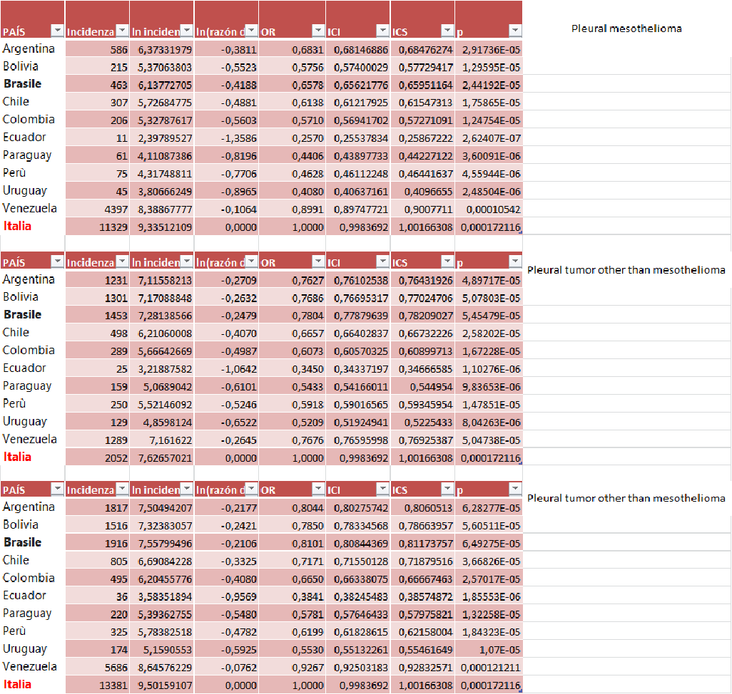
Table N°3.Incidence OR’s poisson model from mesothelioma in Italy and South America.
