Supplementary files

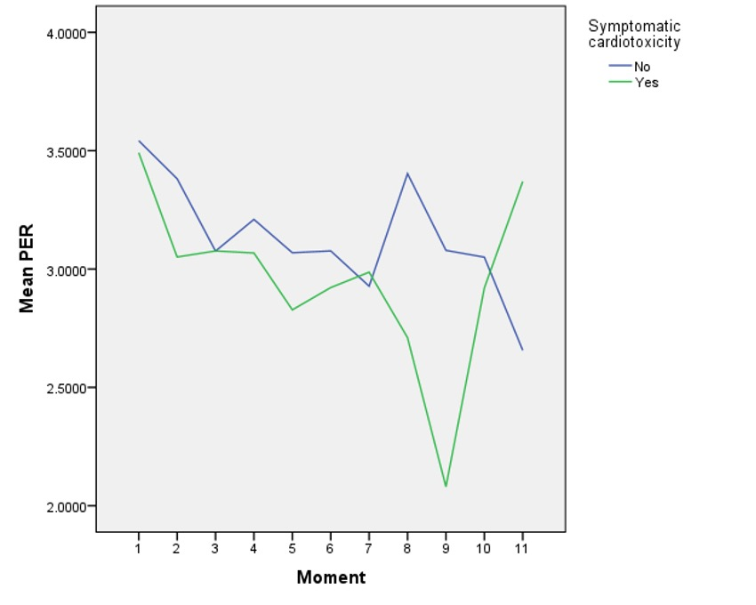
A

B

Moments | The mean PER (Wald confidence interval) |  |  |  |  |  | p
 | Asymptomatic |  |  | Symptomatic cardiotoxicity
1 | 3.54 (3.41 - 3.66) |  |  | 3.49 (3.11 - 3.86) |  |  | 0.802
2 | 3.38 (3.26 - 3.50) |  |  | 3.05 (2.66 - 3.43) |  |  | 0.107
3 | 3.07 (2.97 - 3.17) |  |  | 3.07 (2.76 - 3.38) |  |  | 0.997
4 | 3.20 (3.09 - 3.32) |  |  | 3.06 (2.48 - 3.64) |  |  | 0.638
5 | 3.06 (2.92 - 3.20) |  |  | 2.82 (2.38 - 3.27) |  |  | 0.313
6 | 3.07 (2.91 - 3.23) |  |  | 2.92 (2.32 - 3.51) |  |  | 0.622
7 | 2.92 (2.77- 3.07) |  |  | 2.98 (2.71 - 3.25) |  |  | 0.706
8 | 3.40 (3.05 - 3.74) |  |  | 2.71 (2.64 - 2.77) |  |  | < 0.001
9 | 3.07 (2.79 - 3.36) |  |  | 2.08 (2.08 - 2.08) |  |  | < 0.001
10 | 3.05 (2.60 - 3.49) |  |  | 2.92 (2.92 - 2.92) |  |  | 0.569
11 | 2.65 (2.44 - 2.87) |  |  | 3.37 (3.37 - 3.37) |  |  | < 0.001

Supplementary 1: Longitudinal changes in Mean PER by symptomatic cardiotoxicity status, analyzed by GEE method. A – The mean PER’s curve; B – Table showing the mean of PER’s values; Nº – number; in bold, p < 0.05.

A
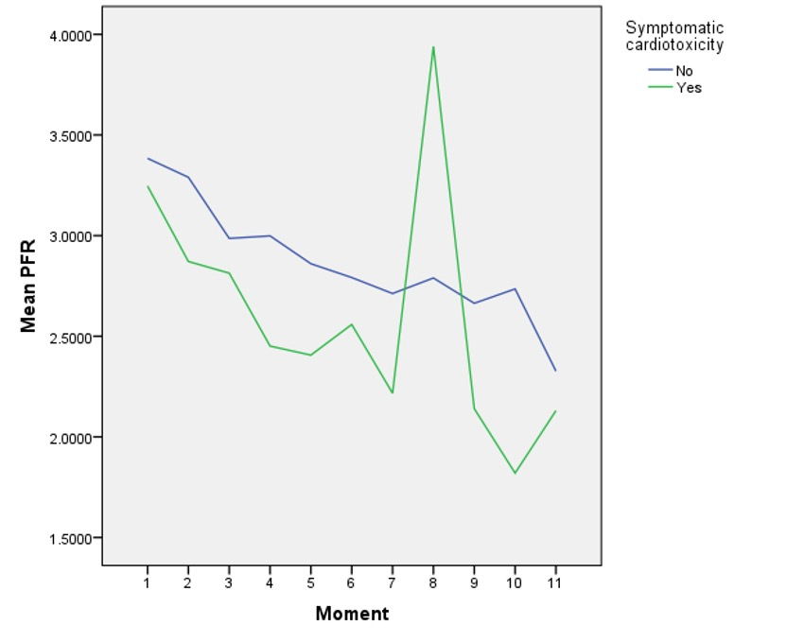

B

Moments | The mean PFR (Wald confidence interval) |  |  |  |  |  | p
 | Asymptomatic |  |  | Symptomatic cardiotoxicity
1 | 3.38 (3.24 - 3.52) |  |  | 3.24 (2.77 - 3.71) |  |  | 0.584
2 | 3.28 (3.15 - 3.42) |  |  | 2.87 (2.52 - 3.21) |  |  | 0.026
3 | 2.98 (2.85 - 3.11) |  |  | 2.81 (2.45 - 3.17) |  |  | 0.380
4 | 2.99 (2.85 - 3.14) |  |  | 2.45 (2.29 - 2.60) |  |  | < 0.001
5 | 2.86 (2.72 - 2.99) |  |  | 2.40 (2.11- 2.69) |  |  | 0.005
6 | 2.79 (2.62 - 2.96) |  |  | 2.55 (2.22 - 2.88) |  |  | 0.622
7 | 2.71 (2.46- 2.95) |  |  | 2.21 (1.92 - 2.50) |  |  | 0.011
8 | 2.78 (2.43 - 3.14) |  |  | 3.94 (1.79- 6.08) |  |  | 0.300
9 | 2.66 (2.41 - 2.91) |  |  | 2.14 (2.14 - 2.14) |  |  | < 0.001
10 | 2.73 (2.52- 2.94) |  |  | 1.82 (1.82 - 1.82) |  |  | < 0.001
11 | 2.32 (1.97 - 2.68) |  |  | 2.13 (2.13 - 2.13) |  |  | 0.279

Supplementary 2: Longitudinal changes in Mean PFR by symptomatic cardiotoxicity status, analyzed by GEE method. A – The mean PFR’s curve; B – Table showing the mean of PFR’s values; Nº – number; in bold, p < 0.05.

A
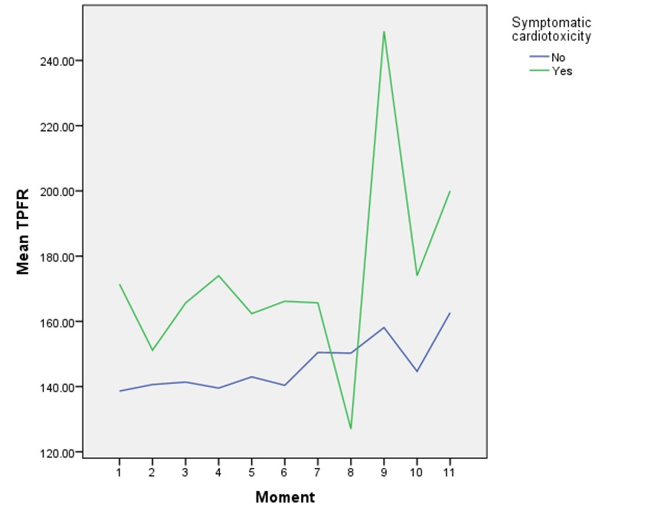

B
Moments | The mean TPFR (Wald confidence interval) |  |  |  |  |  | p
 | Asymptomatic |  |  | Symptomatic cardiotoxicity
1 | 138.61 (131.90 - 145.32) |  |  | 171.42 (140.25 - 202.60) |  |  | 0.044
2 | 140.62 (134.85 - 146.38) |  |  | 151.14 (132.23 - 170.05) |  |  | 0.297
3 | 141.37 (135.30 - 147.45) |  |  | 165.64 (143.83 - 187.45) |  |  | 0.036
4 | 139.54 (132.90 - 146.17) |  |  | 174.00 (141.97 - 206.03) |  |  | 0.039
5 | 142.97 (135.54 - 150.40) |  |  | 162.37 (125.52- 199.22) |  |  | 0.312
6 | 140.38 (130.70 - 150.07) |  |  | 166.16 (138.25 - 194.08) |  |  | 0.087
7 | 150.44 (133.75- 167.13) |  |  | 165.66 (153.96 - 177.36) |  |  | 0.143
8 | 150.25 (131.63 - 168.86) |  |  | 127.00 (100.66 - 153.33) |  |  | 0.158
9 | 158.11 (138.21 - 178.01) |  |  | 249.00 (249.00 - 249.00) |  |  | < 0.001
10 | 144.66 (119.91 - 169.42) |  |  | 174.00 (174.00 - 174.00) |  |  | < 0.001
11 | 162.66 (132.78 - 192.55) |  |  | 200.00 (200.00 - 200.00) |  |  | 0.014

Supplementary 3: Longitudinal changes in Mean TPFR by symptomatic cardiotoxicity status, analyzed by GEE method. A – The mean TPFR’s curve; B – Table showing the mean of TPFR’s values; Nº – number; in bold, p < 0.05.

A
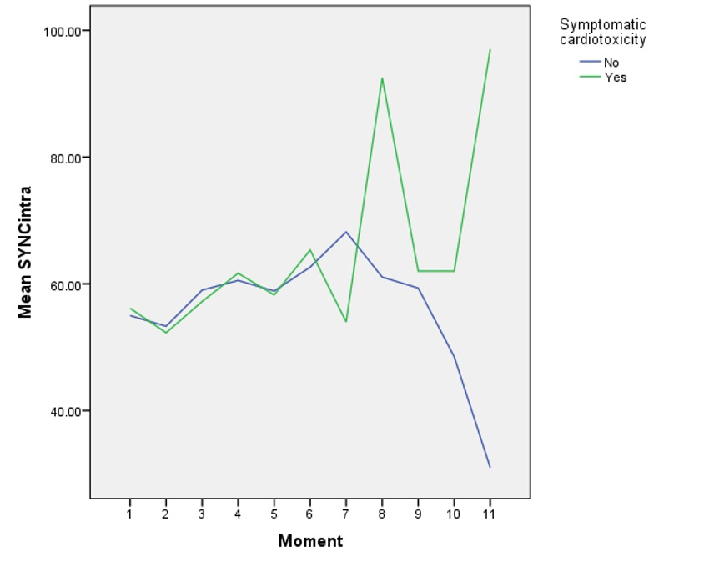

B
Moments | The mean SD LVmPA (Wald confidence interval) |  |  |  |  |  | p
 | Asymptomatic |  |  | Symptomatic cardiotoxicity
1 | 54.99 (50.10 - 59.88) |  |  | 56.14 (45.39 - 66.88) |  |  | 0.848
2 | 53.31 (48.46 - 58.16) |  |  | 52.28 (39.77 - 64.79) |  |  | 0.888
3 | 59.00 (54.06 - 63.95) |  |  | 57.21 (50.35 - 64.07) |  |  | 0.677
4 | 60.53 (55.47 - 65.59) |  |  | 61.66 (52.01 - 71.31) |  |  | 0.838
5 | 58.86 (53.30 - 64.43) |  |  | 58.25 (46.47- 70.02) |  |  | 0.926
6 | 62.63 (55.55 - 69.70) |  |  | 65.33 (54.22 - 76.44) |  |  | 0.688
7 | 68.18 (53.63 - 82.73) |  |  | 54.00 (38.73 - 69.26) |  |  | 0.187
8 | 61.06 (49.26 - 72.85) |  |  | 92.50 (58.54 - 126.45) |  |  | 0.087
9 | 59.33 (47.58 - 71.08) |  |  | 62.00 (62.00 - 62.00) |  |  | 0.657
10 | 48.50 (33.90 - 63.09) |  |  | 62.00 (62.00 - 62.00) |  |  | 0.070
11 | 31.00 (5.12 - 56.87) |  |  | 97.00 (97.00 - 97.00) |  |  | < 0.001

Supplementary 4: Longitudinal changes in Mean SD LVmPA by symptomatic cardiotoxicity status, analyzed by GEE method. A – The mean SD LVmPA’s curve; B – Table showing the mean of SD LVmPA’s values; Nº – number; in bold, p < 0.05.

A
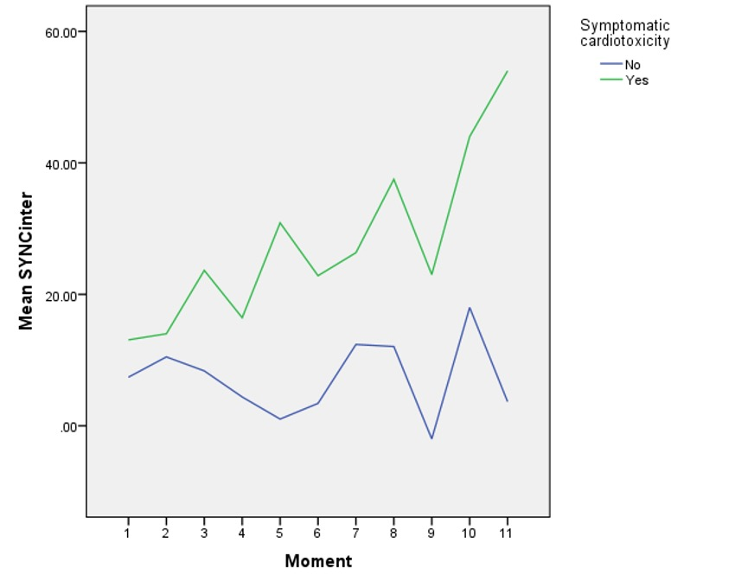

B
Moments | The mean LV-RVmPA (Wald Confidence Interval) |  |  |  |  |  | p
 | Asymptomatic |  |  | Symptomatic cardiotoxicity
1 | 7.39 (1.38 - 13.40) |  |  | 13.07 (-0.82 - 26.97) |  |  | 0.462
2 | 10.47 (4.17 - 16.77) |  |  | 14.00 (-5.25 - 33.25) |  |  | 0.733
3 | 8.35 (1.73 - 14.96) |  |  | 23.64 (-0.78 - 48.06) |  |  | 0.236
4 | 4.38 (-2.57 - 11.34) |  |  | 16.44 (-3.20 - 36.09) |  |  | 0.257
5 | 1.02 (-7.68 - 9.73) |  |  | 530.87 (13.40 - 48.34) |  |  | 0.003
6 | 3.40 (-5.78 - 12.59) |  |  | 22.83 (-8.37 - 54.04) |  |  | 0.242
7 | 12.37 (-1.09 - 25.83) |  |  | 26.33 (1.84 - 50.81) |  |  | 0.327
8 | 12.06 (-7.37 - 31.49) |  |  | 37.50 (-14.47 - 89.47) |  |  | 0.369
9 | -2.00 (-24.68 - 20.67) |  |  | 23.00 (23.00 - 23.00) |  |  | 0.031
10 | 18.00 (14.24 - 21.57) |  |  | 44.00 (44.00 - 44.00) |  |  | < 0.001
11 | 3.66 (-21.23 - 28.56) |  |  | 54.00 (54.00 - 54.00) |  |  | < 0.001

Supplementary 5: Longitudinal changes in Mean LV-RVmPA by symptomatic cardiotoxicity status, analyzed by GEE method. A – The mean LV-RVmPA’s curve; B – Table showing the mean of LV-RVmPA’s values; Nº – number; in bold, p < 0.05.

