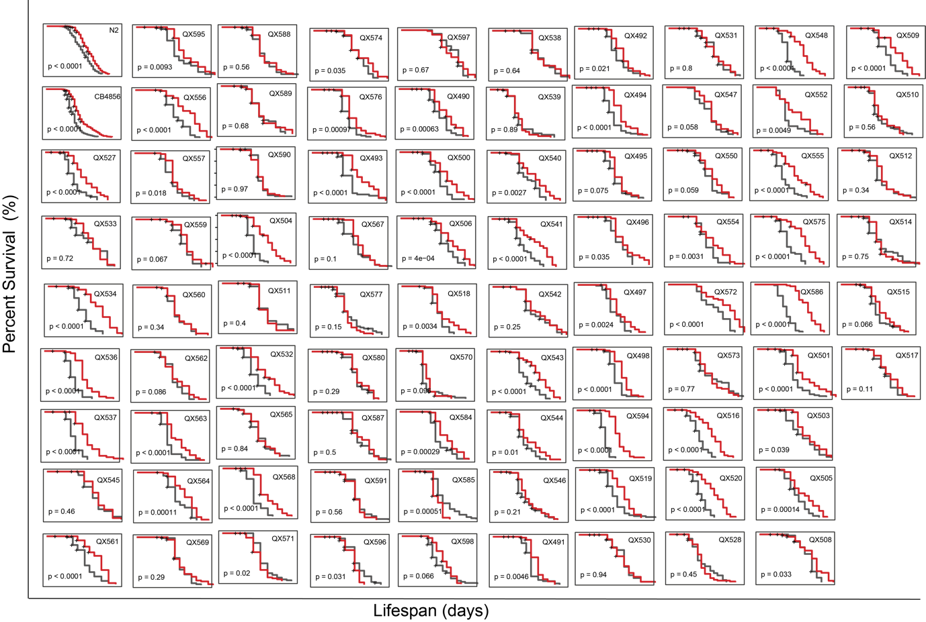
Figure S1: Lifespans of 85 RIAILs exhibit large variations at both control and Dox-treated conditions. Lifespans of 85 RIAIL strains. Control condition: black lines; Dox treated: red lines. Statistical analysis was performed by log-rank analysis (*p<0.05, **p<0.01, ***p<0.001, ****p<0.0001, ns. not significant).

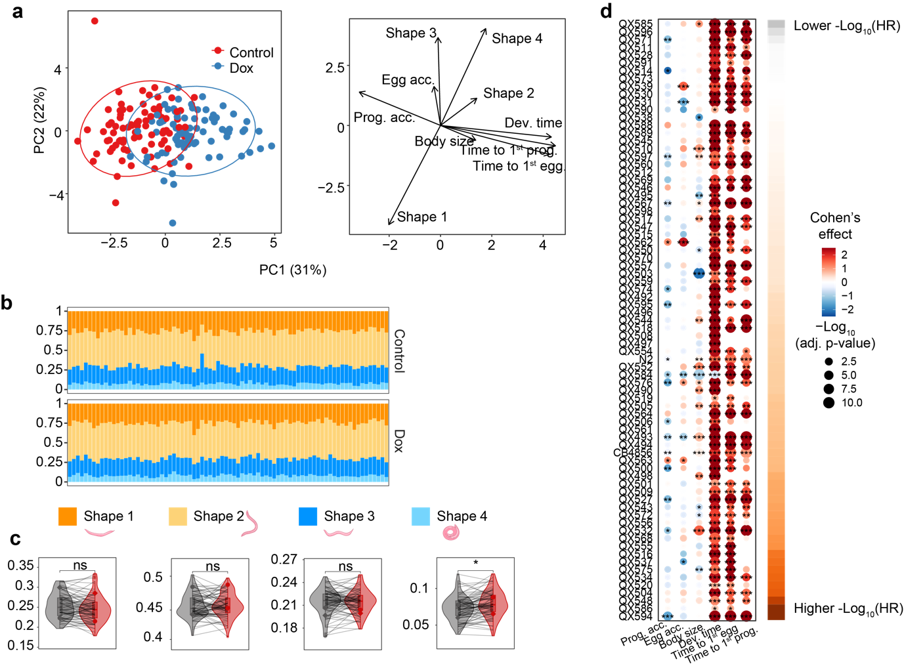
Figure S2: Dox effect on physiological phenotypes, transcriptome, and proteome. (a) PCA analysis showing the Dox effect on 10 clinical phenotypes and indicating the main affected phenotypes. (b) Percentage of time that a RIAIL strain spent in different shapes at control (upper) and Dox-treated (bottom) conditions. (c) Violin plots of the percentage of time that RIAIL strains spent in different shapes under control (black) and Dox (red) conditions. P-values represent the comparison of each trait between the control and Dox, calculated using a two-tailed Student’s t-test. Lines indicate the changes of each phenotype in each strain upon Dox. (d) The dot plot shows the changes in physiological traits upon Dox among RIAILs. Strains were ranked by lifespan extension induced by MSR (colored in orange). The Dox effect on these traits was evaluated by Cohen’s effect and represented by color. -Log₁₀(adj.P.Val) is shown by dot size and indicated as * -Log₁₀(adj.P.Val) < 0.05, ** -Log₁₀(adj.P.Val) < 0.01, *** -Log₁₀(adj.P.Val) < 0.001.

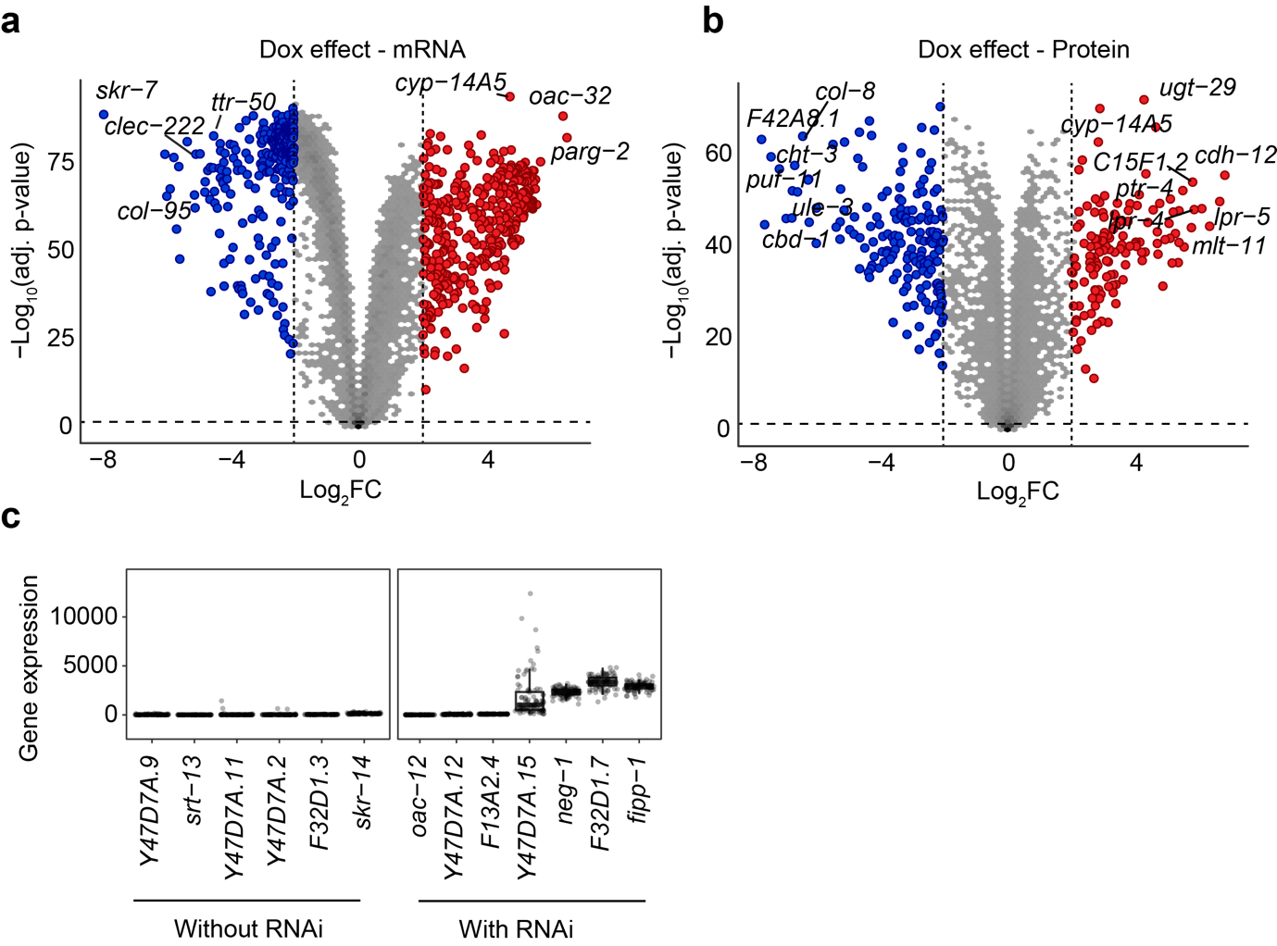
Figure S3: Dox effect on transcriptome and proteome. (a, b) Volcano plots showing the Dox effect on transcriptome (a) and proteome (b). Up- and down-regulated genes/proteins are indicated by red and blue, respectively. (c) Boxplot shows that the candidate genes identified from the QTL peak with corrected RNAi have higher gene expression than those without RNAi or corrected RNAi.

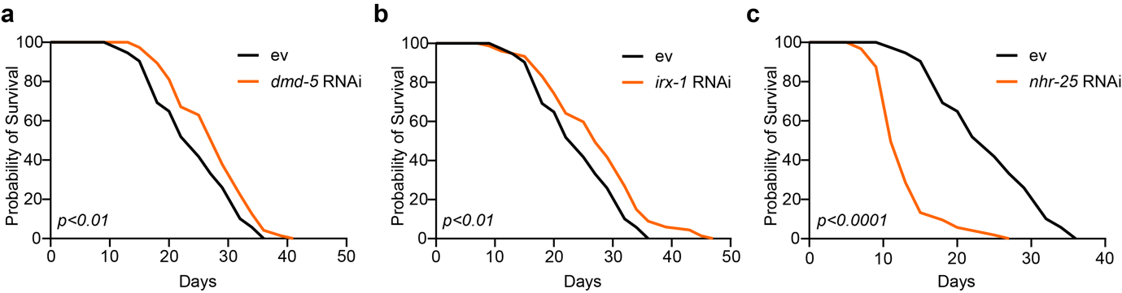
Figure S4: The effects of three identified longevity-related transcription factors. (a-b) RNAi of dmd-5 (a) and irx-1 (b) prolonged worm lifespan. (c) RNAi of nhr-25 shortened the lifespan of C. elegans. Statistical analysis was performed by log-rank analysis.

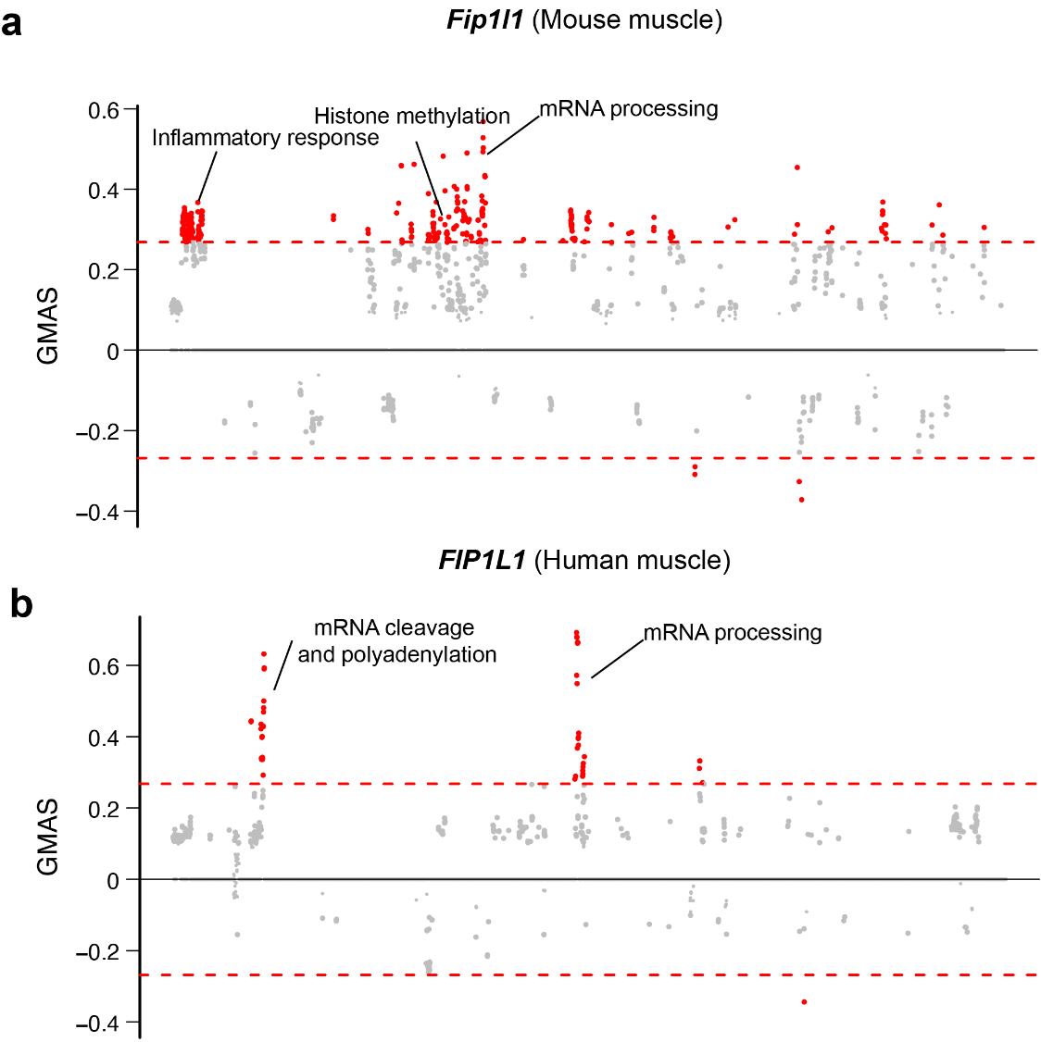

Figure S5: Exploring the biological function of FIP1L1 in mice and humans. (a-b) Manhattan plots showing the associated gene expression modules of Fip1l1 in mouse (a) and human muscles (b). Data were retrieved from https://systems-genetics.org/gmad⁷⁵. The threshold is represented by the red dashed line (absolute gene-module association score ≥ 0.268). Terms above the threshold are identified as the significant associated terms. GO terms or gene modules are ranked by similarity.

Table S1: Primers used for C. elegans qRT-PCR
Gene | Forward (sequence 5’→3’) | Reverse (sequence 5’→3’)
Reference gene
cdc-42 | TCGACAATTACGCCGTCACA | AGGCACCCATTTTTCTCGGA
pmp-3 | GTCGAACGATGTGGTGGTCT | AGGCACCCATTTTTCTCGGA
Target genes
clec-4 | GGGATATGGAGCGACACTGG | TCGCAAATCTTCTGGCCCTT
timm17 | ACCAGAGAGCCATGCCCATATC | ATCACCGAAGTTGGAGGGGG
hsp-6 | AGAGCCAAGTTCGAGCAGAT | TCTTGAACAGTGGCTTGCAC
hsp-60 | GGAAGCCCAAAGATCACAAA | CAGCCTCCTCATTAGCCTTG

