Table 2. Comparative visualization of training dynamics and class-specific Dice progression among State-of-the-Art Models
Models | Training results
RAAGR2-Net [32] | 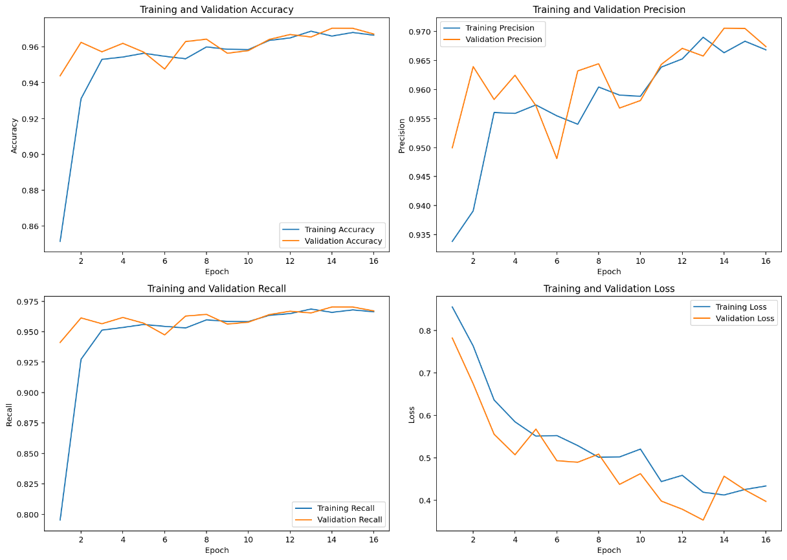  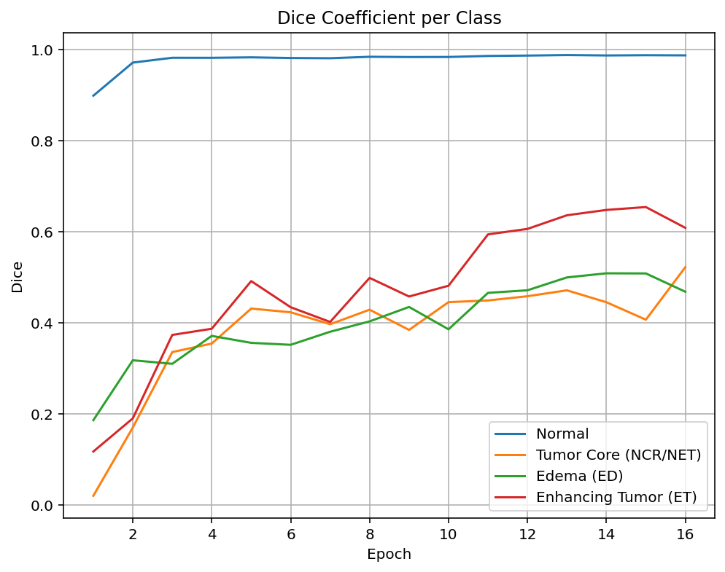
TransUNet [29] | 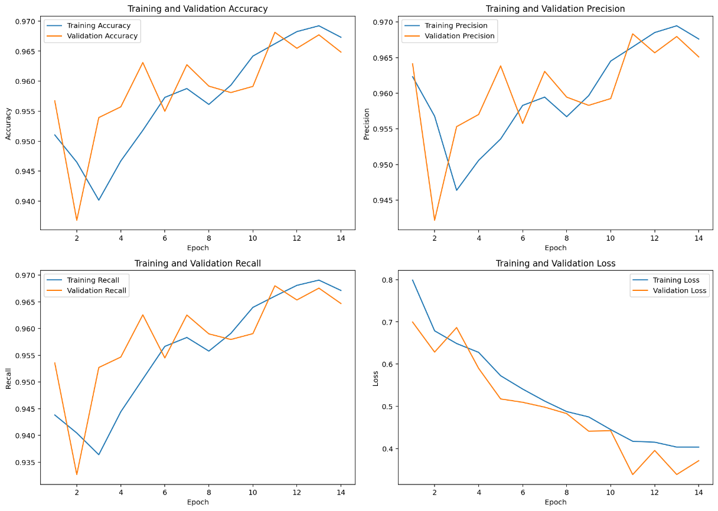  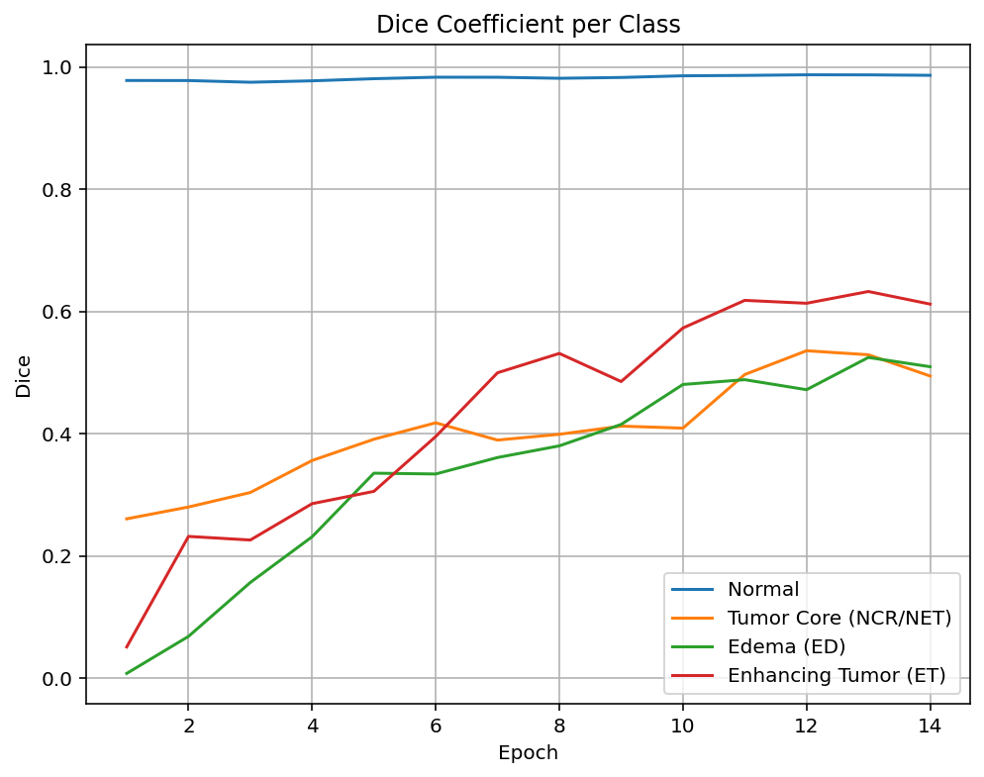
NestedFormer [34] | 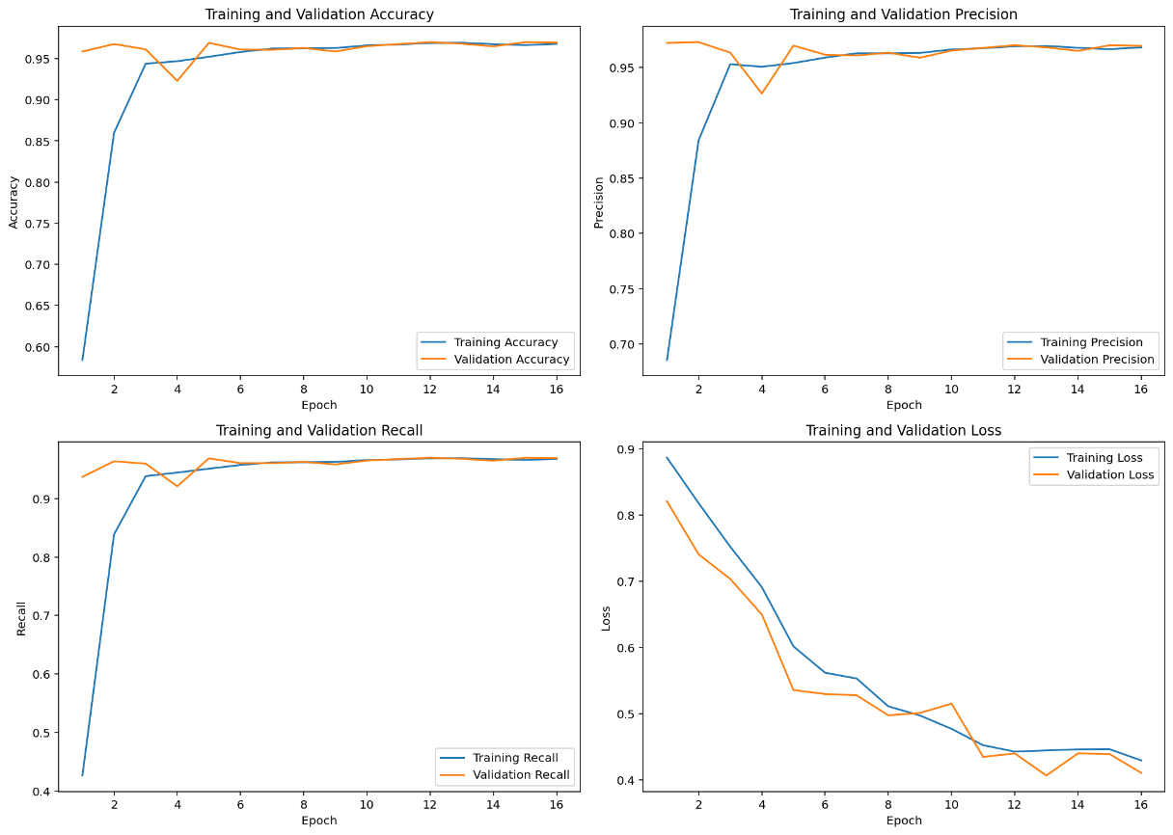  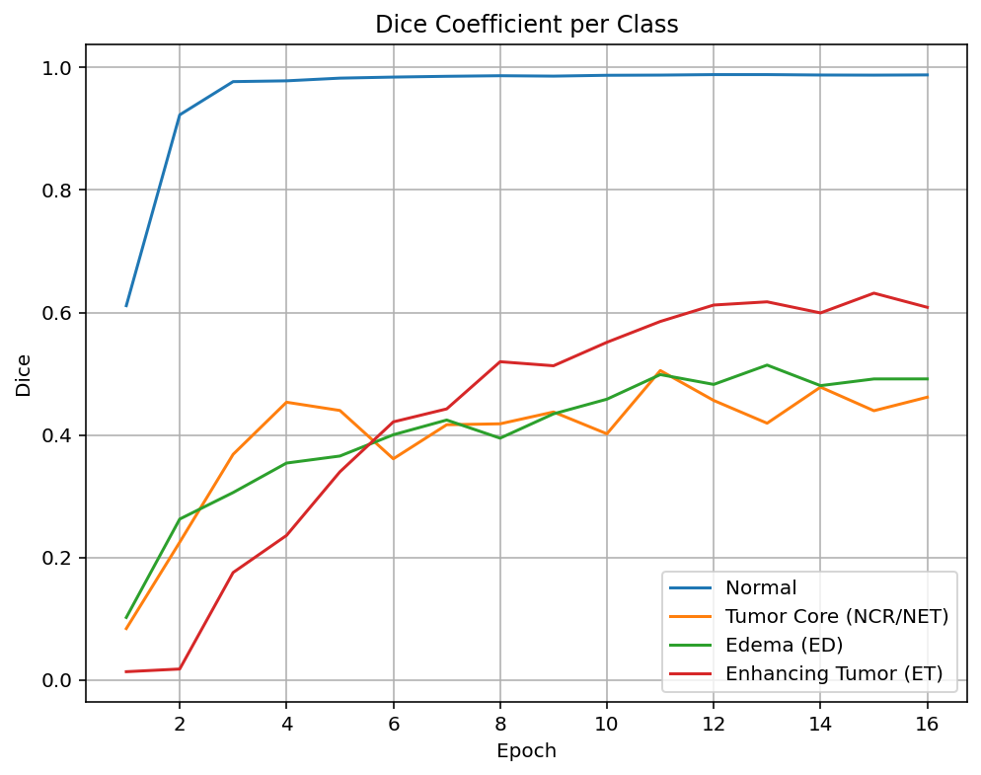
dResU-Net [31] | 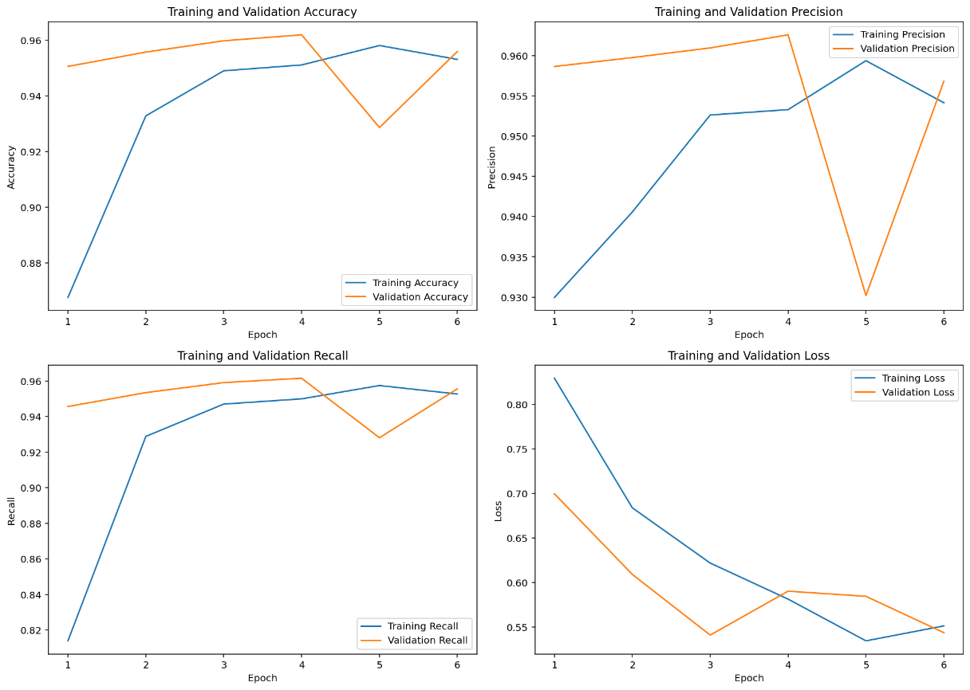  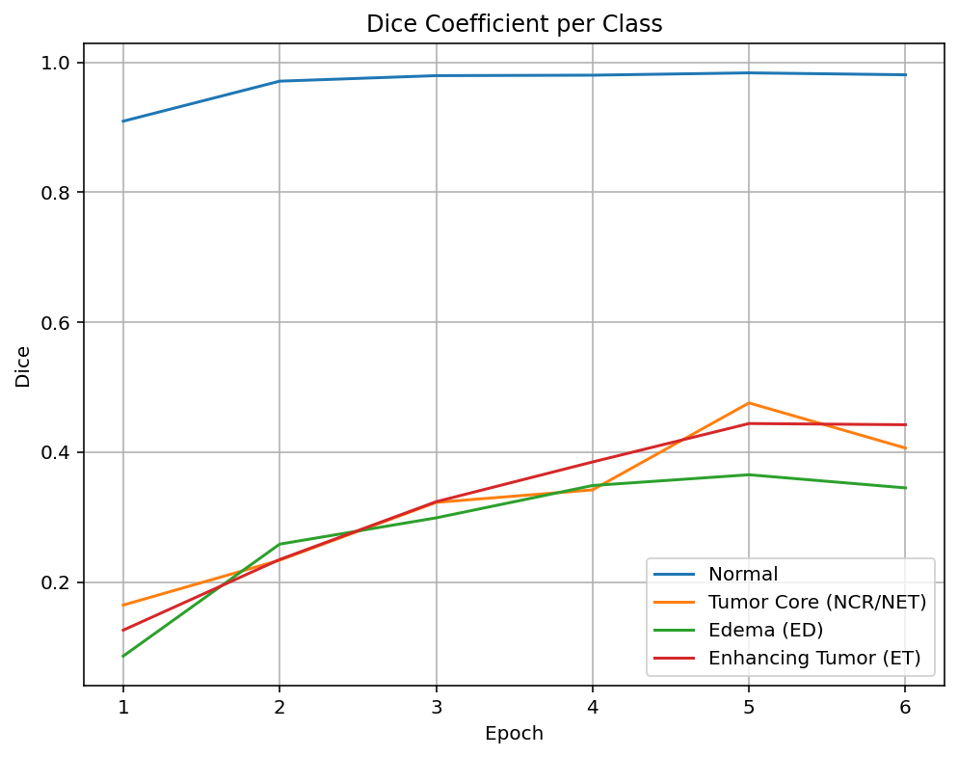
VcaNet [30] | 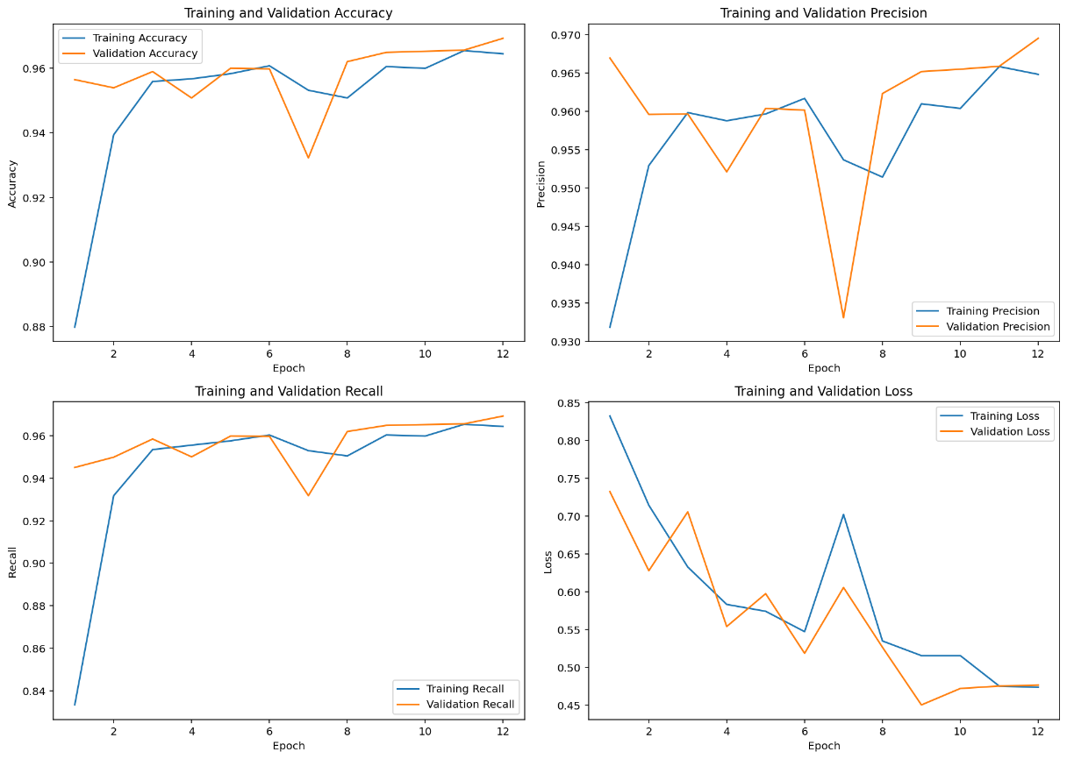  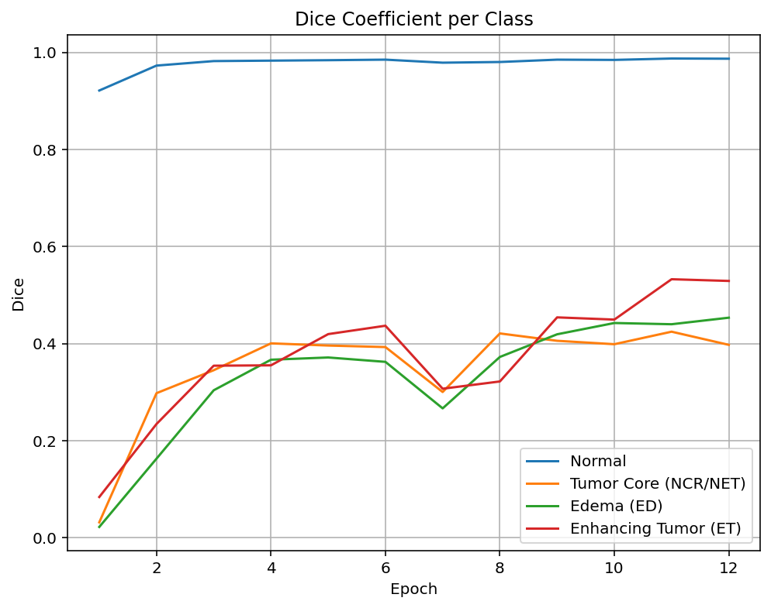
Ours | 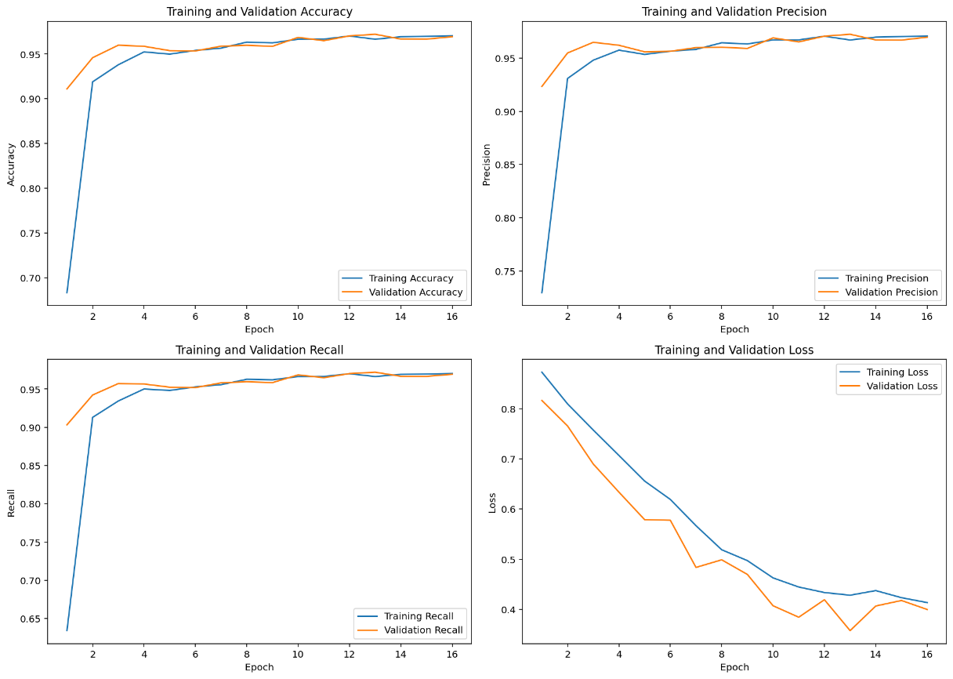  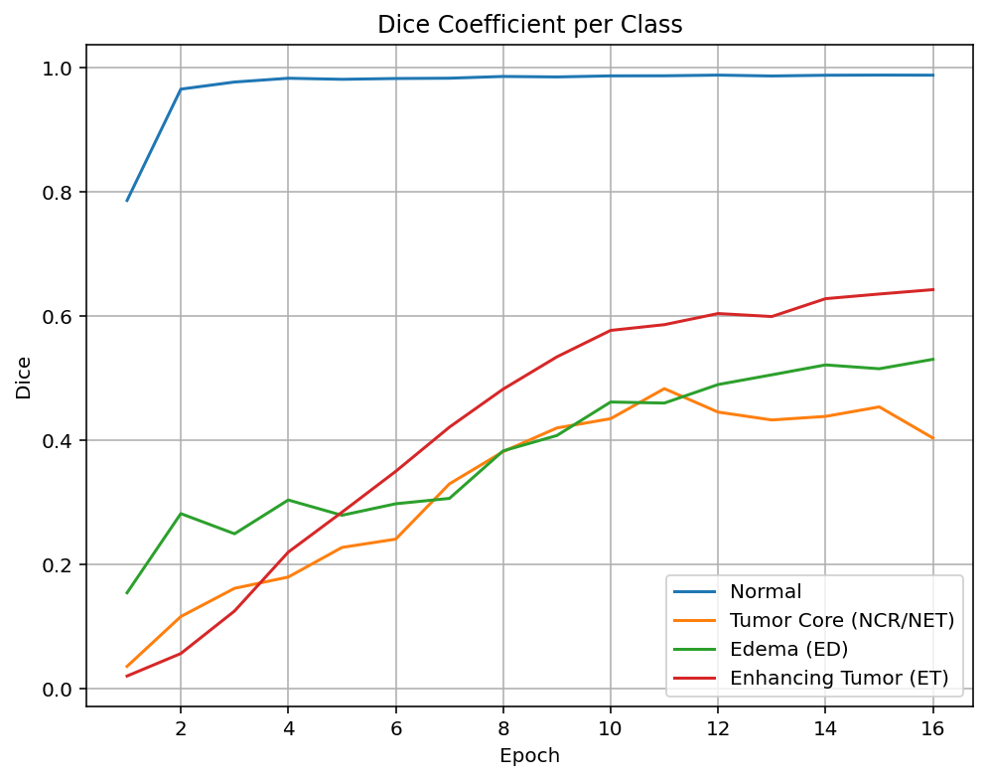

Table 3. Visual comparison of segmentation results for RAAGR2-Net [32], TransUNet [29], NestedFormer [34], dResU-Net [31], VcaNet [30], and our model on BraTS2020 defined test samples. The outcomes demonstrate the ability of each architecture to delineate tumor parts, including Tumor Core, Edema, and Enhancing Tumor.
Models | Results (Green: Edema (ED), Blue: Tumor Core (NCR/NET), Yellow: Enhancing Tumor (ET), Dark Purple (Background): Healthy tissue or non-tumor regions)
RAAGR2-Net [32] | 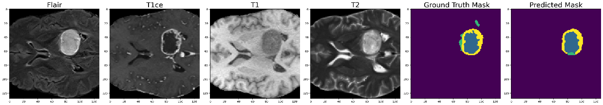  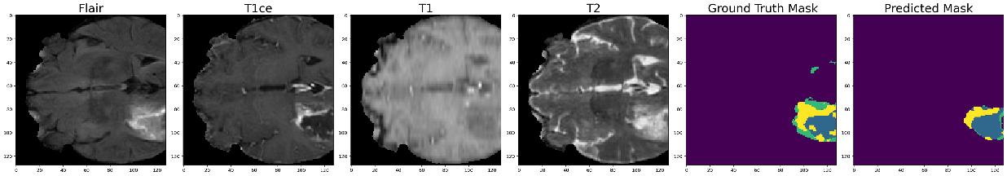  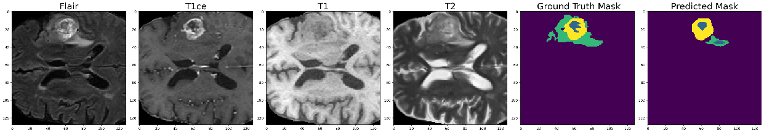
TransUNet [29] | 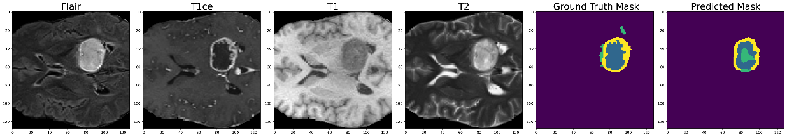  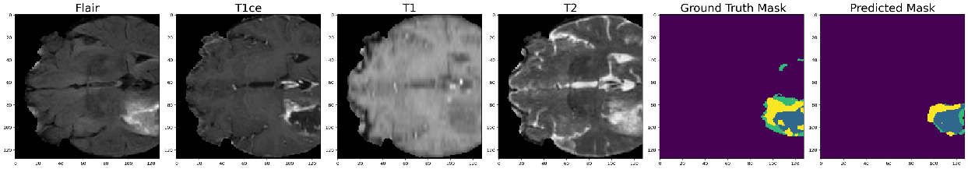  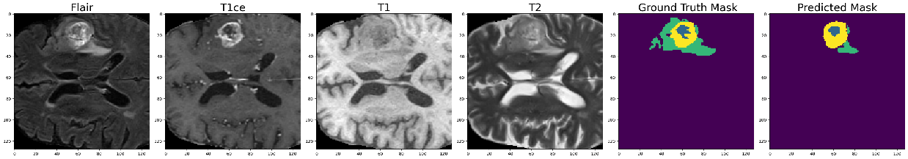
NestedFormer [34] | 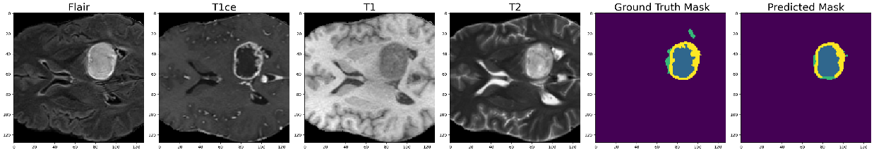  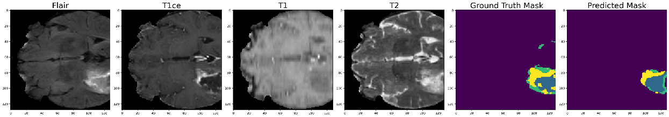  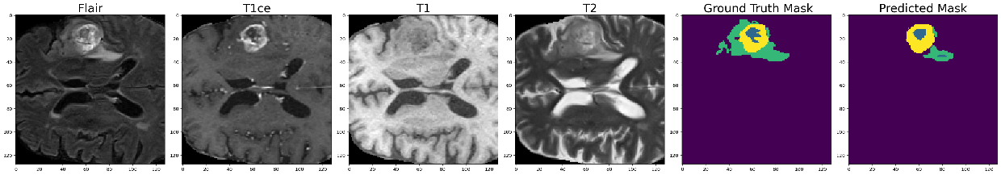
dResU-Net [31] | 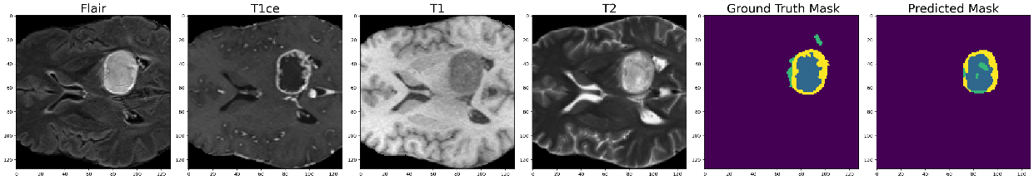  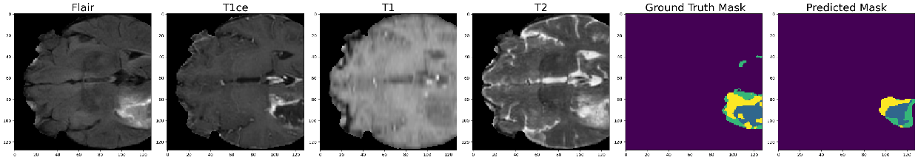  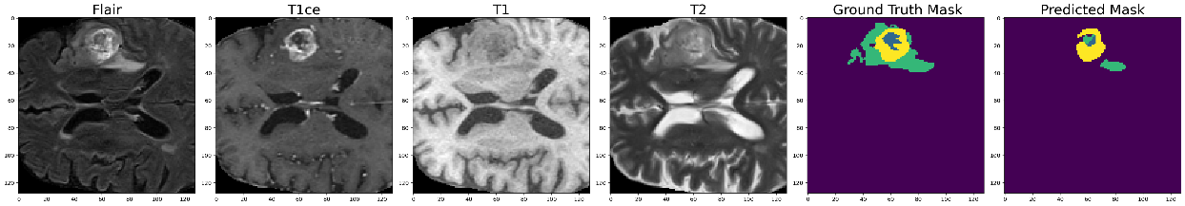
VcaNet [30] | 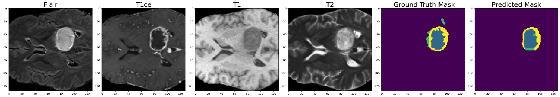  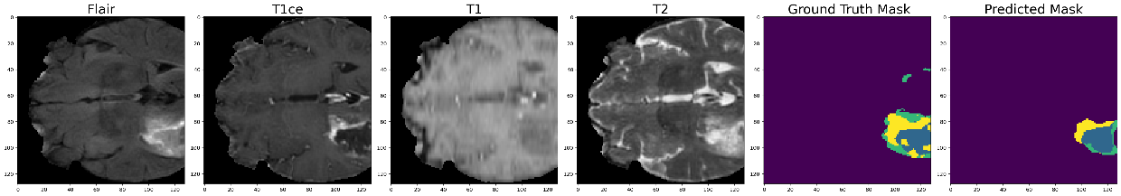  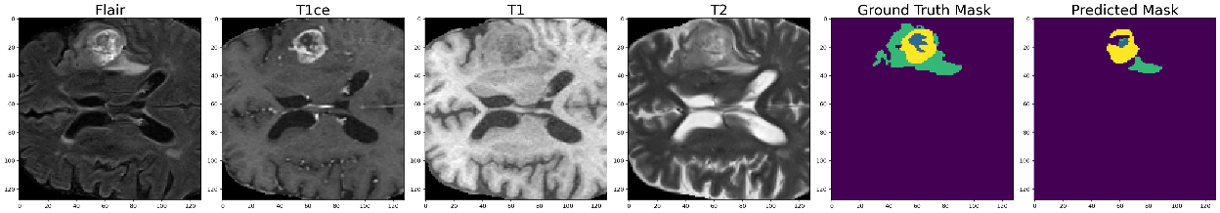
Ours | 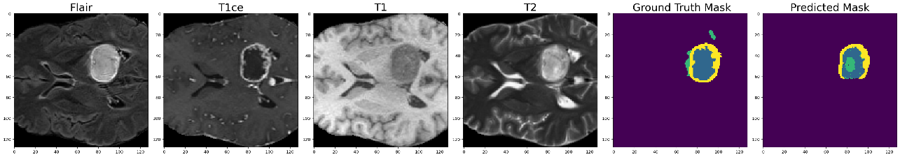  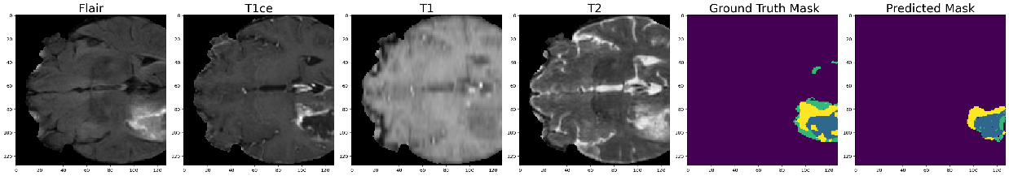  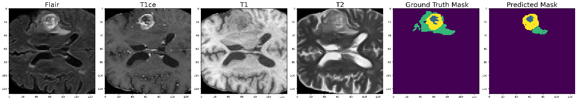

Table 4. Visual Analysis of Segmentation with Grad-CAM Attention Maps Using Some Network Layers.
Results
