Title: Taurine, glycine, tryptophan and kynurenine are key metabolic signatures for differentiation of extrapulmonary pleural tuberculosis
Running title: Metabolic classifiers for pleural TB
Authors: Khushboo Borah Slater^{1*}, Shagun Shagun¹, Holly May-Lewis², Ye Xu³, Roberto Stefan Almeida Ribeiro⁴, Raquel da Silva Correa⁴, Thiago Thomaz Mafort⁵, Ana Paula Santos⁵, Rogério Rufino⁵, Luciana Rodrigues⁴

¹Department of Biosciences, Faculty of Health and Life Sciences, University of Exeter, EX4 4QD
² School of Biosciences, University of Surrey, Guildford, United Kingdom
³ Department of Clinical Laboratory, Shanghai Ninth People’s Hospital, Shanghai Jiao Tong University School of Medicine, Shanghai, China
⁴Department of Pathology and Laboratories, Laboratory of Immunopathology, Medical Sciences Faculty (FCM), Rio de Janeiro State University (UERJ), Rio de Janeiro, RJ, Brazil.
⁵ Department of Pulmonary Care, Pedro Ernesto University Hospital (HUPE), UERJ, Rio de Janeiro, RJ, Brazil.

*Corresponding author email: k.borah-slater@exeter.ac.uk

Figure. S1
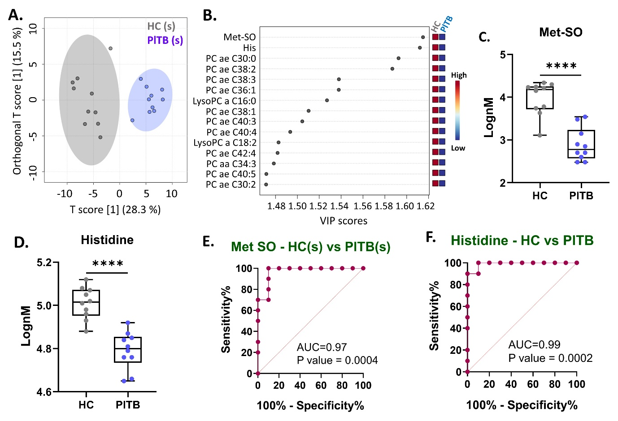

Figure. S1. Metabolite features for differentiation of pleural TB from healthy controls (HC). A. OPLS-DA plot showing the separation of PlTB from HC. B. VIP scores showing 15 ranked metabolites that separated PlTB from HC. OPLS-DA and VIP plots were generated using nM concentrations of the metabolite features. C. Box plot showing methionine sulfoxide (Met-SO) abundances in PlTB vs. HC. D. Box plot showing histidine in in PlTB vs. HC. E, F. Receiver operating characteristic (ROC) curves showing sensitivity and specificity of Met-SO and histidine as models to classify PlTB from HC. Values are mean ± S.D. (N=10). * Indicates statistically significant differences, p ≤0.05. HC: healthy control; PlTB: pleural TB; area under the curve (AUC).

Figure.S2
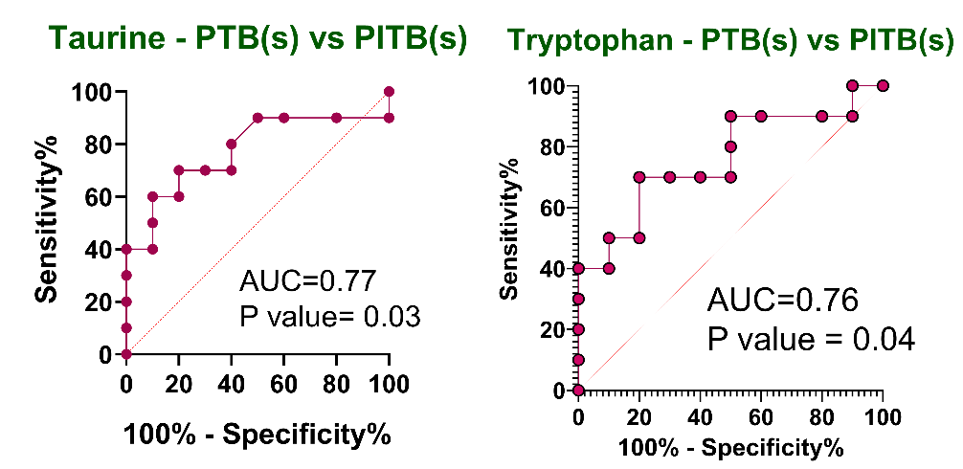
Figure. S2. ROC analysis of taurine and tryptophan as metabolic classifiers of PlTB vs PTB. Graph shows area under the curve (AUC) and sensitivity and specificity on X- and Y-axis respectively. PTB: pulmonary TB; PlTB: pleural TB.
Figure.S3
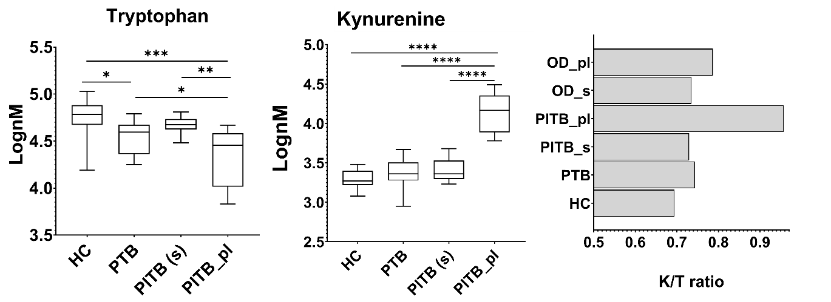

Figure. S3. Clinical quantification of tryptophan and kynurenine levels. Amounts of tryptophan (T) and kynurenine (K) quantified in HC, PTB and PlTB groups. Serum levels were measured for HC and PTB groups, and both serum and pleural fluid levels were measured for PlTB groups. K/T ratio was highest in pleural fluid of PlTB and OD and in serum of PTB. One-way Anova was used to compare the four groups, and multiple comparisons were performed using uncorrected Fisher’s LSD test; * indicates statistically significant differences. HC: healthy control; PTB: pulmonary TB; PlTB (s): serum from pleural TB; PlTB_pl: pleural fluid from pleural TB.

Figure.S4
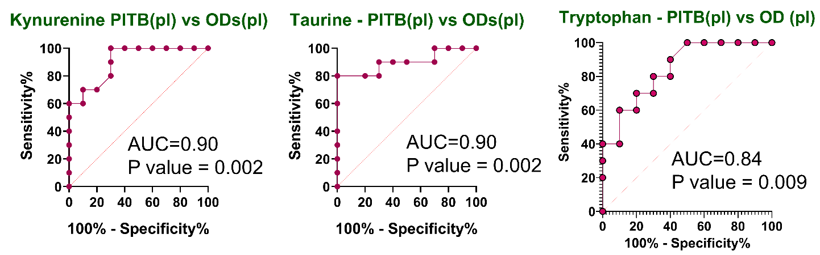

Figure. S4. ROC analysis of kynurenine, taurine and tryptophan as metabolic classifiers of PlTB vs PTB. Graph shows area under the curve (AUC) and sensitivity and specificity on X- and Y-axis respectively. PlTB: pleural TB; OD: non-TB pleural effusions.

