Supporting data

Exosomal viroid RNA and its association with PP2 and TET8 suggest a role in transmission
Neha Devi¹, Nisha Devi¹, Vasudha Sharma^{1,} Ravi Gupta², Sunny Dhir¹*, Yashika Walia¹*
¹Molecular Plant Virology Group, R&D Lab, Department of Bio-Sciences & Technology, Maharishi Markandeshwar (Deemed to be University), Mullana, Ambala-133207 HR India
²Plant Stress Physiology and Proteomics Laboratory, College of General Education, Kookmin University, Seoul, South Korea
Neha Devi: nehadevi611999@gmail.com
Vasudha Sharma: vasu.3096sharma@gmail.com
Nisha Devi: nishapahal99@gmail.com
Ravi Gupta: ravigupta@kookmin.ac.kr

*Corresponding Authors
Dr. Yashika Walia; yashikawalia@gmail.com, yashika.dhir@mmumullana.org
ORCID ID: 0000-0002-0796-0050
Dr. Sunny Dhir; sunny72155@gmail.com, sunny.dhir@mmumullana.org
ORCID ID: 0000-0002-3790-8333

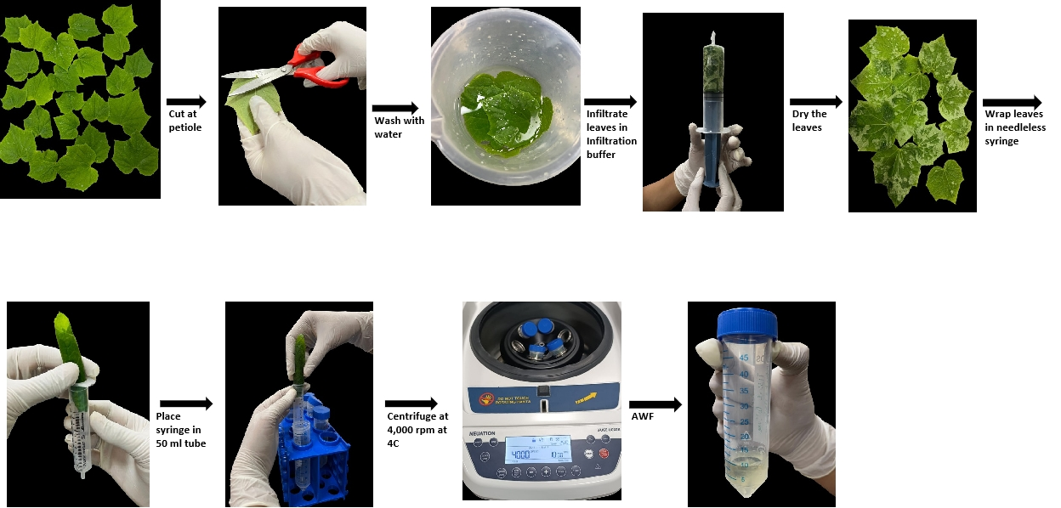
Fig. S1 showing the procedure followed for isolation of AWF from cucumber leaves

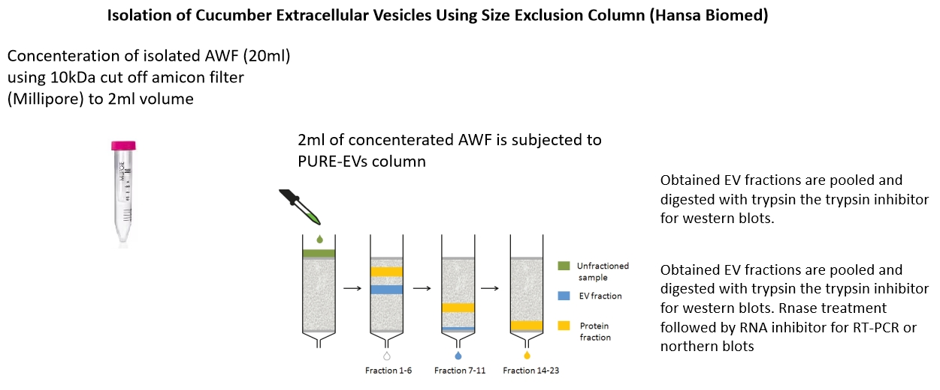
Fig. S2 showing the procedure followed for isolation of EVs from isolated AWF of cucumber

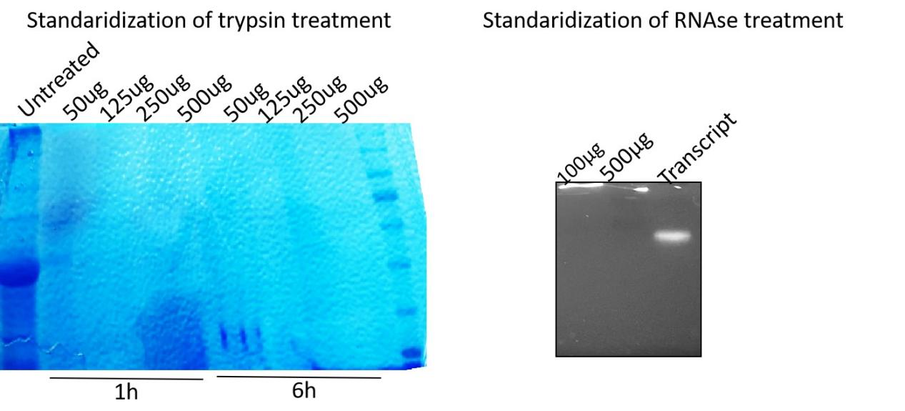
Fig. S3 and S4: Standardization of trypsin and RNase concentration for treatment of EVs with trypsin and RNase for protease protection assay.


1:10 1:100 1:1000
Dilution
minus ASSVd 3’prime biotin probe

Fig. S5: Showing labeling of minus strand of ASSVd transcript with Biotin at its 3’ end and its detection using anti anti-Streptavidin antibody.
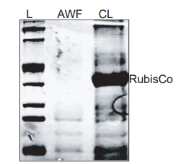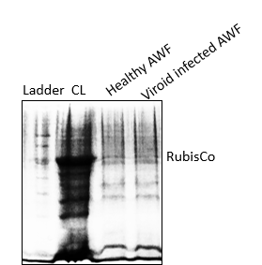
b
a
Viroid infected

Fig S6 a and b) Coomassie staining of SDS PAGE with total protein extract isolated from AWF and whole cell lysate (CL). Absence of Rubisco protein at 55kDa in AWF fraction compared to CL indicate purity of AWF and absence of cytosolic contamination
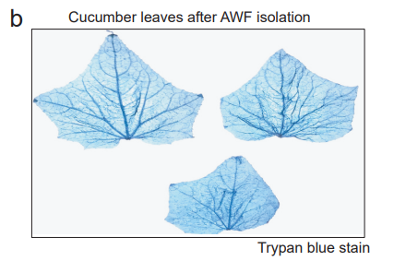
Fig. S7 Trypan blue staining of leaves used for AWF isolation. Absence of any cell damage as indicated by clear leaves suggest purity of isolated AWF free from cellular content.

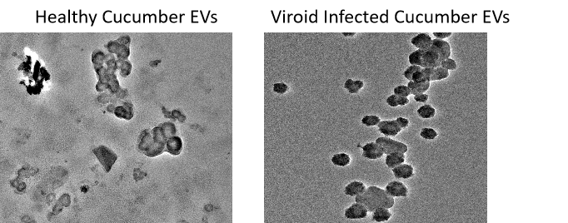
Fig. S8 Showing TEM images of EVs isolated from healthy cucumber apoplast and viroid infected cucumber apoplast
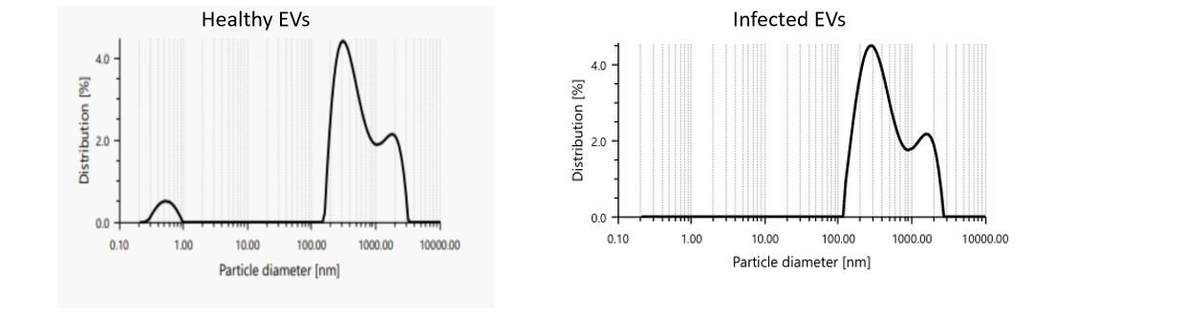
Fig. S9 Showing the diameter of particles in nanometre and particle distribution in percentage of EVs isolated from healthy cucumber apoplast and viroid infected cucumber apoplast.
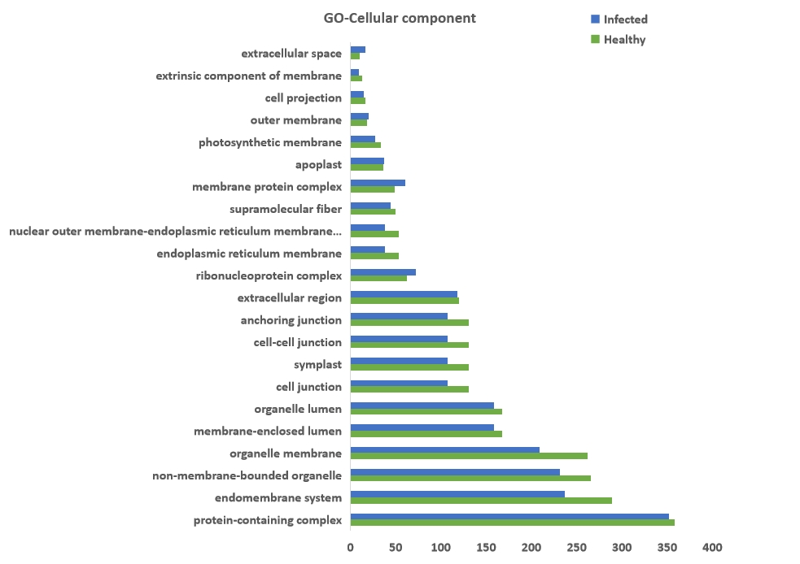

Fig. S10 Bar showing classification of viroid infected and healthy EV proteome based on sub-cellular component
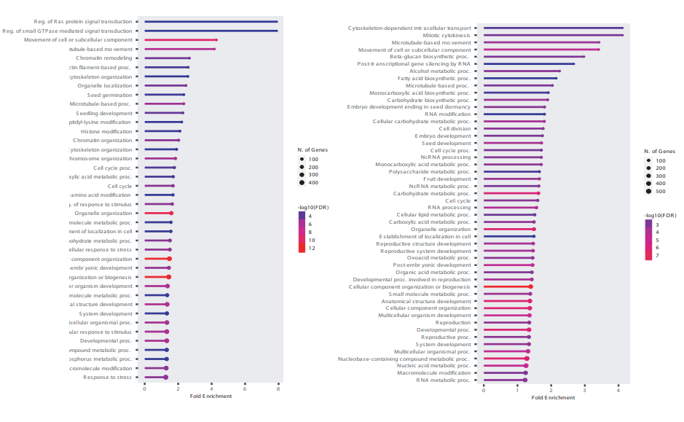
Viroid infected EVs
Healthy EVs

Fig. S11 Bar graph showing the classification of viroid infected and healthy EV proteome based on biological processes with notable enrichment of proteins related to non-coding RNA processes in viroid infected EVs compared to healthy EVs. (Each sample is pool of at least 50 biological replicates).
We tested whether Arabidopsis TET8 (AtTET8) antibodies would cross-react with cucumber Tet8 (CsTet8) protein and found that the Arabidopsis Tet8 (AT2G23810) ortholog in cucumber is Tet8/Lipoxygenase domain 3 (Csa1g287020) that shared 65.67% homology with AtTet8 (Fig. S7). Additionally, the 18 amino acids used to generate the peptide from the EC2 domain (Phytoab) were over 90% identical between the Arabidopsis and cucumber Tet8, suggesting that AtTet8 antibodies would cross-react with cucumber Tet8 (Fig. S8).

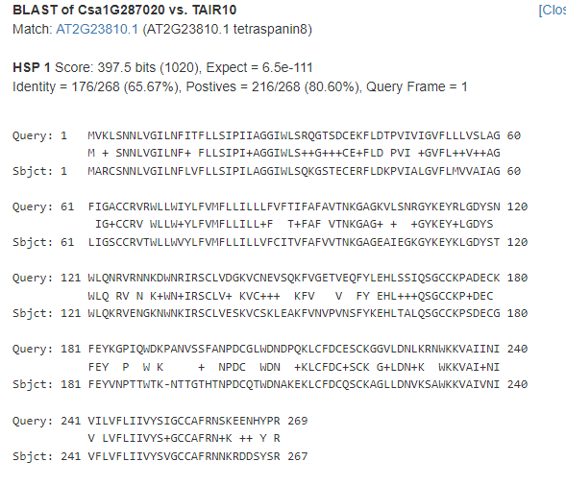

Fig. S12 Sequence Homology between CsTET8 and AtTET8 showing 65.67% identity between the two proteins. The EC2 domain froM which the antibody of Phytoab AtTET8 is made is marked in red boxes

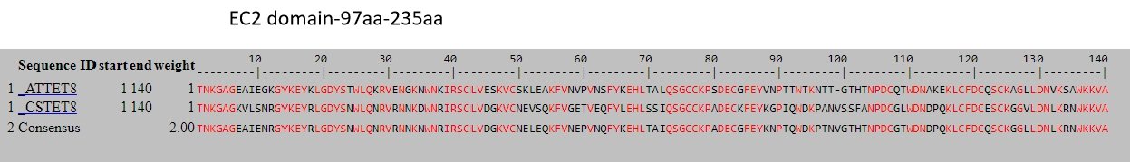
Fig. S13: Multiple alignment between EC2 domain of CsTET8 and AtTET8 showing consensus sequences between the two proteins
To further confirm this cross-reactivity, we cloned CsTET8 (Csa_1g287020), the cucumber ortholog of AtTET8, into the pSITE2CA and HApBA plant binary vector with a GFP tag for visualization. These recombinant plasmid and were then transiently expressed in Nicotiana plants, and western blot analysis using anti-GFP, anti-TET8 and anti-AtTET8 antibodies confirmed that the AtTET8 antibodies effectively recognized CsTET8 (Fig. S14 and S15) at size of approximately 55kDa and 25kDa, respectively. Based on these findings, we proceeded to use the available AtTET8 antibodies in further experiments.
Generation of constructs
The CsTET8 gene (Csa1g287020) was amplified from cucumber plants using the RT-PCR method. In brief, RNA was extracted from healthy cucumber plants with RNAiso Plus. Reverse transcription was performed with the Verso cDNA synthesis kit (Thermo). PCR amplification was carried out using Phusion DNA polymerase (Thermo) with specific primers (CsTET8F/R) (Table S1). The PCR products were resolved on a 1.5% agarose gel, and the desired bands were excised and purified using the GeneJET Thermo kit. The purified fragments were then cloned into the pJET1.2 vector (Thermo) and transformed into TOP10 competent cells. The recombinant plasmid was sequenced, confirming 100% identity to CsTET8.
The CsTET8 gene was further amplified using adaptor primers (CsTET8att F and CsTET8att R) and universal primers (Adaptor F/R) (Table S1). The amplified fragment was ligated into the PDONR207 vector using BP clonase (Invitrogen) and transformed into TOP10 competent cells. The transformed cells were plated on LA plates containing 100 mg/ml kanamycin. Recombinant plasmids were verified through colony PCR using the vector-specific primer (Nru R) and the gene-specific primer (CsTET8 F).
Subsequently, the pDONR-CsTET8 clone was sub cloned into the pSITE2CA vector and the HA-pBA vector (Chakrabarty et al., 2007) for expression under the CaMV35S promoter, with N-terminal GFP and HA tags, respectively, using the LR clonase enzyme (Thermo Scientific, USA). The ligated products were transformed into LA plates containing 50 mg/ml spectinomycin. Recombinant clones were screened by colony PCR with the CaMV35S forward primer and CsTET8R primer. The GFP-TET8 and HA-TET8 constructs were then transformed into the Agrobacteriun strain GV3101 using chemical transformation and used for transient expression analysis in Nicotiana benthamiana plants, as described by Walia et al. (2020).

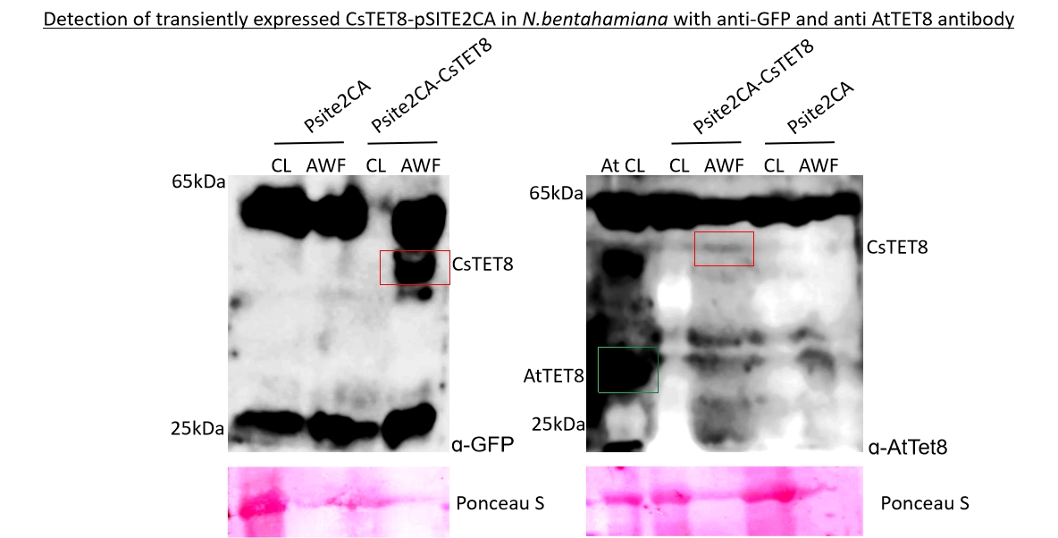

Fig. S14: a and b: western blot of N. benthamiana cell lysate (CL) and AWF showing transient expression of CsTET8-pSITE2CA in and empty vector (pSITE2CA) with 25kDa band corresponding to the size of only GFP and app. 55kDa size of CsTET8+GFP detected with (a) anti-GFP antibody. (b) AtTE8 antibody. The band corresponding to the size of CsTET8+GFP is detected in AWF and marked in box. The arabidopsis TET8 band detected with AtTET8 antibody at 30kDa as positive control is marked in green box (Fig.S9b)

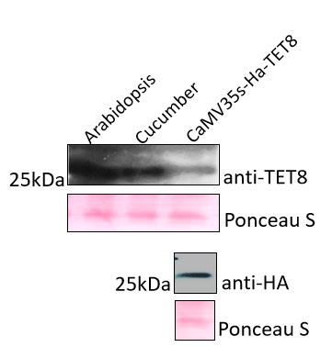

Fig. S15: western blot of N. benthamiana cell lysate (CL) showing transient expression of HA-CsTET8 and arabidopsis and cucumber cell lysate as control showing 30kDa band corresponding to the size of TET8 with anti-TET8 antibody and anti-HA antibody.

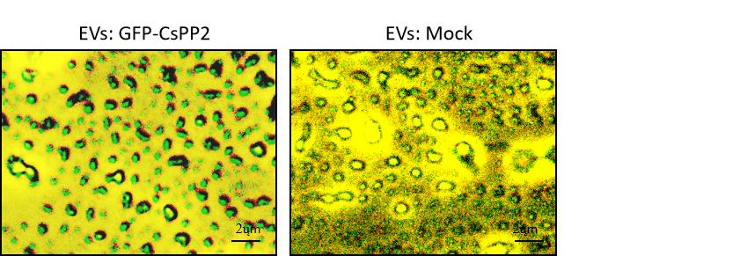
Fig. S16 Image showing EVs from GFP-CsPP2 expressing N. benthamiana and mock plants as visualized under fluorescence microscope using GFP Filter

The sub cellular localization of CsTET8 was monitored by transiently expressing the CsTET8-pSITE2CA in N. benthamiana which revealed the cytoplasmic and plasma membranous localization of CsTET8.
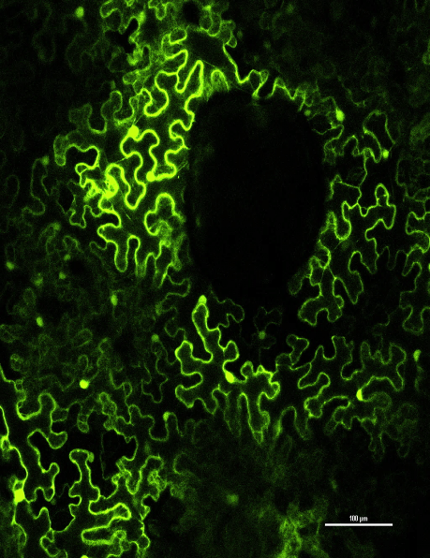
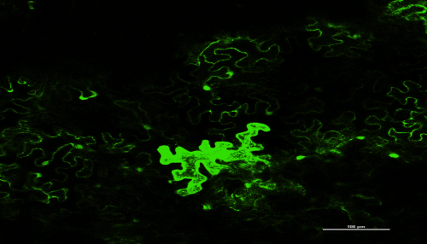
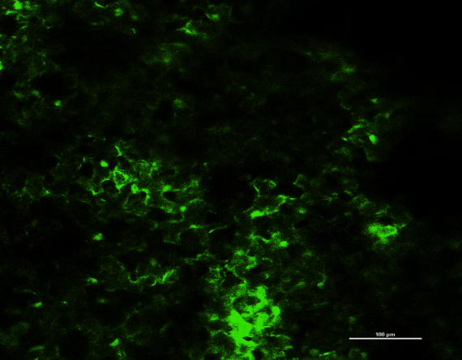
pSITE2CA-CsPP2
pSITE2CA
pSITE2CA-CsTET8
GFP
GFP-CsTET8
PP2-CsTET8

Fig. S17: Localization of GFP-CsTET8 and GFP-CsPP2 in N. benthamiana. Speckles are observed on plasma membrane for both CsTET8 and CsPP2 hinting towards its association with membranous bodies.

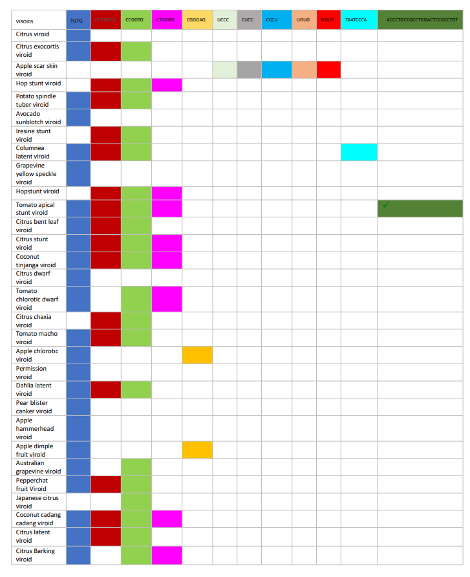
Fig. S18: EXOmotifs observed in various viroids

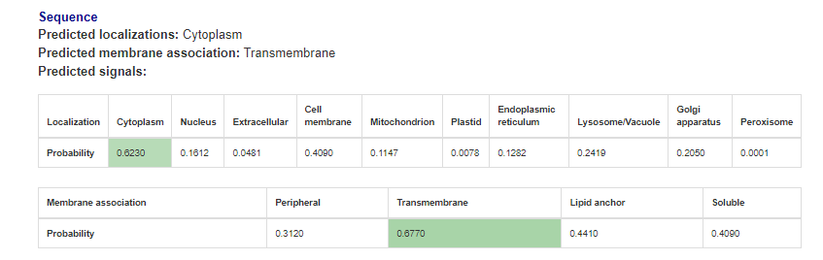
Fig. S19 Showing the presence of transmemberane domain in the CsPP2 as analyzed using DeepLoC 2.1 tool (DeepLoc 2.1 - DTU Health Tech - Bioinformatic Services)

Primer name | Sequence
ASSVdICC | GTCGACGAAGGCCGGTGAGAA
ASSVd ICH | GTCGACGACGACAGGTGAGTT
CsTET8 f | ATGGTCAAACTCAGCAATAATCTC
CsTET8 r | TCATTTCCATCTAGGATAATG
CsTET8 att F | AAAAAGCAGGCTCAATGGTCAAACTCAGCAATAATC
SCsTET8 att R | AGAAAGCTGGGTATCATTTCCATCTAGGATAATG
Adaptor F | GGG GAC AAG TTT GTA CAA AAA AGC AGG CT
Adaptor R | GGG GAC CAC TTT GTA CAA GAA AGC TGG GT
CaMV35S | GACTCACTATAGGGAGAG
Nru R | ACGGAAACAGCTATGAC
CsPP2-HIS F BamH1 | GAGGATCCATGGTTTGCATAGAGACAGAA
CsPP2-HIS R Xho1 | GACTCGAGTTTAGCATCCGCAACTGGATT
CsPP2 att F | AAAAAGCAGGCTCAAATGGTTTGCATAGAGACAGAA
CsPP2 att R | AGAAAGCTGGGTATAAAAAGCAGGCTCAA
FP1 | AGTAATACGACTCACTATAGGGGGGAAACACCTATTGTGTT
RP4 | GGTAAACACCGTGCGGTTC

Table S1: Primers used during the study

