Table S1 “Baseline characteristics and the clinical score of participants in the observational experiment”
Characteristics | Control group (n=29) | VLS group (n=30) | t/Z/ X2 | p-Value
Ages (years) | 43.24 ± 11.48 | 44.97 ± 11.60 | − 0.615 | 0.539
Weight (kg) | 56.44 ± 6.35 | 56.35 ± 5.27 | − 0.114 | 0.909
BMI (kg/m2) | 21.82 ± 2.02 | 22.07 ± 1.96 | − 0.553 | 0.580
Vaginal PH | 4.03 ± 0.25 | 4.08 ± 0.30 | − 0.390 | 0.696
HPV infection, n (%) | 2（6.90） | 2 (6.67) | 0.002 | 0.972
Hypertension, n (%) | 4 (13.80) | 6 (20.00) | − 0.063 | 0.525
Diabetes, n (%) | 1 (3.45) | 2 (6.67) | − 0.033 | 0.574
Currently smoking, n (%) | 4 (13.80) | 2 (6.67) | 0.072 | 0.365
Consumed alcohol, n (%) | 6 (20.68) | 5 (16.67) | 0.041 | 0.692
Ever pregnant, n (%) | 24 (82.76) | 26 (86.67) | − 0.039 | 0.676
Skin color | 0.52 ± 0.83 | 2.03 ± 0.85 | − 5.162 | 0.000
Skin elasticity | 0.38 ± 0.68 | 1.63 ± 0.89 | − 4.900 | 0.000
Pruritus degree | 0.62 ± 0.86 | 1.80 ± 0.85 | − 4.418 | 0.000
Lesion scope | 0.28 ± 0.59 | 2.00 ± 0.87 | − 5.786 | 0.000
Dyspareunia | 0.03 ± 0.59 | 0.07 ± 0.25 | − 0.558 | 0.577
IGA | 0.28 ± 0.45 | 3.50 ± 0.78 | − 6.829 | 0.000
DLQI | 0.34 ± 0.67 | 15.83 ± 3.71 | − 6.783 | 0.000
VQLI | 0.66 ± 1.20 | 24.03± 3.21 | − 6.757 | 0.000
C: health control; VLS: Vulvar lichen sclerosus; BMI: Body Mass Index; HPV: Human papillomavirus; IGA:Investigator’s global assessment; DLQL:Dermatology life quality index; VQLI:Vulvar quality of life index.

Table S2 “Bacteria isolated from vaginal swaps samples”
Bacteria Genus | Frequency
Bacteria Genus | C |  | V
Lactobacillus | 86 | 37
Gardnerella | 5 | 23
Streptococcus | 6 | 13
Staphylococcus | 4 | 2
Escherichia | 0 | 4
Ligilactobacillus salivarius | 1 | 1
Corynebacterium callunae | 0 | 1
Total | 102 | 81
C: Health control; V: Vulvar lichen sclerosus.

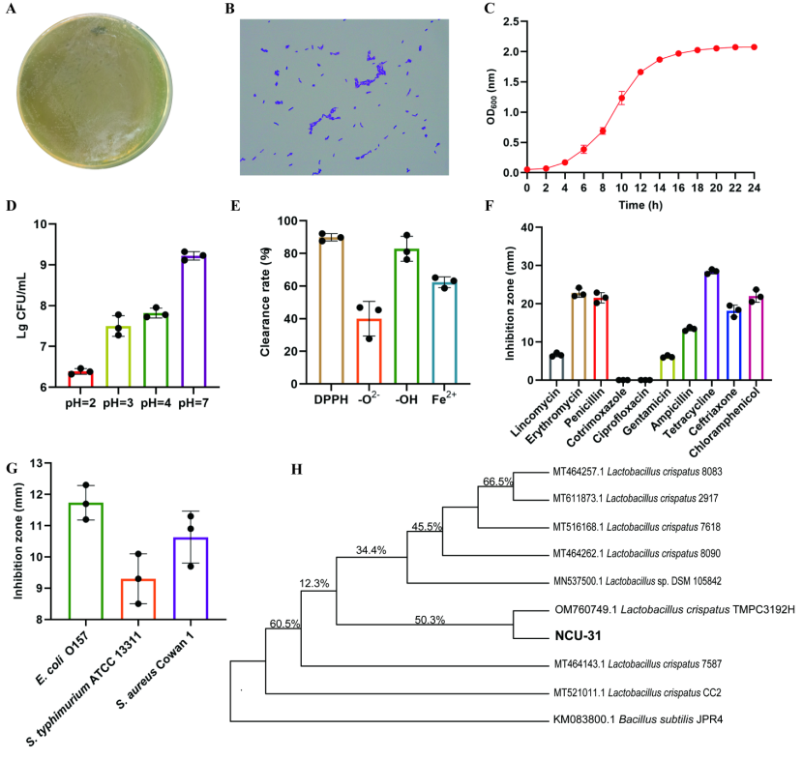
Figure S1. Evaluation of the probiotic properties of L. crispatus in vitro. (A) Images of L. crispatus plates. (B) Gram stain images of L. crispatus. (C) Growth characteristic of L. crispatus. (D) Acid tolerance of L. crispatus. (E) Assessment of the antioxidant capacity of L. crispatus postbiotics. (F) Evaluation of resistance properties in L. crispatus. (G) Inhibition of common pathogenic bacteria growth by L. crispatus postbiotics. (H) Neighbor-Joining phylogenetic tree of strain L. crispatus.
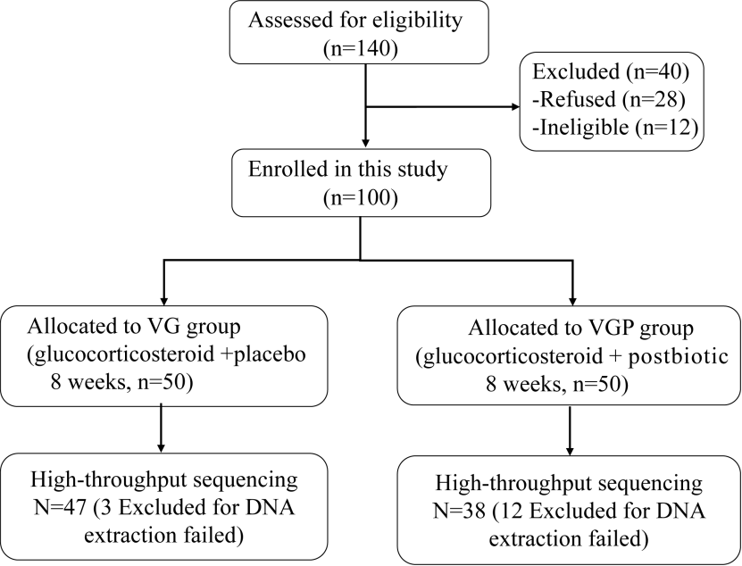
Figure S2. Flow chart of patient recruitment and randomization.
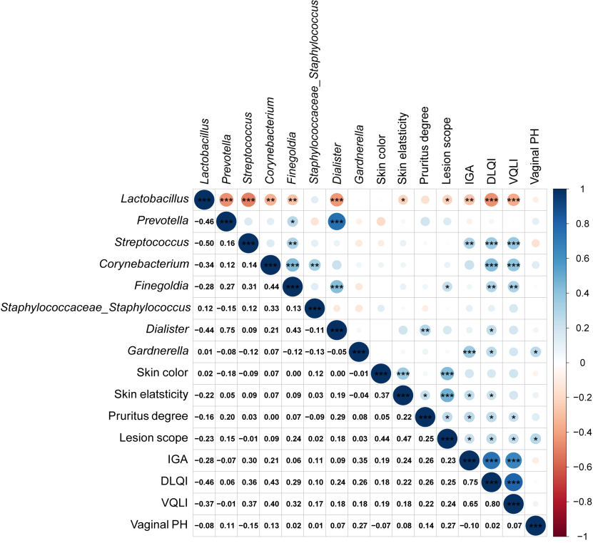
Figure S3. Spearman correlation analysis was conducted to examine the relationship between the vulvar skin microbiota and crucial clinical parameters, such as skin symptoms, signs, and vaginal pH in VLS patients. A red hue signifies a negative correlation, whereas blue signifies a positive correlation. * p < 0.05, ** p < 0.01.

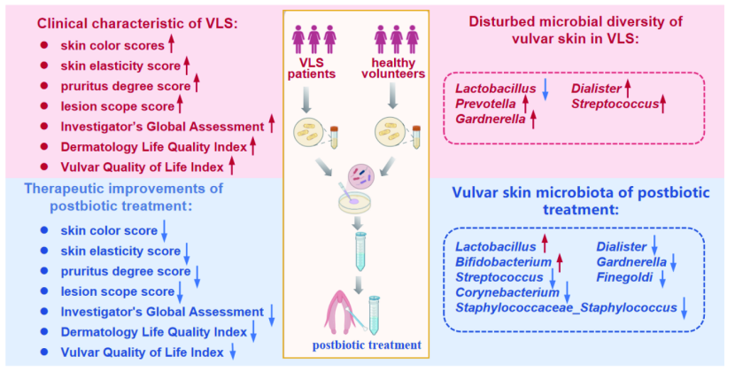
Figure S4. Schematic diagram of how L. crispatus postbiotic influences the clinical skin symptoms of VLS patients and the associated imbalance of skin microbiota.

