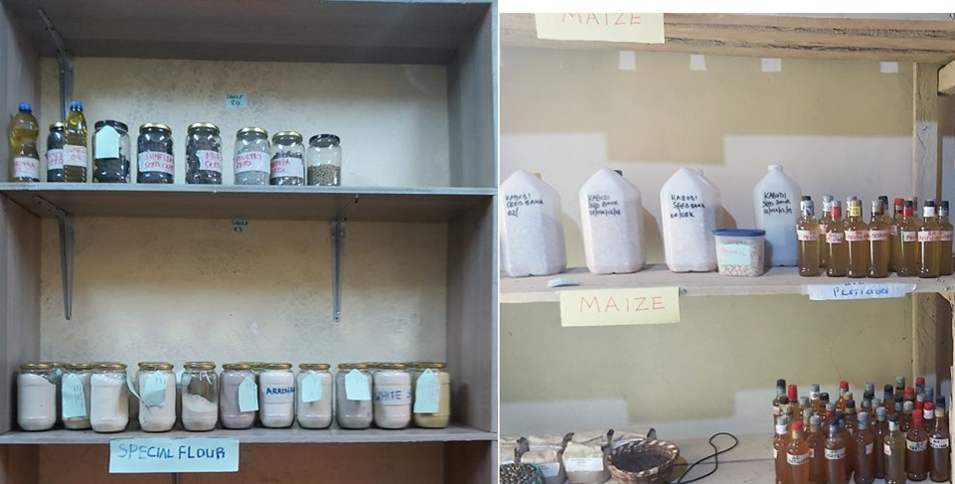
Fig S1. Examples of value-added products developed by community seed banks in Kenya. Top left: seed varieties; Bottom left: composite flours; right: sunflower oil and biopesticides/foliar fertilizer. (Photo credit: Dr. Benson Ouma Nyongesa)

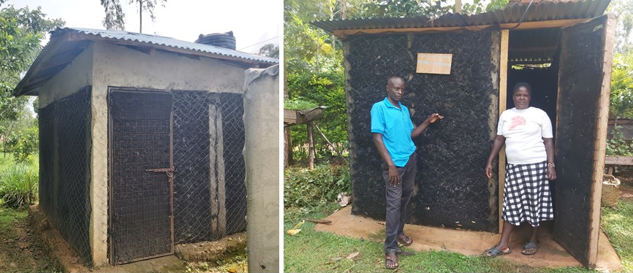
Fig S2. The Vihiga Community Seed Bank (left) and Joseck Mukuna and Family Seed Bank (right) utilize a charcoal-cooled storage structure for vegetable preservation. (Photo credit: Dr. Benson Ouma Nyongesa).
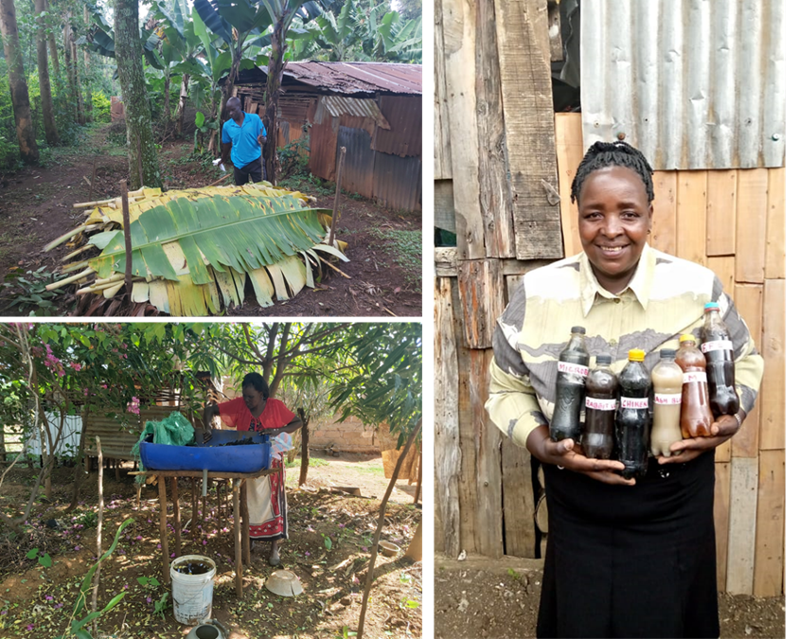
Fig S3. Nature-positive farming practices promoted by community seed banks in Kenya. Top left: composting; left bottom: vermijiuce production; right: various bio-inputs, including rabbit urine, chicken waste foliar fertilizer, fermented plant extracts, and effective microbes. (Photo credit: Dr. Benson Ouma Nyongesa

