Supplementary tables and figures

Supplementary 1: Search strategy

Supplementary table 1: Assessment of included trials reporting quality of life using CONSORT PRO extension checklist
Supplementary table 2: Studies assessing reporting of quality of life in cancer trials

Supplementary figure 1: Kaplan-Meier curves of time to publication of HRQoL results
Supplementary figure 2: Kaplan-Meier curves of time to secondary publication of HRQoL data

Supplementary1: Search strategy
MEDLINE
1. exp High‐Throughput Nucleotide Sequencing/
2. exp Molecular Sequence Annotation/
3. (next generation or next‐gen or NGS).ti,ab,kw.
4. sequence analysis, DNA/
5. 1 or 2 or 3 or 4
6. exp Molecular Targeted Therapy/
7. ((match* or non‐match* or molecular* or target*) adj3 (therap* or group* or mutation* or compound*)).ti,ab,kw.
8. ((molecular* or tumor* or tumour*) adj3 (marker* or mutation* or screen* or understanding* or alteration* or subtype*)).ti,ab,kw.
9. diagnostic precision.mp.
10. ((action* or target*) adj3 mutation*).ti,ab,kw.
11. genetic alteration*.mp.
12. ((personal* or individual*) adj3 (treatment* or therap*)).ti,ab,kw.
13. 6 or 7 or 8 or 9 or 10 or 11 or 12
14. exp Neoplasms/
15. (cancer* or tumor* or tumour* or neoplas* or malignan* or carcinoma* or adenocarcinoma* or choriocarcinoma* or leukemia* or leukaemia* or metastat* or sarcoma* or teratoma* or oncolog*).mp.
16. 14 or 15
17. 5 and 13 and 16
18. randomized controlled trial.pt.
19. controlled clinical trial.pt.
20. randomized.ab.
21. placebo.ab.
22. drug therapy.fs.
23. randomly.ab.
24. trial.ti.
25. groups.ab.
26. exp cohort studies/ or exp epidemiologic studies/ or exp clinical trial/ or exp evaluation studies as topic/ or exp statistics as topic/
27. ((control and (group* or study)) or (time and factors) or program or survey* or ci or cohort or comparative stud* or evaluation studies or follow up*).mp.
28. 18 or 19 or 20 or 21 or 22 or 23 or 24 or 25 or 26 or 27
29. (animals/ not humans/) or comment/ or editorial/ or exp review/ or meta analysis/ or consensus/ or exp guideline/
30. hi.fs. or case report.mp.
31. 29 or 30
32. 28 not 31
33. 17 and 32

Embase
1. exp high throughput sequencing/
2. exp molecular genetics/
3. (next generation or next‐gen or NGS).ti,ab,kw.
4. DNA sequencing/
5. 1 or 2 or 3 or 4
6. exp molecularly targeted therapy/
7. ((match* or non‐match* or molecular* or target*) adj3 (therap* or group* or mutation* or
compound*)).ti,ab,kw.
8. ((molecular* or tumor* or tumour*) adj3 (marker* or mutation* or screen* or understanding* or alteration*
or subtype*)).ti,ab,kw.
9. diagnostic precision.mp.
10. ((action* or target*) adj3 mutation*).ti,ab,kw.
11. genetic alteration*.mp.
12. ((personal* or individual*) adj3 (treatment* or therap*)).ti,ab,kw.
13. 6 or 7 or 8 or 9 or 10 or 11 or 12
14. exp neoplasm/
15. (cancer* or tumor* or tumour* or neoplas* or malignan* or carcinoma* or adenocarcinoma* or
choriocarcinoma* or leukemia* or leukaemia* or metastat* or sarcoma* or teratoma* or oncolog*).ti,ab,kw.
16. 14 or 15
17. 5 and 13 and 16
18. crossover procedure/
19. double‐blind procedure/
20. randomized controlled trial/
21. single‐blind procedure/
22. random*.mp.
23. factorial*.mp.
24. (crossover* or cross over* or cross‐over*).mp.
25. placebo*.mp.
26. (double* adj blind*).mp.
27. (singl* adj blind*).mp.
28. assign*.mp.
29. allocat*.mp.
30. volunteer*.mp.
31. exp cohort studies/ or exp epidemiologic studies/ or exp clinical trial/ or exp evaluation studies as topic/ or
exp statistics as topic/
32. ((control and (group* or study)) or (time and factors) or program or survey* or ci or cohort or comparative
stud* or evaluation studies or follow up*).mp.
33. 18 or 19 or 20 or 21 or 22 or 23 or 24 or 25 or 26 or 27 or 28 or 29 or 30 or 31 or 32
34. (animals/ not humans/) or comment/ or editorial/ or exp review/ or meta analysis/ or consensus/ or exp
practice guideline/
35. hi.fs. or case report.mp.
36. 34 or 35
37. 33 not 36
38. 17 and 37

CENTRAL
#1 MeSH descriptor: [High‐Throughput Nucleotide Sequencing] explode all trees
#2 MeSH descriptor: [Molecular Sequence Annotation] explode all trees
#3 (next gen* or NGS)
#4 MeSH descriptor: [Sequence Analysis, DNA] explode all trees
#5 #1 or #2 or #3 or #4
#6 MeSH descriptor: [Molecular Targeted Therapy] explode all trees
#7 ((match* or non‐match* or molecular* or target*) near/3 (therap* or group* or mutation* or compound*))
#8 ((molecular* or tumor* or tumour*) near/3 (marker* or mutation* or screen* or understanding* or alteration*
or subtype*))
#9 diagnostic precision
#10 ((action* or target*) near/3 mutation*)
#11 genetic alteration*
#12 ((personal* or individual*) near/3 (treatment* or therap*))
#13 #6 or #7 or #8 or #9 or #10 or #11 or #12
#14 MeSH descriptor: [Neoplasms] explode all trees
#15 (cancer* or tumor* or tumour* or neoplas* or malignan* or carcinoma* or adenocarcinoma* or
choriocarcinoma* or leukemia* or leukaemia* or metastat* or sarcoma* or teratoma* or oncolog*)
#16 #14 or #15
#17 #5 and #13 and #16

Supplementary table 1: Assessment of included trials reporting quality of life using CONSORT PRO extension checklist [1]
Study ID | RCTs reporting HRQoL in primary, secondary publication or both from 2013 | Structured summary of trial design, methods, results, and conclusions. | Scientific background and explanation of rationale. | Specific objectives or hypotheses. | Completely defined prespecified primary and secondary outcome measures, including how and when they were assessed. | Statistical methods used to compare groups for primary and secondary outcomes. | For each group, numbers of participants who were randomly assigned, received intended treatment, and were analyzed for primary outcome. | A table showing baseline demographic and clinical characteristics for each group. | For each primary and secondary outcome, results for each group, and estimated effect size and its precision. | Trial limitations, addressing sources of potential bias, imprecision, and, if relevant, multiplicity of analyses and Generalizability of the trial findings. | Interpretation consistent with results, balancing benefits and harms, and considering other relevant evidence.
Abdou-Alfa 2020 [2] | Yes | No | No | No | Yes | No | Yes | Yes | Yes | No | No
Amado 2008 [3] | Yes | No | No | No | No | No | No | No | No | No | No
Andre 2019 [4] | Yes | No | No | No | Yes | No | Yes | Yes | Yes | No | No
Colombo 2022 [5] | Yes | No | No | No | No | No | No | No | No | No | No
Brugger 2011 [6] | Yes | No | No | No | No | No | No | No | No | No | No
Chi 2023 [7] | Yes | Yes | No | No | Yes | Yes | Yes | No | Yes | No | No
Ciuleanu 2012 [8] | Yes | No | No | No | Yes | No | Yes | Yes | Yes | No | No
Clarke 2018 [9] | Yes | No | No | No | Yes | No | Yes | No | No | No | No
Clarke 2022 [10] | Yes | Yes | No | No | Yes | Yes | No | No | No | No | No
Dash 2020 [11] | Yes | No | No | No | No | No | Yes | Yes | Yes | No | No
De Bono 2020 [12] | Yes | No | No | No | Yes | No | Yes | Yes | Yes | No | No
Dieras 2020 [13] | Yes | No | No | No | Yes | No | Yes | Yes | Yes | Yes | No
Grob 2015 [14] | Yes | Yes | No | No | Yes | Yes | Yes | Yes | Yes | Yes | No
Kristeleit 2022 [15] | Yes | No | No | No | Yes | No | No | No | No | No | No
Lee 2024 [16] | Yes | No | No | No | Yes | No | Yes | Yes | Yes | No | No
Litton 2018 [17] | Yes | Yes | No | No | Yes | No | Yes | Yes | Yes | No | No
Liu 2020 [18] | Yes | Yes | No | No | Yes | No | Yes | Yes | Yes | No | No
Mok 2017 [19] | Yes | No | No | No | Yes | No | Yes | Yes | Yes | No | No
Nicum 2024 [20] | Yes | No | No | No | No | No | No | No | No | No | No
Penson 2020 [21] | Yes | No | No | No | Yes | No | Yes | Yes | Yes | No | No
Perl 2019 [22] | Yes | No | No | No | No | No | No | No | Yes | No | No
Robson 2017 [23] | Yes | No | No | No | Yes | No | Yes | Yes | Yes | No | No
Soria 2015 [24] | Yes | No | No | No | No | No | Yes | Yes | Yes | No | No
Soulieres 2018 [25] | Yes | No | No | No | Yes | No | Yes | Yes | Yes | No | No
Turner 2023 [26] | Yes | No | No | No | No | No | No | No | No | No | No
Wells 2012 [27] | Yes | No | No | No | No | No | No | No | No | No | No

Supplementary table 2: Studies assessing reporting of quality of life in cancer trials
Study | Years Included | Included Trials | Number of RCTs | Cancer Type | Patient Population | Treatment Type | Key Findings
Brundage 2010 [28] | 2002–08 | Phase III RCTs | 794 | All cancers | All cancer patients | All therapies | 25.4% included non-Small Cell Lung Cancer as a primary endpoint; 14% published HRQoL separately.
Di Costanzo 2023 [29] | 2010–22 | Phase III RCTs | 85 | Advanced genitourinary cancers | Advanced cancer patients | All therapies | Only 1.2% listed HRQoL as primary endpoint; 29.4% did not include HRQoL at all; 65.9% did not report HRQoL in primary publications; 21.2% met ≥1 CONSORT-PRO item.
Hwang 2018 [30] | 2010–15 | Phase III RCTs | 352 | Solid tumours | Advanced cancer patients | All therapies | 54% included HRQoL; 23% did not report HRQoL; no strong association between PFS benefit and HRQoL improvement.
Marandino 2018 [31] | 2012–16 | Phase III RCTs | 446 | Solid tumours | All cancer patients | All therapies | 47.1% did not include HRQoL as an endpoint; 37.6% did not report HRQoL data; 12.5%, 30.9%, and 40.3% reported in secondary publications at 12, 24, and 36 months.
Salomone 2022 [32] | 2010–21 | Phase III RCTs | 172 | Non-Small Cell Lung Cancer | Metastatic patients | All therapies | 23.3% did not include HRQoL; 59.3% did not report HRQoL in primary publications; only 19.6% reported in secondary publications by 36 months.
Samuel 2022 [33] | 2019 | Phase III RCTs | 45 | All cancers | Advanced cancer patients | All therapies | Only 24% reported HRQoL; HRQoL benefit correlated with OS benefit but not with PFS.
Servetto 2022 [34] | 2013–21 | Phase III RCTs | 106 | Solid tumours | All cancer patients | Immunotherapy | 78.3% did not report HRQoL in primary publication; 48.5% did not report HRQoL at all; median delay of 33.6 months to secondary HRQoL publication.
St Germain 2020 [35] | 1999–2015 | National cancer institute-funded trials | 108 | All cancers | All cancer patients | All therapies | 33% reported HRQoL as separate publication; 62% included HRQoL in any form; substantial underreporting noted despite NCI funding.
Sherry 2025 [36] | 2002-24 | Phase III RCTs | 791 | All cancers | All cancer patients | All therapies | Only 34% of 791 oncology RCTs published HRQoL results, and just 6% demonstrated superiority in both overall survival and HRQoL, highlighting substantial underreporting and limited patient-centered benefit.
Waisberg 2022 [37] | 2000–20 | Phase III RCTs | 85 | Non-Small Cell Lung Cancer | Untreated advanced cancer patients | All therapies | Only 11.8% fulfilled all CONSORT-PRO items; median of 3 criteria met; 24.7% included HRQoL subgroup analyses.
RCTs: Randomised control trials; HRQoL: Health related quality of life; CONSORT-PRO

Supplementary figure 1: (A) Kaplan-Meier curves of time to publication of HRQoL results (n = 26). (B) Kaplan-Meier curve of differential time to publication of HRQoL results between positive and negative RCTs (positive trials, n = 22; negative trials, n = 4).
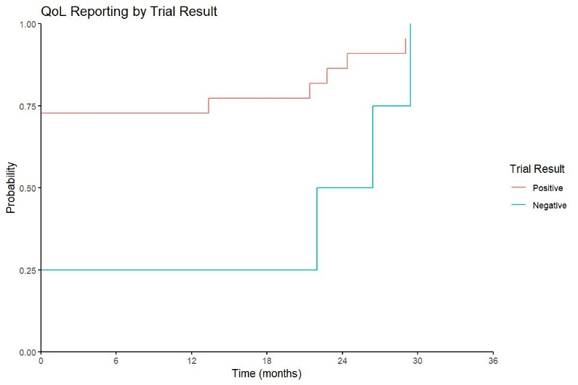
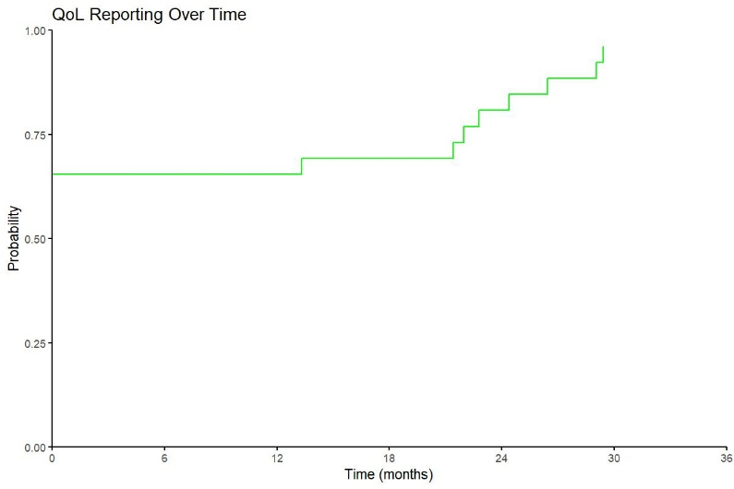

1 [A] 1 [B]

Supplementary figure 2. (A) Kaplan-Meier curves of time to secondary publication of HRQoL data, for RCTs not reporting HRQoL data in primary publication (n = 44). (B) Kaplan-Meier curve of differential time to secondary publication with HRQoL data between positive and negative trials, for RCTs not reporting HRQoL results in primary paper (positive trials, n = 33; negative trials, n = 11).

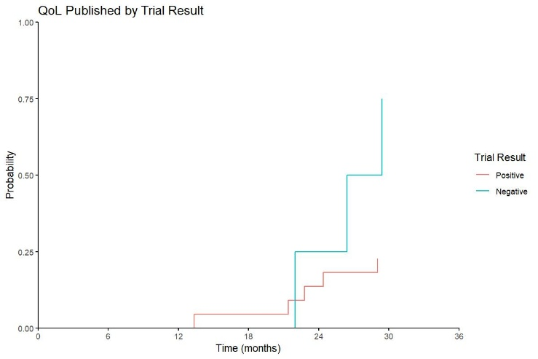
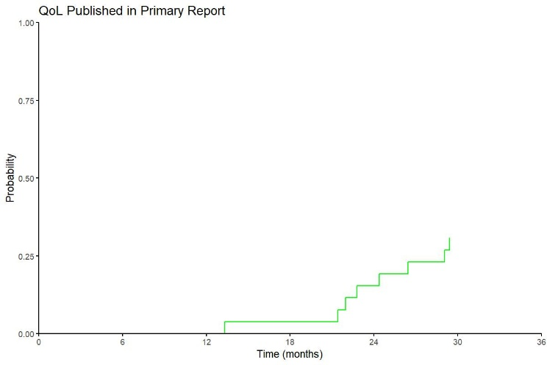

2 [A] 2 [B]

References
1. Calvert M, Blazeby J, Altman DG, Revicki DA, Moher D, Brundage MD, Group CP. Reporting of patient-reported outcomes in randomized trials: the CONSORT PRO extension. JAMA. 2013;309(8):814-22. doi: 10.1001/jama.2013.879. PubMed PMID: 23443445.
2. Abou-Alfa GK, Sahai V, Hollebecque A, Vaccaro G, Melisi D, Al-Rajabi R, et al. Pemigatinib for previously treated, locally advanced or metastatic cholangiocarcinoma: a multicentre, open-label, phase 2 study. Lancet Oncol. 2020;21(5):671-84. Epub 20200320. doi: 10.1016/S1470-2045(20)30109-1. PubMed PMID: 32203698; PubMed Central PMCID: PMCPMC8461541.
3. Amado RG, Wolf M, Peeters M, Van Cutsem E, Siena S, Freeman DJ, et al. Wild-type KRAS is required for panitumumab efficacy in patients with metastatic colorectal cancer. J Clin Oncol. 2008;26(10):1626-34. Epub 20080303. doi: 10.1200/JCO.2007.14.7116. PubMed PMID: 18316791.
4. Andre F, Ciruelos E, Rubovszky G, Campone M, Loibl S, Rugo HS, et al. Alpelisib for PIK3CA-Mutated, Hormone Receptor-Positive Advanced Breast Cancer. N Engl J Med. 2019;380(20):1929-40. doi: 10.1056/NEJMoa1813904. PubMed PMID: 31091374.
5. Colombo N, Nicoletto MO, Benedetti Panici P, Tognon G, Bologna A, Lissoni AA, et al. LBA58 - BAROCCO: A randomized phase II study of weekly paclitaxel vs cediranib-olaparib combination given with continuous or intermittent schedule in patients with recurrent platinum resistant ovarian cancer (PROC). Annals of Oncology. 2019;30:v896. doi: https://doi.org/10.1093/annonc/mdz394.055.
6. Brugger W, Triller N, Blasinska-Morawiec M, Curescu S, Sakalauskas R, Manikhas GM, et al. Prospective molecular marker analyses of EGFR and KRAS from a randomized, placebo-controlled study of erlotinib maintenance therapy in advanced non-small-cell lung cancer. J Clin Oncol. 2011;29(31):4113-20. Epub 20111003. doi: 10.1200/JCO.2010.31.8162. PubMed PMID: 21969500.
7. Chi KN, Rathkopf D, Smith MR, Efstathiou E, Attard G, Olmos D, et al. Niraparib and Abiraterone Acetate for Metastatic Castration-Resistant Prostate Cancer. J Clin Oncol. 2023;41(18):3339-51. Epub 20230323. doi: 10.1200/JCO.22.01649. PubMed PMID: 36952634; PubMed Central PMCID: PMCPMC10431499.
8. Ciuleanu T, Stelmakh L, Cicenas S, Miliauskas S, Grigorescu AC, Hillenbach C, et al. Efficacy and safety of erlotinib versus chemotherapy in second-line treatment of patients with advanced, non-small-cell lung cancer with poor prognosis (TITAN): a randomised multicentre, open-label, phase 3 study. Lancet Oncol. 2012;13(3):300-8. Epub 20120124. doi: 10.1016/S1470-2045(11)70385-0. PubMed PMID: 22277837.
9. Clarke N, Wiechno P, Alekseev B, Sala N, Jones R, Kocak I, et al. Olaparib combined with abiraterone in patients with metastatic castration-resistant prostate cancer: a randomised, double-blind, placebo-controlled, phase 2 trial. Lancet Oncol. 2018;19(7):975-86. Epub 20180604. doi: 10.1016/S1470-2045(18)30365-6. PubMed PMID: 29880291.
10. Clarke NW, Armstrong AJ, Thiery-Vuillemin A, Oya M, Shore N, Loredo E, et al. Abiraterone and Olaparib for Metastatic Castration-Resistant Prostate Cancer. NEJM Evid. 2022;1(9):EVIDoa2200043. Epub 20220603. doi: 10.1056/EVIDoa2200043. PubMed PMID: 38319800.
11. Dash AB, Zhang J, Shen L, Li B, Berg D, Lin J, et al. Clinical benefit of ixazomib plus lenalidomide-dexamethasone in myeloma patients with non-canonical NF-kappaB pathway activation. Eur J Haematol. 2020;105(3):274-85. Epub 20200601. doi: 10.1111/ejh.13435. PubMed PMID: 32350909; PubMed Central PMCID: PMCPMC7497066.
12. de Bono J, Mateo J, Fizazi K, Saad F, Shore N, Sandhu S, et al. Olaparib for Metastatic Castration-Resistant Prostate Cancer. N Engl J Med. 2020;382(22):2091-102. Epub 20200428. doi: 10.1056/NEJMoa1911440. PubMed PMID: 32343890.
13. Dieras V, Han HS, Kaufman B, Wildiers H, Friedlander M, Ayoub JP, et al. Veliparib with carboplatin and paclitaxel in BRCA-mutated advanced breast cancer (BROCADE3): a randomised, double-blind, placebo-controlled, phase 3 trial. Lancet Oncol. 2020;21(10):1269-82. Epub 20200827. doi: 10.1016/S1470-2045(20)30447-2. PubMed PMID: 32861273.
14. Grob JJ, Amonkar MM, Karaszewska B, Schachter J, Dummer R, Mackiewicz A, et al. Comparison of dabrafenib and trametinib combination therapy with vemurafenib monotherapy on health-related quality of life in patients with unresectable or metastatic cutaneous BRAF Val600-mutation-positive melanoma (COMBI-v): results of a phase 3, open-label, randomised trial. Lancet Oncol. 2015;16(13):1389-98. doi: 10.1016/S1470-2045(15)00087-X. PubMed PMID: 26433819.
15. Kristeleit R, Lisyanskaya A, Fedenko A, Dvorkin M, de Melo AC, Shparyk Y, et al. Rucaparib versus standard-of-care chemotherapy in patients with relapsed ovarian cancer and a deleterious BRCA1 or BRCA2 mutation (ARIEL4): an international, open-label, randomised, phase 3 trial. Lancet Oncol. 2022;23(4):465-78. Epub 20220314. doi: 10.1016/S1470-2045(22)00122-X. PubMed PMID: 35298906.
16. Lee JM, Brady MF, Miller A, Moore RG, MacKay H, McNally L, et al. Cediranib and Olaparib Combination Compared With Cediranib or Olaparib Alone, or Chemotherapy in Platinum-Resistant or Primary Platinum-Refractory Ovarian Cancer: NRG-GY005. J Clin Oncol. 2024;42(36):4305-16. Epub 20241003. doi: 10.1200/JCO.24.00683. PubMed PMID: 39361946; PubMed Central PMCID: PMCPMC11652233.
17. Litton JK, Rugo HS, Ettl J, Hurvitz SA, Goncalves A, Lee KH, et al. Talazoparib in Patients with Advanced Breast Cancer and a Germline BRCA Mutation. N Engl J Med. 2018;379(8):753-63. Epub 20180815. doi: 10.1056/NEJMoa1802905. PubMed PMID: 30110579; PubMed Central PMCID: PMCPMC10600918.
18. Liu JF, Brady MF, Matulonis UA, Miller A, Kohn EC, Swisher EM, et al. Olaparib With or Without Cediranib Versus Platinum-Based Chemotherapy in Recurrent Platinum-Sensitive Ovarian Cancer (NRG-GY004): A Randomized, Open-Label, Phase III Trial. J Clin Oncol. 2022;40(19):2138-47. Epub 20220315. doi: 10.1200/JCO.21.02011. PubMed PMID: 35290101; PubMed Central PMCID: PMCPMC9242406.
19. Mok TS, Wu YL, Ahn MJ, Garassino MC, Kim HR, Ramalingam SS, et al. Osimertinib or Platinum-Pemetrexed in EGFR T790M-Positive Lung Cancer. N Engl J Med. 2017;376(7):629-40. Epub 20161206. doi: 10.1056/NEJMoa1612674. PubMed PMID: 27959700; PubMed Central PMCID: PMCPMC6762027.
20. Nicum S, McGregor N, Austin R, Collins L, Dutton S, McNeish I, et al. Results of a randomised Phase II trial of olaparib, chemotherapy or olaparib and cediranib in patients with platinum-resistant ovarian cancer. Br J Cancer. 2024;130(6):941-50. Epub 20240120. doi: 10.1038/s41416-023-02567-6. PubMed PMID: 38245661; PubMed Central PMCID: PMCPMC10951211.
21. Penson RT, Valencia RV, Cibula D, Colombo N, Leath CA, 3rd, Bidzinski M, et al. Olaparib Versus Nonplatinum Chemotherapy in Patients With Platinum-Sensitive Relapsed Ovarian Cancer and a Germline BRCA1/2 Mutation (SOLO3): A Randomized Phase III Trial. J Clin Oncol. 2020;38(11):1164-74. Epub 20200219. doi: 10.1200/JCO.19.02745. PubMed PMID: 32073956; PubMed Central PMCID: PMCPMC7145583.
22. Perl AE, Martinelli G, Cortes JE, Neubauer A, Berman E, Paolini S, et al. Gilteritinib or Chemotherapy for Relapsed or Refractory FLT3-Mutated AML. N Engl J Med. 2019;381(18):1728-40. doi: 10.1056/NEJMoa1902688. PubMed PMID: 31665578.
23. Robson M, Im SA, Senkus E, Xu B, Domchek SM, Masuda N, et al. Olaparib for Metastatic Breast Cancer in Patients with a Germline BRCA Mutation. N Engl J Med. 2017;377(6):523-33. Epub 20170604. doi: 10.1056/NEJMoa1706450. PubMed PMID: 28578601.
24. Soria JC, Wu YL, Nakagawa K, Kim SW, Yang JJ, Ahn MJ, et al. Gefitinib plus chemotherapy versus placebo plus chemotherapy in EGFR-mutation-positive non-small-cell lung cancer after progression on first-line gefitinib (IMPRESS): a phase 3 randomised trial. Lancet Oncol. 2015;16(8):990-8. Epub 20150706. doi: 10.1016/S1470-2045(15)00121-7. PubMed PMID: 26159065.
25. Soulieres D, Licitra L, Mesia R, Remenar E, Li SH, Karpenko A, et al. Molecular Alterations and Buparlisib Efficacy in Patients with Squamous Cell Carcinoma of the Head and Neck: Biomarker Analysis from BERIL-1. Clin Cancer Res. 2018;24(11):2505-16. Epub 20180228. doi: 10.1158/1078-0432.CCR-17-2644. PubMed PMID: 29490986.
26. Turner NC, Oliveira M, Howell SJ, Dalenc F, Cortes J, Gomez Moreno HL, et al. Capivasertib in Hormone Receptor-Positive Advanced Breast Cancer. N Engl J Med. 2023;388(22):2058-70. doi: 10.1056/NEJMoa2214131. PubMed PMID: 37256976; PubMed Central PMCID: PMCPMC11335038.
27. Wells SA, Jr., Robinson BG, Gagel RF, Dralle H, Fagin JA, Santoro M, et al. Vandetanib in patients with locally advanced or metastatic medullary thyroid cancer: a randomized, double-blind phase III trial. J Clin Oncol. 2012;30(2):134-41. Epub 20111024. doi: 10.1200/JCO.2011.35.5040. PubMed PMID: 22025146; PubMed Central PMCID: PMCPMC3675689.
28. Brundage M, Bass B, Davidson J, Queenan J, Bezjak A, Ringash J, et al. Patterns of reporting health-related quality of life outcomes in randomized clinical trials: implications for clinicians and quality of life researchers. Qual Life Res. 2011;20(5):653-64. Epub 20101126. doi: 10.1007/s11136-010-9793-3. PubMed PMID: 21110123.
29. Di Costanzo F, Napolitano F, Salomone F, Amato AR, Alberico G, Migliaccio F, et al. Analysis of Health-Related Quality of Life Reporting in Phase III RCTs of Advanced Genitourinary Tumors. Cancers (Basel). 2023;15(23). Epub 20231204. doi: 10.3390/cancers15235703. PubMed PMID: 38067406; PubMed Central PMCID: PMCPMC10705354.
30. Hwang TJ, Gyawali B. Association between progression-free survival and patients' quality of life in cancer clinical trials. Int J Cancer. 2019;144(7):1746-51. Epub 20181206. doi: 10.1002/ijc.31957. PubMed PMID: 30374970.
31. Marandino L, La Salvia A, Sonetto C, De Luca E, Pignataro D, Zichi C, et al. Deficiencies in health-related quality-of-life assessment and reporting: a systematic review of oncology randomized phase III trials published between 2012 and 2016. Ann Oncol. 2018;29(12):2288-95. doi: 10.1093/annonc/mdy449. PubMed PMID: 30304498.
32. Salomone F, Di Costanzo F, Pecoraro G, Viscardi G, Viggiano A, Napolitano F, et al. Health-related quality of life is underestimated and underreported in phase III clinical trials in NSCLC. Lung Cancer. 2022;174:36-44. Epub 20221019. doi: 10.1016/j.lungcan.2022.10.003. PubMed PMID: 36302311.
33. Samuel JN, Booth CM, Eisenhauer E, Brundage M, Berry SR, Gyawali B. Association of Quality-of-Life Outcomes in Cancer Drug Trials With Survival Outcomes and Drug Class. JAMA Oncol. 2022;8(6):879-86. doi: 10.1001/jamaoncol.2022.0864. PubMed PMID: 35482347; PubMed Central PMCID: PMCPMC9052107.
34. Servetto A, Salomone F, Di Costanzo F, Iuliano R, Marandino L, Napolitano F, et al. Inadequate health-related quality of life assessment and reporting in phase III clinical trials of immune checkpoint inhibitors in solid cancers: A systematic review. Crit Rev Oncol Hematol. 2022;172:103649. Epub 20220305. doi: 10.1016/j.critrevonc.2022.103649. PubMed PMID: 35259486.
35. St Germain D, Denicoff A, Torres A, Kelaghan J, McCaskill-Stevens W, Mishkin G, et al. Reporting of health-related quality of life endpoints in National Cancer Institute-supported cancer treatment trials. Cancer. 2020;126(11):2687-93. Epub 20200401. doi: 10.1002/cncr.32765. PubMed PMID: 32237256.
36. Sherry AD, Miller AM, Parlapalli JP, Kupferman GS, Beck EJ, McDonald J, et al. Overall Survival and Quality-of-Life Superiority in Modern Phase 3 Oncology Trials: A Meta-Epidemiological Analysis. JAMA Oncol. 2025. Epub 20250601. doi: 10.1001/jamaoncol.2025.1002. PubMed PMID: 40451185; PubMed Central PMCID: PMCPMC12127959.
37. Waisberg F, Lopez C, Enrico D, Rodriguez A, Hirsch I, Burton J, et al. Assessing the methodological quality of quality-of-life analyses in first-line non-small cell lung cancer trials: A systematic review. Crit Rev Oncol Hematol. 2022;176:103747. Epub 20220616. doi: 10.1016/j.critrevonc.2022.103747. PubMed PMID: 35717006.

