Impacts of Multi-Observation Interests on Rainstorm Forecasts in East China: An OSSE—Based Study
Yakai Guo ^{1, 5, *}, Changliang Shao ^{2, 5, +}, Guanjun Niu ^{3, 5}, and Yuting Dong ^{4, 5}
¹Henan Meteorological Bureau, China Meteorological Administration, Zhengzhou 450003, China
²Meteorological Observation Centre, China Meteorological Administration, Beijing 100081, China
³Meteorological Development and Planning Institute, China Meteorological Administration, Beijing 100081, China
⁴Alfred Wegener Institute, Helmholtz Centre for Polar and Marine Research, Bremerhaven 27570, Germany
⁵Observation System Evaluation Innovation Group, China Meteorological Administration, Beijing 100081, China
*Corresponding: guoykhmb@126.com, shaocl@cma.gov.cn

1. Definition of M

1.1 Synoptic
The temperature-logarithmic pressure diagram (abbreviated as T-lnp diagram), widely used in meteorology, provides intuitive vertical distributions of meteorological elements. Combined with the standard atmosphere, it allows for further analysis of environmental atmospheric stability and various empirical parameters of convective indices (such as the showalter index, wind shear, convective available potential energy, etc.; Emanuel, 1994). However, due to the complexity and diversity of these parameters, as well as the invalidation of some parameters (e.g., missing data) caused by significant differences in thermodynamic conditions between the middle and upper levels compared to the lower levels, universal quantification becomes challenging. Therefore, this study adopts positive-definite height parameters applicable to the lower and middle troposphere, such as the lifting condensation level (LCL; Thompson et al., 2003), to reduce the complexity of quantitative assessment. The $dis$ is defined as the absolute error of the LCL between the experimental and the RT data, and further the $dis$ difference between the observation interest experiment and control data is defined as the thermodynamic benefit/cost, named as THE.
In addition, refer to the objective identification method for the atmospheric mesoscale vortex (Fu et al., 2020), which involves screening relative vorticity based on the corrected relative vorticity derived from the lower-level wind vector field (such as the proportional parameters within the two vorticity components). Then through the identification of mesoscale cyclonic circulations (e.g., the eight-quadrant method; Tang et al., 2023) and the determination of the closure of circulation centers (employing the asymmetric multi-point method; Zhang et al., 2023), the restrict vorticity (known as RV) could be achieved. Subsequently, through center merging based on distance, consolidated cyclonic centers are obtained, and cyclonic tracks are derived. However, the aforementioned methods for calculating RV is primarily tailored for coarser-grid reanalysis data. In finer datasets, flow fields are more complex. To obtain reasonable vortex centers, corresponding parameter adjustments are outlined here: the vorticity threshold is set to 1e-6, the horizontal wind shear parameter is 0.05, and the search radius is 100 Km. Both the wind direction and wind speed quadrant thresholds for satisfying cyclonic shear are set to 6. The $dis$ is defined as the Haversine spherical great-circle distance (Sinnot, 1984) between the vortex centers of the experimental atmosphere and those of the RT atmosphere. Furthermore, the sum of the $dis$ differences between the experimental and the control data at various time slices is defined as the benefit/cost, named as VOR. Noted that lower-layer wind are often affected by terrain, e.g., whose altitude exceeding 2 Km. To ensure the completeness of wind field data, this study employs winds of 700 hPa layer (approximately 3.3 km) for evaluation.

1.2 Objective
For surface atmosphere, the $dis$ for both 2m temperature (T2) and the difference between T2 and dew point (D2) are defined as the root mean square errors (RMSE) between experimental and RT data. The $dis$ for the 10m wind vector (W10) is defined as the root mean square vector errors (RMSVE) between the experimental and RT data. Subsequently, the sum of the $dis$ differences between the observation interest (or observation interest group; OIG) and the control data (CTR) across various time slices is defined as the benefit/cost. Thus, the surface metrics, i.e., SUR₁, SUR₂ and SUR₃, represent the benefit/cost of surface element as T2, T2-D2, and W10 respectively.
For upper atmosphere, the $dis$ for both temperature (T) and relative humidity (RH) are defined as their RMSE between the experimental atmosphere and the RT atmosphere, while the $dis$ for the wind vector (i.e., $(u,v)$, or briefed as W) is defined as the RMSVE between them. Thus, the sum of the $dis$ differences between OIG and CTR at various time slices and vertical levels is defined as the benefit/cost.Thus, the upper metrics, i.e., UPP₁, UPP₂ and UPP₃, represents the benefit/cost of upper element as T, RH, and W respectively.
For the vertical profiles (Wang et al., 2008), the $dis$ for T, RH, and W are the same as those for upper atmosphere, but their benefits/costs are defined as the sum of $dis$ differences between OIG and CTR at various time slices across different levels. This involves a vector with a layer sequence. Thus, the profile metrics, PRO₁, PRO₂ and PRO₃, represent the benefits/costs in terms of the profile element (as T, RH, and W) vectors respectively.

1.3 Energy
The moist static energy can quantify the overall state of the atmosphere considering the quick water vapor temperature feedback during convection (Neelin and Held, 1987), and disregarding the kinetic energy when compare to the total energy (i.e., TE). The definitions of $dis$ and benefit/cost for moist static energy are similar to T of upper atmosphere, but the benefit/cost of total moist static energy covering from 1000 to 700 hPa layers is defined as metric MSE .
Moreover, the turbulent kinetic energy quantifies the main dynamic characteristics of the lower atmosphere based on the vertical variations of the wind field in the lower atmosphere (Xian et al., 2025). Similar to MSE, the benefit/cost of turbulent kinetic energy covering the 1000 to 700 hPa layers is defined as metric TKE .

1.4 Economic
The economic cost loss relative value (ECLV) evaluates the relative worth of forecasts by considering economic costs and losses, thus facilitating informed decision-making in risk management (Richardson, 2000; Wilks, 2001). ECLV weights contingency table counts to assess forecast value based on user info. Regardless of occurrence, the costs arise from preventing undesired outcomes, while no cost arises without prevention, occurrence leads to loss and non-occurrence to neither. Max ECLV of forecast occurs when cost/loss ratio equals climatological probability, and ECLV varies in (-∞, 1], while 1 represents its optima. The ECLV of the rare events (e.g., rainfall exceeding 50 mm, and 100 mm) in forecast is likely negative for most cost/loss rate.
Therefore, the $dis$ of the ECLV of the 12 lead hour rainfall forecast is defined as 1-ECLV, which indicates the distance from the optima. The ECLV’s benefit/cost, i.e., the sum of $dis$ differences between OIG and CTR across various cost/loss rates, is defined as metric ECO. And ECO₁ and ECO₂ represent for the rainstorm forecast and heavy rainstorm forecast respectively.

2. Forecast Sensitivity to OIG
For 3DVAR surface assimilation, SR absorbed the most T2, U10 and V10 observations (around 990), while RA absorbed the least, e.g., around 150 (Fig. S1 A). Among all variables, U10 observation entry is relatively minimum. In particular, the T2 observations of EA1 and EA2 are slightly smaller than those of ED, while the 10m winds observation (U10 and V10 or briefed as W10) of EA3 is almost the same as ED1 and ED2. All surface OMB quantities have shown a consistent U-shaped distribution. For EnSRF upper-layer assimilation, UR absorbed the most T, U and V observations, while LA absorbed the least (Fig. S1 B). Among all variables, T observation is the least. In particular, LA5 absorbed the least observations in all experiments. All upper OMB quantities have shown a distribution that increases approximately linearly.
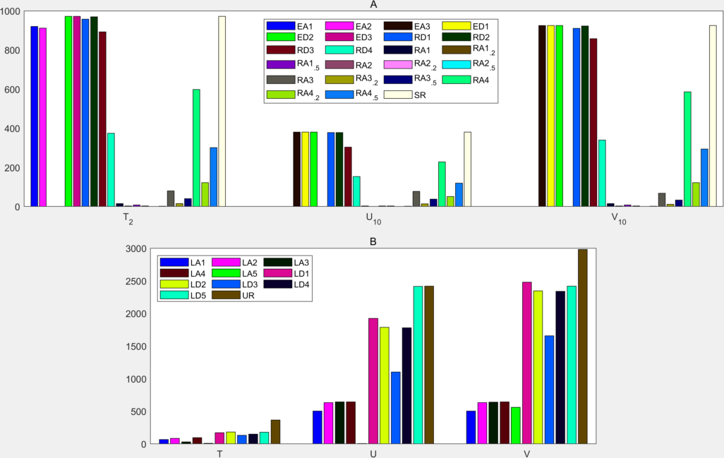
Figure S1. The observation minus forecast (OMB) quantity of each assimilation, x-axis and y-axis represent variable and observation quantity respectively. A represents for the 3DVar assimilation of surface. B represents for the EnSRF assimilation of upper atmosphere.
Noted that D2 and RH are introduced into both 3DVar and EnSRF through temperature entry (Baker et al., 2012; Shao et al., 2015), therefore, the OMB quantities of T2 and T also include humidity contributions. In particular, the consistent distributions among different variable entries of OMB could lay the fact that every observation interest of one OIG has the similar assimilation entry, and thus ensure an equatable comparison among different interests during this group (Lahoz et al., 2006; Lorenc and Marriott, 2013; Necker et al., 2018).

2.1 Synoptic

2.1.1 Thermodynamic
The vertical profiles of temperature of ZZ station at 12:00 on July 19 2016 among various datasets are relatively close, but significant differences are observed in the dew point profiles (Fig. S2-1 A). Specifically, below the 700hPa level, the temperature-dew differences in all experiments are close to or less than 2℃, indicating a relatively consistent saturation in the lower and middle troposphere. However, in the EC data, the temperature-dew point difference in the upper troposphere (above the 500hPa layer) is much larger than in other datasets, suggesting a notable dry atmosphere of upper layers (Emanuel, 1994), while other experiments exhibit a significant deep and moist atmospheric layer. The wind hodograph plots (Fig. S2-1 B) reveal counterclockwise rotation of wind barbs near the center (typically the lower layers) and clockwise rotation away from the center (typically the upper layers), representing cold and warm invasion in the lower and upper troposphere, respectively. This pattern is relatively stable in the EC data, but there are notable counterclockwise fluctuations in the overall clockwise rotation of wind away from the center in other experiments, indicating alternating cold and warm invasion (Houze, 2004) in the middle troposphere.
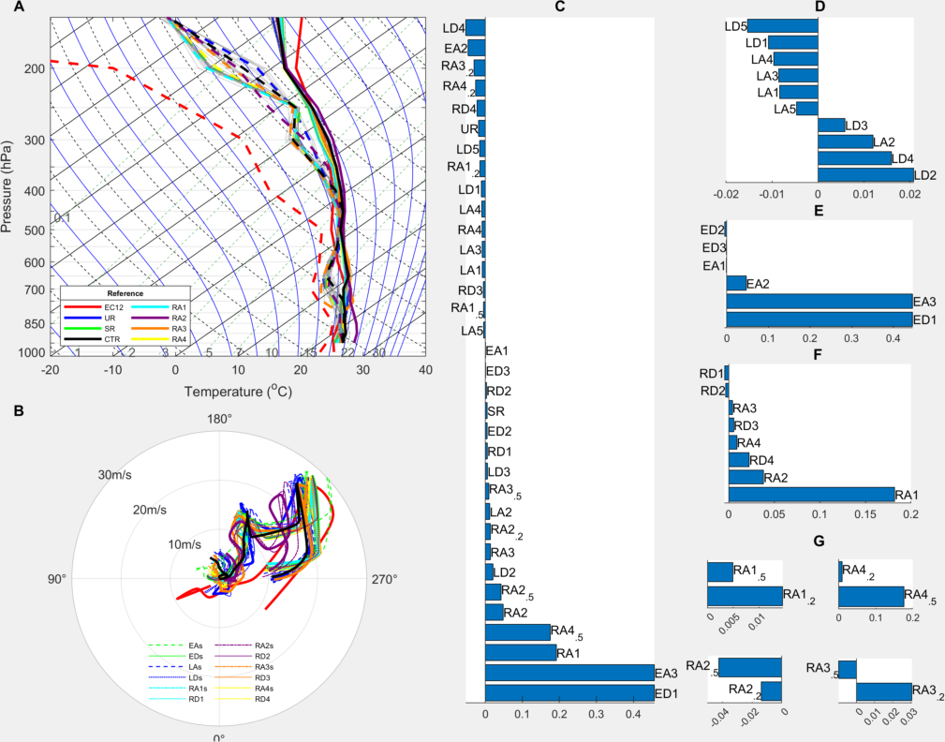
Figure S2-1. The typical thermodynamic condition and its benefit/cost ranking (at 12:00 on July 19, 2016) experienced by Zhengzhou station. A presents the T-lnP diagram, where the thick solid and dashed lines represent the temperature and dew of RT (colored), respectively, while the temperatures and dew of OIG are denoted by gray fine dotted-dashed and dashed lines. Note that the fine solid black line, fine solid blue line, fine dashed black line, and fine dashed green line represent isotherms, moist adiabats, dry adiabats, and saturation vapor mixing ratio, respectively. B shows the wind hodograph (at 12:00 on July 19, 2016) experienced by Zhengzhou station, with the colored thick solid lines indicating the RT experiments, and the legend is consistent with A. C displays the benefits/costs of lifting condensation level at UTC 12:00 (THE; units: Km) for various experiments when referred to EC data. D to G are similar to C, but for the Layer-, Element-, Region-, and Density-type OIG respectively when referred to tailored RT.
The THE of all experiments show equable cost and benefit numbers (18 and 16, respectively), with slighter more costs, among which, LD4 (EA3/ED1) exhibits the optimal benefit (max cost) (Fig. S2-1 C). For the Layer-type OIG, THE showed a more significant error reduction, leading to pronounced benefits, with LD5 (LD2) yielding optimal benefit (max cost) (Fig. S2-1 D). In contrast, both the Element and Region-type OIGs demonstrate significant costs. Notably, ED2 (ED1) and RD1 (RA1) exhibited the optimal benefits (max cost) respectively (Fig. S2-1 E and F). For the Density-type OIG, the optimal benefit (max cost) characteristics differed, but all experiments except RA4 show that 50% density yields greater benefits (or incurred lighter costs) than 20% density of (Fig. S2-1 G).

2.1.2 Vortex
Fig. S2-2A depicts the movement paths of the 700hPa vortexes and the background airflow within the simulated period for each experiment. In the background flow, a prominent southwest jet (>12 m/s) is observed in the southeast of the study area. As the weak northerly winds from the cold center over the Loess Plateau (northwest off the TaiHang mountain) move south and meet the southwest jet in the warm sector at the Zhengzhou-Xuchang border, a cyclone forms and intensifies as it moves eastward and northward along with the jet. The cyclone paths in EC and all experiments show acceleration toward the east between 06:00 and 09:00 and toward the north between 12:00 and 15:00 (indicating vortex movement), and weakening and development between 09:00 and 12:00 and between 15:00 and 18:00 (indicating vortex maintenance). However, during vortex movement, the eastward acceleration of the vortex in EC data is faster compared to other experiments, resulting in a significantly eastward-shifted vortex path subsequently. During vortex maintenance, significant differences in vortex centers emerge due to large variations in vortex development among the OSSE experiments (not shown), as exemplified by the EA experiment. In particular, the vortex' most northwest oriented paths are consistent with a nearby study (Xia and Zhang, 2019).
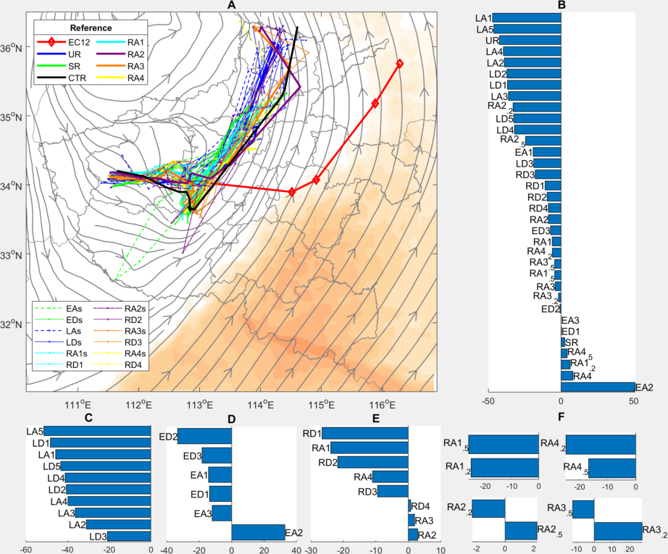
Figure S2-2. The 700hPa vortex tracking covering from UTC 06:00 to 18:00 on July 19 2016, and the benefits/costs of VOR. A shows the vortex path tracking and atmospheric flow background, with shaded areas indicating wind speeds greater than 12m/s (contour range from 12 to 30, with an interval of 4). Note that the streamlines and wind speed shading represent the average of all data at the 700hPa level during the study period. B presents the benefits and costs (in Km) of VOR, with reference to EC. C to F show the benefits and costs of Layer, Element, Region, and Density respectively using tailored references.
The VOR shows notable benefits, with LA1 (EA2) exhibiting the greatest benefit (or cost) (Fig. S2-2 B). The Layer-type OIG shows significant benefits, with LA5 (LD3) yielding the max (min) benefit (Fig. S2-2 C). Both Element- and Region-type OIGs demonstrate pronounced benefits, with the optimal benefits (max costs) in ED2 (EA2) and RD1 (RA2) respectively (Fig. S2-2 D and E). In the Density-type OIG, RA1 and RA4 show significant benefits, while RA2 and RA3 both have coexisting benefits/costs. Furthermore, the 50% density of NW and SO yield more benefits than the 20% density, whereas those of CW and ME show the opposite trend (Fig. S2-2 F).

2.2 Objective

2.2.1 Surface
The surface element metrics as SUR₁, SUR₂, and SUR₃ have shown significant error reductions, leading to notable benefits. In particular, EA2 (RA2_{.5}), EA2 (RA2), and RD1 (RA2) exhibit the greatest benefits (max costs) respectively (Fig. S3-1A1-A3). When all surface metrics of the Layer-type OIG demonstrate error reductions, resulting in clear benefits, with LD5 (LD3), LD5 (LD3), and LD1 (LA1) yielding the optimal benefits (max costs) respectively (Fig. S3-1B1-B3). The Element-type OIG shows significant benefits, and the ranking of benefits among different experiments is consistent for different metrics, with ED2 (EA2) yielding the max (min) benefit (Fig. S3-1 C1-C3). The Region-type OIG also demonstrates significant benefits, but their rank among experiments differs slightly for different metric, particularly with RD2 (RA2) exhibiting the greatest benefit (or max cost) (Fig. S3-1 D1-D3). In the Density-type OIG, the surface metrics generally show error reductions, leading to significant benefits. Notably, the 50% density in each region yield greater benefits than the 20% density (Fig. S3-1 E1-E3).
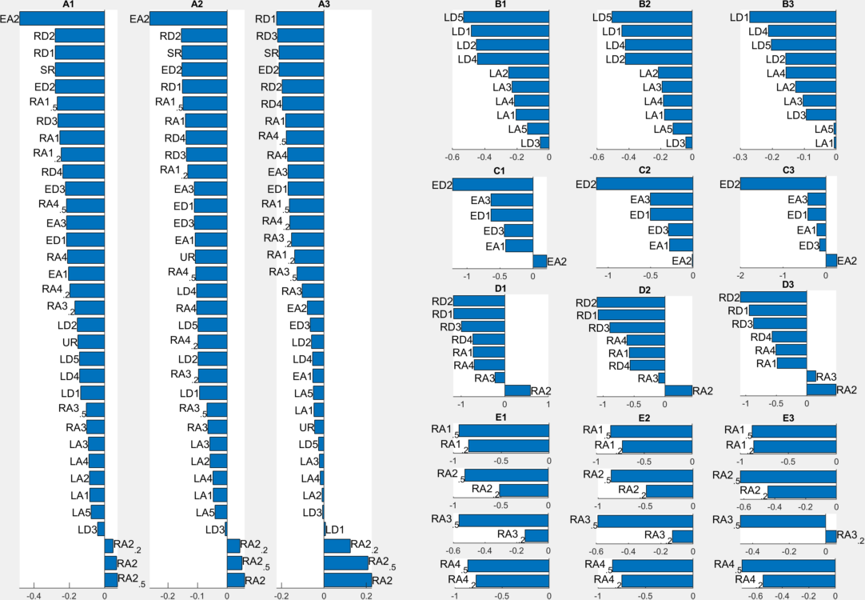
Figure S3-1. The benefits/costs in SUR₁, SUR₂, and SUR₃ metrics as indexed in 1, 2 and 3 respectively. A represents the benefits/costs using EC reference. B to E depict the benefits/costs of the Layer, Element, Region, and Density-type OIGs, respectively using tailored references.

2.2.2 Upper
The error increase in UPP₁ is prominent, leading to significant costs (Fig. S3-2 A1), with RA4_{.2} (UR) exhibiting the optimal benefit (max cost). In contrast, both the UPP₂ and UPP₃ show error decrease significantly, resulting in notable benefits, particularly with RD4 (LA2) and RD4 (RA2) yielding the optimal benefit (max cost) respectively (Fig. S3-2 A2-A3). The UPP₁ and UPP₂ in the Layer-type OIG decrease, leading to clear benefits, with LD5 (LA1) and LD5 (LD3) exhibiting the optimal benefit (or max cost) respectively (Fig. S3-2 B1-B2). However, the UPP₃ increases, resulting in significant costs, with LD3 (LA2) showing the max (min) cost (Fig. S3-2 B3). The Element-type OIG shows significant benefits, and their rank among different experiments is consistent with all metrics, with ED2 (EA2) yielding the optimal benefit (max cost) (Fig. S3-2 C1-C3). The Region-type OIG also demonstrates significant benefits, but their rank among experiments differs slightly for different metrics, particularly with RD2 (RA2) exhibiting the optimal benefit (max cost) (Fig. S3-2 D1-D3). In the Density-type OIG, all the metrics decrease, leading to significant benefits, notably with the 50% density of each region yielding greater benefits than the 20% density (Fig. S3-2 E1-E3). It can be observed that the benefits ranking for all the metrics in Element-, Region-, and Density-type OIG aligns well with the benefits ranking for surface metrics (Fig. S3-2 C-E).
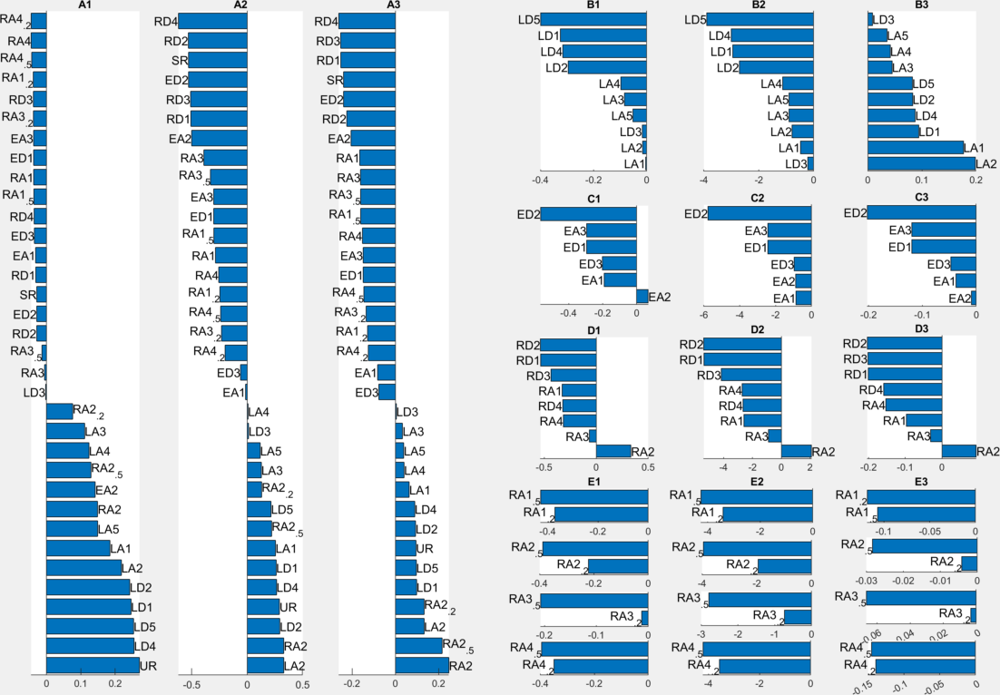
Figure S3-2. Same to Fig. S3-1, but indexes 1, 2, and 3 representing metrics of UPP₁, UPP₁, and UPP₃ respectively.

2.2.3 Profile
Within EC RT, the PRO₁ profiles show that positive biases are more pronounced, indicating significant costs. Among them, the significant costs lay between 700hPa and 200hPa in the layer deny experiments, while the Element-type OIG yield the greatest benefits below 700hPa (Fig. S3-3 A1). The PRO₂ profiles exhibit significant negative deviations between 500 and 400hPa, where the Element-type OIG yielding great benefits (Fig. S3-3 A2). The PRO₃ profiles show significant benefits between 925 and 850hPa, where the Element-type OIG yield the greatest benefit, while the Layer-type OIG incur the max cost (Fig. S3-3 A3). It should be noted that, except RA2, all the profile metrics in Region- and Density-type OIG demonstrate benefits.
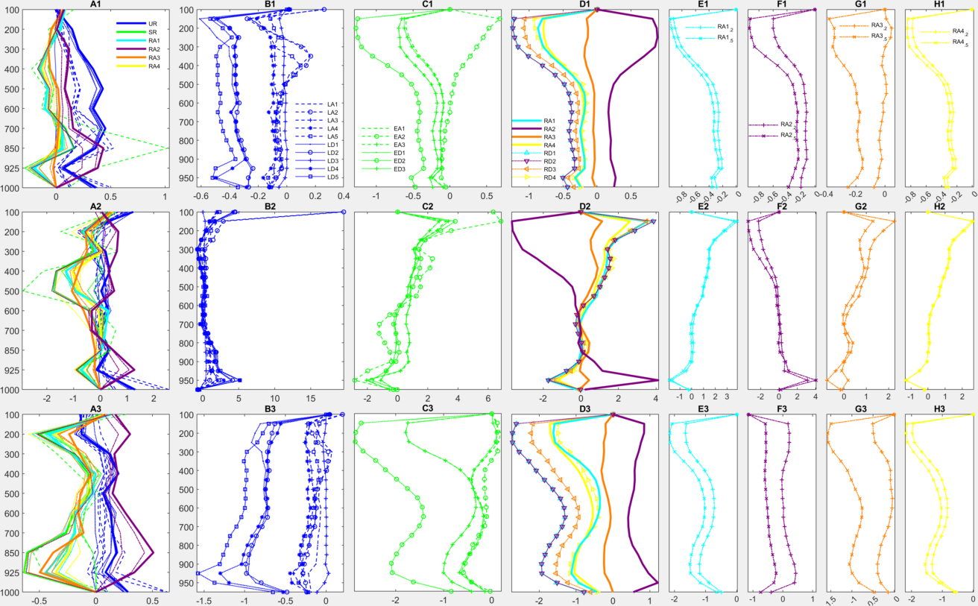
Figure S3-3. Same to Fig. S3-2, but indexes 1, 2, and 3 representing metrics as PRO₁, PRO₂, and PRO₃ respectively.
Within tailored RT, both PRO₁ and PRO₃ show that the layer allow experiments yield slightly more benefits than the deny (Fig. S3-3 B1 and B3). PRO₂ show that the costs are relatively low between 700 and 300hPa, but high above 200hPa and below 800hPa (Fig. S3-3 B2). Also, both the PRO₁ and PRO₃ profiles show the element deny experiments yield more benefits than the element allow experiments, with their max differences laying above 200hPa (Fig. S3-3 C1 and C3), while the PRO₂ profiles show the element allow experiments demonstrate significant benefits around 925hPa but costs around 100hPa (Fig. S3-3 C2). For the Region-type OIG, RD2 and RA2 exhibit symmetrical benefits or costs for all the profile metrics (Fig. S3-3 D1-D3). Both the PRO₁ and PRO₃ profiles show that except RD2, most experiments demonstrate benefits. However, the PRO₂ profiles show that RD2 yields significant costs below 900hPa but significant benefit around 500hPa, while other experiments behave oppositely (Fig. S3-3 D2). For the Density-type OIG, all the profile metrics show that the 50% density mostly yield better (smaller) benefits (costs) compared to the 20% density (Fig. S3-3 E1-E3, F1-F3, G1-G3, H1-H3).

2.3 Energy

2.3.1 Moist static energy
In MSE, significant positive deviations indicate an overall cost within EC RT, with EA2 (LA2) exhibiting the optimal benefit (max cost) (Fig. S4-1 A). Within tailored RT, the overall benefit of the Layer-type OIG is evident, with LD5 (LA1) demonstrating the optimal benefit (max cost) (Fig. S4-1 B). The Element- and Region-type OIG yield overall benefits, with ED2 (EA2) and RD1 (RA2) showing the optimal benefits (max costs) respectively (Fig. S4-1 C~D). For the Density-type OIG, the 50% density experiments yield greater benefits compared to the 20% density (Fig. S4-1 E).
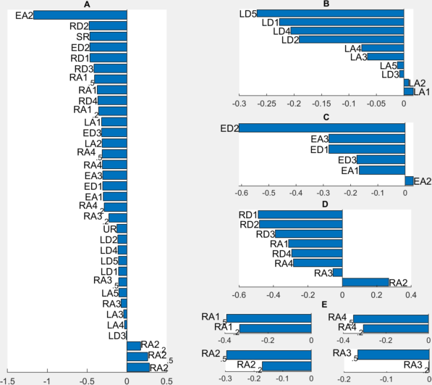
Figure S4-1. The total moist static energy (MSE, KJ) benefits/costs of the 1000~700hPa layer for all experiments. A depicts the benefits/costs when referred to EC. B~E show the benefits/costs of the Layer-, Element-, Region-, and Density-type OIG, respectively using tailored RT.

2.3.2 Turbulent Kinetic Energy
In TKE, similar to MSE, significant positive deviations indicate an overall cost within EC RT (Fig. S4-1 A and S4-2 A), but with UR (LA2) exhibiting the optimal benefit (max cost). Within tailored RT, the overall benefit of the Layer-type OIG is evident, with LD5 (LD3) demonstrating the optimal benefit (max cost) (Fig. S4-2 B). The Element- and Region-type OIG yield overall benefits, with ED2 (EA1) and RD1 (RA2) showing the optimal benefits (max costs) respectively (Fig. S4-2 C~D). For the Density-type OIG, the 50% density experiments yield greater benefits compared to the 20% density (Fig. S4-2 E).
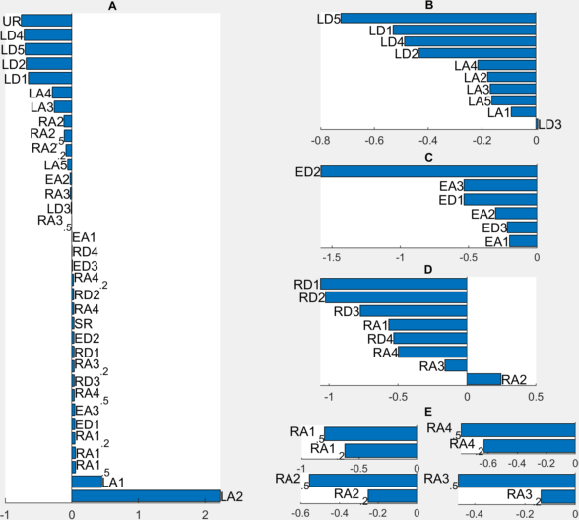
Figure S4-2. The turbulent kinetic energy (TKE; KJ) benefits/costs of the 1000~700hPa layer for all experiments. A depicts the benefits/costs with EC as the RT. B~E show the benefits/costs of the Layer-, Element-, Region-, and Density-type OIG, respectively using tailored RT.

2.4 Economic

2.4.1 Rainstorm
Fig. S5-1 illustrates the curves of the ECLV in relation to the cost-loss ratio for 12-hour precipitation forecasts exceeding 50mm during various datasets. These curves display consistent patterns under different RT. Utilizing the 12-hour precipitation forecast as referred to EC, it is observed that the economic value remains negative within a cost-loss ratio range of 0.05 to 0.35 (Fig. S5-1 A). This indicates that the ECLV of the forecasts for all experiment setups is comparatively low, particularly when investments are minimal or losses are substantial. Conversely, at moderate levels of investments or losses (for instance, a ratio of 0.4), the ECLV tends to approach the zero line, suggesting an enhanced economic value of the forecasts. Within this context, the overall economic value of CTR is found to be intermediate when compared to all other experiments.
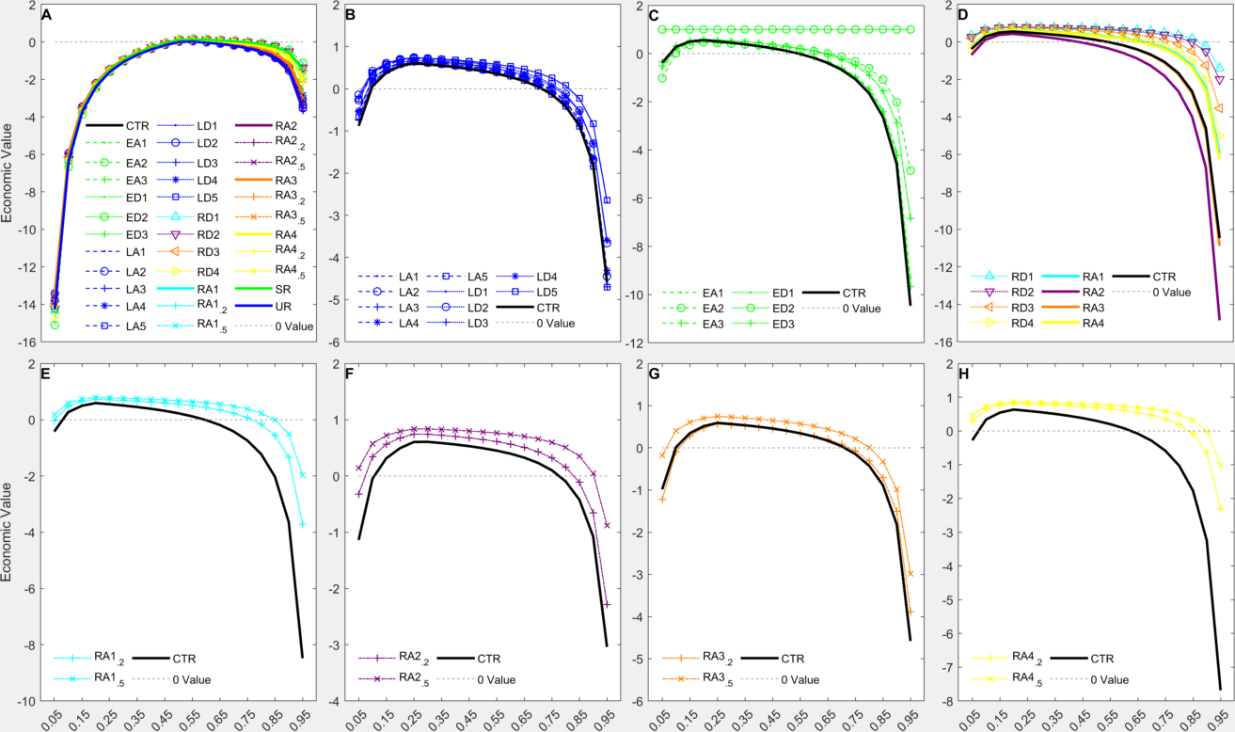
Figure S5-1. Comparison of ECLV curves for 12-hour precipitation forecasts exceeding 50 mm among all experiments. A represents the ECLV with EC as the RT. B to D depict the ECLV curves for the Layer-, Element-, and Region-type OIG respectively. E to H show the ECLV curves for for density pairs of NW, CW, SO, and ME respectively in the Density-type OIG.
Moreover, the economic value approaches the zero line when the cost-loss ratio is close to 0.05, among which the economic value of CTR is the smallest (Fig. S5-1 B). The economic values of both the Element interest and Region-type OIGs peak when the cost-loss ratio is near 0.05 (Fig. S5-1 C and D). However, the economic value of CTR is the smallest among the Element-type OIG but intermediate among the Region-type OIG, particularly as ED2 consistently remains near 1 in the Element-type OIG. In Density-type OIG, the economic value of each experiment peaks when the cost-loss ratio is close to 0.05 (Fig. S5-1 E-H), and the economic value of the CTR experiment is the smallest while the economic value of the 50% density is greater than that of the 20% density.
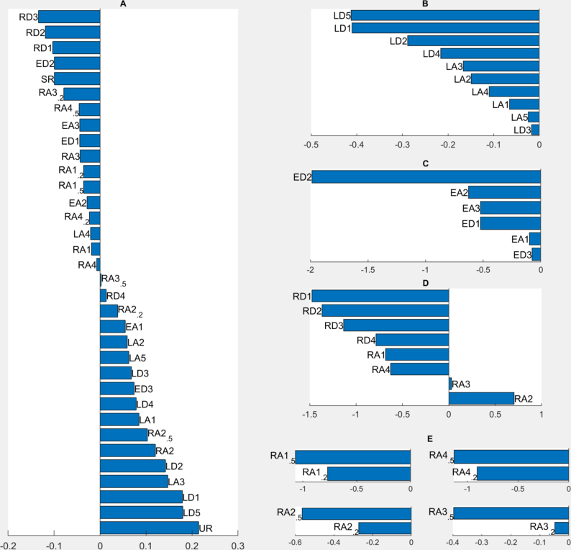
Figure S5-2. The ECO₁ ranks for all experiments. A represents the ECO₁ ranks with EC as the RT. B to E depict the ECO₁ ranks for the Layer, Element, Region, and Density-type OIGs respectively.
The ECO₁ show significant costs, among which, the RD3(UR) exhibits optimal benefit(max cost) (Fig. S5-2 A). The ECLV for the Layer-type OIG show significant benefits, with LD5(LD3) having the best(lest) benefit (Fig. S5-2 B). For the Element-type OIG, the ECO₁ shows significant benefits, with ED2(ED3) yielding the most(lest) benefit (Fig. S5-2 C). Simultaneously, for the Region-type OIG, the ECO₁ show significant benefits, with RD1(RA2) exhibiting the optimal benefit(max cost) (Fig. S5-2 D). For the Density-type OIG, the ECO₁ show significant benefits, with the 50% density yielding greater benefits than the 20% density (Fig. S5-2 E).

2.4.2 Heavy Rainstorm
Fig. S5-3 illustrates the curves of the ECLV in relation to the cost-loss ratio for 12 hour precipitation forecasts exceeding 100mm during various datasets. These curves display consistent patterns under different RT. Utilizing the 12-hour precipitation forecast from the EC dataset as the RT, it is observed that the economic value remains negative within a cost-loss ratio range of 0.55 to 0.95 (Fig. S5-3 A). This indicates that the ECLV of the forecasts for all experiment setups is comparatively low, particularly when investments are minimal or losses are substantial. Conversely, at moderate levels of investments or losses (for instance, a ratio of 0.35), the ECLV tends to approach the zero line, suggesting an enhanced economic value of the forecasts. Within this context, the overall economic value of CTR is found to be intermediate when compared to all other experiments.
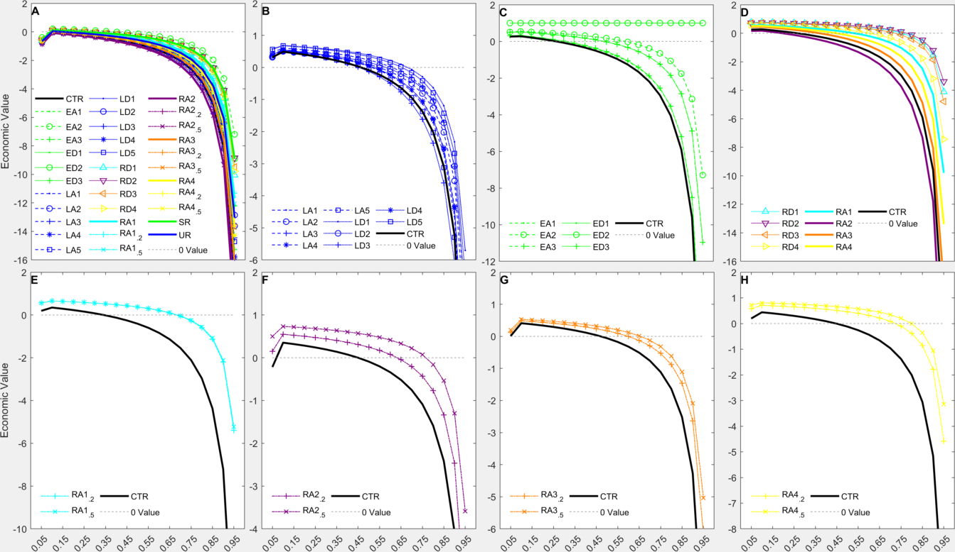
Figure S5-3. Comparison of ECLV curves for 12-hour precipitation forecasts exceeding 100 mm among all experiments. A represents the ECLV with EC as the RT. B to D depict the ECLV curves for the Layer-, Element-, and Region-type OIGs respectively. E to H show the ECLV curves for for density pairs of NW, CW, SO, and ME respectively in the Density-type OIG.
Moreover, the ECLV approaches the zero line when the cost-loss ratio is less than 0.45, among which the economic value of CTR is the smallest (Fig. S5-3 B). The economic values of both the Element- and Region-type OIG peak when the cost-loss ratio is near 0.05 (Fig. S5-3 C and D). However, the economic value of CTR is the smallest among the Element-type OIG but intermediate among the Region-type OIG, particularly as ED2 consistently remains near 1 in the Element-type OIG. In Density-type OIG, the economic value of each experiment peaks when the cost-loss ratio is less than 0.65 (Fig. S5-3 E-H), and the economic value of the CTR experiment is the smallest while the economic value of the 50% density is greater than that of the 20% density.
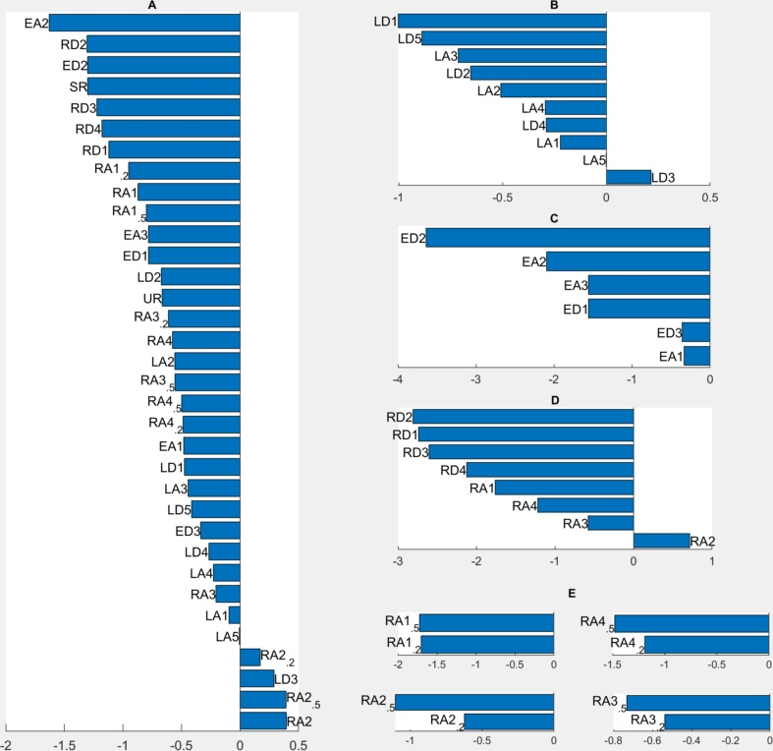
Figure S5-4. The ECO₂ ranks for all experiments. A represents the ECO₂ ranks with EC as the RT. B to E depict the ECO₂ ranks for the Layer-, Element-, Region-, and Density-type OIG respectively.
The ECO₂ show significant costs, among which, the EA2 (RA2) exhibits optimal benefit (max cost) (Fig. S5-4 A). The ECLV for the Layer-type OIG show significant benefits, with LD1 (LD3) having the best(lest) benefit (Fig. S5-4 B). For the Element-type OIG, the ECO₂ shows significant benefits, with ED2 (EA1) yielding the most(lest) benefit (Fig. S5-4 C). Simultaneously, for the Region-type OIG, the ECO₂ show significant benefits, with RD2 (RA2) exhibiting the optimal benefit(max cost) (Fig. S5-4 D). For the Density-type OIG, the ECO₂ show significant benefits, with the 50% density yielding greater benefits than the 20% density (Fig. S5-4 E).

3. Relative Impacts of OIG
During the Element-type OIG as referred to EC, both EA1 and ED1 exhibit costs in THE and TKE, with ED1 incurring $C_{max}$ of 0.46 km and 0.05 KJ respectively in VOR and TKE (Fig. 6 A). ED2 yields benefits across most metrics, particularly $B_{max}$ of -0.1, -0.24 m/s, -0.53, and -0.21 m/s, respectively in ECO₁, UPP₃, UPP₂, and SUR₃, while EA2 yields $B_{max}$ of -1.17 KJ, -0.48℃, -0.26℃, and -1.63, respectively in MSE, SUR₁, SUR₂, and ECO₂, and also $C_{max}$ of 0.14℃ and 50.96 Km, respectively in UPP₁ and VOR. EA3 and ED3 exhibit neutral performance, particularly, the benefit/cost performance of EA3 and ED3 equals to that of ED1 and EA1 respectively. Furthermore, as referred to the tailored RT, ED2 yields $B_{max}$ in all metrics except THE, while EA2 incurs costs in up to six metrics (Fig. 6 B). EA3 and ED3 also exhibit equivalent benefit/cost to ED1 and EA1 respectively, with EA3 and ED1 both yielding $C_{max}$ in THE.
During the Region-type OIG as referred to EC, both RA1 and RD1 show benefits in all metrics except THE and TKE, with RA1 exhibiting $C_{max}$ of 0.19 Km in THE (Fig. 6 C), and RD1 yielding $B_{max}$ of -0.28℃ and -0.15℃, respectively in SUR₁ and SUR₂. RA2 incurs costs in all metrics except VOR and TKE, with $C_{max}$ of 0.23 m/s and 0.15℃ respectively in SUR₃ and UPP₁, and $B_{max}$ of -0.12 KJ in TKE, while RD2 shows benefits in all metrics except THE and TKE, with $B_{max}$ of -0.28℃, -0.15℃, -0.46 KJ, and -1.31, respectively in SUR₁, SUR₂, MSE and ECO₂. RA3 exhibits benefits in all metrics except THE, while RD3 shows benefits in all metrics except TKE, with yielding $B_{max}$ of -17.8 Km and -0.13, respectively in VOR and ECO₁. Both RA4 and RD4 show benefits in most metrics except TKE, with the latter yielding $B_{max}$ of -0.62 and -0.26 m/s, respectively in UPP₂ and UPP₃, however, their benefit/cost performances in VOR and ECO₁ are opposite. Furthermore, as referred to the tailored RT, RA2 and RD2 incurred costs and benefits respectively in all metrics, with RD2 achieving $B_{max}$ in all metrics except THE, VOR, MSE, and ECO₁ (Fig. 6 D). RD1 demonstrated benefits for all metrics, with $B_{max}$ in VOR, MSE, TKE, and ECO₁, while RA1 showed benefits in all metrics except $C_{max}$ in THE . RD3 incurred benefits in all metrics except THE, while RA3 incurred benefits in all metrics except THE, VOR, MSE, and ECO₁. RA4 yields similar performance as RA1, while RD4 incurred benefits in all metrics except THE and VOR.
During the Density-type OIG as referred to EC, RA1_{.2} demonstrated benefits in all metrics except VOR and TKE, while RA1_{.5} exhibited benefits in all metrics except TKE, with $B_{max}$ of -0.27℃, -0.15℃, and -0.41 KJ, respectively in SUR₁, SUR₂, and MSE (Fig. 6 E). Conversely, RA2_{.2} and RDR2_{.5} both showed costs in all metrics except VOR and TKE, with RDR2_{.5} incurring $C_{max}$ of 0.21 m/s, 0.13°C, 0.22 m/s, and 0.1, respectively in SUR₃, UPP₁, UPP₃, and ECO₁, and $B_{max}$ of -0.11 KJ in TKE, and RA2_{.2} incurring $B_{max}$ of -33 Km in VOR. RA3_{.2} showed benefits in all metrics except TKE, while RA3_{.5} demonstrated benefits in all metrics except THE and ECO₁, with $B_{max}$ of -0.33 in UPP₂. RA4_{.2} showed benefits in all metrics except TKE, while RA4_{.5} demonstrated benefits in all metrics except THE, VOR, and TKE, with $C_{max}$ of 0.18 Km in THE. Furthermore, as referred to the tailored RT, RA1_{.2} and RA1_{.5} both demonstrated benefits in all indicators except THE, with RA1_{.5} showing $B_{max}$ in SUR₁, SUR₂, UPP₁, UPP₂, MSE and ECO₂ (Fig. 6 F). RA2_{.2} exhibited benefits in all metrics, while RA2_{.5} showed benefits in all metrics except VOR, with $B_{max}$ in SUR₂. RA3_{.5} demonstrated benefits in all metrics, while RA3_{.2} showed benefits in all indicators except VOR, THE, and SUR₃, with $C_{max}$ in VOR. RA4_{.2} and RA4_{.5} both showed benefits in all metrics except THE, with RA4_{.5} incurring $C_{max}$ in THE and $B_{max}$ in UPP₃ and ECO₁ respectively.
During the Layer-type OIG as referred to EC, the entire group has shown benefits ($B_{max}$; interest) in VOR (-47.08 Km; LA1), SUR₁ (-0.16℃; LD2), SUR₂ (-0.1; LD4), and MSE (-0.32 KJ; LA1) respectively, but costs ($C_{max}$; interest) in UPP₁ (0.26℃; LD4), UPP₂ (0.33; LA2), and UPP₃ (0.13 m/s; LA2) respectively (Fig. 6 G). Also, LD2 shows $B_{max}$ of -0.06 m/s and -0.67 in SUR₃ and ECO₂ respectively, LD4 shows $B_{max}$ of -0.05 Km in THE, but LD5 shows $C_{max}$ of 0.18 in ECO₁. Furthermore, as referred to the tailored RT, the entire group has shown benefits ($B_{max}$; interest) in VOR (-51.5 Km; LA5), SUR₁ (-0.53℃; LD5), SUR₂ (-0.51; LD5), SUR₃ (-0.27 m/s; LD1), UPP₁ (-0.4℃; LD5), UPP₂ (-3.89; LD5), and ECO₁ (-0.41; LD5) respectively (Fig. 6 H), but costs ($C_{max}$; interest) in UPP₃ (0.2 m/s; LA2). Also, LD1 demonstrates $B_{max}$ of -1 in ECO₂, LD5 shows $B_{max}$ of -0.72 in ECO₂, but LD2 shows $C_{max}$ of 0.02 Km in THE.

