APPENDIX A
BES basic indicators selection:
The initial extraction narrowed the dataset by removing the indicators not available for the time frame considered. A growth rate was then computed for each indicator as the percentage change between 2011 and 2020. This transformation was designed to align with the temporal structure of the convergence analysis, which compares provincial mobility rates across the same two years. Then, a diagnostic for multicollinearity was performed through the computation of a pairwise correlation matrix. Variable pairs showing a correlation coefficient above ±0.4 were flagged, and from each correlated pair, the indicator correlating with other variables was excluded from the analysis to mitigate the risk of inflated variance and unreliable coefficient estimates. After this filtering process, the final set of 16 BES indicators retained for the conditional convergence models included only those variables that were complete, informative, and sufficiently independent from each other (see Table A.1). These were further rescaled using min-max normalization to ensure comparability across heterogeneous measurement scales.

Table A.1 – Selected BES basic indicators.
Variable | BES dimension
- Infant mortality | Health
- Mortality from road accidents (ages 15–34) | Health
- Mortality from cancer (ages 20–64) | Health
- Mortality from dementia and nervous system diseases (ages 65 and over) | Health
- Children benefiting from municipal early childhood services | Education and training
- Municipal administrators under the age of 40 | Politics and institutions
- Municipality's revenue collection capacity | Politics and institutions
- Reported robberies | Safety
- Spread of agritourism enterprises | Landscape and cultural heritage
- Density of historical green areas | Environment
- Availability of urban green space | Environment
- Urban waste produced | Environment
- Propensity to patent | Innovation, research and creativity
- Employees in cultural enterprises | Innovation, research and creativity
- Hospital-related emigration to another region | Services quality
- Specialistic doctors | Services quality

Metadata for the 16 BES basic indicators selected to implement the β-convergence analyses

Table A.2 – Metadata.
Domain | Indicator | Definition | Unit of Measure | Source
Health | Infant mortality | Deaths under one year of age per 1,000 live births | Per 1,000 live births | Istat (For deaths: Survey of deaths and causes of death; For live births: Annual recording of vital events and calculation of the resident population)
Health | Mortality from road accidents (ages 15–34) | Age-standardized mortality rate for road traffic accidents (ages 15–34), standardized to the 2013 European population, per 10,000 residents | Standardized rates per 10,000 residents | Istat (For mortality data: Survey of road traffic accidents involving personal injuries; For population data: Survey of the municipal resident population by sex, year of birth, and marital status)
Health | Mortality from cancer(ages 20–64) | Standardized cancer mortality rates (initial cause) using the 2013 European standard population, for individuals aged 20–64, per 10,000 residents | Standardized rates per 10,000 residents | Istat (Causes of Death and Resident Population Surveys)
Health | Mortality from dementia and nervous system diseases (ages 65 and over) | Mortality rates for diseases of the nervous system and mental and behavioral disorders (underlying cause), age-standardized to the 2013 European population for the 65 years and over age group, per 10,000 residents | Standardized rates per 10,000 residents | Istat( For deaths: ISTAT, Deaths and Causes of Death Survey; For population: ISTAT, Municipal Resident Population Survey)
Education and training | Children benefiting from municipal early childhood services | Percentage of children aged 0–2 using early childhood services provided by public or contracted private facilities funded by municipalities | Percentage values | Istat (Municipal Social Services Survey)
Politics and institutions | Municipal administrators under 40 | Percentage of elected municipal officials under the age of 40 | Percentage values | Istat (Ministry of Interior Data)
Politics and institutions | Municipalities’ revenue collection capacity | Percentage ratio between collected revenues and certified revenues | Percentage values | Istat (Ministry of Economy and Finance Data)
Safety | Reported robberies | Number of reported robberies per 100,000 residents | Per 100,000 inhabitants | Istat (Ministry of Interior – SDI)
Landscape and cultural heritage | Spread of agritourism enterprises | Number of agritourism farms per 100 km² | Per 100 km² | Istat (Agritourism Business Survey)
Landscape and cultural heritage | Density of historical green areas | Area (in m²) of historic green spaces and urban parks of significant public interest (Legislative Decree 42/2004) in provincial capital municipalities, per 100 m² of urbanized area (town centers and inhabited nuclei) as recorded by the 2011 Population Census | Per 100 m² | Processed using data from the Environmental Data Survey in Cities, Territorial Bases of the Censuses
Environment | Availability of urban green space | Square meters of urban green space per resident in provincial/metropolitan capital cities | m² per resident | Istat (Environmental Data Survey in Cities)
Environment | Urban waste produced | Urban waste produced per resident (in kg) | Kg per resident | Istat (elaboration on ISPRA data)
Innovation, research and creativity | Propensity to patent | Total number of patent applications filed with the European Patent Office (EPO) per million inhabitants | Per 1,000,000 residents | OCSE (database Regpat)
Innovation, research and creativity | Employees in cultural enterprises | Percentage of employees in cultural sectors out of total employees. Includes publishing, media, design, arts, libraries, museums, and cultural institutions. | Percentage values | Istat (ASIA UL Register)
Service quality | Hospital-related emigration to another region | Percentage of hospital discharges for acute care in other regions, out of total discharges of residents. | Percentage values | Istat (Hospital Discharge Data – Ministry of Health)
Service quality | Specialistic doctors | Medical specialists (excluding GPs and paediatricians) per 10,000 inhabitants. | Per 10,000 inhabitants | Istat (IQVIA – OneKey database)

Descriptive Statistics
Table A.3 presents descriptive statistics for the PTR at two time points (2011 and 2020), as well as for the set of 16 sociodemographic BES covariates included in the convergence analysis, considered at the beginning of the study period (2011).
The summary statistics reported in Table A.3 reveal that the PTR exhibited a slight upward shift between 2011 and 2020, with the mean increasing from 0.080 (SD = 0.014) to 0.081 (SD = 0.015) and the interquartile median rising from 0.079 to 0.082. Both distributions are approximately symmetric (skewness of -0.076 and -0.201, respectively) and platykurtic (kurtosis of -1.184 and 1.107), indicating a slight concentration of observations around the mean and relatively light tails.
Among the 16 BES indicators, variability is markedly heterogeneous. Mortality indicators range from low‐variance measures – such as cancer mortality (mean = 9.502, SD = 0.931; skewness = 0.474) – to highly dispersed outcomes – road accident mortality (mean = 0.987, SD = 0.536; skewness = 1.272) and dementia‐related mortality (mean = 28.144, SD = 4.623; skewness = 0.248). Early childhood service utilization (mean = 13.531, SD = 7.246; skewness = 0.213) and the proportion of young municipal administrators (mean = 31.441, SD = 4.703; skewness = -0.043) both display modest dispersion and near‐zero skewness.
Financial and crime‐related metrics show greater heterogeneity: municipal revenue capacity averages 74.548 (SD = 10.190; skewness = -0.468), whereas reported robberies present an extremely right‐tailed distribution (mean = 42.086, SD = 36.443; skewness = 3.095; kurtosis = 13.545). Agritourism spread (mean = 6.596, SD = 5.256; skewness = 1.577) and cultural enterprise employment (mean = 1.169, SD = 0.418; skewness = 3.661) similarly exhibit pronounced positive skew. Green‐space indicators are among the most variable: historical green area density (mean = 1.682, SD = 4.168; skewness = 6.582) and urban green availability (mean = 45.329, SD = 102.598; skewness = 7.194) both feature extreme ranges and heavy right‐hand tails. Finally, innovation propensity (mean = 68.333, SD = 72.545; skewness = 2.505), hospital emigration (mean = 9.380, SD = 5.851; skewness = 1.142), and specialist doctors density (mean = 27.607, SD = 7.836; skewness = 1.084) all display moderate to high positive skewness, underscoring the uneven distribution of socioeconomic resources and health‐care outflows across the provinces.

Table A.3 – Summary statistics.
variable | mean | sd | median | min | max | range | skew | kurtosis | se
PTR 2011 | 0.08 | 0.014 | 0.079 | 0.049 | 0.104 | 0.055 | -0.076 | -1.184 | 0.001
PTR 2020 | 0.081 | 0.015 | 0.082 | 0.047 | 0.112 | 0.065 | -0.201 | -1.107 | 0.002
Infant mortality | 2.911 | 1.282 | 3 | 0.6 | 6.9 | 6.3 | 0.459 | 0.431 | 0.126
Mortality from road accidents (ages 15–34) | 0.987 | 0.536 | 0.9 | 0.1 | 2.9 | 2.8 | 1.272 | 2.222 | 0.053
Mortality from cancer (ages 20–64) | 9.502 | 0.931 | 9.45 | 7.6 | 12.7 | 5.1 | 0.474 | 0.149 | 0.091
Mortality from dementia and nervous system diseases (ages 65 and over) | 28.144 | 4.623 | 28.1 | 18.8 | 39.9 | 21.1 | 0.248 | -0.253 | 0.453
Children benefiting from municipal early childhood services | 13.531 | 7.246 | 13.65 | 0.6 | 33.4 | 32.8 | 0.213 | -0.664 | 0.711
Municipal administrators under the age of 40 | 31.441 | 4.703 | 31.35 | 19.9 | 43.3 | 23.4 | -0.043 | -0.427 | 0.461
Municipality's revenue collection capacity | 74.548 | 10.19 | 76 | 47 | 95 | 48 | -0.468 | -0.249 | 0.999
Reported robberies | 42.086 | 36.443 | 31.1 | 5.7 | 268.3 | 262.6 | 3.095 | 13.545 | 3.574
Spread of agritourism enterprises | 6.596 | 5.256 | 4.9 | 0.7 | 27.8 | 27.1 | 1.577 | 2.456 | 0.515
Density of historical green areas | 1.682 | 4.168 | 0.7 | 0 | 36.9 | 36.9 | 6.582 | 49.248 | 0.409
Availability of urban green space | 45.329 | 102.598 | 22.7 | 3.4 | 960.5 | 957.1 | 7.194 | 58.851 | 10.061
Urban waste produced | 522.942 | 95.549 | 500.5 | 336 | 802 | 466 | 0.683 | 0.231 | 9.369
Propensity to patent | 68.333 | 72.545 | 47.4 | 0.6 | 512 | 511.4 | 2.505 | 11.44 | 7.114
Employees in cultural enterprises | 1.169 | 0.418 | 1.1 | 0.7 | 3.8 | 3.1 | 3.661 | 18.133 | 0.041
Hospital-related emigration to another region | 9.38 | 5.851 | 7.7 | 1.8 | 27.4 | 25.6 | 1.142 | 0.79 | 0.574
Specialistic doctors | 27.607 | 7.836 | 24.8 | 16.4 | 50.9 | 34.5 | 1.084 | 0.325 | 0.768

APPENDIX B
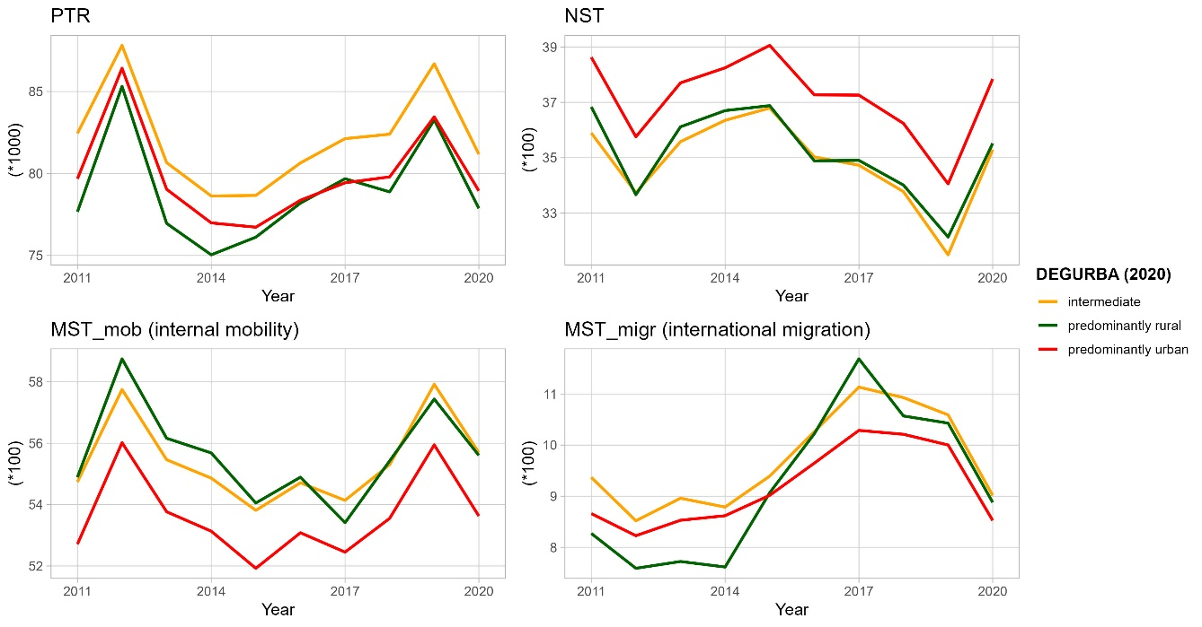
Figure B.1 – Trends for mean values of the standardized Population Turnover Rate (*1000) and its components (*100) for Italian provinces by DEGURBA classification, 2011–2020. Note: different scales for y axes.

