Supplementary Material for
Cancer and industrial activities in China

This supplemental material includes:

Supplementary text S1 to S4
Figs. S1 to S6
Tables S1 to S12

SUPPORTING INFORMATION TEXT

Text S1 – BACKGROUND ON ENVIRONMENTAL CAUSES OF CANCER

Estimates suggest that 2 to 3 million Chinese die of cancer each year and 3 to 4 million Chinese receive a new cancer diagnosis annually. Cancer incidence estimated from available 2013 cancer registries was 284.6/100,000 and age-standardized incidence rates were around 190/100,000 (1). Cancer mortality estimated from available 2013 cancer registries was 176.3/100,000 and age-standardized mortality rates were around 111/100,000 (1). Lung cancer was the most common site of new cancers, followed by stomach, liver, colorectal, and esophageal cancers. 2013 stomach, liver, and esophageal cancer incidence rates were more than 2 times the global average and lung cancer incidence was more than 1.5 times the global average.

A growing literature documents the behavioral and environmental determinants of cancers worldwide. The International Agency for Research on Cancer (IARC) classifies more than one hundred agents known to be carcinogenic to humans (2). Global estimates suggest as much as three-quarters of lung cancer deaths, two-thirds of esophageal cancer deaths, one-half of liver cancer deaths, and one-quarter of stomach cancer deaths may be attributable to avoidable behavioral and environmental factors (3). Individual-level behavioral determinants of cancers, including smoking, diet, obesity, alcohol consumption, and physical activity, appear to account for the majority of preventable new cancers (3-6). The role of environmental factors is also significant. For example, estimates suggest as much as 45 percent of global lung cancer may be attributable to environmental pollution (5-7).

According to the IARC and several multi-disciplinary literatures, key environmental determinants of cancer include outdoor air pollution and toxic substances. The literature highlights measurable relationships between outdoor particulates and cancer incidence and mortality (7-10). Many organic chemicals, inorganic chemicals, heavy metals, and other toxic substances are causally linked to cancer. The Lancet Commission on Pollution and Health identifies several toxic contaminants as among the “greatest threats to health” (7). Lung and other respiratory cancers are known to be associated with arsenic, benzene, beryllium, cadmium, chromium, nickel, and other toxic substances (2). Stomach, liver, and esophageal cancers are causally related to the lead, arsenic, and other organic and inorganic substances (2).

Industrial processes and the combustion of fossil fuels are key anthropogenic sources of both outdoor air pollution and toxic substance pollution. Nearly all manufacturing facilities emit coarse (PM-10) and fine particulates (PM-2.5). Industrial activities are prominent anthropogenic sources of environmental circulation of substances of toxic significance including arsenic, asbestos, benzene, cadmium, chromium, formaldehyde, lead, nickel, and silica (7). The IARC asserts that lung cancers are known to be causally related to metals production, rubber production, coal combustion, and iron and steel processing (2). The chemical industry is an important source of conventional and toxic air, water, and solid waste pollution, and the chemicals sector collectively manufactures, processes, or otherwise uses most known hazardous chemicals. The cement industry is associated with arsenic, cadmium, chromium, lead, zinc, dioxin and furans (11). The coking industry is a major source of pollution, globally and in China (12). Polycyclic aromatic hydrocarbons emitted by the coking, iron and steel, metals processing, rubber, and electricity sectors are associated with lung, stomach, liver, and other cancers (13). The pulp and paper industry is associated with potentially toxic compounds including pesticides, chlorinated organic compounds, carboxylic organic acids, and chromium (14). The tanning sector in China uses large amounts of chromium to stabilize and color products, and highly toxic hexavalent chromium is a common byproduct (15).

In sum, many potential pathways link industrial facilities and associated environmental factors to cancer incidence and mortality. Nevertheless, few existing studies attempt to systematically disentangle the disease burden of specific cancer causes in China. Most studies exploring specific determinants in China focus on single cancer sites, small geographic locations, or narrow subpopulations (16-19). Studies with more systematic aims typically exclude most environmental agents, for data availability and other reasons (20).

References for this SI appendix:

1. Chen, W., et al. (2017). Cancer incidence and mortality in China in 2013: an analysis based on urbanization level. Chin J Cancer Res, 29(1), 1-10.

2. International Agency for Research on Cancer. IARC monographs on the evaluation of carcinogenic risks to humans, volumes 1-121. Lyon, France: IARC; 1972-2019.

3. Danaei, G., et al. (2005). Causes of cancer in the world: comparative risk assessment of nine behavioural and environmental risk factors. The Lancet, 366(9499), 1784-1793.

4. Doll, R., & Peto, R. (1981). The causes of cancer: quantitative estimates of avoidable risks of cancer in the United States today. Journal of the National Cancer Institute, 66(6), 1192-1308.

5. GBD 2015 Risk Factors Collaborators. (2016). Global, regional, and national comparative risk assessment of 79 behavioural, environmental and occupational, and metabolic risks or clusters of risks, 1990–2015: a systematic analysis for the Global Burden of Disease Study 2015. Lancet, 388: 1659-1724.

6. GBD 2015 Mortality and Causes of Death Collaborators (2016). Global, regional, and national life expectancy, all-cause mortality, and cause-specific mortality for 249 causes of death, 1980–2015: a systematic analysis for the Global Burden of Disease Study 2015. Lancet, 388: 1459–544.

7. Landrigan, P. J. et al. The Lancet Commission on pollution and health. Lancet, 391(10119), 462-512.

8. Turner, M. C. et al. (2011). Long-term ambient fine particulate matter air pollution and lung cancer in a large cohort of never-smokers. American journal of respiratory and critical care medicine, 184(12), 1374-1381.

9. Loomis, D., et al. (2013). The carcinogenicity of outdoor air pollution. Lancet Oncology, 14(13), 1262.

10. Hamra GB et al. (2014). Outdoor particulate matter exposure and lung cancer: a systematic review and meta-analysis. Environ Health Perspect 122:906–911.

11. Schuhmacher, M., Domingo, J. L., & Garreta, J. (2004). Pollutants emitted by a cement plant: health risks for the population living in the neighborhood. Environmental research, 95(2), 198-206.

12. Wang, Y., Cheng, K., Tian, H. Z., Yi, P., & Xue, Z. G. (2018). Analysis of reduction potential of primary air pollutant emissions from coking industry in China. Aerosol Air Qual. Res, 18, 533-541.

13. Boström, C. E., Gerde, P., Hanberg, A., Jernström, B., Johansson, C., Kyrklund, T., ... & Westerholm, R. (2002). Cancer risk assessment, indicators, and guidelines for polycyclic aromatic hydrocarbons in the ambient air. Environmental health perspectives, 110(suppl 3), 451-488.

14. Soskolne, C. L., & Sieswerd, L. E. (2010). Cancer risk associated with pulp and paper mills: a review of occupational and community epidemiology. Chronic Diseases and Injuries in Canada, 29.

15. Sundar, V. J., Rao, J. R., & Muralidharan, C. (2002). Cleaner chrome tanning—emerging options. Journal of cleaner production, 10(1), 69-74.

16. Lam, T. H. et al. (1997). Mortality attributable to cigarette smoking in China. Jama, 278(18), 1505-1508.

17. Li, P. et al. (2012). Occupational and environmental cancer incidence and mortality in China. Occupational medicine, 62(4), 281-287.

18. Wu, M. et al. (2011). A large proportion of esophageal cancer cases and the incidence difference between regions are attributable to lifestyle risk factors in China. Cancer letters, 308(2), 189-196.

19. Islami, F. et al. (2017) Cancer deaths and cases attributable to lifestyle factors and infections in China, 2013. Ann Oncol 28, 2567-2574.

20. Wang, J. B. et al. (2012). Attributable causes of cancer in China. Annals of oncology, 23(11), 2983-2989.

Text S2 - DATA APPENDIX

Administrative units

Administrative units in China are divided into 5 levels: province-level, prefecture-level, county-level, town-level, and village-level. The following approximations may be useful to understand these administrative units. Like the main analysis, area and population summary statistic approximations below omit the five large, remote, and sparsely population western / northwestern provinces of Tibet, Xinjiang, Inner Mongolia, Qinghai, and Gansu.

Province-level administrative units:
Number: ~30 units.
Average size: ~180,000 km² (~the land area of a large US state like OK or WA)
Average population: ~50 million

Prefecture-level administrative units:
Number: ~350 units.
Average size: ~18,000 km² (~ the land area of a small US state like CT or NJ)
Average population: ~5 million

County-level administrative units:
Number: ~2900 units.
Average size: ~2,000 km² (~ 2/3 the land area of an average US county)
Average population: ~600,000

Township-level administrative units:
Number: ~47,000 units.
Average size: ~125 km² (~ the land area of a densely population US coastal city)
Average population: ~35,000

Village-level administrative units:
Number: ~700,000 units.
Average size: ~10 km² (~ the land area of a US urban neighborhood)
Average population: ~2,000

Administrative data

We observe census, administrative, and geographic data on 2,457 county-level divisions (henceforth “counties”) identified by NBS and not located in the five large, remote, and sparsely populated western / northwestern provinces of Tibet, Xinjiang, Inner Mongolia, Qinghai, and Gansu. All counties are identified by 6-digit administrative codes provided by the NBS.

We observe census and administrative data on 641,022 village-level divisions (henceforth “villages”) identified by NBS with 12-digit official administrative codes in 2010. We use a software called Xgeocoding to get the latitude and longitude coordinates of village centroid by inputting the name of villages, and we then calculate geographic information based on the village coordinates through ArcGis. The Xgeocoding successfully produced latitude and longitude coordinates for 599,822 (93.6% of 641,022) villages. The exact nature of missingness for the remaining 6.4% of village coordinates is not observable. One possible explanation is that the changing of administrative division over years makes the software unable to identify the exact location of village centroid.

Thus, in order to facilitate clean and reliable matches across disparate geographic, economic, and socio-demographic data sources, we retain and analyze 599,822 villages that have non-missing geographic coordinates. We compare characteristics of villages with missing or unmatched identifiers (6.4%) to characteristics of final sample villages (93.6%) below.

Comparing final sample villages and dropped villages due to missing information
Variable | Sample villages | Dropped villages | Diff. in means | P-value  for  Diff.
Characteristics of the county of this village
Population (100,000s) | 657.42 | 716.95 | -59.53 | 0.17
% Population rural | 58.0 | 53.0 | 5.0 | 0.01
% Population 0 to 14 | 17.55 | 15.29 | 2.26 | 0.01
% Population 65+ | 9.35 | 9.57 | -0.22 | 0.21
Years of schooling | 8.63 | 8.97 | -0.35 | 0.01
% Adults illiterate | 5.67 | 5.20 | 0.47 | 0.02
Household size | 3.20 | 3.05 | 0.15 | 0.01
Economic indicators for the county of this village
% Employment in agriculture and natural resources | 55.98 | 49.27 | 6.71 | 0.01
% Employment in industrial activity | 20.93 | 21.79 | -0.86 | 0.32
% Employment in services | 23.10 | 28.87 | -5.77 | 0.01
Value added of industrial sector (100 million CNY) | 69.13 | 63.64 | 5.49 | 0.29
GDP (100 million CNY) | 128.07 | 127.25 | 0.82 | 0.92
Local government revenue (100 million CNY) | 6.01 | 6.13 | -0.12 | 0.85
Local government expenditures (100 million CNY) | 13.99 | 19.50 | -5.51 | 0.01
Household wealth measures for the county of this village
Rooms per house | 3.41 | 3.27 | 0.13 | 0.01
House area (sq meters per person) | 31.92 | 32.26 | -0.35 | 0.45
% households w/ tapwater | 58.0 | 62.0 | -4.0 | 0.07
% households w/ kitchen | 82.0 | 85.0 | -3.0 | 0.01
% households w/ toilet | 70.0 | 73.0 | -4.0 | 0.02
% households w/ bath | 49.0 | 55.0 | -6.0 | 0.01
Health measures
Birth rate | 11.00 | 9.65 | 1.35 | 0.01
Mortality rate | 6.13 | 6.14 | -0.01 | 0.96
# villages | 599,822 | 41,200

The table above illustrates that final sample villages (93.6%) and villages with administrative changes (6.4%) differ statistically on some dimensions but not on others. Employment in industrial activities, value-added from industrial activities, GDP, and government expenditures are statistically indistinguishable between sample villages and villages with administrative changes. Dropped villages do tend to be in counties with populations that are statistically more urban, less immigrant, and more educated. The magnitudes of statistical differences in socio-demographic characteristics, however, are typically small. Household wealth indicators are also different statistically but similar in magnitude. Birth rates are lower in sample villages.

The reader should recall that main analyses include county-level fixed effects (and/or instrumental variable approaches) that control for all county-level differences, including those possibly related to selection.

Although socio-demographic data are not directly available at the village-level, we do observe geographic information and economic establishment numbers and characteristics at the village (sub-county) level. We exploit this variation for the majority of the analysis. Within county, we find that dropped villages are 14.7% (95% CI: 13.2 - 16.2) less likely to contain a polluting industrial facility than sample villages. Conditional on at least one industrial facility, within-county analyses show that dropped villages have somewhat lower total polluting industrial output [Diff: 272,000 CNY (95% CI: 166,000 – 377,000)], somewhat lower total polluting industrial employment [Diff: 311 people (95% CI: 183 – 439)], and somewhat lower total polluting industrial assets [Diff: 194,000 CNY (95%: 78,600 – 310,000}]. Polluting sector distributions are similar across dropped and sample villages, with the most common sectors as chemical, food, and cement in both sectors.

Economic census data

The economic census of 2008 is designed to identify secondary and tertiary establishments in China. Establishments from the primary sector - agriculture, forestry, animal husbandry, and fisheries – are not included. The secondary sector includes mining, manufacturing, electricity, gas and water, and construction establishments. The tertiary sector includes all economic establishments not otherwise classified, but the vast majority of facilities are in the services sector. Tertiary sectors include warehousing and postal services, information transmission, computer services and software, wholesale and retail, accommodation and catering, financial services, real estate, leasing and business services, scientific research, technical services and geological exploration, water, environment and public facilities management, resident services and other services, education, health, and others.

Economic census offices are established by local governments. Census offices survey companies and follow up to ensure response. Surveyed establishments fill out information as requested by the census offices. Identification of industrial sector is classified based on a) the type of products that the companies produce; and b) the corporate registration information at the Local Bureau of Industry and Commerce. Other important company information includes employment, output, and assets.

Local Chinese government agencies oversee the census. Locations and industry types are readily verifiable, and we believe this information is reliable. The quality of output, employment, and asset data in the economic census data has been questioned (1). The main analysis does not rely on this information.

The main analysis uses a version of the census that includes all facilities owned by the state and all facilities owned by domestic or foreign private owners with annual sales exceeding 5 million RMB (about $700,000). Although some small private facilities voluntarily report into the dataset, the overall population of small private facilities is underrepresented. Comparisons with published statistics show sample enterprises represent over 91% of total 2008 revenue. All results in the paper are statistically similar if small private facilities voluntarily reporting into the census are excluded. Relevant results in the paper should be interpreted as the effect of medium and large size facilities on cancer, and these results are not biased by the omission of the smallest industrial establishments. External validity for small establishments represents a useful area for future research.

The Chinese Ministry of Environmental Protection officially designates polluting industrial sectors (2). Rather than construct our own “polluting facility” designations, we use this official information to designate polluting industrial sectors. Census data identify establishments in 525 secondary sectors. Of these, 167 secondary sectors are designated as “polluting” in the government industrial sector list (2). Nearly all facilities in the chemical, dye, fiber, leather, pharmaceutical, cement, coking, electricity, food, iron and steel, metals, paper, rubber, and vegetable oil industries are classified as “polluting.”

We omit all establishments in mining, coal, and oil and gas sectors from the analysis, as it is widely understood that wellheads and mine mouths may be typically sited away from the establishment locations actually recorded in the census. Main results are similar if we include these facilities in the analysis. This is perhaps not surprising because the analysis typically exploits variation across villages in counties with at least one “cancer village” and the vast majority (~90%) of mining, coal, and oil / gas establishment locations recorded in the census are in more remote counties without any cancer villages.

Cancer data

County-level analyses use observed cancer incidence and mortality data from the China Ministry of Health’s 2013 National Central Cancer Registry (NCCR). Descriptions provided in the main text summarize key points of the NCCR data.

“Cancer village” data include indicators for village-level cancer clusters. We ultimately identified 392 village-level spatial clusters reported in Chinese media, of which 380 overlapped with the village-level dataset. We also identified a few village-level clusters in Inner Mongolia and the far western provinces, as well as 52 clusters reported for larger geographic areas than the village. The data generating process involved first manually identifying clusters in the media. We searched internet search engines like Google and Baidu (the most popular search engine in China) with key words “cancer cluster” or “cancer villages” in Chinese (Ai Zheng Cun in Chinese; meaning cancer cluster at the village level). We constructed a list of villages and regions defined by unusual levels of cancer morbidity and mortality over small geographic scales. We noted an article in a Hong Kong journal, Phoenix Weekly, that documented a list of around 110 reported cancer clusters by 2009. We had identified many of these same clusters directly, as well as many others. We then implemented a forwards/backwards search: we investigated every media mention of the village names on the list for cancer incidence information as well as references to other villages and iterated. This process mimicked an early literature (23), and we are confident that the final sample dataset contains essentially all cancer villages reported by 2015 in credible Chinese media. We then cross-referenced the final list with an independent earlier literature identifying the cancer village phenomenon. We confirmed that the list yielded similar total cluster numbers and geographic dispersions relative to another known comprehensive list (23).

We successfully located the original news source classifying the village as a cancer cluster for the significant majority of village-level cancer clusters. We classified the original news sources into official media and unofficial media. ~40% of all identified “cancer villages” were identified by official government-sanctioned news sources like China Central Television (CCTV), the Xinhua news agency, People Daily, or an official government website. These sources are considered most credible. ~75% of all “cancer villages” were classified as spatial cancer clusters by at least one official Chinese government news source or a reputable nationally-circulated Chinese magazine or journal news source. Less than one quarter of cancer cluster designations lacked a clear first report or reflected first reports found in blogs, forums, Sina Weibo (similar to Twitter), or other unofficial sources.

The table below highlights the broad spatial dispersion of cancer villages and the high spatial correlation (at the province level) between officially reported and total reported villages. We note qualitatively similar, but statistically noisier, results when we replicate the main analyses using only the most reputable sources to define clusters.

Raw data: village-level cancer clusters by province and reporting source
Province | Total reported | Reported in More  Reputable source | Province | Total reported | Reported in More  Reputable source
Hebei | 61 | 55 | Sichuan | 8 | 8
Henan | 51 | 40 | Tianjin | 5 | 4
Hunan | 44 | 15 | Guizhou | 5 | 4
Shandong | 40 | 26 | Yunnan | 5 | 4
Jiangsu | 30 | 24 | Shaanxi | 5 | 5
Guangdong | 28 | 24 | Heilongjiang | 3 | 3
Zhejiang | 21 | 16 | Chongqing | 3 | 3
Anhui | 14 | 11 | Jilin | 2 | 1
Jiangxi | 14 | 13 | Shanghai | 2 | 0
Shanxi | 11 | 11 | Beijing | 1 | 1
Fujian | 11 | 4 | Guangxi | 1 | 1
Hainan | 10 | 10 | Ningxia | 0 | 0
Hubei | 9 | 6 | Total | 392 | 297
Liaoning | 8 | 8
Although we have reason to be confident in the quality of cancer village identifications, we are less certain that specific cancer incidence and mortality reported along with village-level cluster identification are fully reliable. Moreover, much of these data are simply unavailable. However, where possible, we cautiously note media accounts on incidence and mortality for context. These accounts suggest the average spatial cluster occurred among a village population of roughly 1788 people (n = 134). Reported summaries of village health station and doctor data suggest annualized cluster crude incidence rates of 779 per 100,000 (n = 39, s.d. 916) and crude mortality rates of 760 per 100,000 (n = 90, s.d. 1009). Average incidence and mortality rate ratios are 3.4 and 5.4 relative to national averages, although they are not age standardized. Meaningful (large-n) descriptive statistics on specific cancers are not available, but several reports note elevated levels of stomach, esophageal, liver, and lung cancers. The table below highlights incidence and mortality.

Population and raw cancer incidence or mortality rates, as identified in original media reports
Variable | Obs | Mean | Std. Dev. | Min | Max
Population(persons) | 134 | 1788 | 1875 | 60 | 13000
New cancer patients (cases) | 73 | 43.4 | 55.4 | 5 | 350
Cancer deaths (cases) | 146 | 34.8 | 34.0 | 2 | 210
Crude incidence (1/100000) | 39 | 779 | 916 | 46.3 | 4333
Crude mortality (1/100000) | 90 | 760 | 1009 | 58.8 | 7500

The final thing to note about “cancer village” data is that summary statistics strongly suggest cancer cluster determinations in villages with industrial establishments were made after at least one of the industrial enterprises was operating. The overwhelming majority of “cancer cluster” determinations were reported in 2003 or later and roughly half were reported in 2006 or later. Nearly 90% of “cancer villages” containing a polluting industrial facility had at least one of those facilities open in 2003 or earlier. ~98% of “cancer villages” containing a polluting industrial facility had at least one of those facilities open in 2006 or earlier.

References for this SI data appendix (also cited in the main body).

1. Koch-Weser, I. N. (2013). The reliability of China’s economic data: An analysis of national output. US-China Economic and Security Review Commission Staff Research Project, 4.

2. China Ministry of Environmental Protection. (2009). Category namelist of environmental regulation industry for listed companies. MEP.

TEXT S3 - SENSITIVITY ANALYSIS FOR DIFFERENTIAL MISCLASSIFICATION

In the spirit of Greenland (1996), we quantitatively assess bias using simple sensitivity analysis. For this exercise, we assume no significant confounding, which in our case is a conservative assumption given that odds ratio tends to get larger with additional controls. We focus on within-county comparisons, as this is also conservative.

The baseline case control analysis can be represented by:

Exposure (Polluting industry) No exposure (No polluting industry)

Cases (CV) 89 291
Controls (nonCV) 7129 65648

The baseline odds ratio is therefore (89/7129) / (291/65648) = 2.82.

One concern is that villages are “less likely to be identified as cancer cluster b/c it’s not near a polluting industry, holding actual cancer incidence and mortality constant.” Thus, suppose that cluster designations for the exposed group (i.e. those villages with polluting industries) are measured accurately but suppose there are some false negatives among non-exposed because of outcome misclassification.

If exposure were irrelevant (and results were simply driven by problematic outcome classification), we’d expect odds ratio of 1. In order to achieve an odds ratio of 1, we need (89 / 7129) / (291 +n / 65648 – n). Solving for n yields n = 522. We would need 522 more unexposed cases . This requires roughly 180% more non-exposed cases than we actually observe. This does not sound plausible.

Another concern is that villages are “more likely to be identified as cancer cluster b/c it’s near a polluting industry, holding actual cancer incidence and mortality constant.” Thus, suppose that cluster designations for the non-exposure group (i.e. those villages without polluting industries) are measured accurately but suppose there are some false positives among exposed (i.e. those villages with polluting industry) because of outcome misclassification.

If exposure were irrelevant (and results are simply driven by problematic outcome classification), we’d expect an odds ratio of 1. In order to achieve an odds ratio of 1, we need (89-n / 7129+n ) = 291/65648. Solving for n yields n = 57. We would need 57 exposed cases to be false positives, or 64% of exposed cases to be false positives for true result to be null in the baseline model.

In sum, although we are unable to conclusively rule out differential misclassification of outcomes, misclassification would have to be large to explain findings.

TEXT S4 - BASELINE VILLAGE-LEVEL REGRESSIONS: MODELING DETAILS
For village i in county c, we consider the relationships between cluster designations y_{ic} and explanatory variables X_{ic}. y_{ic} is an indicator equal to 1 if the village is a spatial cancer cluster and 0 otherwise. X_{ic} includes the key independent variable, typically an indicator equal to 1 if the village contains at least one polluting industrial facility and 0 otherwise. X_{ic,} may or may not also include village-level control variables, including economic, political, and geographic controls.

Given this set-up:

A basic linear probability model is given by: Pr (y_{ic} = 1 | X_{ic}) = α + β X_{ic} .

A fixed effects linear probability model is given by Pr (y_{ic} = 1 | X_{ic}) = α_{c} + β X_{ic} , where α_{c} is a county-level fixed effect (equivalently, a variable equal to 1 for all observations in county c and 0 otherwise).

Since the dependent variable is a binary 0/1 indicator for “is this village a spatial cancer cluster,” we commonly examine results from logistic probability models:

A standard “case-control” logistic regression model is given by: Pr (y_{ic} = 1 | X_{ic}) = F (α + β X_{ic}) , where F is the cumulative logistic distribution F(z) = [exp(z)] / [1 + exp(z)]. See STATA command rlogit.

A conditional fixed effects logistic model is given by: Pr (y_{ic} = 1 | X_{ic}) = F (α_{c} + β X_{ic}) , where F is the cumulative logistic distribution F(z) = [exp(z)] / [1 + exp(z)] and α_{c} is a county-level fixed effect (equivalently, a variable equal to 1 for all observations in county c and 0 otherwise). See STATA command clogit.

Since we use a logistic model frequently, we note that it can be motivated in two ways.

1. The logistic model can simply be pragmatically motivated as a nonlinear probability model. Instead of the probability being a linear function of the X variables (as in the linear probability model), the log odds are a linear function of the X variables.

2. The logistic model can be motivated by theory as a latent variable model. Here, the true model based on a continuous y*, which represents the extent of cancer incidence and mortality in the village. For villages where y* crosses some sufficiently high threshold, the village is categorized as a cancer village and the binary y is observed as y = 1. For villages where y* does not reach the high cancer threshold, the village is not categorized as a cancer village and the binary y is observed as y=0. Formally, y_{ic}* = α_{c} + β Xic + ε_{ic} , where y_{ic}* is the latent variable; y_{ic} = 1 and the village is a spatial cancer cluster if y_{ic}* > 0 and y_{ic} = 0 otherwise; and ε_{ic} is an idiosyncratic logistically distributed error term.

SUPPORTING INFORMATION FIGURES
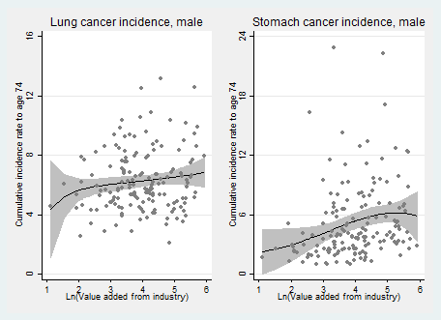
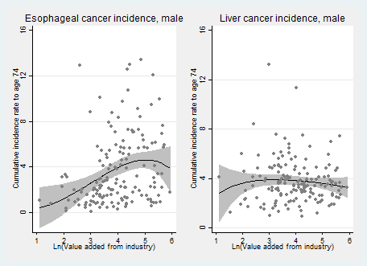

Fig. S1. County-level relationships between industrial activity and age-standardized male cancer incidence: four most common cancers. Panels depict scatter plots overlaid with fitted polynomial regression predictions and 95% CIs. Each plotted data point represents a county-level cancer registry. All response variables represent cumulative incidence rate to age 74 for each listed cancer. Explanatory variables represent the natural log of value added from industrial production in hundred million CNY. The panels depict positive county-level associations between industrial activity and age-standardized incidence from lung, trachea, and bronchus cancer; stomach cancer; and esophageal cancer. These relationships tend to increase at a decreasing rate. We detect no clear association between industrial activity and age-standardized incidence from liver cancer. Limited data drive imprecise estimates in the distributional tails.
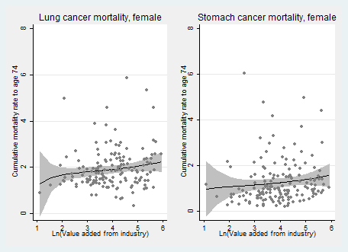
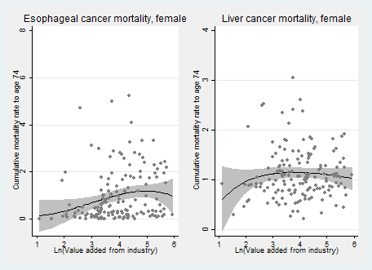

Fig. S2. County-level relationships between industrial activity and age-standardized female cancer mortality: four most common cancers. Panels depict scatter plots overlaid with fitted polynomial regression predictions and 95% CIs. Each plotted data point represents a county-level cancer registry. All response variables represent cumulative mortality rate to age 74 for each listed cancer. Explanatory variables represent the natural log of value added from industrial production in hundred million CNY. The panels depict modest positive county-level associations between industrial activity and age-standardized mortality from lung, trachea, and bronchus cancer; stomach cancer; and esophageal cancer. We detect no clear association between industrial activity and age-standardized mortality from liver cancer. Limited data drive imprecise estimates in the distributional tails.

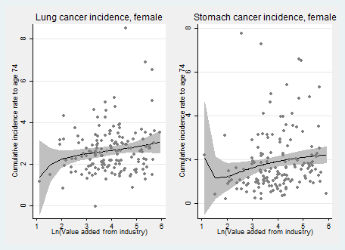
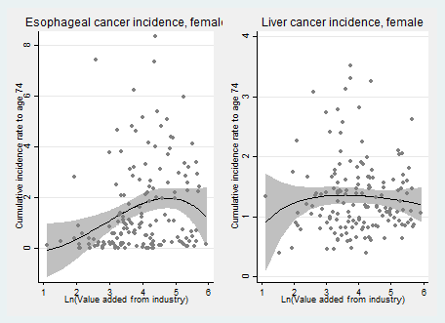

Fig. S3. County-level relationships between industrial activity and age-standardized female cancer incidence: four most common cancers. Panels depict scatter plots overlaid with fitted polynomial regression predictions and 95% CIs. Each plotted data point represents a county-level cancer registry. All response variables represent cumulative incidence rate to age 74 for each listed cancer. Explanatory variables represent the natural log of value added from industrial production in hundred million CNY. The panels depict positive county-level associations between industrial activity and age-standardized incidence from lung, trachea, and bronchus cancer; stomach cancer; and esophageal cancer. We detect no clear association between industrial activity and age-standardized incidence from liver cancer. Limited data drive imprecise estimates in the distributional tails.

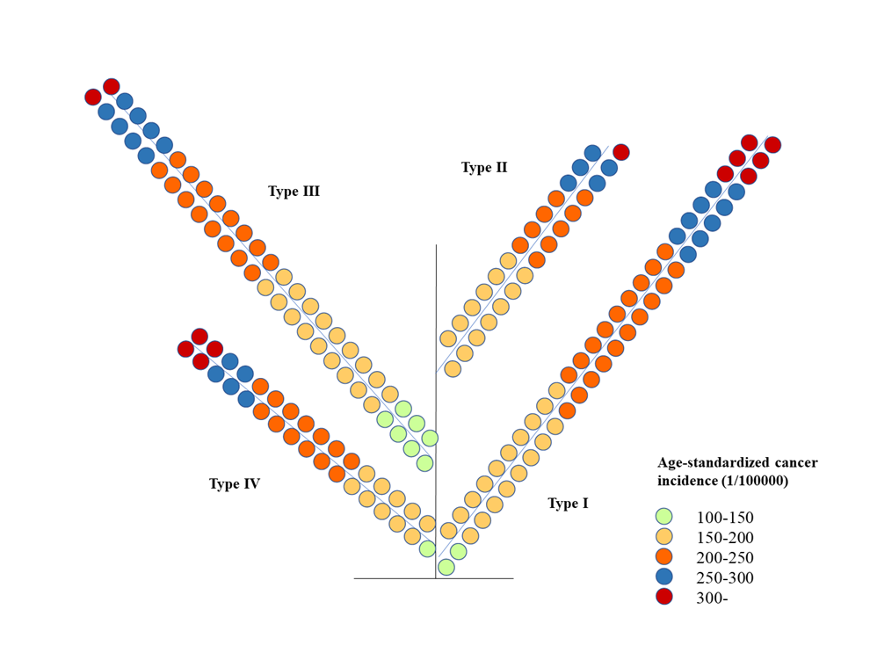
Fig. S4. An “evolution tree” perspective on county-level cancer incidence as reported in official cancer registry data. We use the k-means clustering method to assign the counties with county-level cancer registries to four “types.” The underlying socio-economic factors used for group assignment include GDP per capita, % employment in agriculture / manufacturing / services, population, adult illiteracy rates, and the proportion of households with tap water (a standardized household wealth indicator). Adding other factors does not affect conclusions. The four types are: I, poor and disproportionately agricultural / rural counties; II, poor and disproportionately industrialized / urbanized counties; III, medium wealth and disproportionately agricultural / rural counties; and IV, higher wealth and disproportionately industrialized / urbanized counties. We then explore age-standardized cancer incidence by type. We see that, although the mean male age-standardized cancer incidence for males is highest in Type IV, incidence by type is not obviously different graphically. Indeed, mean cancer incidence is not statistically different across types. We conclude that socio-economic characteristics broadly associated with economic development are not necessarily related to higher cancer incidence. In contrast, our analyses that attempt to isolate the effects of polluting industrial facilities document stark relationships.

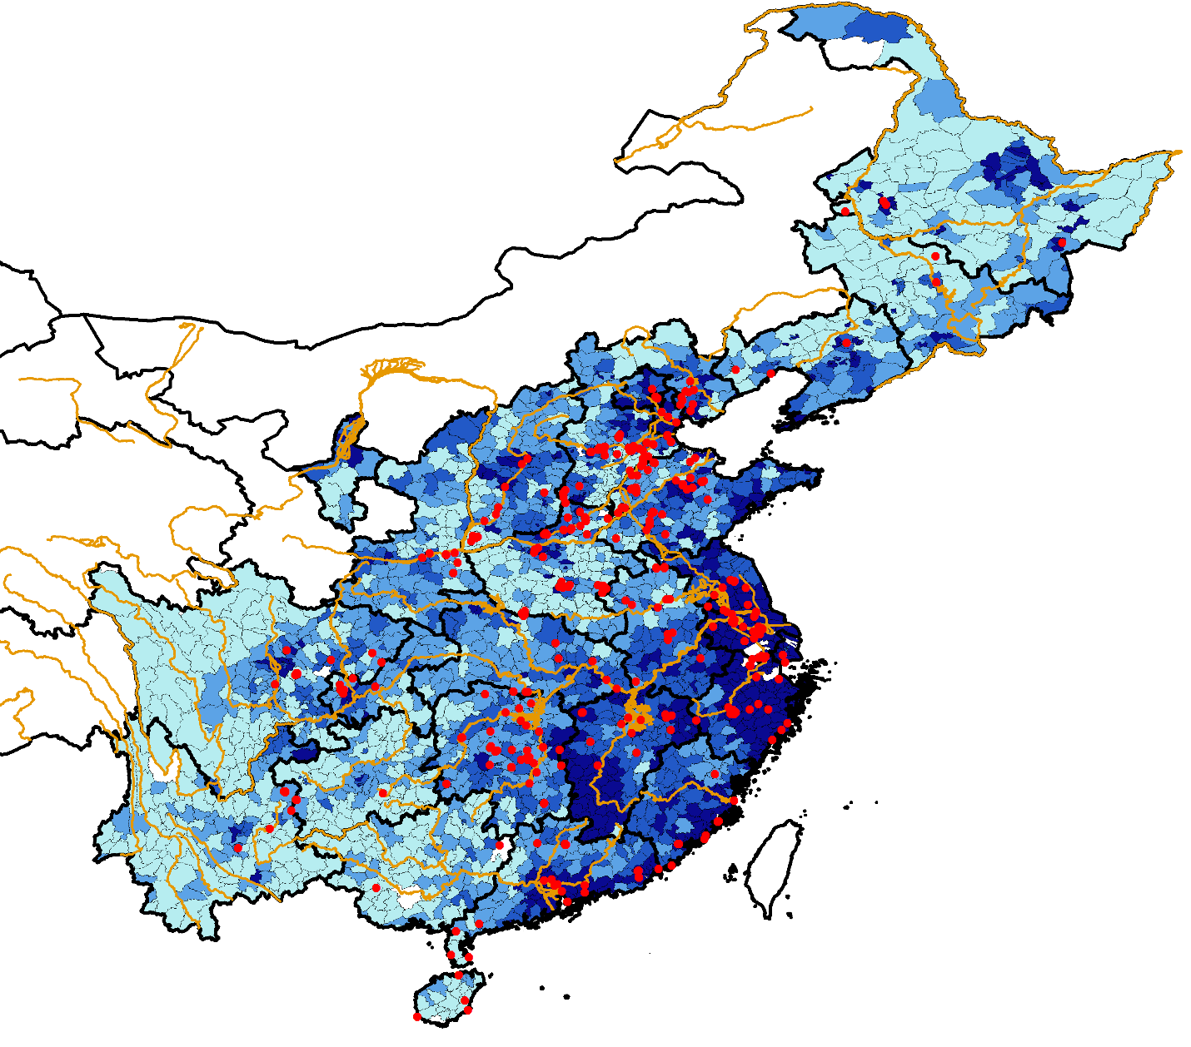

Fig. S5. “Cancer village” locations overlaid on choropleth of industrial activity quartiles, with major rivers and provincial boundaries included. Darker colors represent greater county-level share of employment in industrial activity. Village-level cancer clusters are represented by red dots. White indicates no data; we do not analyze the sparsely populated far west and northwestern provinces. Major rivers are in orange and provincial boundaries are represented by thicker black lines. Counties with cancer villages have greater shares of employment in industrial activities. Counties with cancer villages are statistically no more likely to be near major rivers or provincial borders.

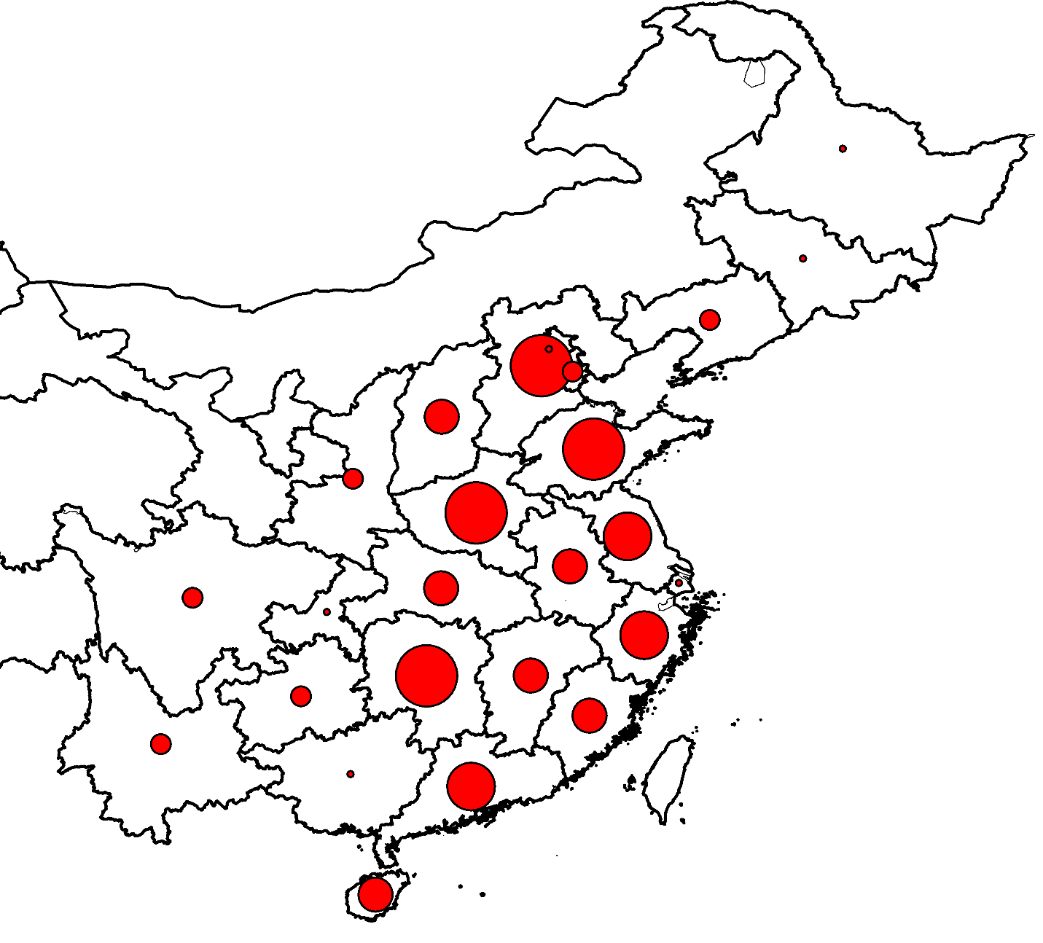

Fig. S6. Proportional symbol map of “cancer villages” by province. Red dots vary in size to represent the number of village-level cancer clusters in each province. The five categories of red dots represent 1-4, 5-8, 9-15, 16-30, and 31-61 village-level cancer clusters. We do not analyze the sparsely populated and less developed far west and northwestern provinces. The figure shows that all but one of the sample provinces contain at least one cancer village, and cancer villages are more common in populated and developed central and eastern provinces. Cancer village clusters are particular common in Hebei, Henan, Hunan, and Shandong provinces.

Variable | Counties without cancer clusters | Counties with cancer clusters | Difference in means | P-value
General characteristics
Population (1000s) | 571.88 | 762.52 | -190.64 | 0.00
% Area in agriculture | 0.45 | 0.46 | -0.01 | 0.68
Socio-demographic characteristics
% Population minority | 4.48 | 3.27 | 1.21 | 0.24
% Population 0 to 14 | 16.25 | 16.19 | 0.06 | 0.85
% Population 65+ | 9.01 | 9.13 | -0.12 | 0.46
Years of schooling | 9.17 | 8.97 | 0.21 | 0.03
% Adults illiterate | 4.45 | 4.44 | 0.01 | 0.96
Household size | 3.16 | 3.19 | -0.04 | 0.30
Economic indicators
% Employment in agriculture and natural resources | 45.11 | 46.00 | -0.88 | 0.68
% Employment in industrial activity | 24.88 | 28.10 | -3.23 | 0.01
% Employment in services | 30.03 | 25.90 | 4.13 | 0.00
Value added of industrial sector (100 million CNY) | 61.61 | 110.35 | -48.74 | 0.00
GDP (100 million CNY) | 111.10 | 181.44 | -70.34 | 0.00
Local government revenue (100 million CNY) | 5.68 | 9.76 | -4.08 | 0.00
Local government expenditures (100 million CNY) | 12.84 | 17.13 | -4.29 | 0.00
Household wealth measures
Rooms per house | 3.24 | 3.38 | -0.14 | 0.04
House area (sq meters per person) | 32.04 | 34.08 | -2.04 | 0.00
% households w/ tapwater | 66.44 | 66.71 | -0.27 | 0.87
% households w/ kitchen | 84.86 | 85.39 | -0.52 | 0.60
% households w/ toilet | 72.25 | 74.83 | -2.57 | 0.10
% households w/ bath | 56.71 | 60.55 | -3.84 | 0.04
Health measures
Birth rate | 10.33 | 10.65 | -0.33 | 0.19
Mortality rate | 5.59 | 5.79 | -0.21 | 0.08
# OF COUNTIES | 1010 | 213
SUPPORTING INFORMATION TABLES

Table S1. Comparison of county-level variables. Subsample from prefectures with at least one cancer cluster.

Variable | Counties without cancer clusters | Counties with cancer clusters | Difference in means | P-value
General characteristics
Population (1000s) | 484.72 | 762.52 | -277.79 | 0.00
% Area in agriculture | 0.50 | 0.46 | 0.04 | 0.03
Socio-demographic characteristics
% Population minority | 11.82 | 3.27 | 8.55 | 0.00
% Population 0 to 14 | 16.86 | 16.19 | 0.68 | 0.06
% Population 65+ | 9.11 | 9.13 | -0.03 | 0.85
Years of schooling | 8.84 | 8.97 | -0.12 | 0.18
% Adults illiterate | 5.43 | 4.44 | 0.99 | 0.01
Household size | 3.16 | 3.19 | -0.04 | 0.26
Economic indicators
% Employment in agriculture and natural resources | 50.25 | 46.00 | 4.25 | 0.03
% Employment in industrial activity | 21.55 | 28.10 | -6.55 | 0.00
% Employment in services | 28.20 | 25.90 | 2.30 | 0.07
Value added of industrial sector (100 million CNY) | 46.06 | 110.35 | -64.29 | 0.00
GDP (100 million CNY) | 88.17 | 181.44 | -93.27 | 0.00
Local government revenue (100 million CNY) | 4.32 | 9.76 | -5.44 | 0.00
Local government expenditures (100 million CNY) | 11.58 | 17.13 | -5.54 | 0.00
Household wealth measures
Rooms per house | 3.14 | 3.38 | -0.24 | 0.00
House area (sq meters per person) | 30.58 | 34.08 | -3.50 | 0.00
% households w/ tapwater | 62.36 | 66.71 | -4.35 | 0.02
% households w/ kitchen | 83.69 | 85.39 | -1.7 | 0.14
% households w/ toilet | 69.01 | 74.83 | -5.82 | 0.00
% households w/ bath | 49.45 | 60.55 | -11.1 | 0.00
Health measures
Birth rate | 10.44 | 10.65 | -0.21 | 0.41
Mortality rate | 5.82 | 5.79 | 0.03 | 0.79
# OF COUNTIES | 2243 | 213
Table S2. Comparison of county-level variables. All county sample.
Table S3. Comparison of VILLAGE-LEVEL variables.

Variable | Villages without cancer clusters | Villages with cancer clusters | Diff.  in  means | P-value
FULL SAMPLE
Economic control variables
Total retail sales in village (100s of million CNY) | 0.056 | 0.039 | 0.017 | 0.22
Size of educational sector (100s of employees) | 0.214 | 0.220 | -0.006 | 0.86
Size of healthcare sector (in 100s of employees) | 0.080 | 0.044 | 0.036 | 0.01
Size of non-polluting industrial sector (100s of empls) | 0.714 | 1.409 | -0.695 | 0.01
Geo-political control variables
Distance to nearest Chinese coastline | 362.0 | 258.5 | 103.5 | 0.01
Distance to nearest large city (urban pop >1 million) | 201.9 | 169.3 | 32.6 | 0.01
Distance to nearest county border | 5.61 | 4.70 | 0.91 | 0.01
Distance to nearest river | 7.55 | 7.28 | 0.26 | 0.69
Distance to nearest province boundary | 48.1 | 49.6 | -1.57 | 0.65
# OF VILLAGES | 599,442 | 380
SUBSAMPLE OF COUNTIES WITH AT LEAST ONE CANCER CLUSTER.
Economic control variables
Total retail sales in village (100s of million CNY) | 0.048 | 0.039 | 0.009 | 0.49
Size of educational sector (100s of employees) | 0.211 | 0.220 | -0.010 | 0.78
Size of healthcare sector (in 100s of employees) | 0.073 | 0.044 | 0.029 | 0.02
Size of non-polluting industrial sector (100s of empls) | 0.996 | 1.409 | -0.413 | 0.11
Geo-political control variables
Distance to nearest Chinese coastline | 279.7 | 258.5 | 21.2 | 0.17
Distance to nearest large city (urban pop >1 million) | 184.6 | 169.3 | 15.3 | 0.05
Distance to nearest county border | 5.21 | 4.70 | 0.51 | 0.08
Distance to nearest river | 7.70 | 7.28 | 0.42 | 0.48
Distance to nearest province boundary | 50.2 | 49.6 | 0.53 | 0.86
# OF VILLAGES | 72,777 | 380

Table S4. Village-level case control analyses. The effects of polluting industrial facilities on the probability that the village contains a spatial cancer cluster.

 | Odds Ratios (95% CI)
 | Baseline | Adjusted for other economic and geo-political factors
Full sample (599,822 villages) | 3.88 (2.93 – 5.14) | 3.45 (2.61 – 4.58)
Restricted sample (73,157 villages) | 2.82 (2.17 – 3.65) | 2.81 (2.14 – 3.68)
NOTES: Village-level economic control variables include total retail sales, total employment in educational sector, total employment in the healthcare sector, and total employment at industrial facilities not in polluting sectors. Economic covariates are intended to control for village-level economic activity possibly correlated with both industrial activity in polluting sectors and health. Village-level geo-political control variables include distances to major coastline, nearest large city, county border, river, and provincial boundary. Geo-political covariates are intended to control for village-level geopolitical factors possibly correlated with both industrial activity in polluting sectors and health.
Table S5. Conditional fixed-effects logit regressions. The effect of industrial facilities on cancer cluster locations.

Explanatory Variable | [1] | [2] | [3] | [4]
Presence of Polluting Industrial Facility | 1.064 | 0.976 | 1.012 | 1.012
 | (0.144) | (0.147) | (0.147) | (0.148)
Presence of Non-polluting industrial facility |  | 0.249 | 0.313 | 0.313
 |  | (0.165) | (0.174) | (0.175)
Total retail sales |  |  | -0.116 | -0.117
 |  |  | (0.086) | (0.086)
Size of educational sector (employees) |  |  | -0.063 | -0.063
 |  |  | (0.070) | (0.070)
Size of public health sector (employees) |  |  | -0.353 | -0.357
 |  |  | (0.221) | (0.223)
Distance to nearest coastline |  |  |  | -0.002
 |  |  |  | (0.001)
Distance to nearest large city (pop > 1,000,000) |  |  |  | -0.002
 |  |  |  | (0.002)
Distance to nearest county border |  |  |  | -0.004
 |  |  |  | (0.025)
Distance to nearest major river |  |  |  | -0.001
 |  |  |  | (0.017)
Distance to nearest province border |  |  |  | 0.006
 |  |  |  | (0.007)

NOTES: Estimates are regression coefficients from regressions with county-level fixed effects. Clustered standard errors in parentheses.

Table S6. Fixed Effects linear probability regressions. The effect of industrial facilities on cancer cluster locations.

Explanatory Variable | [1] | [2] | [3] | [4]
Presence of Polluting Industrial Facility | 0.008 | 0.007 | 0.008 | 0.008
 | (0.001) | (0.001) | (0.001) | (0.001)
Presence of Non-polluting industrial facility |  | 0.001 | 0.002 | 0.002
 |  | (0.001) | (0.001) | (0.001)
Total retail sales |  |  | -0.001 | -0.001
 |  |  | (0.000) | (0.000)
Size of educational sector (employees) |  |  | -0.001 | -0.001
 |  |  | (0.000) | (0.000)
Size of public health sector (employees) |  |  | -0.001 | -0.001
 |  |  | (0.000) | (0.000)
Distance to nearest coastline |  |  |  | -0.000
 |  |  |  | (0.000)
Distance to nearest large city (pop > 1,000,000) |  |  |  | -0.000
 |  |  |  | (0.000)
Distance to nearest county border |  |  |  | -0.000
 |  |  |  | (0.000)
Distance to nearest major river |  |  |  | -0.000
 |  |  |  | (0.000)
Distance to nearest province border |  |  |  | 0.000
 |  |  |  | (0.000)

NOTES: Estimates are regression coefficients from regressions with county-level fixed effects. Clustered standard errors in parentheses.

Explanatory Variable | Two Stage Least Squares (2SLS) |  |  |  | Bivariate Probit
 | [1] | [2] | [3] | [4] | [5] | [6] | [7] | [8]
Distance to Major Railway (Logged) | -0.015 | -0.011 | -0.011 | -0.009 | -0.081 | -0.075 | -0.072 | -0.063
 | (0.004) | (0.003) | (0.008) | (0.003) | (0.020) | (0.016) | (0.016) | (0.015)
Presence of Non-polluting Ind. Facility |  | 0.331 | 0.323 | 0.309 |  | 1.373 | 1.342 | 1.254
 |  | (0.019) | (0.020) | (0.017) |  | (0.048) | (0.049) | (0.039)
Total retail sales |  |  | 0.005 | 0.004 |  |  | 0.016 | 0.011
 |  |  | (0.002) | (0.002) |  |  | (0.007) | (0.007)
Size of educational sector (employees) |  |  | 0.015 | 0.015 |  |  | 0.058 | 0.059
 |  |  | (0.003) | (0.003) |  |  | (0.012) | (0.012)
Size of public health sector (employees) |  |  | 0.005 | 0.005 |  |  | 0.029 | 0.031
 |  |  | (0.003) | (0.003) |  |  | (0.011) | (0.010)
Distance to nearest coastline |  |  |  | -0.001 |  |  |  | -0.001
 |  |  |  | (0.000) |  |  |  | (0.000)
Distance to nearest large city |  |  |  | -0.001 |  |  |  | -0.001
 |  |  |  | (0.000) |  |  |  | (0.000)
Distance to nearest county border |  |  |  | -0.001 |  |  |  | -0.004
 |  |  |  | (0.001) |  |  |  | (0.004)
Distance to nearest major river |  |  |  | -0.001 |  |  |  | -0.009
 |  |  |  | (0.000) |  |  |  | (0.003)
Distance to nearest province border |  |  |  | 0.0001 |  |  |  | 0.001
 |  |  |  | (0.001) |  |  |  | (0.001)
Table S7a. Two stage regressions: first stage. The effect of distance to railways on industrial facility locations.

NOTES: Estimates are regression coefficients. Clustered standard errors in parentheses. We see that first-stage instruments that are “strong” or “relevant.” First-stage 2SLS coefficients indicate that a 10% increase in a village’s distance to a railway is associated with a roughly 9 to 13% reduction (p < 0.01) in the probability that the village has one or more polluting facilities. First stage F-stats in the 2SLS models range from 11.3 (p < 0.01) to 17.4 (p < 0.01).

Table S7b. Two stage regression: second stage. The effect of industrial facilities on cancer cluster locations.
Explanatory Variable | Two Stage Least Squares |  |  |  | Bivariate Probit
 | [1] | [2] | [3] | [4] | [5] | [6] | [7] | [8]
Presence of Polluting Industrial Facility | 0.042 | 0.052 | 0.057 | 0.059 | 1.120 | 0.529 | 0.549 | 0.381
 | (0.024) | (0.031) | (0.033) | (0.041) | (0.533) | (0.252) | (0.251) | (0.335)
Presence of Non-polluting Ind. Facility |  | -0.014 | -0.015 | -0.015 |  | -0.019 | -0.002 | 0.041
 |  | (0.010) | (0.011) | (0.013) |  | (0.099) | (0.098) | (0.130)
Total retail sales |  |  | -0.001 | -0.001 |  |  | -0.034 | -0.036
 |  |  | (0.000) | (0.000) |  |  | (0.037) | (0.038)
Size of educational sector (employees) |  |  | -0.001 | -0.001 |  |  | -0.013 | -0.010
 |  |  | (0.001) | (0.001) |  |  | (0.019) | (0.019)
Size of public health sector (employees) |  |  | -0.001 | -0.001 |  |  | -0.118 | -0.114
 |  |  | (0.000) | (0.000) |  |  | (0.069) | (0.067)
Distance to nearest coastline |  |  |  | 0.000 |  |  |  | 0.0000
 |  |  |  | (0.000) |  |  |  | (0.000)
Distance to nearest large city |  |  |  | 0.000 |  |  |  | -0.001
 |  |  |  | (0.000) |  |  |  | (0.000)
Distance to nearest county border |  |  |  | -0.000 |  |  |  | -0.010
 |  |  |  | (0.000) |  |  |  | (0.008)
Distance to nearest major river |  |  |  | 0.000 |  |  |  | -0.002
 |  |  |  | (0.000) |  |  |  | (0.004)
Distance to nearest province border |  |  |  | -0.000 |  |  |  | 0.001
 |  |  |  | (0.000) |  |  |  | (0.001)

NOTES: Estimates are regression coefficients. Clustered standard errors in parentheses.

Table S8. Conditional fixed effects logits. The effect of industrial facilities on cancer cluster locations, disaggregated by sector.
Industry Var. | Cement  only | Chemical only | Coking only | Dye only | Electricity only | Fiber only | Food only | Iron only | Tanning only | Metals only | Paper only | Pharma only | Rubber only | Veg oils only | All Polluting Industries Together
cement | 0.311 |  |  |  |  |  |  |  |  |  |  |  |  |  | -0.283
 | (0.300) |  |  |  |  |  |  |  |  |  |  |  |  |  | (0.319)
chemical |  | 1.283 |  |  |  |  |  |  |  |  |  |  |  |  | 0.963
 |  | (0.209) |  |  |  |  |  |  |  |  |  |  |  |  | (0.238)
coking |  |  | 0.957 |  |  |  |  |  |  |  |  |  |  |  | 0.322
 |  |  | (0.484) |  |  |  |  |  |  |  |  |  |  |  | (0.533)
dye |  |  |  | 1.105 |  |  |  |  |  |  |  |  |  |  | 0.626
 |  |  |  | (0.232) |  |  |  |  |  |  |  |  |  |  | (0.286)
electricity |  |  |  |  | 1.432 |  |  |  |  |  |  |  |  |  | 0.878
 |  |  |  |  | (0.539) |  |  |  |  |  |  |  |  |  | (0.563)
fiber |  |  |  |  |  | 1.611 |  |  |  |  |  |  |  |  | 0.903
 |  |  |  |  |  | (0.471) |  |  |  |  |  |  |  |  | (0.505)
food |  |  |  |  |  |  | 1.283 |  |  |  |  |  |  |  | 0.521
 |  |  |  |  |  |  | (0.343) |  |  |  |  |  |  |  | (0.415)
iron |  |  |  |  |  |  |  | 1.099 |  |  |  |  |  |  | 0.584
 |  |  |  |  |  |  |  | (0.351) |  |  |  |  |  |  | (0.386)
tanning |  |  |  |  |  |  |  |  | 2.341 |  |  |  |  |  | 2.006
 |  |  |  |  |  |  |  |  | (0.354) |  |  |  |  |  | (0.387)
metals |  |  |  |  |  |  |  |  |  | 0.734 |  |  |  |  | -0.056
 |  |  |  |  |  |  |  |  |  | (0.366) |  |  |  |  | (0.433)
paper |  |  |  |  |  |  |  |  |  |  | 0.462 |  |  |  | -0.261
 |  |  |  |  |  |  |  |  |  |  | (0.547) |  |  |  | (0.657)
pharma |  |  |  |  |  |  |  |  |  |  |  | 1.518 |  |  | 0.775
 |  |  |  |  |  |  |  |  |  |  |  | (0.423) |  |  | (0.512)
rubber |  |  |  |  |  |  |  |  |  |  |  |  | 1.017 |  | 0.263
 |  |  |  |  |  |  |  |  |  |  |  |  | (0.361) |  | (0.444)
veg oils |  |  |  |  |  |  |  |  |  |  |  |  |  | 0.698 | 0.099
 |  |  |  |  |  |  |  |  |  |  |  |  |  | (0.585) | (0.609)

NOTES: Estimates are regression coefficients from regressions with county-level fixed effects. Clustered standard errors in parentheses.

Table S9. The effect of total polluting industry size and average polluting facility size on cancer cluster locations. Conditional fixed effects logit regressions.

Explanatory Variable | [Baseline] | [1] | [2] | [3] | [4]
Presence of polluting | 1.064 | -1.371 | -3.016 | -1.196 | -2.663
industrial facilities | (0.144) | (0.430) | (0.680) | (0.431) | (0.682)
Sector size - Total employees |  | 0.445 |  | 0.404
at polluting facilities (log) |  | (0.072) |  | (0.074)
Sector size - Total output at |  |  | 0.350 |  | 0.314
polluting facilities (log) |  |  | (0.056) |  | (0.057)
Sector composition - # of |  |  |  | 0.023 | 0.029
polluting industrial facilities |  |  |  | (0.013) | (0.012)

NOTES: Estimates are regression coefficients from regressions with county-level fixed effects. Clustered standard errors in parentheses. Logged variables set to 0 if observed value equals 0; note that regressions also contain discrete 0/1 variables for the presence of polluting industrial facilities. Results from columns [1] and [2] are interpreted in the text by noting that k^beta yields the odds ratio for a k-fold increase in the variable. 2^beta generates results for a doubling of the variable of interest. Results from columns [3] and [4] are interpreted in standard odds ratio form. Three findings emerge: (a) Village-level results are robust to parameterizations involving continuous explanatory variables. (b) Villages with larger total polluting industrial sectors are associated with greater odds of spatial cancer clusters. (c) Given a fixed total polluting industry size, larger numbers of smaller facilities are associated with greater cancer cluster odds than smaller numbers of larger facilities.

Table S10. The effect of industrial facilities on cancer cluster locations, with interactions to illustrate north vs. south and rural vs. urban heterogeneity. Marginal effects from conditional fixed effects and fixed effects linear probability regressions.

Explanatory Variable | [1] | [2] | [3] | [4] | [5] | [6]
 | Conditional Fixed Effects Logit |  |  | Fixed Effects Linear Probability
Presence of Polluting | 0.008 | 0.007 | 0.007 | 0.008 | 0.006 | 0.007
Industrial Facility | (0.002) | (0.002) | (0.002) | (0.001) | (0.002) | (0.002)
Polluting Facility × North |  | 0.001 |  |  | 0.005
Polluting Facility × North |  | (0.002) |  |  | (0.003)
Polluting Facility × Urban |  |  | 0.000 |  |  | 0.001
Polluting Facility × Urban |  |  | (0.002) |  |  | (0.003)
Other facility controls | YES | YES | YES | YES | YES | YES
Other economic controls | YES | YES | YES | YES | YES | YES
Geo-political controls | YES | YES | YES | YES | YES | YES

NOTES: Estimates are marginal effects from regressions with county-level fixed effects. Clustered standard errors in parentheses. Regressions [1] and [4] simply replicate regressions in column D of Table 1 Rows A and B. In regressions [2] and [5], the baseline effect of being a northern county is subsumed into the county fixed effects. Regressions [3] and [6] also include a village-level urban village identifier; coefficients on this variable are never statistically significant. Interaction coefficients are interpreted as the incremental effect of being in the north or being urban relative to the baseline effect (south or rural). The key finding is that, on average, villages with industrial facilities are associated with increased probabilities of cancer clusters. However, there are no incremental effects of north vs. south or urban vs. rural. We interpret these results as providing no obvious support for spatial heterogeneity across region or land use.

Table S11. Tests of spatial stratified heterogeneity (SSH) in county-level cancer registry data.

 | All cancer incidence, Male |  | All cancer incidence, Female
 | Urban/Rural | North/South | Urban/Rural | North/South
q statistic | 0.0038 | 0.0003 | 0.0000 | 0.0847
p value | 0.7728 | 0.8612 | 0.9877 | 0.0023
 | All cancer mortality, Male |  | All cancer mortality, Female
 | Urban/Rural | North/South | Urban/Rural | North/South
q statistic | 0.0121 | 0.0009 | 0.0083 | 0.0751
p value | 0.4812 | 0.7461 | 0.6200 | 0.0034

NOTES: Following Wang et al. (2016), the q-statistic measures the degree of spatial stratified heterogeneity of Y. Potential values fall in the interval [0,1], where 0 indicates that spatial stratification of heterogeneity is not significant and 1 indicates perfect spatial stratification of heterogeneity. We implement the tests using http://www.geodetector.org . Results show that all q-statistics are close to zero (less than 0.09) in magnitude, and we fail to reject a null of no stratified heterogeneity for the majority of explorations. Collectively, heterogeneity findings do not provide strong support for spatial stratified heterogeneity. See: Wang, J. F., Zhang, T. L., & Fu, B. J. (2016). A measure of spatial stratified heterogeneity. Ecological Indicators, 67, 250-256.

Table S12. Relationships between individual-level health behaviors and the presence of polluting industrial facilities: Evidence from China Family Panel Studies data

 | (1) | (2) | (3) | (4) | (5) | (6) | (7) | (8) | (9)
 | Smoking | Meat | Fish | Fruit & Vegetable | Dairy | Bean | Eggs | Pickled | Fried
Polluting  Facility | -0.00 | 0.37 | 0.16 | 0.54 | -0.01 | 0.23 | 0.17 | 0.52 | 0.02
Polluting  Facility | (0.01) | (0.39) | (0.19) | (0.57) | (0.10) | (0.12) | (0.14) | (0.37) | (0.06)
Observations | 31,306 | 31,360 | 31,353 | 31,396 | 31,384 | 31,360 | 31,360 | 31,369 | 31,376

NOTES: Although we take several approaches to minimize potential confounding, results could be biased if villages with polluting industrial facilities have different smoking rates and diets when compared to villages in the same counties without polluting industrial facilities (after controlling for income proxies, economic proxies, political proxies, and geography). To consider the issue, we collect and examine restricted use data from the 2010 China Family Panel Studies longitudinal survey of Chinese families. The main section of this survey includes data on individual-level responses from more than 30,000 adults in 635 villages in 25 provinces. Respondents are selected to reconstruct a nationally representative sample, and response rates are very high (~80%). A supplemental section of the survey includes village-level characteristics on the villages included in the survey, developed by asking committee representatives (i.e. local government officials) to describe local economic and other activity in the village. We match individual-level responses to questions about smoking (did you smoke in the past month?) and diet (in the past month, how many times did you eat meat, fish, fruit and vegetables, dairy, beans, eggs, pickled foods, or fried foods per week on average?) -to- village-level responses to questions about polluting industrial facilities in the village (is there a chemical, refining, paper, or similar industrial facility in this village or within 5km?).

Results in Table S12 explore the question, “do villages with and without polluting industrial facilities have similar smoking rates and diets, after controlling for basic economic conditions?” We regress individual’s smoking behavior on the presence of a polluting industrial facility within 5km of the village center and household income (in logs). We regress individual’s diet choices on the presence of a polluting industrial facility within 5km of the village center and household income (in logs).

Results in Table S12 fail to reveal significant relationships between smoking and the presence of polluting industrial facilities. Results in Table S12 fail to reveal significant relationships between any measure of diet and the presence of polluting industrial facilities. All estimates in Table S12 are all small in magnitude and we fail to reject a null of no differences. As smoking rates and diets are uncorrelated with the presence of polluting industrial facilities, omitting smoking rates and diets from our main analysis due to data limitations is unlikely to impact our results.

See EPA’s Integrated Risk Information System assessments. https://www.epa.gov/iris .
We are unable to definitively assess the percent of total pollution in China emitted by facilities in our dataset. But since the dataset includes facilities representing more than 91% of total industrial revenue, and since it includes facilities in the most pollution intensive industries (chemical, dye, fiber, leather, pharmaceutical, cement, coking, electricity, food, iron and steel, metals, paper, rubber, and vegetable oil industries), we are reasonably confident that enterprises in our dataset are responsible for the significant majority of air, water, waste, and other pollution generated by industrial facilities.

