Supporting information

Supplementary tables 3-15 are also available at the below link.
https://drive.google.com/drive/folders/1Rt1nBhppteT7JQKBRlp-WKA4Xj4c-wg2?usp=sharing

Supplementary table 1. Clinical information of subjects
 | Non-ul | Ul | GC
Number of subjects | 299 | 103 | 323
Age: median (range) | 63 (26-89) | 63 (25-93) | 67 (26-94)
Gender (F/M) | 144/155 | 30/73 | 98/225
H. pylori status (-/+) | 144/155 | 17/86 | 15/247
Age, Non-ul vs. GC, P=0.0001, Ul vs. GC, P<0.0001.
Gender, Non-ul vs. Ul, P=0.0009, Non-ul vs. GC, P<0.0001.
H. pylori status, Non-ul vs. Ul, P<0.0001, Non-ul vs. GC, P<0.0001.
Age was assessed by the Mann-Whitney U-test. Gender and H. pylori status was assessed by the Fisher's exact test
H. pylori status was not determined for 15 GC patients.

Supplementary table 2. Primer assay used for sanger sequencing, pyrosequencing and real-time PCR
Assay | Forward primer (1st step PCR) | Reverse primer (1st step PCR) | Forward primer (2nd step PCR) | Reverse primer (2nd step PCR) | Sequence primer
name | sequence | sequence | sequence | sequence | sequence
16S rRNA V3-V4 region (F34－R805) | TCGTCGGCAGCGTCAGATGTGTATAAGAGACAGCCTACGGGNGGCWGCAG | GTCTCGTGGGCTCGGAGATGTGTATAAGAGACAGGACTACHVGGGTATCTAATCC | NA | NA | NA
IGF2 | GAGGATTAGGGAGGGAAATATAGT | CCCAAACCCCCAAATTATC | GAGGATTAGGGAGGGAAATATAGT | U-CCCAAACCCCCAAATTATC | AATGGTTATTTAGTTTTTAG
SLC16A12 | TAGAGGGAGAGGTGGTTTAGGTGAT | CACCCAAATTAAAATCCCAAACTC | TAGAGGGAGAGGTGGTTTAGGTGAT | U-CACCCAAATTAAAATCCCAAACTC | AAGGGTATTTTTTAAGGAAG
SOX11 | AGTTGGGGGAGTGATGTTATTTA | AACAACCCCAAACCCCTCTCT | GGGGGAGTGATGTTATTTATATGAT | U-CCCCCAACTCTCCCAAAC | GAGATTTTAATTTTTTGTAGAAG
MYOD1 | AATTAGGGGATAGAGGAGTATTGAAAG | ACAACCCTAAACRACTACACTTAACTC | GAAAGTTAGTTTAGAGGTGA | U-ACAACCCTAAACRACTACACTTAACTC | GAGGTTTGGAAAGGG
P2RX7 | GAAGAGTAGAGTTTTGGTTTAGTTT | AAACCACTTAATAATACCATAATTC | GAAGAGTAGAGTTTTGGTTTAGTTT | U-AAACCACTTAATAATACCATAATTC | TGTAGTGATGTTTTTTAGTATGAG
TP53 Exon 2-4 | TGGAAGTGTCTCATGCTGGA | GCCAGGCATTGAAGTCTCAT | NA | NA | ATGCTGGATCCCCACTTTTC
TP53 Exon 5-6 | CCAGTTGCTTTATCTGTTCACTTG | CACTGACAACCACCCTTAACC | NA | NA | CACTTGTGCCCTGACTTTCA
TP53 Exon 7-8 | AAAAGGCCTCCCCTGCTT | AAAAGTGAATCTGAGGCATAACTG | NA | NA | CCACAGGTCTCCCCAAGG
TP53 Exon 9 | CCTTTCCTTGCCTCTTTCCT | TGTCTTTGAGGCATCATCACTGC | NA | NA | CCCCAATTGCAGGTAAAACA
TP53 Exon 10 | ACTTCTCCCCCTCCTCTGTT | GAAGGCAGGATGAGAATGGA | NA | NA | GAATCCTATGGCTTTCCAACC
TP53 Exon 11 | AAAGCATTGGTCAGGGAAAA | GGCTGTCAGTGGGGAACA | NA | NA | GGGCACAGACCCTCTCACT
Telomere F | CGGTTTGTTTGGGTTTGGGTTTGGGTTTGGGTTTGGGTT | NA | NA | NA | NA
Telomere R | GGCTTGCCTTACCCTTACCCTTACCCTTACCCTTACCCT | NA | NA | NA | NA
Beta-globin F | GCTTCTGACACAACTGTGTTCACTAGC | NA | NA | NA | NA
Beta-globin R | CACCAACTTCATCCACGTTCACC | NA | NA | NA | NA
NA, Not applicable; U =biotin labeled universal primer tag: 5'-biotin-GGGACACCGCTGATCGTTTA, NA, not applicable;
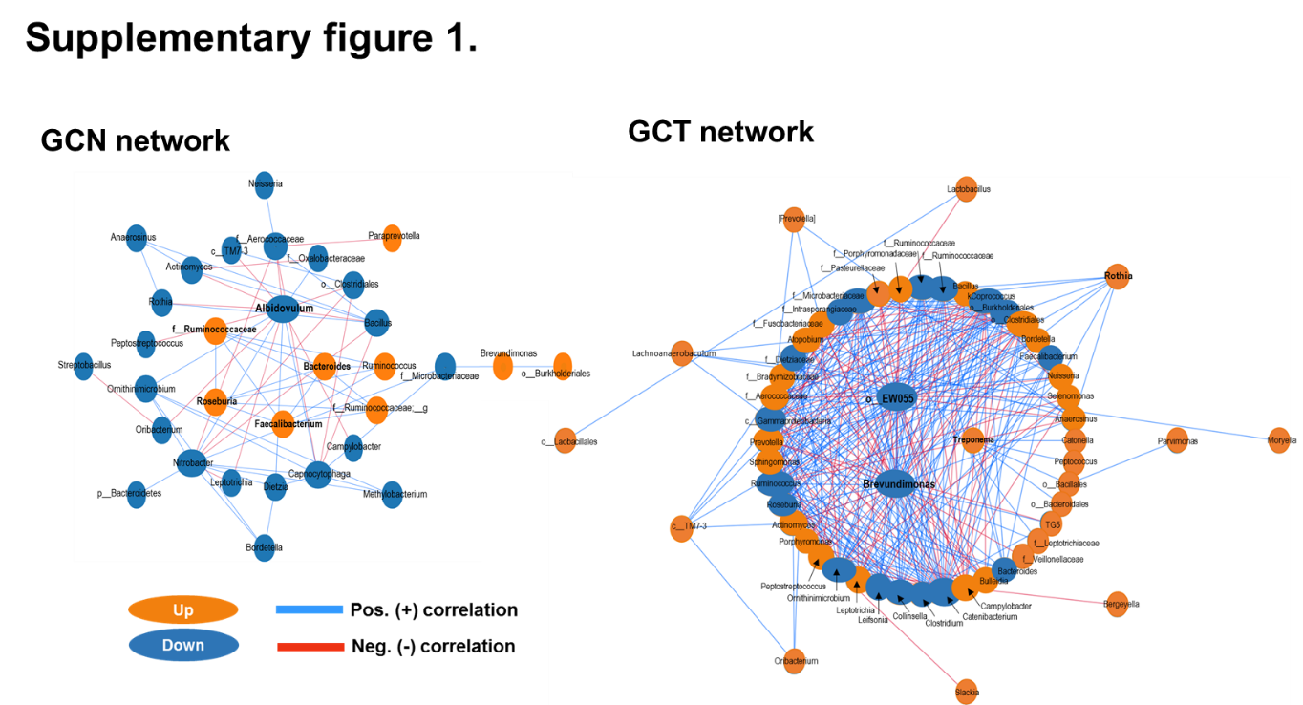
Supplementary figure 1.
Co-abundance patterns among the genera of the GCN and GCT groups. Co-abundance network analysis was performed through CCLasso correlation algorithms.

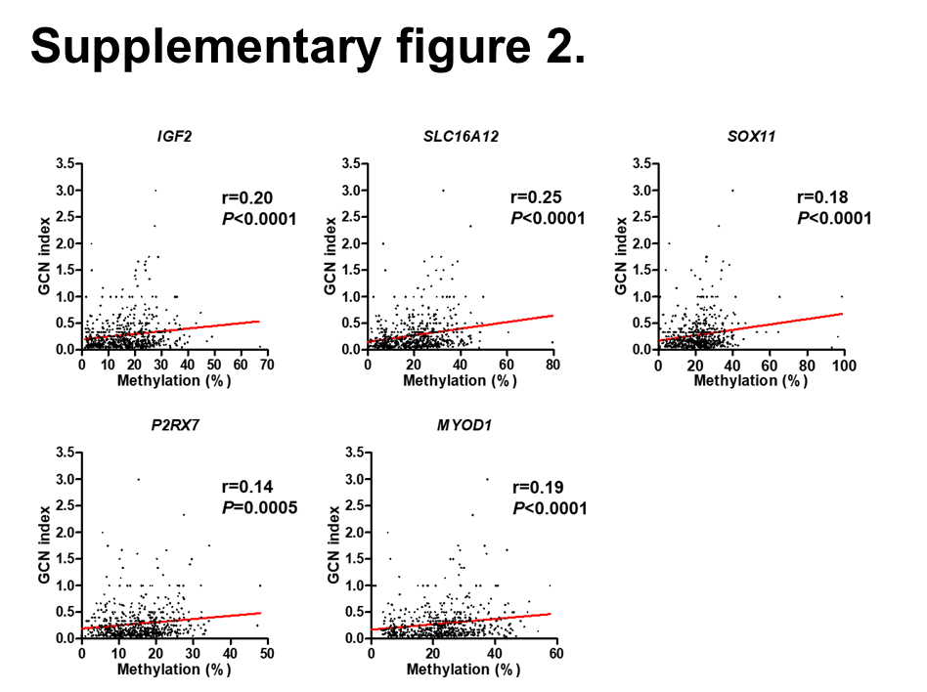
Supplementary figure 2.
Association between GCN index and methylation status of H. pylori infection-associated five gene promoters (IGF2, SLC16A12, SOX11, P2RX7, MYOD1). Statistical analysis was performed using the Spearman correlation analysis.

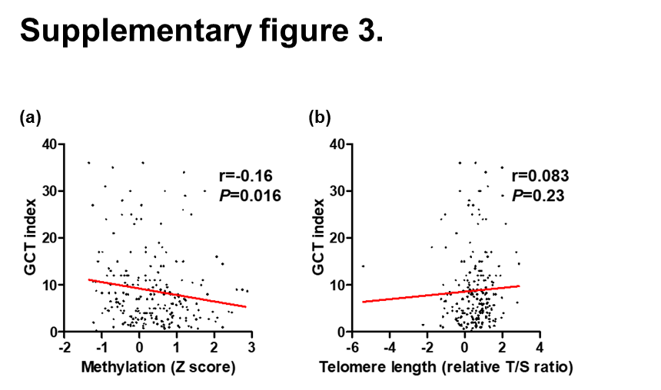
Supplementary figure 3.
Association between GCT index and mean Z score methylation of H. pylori infection-associated five gene promoters (IGF2, SLC16A12, SOX11, P2RX7, MYOD1) and telomere shortening. Statistical analysis was performed using the two-tailed Spearman correlation analysis.

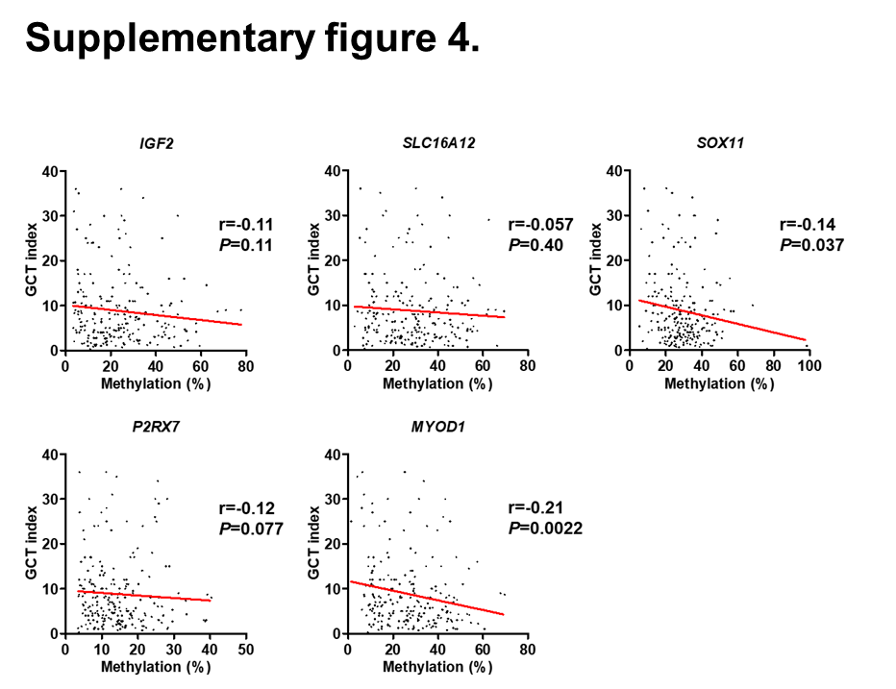

Supplementary figure 4.
Association between GCT index and methylation status of H. pylori infection-associated five gene promoters (IGF2, SLC16A12, SOX11, P2RX7, MYOD1). Statistical analysis was performed using the two-tailed Spearman correlation analysis.

