Extended data
Extended Data Table 1. Performance metrics of machine learning models for predicting APOE ε4 carriers from non-carriers using plasma APOE ε4 proteins.
 | Sensitivity | Specificity | PPV | NPV | AUC
Non-impaired controls | 0.92 | 0.97 | 0.95 | 0.96 | 0.97
Alzheimer’s disease | 0.95 | 0.94 | 0.94 | 0.95 | 0.96
Males | 0.93 | 0.96 | 0.93 | 0.95 | 0.94
Females | 0.92 | 0.96 | 0.94 | 0.94 | 0.94
Black / African American | 0.91 | 0.91 | 0.87 | 0.94 | 0.91
American Indian / Alaskan Native | 0.91 | 0.97 | 0.94 | 0.96 | 0.96
APOE ε4 AD-specific proteins | 0.63 | 0.70 | 0.59 | 0.74 | 0.70
Homozygous APOE ε4 carriers | 0.85 | 0.99 | 0.92 | 0.99 | 0.95
Heterozygous APOE ε4 carriers | 0.93 | 0.97 | 0.94 | 0.96 | 0.93
APOE ε4 non-carriers | 0.97 | 0.94 | 0.96 | 0.96 | 0.94

Extended Data Table 2. Performance metrics of machine learning models for predicting APOE ε4 carriers from non-carriers using cerebrospinal fluid APOE ε4 proteins.
 | Sensitivity | Specificity | PPV | NPV | AUC
Non-impaired controls | 0.99 | 1 | 1 | 1 | 0.99
Alzheimer’s disease | 1 | 0.99 | 0.99 | 0.99 | 0.99
Males | 1 | 0.99 | 0.99 | 1 | 0.99
Females | 0.99 | 1 | 1 | 0.99 | 0.99
APOE ε4 AD-specific proteins | 0.75 | 0.61 | 0.75 | 0.67 | 0.75
Homozygous APOE ε4 carriers | 0.75 | 1 | 1 | 0.99 | 0.94
Heterozygous APOE ε4 carriers | 1 | 0.99 | 0.97 | 1 | 1
APOE ε4 non-carriers | 0.99 | 0.99 | 0.99 | 0.99 | 0.99

Extended Data Table 3. Performance metrics of machine learning models for predicting APOE ε4 carriers from non-carriers using brain APOE ε4 proteins.
 | Sensitivity | Specificity | PPV | NPV | AUC
Alzheimer’s disease (dlPFC) | 0.80 | 0.89 | 0.87 | 0.83 | 0.94
Males (dlPFC) | 0.76 | 0.77 | 0.78 | 0.75 | 0.89
Females (dlPFC) | 0.80 | 0.77 | 0.80 | 0.78 | 0.88
Black / African American (dlPFC) | 0.90 | 1 | 1 | 0.83 | 0.94
Alzheimer’s disease (STG) | 0.80 | 0.89 | 0.8 | 0.89 | 0.91
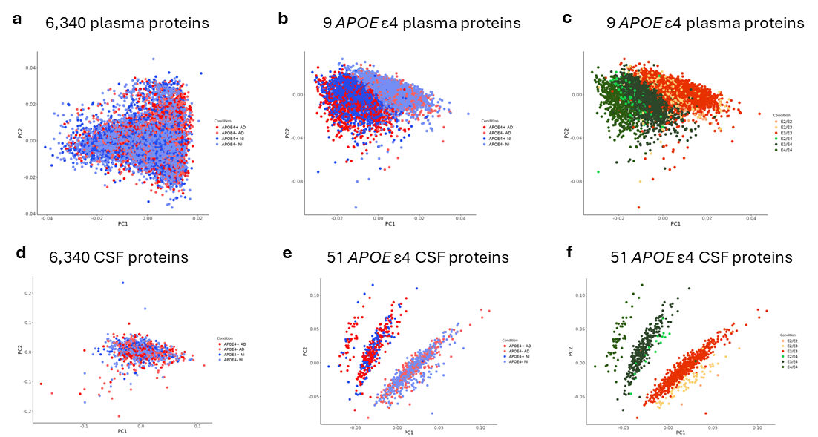
Extended Data Fig. 1. Principal component analyses of plasma and cerebrospinal fluid proteins. Plasma proteins principal component analysis (PCA) of (a) all 6,340 proteins, (b) nine identified APOE ε4 proteins showing clustering based on presence (+) or absence (-) of an APOE ε4 allele, and (c) nine identified APOE ε4 proteins showing clustering based on the number of APOE ε4 alleles. Cerebrospinal fluid (CSF) PCA of (d) all 6,340 proteins, (e) 51 identified APOE ε4 proteins showing clustering based on presence (+) or absence (-) of an APOE ε4 allele, and (e) 51 identified APOE ε4 proteins showing clustering based on the number of APOE ε4 alleles. Abbreviations: AD: Alzheimer’s disease; NI: non-impaired control.

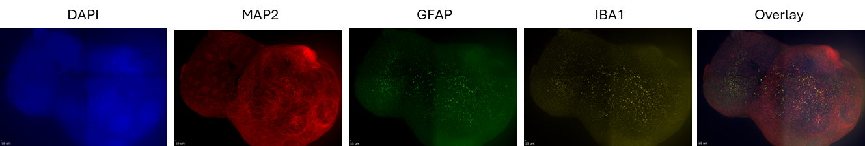
Extended Data Fig. 2. Representative immunofluorescent image of a cortical organoid. Images show staining for DAPI (nuclei), microtubule associated protein 2 (MAP2; neurons), glial fibrillary acidic protein (GFAP; astrocytes), ionized calcium-binding adapter molecule 1 (IBA1; microglia), and an overlay of all four markers.

