Supplementary Table 1. Search terms that were used to search the databases.
Search Category | Search Terms
General STH & MDA & Region | "Soil-transmitted helminths AND Mass Drug Administration AND Southeast Asia"
STH & MDA & Country* | "Soil-transmitted helminths AND Mass Drug Administration AND Thailand"
STH & MDA & Country* | "Soil-transmitted helminths AND Mass Drug Administration AND Myanmar"
STH & MDA & Country* | "Soil-transmitted helminths AND Mass Drug Administration AND Cambodia"
STH & MDA & Country* | "Soil-transmitted helminths AND Mass Drug Administration AND Laos"
STH & MDA & Country* | "Soil-transmitted helminths AND Mass Drug Administration AND Vietnam"
STH & MDA & Country* | "Soil-transmitted helminths AND Mass Drug Administration AND Philippines"
STH & MDA & Country* | "Soil-transmitted helminths AND Mass Drug Administration AND Malaysia"
STH & MDA & Country* | "Soil-transmitted helminths AND Mass Drug Administration AND Timor-Leste"
STH & MDA & Country* | "Soil-transmitted helminths AND Mass Drug Administration AND Indonesia"
STH & MDA & Country* | "Soil-transmitted helminths AND Mass Drug Administration AND Singapore"
STH & MDA & Country* | "Soil-transmitted helminths AND Mass Drug Administration AND Brunei Darussalam"
Specific STH & MDA & Region | "Hookworm AND Mass Drug Administration AND Southeast Asia"
Specific STH & MDA & Region | "Ascaris AND Mass Drug Administration AND Southeast Asia"
Specific STH & MDA & Region | "Trichuris AND Mass Drug Administration AND Southeast Asia"
* Countries included are the members of Association of Southeast Asian Nations

Supplementary Table 2. Inclusion and exclusion criteria that were used to screen papers.
Inclusion Criteria | Exclusion Criteria
1. Studies that report the effects of PC against STH infections | 1. Studies not reporting MDA efficacy end-points (e.g., cure rates, egg reduction rates, and/or changes in infection prevalence)
2. Studies using randomized control trials, intervention studies, and observational studies | 2. Studies published beyond January 2011 to January 2025
3. Studies using anthelmintics as monotherapy or combination therapy interventions | 3. Studies not conducted in any SEA country*
4. Studies that conducted single or multiple dose administration or mentioned histories of such administrations in the population studied | 4. Studies not in the English language
5. Studies conducted on preschool- and school-aged children, adults, and other vulnerable groups (i.e., women of reproductive age and immunocompromised individuals). | 5. Literature reviews, comments, perspectives and protocols
 | 6. Studies not yet published in a peer-reviewed journal (i.e., preprints)
* Countries are limited to the member states of the ASEAN.

Supplementary Table 3. Study codes and key information of the selected studies in this systematic review.
Code | Authors | Year of Publication | Country | Title
ST1 | Soukhathammavong et al. | 2012 | Lao PDR | Low Efficacy of Single-Dose Albendazole and Mebendazole against Hookworm and Effect on Concomitant Helminth Infection in Lao PDR
ST2 | Conlan et al. | 2012 | Lao PDR | Soil-transmitted helminthiasis in Laos: a community-wide cross-sectional study of humans and dogs in a mass drug administration environment.
ST3 | Monse et al. | 2013 | Philippines | The Fit for School health outcome study - a longitudinal survey to assess health impacts of an integrated school health programme in the Philippines
ST4 | Sanza et al. | 2013 | Philippines | Monitoring the impact of a mebendazole mass drug administration initiative for soil-transmitted helminthiasis (STH) control in the Western Visayas Region of the Philippines from 2007 through 2011
ST5 | Levecke et al. | 2014 | Cambodia and Vietnam | Assessment of Anthelmintic Efficacy of Mebendazole in School Children in Six Countries Where Soil-Transmitted Helminths Are Endemic
ST6 | Park et al. | 2016 | Indonesia | Worm-free children: an integrated approach to reduction of soil-transmitted helminth infections in Central Java
ST7 | Belizario et al. | 2016 | Philippines | High Burden Of Soil-Transmitted Helminthiases In Preschool-Age Children In Masbate: A Decade Of Implementation Of The Integrated Helminth Control Program In The Philippines
ST8 | Dunn et al. | 2017 | Myanmar | A cross-sectional survey of soil-transmitted helminthiases in two Myanmar villages  receiving mass drug administration: epidemiology of infection with a focus on adults
ST9 | Ash et al. | 2017 | Lao PDR | Controlling Taenia solium and soil transmitted helminths in a northern Lao PDR village: Impact of a triple dose albendazole regime
ST10 | Staal et al. | 2018 | Indonesia | Prevalence of Atopy following Mass Drug Administration with Albendazole: A Study in School Children on Flores Island, Indonesia
ST11 | Clarke et al. | 2018 | Timor Leste | (S)WASH-D for Worms: A pilot study investigating the differential impact of school- versus community-based integrated control programs for soil-transmitted helminths
ST12 | Vaz Nery et al. | 2018 | Timor Leste | Use of quantitative PCR to assess the efficacy of albendazole against Necator americanus and Ascaris spp. in Manufahi District, Timor-Leste
ST13 | Sungkar et al. | 2018 | Indonesia | The effect of albendazole toward anemia in children with soil-transmitted helminths infection in a remote and endemic area
ST14 | Dunn et al. | 2019 | Myanmar | Soil-transmitted helminth reinfection four and six months after mass drug administration: results from the delta region of Myanmar
ST15 | Chai et al. | 2020 | Myanmar | Effect of Mass Drug Administration with a Single Dose of  Albendazole on Ascaris lumbricoides and Trichuris trichiura Infection among Schoolchildren in Yangon Region, Myanmar
ST16 | Sapulete et al. | 2020 | Indonesia | Efficacy of Albendazole-Pyrantel Pamoate Compared to Albendazole Alone for Trichuris trichiura Infection in Children: A Double Blind Randomised Controlled Trial
ST17 | Keller et al. | 2021 | Lao PDR | Long-term outcomes of ivermectin albendazole versus albendazole alone against soil-transmitted helminths: Results from randomized controlled trials in Lao PDR and PembaIsland, Tanzania
ST18 | Stracke et al. | 2021 | Thailand | Field evaluation of the gut microbiome composition of pre-school and school-aged children in Tha Song Yang, Thailand, following oral MDA for STH infections
ST19 | Colella et al. | 2021 | Cambodia | Risk profiling and efficacy of albendazole against the hookworms Necator americanus and Ancylostoma ceylanicum in Cambodia to support control programs in Southeast Asia and the Western Pacific
ST20 | Mationg et al. | 2021 | Philippines | "The Magic Glasses Philippines": a cluster randomised controlled trial of a health education package for the prevention of intestinal worm infections in schoolchildren
ST21 | Hong et al. | 2021 | Myanmar | Failure of Repeated MDA with Albendazole for Trichuriasis Control in Schoolchildren of the Yangon Region, Myanmar
ST22 | Hürlimann et al. | 2022 | Lao PDR | Efficacy and safety of co-administered ivermectin and albendazole in school-aged children and adults infected with Trichuris trichiura in Côte d'Ivoire, Laos, and Pemba Island, Tanzania: a double-blind, parallel-group, phase 3, randomised controlled tria
ST23 | Tee et al. | 2022 | Malaysia | Efficacy of triple dose albendazole treatment for soil-transmitted helminth infections
ST24 | Le et al. | 2023 | Timor Leste | The impact of ivermectin, diethylcarbamazine citrate, and albendazole mass drug administration on the prevalence of scabies and soil-transmitted helminths in school-aged children in three municipalities in Timor-Leste: a before-after assessment
ST25 | Dyer et al. | 2023 | Vietnam | Community-wide versus school-based targeted deworming for soil-transmitted helminth control in school-aged children in Vietnam: the CoDe-STH cluster-randomised controlled trial
ST26 | Welsche et al. | 2024 | Lao PDR | Egg excretion patterns of soil-transmitted helminth infections in humans following albendazole-ivermectin and albendazole treatment
ST27 | Nachaiwieng et al. | 2024 | Thailand | The impact of an integrated intervention program combining drug therapy with water, sanitation, and hygiene (WASH) education on reinfection with intestinal parasitic infections among the Karen hill tribe in northern Thailand

Supplementary Figure 1. Results of the risk of bias assessment of studies classified as randomized-controlled trials.
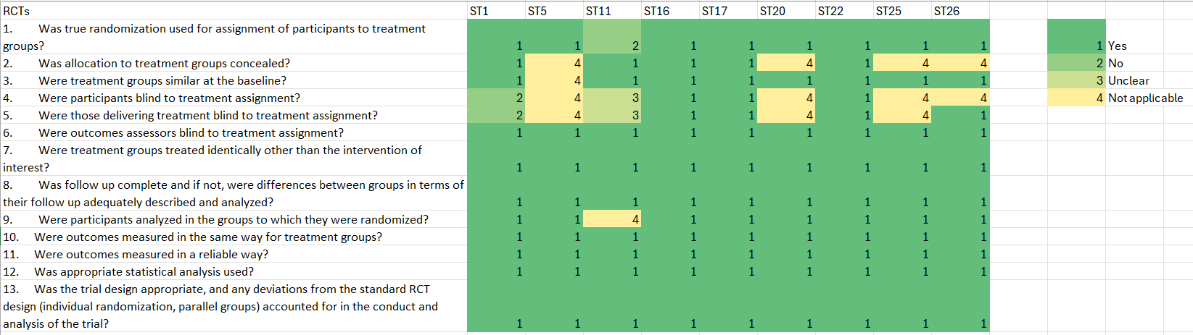
Supplementary Figure 2. Results of the risk of bias assessment of studies classified as analytical cross-sectional studies.

Supplementary Figure 3. Results of the risk of bias assessment of studies classified as quasi-experimental studies
