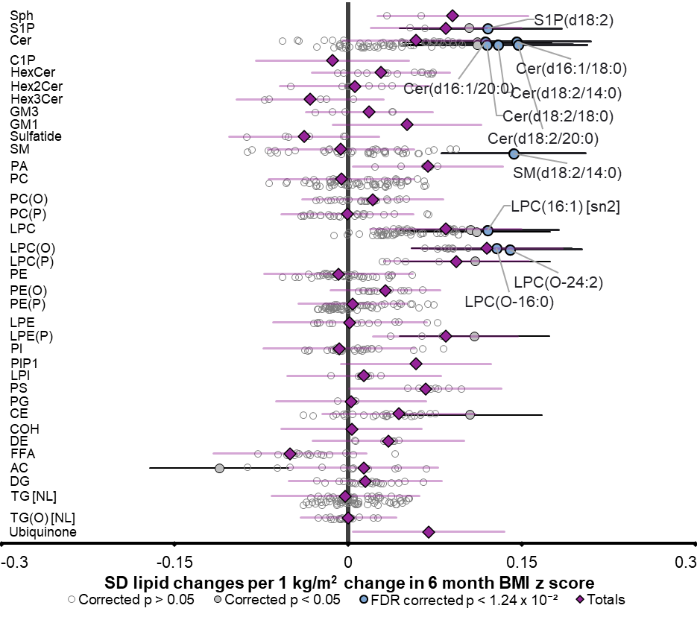
Supplementary Figure 1. Infant 6 month lipidome associations with infant 6 month BMI z-score. Linear regression analysis between 6-month lipidome and BMI z-score was performed adjusting for infant sex and breastfeeding status (n=723). Each circle represents an individual lipid species, open circles represent p > 0.05, white closed grey circles represent corrected p < 0.05, the top 10 most significantly associated lipid species are shown in blue and labelled. Purple diamonds represent lipid class totals. All p values were corrected for multiple comparisons (Benjamini and Hochberg correction). Horizontal bars indicate 95% confidence intervals for significant species.

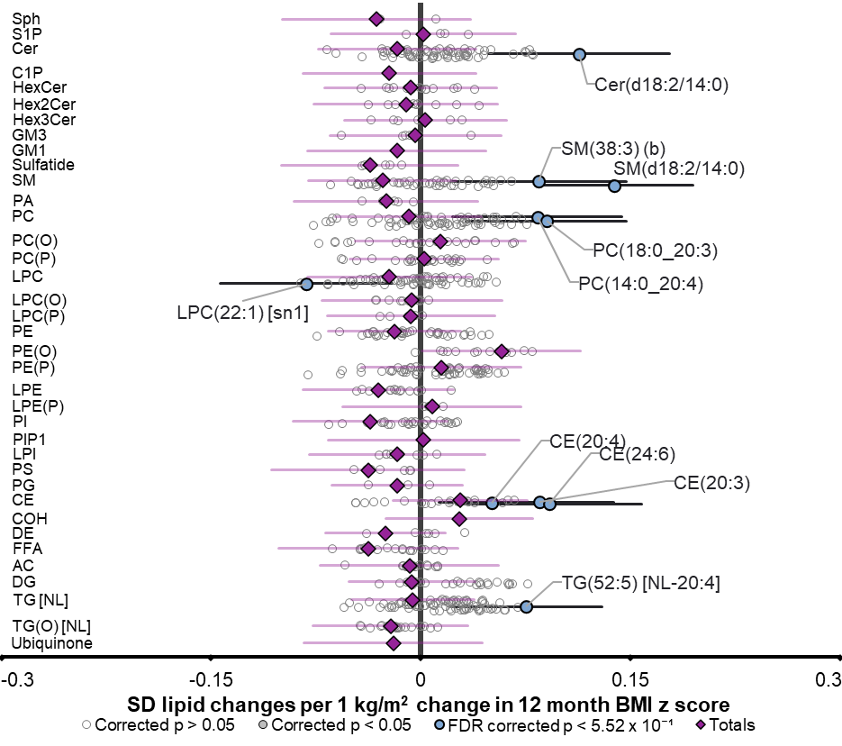
Supplementary Figure 2. Infant 12 month lipidome associations with infant 12 month BMI z-score. Linear regression analysis between 6-month lipidome and BMI z-score was performed adjusting for infant sex, clinical lipids, and breastfeeding status (n=704). Each circle represents an individual lipid species, open circles represent p > 0.05, white closed grey circles represent corrected p < 0.05, the top 10 most significantly associated lipid species are shown in blue and labelled. Purple diamonds represent lipid class totals. All p values were corrected for multiple comparisons (Benjamini and Hochberg correction). Horizontal bars indicate 95% confidence intervals for significant species.

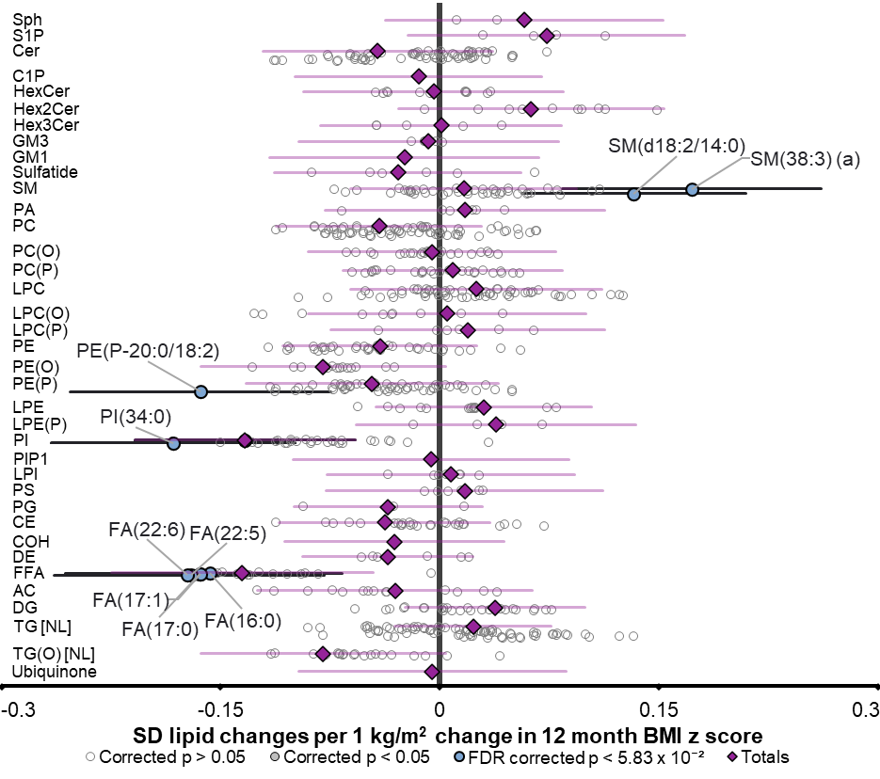
Supplementary Figure 3. Infant 48 month lipidome associations with infant 48 month BMI z-score. Linear regression analysis between 48-month lipidome and BMI z-score was performed adjusting for infant sex, clinical lipids, and breastfeeding status (n=456). Each circle represents an individual lipid species, open circles represent p > 0.05, white closed grey circles represent corrected p < 0.05, the top 10 most significantly associated lipid species are shown in blue and labelled. Purple diamonds represent lipid class totals. All p values were corrected for multiple comparisons (Benjamini and Hochberg correction). Horizontal bars indicate 95% confidence intervals for significant species.

