Supplemental material
Figure S1. The surface morphology and elemental composition of ZnO-NPs were determined by scanning electron microscope (SEM-EDX).
Figure S2. Potting experimental treatment site.
Figure S3. Effects of ZnO-NPs on vanadium (V) accumulation in grain (a), glume (b), stem (c), leaf (d), root (e), at the mature stage. Values shown are mean ± standard error (n = 5). Different lowercase letters in each column indicate significant differences (P < 0.01) among all treatments based on one-way ANOVA followed by Tukey’s HSD-test.
Figure S4. Correlation heat map of amino acid content and plant properties. A pairwise comparison of phytochemical parameters was displayed with a color gradient denoting Spearman's correlation coefficients. * Correlation is significant at P < 0.05 (two-tailed).
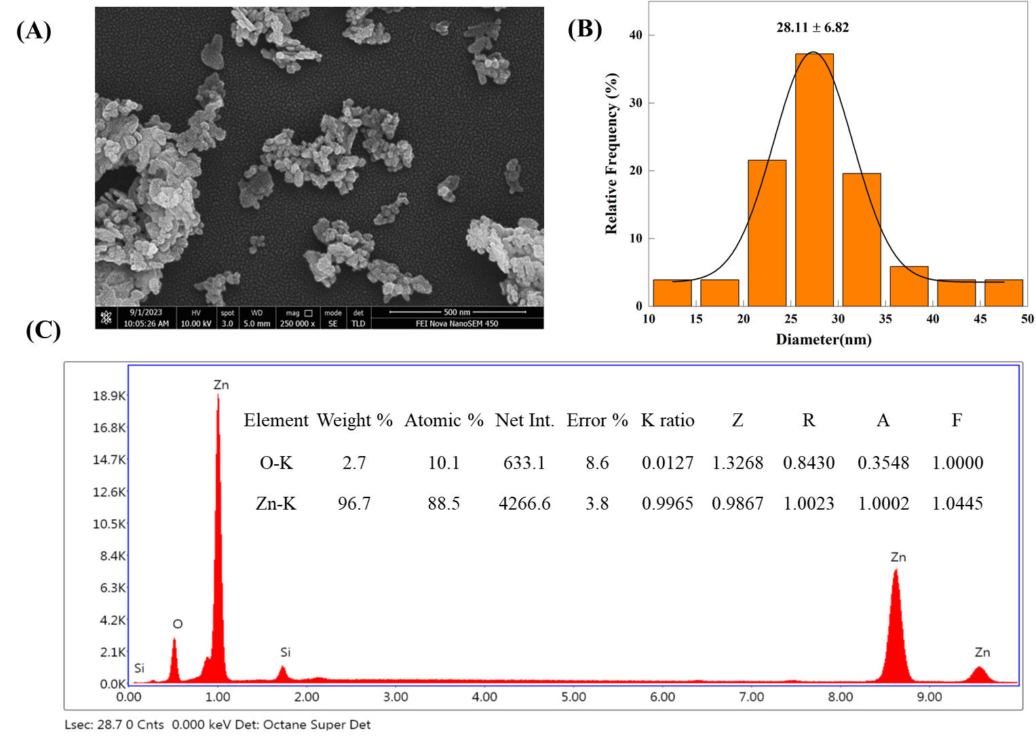
Figure S1. The surface morphology and elemental composition of ZnO-NPs determined by scanning electron micrscorpe (SEM-EDX).
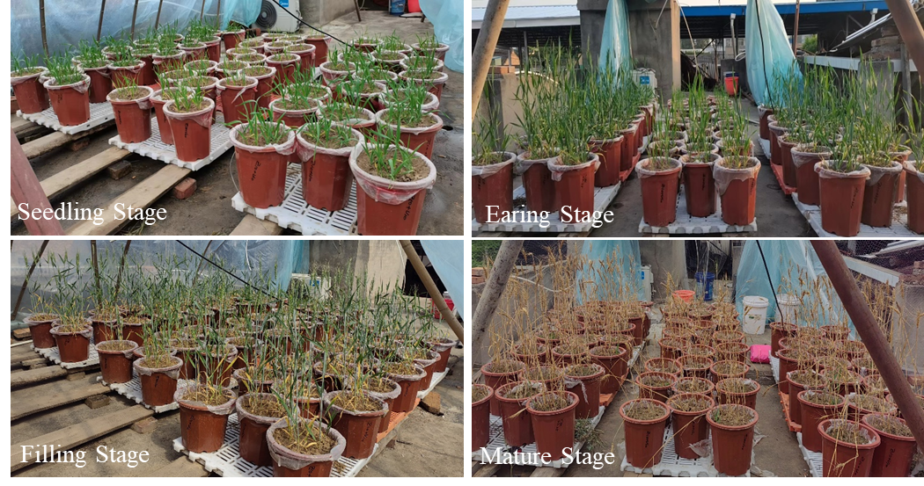
Figure S2. Potting experimental site.
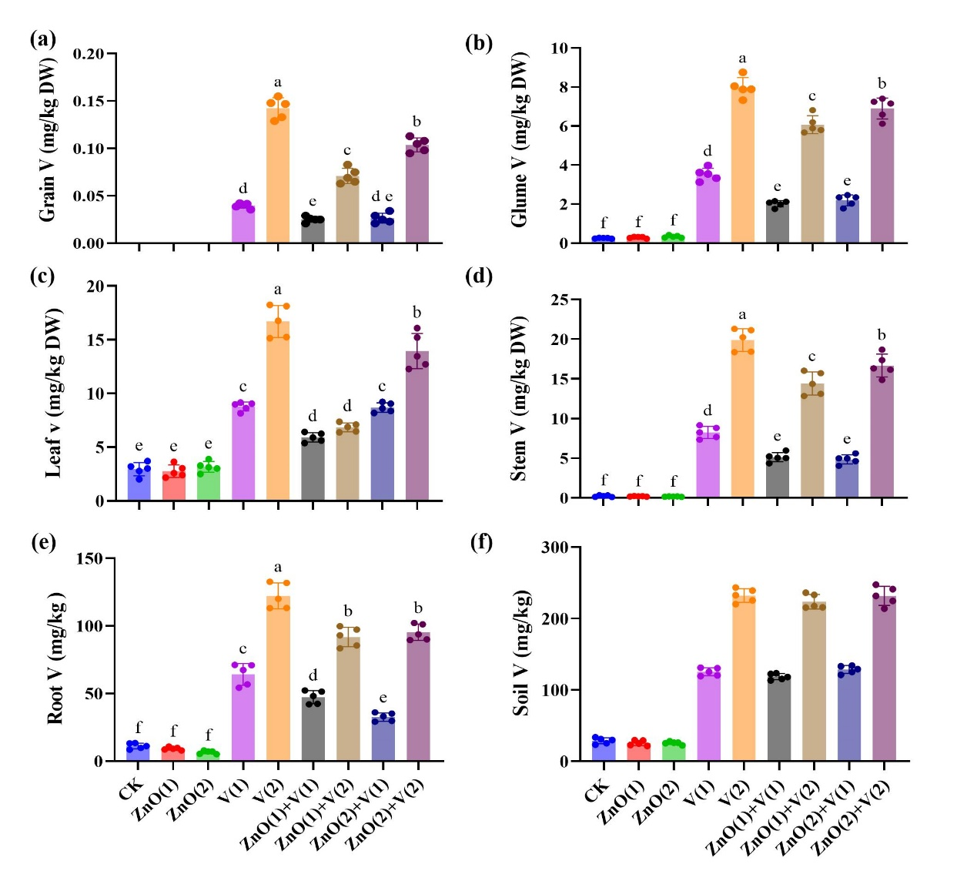
Figure S3. Effects of ZnO-NPs on vanadium (V) accumualtion in grain (a), glume (b), stem (c), leaf (d), root (c), and soil (f) at the mature satge. Values shown are mean ± standard error (n = 5). Different lowercase letters in each column indicates significant differences (P < 0.01) among all treatments based on one-way ANOVA followed by Tukey’s HSD-test.
Figure S4. Correlation heat map of amino acid content and plant properties . A pairwise comparison of phytochemical parameters was displayed with a color gradient denoting Spearman's correlation coefficients. * Correlation is significant at P < 0.05 (two-tailed).

