Supplementary Information

Polymer Dispersed Liquid Crystals-impregnated Switchable Thermochromic Transparent Woods with Excellent Ultraviolet Blocking Performance for Smart Windows

Cheng Ai Li¹ · Jae Kyu Ahn¹ · Hyeon Ji Jeong¹ · Jang Hee Kim¹ · Taeyoung Park¹ · Do Kyoung Han² · Jin Kim³ · Dong Ju Lee⁴ · Sung Ho Song¹

Cheng Ai Li and Jae Kyu Ahn contributed equally to this work.

Jin Kim
jinnie.kim@hanbat.ac.kr

Dong Ju Lee
dongjulee@chungbuk.ac.kr

Sung Ho Song
shsong805@kongju.ac.kr

¹ Division of Advanced Materials Engineering, Center for Advanced Materials and Parts of Powders, Kongju National University, Cheonan-si 31080, Republic of Korea

² Division of Materials Analysis and Research, Korea Basic Science Institute, 169–148, Gwahak-ro, Yuseong-Gu, Daejeon 34133, Republic of Korea
Department of Chemistry, Chung-Ang University, Seoul 06974, Republic of Korea

³ Department of Materials Science and Engineering, Hanbat National University, Daejeon 34158, Republic of Korea
⁴ Department of Urban, Energy, and Environmental Engineering, Chungbuk National University, Cheongju 28644, Republic of Korea

Figure S1. Weight loss after lignin modification and bleaching. (a) balsa, (b) bass, and (c) pine woods.

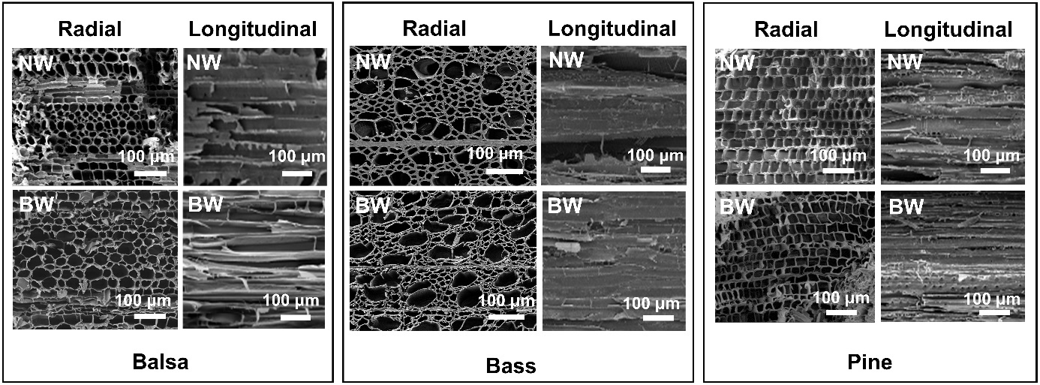

Figure S2. SEM images of balsa, bass, and pine NWs and BWs.

Figure S3. Experimental stress-strain curves of epoxy, NWs, and Epoxy/TWs using (a) balsa, (b) bass, and (c) pine woods.

Figure S4. Images of PDLC/TWs below 25 ºC and above 40 ºC and SEM images of PDLC/TWs. (a) balsa, (b) bass, and (c) pine PDLC/TWs.

Figure S5. (a) Enlarged view of the FTIR curves between 1450 and 1650 cm⁻¹ in Figure 4d. (b) FTIR and (c) Raman spectra of balsa, bass, and pine PDLC/TWs.

Figure S6. DSC spectra of PDLC film and PDLC/TW.

Figure S7. Comparison of the thermal conductivities of glass and PDLC/TW.

