Effects of Bacillus on Continuous Cropping of Sugar Beets and Their Rhizosphere Microbial Community

Qun Song¹, Zenghao Wang¹, Youkai Gao, Liuli Wei, Yuguang Wang, Rui Chen, Gui Geng* , Yanchun Sun*
College of Advanced Agriculture and Ecological Environment, Heilongjiang University, Harbin 150000, China
* Corresponding author.
E-mail: genggui01@163.com (Gui Geng)
2017053@hlju.edu.cn (Yanchun Sun)
¹ Both authors contributed equally to this paper and share first authorship.

Abstract
Background and Aims Sugar beet is a vital sugar-producing crop, and continuous cropping poses a major threat to its growth, leading to a decline in its yield and quality. This study aimed to investigate the effects of two bacterial agents, Bacillus subtilis and Bacillus mucilaginosus, on the growth, soil physicochemical properties, and rhizosphere microbial community of sugar beet seedlings.
Methods We employed pot experiments and amplicon sequencing to analyze the impact of applying two different Bacillus agents on the microbial community structure in the rhizosphere soil of continuously cropped sugar beet and explore the microbial composition, environmental driving factors, and potential functions present within the microbial communities.
Results The results showed that both Bacillus agents and their combination significantly promoted the growth of continuous cropping sugar beet seedlings, reaching or even surpassing the levels observed in crop rotation, improved soil pH, and enhanced soil environment. High-throughput sequencing analysis of the rhizosphere soil revealed that all Bacillus treatments induced changes in the diversity and structural composition of the rhizosphere microbial community, and significantly increased the relative abundance of Proteobacteria, thereby enriching beneficial microorganisms such as Pseudomonas, Novosphingobium, and Sphingomonas compared with that in the control group. Additionally, the application of Bacillus inoculants significantly enhanced the nitrate respiration, nitrogen respiration, and chitinolytic functions.
Conclusion These two bacterial agents optimized soil physicochemical properties and improved the rhizosphere soil microbial community structure, promoting sugar beet seedling growth and effectively mitigating the negative effects of continuous cropping.
Keywords: Bacillus mucilaginosus; Bacillus subtilis; continuous cropping obstacle; microbial community structure; sugar beet
1. Introduction
Sugar beet (Beta vulgaris L.) is a biennial herbaceous dicotyledonous plant belonging to the family Chenopodiaceae. As a globally significant vegetable crop, it contributes to 30% of the world's sugar production and is one of the major sugar-producing crops in China and worldwide (Steven et al. 2019). Beyond sugar production, sugar beet is also used to produce ethanol, glycerol, citric acid, and other light industrial products. Additionally, it serves as a valuable feed source, offering high comprehensive utilization value (Chhikara et al. 2018; Mall et al. 2021). Compared with sugarcane, sugar beet exhibits greater drought tolerance, cold resistance, and salt–alkali tolerance, demonstrating strong stress resistance and adaptability to adverse environmental conditions (Jbawi et al. 2016). Sugar beet is cultivated worldwide, primarily in Russia, North America, France, Germany, and parts of northern China (Holmquist et al. 2020). The continuous reduction in arable land has made continuous cropping a common farming practice in global agriculture. Continuous cropping refers to the repeated cultivation of the same crop in the same field over successive seasons (Wu et al. 2015). Studies have shown that this practice can lead to various issues, including changes in soil enzyme activity, deterioration of soil physicochemical properties (Zhu et al. 2020), imbalances in soil microbial populations (Tang et al. 2015), and increased soil-borne diseases. As a deep-rooted crop, sugar beet consumes a substantial amount of soil nutrients and is highly sensitive to continuous cropping. Prolonged continuous cultivation can lead to reduced sugar content, lower yields, and increased incidence of pests and diseases (Cui et al. 2022).
A healthy soil environment is essential for the normal growth of sugar beet and is a prerequisite for achieving high sugar content and yield. Soil quality is influenced by not only its physicochemical properties but also its microbial characteristics (Kui et al. 2021). Soil microorganisms are a fundamental component of the soil ecosystem, playing a key role in soil formation, fertility maintenance, and plant growth. They are considered key indicators of soil quality (Pimentel et al. 1992). The rhizosphere, as a critical soil region surrounding plant roots, harbors microorganisms closely linked to plant growth, development, and nutrient exchange (Tkacz et al. 2015; Tong et al. 2018; Zheng et al. 2020). These microbial communities interact with plants, participate in essential nutrient cycles, and regulate most soil ecological processes, playing an irreplaceable role in maintaining plant health and soil carbon cycling (Cao et al. 2018; Das et al. 2019; Kang et al. 2022). Additionally, plant growth stages influence the structure and dynamics of the rhizosphere microbial community (Zhang et al. 2024). Soil enzymes are produced by soil microorganisms, and the changes in their activity not only reflect shifts in the microbial community but also play a crucial role in soil nutrient cycling (Liu et al. 2018; Qi et al. 2016). Therefore, soil, microorganisms, and plants are closely interconnected, significantly influencing agricultural productivity; microbial abundance and diversity, in particular, are crucial for soil fertility and plant development (Ahsan et al. 2024; Li et al. 2020).
The widespread use of chemical fertilizers has profoundly affected the ecological functions of the soil microenvironments in agricultural ecosystems. Over the past few decades, chemical fertilizers have been extensively applied to enhance soil nutrient availability and increase crop yields. However, excessive use of chemical fertilizers has led to serious problems, such as soil degradation, reduced organic matter, and negative impacts on soil microbial diversity (Sun et al. 2015; Zhang et al. 2020). In contrast, microbial fertilizers, which contain active microorganisms and their metabolites, can effectively improve soil fertility, nutrient availability, and overall growth environments; they promote plant growth and development, enhance resistance to pests and diseases, and unlock soil potential to improve agricultural yield and quality (Cai et al. 2021; Duan et al. 2022). Bacillus species, widely present in soil, can produce various metabolites that promote plant growth and protect plants from pathogens (Olanrewaju et al. 2021). They are among the most effective biocontrol agents, offering an eco-friendly alternative to synthetic fungicides (Solanki et al. 2012). Additionally, Bacillus species can alter soil enzyme activity, improving soil quality and nutrient availability (Chen et al. 2022; Shao et al. 2023). Studies have shown that the members of the Bacillus genus exhibit broad-spectrum antagonistic activity against various soil-borne pathogens; artificial inoculation with Bacillus strains significantly enhances the growth and yield of various crops (Gajbhiye et al. 2009; Govindasamy et al. 2010). For example, Bacillus subtilis strain PTS-394 promotes plant growth and suppresses soil-borne diseases in tomatoes (Qiao et al. 2017), whereas B. subtilis T6-1 significantly alleviates continuous cropping stress in poplar by improving the rhizosphere microbial community structure and inhibiting the growth of pathogenic fungi (Sui et al. 2022). Furthermore, Bacillus mucilaginosus can promote alfalfa growth and regulate soil properties (Wang et al. 2023). Given these benefits, investigating the effects of Bacillus species on the rhizosphere soil properties and microbial community structure of continuously cropped sugar beet is crucial for mitigating continuous cropping-related challenges and achieving sustainable, green cultivation of sugar beet.
Currently, 16S and internal transcribed spacer (ITS) amplicon sequencing have become essential tools for studying microbial community composition in environmental samples (Kui et al. 2021). This study used pot experiments and high-throughput sequencing of 16S rRNA and ITS amplicons for investigating the effects of B. subtilis and B. mucilaginosus on the growth and development of continuously cropped sugar beet seedlings. Additionally, the study analyzed the changes in the physicochemical properties of rhizosphere soil and shifts in the composition and functional diversity of the rhizosphere soil microbial communities. The main objective of the study was to determine the influence of these two Bacillus species on continuous cropping stress in sugar beet and examine the effects of the composition and diversity of bacterial and fungal communities in its rhizosphere soil. Further, the study aimed to evaluate the correlations between changes in rhizosphere soil microorganisms and Bacillus application, and predict the changes in the ecological functions of these microorganisms in continuously cropped sugar beet rhizosphere soil. Ultimately, this study sought to provide a theoretical basis for mitigating continuous cropping challenges in sugar beet and offer valuable insights for developing improved agricultural management strategies.
2 Materials and Methods
2.1 Materials and Experimental Design
The sugar beet variety “KWS1260” from KWS Company (Einbeck, Germany) was selected as the plant material. The B. mucilaginosus powder (5 billion viable bacteria per gram) and B. subtilis powder (50 billion viable bacteria per gram) were supplied by Beihai Qiangxing Biotechnology Co., Ltd. Soil samples were collected from the black soil region of Hulan District, Harbin City, Heilongjiang Province (latitude: 46°00'14"N, longitude: 126°38'49"E). The soil samples were from fields with 2 years of continuous sugar beet cropping. The experiment was conducted in the soil light culture room of the agricultural building at Heilongjiang University. A pot experiment was designed with five treatment groups: noncontinuous cropping soil as the positive control (NC), continuous cropping soil for 2 years as the control (CK), continuous cropping soil treated with B. subtilis powder at an application rate of 1 g/kg (CK + K), continuous cropping soil treated with B. mucilaginosus powder at an application rate of 1 g/kg (CK + J), and continuous cropping soil treated with a combination of B. subtilis and B. mucilaginosus powder, each applied at the rate of 0.5 g/kg (CK + KJ). Each treatment had eight replicates. At the start of the experiment, the required bacterial agents were mixed into the soil using the soil-mixing method, and the sugar beet seeds (KWS1260) were sown in pots containing 900 g of soil. Each pot retained five seedlings for subsequent experiments. During the seedling growth period, the light intensity was maintained at 700 μmol·m^{–2}·s^{–1}, with a 14-h light/10-h dark cycle. The temperature was set at 28°C ± 1°C during the day and 21°C ± 1°C at night, with a relative humidity of 40%–50%.
2.2 Soil Sampling
Soil sampling was conducted on the 28th day. For non-rhizosphere soil sampling, three replicates were randomly selected from each treatment group, and samples were collected using the five-point sampling method. The three replicates were mixed and recorded as one sample. The collected non-rhizosphere soil samples were air-dried and passed through a 2-mm sterile sieve for determining soil properties and enzyme activities. For rhizosphere soil sampling, three uniformly growing sugar beet seedlings were randomly selected. A sterile scalpel was used to cut the roots of the sugar beet seedlings, and excess non-rhizosphere soil was shaken off to ensure experimental rigor. The beetroots were placed in a 50-mL sterile tube containing 25 mL of 10mM sterile phosphate-buffered saline solution (w/v) and oscillated at 180 rpm at 4°C for 5 h to separate the rhizosphere soil from the root surface. The samples were then centrifuged at 3200g at 4°C for 15 min, and the roots were removed to obtain the rhizosphere soil. Each treatment had five replicates, and the rhizosphere soil samples were stored at –80°C for high-throughput sequencing.
2.3 Plant Growth Index Measurement
Plant growth was observed and recorded through random sampling of uniformly growing sugar beet plants. Plant height and root length were measured using a tape measure from the growth point to the tip of the longest leaf, with five replicates per treatment. The stem diameter was measured at the base of the first stem node using a Vernier caliper (0.02 precision), with five replicates per treatment. Leaf and root areas were scanned using an Epson scanner (Anlie-3000C; Lincoln Li-Cor Biosciences Inc., CA, USA) and analyzed using WinRHIZO software (Beijing Ecotech Co., Ltd., China), with three replicates per treatment. The fresh weight of aboveground plant parts was measured using an electronic balance (model: 5001; Hangzhou Wante Weighing Apparatus Co., Ltd.) after wiping off surface moisture and dust, with five replicates per treatment. Five sugar beet plants were randomly selected from each treatment, and their weight was measured immediately. Dry weight was measured by first drying the plant samples at 105°C for 30 min, followed by drying at 75°C until a constant weight was achieved. The dried samples were then weighed using an electronic balance (Shanghai Liangping Instrument Co., Ltd., China), with five replicates per treatment.
2.4 Analysis of Soil Properties and Enzyme Activity
Soil ammonium nitrogen (AN) was determined using the indophenol blue colorimetric method, whereas soil nitrate nitrogen (NO₃-N) was assessed using the dual-wavelength method. Soil available phosphorus (AP) was measured using the NaHCO₃ extraction–molybdenum antimony colorimetric method. Soil available potassium (AK) and trace elements were extracted using ammonium acetate and directly measured using a flame photometer (Shanghai Yuan Analysis Instrument Co., Ltd.). Soil pH was determined using a potentiometer (Shanghai Jingke Instrument Co., Ltd.) at a water-to-soil ratio of 5:1. Soil electrical conductivity (EC) was measured using a conductivity meter (Shanghai Jingke Instrument Co., Ltd.) with the same water-to-soil ratio of 5:1. Soil enzyme activities were assessed as follows: urease (URE) activity was determined using the indophenol blue colorimetric method, phosphatase (PHO) activity was measured using the phenyl phosphate disodium colorimetric method, sucrase (SUC) activity was determined using the 3,5-dinitrosalicylic acid colorimetric method, and catalase (CAT) activity was analyzed using the potassium permanganate titration method (Bao 2005). All soil samples were measured in triplicate, and soil extracellular enzyme activities were measured with inorganic controls included for each treatment.
2.5 Amplicon Sequencing and Analysis
For amplicon sequencing and analysis, total DNA from the microbial community was extracted using the cetyltrimethylammonium bromide method. DNA quality was evaluated using 2% agarose gel electrophoresis, whereas concentration and purity were determined using AMPure XT beads (Beckman Coulter Genomics, MA, USA) and Qubit (Invitrogen, USA, CA, 90720). Bacterial polymerase chain reaction (PCR) amplification was performed using the 341F and 805R primers to amplify the V3–V4 region of the 16S rRNA gene. Fungal ITS amplification was performed using the ITS1F and ITS2R primers (Huang et al. 2005). PCR products were recovered using 2% agarose gel electrophoresis and purified using the AMPure XT bead recovery kit. Finally, the concentration and purity of the recovered products were assessed using the Agilent 2100 Bioanalyzer (Agilent, USA, CA, 95054) and the Illumina library quantification kit (Kapa Biosciences, MA, USA). The 16S and ITS high-throughput sequencing was performed by LC-Bio (Hangzhou, China).
The raw sequencing data were quality-controlled using the fqtrim software to remove adapter sequences and low-quality bases. Reads were assembled, and Vsearch software was used for operational taxonomic unit (OTU) clustering at a 97% similarity threshold, with chimeras removed. The representative OTU sequences were annotated using the SILVA and UNITE databases at a confidence threshold of 0.7 to obtain species taxonomic annotation results (Kõljalg et al. 2020; Quast et al.2012). Sequences corresponding to chloroplasts and mitochondria were removed, and OTU data were normalized using the minimum sampling method (Li et al. 2020).
2.6 Statistical Analysis
Statistical analyses of plant and soil parameters were performed using IBM SPSS 26 statistical software (SPSS Inc., CT, USA) for one-way analysis of variance. The normality of the data was assessed using the Shapiro–Wilk test (P > 0.05), whereas the homogeneity of variance was examined using Levene's test (P > 0.05). Based on the outcomes of the homogeneity of variance analysis, Duncan's multiple range test (P > 0.05) was employed when the significance level exceeded 0.05. In contrast, the Kruskal–Wallis nonparametric test (P > 0.05) was applied when the significance level fell below 0.05. All statistical analyses were conducted with a 95% confidence interval. The Mothur software (Schloss et al. 2009) was used to calculate α-diversity, including the Chao1 and Simpson indices. Duncan's multiple range test was used to assess the differences between continuous cropping and bacterial agent–treated sugar beet soil samples. Non-metric multidimensional scaling (NMDS) was used to calculate the Bray–Curtis distance matrix and visualize it to examine the β-diversity of microbial community functions. Linear discriminant analysis (LDA) effect size (LEfSe) was used to identify microbial taxonomic biomarkers (Segata et al. 2011). The "ggcor" package in R was used for Spearman correlation analysis, whereas Manter tests were conducted to evaluate the relationship between microbial community composition and environmental factors (Yuan et al. 2021). Spearman correlations were calculated using the R package to explore correlations among all microorganisms, with a Spearman correlation coefficient r value of 0.7 and P <0.01. Other analyses were performed using R software (version 4.0.0) and the LC-Bio cloud platform.
3 Results
3.1 Soil Properties and Growth Indicators
Different Bacillus treatments significantly affected various growth indicators of continuous cropping sugar beet seedlings (Table 1). Compared with the NC group, the CK group showed significant reduced in terms of plant Height, stem diameter (SD), aboveground dry weight (DW), root dry weight (RDW), root surface area (RSA), and leaf surface area (LSA), only in root length (RL) was no significant difference observed. This result confirms the inhibitory effect of continuous cropping on sugar beet growth. The three bacterial inoculation treatment groups also exhibited significant differences compared with the CK group. Specifically, all three Bacillus-treated groups (CK + K, CK + J, and CK + KJ) significantly enhanced sugar beet seedling Height, SD, DW and LSA, exceeding those in both the CK and NC groups, with the CK + KJ group showed the most significant increase, with an average plant Height of 16.73 cm and an average SD of 5.261 cm, marking increments of 29.39% and 35.84% over the CK group, respectively. And the CK + J group showed the most significant increase in DW and LSA. Additionally, all three Bacillus-treated groups (CK + K, CK + J, and CK + KJ) showed significantly higher RDW, RL and RSA compared with the CK group, and no significant variation compared with the NC group. These results indicated that both Bacillus agents and their combination significantly promoted the growth of continuous cropping sugar beet seedlings, reaching or even surpassing the levels observed in crop rotation.

Table 1 Plant indicators of different groups
Group | NC | CK | CK + K | CK + J | CK + KJ
Height (cm)  SD (cm)  DW (g)  RDW (g)  RL (cm)  RSA (cm²)  LSA (cm²) | 14.27 ± 0.196c  4.214 ± 0.386c  0.410±0.021c  0.213 ± 0.021a  24.66 ± 2.499ab  65.80 ± 4.821ab  63.35 ± 4.353c | 12.93 ± 0.256d  3.873 ± 0.331d  0.177 ± 0.007d  0.127 ± 0.015b  22.31 ± 3.056b  39.33 ± 5.239c  32.35 ± 1.239d | 14.65 ± 0.220c  4.165 ± 0.264c  0.550 ± 0.051b  0.253 ± 0.032a  24.87 ± 1.333a  60.98 ± 7.343b  74.83 ± 8.101c | 15.53 ± 0.105b  4.748 ± 0.205b  0.663 ± 0.029a  0.277 ± 0.047a  24.57 ± 1.545ab  83.98 ± 5.869a  102.3 ± 1.637a | 16.73 ± 0.161a  5.261 ± 0.328a  0.560 ± 0.006b  0.217 ± 0.046a  23.61 ± 2.057ab  81.88 ± 4.642a  91.58 ± 1.175b
NC, Noncontinuous cropping soil; CK, continuous cropping soil for 2 years as the control; CK+ K, continuous cropping soil with B. subtilis; CK + J, continuous cropping soil with B. mucilaginosus; CK + KJ, continuous cropping soil with a combination of B. subtilis and B. mucilaginosus. Height, Plant height; SD, stem diameter; DW, aboveground dry weight; RDW, root dry weight; RL, root length; RSA, root surface area; LSA, leaf surface area. The values in the table are presented as the average ± standard deviation (n = 5). Different lowercase letters in the same row indicate significant differences (P < 0.05; Duncan and Kruskal–Wallis tests).
Applying two Bacillus inoculants and their combination altered the physicochemical properties and enzyme activities of continuous cropping soil (Table 2). The pH values in all Bacillus-inoculated treatment groups were significantly higher than those in the CK group, with the CK + J group showed the most pronounced effect, achieving a pH level close to that of NC. The measurements of ammonium nitrogen (AN), available phosphorus (AP), and available potassium (AK) in the soil after Bacillus treatments revealed three distinct outcomes. Compared with the CK, neither the individual Bacillus inoculants (CK + K, CK + J) nor their combination (CK + KJ) exhibited significant differences in the AN content. However, the AP content increased significantly by 12.18%, 7.99%, and 19.26% in the treated groups, with the CK + KJ group exhibiting a significantly higher increase than both CK + K and CK + J groups. Additionally, both AN and AP contents were lowest in the NC group, with a significant difference from the other four groups. In contrast, the AK content in Bacillus-inoculated groups was considerably lower than in the CK group, and close to the NC group. These results suggested that B. subtilis and B. mucilaginosus could promote an increase in soil AP content, with a synergistic effect between the two Bacillus strains, while having no effect on AN content and reducing AK content. Differences were also observed in soil enzyme activities among Bacillus treatments. Compared with the CK group, the NC group and Bacillus-treated groups exhibited reduced Catalase (CAT) activity, with the combined Bacillus inoculant treatment (CK + KJ) causing the most significant decrease. Phosphatase (PHO) activity did not differ significantly between groups, whereas urease (URE) activity increased in the Bacillus-inoculated groups, particularly in the CK + KJ group, which showed a 19% increase over the CK group. Additionally, sucrase (SUC) activity in all three Bacillus-inoculated treatment groups was increased, with the CK + K group significantly higher than that in the CK group. These findings suggested that both Bacillus strains could promote specific soil enzyme activities.

Table 2 Physicochemical properties and enzyme activities of soil in different groups
Grope | NC | CK | CK+K | CK+J | CK+KJ
pH  AN(mg/kg)  AP(mg/kg)  AK(mg/kg)  Catalase(μmol/d/g)  Phosphatase(nmol/d/g)  urease(mg/d/kg)  sucrase(mg/g) | 6.98 ± 0.008a  4.21 ± 0.407b  76.05 ± 2.481d  315.06 ± 4.033c  38.04 ± 1.318b  1.88 ± 0.343a  501.34 ± 16.852b  52.47 ± 0.199ab | 6.42±0.015c  5.35±0.159a  129.03±4.342c  603.15±9.272a  43.45±1.026a  2.10±0.223a  527.88±41.605b  50.61±1.428b | 6.9±0.015b  5.54±0.242a  144.74±2.261b  331.82±2.640bc  33.74±3.301b  2.67±0.374a  577.80±4.696ab  55.50±0.207a | 6.94±0.038ab  5.17±0.121a  139.35±2.379b  272.38±5.280d  33.74±5.990c  2.39±0.162a  567.46±14.216ab  55.08±0.406ab | 6.89±0.026b  5.58±0.358a  153.88±0.812a  347.07±4.033b  26.47±1.710c  2.32±0.079a  628.18±26.383a  54.19±0.073ab
NC, Noncontinuous cropping soil; CK, continuous cropping soil for 2 years as the control; CK+ K, continuous cropping soil with B. subtilis; CK + J, continuous cropping soil with B. mucilaginosus; CK + KJ, continuous cropping soil with a combination of B. subtilis and B. mucilaginosus. pH, Soil acidity/alkalinity; AN, ammonium nitrogen; AP, available phosphorus; AK, available potassium. The values in the table are presented as the average ± standard deviation (n = 5). Different lowercase letters in the same row indicate significant differences (P < 0.05; Duncan and Kruskal–Wallis tests).
3.2 Alpha Diversity of Microbial Communities
Alpha diversity indices are critical parameters for assessing species diversity within communities. This study used Chao1 and Simpson indices to evaluate the alpha diversity of rhizosphere microbial communities among noncontinuous cropping soil, continuous cropping soil and Bacillus-treated soil (Fig. 1). The CK treatment showed mildly reductions in the richness and diversity of bacterial and fungal communities compared with NC treatment group (Fig. 1A-D). Compared with CK, Bacillus treatments significantly reduced the bacterial richness of the rhizosphere soil (Chao1) but had minimal impact on bacterial diversity (Simpson index) (Fig. 1A and 1B). Meanwhile, Bacillus treatments showed no significant effect on the diversity of the soil fungal community. However, both the CK + K and CK + J treatment groups demonstrated moderate reductions in the richness of soil fungal community to some extent (Fig. 1C and 1D). Overall, Bacillus inoculants mildly reduced the richness of bacterial and fungal communities but did not significantly affect their diversity.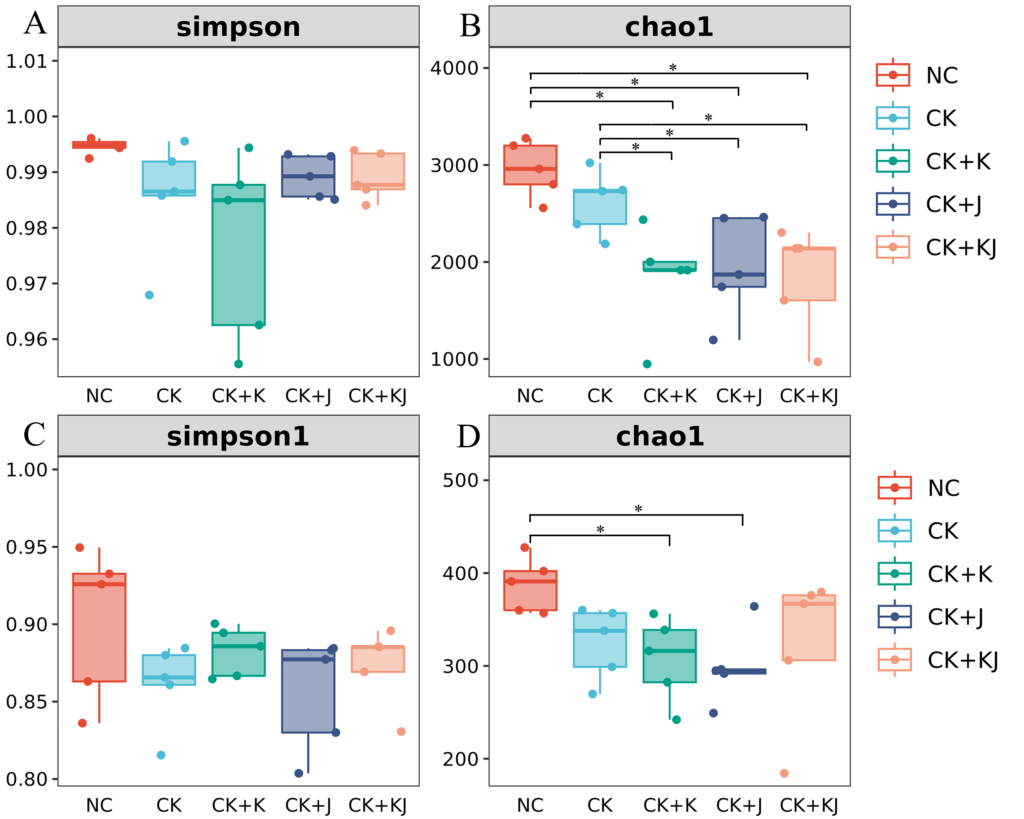
Figure 1. Alpha diversity of bacterial and fungal communities. (A and B) Bacterial alpha diversity; (C and D) fungal alpha diversity. Simpson index (A and C); Chao1 index (B and D). “*” indicates significance at P < 0.05. NC, Noncontinuous cropping soil; CK, continuous cropping soil for 2 years as the control; CK+ K, continuous cropping soil with B. subtilis; CK + J, continuous cropping soil with B. mucilaginosus; CK + KJ, continuous cropping soil with a combination of B. subtilis and B. mucilaginosus.
3.3 Beta Diversity of Microbial Communities
The NMDS analysis based on Bray–Curtis distance revealed distinct clustering patterns in microbial communities (Fig. 2). The CK treatment exhibited clear separation from NC treatment, indicating that continuous cropping effectively altered the composition of rhizosphere microbial communities (Fig. 2A and 2B). For bacterial communities, the three different Bacillus treatments formed distinct clusters in sugar beet rhizosphere soil, showing clear separation from CK. The CK + J treatment group exhibited the most significant differences, indicating that Bacillus application effectively altered the composition of rhizosphere bacterial communities (Fig. 2A). In contrast, fungal communities demonstrated varying patterns. The fungal communities in CK treatment clustered with those from various Bacillus treatments without clear separation, suggesting no significant impact of Bacillus treatment on fungal community composition. (Fig. 2B).
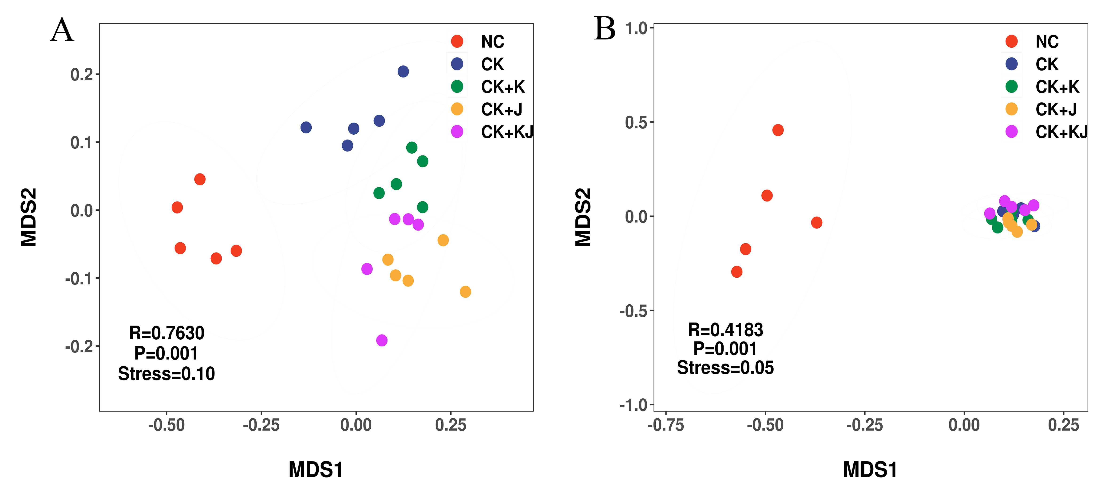
Figure 2. NMDS ordination based on Bray–Curtis distances for bacterial (A) and fungal (B) communities. NC, Noncontinuous cropping soil; CK, continuous cropping soil for 2 years as the control; CK+ K, continuous cropping soil with B. subtilis; CK + J, continuous cropping soil with B. mucilaginosus; CK + KJ, continuous cropping soil with a combination of B. subtilis and B. mucilaginosus.
3.4 Variations in Microbial Community Structure
Bacterial community amplicon sequence variants (ASVs) were classified into 40 phyla, 143 classes, 325 orders, 537 families, 1152 genera, and 1913 species based on high-throughput sequencing results. Microbial community composition bar charts revealed that, after Bacillus treatment, the rhizosphere soil bacterial community of sugar beet differed significantly from that of CK and NC, while CK and NC also exhibited distinct compositions. Although the fungal communities showed no significant difference between Bacillus treatments and CK treatment, they demonstrated marked divergence from NC (Fig. 3). Proteobacteria, Acidobacteria, Actinobacteria, Planctomycetota, and Gemmatimonadota were the five dominant bacterial phyla across the five treatment groups. Proteobacteria of the five treatment groups exhibited the highest relative abundance, accounting for 42.16%, 48.67%, 63.24%, 62.18%, and 59.86% of bacterial communities, respectively. Compared with CK and NC, Bacillus treatment significantly increased Proteobacteria abundance in the rhizosphere soil while decreasing the abundance of Acidobacteria, Planctomycetota, and Gemmatimonadota (Fig. 3A). Pseudomonas, Novosphingobium, Sphingomonas, and Parablastomonas were the four dominant bacterial genera. Pseudomonas had the highest relative abundance in the CK + K treatment group, with B. subtilis inoculation further increasing its presence. In contrast, Novosphingobium exhibited higher relative abundance in the CK + J and CK + KJ groups compared with the CK and NC groups. Additionally, the relative abundance of Sphingomonas and Parablastomonas was higher in all three Bacillus-inoculated treatment groups compared with the CK and NC groups (Fig. 3B).
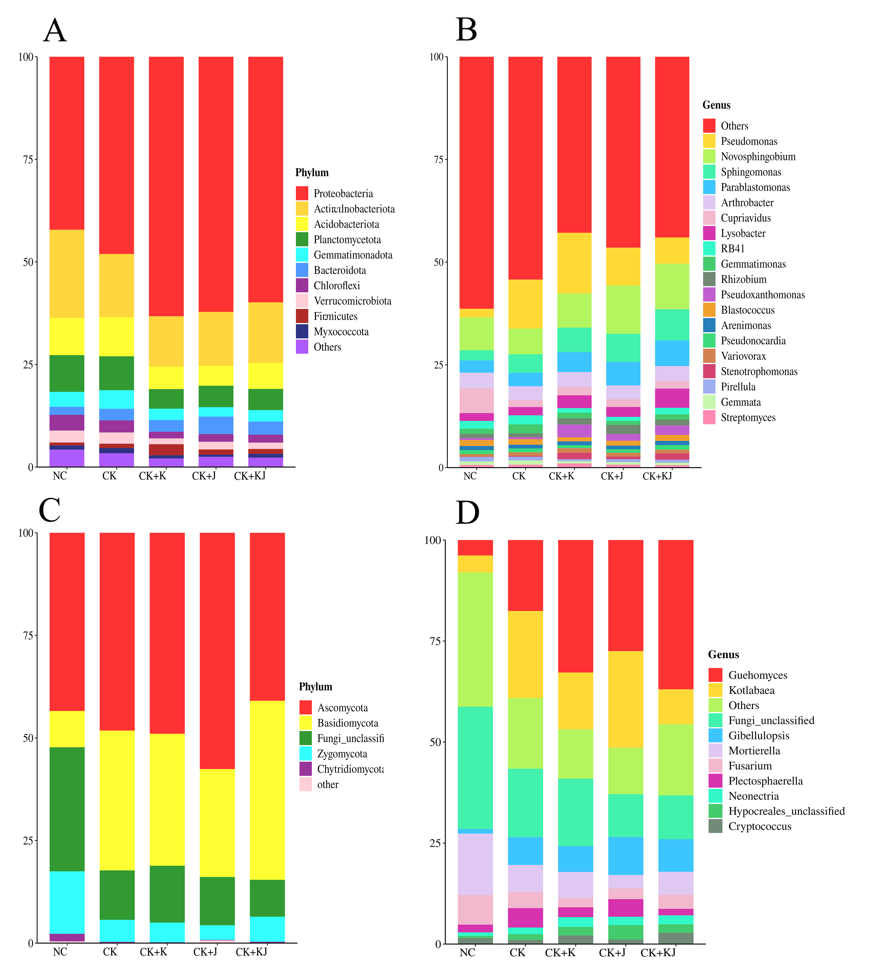
Figure 3. Relative abundance of bacterial and fungal phyla and genera in sugar beet rhizosphere soil under different treatments: (A) bacterial phyla, (B) bacterial genera, (C) fungal phyla, and (D) fungal genera. Different colors represent dominant taxa. NC, Noncontinuous cropping soil; CK, continuous cropping soil for 2 years as the control; CK+ K, continuous cropping soil with B. subtilis; CK + J, continuous cropping soil with B. mucilaginosus; CK + KJ, continuous cropping soil with a combination of B. subtilis and B. mucilaginosus.
The high-throughput sequencing results revealed that fungal community ASVs from the five treatments were classified into 14 phyla, 46 classes, 96 orders, 195 families, 370 genera, and 635 species. Ascomycota, Basidiomycota, Zygomycota, and Chytridiomycota were the four dominant fungal phyla. The CK + J treatment increased Ascomycota abundance compared with the CK and NC. In contrast, the CK + KJ group exhibited the highest Basidiomycota abundance (Fig. 3C). Guehomyces, Kotlabaea, Gibellulopsis, and Mortierella were the primary fungal genera in sugar beet rhizosphere soil. The combined bacterial agent treatment (CK + KJ) significantly reduced the relative abundance of Kotlabaea in continuous cropping soils (CK), while maintaining levels comparable to that in NC (Fig. 3D).
3.5 Differences in Microbial Community Composition
The differential responses of rhizosphere microbial communities in beetroot under various treatments were evaluated using LEfSe (LDA > 2) (Fig. 4). The cladogram analysis revealed a greater number of bacterial biomarker taxa compared with fungal counterparts. Except NC group, the CK + K group demonstrated extensive correlation nodes and occupied a larger area in the diagram, indicating that more microbial species played crucial biological roles following B. subtilis application.
Verrucomicrobiota, Acidobacteriota, Firmicutes, and Proteobacteria exhibited significant species differences in rhizosphere soil bacterial communities across the five treatment groups (Fig. 4, bacteria). At the phylum level, Chloroflexi and Verrucomicrobiota play key biological roles in NC bacterial communities. At the genus level, significant enrichment was observed in specific taxa including Herpetosiphon, Gaiella, Conexibacter, Paenarthrobacter, Chthoniobacter, and Nitrospira. Bacterial communities in continuous cropping soil played key biological roles at the phylum level, including, Acidobacteriota, Myxococcota, Latescibacterota, and Gemmatimonadota, 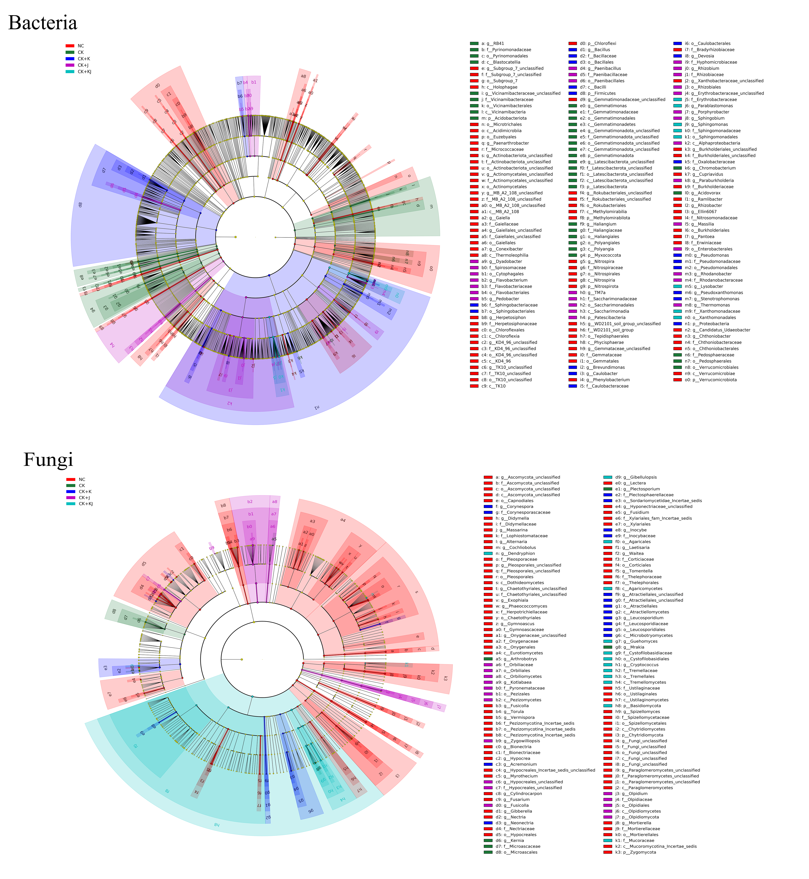
Figure 4. LEfSe-generated cladograms illustrating differences in bacterial and fungal abundance across taxonomic levels. Circular rings radiating outward represent phylum-to-genus classifications. Different color nodes in the branch diagram indicate microbial groups playing key biological roles in specific communities. The species names represented by English letters in the figure are listed in the legend on the right. NC, Noncontinuous cropping soil; CK, continuous cropping soil for 2 years as the control; CK+ K, continuous cropping soil with B. subtilis; CK + J, continuous cropping soil with B. mucilaginosus; CK + KJ, continuous cropping soil with a combination of B. subtilis and B. mucilaginosus.
with notable genus-level enrichment of Gemmatimonas, Haliangium, RB41, Chromobacterium, and Acidovorax. In CK + K treatment group, key biomarker taxa were in the following: Bacillus (order to genus), Sphingomonas (order to family), Caulobacter (order to genus), Pseudoxanthomonas (order to genus), and Oxalobacteraceae (family). The CK + J treatment group demonstrated a more complex biomarker profile, encompassing Patescibacteria (phylum to genus), Flavobacterium (order to genus), Cytophagales (order to genus), Paenibacillus (order to genus), Enterobacterales (order to genus), Rhizobium (order to genus), Sphingobium (genus), Paraburkholderia (genus), Massilia (genus), Rhodanobacter (family to genus), and Thermomonas (genus), all of which play important biological regulatory roles in rhizosphere soil. The CK + KJ treatment group resulted in the emergence of Parablastomonas, Sphingomonas, and Lysobacter as predominant genera. This multi-level taxonomic analysis underscored treatment-specific modulation of microbial consortia with distinct ecological implications.
In the rhizosphere soil fungal community, Basidiomycota was the dominant phylum, with some species showing significant differences across the five treatments (Fig. 4, Fungi). NC exhibited the highest diversity of biomarkers. At the phylum level, Chytridiomycota and Zygomycota were identified. At the genus level, the following taxa showed significant enrichment: Paraglomeromycetes (from class to genus), Tomentella (order to genus), Ustilaginaceae (order to genus), Onygenaceae (order to genus), Chaetothyriales (order to genus), Pleosporales (order to genus), as well as the genera Phaeococcomyces, Exophiala, Gymnoascus, Hypocrea, and Nectria. In CK treatment, Mrakia (genus), Kernia (genus), and Arthrobotrys (genus) were the dominant bacterial genera. Atractiellomycetes (class to genus), Leucosporidiales (order to genus), Corynespora (family and genus), and Acremonium (genus) played key biological roles in CK + K treatment. The CK + J treatment demonstrated significant enrichment of Zygowilliopsis (genus), Fusicolla (genus), and Olpidium (phylum to genus). The CK + KJ biomarkers included Basidiomycota at the phylum level and Dendryphion, Guehomyces, and Gibellulopsis at the genus level, all of which play crucial biological roles in the treated soil.
3.6 Environmental Factors Influencing Microbial Community Composition
This study explored the environmental factors influencing microbial community composition by analyzing the correlation between rhizosphere soil microbial community composition and soil environmental factors (Fig. 5). The analysis revealed significant negative correlations between the following pairs: soil pH and available potassium (AK), AK and sucrase (SUC), as well as magnesium (Mg) and ammonium nitrogen (AN). In contrast, significant positive correlations were observed between AN and both available phosphorus (AP) and zinc (Zn), between AP and Zn, and between soil pH and SUC. The composition of the rhizosphere soil bacterial community exhibited significant correlations with electrical conductivity (EC), AN, AP, manganese (Mn), Zn, copper (Cu), Mg, and urease (URE) (P < 0.05), with the strongest correlations observed with AP, Mn, Zn and Cu. Meanwhile, fungal communities were also significantly correlated with EC, AN, AP, Mn, Zn, Cu, Mg and URE (P < 0.05), with the strongest correlations with AP and Zn. These results suggested that the diversity and composition of rhizosphere soil microbial communities were strongly influenced by environmental factors.
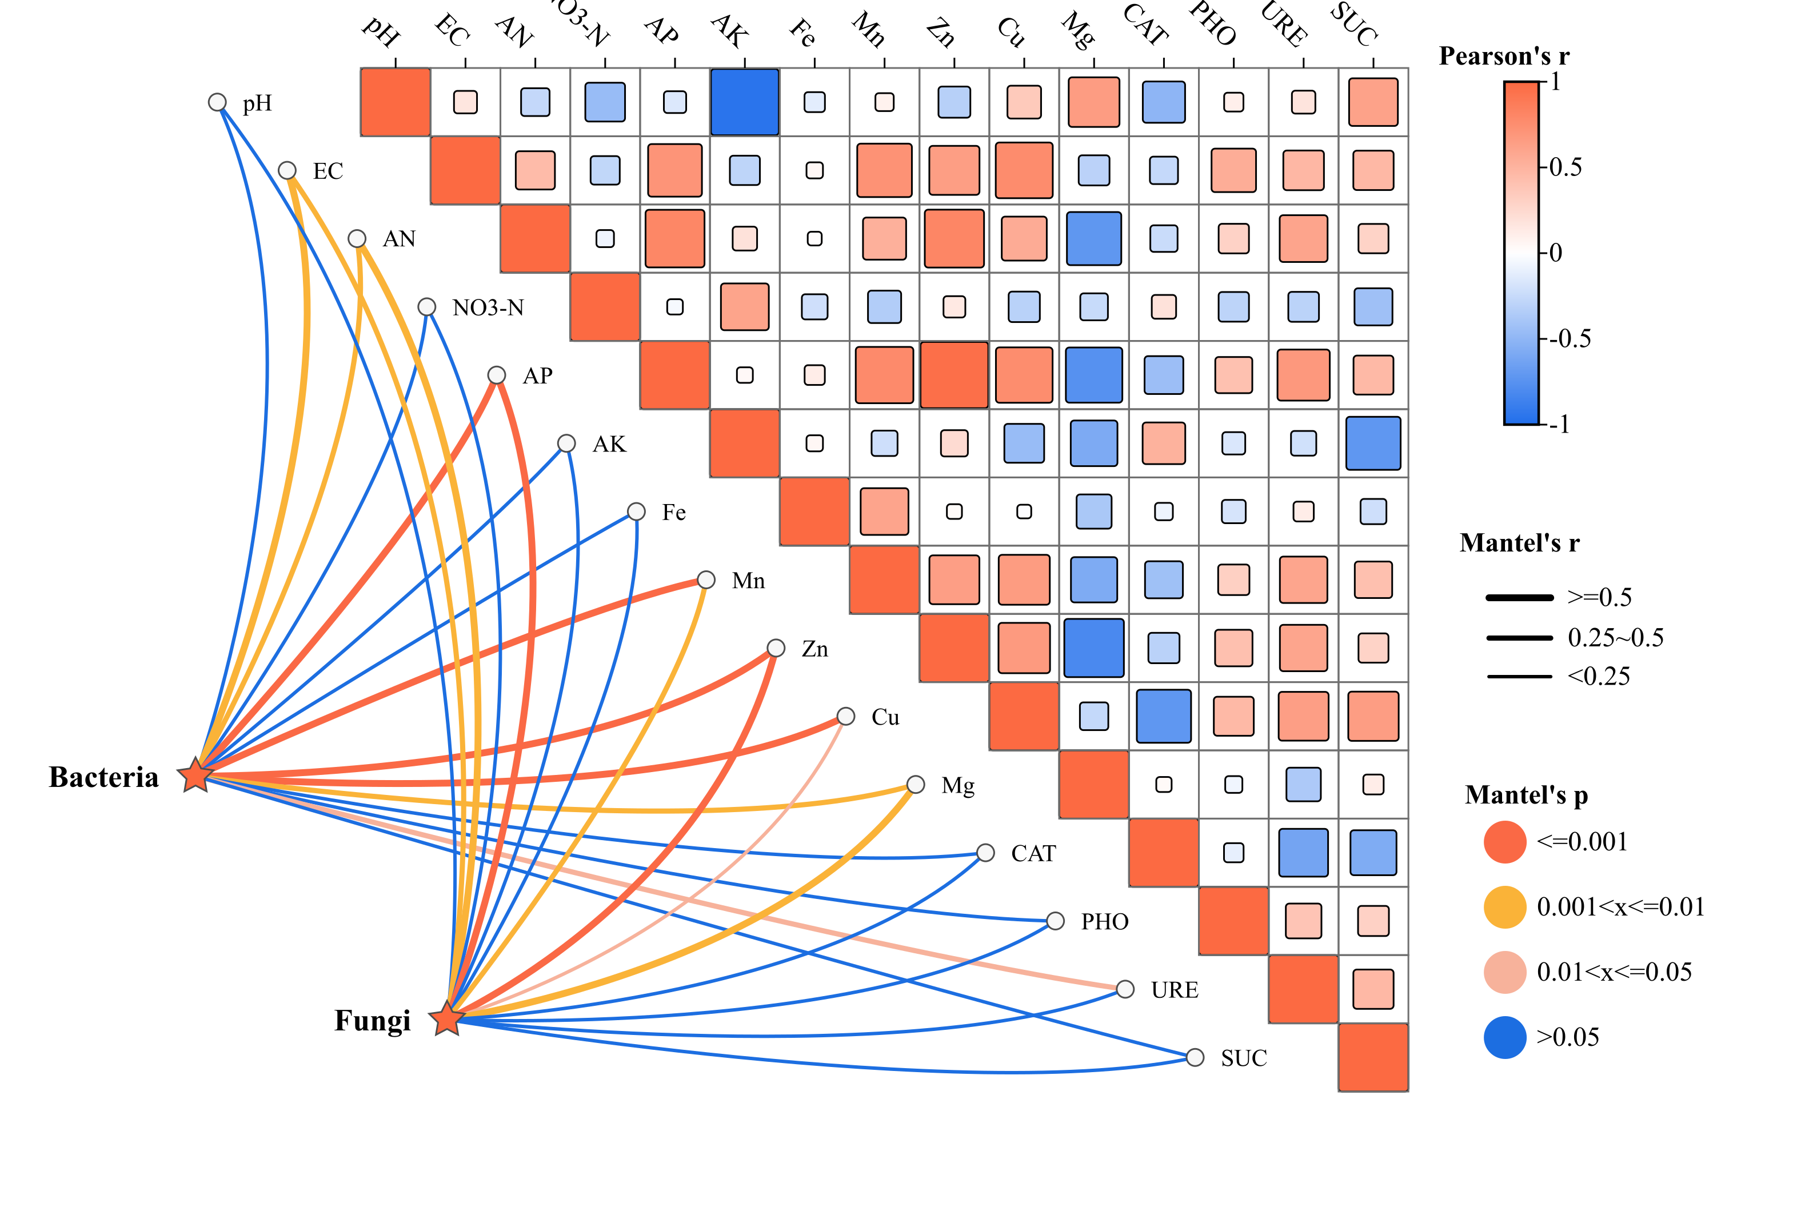
Figure 5. Environmental factors influencing soil microbial community composition in the sugar beet rhizosphere. Pearson correlations between microbial communities and environmental variables were analyzed using Mantel tests. Edge widths represent Mantel statistics, square sizes indicate correlation magnitudes, and colors correspond to Pearson coefficients. Line colors denote P values.
Spearman correlation coefficients between soil environmental factors and dominant microbial taxa were calculated and visualized using clustering heatmaps to highlight their relationships. The analysis showed that the number of bacterial and fungal genera significantly correlated with soil environmental factors, indicating that beetroot rhizosphere microbial communities were closely associated with and susceptible to soil environmental changes (Fig. 6). Further analysis revealed that Zn, AP and Cu were significantly positively correlated with the abundance of Novosphingobium, Parablastomonas, Sphingomonas, Pseudoxanthomonas, Stenotrophomonas, Bacillus, and Lysobacter, with AP exhibited an exceptionally strong positive correlation with Parablastomonas, Stenotrophomonas, Pseudoxanthomonas, and Bacillus, suggesting its significant promoting effect on the enrichment of these taxa. However, they showed a significant negative correlation with the abundance of RB41. Meanwhile, the abundance of RB41 displayed a highly significantly negative correlation with EC and SUC, Whereas the abundance of Pseudoxanthomonas and Stenotrophomonas was significantly positively correlated with EC and SUC. Additionally, the abundance of Lysobacter was positively correlated with URE. Different soil enzyme activities differentially affected soil bacterial communities: CAT, URE, and SUC had more pronounced effects on bacterial communities compared with PHO. SUC and URE exhibited significant positive correlations with Parablastomonas, Pseudoxanthomonas and Lysobacter, whereas CAT showed marked negative correlations with those bacterial genera (Fig. 6A).
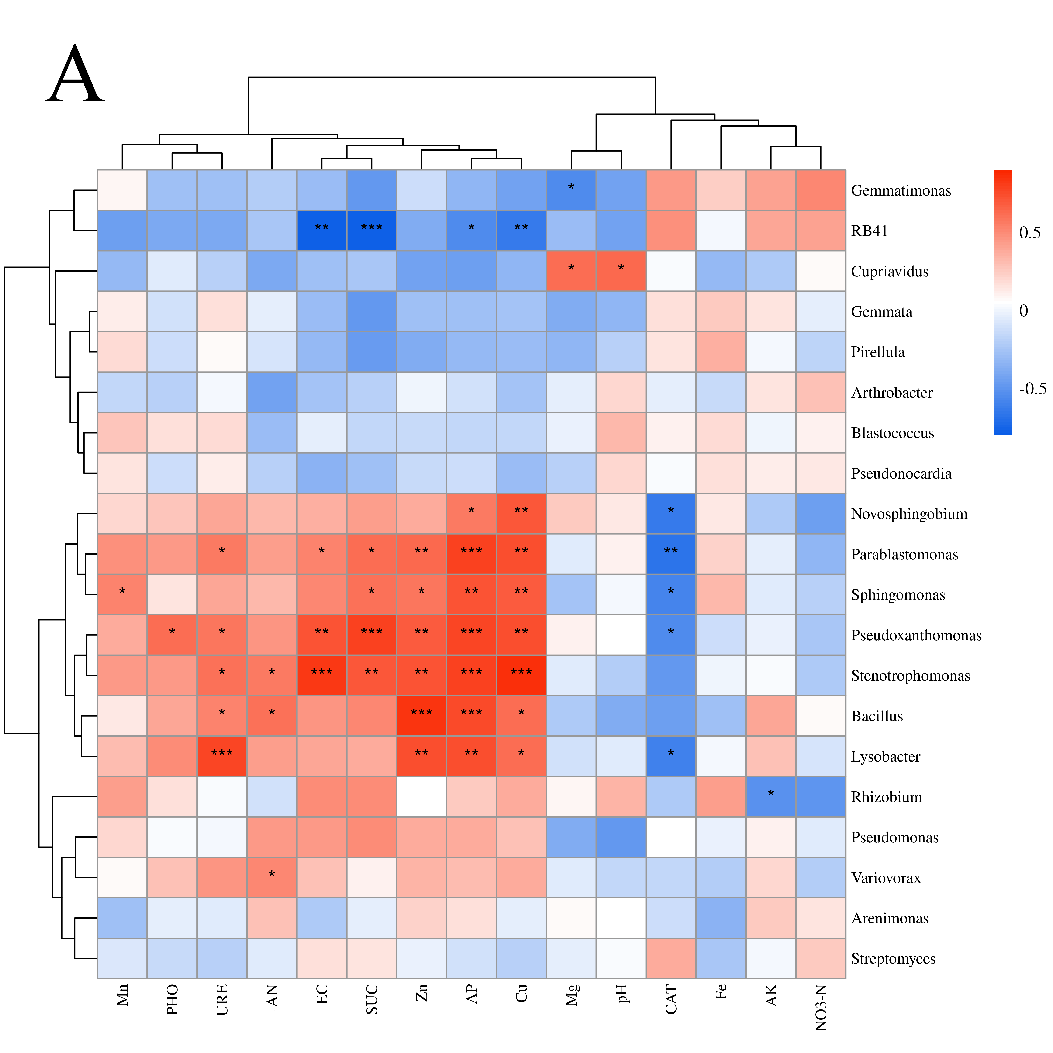
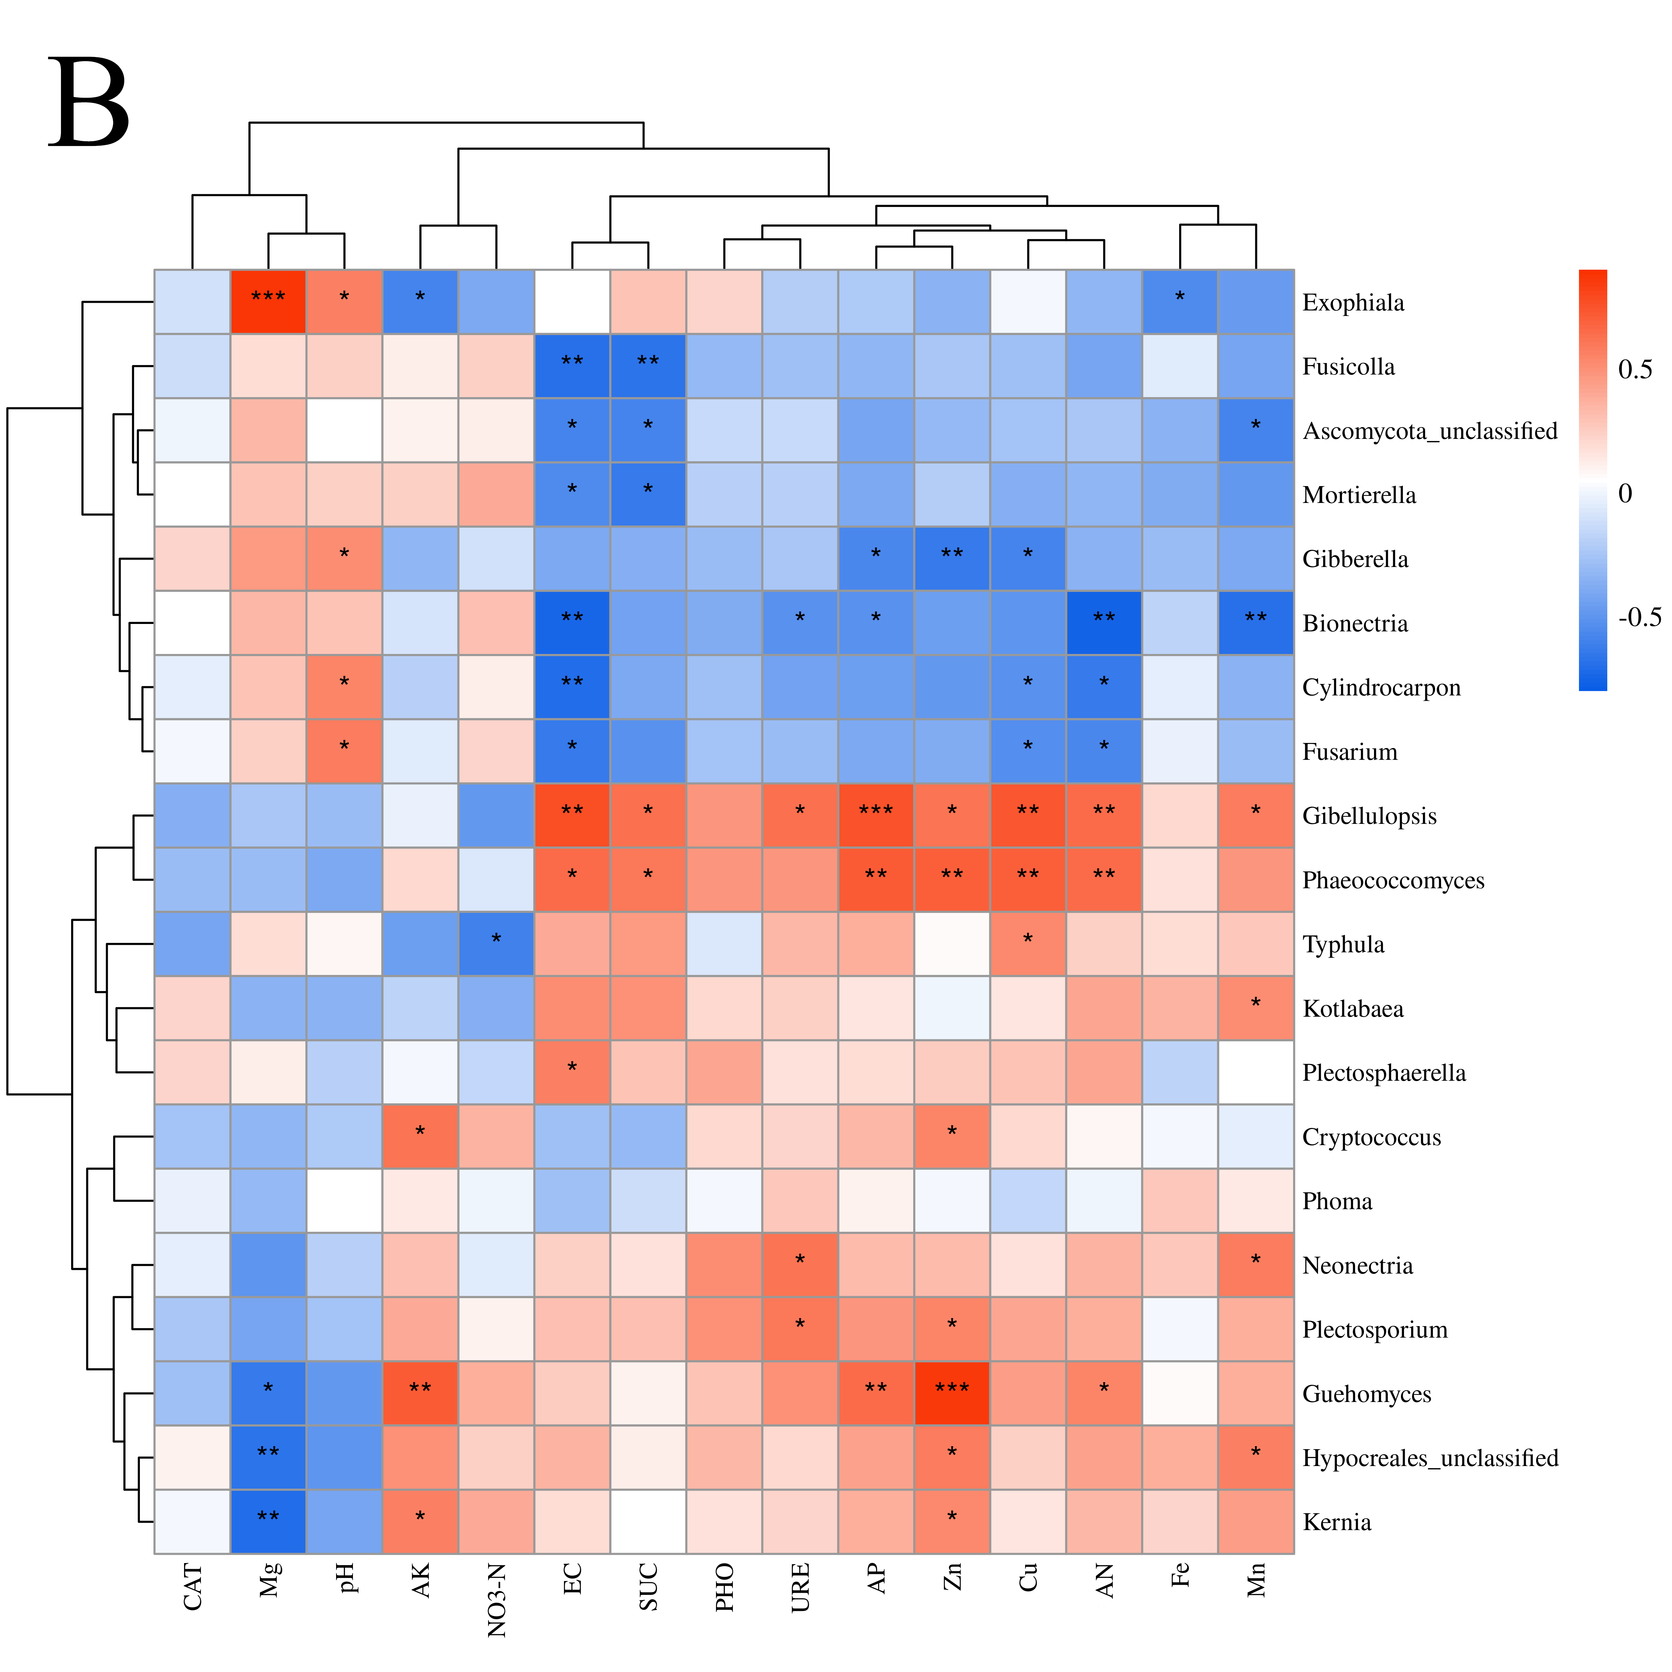
Figure 6. Clustering heatmap showing Spearman correlations between soil environmental factors and dominant bacterial genera (A) and fungal genera (B) (*0.01 < P ≤ 0.05, **0.001 < P ≤ 0.01, ***P ≤ 0.001).
The analysis of soil environmental factors influencing rhizosphere fungal communities showed that Gibellulopsis, Phaeococcomyces and Guehomyces demonstrated significant positive correlations with most factors, such as EC, SUC, AP, Zn, AP, Cu, AN and Mn, whereas Gibberella, Bionectria, Cylindrocarpon and Fusarium exhibited significant negative correlations with those factors. Additionally, Mg not only showed a highly significant positive correlation with Exophiala but also significant negative correlations with Kernia, Hypocreales, and Guehomyces (Fig. 6B). In summary, environmental factors and microbial communities are closely interconnected, with changes in one component likely inducing alterations in the other.
3.7 Prediction of Microbial Community Function
Based on the FAPROTAX database, this study analyzed the rhizosphere soil bacterial communities under different treatments and predicted 90 potential ecological functions. The variation characteristics of the top 10 bacterial functional groups in terms of average relative abundance across samples are shown in Figure 7. Chemoheterotrophy and aerobic chemoheterotrophy were identified as the predominant bacterial ecological functions across all treatment groups, collectively accounting for half of all predicted functions. Other relatively abundant functional categories included nitrate reduction, predatory or exoparasitic behavior, chitinolysis, and aromatic compound degradation.
Differential analysis of functional categories among treatment groups (Fig. 7) revealed that the CK + K and CK + J treatments significantly reduced the relative abundance of chemoheterotrophy compared with the CK group, whereas CK + KJ
Figure 7. Bacterial ecological function enrichment under different treatments "*" : P≦0.05; “**” : P≦0.01. NC, Noncontinuous cropping soil; CK, continuous cropping soil for 2 years as the control; CK+ K, continuous cropping soil with B. subtilis; CK + J, continuous cropping soil with B. mucilaginosus; CK + KJ, continuous cropping soil with a combination of B. subtilis and B. mucilaginosus.
showed no significant difference in chemoheterotroph abundance relative to the CK or NC, suggesting that the co-application of B. subtilis and B. mucilaginosus neutralized their individual inhibitory effects. Meanwhile, CK + K treatment also significantly reduced the relative abundance of aerobic chemoheterotrophy compared with that in the CK group. The NC group demonstrated significantly higher abundance of nitrate reduction processes and predatory or exoparasitic functions compared to all other treatment groups (CK, CK + K, CK + J, and CK + KJ), whereas no significant differences in these functional traits were detected among the CK, CK + K, CK + J, and CK + KJ groups. The CK + KJ treatment showed the highest chitinolytic activity, with significant differences compared with other groups, followed by the CK + K treatment. Regarding aromatic compound degradation and nitrogen respiration functions, all three bacterial inoculation treatments outperformed the NC group, with CK + K treatment demonstrated the most pronounced effect， showed significantly greater than both the NC group and CK group. In terms of ureolysis function, the CK + J treatment showed the highest abundance and significant differences compared with all other groups. For nitrate respiration, the CK + K treatment displayed the highest abundance, with significantly higher than that in the NC group and CK group, followed by the CK + KJ treatment, whereas no significant difference was observed between NC and CK controls. The human pathogens (all) function significantly increased under both the CK + K and CK + KJ treatments compared with controls. These findings indicated that the two Bacillus agents and their mixture exerted minimal effects on the relative abundance of chemoheterotrophy and aerobic chemoheterotrophy functions in rhizosphere soil bacterial communities, but significantly modulated several less dominant functional types.
Figure 8. Distribution and abundance of fungal trophic modes under different treatments. NC, Noncontinuous cropping soil; CK, continuous cropping soil for 2 years as the control; CK+ K, continuous cropping soil with B. subtilis; CK + J, continuous cropping soil with B. mucilaginosus; CK + KJ, continuous cropping soil with a combination of B. subtilis and B. mucilaginosus.
The functional prediction of fungal communities in sugar beet rhizosphere soils under different treatments was performed using the FunGuild tool. The analysis revealed distinct patterns in the relative abundance and distribution of fungal trophic modes across treatments, as illustrated in Figure 8. Except for the NC treatment group, the three most abundant fungal trophic types under other treatments were Undefined Saprotroph (24.07%–36.65%), Unknown trophic mode (13.07%–17.69%), and Dung Saprotroph–Ectomycorrhizal–Soil Saprotroph–Wood Saprotroph (10.36%–34.61%). The CK + KJ treatment exhibited the highest relative abundance of Undefined Saprotroph. The CK + J treatment showed a significant difference in Dung Saprotroph–Ectomycorrhizal–Soil Saprotroph–Wood Saprotroph abundance compared with the CK. The relative abundance of Unknown trophic mode (37.77%), Endophyte–Litter Saprotroph–Soil Saprotroph–Undefined Saprotroph (15.05%), and Animal Pathogen–Endophyte–Fungal Parasite–Lichen Parasite–Plant Pathogen–Wood Saprotroph (12.79%) were significantly higher under the NC treatment than under other treatments. Furthermore, NC displayed the lowest relative abundance of Plant Pathogen (1.73%) and Endophyte–Plant Pathogen (1.89%). No significant differences were observed among treatments for Animal Pathogen–Endophyte–Epiphyte–Undefined Saprotroph. These findings demonstrated that the CK + J treatment significantly influenced the abundance of Dung Saprotroph–Ectomycorrhizal–Soil Saprotroph–Wood Saprotroph in fungal communities, while showing minimal effects on other trophic types. Comparatively, the NC exhibited marked differences in fungal community composition compared with other treatments.
4. Discussion
As one of the most effective biocontrol agents, Bacillus species promote plant growth, regulate soil microbial communities, and exhibit strong antagonistic effects against certain pathogens, demonstrating significant potential in alleviating continuous cropping obstacles (Sui et al. 2022; Xu et al. 2023). This study investigated the effects of B. subtilis and B. mucilaginosus inoculants on the growth and development of continuously cropped sugar beet seedlings and their impact on rhizosphere soil physicochemical properties and microbial communities.
Compared with the continuous cropping CK, sugar beet seedlings treated with B. subtilis, B. mucilaginosus, or a combination of both showed significant improvements in growth parameters, including stem diameter (SD), plant height(Height), and root dry weight (RDW). The level of beet seedlings could recover to the noncontinuous cropping group (NC) level or even higher than the NC group index. These findings aligned with previous studies on crops such as tomato and radish (Chen et al. 2023; Han et al. 2023; Torres et al. 2020). Continuous cropping induced soil acidification, characterized by decreased pH and altered physicochemical properties (Huang et al. 2019). This study revealed that Bacillus inoculants significantly increased soil pH, available phosphorus (AP) content, and urease (URE) and sucrase (SUC) activities while reducing available potassium (AK) content and Catalase (CAT) activity. These trends in environmental factor changes were consistent with previous studies (Han et al. 2023; Shen et al. 2015; Wu et al. 2023). The results demonstrated that both Bacillus species significantly promoted sugar beet seedling growth and regulated soil physicochemical properties.
Bacillus species influence plant growth by regulating rhizosphere microbial community structure and diversity (Chen et al. 2022; Olanrewaju et al. 2021). High-throughput sequencing was performed on rhizosphere soil from continuous cropping sugar beet seedlings and Bacillus-treated groups. Compared to both the CK and NC groups, bacterial community abundance significantly decreased following treatment with either Bacillus inoculant or their combination. At the same time, the single use of the two Bacillus also reduced the abundance of fungal communities compared to the NC group, consistent with the findings of Sui et al (2022). However, Bacillus treatments did not significantly impact fungal and bacterial diversity. NMDS results further indicated that Bacillus treatments altered bacterial community composition in continuous cropping rhizosphere soil but did not affect fungal community structure.
The analysis of microbial community composition revealed that Proteobacteria, Acidobacteria, and Actinobacteria were the dominant bacterial phyla in sugar beet rhizosphere soil. Among these, Proteobacteria had the highest relative abundance, making it the dominant phylum, consistent with findings of Cui, Shen, and others (Cui et al. 2022; Shen et al. 2015). Bacillus treatments significantly increased Proteobacteria abundance compared with CK and NC. Pseudomonas, Novosphingobium, and Sphingomonas within the phylum Proteobacteria were the most abundant genera, with higher relative abundance in inoculant-treated groups than in the CK group. Pseudomonas and Sphingomonas species, recognized as beneficial rhizobacteria, have been shown to promote plant growth under stress conditions by producing volatile compounds and secondary metabolites or by modulating plant hormone balance and signal transduction (Asaf et al. 2020; Li et al. 2022; Wang et al. 2020). The fungal communities in rhizosphere soil were predominantly composed of Ascomycota and Basidiomycota, aligning with previous findings on potato and watermelon soils (Song et al. 2021; Zhao et al. 2017). The influence of Bacillus inoculants on fungal community structure was less pronounced than their impact on bacterial communities. Applying microbial agents might decrease the relative abundance of certain fungal phyla. For instance, Ascomycota was dominant in both control and Bacillus-treated groups; however, its relative abundance was reduced under combined Bacillus inoculant treatment compared with other treatments. The relative abundance of Kotlabaea within Ascomycota also showed a significant reduction, consistent with previous findings (Shen et al. 2020). LEfSe analysis further revealed that bacterial taxa exhibited more biomarker species than fungi, with additional bacterial groups playing crucial biological roles following Bacillus treatment. These results indicated that Bacillus inoculants improved the rhizosphere microecological environment and promoted beneficial bacterial enrichment.
Soil microbial communities serve as integrated responses to environmental factors and plant interactions, effectively reflecting the trends in environment–plant dynamics. The analysis revealed that most environmental factors correlated with bacterial communities also exhibited significant associations with fungal communities, demonstrating that specific soil parameters (e.g., AP and zinc(Zn)) were more closely linked to rhizosphere soil microbial communities. Consequently, the responses of microbial communities to environmental factors may influence microbial abundance and composition, ultimately affecting host plants. The correlation analysis between microbial communities and environmental factors identified that AP, Zn, and copper(Cu) exhibited significant positive correlations with the majority of bacterial and fungal genera and significantly promoted the enrichment of these microbial taxa. These findings suggested that partial environmental factors might regulate microbial diversity while indirectly shaping soil microbial community composition.
The functional prediction results of the beet rhizosphere microecology indicated that in terms of bacterial functional prediction, the addition of Bacillus inoculants had minimal impact on the relative abundance of the primary environmental functions within the bacterial community. However, it exerted a regulatory effect on certain less dominant functional types. Specifically, the nitrate respiration, nitrogen respiration, and chitinolytic functions of the bacterial community were significantly enhanced by the inoculation. Regarding fungal functional prediction, fungi in the rhizosphere soil were predominantly saprotrophic, consistent with the trophic modes observed for fungi in other soil types (Li et al.2022). The abundance of Undefined Saprotroph fungi reached its maximum when the two Bacillus strains were applied in combination. Furthermore, the relative abundance of the Dung Saprotroph-Ectomycorrhizal-Soil Saprotroph-Wood Saprotroph functional guild increased substantially following the addition of B. mucilaginosus. This indicates that the bacterial inoculants elevated the abundance of nutritionally specialized saprotrophic fungi in the soil, which are potentially involved in modulating the structure of soil carbon and nitrogen components.
5. Conclusions
Under continuous cropping conditions, the application of B. subtilis and B. mucilaginosus significantly promoted sugar beet growth, increased soil pH while reducing acidity, enhanced the synthesis of various soil nutrients, improved URE and SUC activities, and modified soil microbial community structure. The dysbiosis of soil microbial flora in continuous cropping systems is a critical factor contributing to sugar beet replanting disorders. Introducing the two aforementioned Bacillus species increased the relative abundance of Proteobacteria while decreasing Ascomycota abundance in rhizosphere soil, thereby optimizing microbial community composition and facilitating the enrichment of beneficial microorganisms such as Pseudomonas, Novosphingobium, and Sphingomonas. This microbial regulation created a favorable environment for sugar beet growth. Furthermore, the addition of Bacillus inoculants enriched a substantial number of functional biomarkers associated with potassium solubilization, nitrogen fixation, salt and drought tolerance, and plant growth promotion. Concurrently, it enhanced the nitrate respiration, nitrogen respiration, and chitinolytic functions within the bacterial community. Additionally, the inoculants elevated the abundance of nutritionally specialized saprotrophic fungi in the soil, thereby contributing to the cycling of soil carbon and nitrogen.This study provides an effective biological strategy for alleviating continuous cropping obstacles in sugar beet production, demonstrating that B. subtilis and B. mucilaginosus serve as efficient bioagents to mitigate the adverse effects of monoculture. These findings advance the understanding of plant–microbiota interactions in continuous cropping systems and offer critical insights for future applications of microbial inoculants in addressing replanting challenges.
Acknowledgments This research was made possible through the collaboration and support of the National Sugar Crop Improvement Centre of Heilongjiang University and Heilongjiang Provincial Key Laboratory of Ecological Restoration and Resource Utilization for Cold Region.
Author contribution Qun Song and Zenghao Wang: Conceptualization, Methodology, Writing-Original draft preparation; Youkai Gao, Liuli Wei, Rui Chen: Data curation, Sample analysis; Yanchun Sun: Conceptualization, Resources, Supervision, Writing-Reviewing; Gui Geng, Yuguang Wang: Methodology, Writing-Reviewing. All authors contributed to the article and approved the submitted version.
Funding This research was funded by the Heilongjiang Provincial Postdoctoral Research Funding Program (LBH-Z23255).
Declaration of competing interest The authors declare that they have no known competing financial interests or personal relationships that could have appeared to influence the work reported in this paper.
Data availability The datasets generated during and/or analyzed during the current study are available from the corresponding author on reasonable request.
References
Asaf S, Numan M, Khan A L, et al (2020) Sphingomonas: from diversity and genomics to functional role in environmental remediation and plant growth. Critical Reviews in Biotechnology 40 (2):138-152. https://doi.org/10.1080/07388551.2019.1709793
Ahsan T, Tian PC, Gao J, et al (2024) Effects of microbial agent and microbial fertilizer input on soil microbial community structure and diversity in a peanut continuous cropping system. Journal of Advanced Research 64:1-13. https://doi.org/10.1016/j.jare.2023.11.028
Bao, S (2005) Soil and agricultural chemistry analysis.,(Agriculture Press: Beijing).
Cai XY, Zhao HH, Chen L, et al (2021) Effects and Mechanisms of Symbiotic Microbial Combination Agents to Control Tomato Fusarium Crown and Root Rot Disease. Frontiers in Microbiology 12: 629793. http://dx.doi.org/10.3389/fmicb.2021.629793
Cao B, Zhang Y, Wang ZY, et al (2018) Insight Into the Variation of Bacterial Structure in Atrazine-Contaminated Soil Regulating by Potential Phytoremediator: Pennisetum americanum (L.) K. Schum. Frontiers in Microbiology 9. https:// doi. org/10.3389/fmicb.2018.00864
Chen XR, Yang F, Bai CW, et al (2022) Bacillus velezensis Strain GUMT319 Reshapes Soil Microbiome Biodiversity and Increases Grape Yields. Biology 11 (10):1486-1486. http://dx.doi.org/10.3390/biology11101486
Chen WM, Wu ZS, Liu CH, et al (2023) Biochar combined with Bacillus subtilis SL-44 as an eco-friendly strategy to improve soil fertility, reduce Fusarium wilt, and promote radish growth. Ecotoxicology and Environmental Safety 251 :114509. https://doi.org/10.1016/j.ecoenv.2023.114509
Chhikara N, Kushwaha K, Sharma P, et al (2018) Bioactive compounds of beetroot and utilization in food processing industry: A critical review. Food Chemistry 272:192-200. https://doi.org/10.1016/j.foodchem.2018.08.022
Cui RF, Geng G, Wang G, et al (2022) The response of sugar beet rhizosphere micro-ecological environment to continuous cropping. Frontiers in Microbiology. 13 : 956785. https://doi.org/10.3389/fmicb.2022.956785
Das S, Gwon HS, Khan MI, et al (2019) Taxonomic and functional responses of soil microbial communities to slag-based fertilizer amendment in rice cropping systems. Environment International 127:531-539. https://doi.org/10.1016/j.envint.2019.04.012
Duan YN, Zhao L, Jiang WT, et al (2022) The Phlorizin-Degrading Bacillus licheniformis XNRB-3 Mediates Soil Microorganisms to Alleviate Apple Replant Disease. Frontiers in Microbiology 13 : 839484. http://dx.doi.org/10.3389/fmicb.2022.839484
Gajbhiye A, Rai AR, Meshram SU, et al (2009) Isolation, evaluation and characterization of Bacillus subtilis from cotton rhizospheric soil with biocontrol activity against Fusarium oxysporum. World Journal of Microbiology and Biotechnology 26 (7):1187-1194. http://dx.doi.org/10.1007/s11274-009-0287-9
Govindasamy V, Senthilkumar M, Magheshwaran V, et al (2010) Bacillus and Paenibacillus spp.: Potential PGPR for Sustainable Agriculture. 10.1007/978-3-642-13612-2_15
Han SC, Kim K, Maung CEH, et al (2023) Growth Enhancement of Tomato by a Plant Growth Promoting Bacterium, Bacillus subtilis PE7. Han-guk toyang biryo hakoeji 56 (4):398-406. https://doi.org/10.7745/kjssf.2023.56.4.398
Holmquist L, Dölfors F, Fogelqvist J, et al (2020) Major latex protein-like encoding genes contribute to Rhizoctonia solani defense responses in sugar beet. Molecular Genetics and Genomics 296 (1):155-164. https://doi.org/10.1007/s00438-020-01735-0
Huang WJ, Sun DL, Fu JT, et al (2019) Effects of Continuous Sugar Beet Cropping on Rhizospheric Microbial Communities. Genes 11 (1):13-13. https://doi.org/10.3390/genes11010013
Jbawi E, Raei AF, Ali A, et al (2016) Genotype – environment interaction study in sugar beet (Beta vulgaris L.). International Journal of Environment 5(3): 74-86. https://doi.org/10.3126/ije.v5i3.15706
Kang P, Pan YQ, Yang P, et al (2022) A comparison of microbial composition under three tree ecosystems using the stochastic process and network complexity approaches. Frontiers in Microbiology 13. https:// doi. org/10.3389/fmicb.2022.1018077
Kõljalg U, Nilsson HR, Schigel D, et al (2020) The Taxon Hypothesis Paradigm—On the Unambiguous Detection and Communication of Taxa. Microorganisms 8 (12):1910-1910. https://doi.org/10.3390/microorganisms8121910
Kui L, Xiang GS, Wang Y, et al (2021) Large-Scale Characterization of the Soil Microbiome in Ancient Tea Plantations Using High-Throughput 16S rRNA and Internal Transcribed Spacer Amplicon Sequencing. Frontiers in Microbiology. 12. https://doi.org/10.3389/fmicb.2021.745225
Li M, Yang FZ, Wu XY, et al (2020) Effects of continuous cropping of sugar beet (Beta vulgaris L.) on its endophytic and soil bacterial community by high-throughput sequencing. Annals of Microbiology. 70: 39. https://doi.org/10.1186/s13213-020-01583-8
Li Q, Huang Y, Xin S, et al (2020) Comparative analysis of bacterioplankton assemblages from two subtropical karst reservoirs of southwestern China with contrasting trophic status. Scientific Reports 10(1): 22296. https://doi.org/10.1038/s41598-020-78459-z
Li Q, Li HC, Yang ZF, et al (2022) Plant growth‐promoting rhizobacterium Pseudomonas sp. CM11 specifically induces lateral roots. New Phytologist 235 (4):1575-1588. http://dx.doi.org/10.1111/nph.18199
Li XY, Liu Y, Wang ZT, et al (2022) Microbiome analysis and biocontrol bacteria isolation from rhizosphere soils associated with different sugarcane root rot severity. Frontiers in Bioengineering and Biotechnology 10:1062351. https://doi.org/10.3389/fbioe.2022.1062351
Liu J, Wu LC, Chen D, et al (2018) Development of a soil quality index for Camellia oleifera forestland yield under three different parent materials in Southern China. Soil and Tillage Research 176: 45-50. https://doi.org/10.1016/j.still.2017.09.013
Mall AK, Misra V, Santeshwari, et al (2021) Sugar Beet Cultivation in India: Prospects for Bio-Ethanol Production and Value-Added Co-Products. Sugar Tech 23 (6):1218-1234. https://doi.org/10.1007/s12355-021-01007-0
Olanrewaju OS, Ayilara MS, Ayangbenro AS, et al (2021) Genome Mining of Three Plant Growth-Promoting Bacillus Species from Maize Rhizosphere. Applied Biochemistry and Biotechnology 193 (12):3949-3969. https://doi.org/10.1007/s12010-021-03660-3
Pimentel D, Stachow U, Takacs AD, et al (1992) Conserving Biological Diversity in Agricultural/Forestry Systems. Bioscience 42 (5):354-362. https://doi.org/10.2307/1311782
Qi RM, Li J, Lin ZX, et al (2016) Temperature effects on soil organic carbon, soil labile organic carbon fractions, and soil enzyme activities under long-term fertilization regimes. Applied Soil Ecology. 102: 36-45. http://dx.doi.org/10.1016/j.apsoil.2016.02.004
Qiao JQ, Yu XY, Liang XJ, et al (2017) Addition of plant-growth-promoting Bacillus subtilis PTS-394 on tomato rhizosphere has no durable impact on composition of root microbiome. BMC Microbiology 17 (1): 131. http://dx.doi.org/10.1186/s12866-017-1039-x
Quast C, Pruesse E, Yilmaz P, et al (2012) The SILVA ribosomal RNA gene database project: improved data processing and web-based tools. Nucleic Acids Research 41 (D1):D590-D596. https://doi.org/10.1093/nar/gks1219
Schloss PD, Westcott SL, Ryabin T, et al (2009) Introducing mothur: Open-Source, Platform-Independent, Community-Supported Software for Describing and Comparing Microbial Communities. Applied and Environmental Microbiology 75 (23):7537-7541. https://doi.org/10.1128/AEM.01541-09
Segata N, Izard J, Waldron L, et al (2011) Metagenomic biomarker discovery and explanation. Genomebiology.com (London. Print) 12 (6): R60-R60. http://genomebiology.com/2011/11/6/R60
Shao FF, Tao WH, Yan HK, et al (2023) Effects of Microbial Organic Fertilizer (MOF) Application on Desert Soil Enzyme Activity and Jujube Yield and Quality. Agronomy. 13 (9):2427-2427. http://dx.doi.org/10.3390/agronomy13092427
Shen ZZ, Ruan YZ, Wang BB, et al (2015) Effect of biofertilizer for suppressing Fusarium wilt disease of banana as well as enhancing microbial and chemical properties of soil under greenhouse trial. Applied Soil Ecology 93: 111-119. http://dx.doi.org/10.1016/j.apsoil.2015.04.013
Solanki MK, Kumar S, Pandey AK, et al (2012) Diversity and antagonistic potential of Bacillusspp. associated to the rhizosphere of tomato for the management of Rhizoctonia solani. Biocontrol Science and Technology 22 (2):203-217. http://dx.doi.org/10.1080/09583157.2011.649713
Song J, Kong ZL, Zhang DD, et al (2021) Rhizosphere Microbiomes of Potato Cultivated under Bacillus subtilis Treatment Influence the Quality of Potato Tubers. International Journal of Molecular Sciences 22 (21):12065-12065. https://doi.org/10.3390/ijms222112065
Steven Z, Zhang R (2019) Sugar Beet. In: Stephen K(ed) In Integrated Processing Technologies for Food and Agricultural By-Products. pp 331-351.
Sui JK, Yu QL, Yang K, et al (2022) Effects of Bacillus subtilis T6-1 on the Rhizosphere Microbial Community Structure of Continuous Cropping Poplar. Biology 11 (5):791-791. https://doi.org/10.3390/biology11050791
Sun RC, Zhang XX, Guo XS, et al (2015) Bacterial diversity in soils subjected to long-term chemical fertilization can be more stably maintained with the addition of livestock manure than wheat straw. Soil Biology and Biochemistry 88: 9-18. http://dx.doi.org/10.1016/j.soilbio.2015.05.007
Tang J, Xue ZQ, Daroch M, et al (2015) Impact of continuous Salvia miltiorrhiza cropping onrhizosphere actinomycetes and fungi communities. Annals of Microbiology 65(3):1267-1275. https://doi.org/10.1007/s13213-014-0964-2
Tkacz A, Cheema J, Chandra G, et al (2015) Stability and succession of the rhizosphere microbiota depends upon plant type and soil composition. The ISME Journal 9:2349–2359. https:// doi. org/ 10. 1038/ ismej. 2015. 41
Tong J, Cao M, Wang R (2018) Effects of restoration time on microbial diversity in rhizosphere and non-rhizosphere soil of Bothriochloa ischaemum. International Journal of Environmental Research and Public Health. https:// doi. org/ 10. 3390/ ijerp h1510 2155
Torres M, Llamas I, Torres B, et al (2020) Growth promotion on horticultural crops and antifungal activity of Bacillus velezensis XT1. Applied Soil Ecology 150: 103453. https://doi.org/10.1016/j.apsoil.2019.103453
Wang Q, Ge CF, Xu SA, et al (2020) The endophytic bacterium Sphingomonas SaMR12 alleviates Cd stress in oilseed rape through regulation of the GSH-AsA cycle and antioxidative enzymes. BMC Plant Biology 20:63. https://doi.org/10.1186/s12870-020-2273-1
Wang D, Poinsot V, Li WX, et al (2023) Genomic Insights and Functional Analysis Reveal Plant Growth Promotion Traits of Paenibacillus mucilaginosus G78. Genes 14(2):392-392. https://doi.org/10.3390/genes14020392
Wu X, Li ZG, Liu HG, et al (2015) The Effect of Long-Term Continuous Cropping of Black Pepper on Soil Bacterial Communities as Determined by 454 Pyrosequencing. PLOS ONE 10 (8):e0136946-e0136946. https://doi.org/10.1371/journal.pone.0136946
Wu LX, Wang Y, Lyu H, et al (2023) Effects of a compound Trichoderma agent on Coptis chinensis growth, nutrients, enzyme activity, and microbial community of rhizosphere soil. PeerJ 11: e15652. https://doi.org/10.7717/peerj.15652
Xu WF, Sun T, Du J, et al (2023) Structure and ecological function of the soil microbiome associated with ‘Sanghuang’ mushrooms suffering from fungal diseases. BMC Microbiology 23 (1): 218. https://doi.org/10.1186/s12866-023-02965-z
Yuan MM, Guo X, Wu L, et al (2021) Climate warming enhances microbial network complexity and stability. Nature Climate Change 11(4): 343-348. https://doi.org/10.1038/s41558-021-00989-9
Zhang SN, Sun LT, Wang Y, et al (2020) Cow manure application effectively regulates the soil bacterial community in tea plantation. BMC Microbiology 20 (1): 190. https://doi.org/10.1186/s12866-020-01871-y
Zhang X, Wu Y, Liu S, et al (2024) Plant growth and development of tropical seagrass deter-mined rhizodeposition and its related microbial community. Mar Pollut Bull 199:115940. https:// doi. org/ 10.1016/j. marpo lbul
Zhao J, Wang YG, Hong L, et al (2017) The rhizosphere microbial community response to a bio-organic fertilizer: finding the mechanisms behind the suppression of watermelon Fusarium wilt disease. Acta Physiologiae Plantarum 40 (1): 17. https://doi.org/10.1007/s11738-017-2581-8
Zheng X, Wang Z, Zhu Y, et al (2020) Effects of a microbial restoration substrate on plant growth and rhizo-sphere bacterial community in a continuous tomato crop-ping greenhouse. Scientific Reports 10:13729. https:// doi. org/ 10.1038/ s41598- 020- 70737-0
Zhu B, Wu JJ, Ji QY, et al (2020) Diversity of rhizosphere and endophytic fungi in Atractylodes macrocephala during continuous cropping. PeerJ 13. https://doi.org/10.7717/peerj.8905

