Supplementary Information for

Attribution of interannual-to-centennial sea level changes in climate models

Ou Wang^{1*}, Tong Lee¹, Thomas Frederikse^{1,2}, Ichiro Fukumori¹, and Ian Fenty¹

¹Jet Propulsion Laboratory, California Institute of Technology, Pasadena, California, U.S.A.
²Joint Institute for Regional Earth System Science and Engineering, University of California, Los Angeles, California, U.S.A.

*Corresponding author: Ou Wang (ou.wang@jpl.nasa.gov)

© 2025. California Institute of Technology. Government sponsorship acknowledged

Contents of this file

Supplementary Text
Text S1

Supplementary Figures
Figure S1
Figure S2

Supplementary Text
Text S1: Adjoint Sensitivities
Figures S1 and S2 show the adjoint sensitivities of monthly mean sea level in December 2015 at Nantucket and Charleston, respectively, to ocean surface heat flux, freshwater flux, and wind stress at various lead times. Because the adjoint sensitivities to heat and freshwater flux tend to persist over longer lead times than those to wind stress, select panels show extended lead times for heat and freshwater flux. The values have been normalized by the maximum sensitivity value in the region (number specified on each panel) and are thus non-dimensional. Similar adjoint sensitives can be found in Wang et al. (2022) for Nantucket sea level and in the Supporting Information of Wang et al. (2024) for Charleston sea level.

For sea level at either Nantucket or Charleston, the adjoint sensitivities due to heat and freshwater fluxes show similar patterns. Significant adjoint sensitivities to heat flux and freshwater flux for Nantucket sea level come from the subpolar North Atlantic. At short lead times, large adjoint sensitivities to heat flux and freshwater flux are found near Nantucket (e.g., Figure 1a). With increasing lead times, the adjoint sensitivities spread clockwise, reaching the subpolar North Atlantic around 3 years (Figures 1b and 1f). The temporal evolution of adjoint sensitivities is consistent with the southward-flowing slope current, the Labrador Current, and the general circulation of the subpolar gyre (Hsieh and Bryan, 1996; Wang et al., 2022). The adjoint sensitivities of Charleston sea level to heat and shortwave fluxes also show large values in the Gulf of Mexico and the Caribbean Sea. With increasing lead times, these relatively large sensitivities spread counterclockwise, crossing the Atlantic Ocean at a lead time of 3 years (Figures 2b and 2f) and reaching the African coast near 25ºN at a lead time of 10 years (Figures 2c and 2g). In contrast, there are no significant sensitivities to heat flux and freshwater flux from the Gulf of Mexico and the Caribbean Sea for Nantucket sea level (not shown).

Adjoint sensitivities to wind stress (Figures S1i–S1p for Nantucket and Figures S2i–S2p for Charleston) generally exhibit wave-like patterns. The spatial scales of these patterns are smaller than those for heat flux and freshwater flux. These wave-like features indicate the effect of coastally trapped waves, which travel southward along the U.S. East Coast, as well as Rossby waves generated by wind stress curl that propagate across the open ocean toward the U.S. East Coast.

For Nantucket, coastally trapped waves are the main mechanism by which wind stress affects sea level variations (see main text; also Wang et al., 2022, 2024), whereas for Charleston, Rossby waves play the dominant role (Wang et al., 2024). To better illustrate the effect of coastally trapped waves for Nantucket, we rotate the adjoint sensitivities to zonal and meridional wind stress into along-bathymetry (Figures S1i-S1l) and cross-bathymetry (Figures S1m-S1p) components (cf. Figures 1i-1p of Wang et al., 2022 for adjoint sensitivities of Nantucket sea level variations to zonal and meridional wind stress), where the positive along-bathymetry direction is defined such that shallow water lies to the right. The positive cross-bathymetry is 90° counterclockwise from this, pointing toward increasing isobaths. The along-bathymetry component dominates, with positive values present in the coastal region north of Nantucket and in distant Arctic coastal regions, including areas north of the Canadian Archipelago and Greenland. These positive values reflect the effect of along-bathymetry wind stress driving onshore Ekman transport, which piles water up near the coast and thereby increases sea level in coastal regions.

For Charleston sea level, the adjoint sensitivities to wind stress are most pronounced in the ocean interior, due to Rossby waves propagating westward across the open ocean. Rossby waves are less affected by bathymetry than coastally trapped waves. For this reason, we present the sensitivities to wind stress as zonal and meridional components (Figures S2i-S2p), rather than rotating them into along-bathymetry and cross-bathymetry components, as was done in Figure S1 to highlight coastally trapped waves.

References
Hsieh, W., & Bryan, K. (1996). Redistribution of sea level rise associated with enhanced greenhouse warming: A simple model study. Climate Dynamics, 12, 535–544. https://doi.org/10.1007/BF00207937
Wang, O., Lee, T., Piecuch, C. G., Fukumori, I., Fenty, I., Frederikse, T., et al. (2022). Local and remote forcing of interannual sea-level variability at Nantucket Island. Journal of Geophysical Research: Oceans, 127, e2021JC018275. https://doi.org/10.1029/2021JC018275
Wang, O., Lee, T., Frederikse, T., Ponte, R. M., Fenty, I., Fukumori, I., & Hamlington, B. D. (2024). What forcing mechanisms affect the interannual sea level co-variability between the Northeast and Southeast Coasts of the United States? Journal of Geophysical Research: Oceans, 129, e2023JC019873. https://doi.org/10.1029/2023JC019873
Supplementary Figures

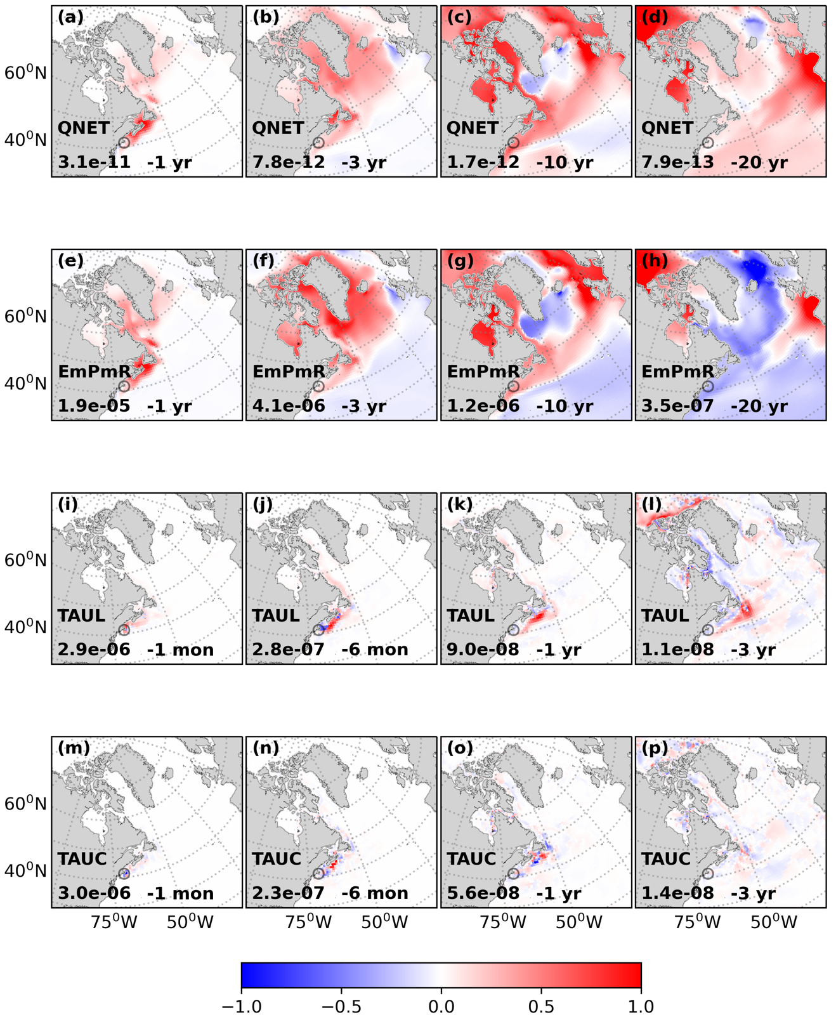
Figure S1. Adjoint sensitivities of Nantucket sea level to (a)-(d) heat flux, (e)-(h) freshwater flux, (i)-(l) along-bathymetry wind stress, and (m)-(p) cross-bathymetry wind stress at various lead times, as specified in each panel. The values are normalized by the maximum magnitude of the corresponding adjoint sensitivity in each panel, as indicated by the number (m per forcing unit per km²; see below for the specific units for each forcing) in the legend, and are therefore non-dimensional. The sign convention for the forcings is positive for downward heat flux (W m⁻²), downward freshwater flux (kg m⁻² s⁻¹), along-bathymetry wind stress (N m⁻²), and cross-bathymetry wind stress (N m⁻²). The positive along-bathymetry direction is defined such that shallow water lies to the right, and the positive cross-bathymetry direction is 90° counterclockwise from this, pointing toward increasing isobaths. The circle denotes Nantucket. Some panels are adapted from Wang et al. (2022).

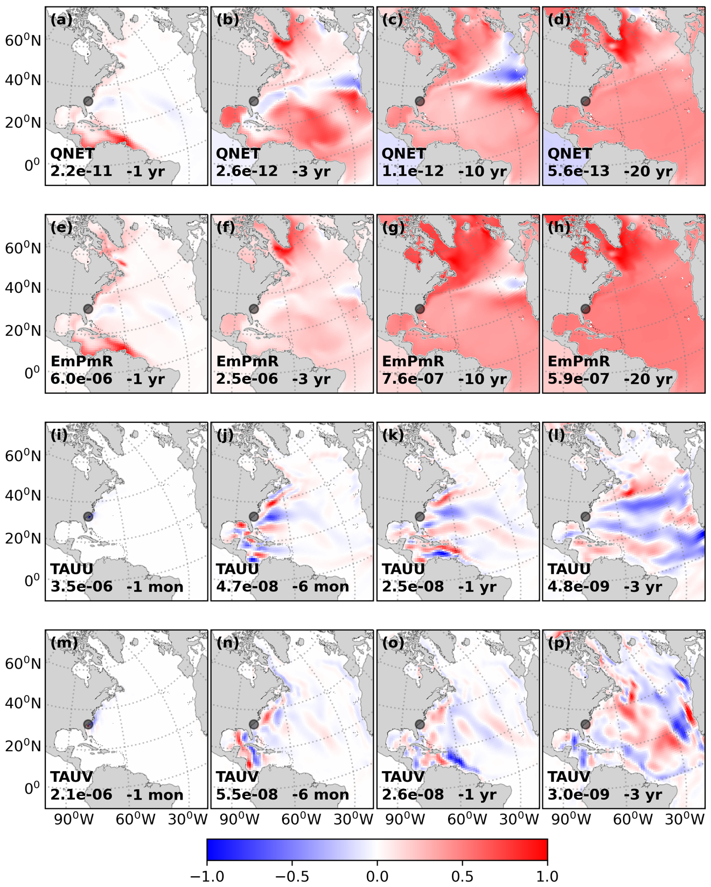
Figure S2. Same as Figure S1, but for Charleston. Unlike Figure S1, where adjoint sensitivities to wind stress are shown as along-bathymetry and cross-bathymetry components, here they are shown as zonal (panels i-l) and meridional (panels m-p) components. The sign convention for zonal and meridional wind stress (N m⁻²) is positive for eastward and northward, respectively. Some panels are adapted from Figure S1 in the Supporting Information of Wang et al. (2024).

