Supplementary Tables
Supplementary Table 1. The sequence of shRNA targeting human SCUBE3.
NO. | Accession | Target sequence | GC%
shSCUBE3-1 | NM_152753 | GTGCATCTGCAAGTCTGGCTA | 52.38%
shSCUBE3-2 | NM_152753 | ATGCAGTTGCAAGAAAGGCTA | 42.86%
shSCUBE3-3 | NM_152753 | AGGCTGCAGTGCTGTCCATTA | 52.38%
CON313 | - | TTCTCCGAACGTGTCACGT | -

Supplementary Table 2. The sequence of shRNA targeting human CCNE1.
NO. |  | Target sequence | GC%
shCCNE-1 |  | CCTGGATGTTGACTGCCTT | 50.00%
shCCNE-2 |  | CCATTTGCCATGGTTATAA | 33.33%
shCCNE-3 |  | CCAGGAAGAGGAAGGCAAA | 47.62%
CON008 |  | TTCTCCGAACGTGTCACGT | -

Supplementary Table 3. Primer sequences for quantitative RT-PCR.
Gene | Primer sequences
SCUBE3 | Forward: GAGTGCGAGCGAGAGATAATGC  Reverse: CCGTCATGTGCCAGGTGGAATC
CCNE1 | Forward: AGGTTTCAGGGTATCAGTGGTGC  Reverse: CTTTCTTTGCTCGGGCTTTGTCC
GAPDH | Forward: TGACTTCAACAGCGACACCCA  Reverse: CACCCTGTTGCTGTAGCCAAA
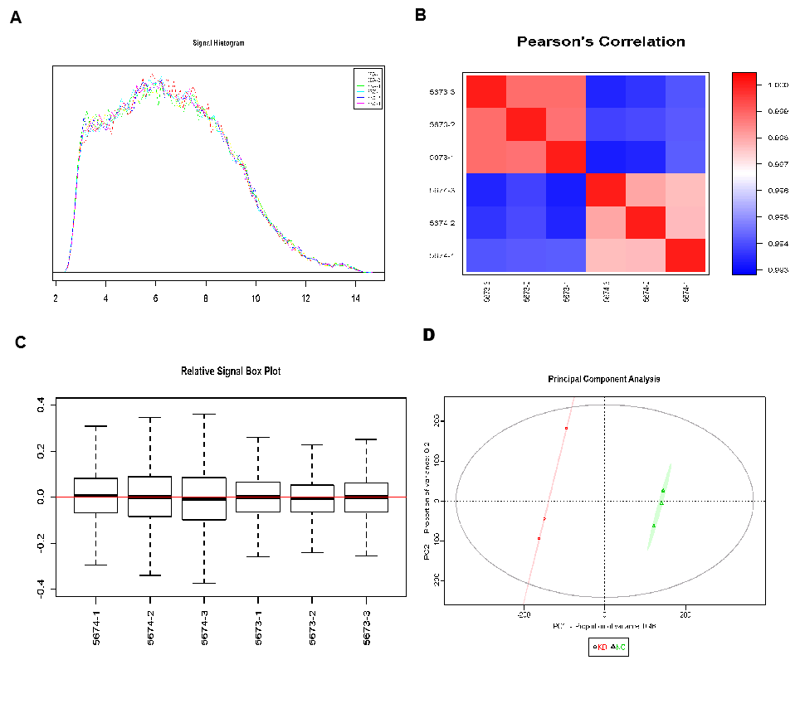
Supplementary Figure S1. Quality evaluation of ChIP data revealed that the ChIP results were reliable. (A) Signal intensity distribution curve. (B) Pearson correlation coefficient distribution between samples. (C) Relative logarithmic signal strength box plot. (D) principal component analysis score map.
Supplementary Figure S2. UALCAN expression analysis of CCNE1.(A)CCNE1 expression based on sample types.(B)CCNE1 expression based on patient's gender.(C)CCNE1 expression based on patient's age.(D)CCNE1 expression based on patient's weight.(E)CCNE1 expression based on tumor grade.(F)CCNE1 expression based on individual cancer stages.***P < 0.001，ns,ns,no significance
Supplementary Figure S3. UALCAN Survival Analysis of CCNE1.(A)Effect of CCNE1 expression level on survival of patients with hepatocellular carcinoma.(B)Effect of CCNE1 expression level and tumor grade on survival of patients with hepatocellular carcinoma. (C)Effect of CCNE1 expression level and gender on survival of patients with hepatocellular carcinoma.(D)Effect of CCNE1 expression level and body weight on survival of patients with hepatocellular Carcinoma.(E)Effect of CCNE1 expression level and race on survival of patients with hepatocellular carcinoma.
Supplementary Figure S4.Stable CCNE1 knockdown lines were established.(A-C)Verification of CCNE1 knockdown was confirmed in vivo by fluorescent microscopy Real-time PCR and Western blot Assay. *P < 0.05.
Supplementary Figure S5.Overexpression of CCNE1 in SCUBE3 knockdown Bel7404 cells (A) Fluorescence images after overexpression. (B-C)Overexpress efficiency were assessed by qRT-PCR and western blot. **P < 0.01

