Supplementary Figures

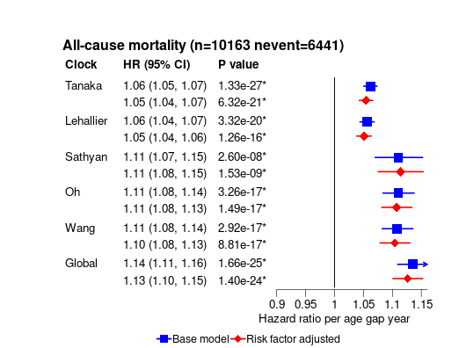
Figure S1: Hazard ratios per classical proteomic age gap year with all -cause mortality. All models stratified by study centre, sex, and five-year age group. Risk factor adjusted model additionally adjusted for education level, smoking status, alcohol consumption, BMI, healthy diet score and physical activity. All error bars show 95% confidence intervals.

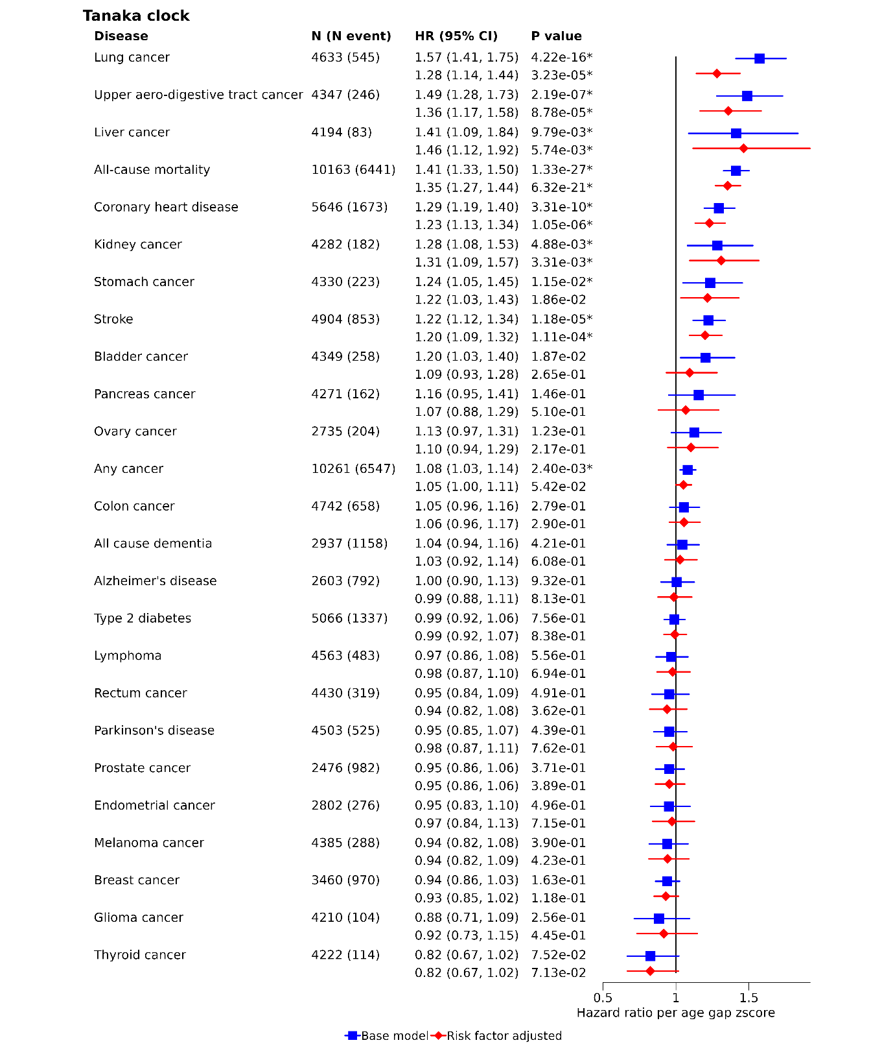
Figure S2: Comparison of strengths of associations with Tanaka proteomic age across disease endpoints. Hazard ratios per Tanaka proteomic age gap z-score with all -cause mortality and 25 incident diseases. All models stratified by study centre, sex, and five-year age group. Risk factor adjusted model additionally adjusted for education level, smoking status, alcohol consumption, BMI, healthy diet score and physical activity. All error bars show 95% confidence intervals.

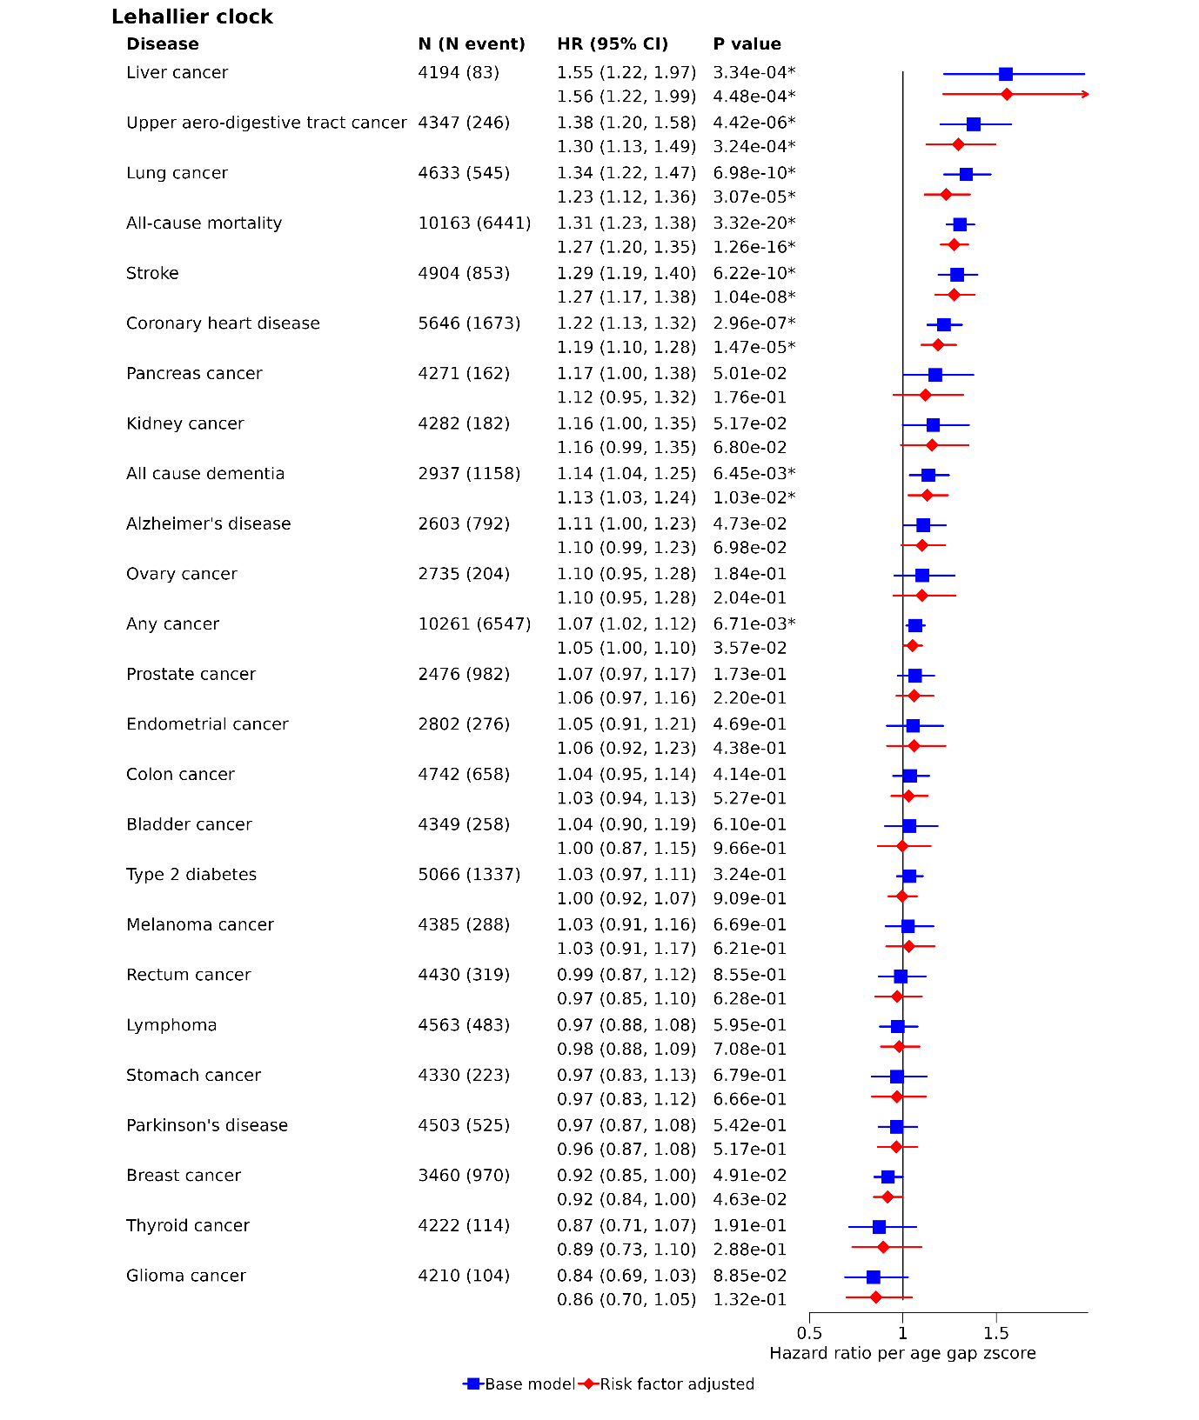
Figure S3: Comparison of strengths of associations with Lehallier proteomic age across disease endpoints. Hazard ratios per Lehallier proteomic age gap z-score with all -cause mortality and 25 incident diseases. All models stratified by study centre, sex, and five-year age group. Risk factor adjusted model additionally adjusted for education level, smoking status, alcohol consumption, BMI, healthy diet score and physical activity. All error bars show 95% confidence intervals.

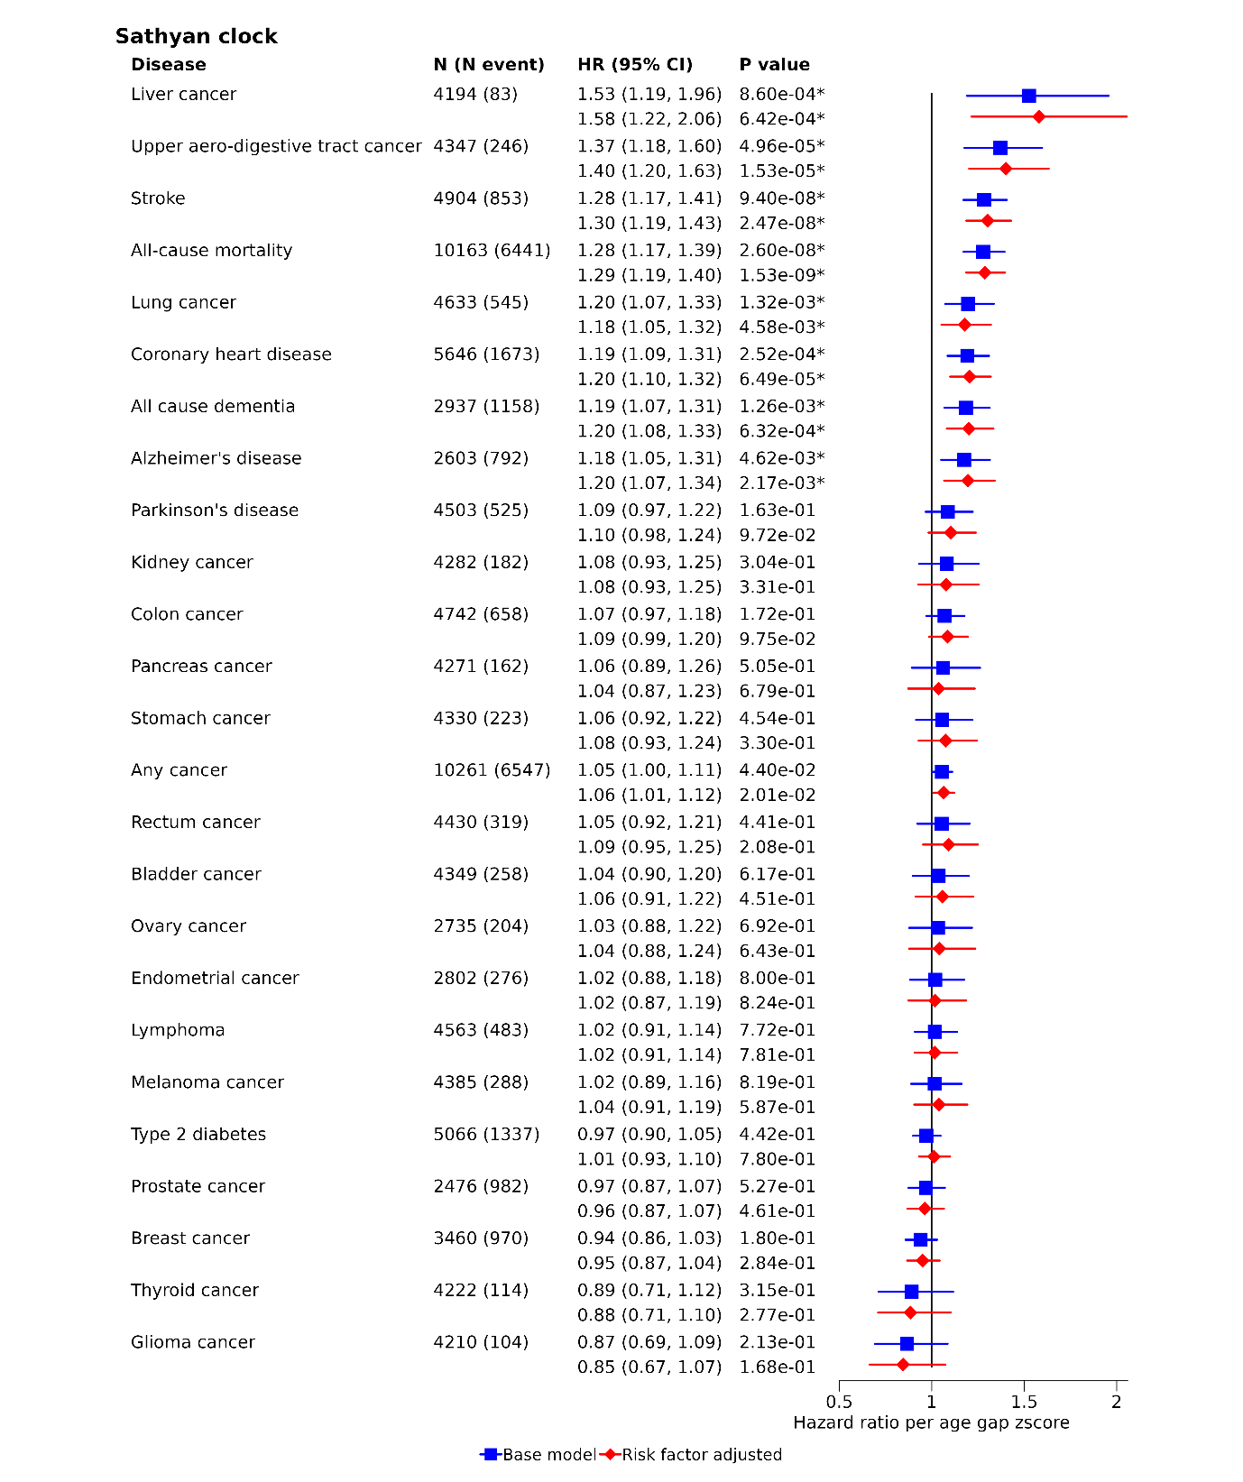
Figure S4: Comparison of strengths of associations with Sathyan proteomic age across disease endpoints. Hazard ratios per Sathyan proteomic age gap z-score with all -cause mortality and 25 incident diseases. All models stratified by study centre, sex, and five-year age group. Risk factor adjusted model additionally adjusted for education level, smoking status, alcohol consumption, BMI, healthy diet score and physical activity. All error bars show 95% confidence intervals.

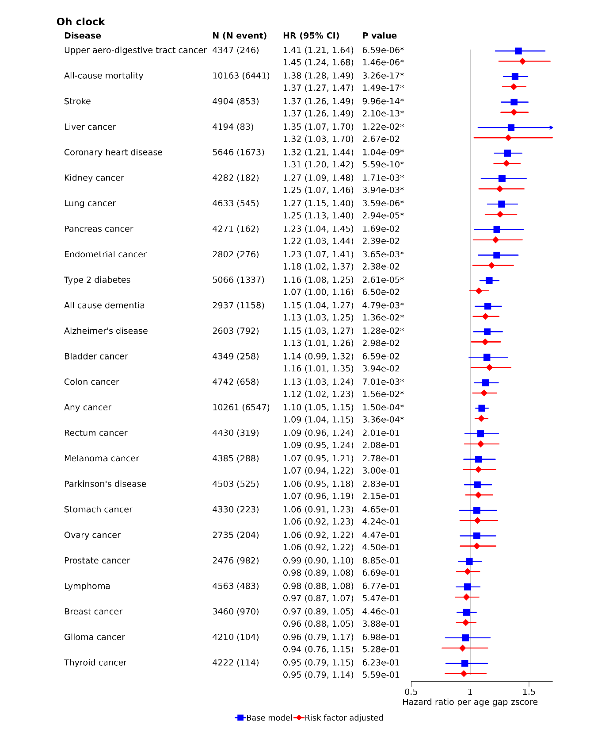
Figure S5: Comparison of strengths of associations with Oh proteomic age across disease endpoints. Hazard ratios per Oh proteomic age gap z-score with all -cause mortality and 25 incident diseases. All models stratified by study centre, sex, and five-year age group. Risk factor adjusted model additionally adjusted for education level, smoking status, alcohol consumption, BMI, healthy diet score and physical activity. All error bars show 95% confidence intervals.

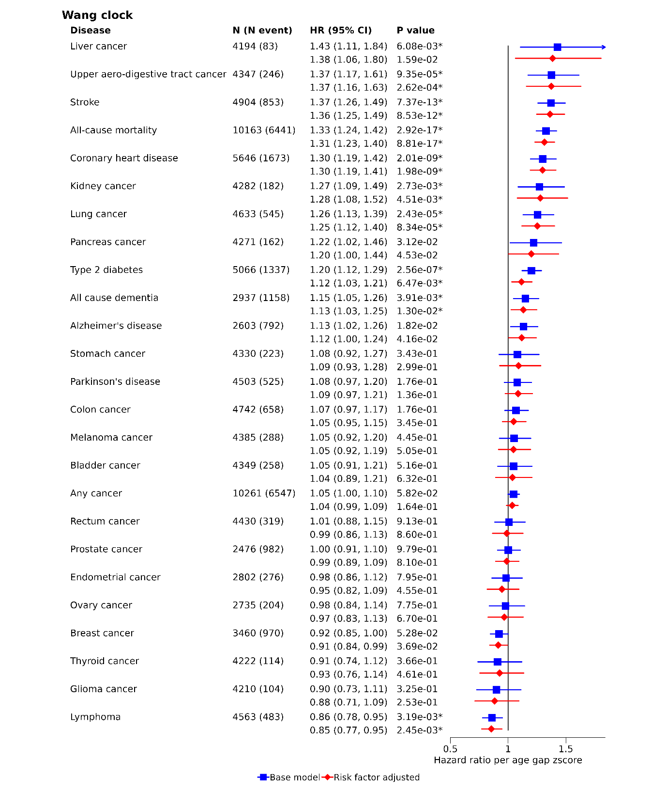
Figure S6: Comparison of strengths of associations with Wang proteomic age across disease endpoints. Hazard ratios per Wang proteomic age gap z-score with all -cause mortality and 25 incident diseases. All models stratified by study centre, sex, and five-year age group. Risk factor adjusted model additionally adjusted for education level, smoking status, alcohol consumption, BMI, healthy diet score and physical activity. All error bars show 95% confidence intervals.

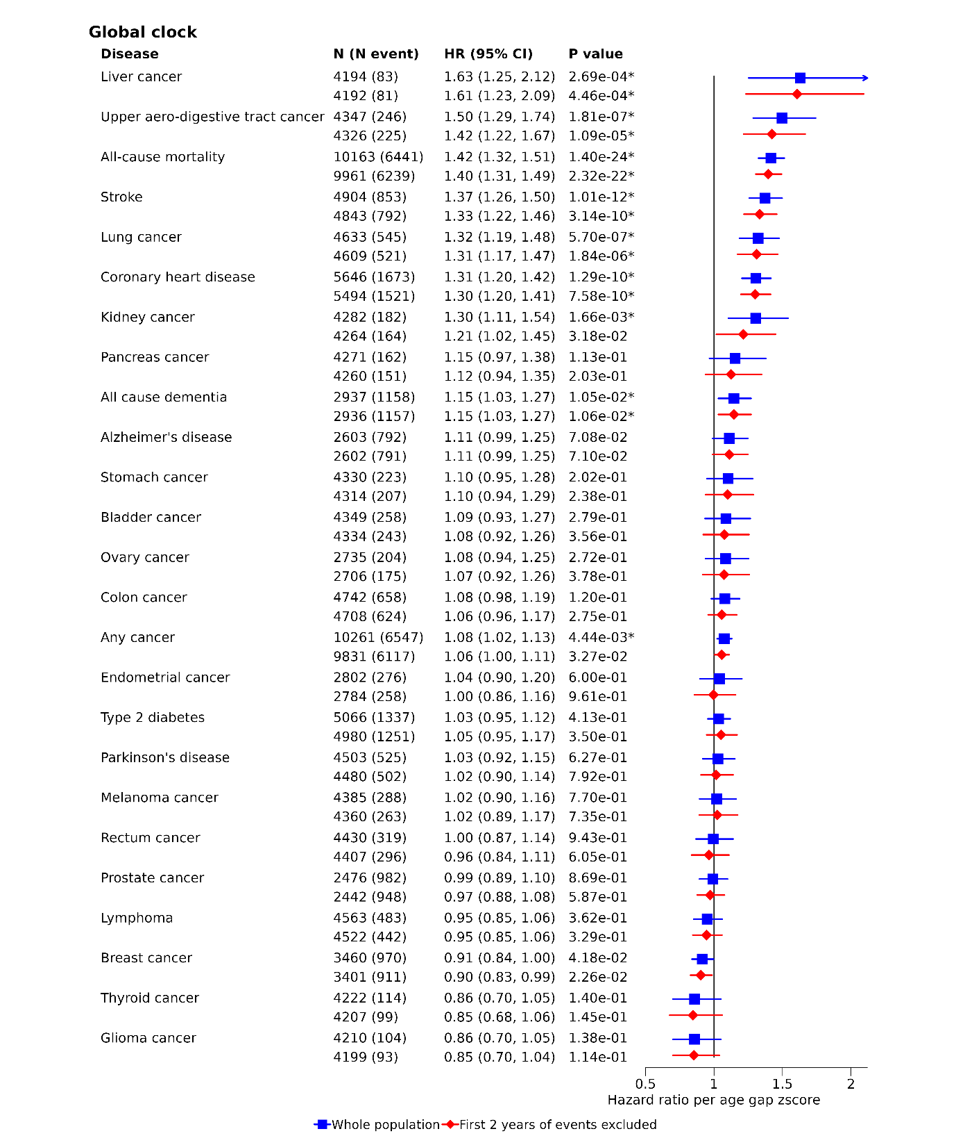
Figure S7: Associations with Global proteomic age across disease endpoints for all events (blue bars) and with events restricted only to events that occurred after two years from baseline (red bars). Hazard ratios per Global proteomic age gap z-score with all -cause mortality and 25 incident diseases. All models stratified by study centre, sex, and five-year age group and adjusted for education level, smoking status, alcohol consumption, BMI, healthy diet score and physical activity. All error bars show 95% confidence intervals.

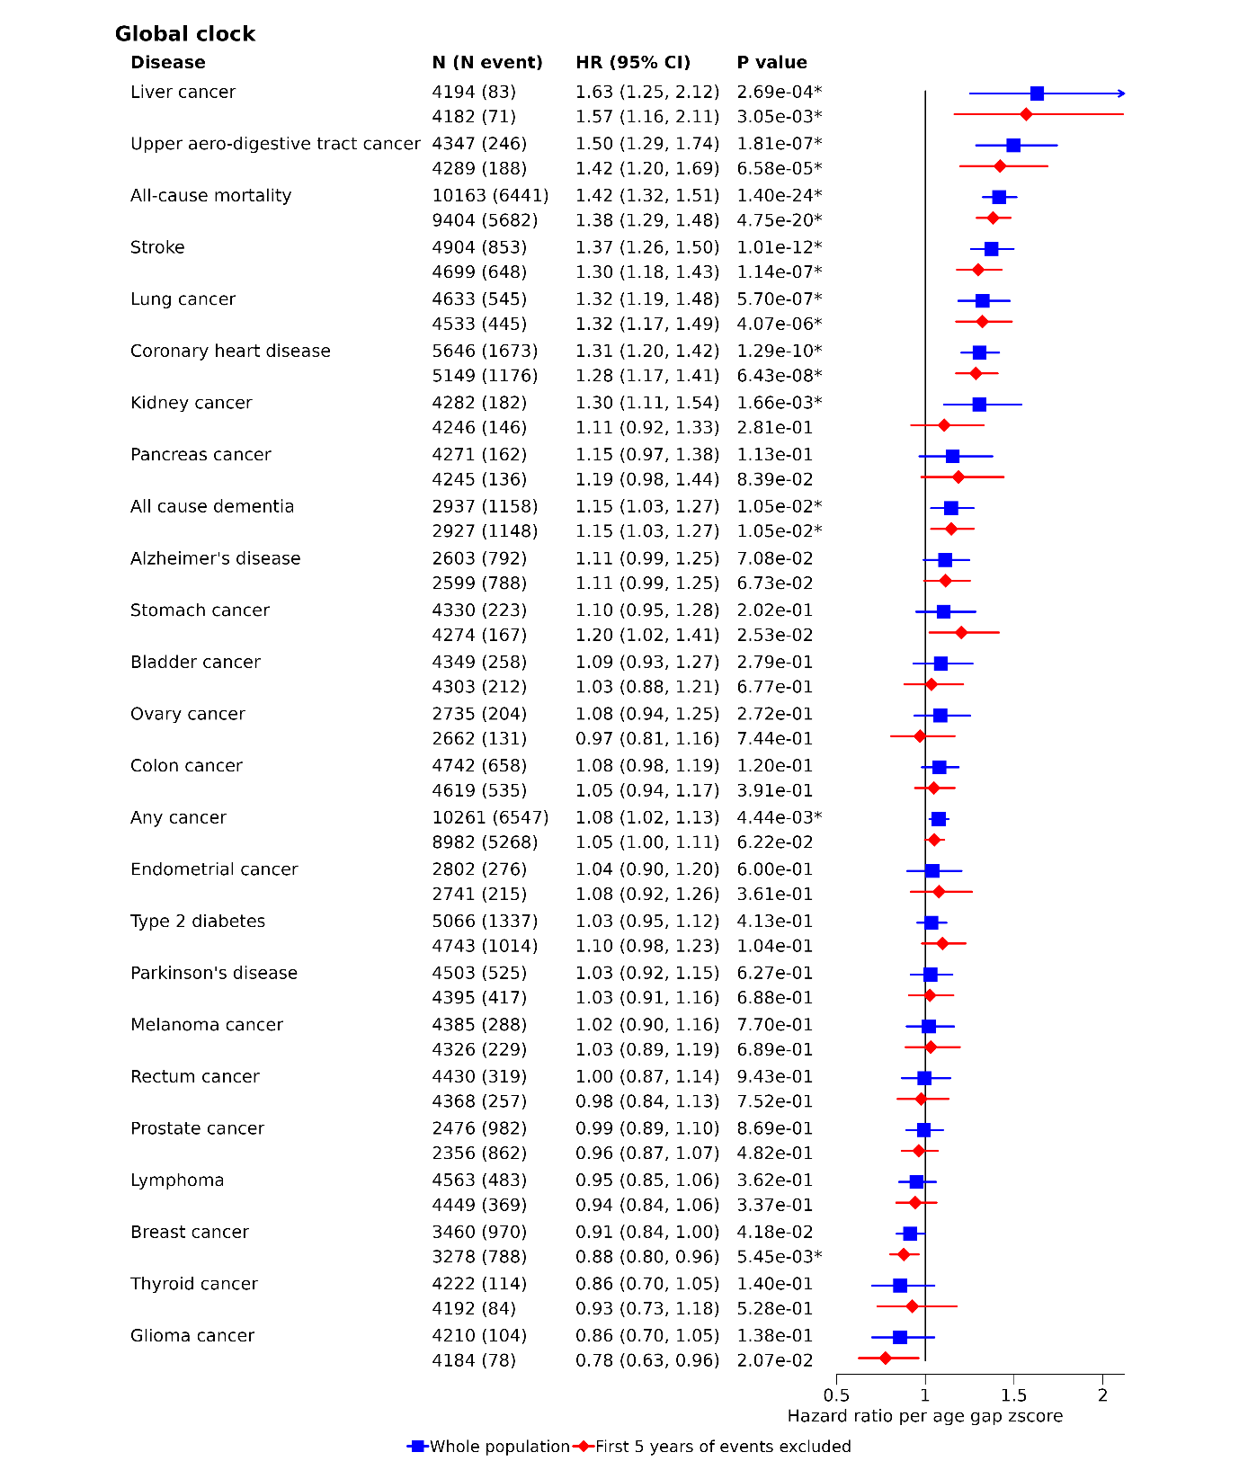
Figure S8: Associations with Global proteomic age across disease endpoints for all events (blue bars) and with events restricted only to events that occurred after five years from baseline (red bars). Hazard ratios per Global proteomic age gap z-score with all -cause mortality and 25 incident diseases. All models stratified by study centre, sex, and five-year age group and adjusted for education level, smoking status, alcohol consumption, BMI, healthy diet score and physical activity. All error bars show 95% confidence intervals.

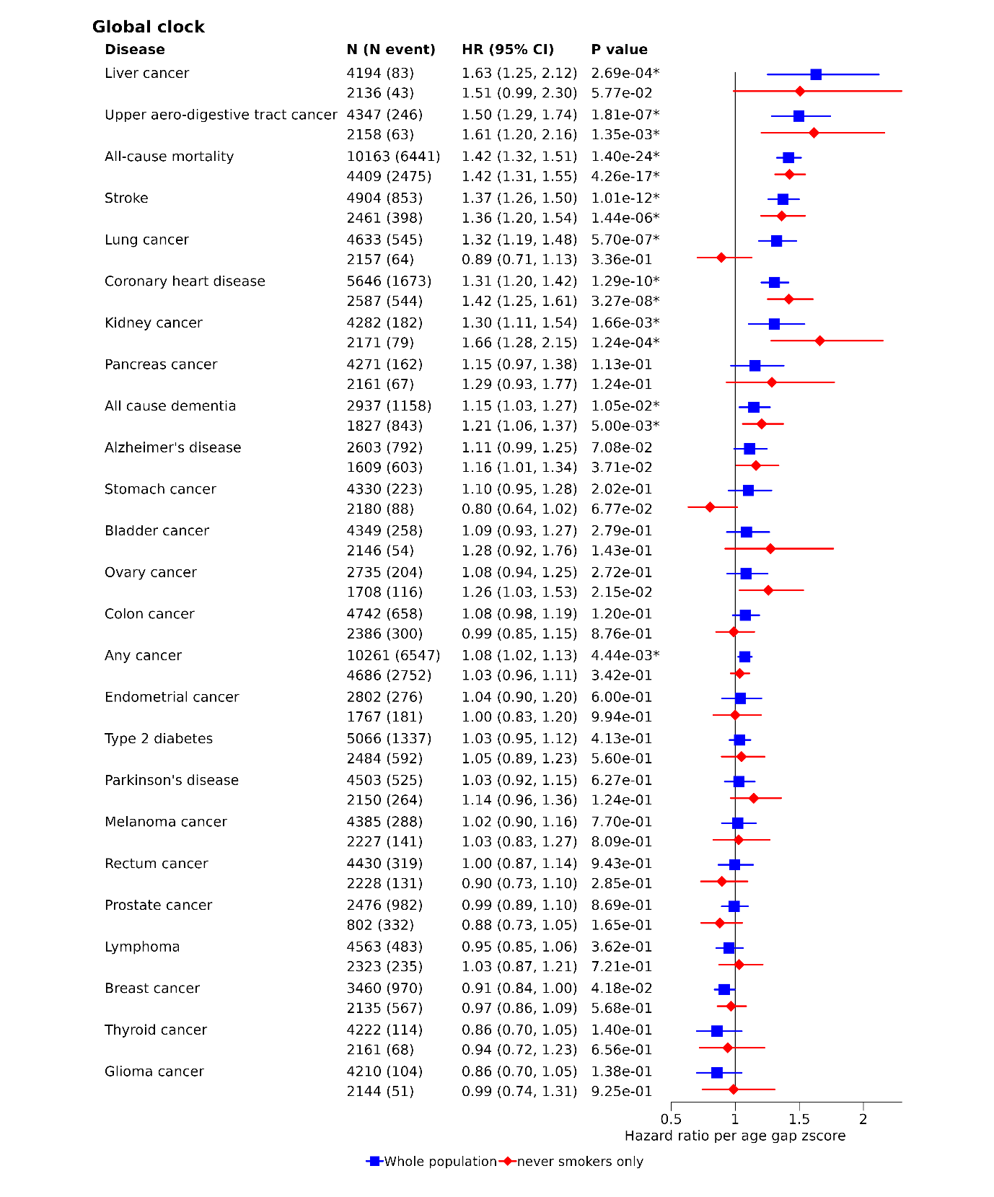
Figure S9: Associations with Global proteomic age across disease endpoints for whole population (blue bars) and for never smokers only (red bars). Hazard ratios per Global proteomic age gap z-score with all -cause mortality and 25 incident diseases. All models stratified by study centre, sex, and five-year age group and adjusted for education level, smoking status (whole population only), alcohol consumption, BMI, healthy diet score and physical activity. All error bars show 95% confidence intervals.

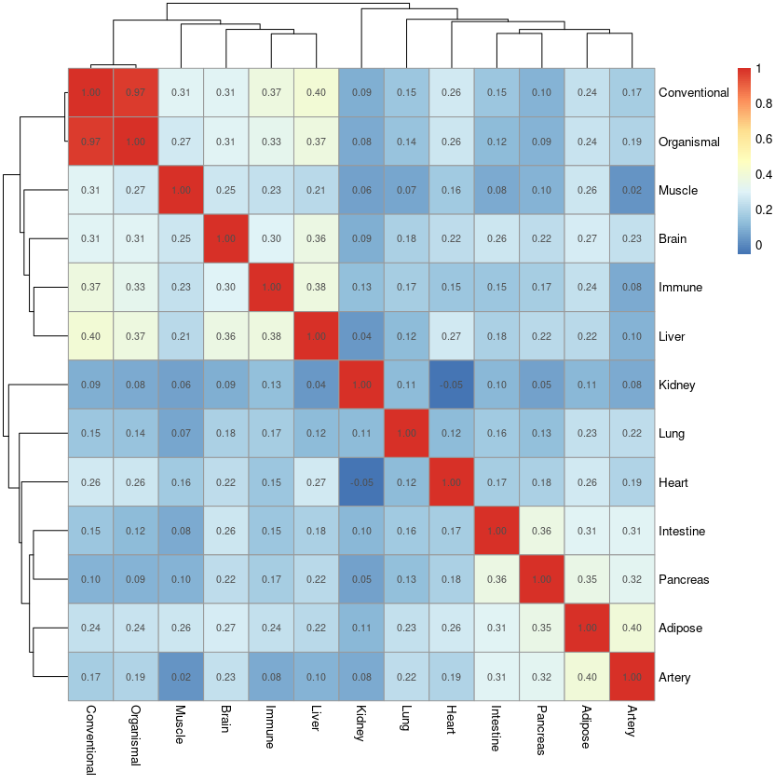

Figure S10: Correlation heatmap of organ specific proteomic age gaps.

Figure S11: Coefficients of lasso selected model of all-cause mortality. Model additionally stratified by study centre, sex, and five-year age group. All error bars show 95% confidence intervals.

