Supplementary Information
Distinct developmental trajectories shape human sensitivity
to rhythms in the environment
Antoine Guinamard, Nicholas E.V. Foster, Sylvain Clément, Valentin Bégel, Sonja A. Kotz, Séverine Samson, Simone Dalla Bella, Delphine Dellacherie

Supplementary Notes
Supplementary Note 1: To test whether RT benefits remained after accounting for accuracy, we fitted a linear mixed-effects model including condition, accuracy difference (Δd′), and their interaction as predictors. In this model (logRT ~ condition * Δd’ + (1+ condition | subject)), Δd′ quantifies the overall accuracy difference between the regular and irregular conditions, with positive values indicating improved accuracy in the regular condition. We found a significant positive interaction between condition and Δd′, indicating that in the regular condition, greater accuracy improvements are associated with smaller reaction time benefits. Conversely, decreases in accuracy are associated with larger reaction time gains, consistent with a speed–accuracy tradeoff. Importantly, the main effect of condition on RT remains significant, showing that the facilitation of reaction times in the regular condition persists even in the absence of accuracy differences, and thus cannot be fully explained by a speed–accuracy tradeoff.

Supplementary Note 2: To examine whether the negative association between Executive Functioning Index (EFI) and reaction time (RT) benefits could be attributed to a greater speed–accuracy tradeoff in children with lower executive functioning, we included accuracy differences (Δd′) and an interaction term (EFI × Δd′) in a multiple regression model predicting ΔRT. The overall model showed a good fit (R² = .26; F_{(2, 95)} = 16.42, p < .001). When accounting for accuracy, EFI remained the only significant predictor of ΔRT (β = –0.26, p = .028), whereas neither Δd′ nor the interaction term reached significance (Δd′: β = 0.31, p = .096; EFI × Δd′: β = 0.16, p = .384). These results suggest that the observed link between RT benefit and executive functioning is not fully explained by a speed–accuracy tradeoff, and may reflect differences in how children engage with temporal regularities based on their level of cognitive control.

Supplementary Figures
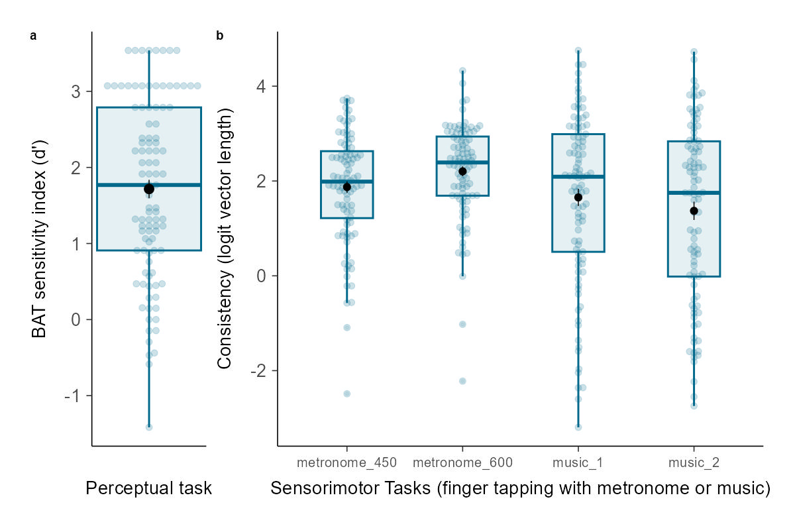
Supplementary Figure 1| distribution of the scores for the perceptual (a) and sensorimotor (b) tasks of the BAASTA. Consistency refers to vector length, a measure of variability in synchronization computed using circular statistics. Consistency scores were logit-transformed for analysis. The original consistency values range from 0 (no consistency) to 1 (perfect consistency). For interpretability, approximate corresponding values are as follows: logit(–2) = 0.12 (low consistency), logit(0) = 0.50 (moderate consistency), logit (2) = 0.88 (high consistency), and logit(4) = 0.98 (very high consistency). For paced tapping tasks with a metronome, 450 and 600 indicates the inter-onset interval in ms. For paced tapping with music, Music 1 corresponds to an extract from Badinerie (Bach), and Music 2 to an extract from the Overture by Rossini. Boxes show the interquartile range (IQR; 25th-75th percentiles) with the median as the central line; whiskers extend to 1.5×IQR. Black dots indicate the mean with error bars representing the s.e.m.; blue dots represent individual observations.
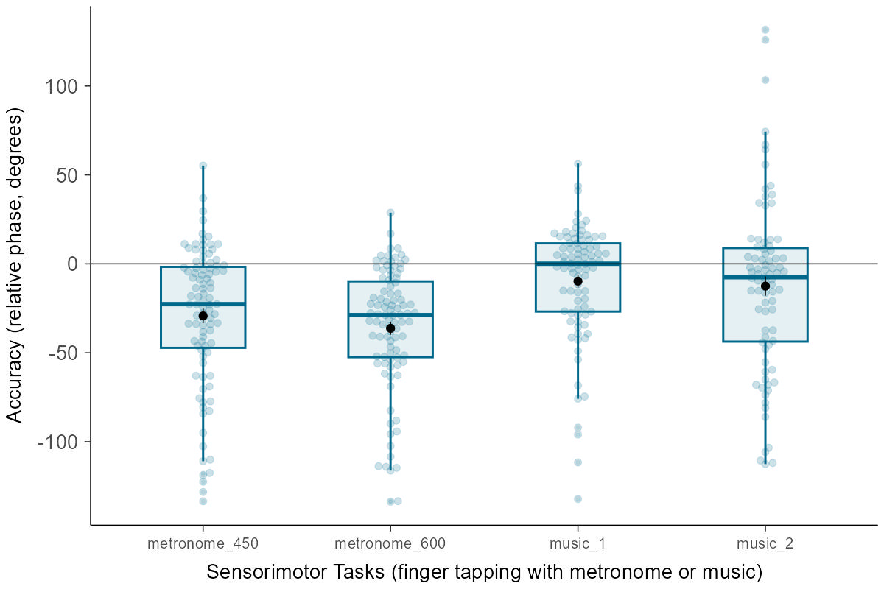
Supplementary Figure 2 | Accuracy in the paced tapping tasks of the BAASTA battery. Accuracy is expressed as the angle of the vector R (θ, or relative phase, in degrees), indicating whether participants tapped before (negative values) or after (positive values) the pacing event. Accuracy was computed only if synchronization performance exceeded chance level, as determined by the Rayleigh test for circular uniformity (see e.g., Dalla Bella et al., 2017, 2024; Sowiński & Dalla Bella, 2013). For paced tapping tasks with a metronome, 450 and 600 indicates the inter-onset interval in ms. For paced tapping with music, Music 1 corresponds to an extract from Badinerie (Bach), and Music 2 to an extract from the Overture by Rossini. Boxes show the interquartile range (IQR; 25th-75th percentiles) with the median as the central line; whiskers extend to 1.5×IQR. Black dots indicate the mean with error bars representing the s.e.m.; blue dots represent individual observations.

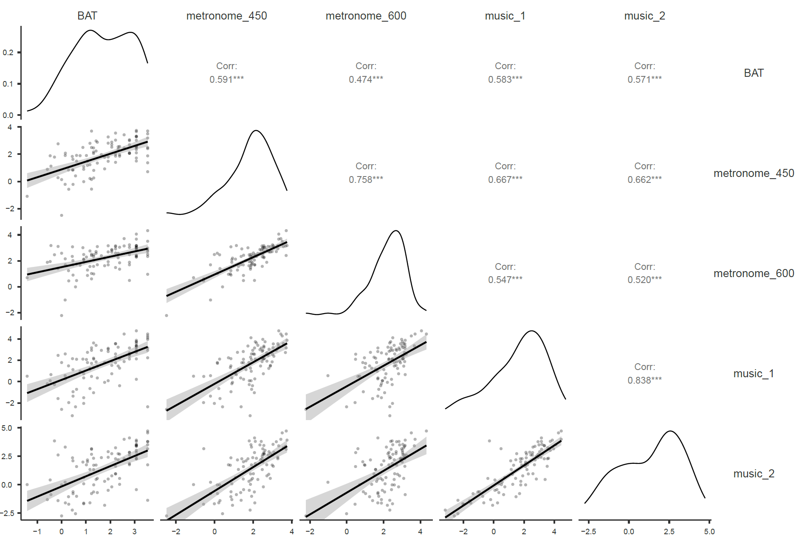
Supplementary Figure 3 | Correlation plots between performance in the explicit tasks from the BAASTA. BAT scores correspond to sensitivity index (d′). Performance in paced tapping tasks is indexed by consistency (logit-transformed vector length). For paced tapping with a metronome, values 450 and 600 indicate the inter-onset intervals in milliseconds. For paced tapping with music, Music 1 refers to an extract from Badinerie (Bach), and Music 2 to an extract from the Overture by Rossini. Pearson’s r is reported as the correlation coefficient. Regression lines are shown with shaded areas representing 95% confidence intervals. **p < .001.

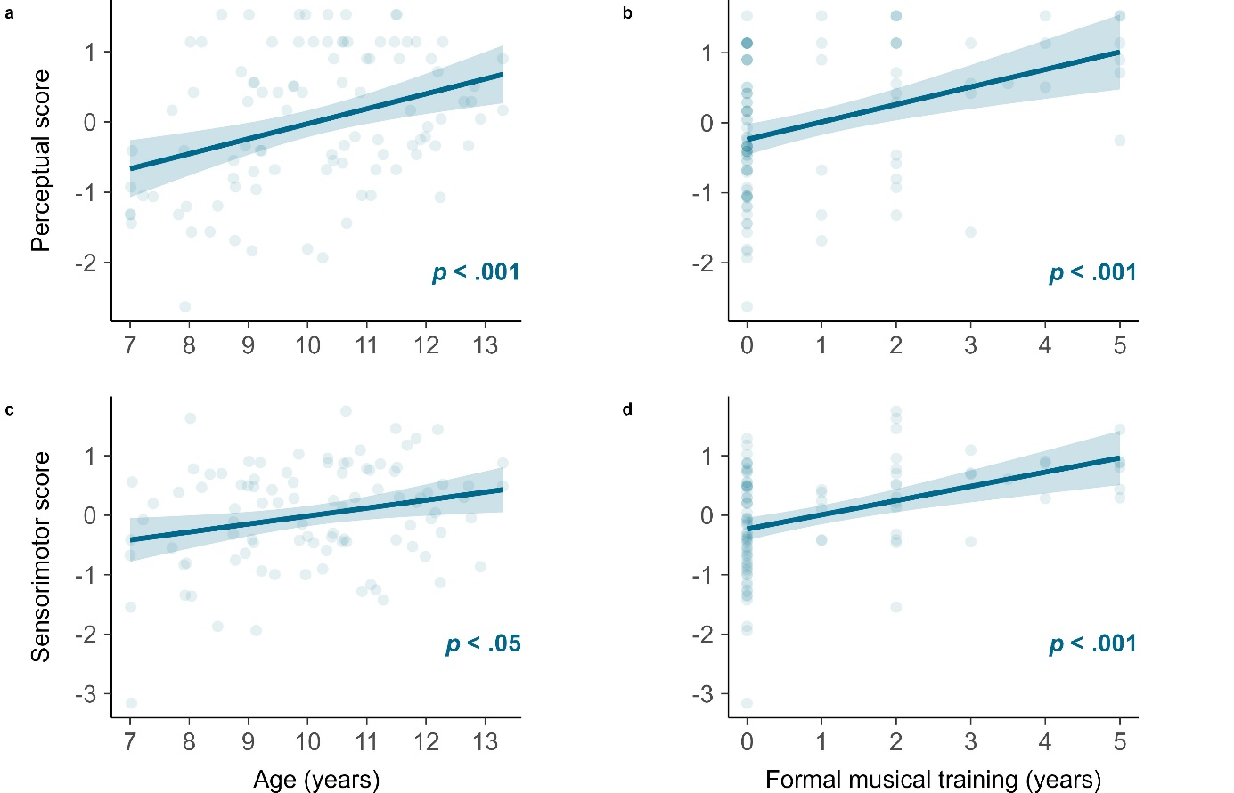
Supplementary Figure 4 | Relation between the perceptual (a, b) and sensorimotor (c, d) components of the BTI and age (a, d) and formal musical training (b, c). Perceptual score is the standardized BAT d’, and Sensorimotor score is the composite consistency score across the synchronization tasks. Regression lines are shown with shaded areas representing 95% confidence intervals for the prediction, and p-values are derived from multiple linear regressions including both age and musical training as predictors.

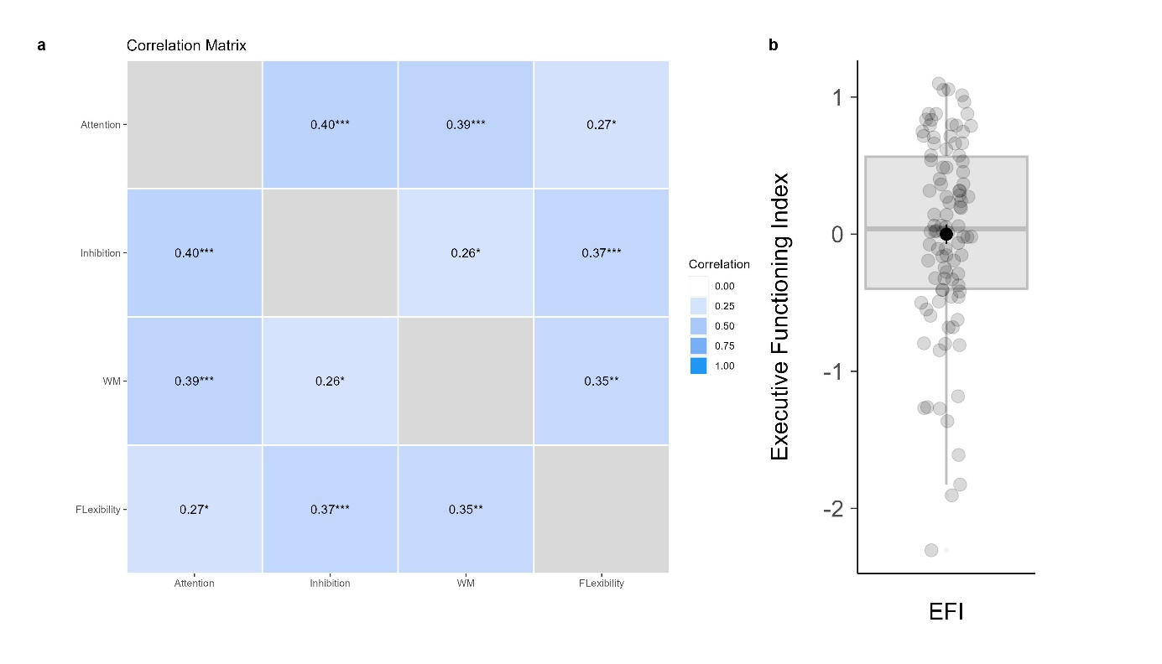
Supplementary Figure 5 | The Executive Functioning Index (EFI). (a) Pairwise correlations between the z-scores of the four EFI components: sustained attention, inhibition, working memory (WM), and cognitive flexibility. p values refer to these correlations. (b) Distribution of EFI scores. The box shows the interquartile range (IQR; 25th–75th percentiles), with the median as the central line; whiskers extend to 1.5 × IQR. Black dots indicate the mean with error bars representing the standard error of the mean (s.e.m.); grey dots represent individual observations. Note: the EFI is computed from z-scores but is not itself standardized; its mean and standard deviation therefore deviate slightly from 0 and 1, respectively. WM = working memory. p < .05, p < .01, p < .001.

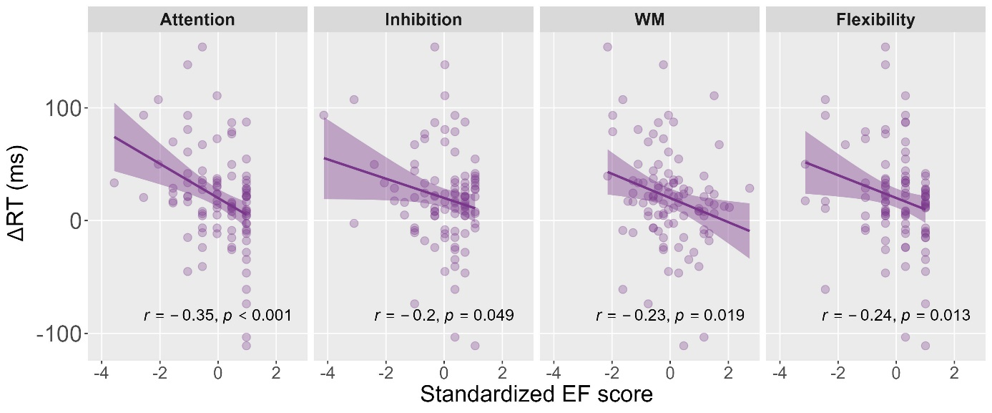
Supplementary Figure 6 | Relationship between reaction time benefits in the implicit rhythmic task (ΔRT) and each of the four standardized executive function scores contributing to the Executive Function Index. Linear regression lines are shown with shaded areas indicating 95% confidence intervals.

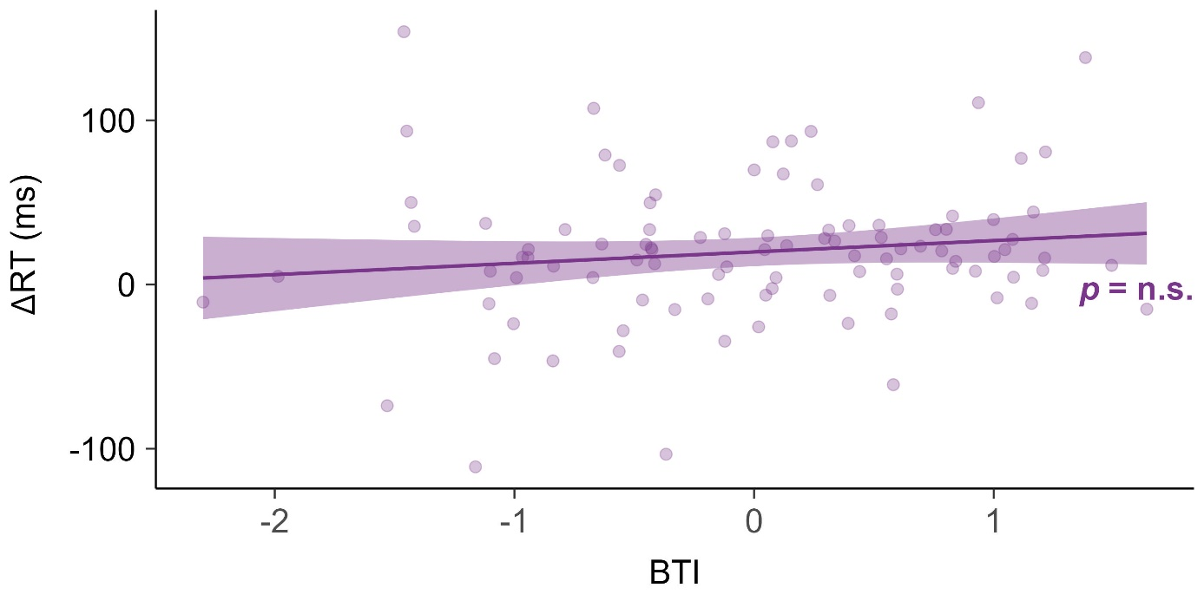
Supplementary Figure 7 | Reaction time benefits as a function of explicit rhythmic abilities. ΔRT in the implicit rhythmic task plotted against the Beat Tracking Index (BTI), an index of explicit rhythm abilities. The regression line is shown with shaded areas representing 95% confidence intervals. “n.s.” indicates non-significant associations (p > .05).

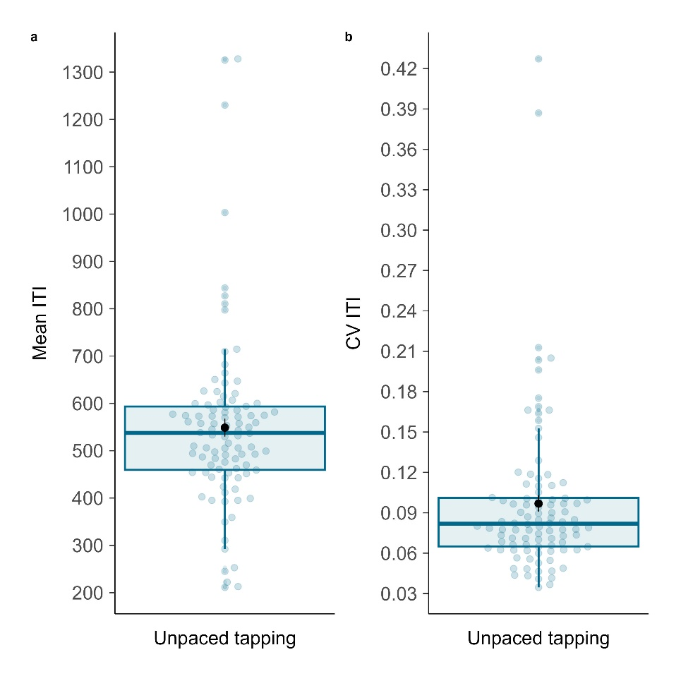
Supplementary Figure 8 | Spontaneous motor tempo in children. Distribution of (a) tapping rate, quantified as the mean inter-tap interval (ITI), and (b) tapping variability, expressed as the coefficient of variation (CV = SD of ITIs / mean ITI). Boxes indicate the interquartile range (IQR; 25th–75th percentiles) with the median as the central line; whiskers extend to 1.5×IQR. Black dots represent the mean ± s.e.m.; blue dots represent individual data points.

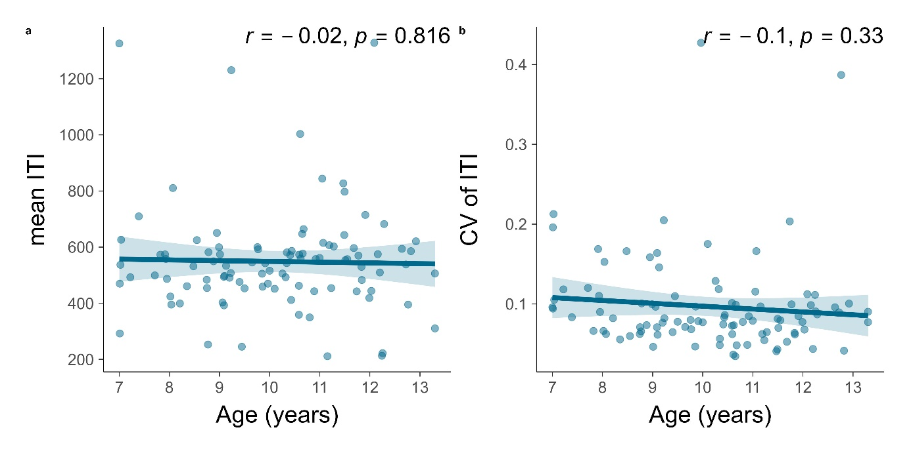
Supplementary Figure 9 | Spontaneous tapping performance as a function of age. (a) Mean inter-tap interval (ITI) plotted against age. (b) Tapping variability, expressed as the coefficient of variation (CV-ITI), plotted against age. Linear regression lines are shown with shaded areas representing 95% confidence intervals. Relationships were not statistically significant

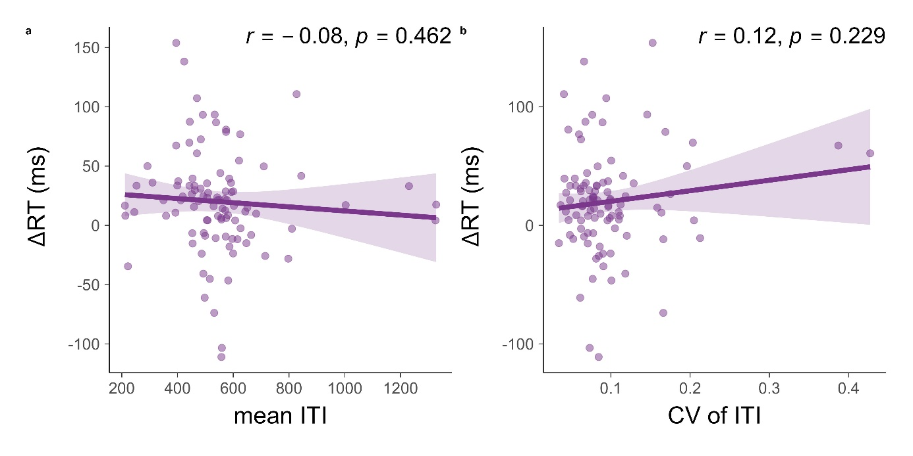
Supplementary Figure 10 | Spontaneous motor tempo as a function of reaction time benefits in the implicit task. (a) Mean inter-tap interval (ITI) plotted against reaction time benefits (ΔRT) in the implicit task. (b) Tapping variability, expressed as the coefficient of variation (CV-ITI), plotted against ΔRT. Linear regression lines are shown with shaded areas representing 95% confidence intervals. Relationships were not statistically significant

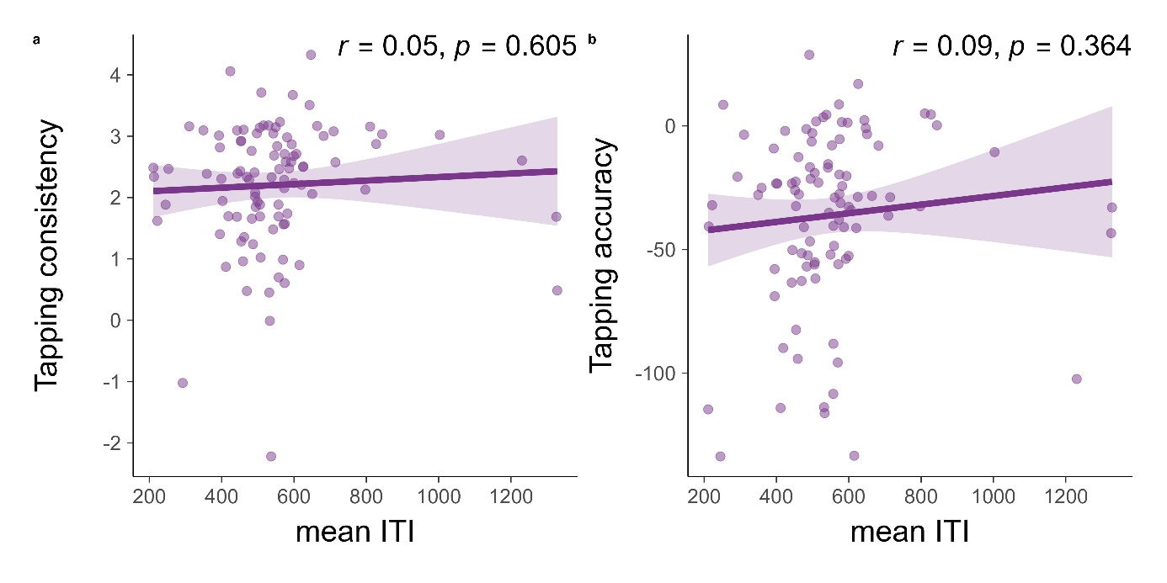
Supplementary Figure 11 | Spontaneous motor tempo as a function of synchronized tapping performance at 600 ms. (a) Consistency, quantified as the vector length (logit-transformed), where 0 = no consistency and 1 = perfect consistency. (b) Accuracy, measured as the vector angle (in degrees), with negative values indicating taps ahead of the beat and positive values indicating taps behind. Linear regression lines are shown with shaded areas representing 95% confidence intervals. Relationships were not statistically significant

Supplementary Tables
Supplementary Table 1 | Descriptive statistics for the explicit rhythmic tasks from the BAASTA.
Task | Measure | M | SD
Beat Alignment Test (BAT) | d' | 1.77 | 1.19
Unpaced tapping | ITI (ms) | 549.00 | 186.00
Unpaced tapping | CV-ITI | 0.10 | 0.06
Paced tapping metronome (450 ms) | consistency | 0.82 | 0.18
Paced tapping metronome (600 ms) | consistency | 0.86 | 0.14
Paced tapping music 1 | consistency | 0.75 | 0.27
Paced tapping music 2 | consistency | 0.70 | 0.30
Paced tapping metronome (450 ms) | accuracy | -29.27 | 39.78
Paced tapping metronome (600 ms) | accuracy | -36.25 | 35.17
Paced tapping music 1 | accuracy | -9.72 | 33.40
Paced tapping music 2 | accuracy | -12.52 | 49.40
Note. ITI = inter-tap interval; CV = coefficient of variation. Consistency refers to vector length, a circular measure of synchronization variability (0 = no consistency, 1 = perfect consistency). Accuracy refers to vector angle (in degrees), indicating whether participants tapped ahead (negative values) or behind (positive values) the pacing stimulus. Accuracy was computed only if synchronization performance exceeded chance level, as determined by the Rayleigh test for circular uniformity. For paced tapping tasks with a metronome, values in parentheses indicate the inter-onset interval. For paced tapping with music, Music 1 corresponds to an extract from Badinerie (Bach), and Music 2 to an extract from the Overture by Rossini.

