Supplemental Section
Supplemental Fig. 3 Mediation model of the relationship between increased pressure-pain tolerance, greater S1 brain activation, and reduced widespread pain.
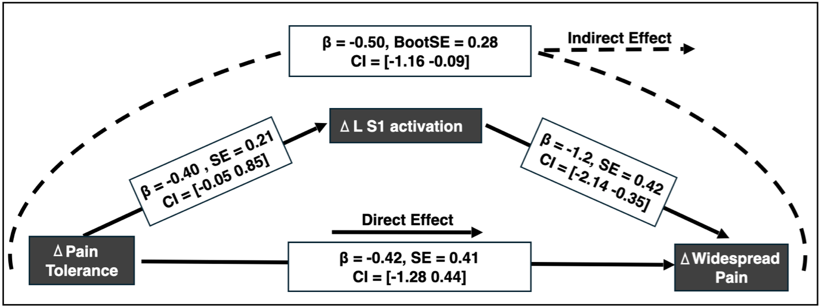This mediation model shows that changes in L S1 activation significantly mediates the relationship between increased pain tolerance and reduced widespread pain. Solid lines represent direct effects, while the dashed line represents the indirect effect through L S1 activation. Standardized beta coefficients (β), standard errors (SE), and confidence intervals (CI) are reported for each path.
Supplemental Table 1. Group-level differences in the relation between FC and widespread pain between EA and ML treatments.
Seed - Cluster | Cluster Size (k) | Contrast | p-value | Peak Coordinates of Cluster  (x, y, z)
L S1 – R aIC | 67 | EA < ML | p = 0.002 | -18, -40, +74
L S1 – R S1 | 52 | EA < ML | p = 0.005 | +28, -30, +48
L precuneus – R aIC | 184 | ML > EA | p < 0.001 | -4, -34, +54
Clusters reflect regions where changes in brain activation in association with reductions in widespread pain is significantly difference between the electroacupuncture (EA) and mock laser (ML) groups (p < 0.001, family-wise error (FWE) corrected). The table includes cluster size, contrast, peak coordinates, and statistical significance.

Supplemental Table 2. Mediation Effects of FC on the Relationship Between Changes in Brain Activations During Pressure-pain and Reductions in Nociplastic Widespread Pain
Path​ |  | Group: EA​  X: L S1 activation​  M: L S1 to R aIC FC​ | Group: ML​  X: L precuneus activation​  M: L precuneus to R aIC FC​
Path a: Brain Activation (X) → FC (M)​ | Beta (SE)​ | 1.18 (0.41)​ | 1.62 (0.31)​
Path a: Brain Activation (X) → FC (M)​ | Confidence Interval​ | [0.30, 2.05]​ | [0.98, 2.25]​
Path b: FC (M)​ → Widespread Pain (Y)​ | Beta (SE)​ | -0.57 (0.18)​ | 0.60 (0.16)​
Path b: FC (M)​ → Widespread Pain (Y)​ | Confidence Interval​ | [-0.96, -0.18]​ | [0.28, 0.93]​
Path c: Brain Activation (X) → Widespread Pain (Y)​ | Beta (SE)​ | -0.76 (0.38) ​ | 0.22 (0.34)​
Path c: Brain Activation (X) → Widespread Pain (Y)​ | Confidence Interval​ | [-1.56, 0.05]​ | [-0.49, 0.93]​
Path c′: Brain Activation (X) → Widespread Pain(Y) after controlling for FC (M)​ | Beta (SE)​ | -0.67 (0.30)​ | 0.97 (0.36) ​
 | Confidence Interval​ | [-1.36, -0.20]​ | [0.34, 1.78]​
Mediation analysis results showing functional connectivity (FC) as a mediator (M) in the relationship between changes in brain activation (independent variable; X) and changes in widespread pain (dependent variable; Y) for EA and ML groups separately. In the EA group, increased left S1 activation (X) influences reductions in widespread pain (Y) through FC between the left S1 and right anterior insula (L S1 – R aIC FC). In the ML group, decreased left precuneus activation (X) influences reductions in widespread pain (Y) through reduced FC between the left precuneus and right anterior insula (L precuneus – R aIC FC). The table presents the beta coefficients, standard errors (SE), and confidence intervals (CI) for both direct and indirect effects. The direct effect represents the direct relationship between activation and changes in widespread pain, while the indirect effect reflects the mediated pathway through FC.

Supplemental Table 3. Participant demographics and clinical outcomes for full sample
 | EA (N=33) |  | ML (N=37) |  | p-value
 |  |  |  |  | Time | Group | Group x Time
 | Pre-tx | Post-tx | Pre-tx | Post-tx | Time | Group | Group x Time
Age (years) | 44.21±12.92 |  | 41.54±9.85 |  | N/A | .339 | N/A
Widespread Pain | 5.52  ±1.56 | 5.18  ±1.61 | 5.03  ±1.36 | 4.76  ±1.62 | .091 | .164 | .858
Pressure-Pain Tolerance | 3.88  ±1.48 | 3.88  ±1.23 | 3.66  ±1.61 | 3.62  ±1.43 | .818 | .514 | .880
BPI Severity | 5.21  ±1.47 | 4.07  ±1.91 | 4.93  ±1.33 | 4.47  ±1.62 | <.001 | .927 | .042
BPI Interference | 5.10  ±2.22 | 3.91  ±2.00 | 5.46  ±1.95 | 4.66  ±2.37 | <.001 | .231 | .398
FM Survey Criteria | 20.34  ±5.18 | 17.34  ±5.97 | 19.54  ±4.09 | 15.27  ±4.65 | <.001 | .108 | .887
Participant demographics and clinical outcomes for the full sample. Values represent group means ± standard deviation for the EA (electroacupuncture) and ML (mock laser) groups at pre- and post-treatment. P-values reflect results from repeated measures ANOVA testing for main effects of Time, Group, and the Group × Time interaction. N/A = not applicable for between-group comparisons of baseline age.
Supplemental Table 4. Participant demographics and clinical outcomes for fMRI analysis
 | EA (N=19) |  | ML (N=25) |  | p-value
 |  |  |  |  | Time | Group | Group x Time
 | Pre-tx | Post-tx | Pre-tx | Post-tx | Time | Group | Group x Time
Age (years) | 43.58±14.58 |  | 41.08±11.22 |  | N/A | .539 | N/A
Widespread Pain | 5.37  ±1.50 | 5.16  ±1.80 | 5.00  ±1.26 | 4.72  ±1.51 | .283 | .321 | .878
Pressure-Pain Tolerance | 3.79  ±1.45 | 3.66  ±1.23 | 3.35  ±1.40 | 3.26  ±1.24 | .329 | .295 | .869
BPI Severity | 5.26  ±1.68 | 4.03  ±1.98 | 5.03  ±1.23 | 4.43  ±1.35 | <.001 | .842 | .127
BPI Interference | 5.32  ±2.38 | 4.01  ±1.83 | 5.42  ±2.16 | 4.74  ±2.36 | .218 | .498 | .027
FM Survey Criteria | 18.00  ±5.25 | 17.05  ±6.33 | 17.20  ±6.37 | 15.20  ±4.00 | .027 | .316 | .417
Participant demographics and clinical outcomes for the fMRI analysis. Values represent group means ± standard deviation for the electroacupuncture (EA) and mock laser (ML) groups at pre- and post-treatment. P-values reflect results from repeated measures ANOVA testing for main effects of Time, Group, and the Group × Time interaction. N/A = not applicable for between-group comparisons of baseline age.

