Appendix 1
Supplementary Table 1. Correlations of the main study variables
Variables | Multimorbidity | IC | EQ-5D-3L level
Multimorbidity | 1
IC | -0.222*** | 1
EQ-5D-3L level | 0.225*** | -0.246*** | 1
IC, intrinsic capacity; ***p < 0.001.

Appendix 2
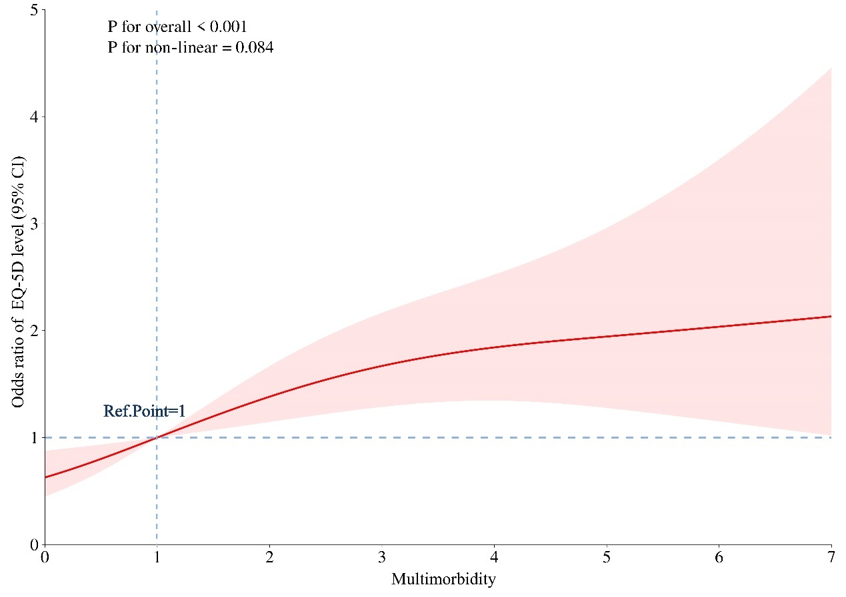
Supplementary Figure 1. Weighted restricted cubic spline curve describing the relationship between CCI score and Low QoL.
Adjusted for all covariates gender, age, marital status, education, nursing home resident status, IC.
Ref. Point, Reference. Point; CI, confidence interval.

