Supplementary Information
Liquid metal dispersed single-atom catalyst with high-temperature stability
Ziyue Zeng^{1†}, Chenyang Wang^{1†}, Mingjun Sun^{3†}, Dong Liu⁴, Donghong Zhang⁴, Shiyi He¹, Zijia Liang², Yushen Ma¹, Yile Zhang¹, Ling Li⁴, Xin Tian⁴, Mengqi Zeng¹, Mingyue Ding^{4,5}*, Feng Ding^{3,6,7}*, Lei Fu^{1,2}*
¹College of Chemistry and Molecular Sciences, Wuhan University; Wuhan 430072, China. ²Institute for Advanced Studies, Wuhan University; Wuhan 430072, China. ³Institute of Technology for Carbon Neutrality, Shenzhen Institute of Advanced Technology, Chinese Academy of Sciences, Shenzhen 518055, China. ⁴School of Power and Mechanical Engineering, Wuhan University, Wuhan 430072, China. ⁵Academy of Advanced Interdisciplinary Studies, Wuhan University, Wuhan 430072, China. ⁶Faculty of Materials Science and Energy Engineering, Shenzhen University of Advanced Technology, Shenzhen 518055, China. ⁷Research Division of Advanced Materials, Suzhou Laboratory, Suzhou 215133, China.
*E-mail: leifu@whu.edu.cn; dingf@szlab.ac.cn; dingmy@whu.edu.cn
†These authors contributed equally to this work.
Materials and Methods
Chemicals and materials
Gallium (Ga, 99.999%) was purchased from Shanghai Minor Metals Co. Ltd., platinum (Pt, 99.9%) and molecular sieve (ZSM-5 zeolites, Si/Al=45) were purchased from Aladdin Industrial Inc. High-purity ethane (99.99%) was purchased from Dalian Special Gas Co., Ltd. and was purified using 4A zeolite before reaction.
Synthesis of liquid metal supported single-atom catalyst
The liquid metal supported single-atom catalyst was synthesized by dissolving Pt into molten Ga in a tube furnace in a H₂/Ar mixture gas at 650 °C, with a heating rate of 5 °C min^{–1}.
Synthesis of liquid metal supported single-atom catalyst for ethane dehydrogenation (EDH)
The catalysts EDH reaction was prepared by similar steps. In order to increase the mass transfer of the ethane, the liquid metal support is coupled with the ZSM-5 (Ga@ZSM-5) by sonication as follows steps. The liquid Ga and ZSM-5 zeolites were transferred to ethylene glycol, and the solution was sonicated by a probe-type sonicator for 2 h (5 s on and 3 s off) at the power of 290 W. After sonication, the resultant precipitations were washed with ethanol and water for 3 times. And then the resultant was flash frozen in liquid nitrogen for 5 min and freeze-dried at −40 ºC, under the pressure less than 200 mTorr, for 24 h using the FreeZone 4.5 Liter Benchtop Freeze Dry System. The Pt powders were mixed with Ga@ZSM-5 and heated in situ in the reactor in a H₂/Ar mixture gas for catalytic measurement.

Catalyst characterization
The morphology of liquid metal supported single atom catalyst was characterized by an F200 transmission electron microscope (TEM) (JEOL, Japan) operated at 200 kV. X-ray diffraction (XRD) data was employed by PANalytical X’Pert-Pro diffractometer, with a Cu K𝛼 radiation (𝜆 = 0.15406 nm), in the 2θ scan mode ranging from 10º to 80º at a scan speed of 8º min⁻¹. In situ XRD was collected with the Rigaku Ultima Ⅳ instrument using Cu Kα (λ = 1.5406 Å) radiation at 40 kV and 40 mA, and the operating voltage and current were 40 kV and 40 mA, respectively. The catalysts were scanned at a rate of 8º min⁻¹ in the 2θ range of 35º ~60º. X-ray photoelectron spectroscopy (XPS) measurements were taken on a high-resolution Thermo Fisher Scientific ESCALAB Xi+ spectrometer using Al K𝛼 radiation under vacuum. Pt L₃ edge XAFS spectra were collected at the BL11B beamline of the Shanghai Synchrotron Radiation Facility (SSRF). During the measurement, the synchrotron radiation ring was operated at 3.5 GeV and the electron current was 200 mA in the top-up mode. The samples were sealed in Kapton film. The white light was monochromatized by a Si (111) double-crystal monochromator. The corresponding metal foils were used as a reference sample to calibrate and measured in the transmission mode. All XAFS spectra were processed using the IFEFFIT package. The elemental composition of the samples before and after the reaction was determined by inductively coupled plasma-atomic emission spectroscopy (ICP-OES).
Catalytic performance measurements
EDH tests were performed under atmospheric pressure in a fixed-bed quartz U-tube reactor. Catalysts were weighed and loaded into 10 mm outside diameter (OD), 8 mm interior diameter (ID) U-tube reactor. 5 sccm of argon and 15 sccm of hydrogen were flowed at 650 ºC for 10 minutes to reduce any metal oxides. And then the reactor was purged with 20 sccm argon for 5 min to prevent hydrogen residue. The EDH reaction was conducted in a C₂H₆/Ar mixture gas (Vol C₂H₆/Vol Ar = 1:7) with a flow rate of 20 mL min⁻¹. The outlet gas products were observed by an online mass spectrometer (Pro-tech, PM-QMS, China). The conversion of ethane and selectivity to all carbonaceous products (including coke) were calculated as follows:
$$Ethane conversion=\frac{molar flow rate of carbon \left(C\right) in products}{molar flow rate of total C in efluent \left(C_{2}H_{6}+products\right)}×100\%$$
$$Product i selectivity=\frac{molar flow rate of C in product i}{molar flow rate of C in all products}×100\%$$
Theoretical calculation
To investigate the atomic-level dispersion of active metals in the liquid Ga, we initially constructed a Ga₉₀Pt₁₀ cubic cell model using LAMMPS software. The initial cell parameter was set to 13 Å, with Pt₁₀ as a cluster molecule and the remaining 90 Ga atoms randomly distributed. Subsequently, ab initio molecular dynamics simulations were performed using the Vienna ab initio simulation package (VASP) to the potential energy curves for both clustered and dispersed states of Pt₁₀ in the Ga₉₀Pt₁₀ structural model at 923 K. For the dispersed state, the damping coefficients for Ga and Pt were set to 10 and 5, respectively, while for the clustered state, they were set to 10 and 1000. All calculations were conducted using the GGA-PBEsol functional¹ and employed the Langevin thermostat and Parrinello-Rahman method^{2,3} for the isothermal-isobaric (nP_{z}T) ensemble. The cutoff energy was set to 400 eV with an energy convergence tolerance of 10^{–6} eV, and the simulation time was 10 ps. Due to the relatively high Pt content in the Ga₉₀Pt₁₀ system, occasional Pt₂ units were observed in the simulation results. Therefore, we further performed the similar ab initio molecular dynamics simulations for the Ga₉₈Pt₂ system and an extra 10 ps NVT MD simulation was carried out starting from the last snapshot of the NPT simulation. Additionally, the crystalNN statistical method⁴ was used to evaluate the Pt–Pt bonding in liquid Ga. To gain further insight into the dispersion of Pt atoms in liquid Ga, we employed the B3LYP/LANL2DZ and B3LYP/6-311G(d) methods to calculate the potential energy curves for the interatomic interactions in Ga₂, GaPt, and Pt₂ diatomic molecules. The potential energy curves for the Ga₂ molecular system calculated using both the B3LYP/LANL2DZ and B3LYP/6-311G(d) methods showed consistency. Therefore, the B3LYP/LANL2DZ method was selected for evaluating and comparing the interactions between other atomic species. Furthermore, we constructed cluster structures such as Pt₂, (Ga₆Pt)₂, (Ga₇Pt)₂, Pt₂Ga, (Ga₆Pt)₂Ga, and (Ga₇Pt)₂Ga, optimizing all cluster molecules using the B3LYP/LANL2DZ method. Additionally, we performed rigid scans of the PtGaPt angle in the Pt₂Ga, (Ga₆Pt)₂Ga, and (Ga₇Pt)₂Ga cluster systems to roughly estimate the energy barrier associated with the incorporation of Ga atoms into the Pt–Pt bond.
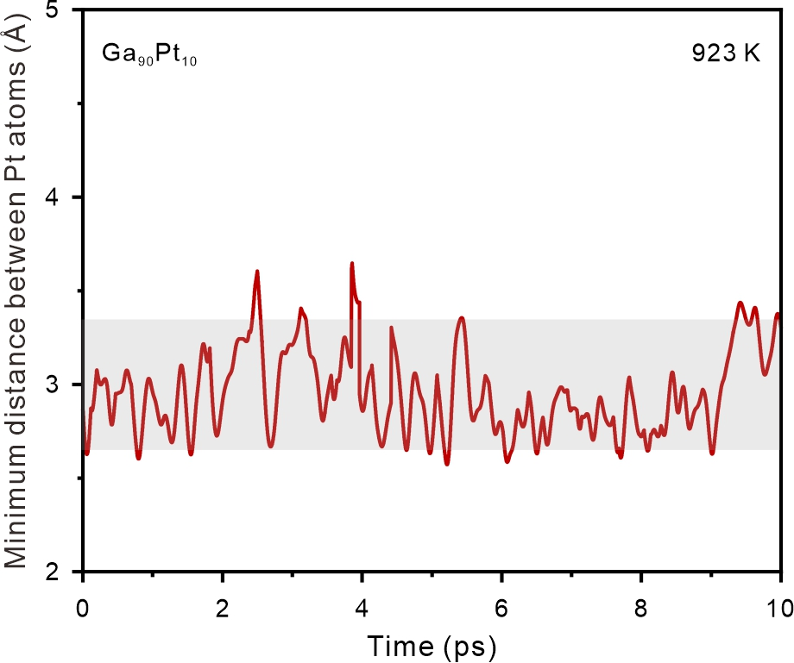
Supplementary Fig. 1 | Time evolution of the minimum Pt–Pt distance in Ga₉₀Pt₁₀ system at 923 K. The gray area marked is 2.65 ~ 3.35 Å, which is 1.2 times of the length of Pt–Pt bond (2.65 ~ 2.79 Å). In Ga₉₀Pt₁₀ system, the shortest Pt–Pt distance luctuates between 2.51 Å and 3.65 Å, which are partly in the range of 1.2 times of the length of Pt–Pt bond (2.65 ~ 2.79 Å)⁵. Generally, when the distance between the two atoms is less than 1.2 times of the sum of their Cambridge Structural Database (CSD) covalent radii, the chemical bond between the two atoms can be considered to be not formed^{6,7} and they are isolated to each other. The relatively high Pt concentration in Ga₉₀Pt₁₀ system, leads to intermittent formation of Pt₂ dimer.
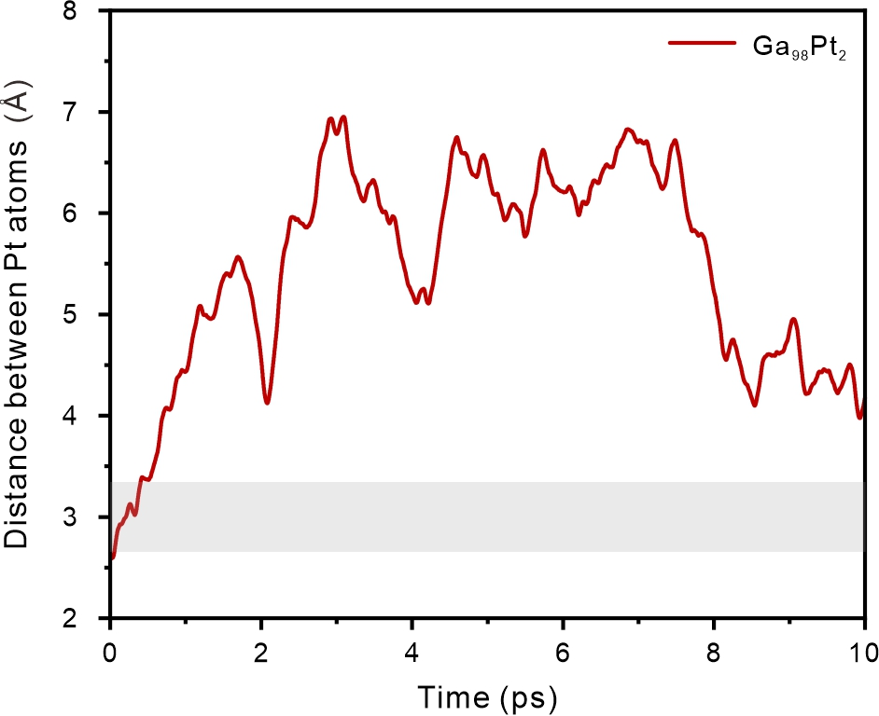
Supplementary Fig. 2 | Time evolution of Pt-Pt interatomic distance in the Ga₉₈Pt₂ system under NPT ensemble simulation. The final structure from the simulation was used as the initial structure for the following NVT ensemble simulation.
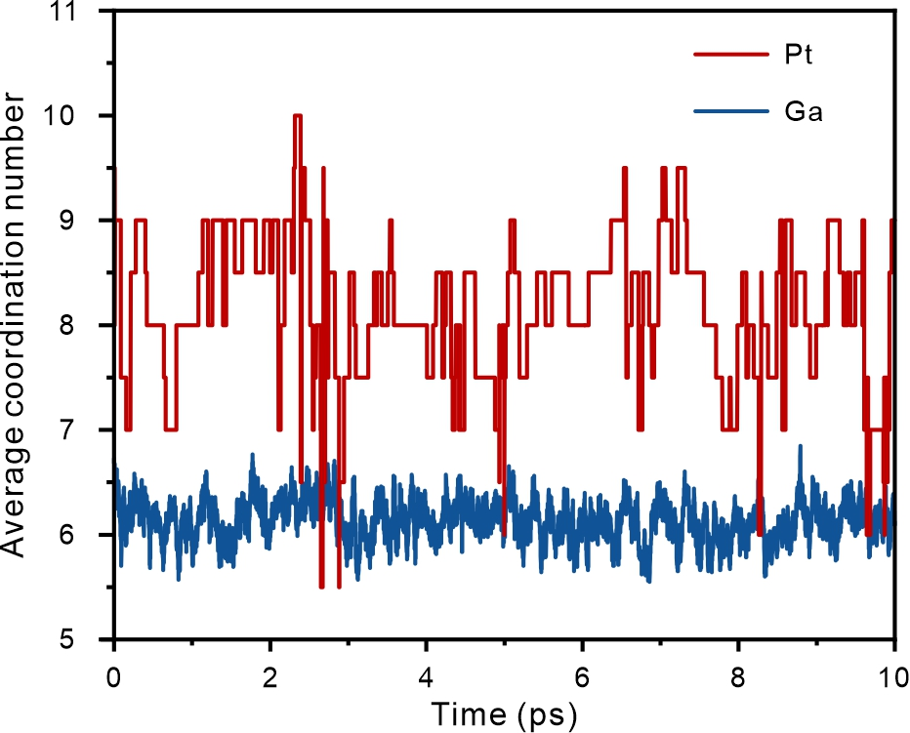
Supplementary Fig. 3 | Variation of the average coordination numbers of Pt and Ga per frame with simulation time in the Ga₉₈Pt₂ system at 923 K. The simulation results indicate that at 923K, the coordination number (CN) of Ga is predominantly 6, while that of Pt mainly falls within the range of 7~9.
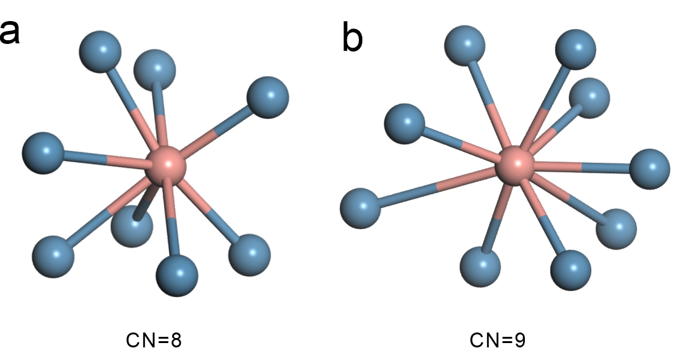
Supplementary Fig. 4 | Structures of the Ga₈Pt and Ga₉Pt clusters. The spontaneous dispersion of Pt into Ga₈Pt and Ga₉Pt clusters occurs in the presence of an abundance of Ga atoms.
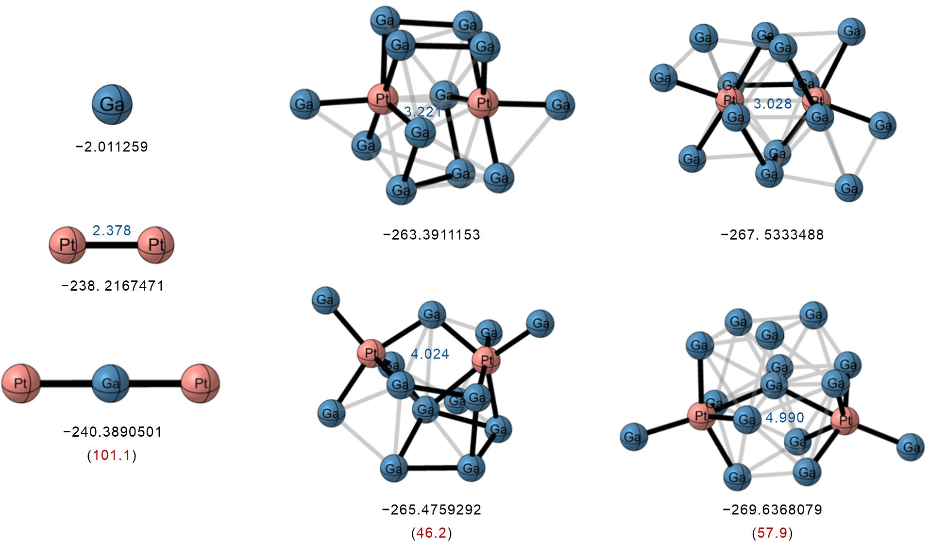
Supplementary Fig. 5 | The formation energies of Pt₂Ga, (Ga₆Pt)₂Ga, and (Ga₇Pt)₂Ga molecules. The figure presents the optimized structures of the molecular systems Pt₂, (Ga₆Pt)₂, (Ga₇Pt)₂, Pt₂Ga, (Ga₆Pt)₂Ga, and (Ga₇Pt)₂Ga. The numbers labeled in black represent the energies of the systems, with the unit in Hartree; the numbers labeled in blue denote bond lengths, with the unit in Å; and the numbers labeled in red indicate the calculated formation energies (ΔE = E_{Ga} + E_{Pt–Ga molecule} – E_{complex}), with the unit in kcal/mol. The formation energies of Pt₂Ga, (Ga₆Pt)₂Ga, and (Ga₇Pt)₂Ga molecules were determined to be 101.1, 46.2, and 57.9 kcal/mol, respectively. These results thermodynamically demonstrate that Ga can readily disrupt the Pt–Pt bonds, leading to the formation of single-atom Pt in liquid Ga.
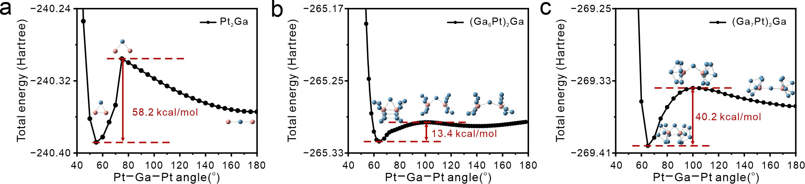
Supplementary Fig. 6 | The energy barriers of Ga atom insertion into the Pt–Pt bond by performing rigid scans of the Pt–Ga–Pt angle. The energy barriers of Ga atom insertion into the Pt–Pt bond in Pt₂, (Ga₆Pt)₂, and (Ga₇Pt)₂ were calculated to be 58.2, 13.4, and 40.2 kcal/mol, respectively. The energy barrier for Ga inserting into the Pt–Pt bond in the (Ga₇Pt)₂Ga system, though higher than that in (Ga₆Pt)₂Ga, is still significantly lower than the typical ~67 kcal/mol barrier that chemical reactions can generally overcome at 923 K. This indicates that the (Ga₇Pt)₂Ga system is kinetically feasible, thereby further facilitating the formation of Ga₈Pt clusters.
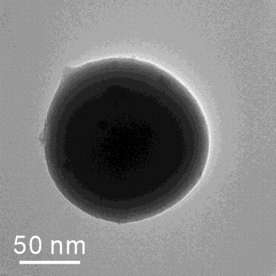
Supplementary Fig. 7 | Scanning transmission electron microscopy (STEM) image of Pt@Ga.
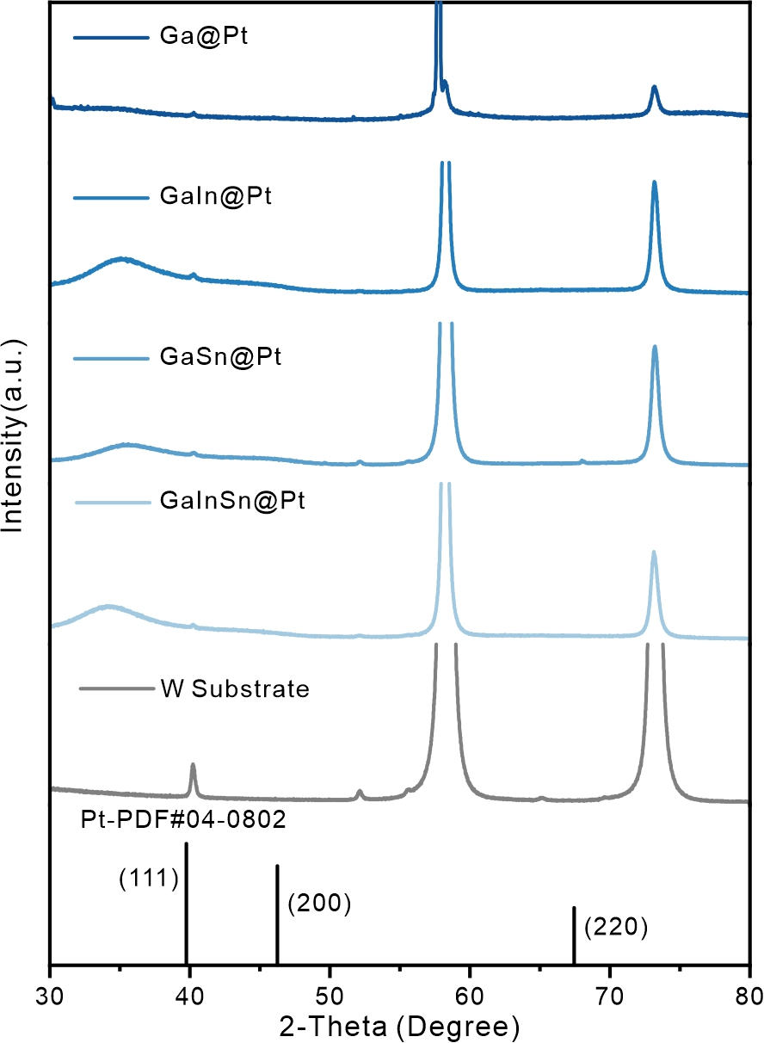
Supplementary Fig. 8 | X-ray diffraction (XRD) patterns of Pt in different liquid state. Three sets of peaks appeared at 39.8°, 46.2°, and 67.5° are ascribed to the (111), (200), and (220) reflections of Pt (PDF # 04–0802). However, the metal peak of Pt was absent in the liquid metal, indicating there was no agglomeration of Pt.
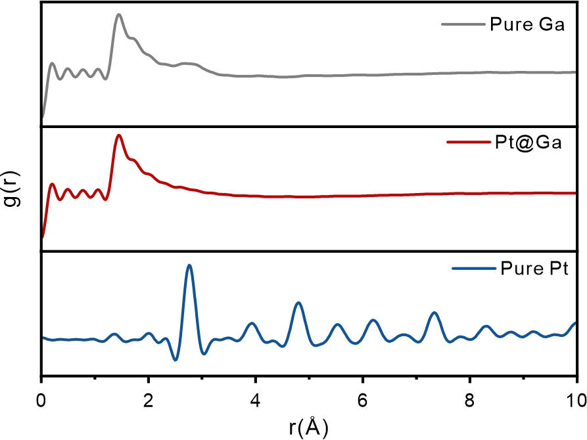
Supplementary Fig. 9 | Pair distribution function (PDF) for Pt@Ga. The PDF spectrums for bulk Pt metal and pure Ga were included for comparison. The PDF clearly demonstrates that the Pt species are in isolated environments without any Pt−Pt bond.
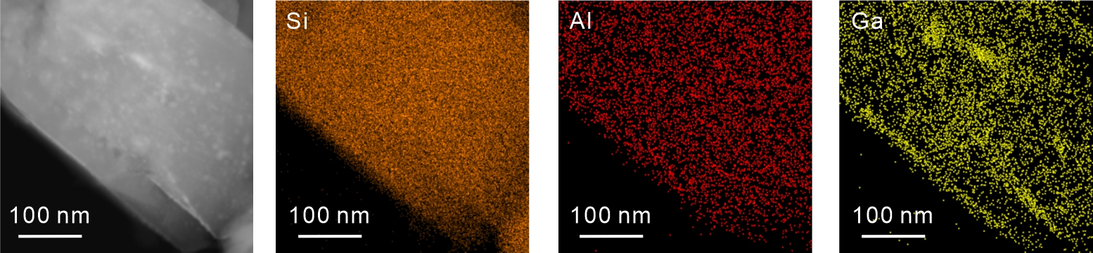
Supplementary Fig. 10 | The STEM image and EDS mappings of Ga loaded on ZSM-5 zeolites. Ga was loaded on the ZSM-5 zeolites to increase the mass transfer of gas in the catalyst.
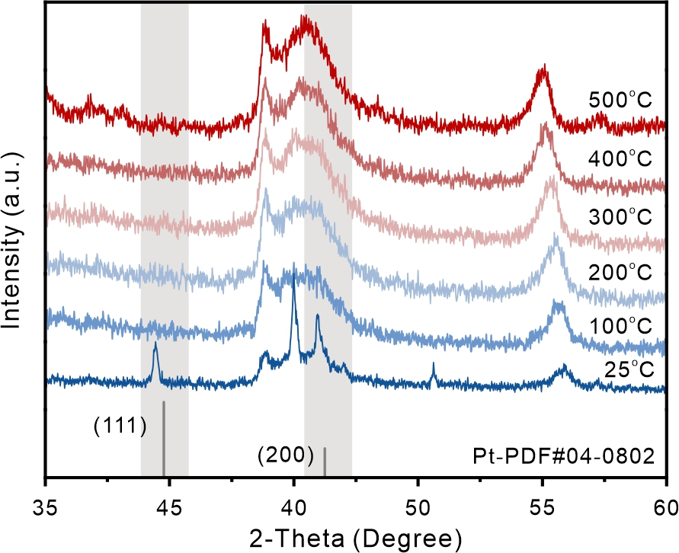
Supplementary Fig. 11 | In situ XRD patterns of Pt@Ga on ZSM-5 in the process of heating up. Initially, the characteristic peaks of Pt can be apparently observed located at 39.8º and 46.3º. With the temperature increasing, the characteristic peaks of Pt were gradually weakened and disappeared subsequently, proving the dispersion of Pt particles.
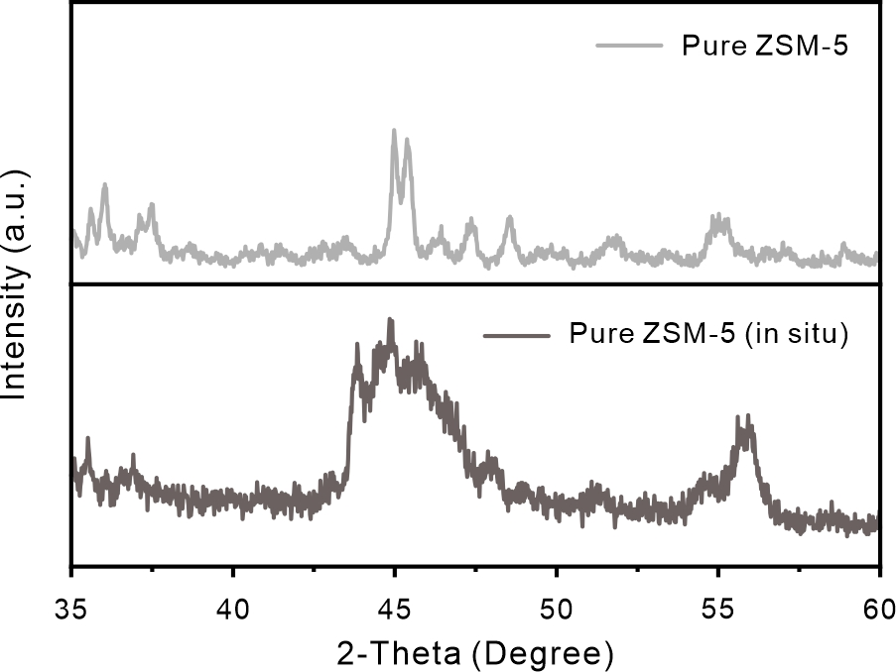
Supplementary Fig. 12 | XRD patterns of pure ZSM-5 and ZSM-5 in in situ equipment. The wide diffraction peak observed at 43º–47º originates from the signal of the carbon within in situ reactor.
Supplementary references
1 Perdew, J. P. et al. Restoring the density-gradient expansion for exchange in solids and surfaces. Phys. Rev. Lett. 100, 136406 (2008).
2 Parrinello, M. & Rahman, A. Polymorphic transitions in single crystals: a new molecular dynamics method. J. Appl. Phys. 52, 7182−7190 (1981).
3 Parrinello, M. & Rahman, A. Crystal structure and pair potentials: a molecular-dynamics study. Phys. Rev. Lett. 45, 1196−1199 (1980).
4 Pan, H. et al. Benchmarking coordination number prediction algorithms on inorganic crystal structures. Inorg. Chem. 60, 1590−1603 (2021).
5 Dedieu, A. & Hoffmann, R. Platinum(0)-platinum(0) dimers. Bonding relationships in a d¹⁰-d¹⁰ system. J. Am. Chem. Soc. 100, 2074−2079 (1978).
6 Lu, T. & Chen, F. Multiwfn: A multifunctional wavefunction analyzer. J. Comput. Chem. 33, 580−592 (2011).
7 Lu, T. A comprehensive electron wavefunction analysis toolbox for chemists, Multiwfn. J. Chem. Phys. 161, 082503 (2024).

